**C Sc 335 Analysis and Design Artifacts for the Final Project 20 pts (TEAM)**

Each team begin analysis and design for your final project (analysis and design will continue throughout the project). Have one team member turn in this document to the D2L Assignment "Final Project Analysis and Design".

**1. Team Name:**  _Zerg Rush

**2. Project (Pokemon or Tower Defense): _Tower Defense**

**3. Team Members** 1: _Ben Walters 2: _Angel Aguayo

*first* ***and*** *last names*

3: _David Weinflash 4: _David Taylor

**4. Find the objects and describe the responsibility(ies) of each**

|  |  |
| --- | --- |
| **Candidate Object** | **Responsibility(ies) in 1 or 2 sentences. What would it do and remember?** |
| Tower | Kills mobs, can be placed |
| Mob | Mobile enemies |
| Map | Contains the graphical and pathing |
| Player | Contains player data such as rank, gold, etc. |
| Tile | Keeps track pathable, placeable, what graphic, etc |
| Sound | Sound stuff |
| Map View | Map selection, options. |
| User Guide | Provide instructions via the start menu |
| Animation | Animations for the towers and mobs |
| Path | The coordinate path the enemy should follow |
| Score View | View to represent the player’s score |
| Menu View | View to represent the menu |

**5. Sequence Diagram:** Write a UML Sequence Diagram should show the most important scenario you can think of. Your sequence diagram should show most of your candidate objects you listed above and how they communicate with each other.

**Recommended:** *Use the Sequence Diagram editor found at*

<https://www.websequencediagrams.com/>

*Export and Image and copy and paste it here*

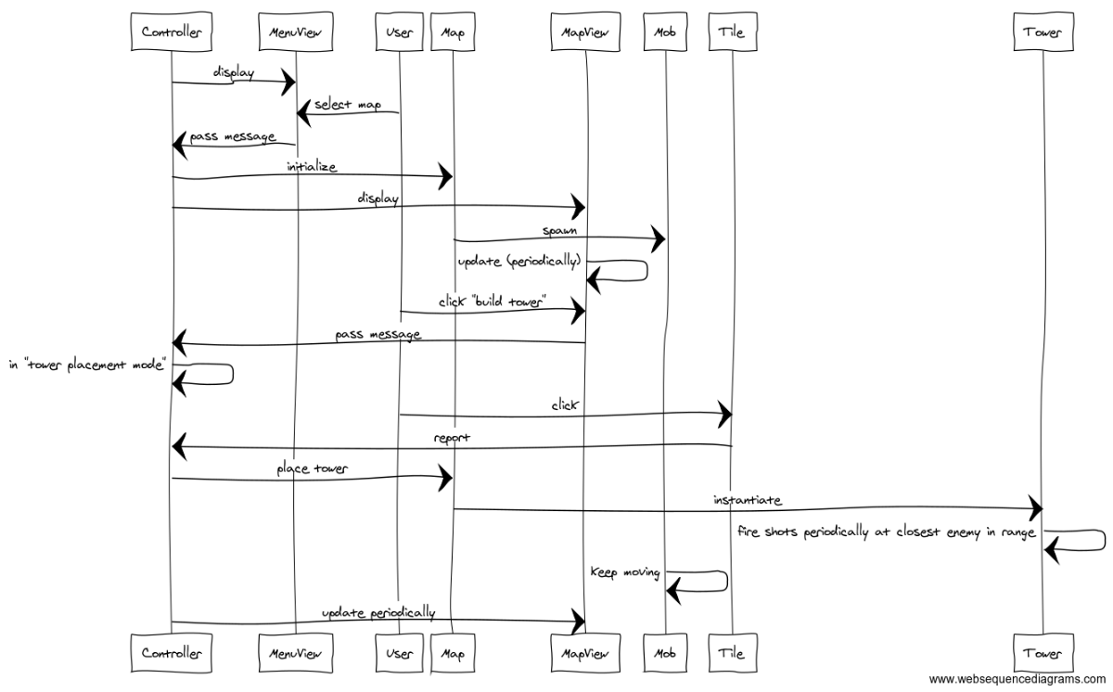

**6. Class Diagram:** Write a UML Class Diagram that shows all of your candidate objects from above. Show any relationships between them the classes such as inheritance or interface implementation. Draw general associations such as dependency or aggregation. Label some to help explain things. Add any multiplicity adornments that seem appropriate. Use notes to explain things if you feel it will help. Each UML class must show the class name. For full credit, each class must have an average of at least one attribute per class. There must be an average of about 1.5 methods per class.

**Optional:**  *Instead of using pencil, paper and scanning to insert an image, use a new Eclipse Project to add classes, methods, and instance variables. No implementation needed. Then use Object Aid UML tool to reverse engineer your code to get the UML class diagram.*

*Installation of Eclipse Plugin in case you don't have it:*

<http://www.objectaid.com/installation>

*Export and Image and copy and paste it here*