众筹网项目文档
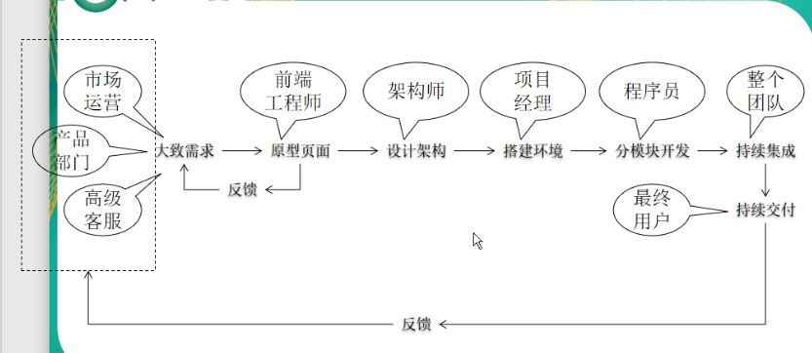

敏捷开发
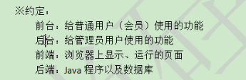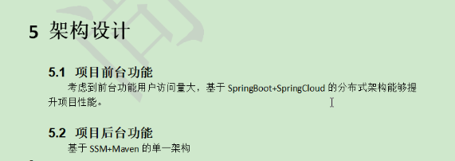

Maven手动创建webapp文件夹（web项目）
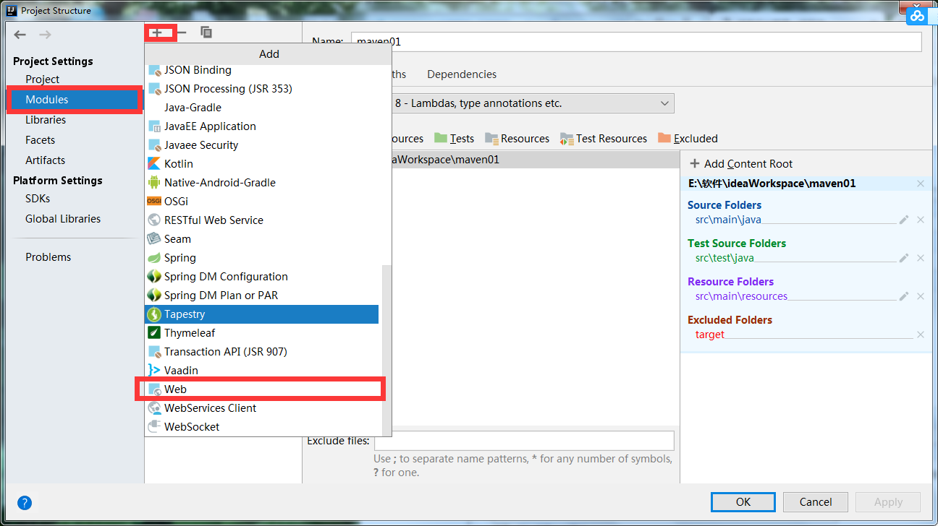

2 . 设置目录,上面的是web.xml的目录，下面的是webapp的目录，先设置下面的。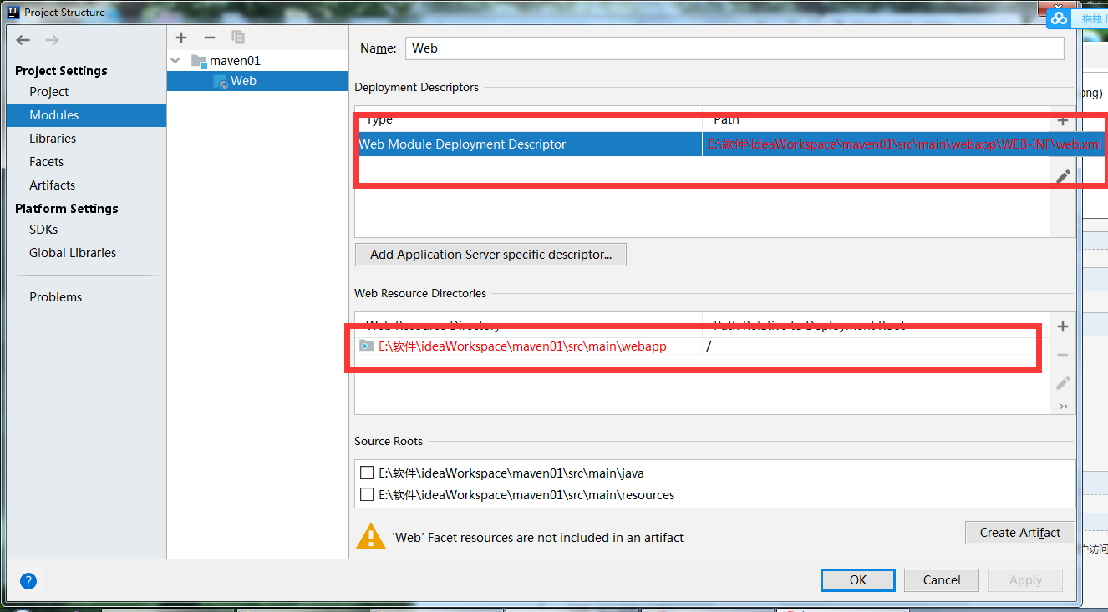

3 . 选择左侧Artifacts-->Web Application:Exlodes-->From Modules

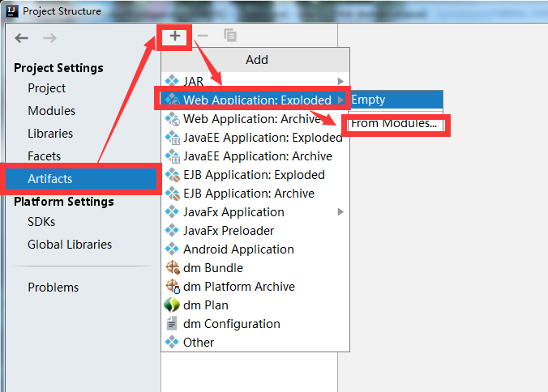

4 . 直接点击ok
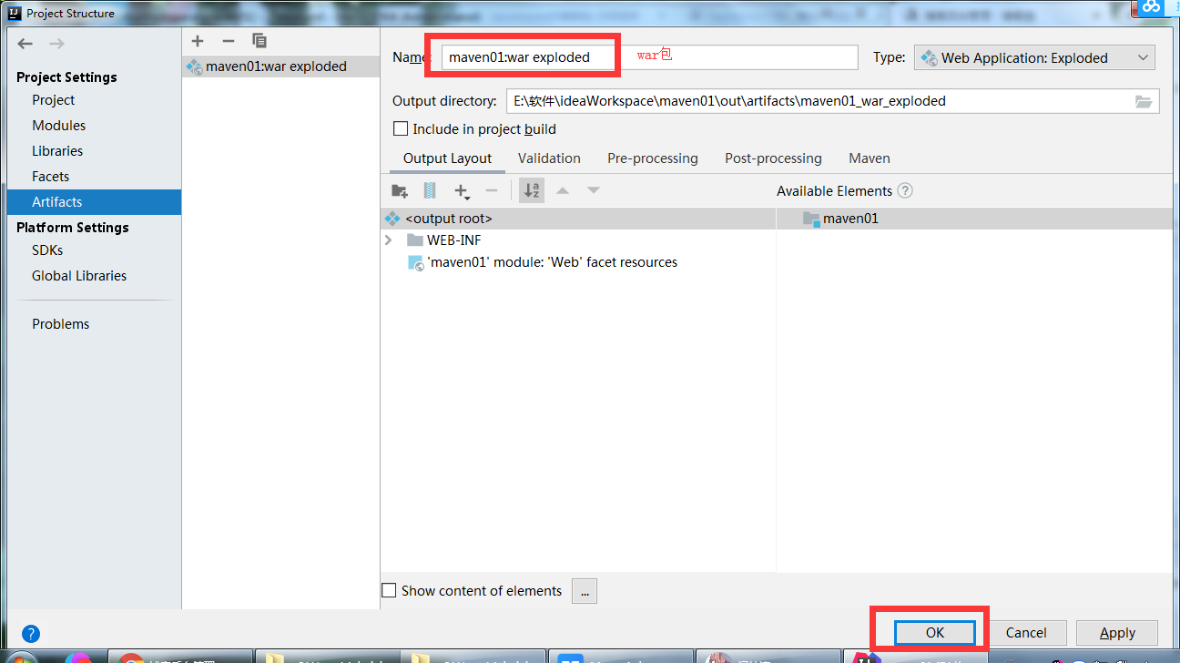

Maven的jar下载失败
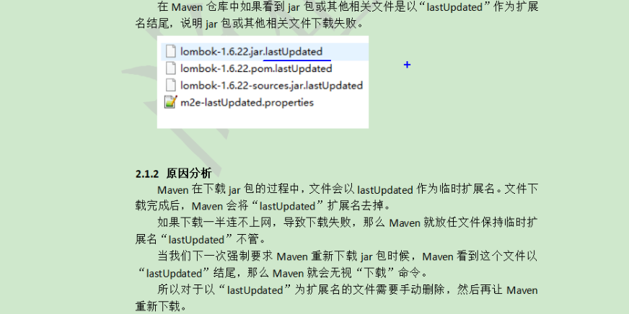
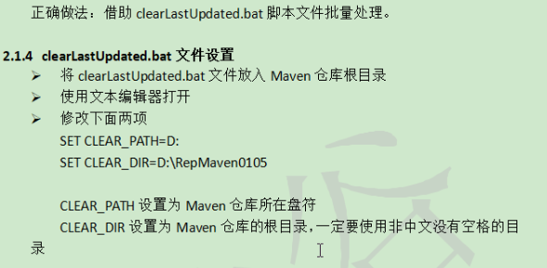
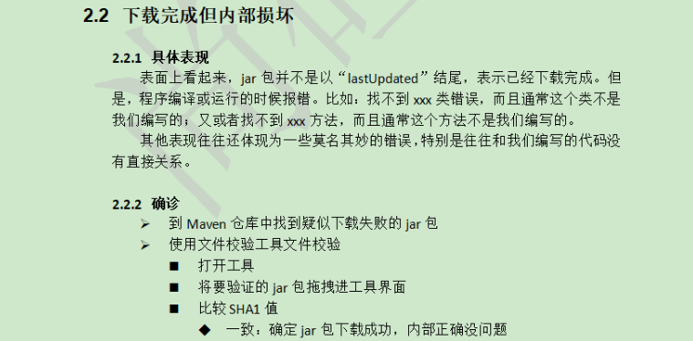

后台

准备工作

单一架构介绍
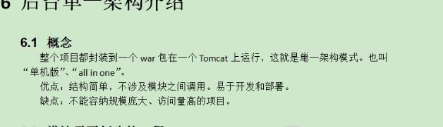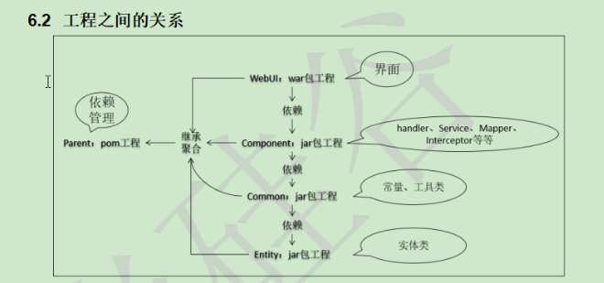

创建工程
父工程----子模块
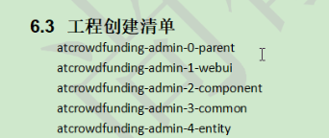
根据架构创建模块之间的依赖关系
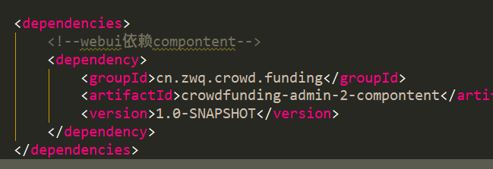
其他模块省略后面省略

父工程的pom文件
<?xml version="1.0" encoding="UTF-8"?>
<project xmlns="http://maven.apache.org/POM/4.0.0"
xmlns:xsi="http://www.w3.org/2001/XMLSchema-instance"
xsi:schemaLocation="http://maven.apache.org/POM/4.0.0 http://maven.apache.org/xsd/maven-4.0.0.xsd">
<modelVersion>4.0.0</modelVersion>
<groupId>cn.zwq.crowd.funding</groupId>
<artifactId>crowdfunding-admin-0-parent</artifactId>
<packaging>pom</packaging>
<version>1.0-SNAPSHOT</version>
<modules>
<module>crowdfunding-admin-1-webui</module>
<module>crowdfunding-admin-2-compontent</module>
<module>crowdfunding-admin-3-common</module>
<module>crowdfunding-admin-4-entity</module>
<module>crowdfunding-admin-0-reverse</module>
</modules>
<properties>
<spring.version>5.0.2.RELEASE</spring.version>
<slf4j.version>1.6.6</slf4j.version> <!--日志框架-->
<log4j.version>1.2.12</log4j.version>
<shiro.version>1.2.3</shiro.version>
<mysql.version>5.1.6</mysql.version>
<mybatis.version>3.4.5</mybatis.version>
<spring.security.version>5.0.1.RELEASE</spring.security.version>
</properties>
<!-- 锁定jar包版本 -->
<dependencyManagement>
<dependencies>
<dependency>
<groupId>org.springframework</groupId>
<artifactId>spring-context</artifactId>
<version>${spring.version}</version>
</dependency>
<dependency>
<groupId>org.springframework</groupId>
<artifactId>spring-web</artifactId>
<version>${spring.version}</version>
</dependency>
<dependency>
<groupId>org.springframework</groupId>
<artifactId>spring-webmvc</artifactId>
<version>${spring.version}</version>
</dependency>
<dependency>
<groupId>org.springframework</groupId>
<artifactId>spring-tx</artifactId>
<version>${spring.version}</version>
</dependency>
<dependency>
<groupId>org.springframework</groupId>
<artifactId>spring-test</artifactId>
<version>${spring.version}</version>
</dependency>
<dependency>
<groupId>org.mybatis</groupId>
<artifactId>mybatis</artifactId>
<version>${mybatis.version}</version>
</dependency>
</dependencies>
</dependencyManagement>
<!-- 项目依赖jar包 -->
<dependencies>
<!-- spring -->
<dependency>
<groupId>org.aspectj</groupId>
<artifactId>aspectjweaver</artifactId>
<version>1.6.8</version>
</dependency>
<dependency>
<groupId>org.springframework</groupId>
<artifactId>spring-aop</artifactId>
<version>${spring.version}</version>
</dependency>
<dependency>
<groupId>org.springframework</groupId>
<artifactId>spring-context</artifactId>
<version>${spring.version}</version>
</dependency>
<dependency>
<groupId>org.springframework</groupId>
<artifactId>spring-context-support</artifactId>
<version>${spring.version}</version>
</dependency>
<dependency>
<groupId>org.springframework</groupId>
<artifactId>spring-web</artifactId>
<version>${spring.version}</version>
</dependency>
<dependency>
<groupId>org.springframework</groupId>
<artifactId>spring-orm</artifactId>
<version>${spring.version}</version>
</dependency>
<dependency>
<groupId>org.springframework</groupId>
<artifactId>spring-beans</artifactId>
<version>${spring.version}</version>
</dependency>
<dependency>
<groupId>org.springframework</groupId>
<artifactId>spring-core</artifactId>
<version>${spring.version}</version>
</dependency>
<dependency>
<groupId>org.springframework</groupId>
<artifactId>spring-test</artifactId>
<version>${spring.version}</version>
</dependency>
<dependency>
<groupId>org.springframework</groupId>
<artifactId>spring-webmvc</artifactId>
<version>${spring.version}</version>
</dependency>
<dependency>
<groupId>org.springframework</groupId>
<artifactId>spring-tx</artifactId>
<version>${spring.version}</version>
</dependency>
<dependency>
<groupId>junit</groupId>
<artifactId>junit</artifactId>
<version>4.12</version>
<scope>test</scope>
</dependency>
<dependency>
<groupId>mysql</groupId>
<artifactId>mysql-connector-java</artifactId>
<version>${mysql.version}</version>
</dependency>
<dependency>
<groupId>javax.servlet</groupId>
<artifactId>javax.servlet-api</artifactId>
<version>3.1.0</version>
<scope>provided</scope>
</dependency>
<dependency>
<groupId>javax.servlet.jsp</groupId>
<artifactId>jsp-api</artifactId>
<version>2.0</version>
<scope>provided</scope>
</dependency>
<dependency>
<groupId>jstl</groupId>
<artifactId>jstl</artifactId>
<version>1.2</version>
</dependency>
<!-- log start -->
<dependency>
<groupId>log4j</groupId>
<artifactId>log4j</artifactId>
<version>${log4j.version}</version>
</dependency>
<dependency>
<groupId>org.slf4j</groupId>
<artifactId>slf4j-api</artifactId>
<version>${slf4j.version}</version>
</dependency>
<dependency>
<groupId>org.slf4j</groupId>
<artifactId>slf4j-log4j12</artifactId>
<version>${slf4j.version}</version>
</dependency>
<!-- log end -->
<dependency>
<groupId>org.mybatis</groupId>
<artifactId>mybatis</artifactId>
<version>${mybatis.version}</version>
</dependency>
<dependency>
<groupId>org.mybatis</groupId>
<artifactId>mybatis-spring</artifactId>
<version>1.3.0</version>
</dependency>
<dependency>
<groupId>c3p0</groupId>
<artifactId>c3p0</artifactId>
<version>0.9.1.2</version>
<type>jar</type>
<scope>compile</scope>
</dependency>
<!--mybatis分页插件-->
<dependency>
<groupId>com.github.pagehelper</groupId>
<artifactId>pagehelper</artifactId>
<version>5.1.2</version>
</dependency>
<dependency>
<groupId>org.springframework.security</groupId>
<artifactId>spring-security-web</artifactId>
<version>${spring.security.version}</version>
</dependency>
<dependency>
<groupId>org.springframework.security</groupId>
<artifactId>spring-security-config</artifactId>
<version>${spring.security.version}</version>
</dependency>
<dependency>
<groupId>org.springframework.security</groupId>
<artifactId>spring-security-core</artifactId>
<version>${spring.security.version}</version>
</dependency>
<dependency>
<groupId>org.springframework.security</groupId>
<artifactId>spring-security-taglibs</artifactId>
<version>${spring.security.version}</version>
</dependency>
<dependency>
<groupId>com.alibaba</groupId>
<artifactId>druid</artifactId>
<version>1.0.9</version>
</dependency>
<!--json-->
<dependency>
<groupId>com.fasterxml.jackson.core</groupId>
<artifactId>jackson-databind</artifactId>
<version>2.9.0</version>
</dependency>
</dependencies>
</project>

数据库设计
使用powerDesign设计数据库模型

逆向工程生成实体类基于maven的Mybatis
逆向工程的pom配置了插件：执行逆向工程的命令----mybatis-generator:generate
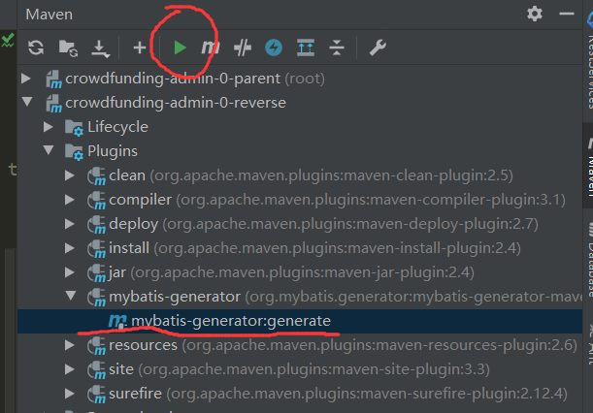

建议新建立一个maven模块生成逆向工程（可能干扰原来的项目）
<groupId>cn.zwq.crowd.funding</groupId>
<artifactId>crowdfunding-admin-0-reverse</artifactId>

逆向工程的maven依赖
<?xml version="1.0" encoding="UTF-8"?>
<project xmlns="http://maven.apache.org/POM/4.0.0"
xmlns:xsi="http://www.w3.org/2001/XMLSchema-instance"
xsi:schemaLocation="http://maven.apache.org/POM/4.0.0 http://maven.apache.org/xsd/maven-4.0.0.xsd">
<parent>
<artifactId>crowdfunding-admin-0-parent</artifactId>
<groupId>cn.zwq.crowd.funding</groupId>
<version>1.0-SNAPSHOT</version>
</parent>
<modelVersion>4.0.0</modelVersion>
<artifactId>crowdfunding-admin-0-reverse</artifactId>
<dependencies>
<dependency>
<groupId>org.mybatis</groupId>
<artifactId>mybatis</artifactId>
<version>3.2.8</version>
</dependency>
</dependencies>
<!--控制maven在构建过程中相关的配置-->
<build>
<plugins>
<plugin>
<groupId>org.mybatis.generator</groupId>
<artifactId>mybatis-generator-maven-plugin</artifactId>
<version>1.3.0</version>
<dependencies>
<!--逆向工程的核心依赖-->
<dependency>
<groupId>org.mybatis.generator</groupId>
<artifactId>mybatis-generator-core</artifactId>
<version>1.3.2</version>
</dependency>
<dependency>
<groupId>com.mchange</groupId>
<artifactId>c3p0</artifactId>
<version>0.9.2</version>
</dependency>
<dependency>
<groupId>mysql</groupId>
<artifactId>mysql-connector-java</artifactId>
<version>5.1.8</version>
</dependency>
</dependencies>
</plugin>
</plugins>
</build>
</project>

逆向工程配置文件

<?xml version="1.0" encoding="UTF-8"?>
<!DOCTYPE generatorConfiguration
PUBLIC "-//mybatis.org//DTD MyBatis Generator Configuration 1.0//EN"
"http://mybatis.org/dtd/mybatis-generator-config_1_0.dtd"> <!--配置本地dtd-->
<!--执行逆向工程的命令 mybatis-generator:generate -->
<generatorConfiguration>
<context id="mysqlTables" targetRuntime="MyBatis3">
<commentGenerator>
<!-- 是否去除自动生成的注释 true:是;false:否 -->
<property name="suppressAllComments" value="true" />
</commentGenerator>
<!--数据库连接的信息：驱动类、连接地址、用户名、密码 -->
<jdbcConnection
driverClass="com.mysql.jdbc.Driver"
connectionURL="jdbc:mysql://localhost:3306/crowdfunding1"
userId="root"
password="123456">
</jdbcConnection>
<!-- 默认false，把JDBC DECIMAL 和 NUMERIC 类型解析为 Integer，为 true时把JDBC DECIMAL
和 NUMERIC 类型解析为java.math.BigDecimal -->
<javaTypeResolver>
<property name="forceBigDecimals" value="false" />
</javaTypeResolver>
<!-- targetProject:生成Entity类的路径 -->
<javaModelGenerator targetProject=".\src\main\java"
targetPackage="cn.crowdfunding.entity">
<!-- enableSubPackages:是否让schema作为包的后缀 -->
<property name="enableSubPackages" value="false" />
<!-- 从数据库返回的值被清理前后的空格 -->
<property name="trimStrings" value="true" />
</javaModelGenerator>
<!-- targetProject:XxxMapper.xml映射文件生成的路径 -->
<sqlMapGenerator targetProject=".\src\main\java"
targetPackage="com.crowdfunding.mapper">
<!-- enableSubPackages:是否让schema作为包的后缀 -->
<property name="enableSubPackages" value="false" />
</sqlMapGenerator>
<!-- targetPackage：Mapper接口生成的位置 -->
<javaClientGenerator type="XMLMAPPER"
targetProject=".\src\main\java"
targetPackage="com.crowdfunding.mapper">
<!-- enableSubPackages:是否让schema作为包的后缀 -->
<property name="enableSubPackages" value="false" />
</javaClientGenerator>
<!-- 数据库表名字和我们的entity类对应的映射指定 -->
<table tableName="t_admin" domainObjectName="Admin" />
</context>
</generatorConfiguration>

各归各位（移动逆向工程生成的文件）

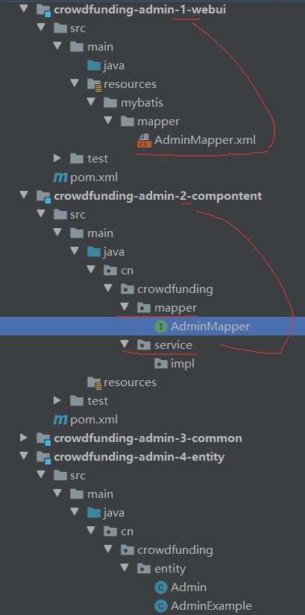

环境搭建
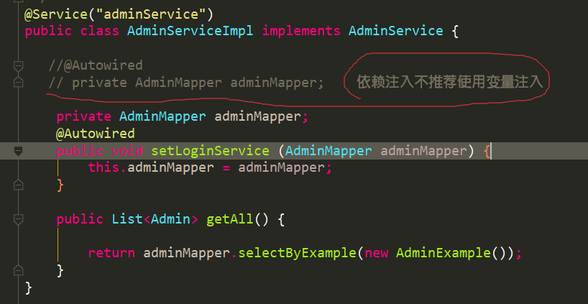
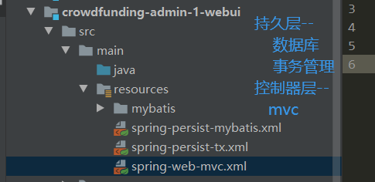

Jdbc.properties
jdbc.driverClassName=com.mysql.jdbc.Driver
jdbc.url=jdbc:mysql://localhost:3306/crowdfunding1?characterEncoding=utf-8?serverTimezone=GMT%2B8
jdbc.username=root
jdbc.password=123456

spring-persist-mybatis.xml
Spring整合mybatis数据源
<?xml version="1.0" encoding="UTF-8"?>
<beans xmlns="http://www.springframework.org/schema/beans"
xmlns:xsi="http://www.w3.org/2001/XMLSchema-instance"
xmlns:context="http://www.springframework.org/schema/context"
xsi:schemaLocation="http://www.springframework.org/schema/beans http://www.springframework.org/schema/beans/spring-beans.xsd http://www.springframework.org/schema/context http://www.springframework.org/schema/context/spring-context.xsd">
<!--开启注解扫描，要扫描service和dao层的注解，忽略controller层注解让SpringMVC框架去管理-->
<context:component-scan base-package="cn.crowdfunding" >
<!--那些注解不扫描 controller注解不扫描-->
<context:exclude-filter type="annotation" expression="org.springframework.stereotype.Controller"/>
</context:component-scan>
<!-- 引入外部数据库的配置文件，location位置填写的是相对位置 -->
<context:property-placeholder location="classpath:jdbc.properties"/>
<!--配置数据源-->
<bean id="dataSource" class="com.alibaba.druid.pool.DruidDataSource">
<property name="driverClassName" value="com.mysql.jdbc.Driver"/>
<property name="url" value="jdbc:mysql:///crowdfunding1"/>
<property name="username" value="${jdbc.username}"/>
<property name="password" value="123456"/>
</bean>
<!--配置sqlSessionFactory工厂-->
<bean id="sqlSessionFactory" class="org.mybatis.spring.SqlSessionFactoryBean">
<!--mybatis配置文件的位置 -->
<property name="configLocation" value="classpath:mybatis/mybatis-config.xml" />
<!--配置mapper配置文件的位置-->
<property name="mapperLocations" value="classpath:mybatis/mapper/*.xml" />
<!--装配数据源-->
<property name="dataSource" ref="dataSource" />
</bean>
<!--配置接口mapper所在的包 生产哪些代理对象-->
<bean id="mapperScannerConfigurer" class="org.mybatis.spring.mapper.MapperScannerConfigurer">
<property name="basePackage" value="cn.crowdfunding.mapper"/>
</bean>
</beans>

测试类（测试数据库连接）
@RunWith(SpringJUnit4ClassRunner.class)
@ContextConfiguration(locations = {"classpath:spring-persist-mybatis.xml","classpath:spring-persist-tx.xml","classpath:spring-web-mvc.xml"})
public class CrowdFundingText {
@Autowired
private DataSource dataSource;
@Autowired
private AdminService adminService;
/**
* spring整合mybatis测试数据库连接
* @throws SQLException
*/
@Test
public void testConnection() throws SQLException{
Connection connection = dataSource.getConnection();
System.out.println(connection);
}
/**
* 测试spring整合mybatis
*/
@Test
public void testMybatis(){
List<Admin> all = adminService.getAll();
for (Admin admin:all) {
System.out.println(admin);
}
}
/**
* 测试事务
*/
@Test
public void testTx(){
adminService.updateAdmin();
}
}

--------------------------------------------------------------------------------------------------
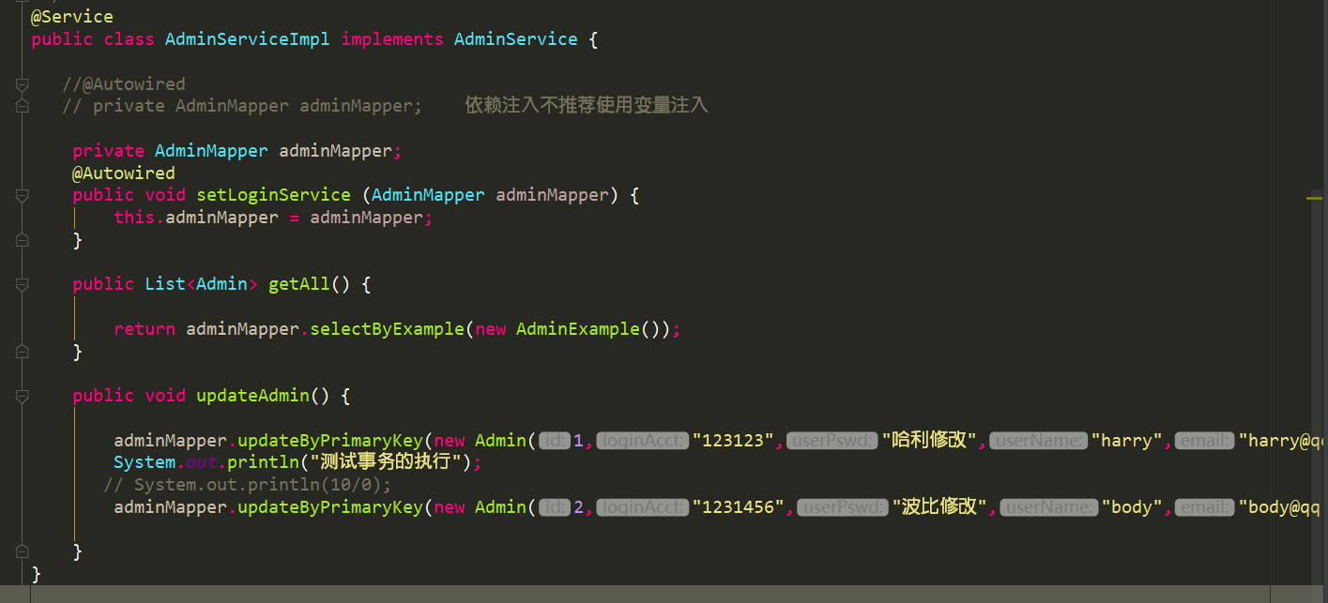

spring-persist-tx.xml（事务）
注解的方式配置参考笔记
<?xml version="1.0" encoding="UTF-8"?>
<beans xmlns="http://www.springframework.org/schema/beans"
xmlns:xsi="http://www.w3.org/2001/XMLSchema-instance"
xmlns:aop="http://www.springframework.org/schema/aop"
xmlns:tx="http://www.springframework.org/schema/tx"
xsi:schemaLocation="
http://www.springframework.org/schema/beans
http://www.springframework.org/schema/beans/spring-beans.xsd
http://www.springframework.org/schema/tx
http://www.springframework.org/schema/tx/spring-tx.xsd
http://www.springframework.org/schema/aop
http://www.springframework.org/schema/aop/spring-aop.xsd">
<!--配置数据源，此处不配也可以正常运行，其他配置文件已经配置过-->
<bean id="dataSource" class="com.alibaba.druid.pool.DruidDataSource">
<property name="driverClassName" value="com.mysql.jdbc.Driver"/>
<property name="url" value="jdbc:mysql:///crowdfunding1"/>
<property name="username" value="root"/>
<property name="password" value="123456"/>
</bean>
<!--配置事务管理器-->
<bean id="dataSourceTransactionManager" class="org.springframework.jdbc.datasource.DataSourceTransactionManager">
<!--装配数据源-->
<property name="dataSource" ref="dataSource"/>
</bean>
<!-- 配置事务的通知-->
<tx:advice id="txAdvice" transaction-manager="dataSourceTransactionManager">
<tx:attributes>
<!--propagation，配置事务的传播行为，必须工作在自己新开的事务中
rollback-for,默认运行时异常回滚，设置后编译时异常也回滚-->
<tx:method name="save*" propagation="REQUIRES_NEW" rollback-for="java.lang.Exception"/>
<tx:method name="remove*" propagation="REQUIRES_NEW" rollback-for="java.lang.Exception"/>
<tx:method name="update*" propagation="REQUIRES_NEW" rollback-for="java.lang.Exception"/>
<tx:method name="delete*" propagation="REQUIRES_NEW" rollback-for="java.lang.Exception"/>
<tx:method name="insert*" propagation="REQUIRES_NEW" rollback-for="java.lang.Exception"/>
<!--查询方法只读 read-only：用于指定事务是否只读。-->
<tx:method name="get*" propagation="SUPPORTS" read-only="true"/>
<tx:method name="query*" propagation="SUPPORTS" read-only="true"/>
<tx:method name="find*" propagation="SUPPORTS" read-only="true"/>
<tx:method name="count*" propagation="SUPPORTS" read-only="true"/>
</tx:attributes>
</tx:advice>
<!-- 配置aop-->
<aop:config>
<!-- 配置切入点表达式 返回值 包名.类名.方法名(参数任意)-->
<aop:pointcut id="pt1" expression="execution(* cn.crowdfunding.service.impl.*.*(..))"/>
<!--建立切入点表达式和事务通知的对应关系 -->
<aop:advisor advice-ref="txAdvice" pointcut-ref="pt1"></aop:advisor>
</aop:config>
</beans>

Spring-web-mvc.xml
<?xml version="1.0" encoding="UTF-8"?>
<beans xmlns="http://www.springframework.org/schema/beans"
xmlns:mvc="http://www.springframework.org/schema/mvc"
xmlns:context="http://www.springframework.org/schema/context"
xmlns:xsi="http://www.w3.org/2001/XMLSchema-instance"
xsi:schemaLocation="
http://www.springframework.org/schema/beans
http://www.springframework.org/schema/beans/spring-beans.xsd
http://www.springframework.org/schema/mvc
http://www.springframework.org/schema/mvc/spring-mvc.xsd
http://www.springframework.org/schema/context
http://www.springframework.org/schema/context/spring-context.xsd">
<!-- 扫描controller的注解，别的不扫描 -->
<context:component-scan base-package="cn.crowdfunding">
<context:include-filter type="annotation" expression="org.springframework.stereotype.Controller"/>
</context:component-scan>
<!-- 配置视图解析器 -->
<bean id="viewResolver" class="org.springframework.web.servlet.view.InternalResourceViewResolver">
<!-- JSP文件所在的目录 -->
<property name="prefix" value="/WEB-INF/pages/" />
<!-- 文件的后缀名 -->
<property name="suffix" value=".jsp" />
</bean>
<!-- 设置静态资源不过滤 -->
<!--<mvc:resources location="/static/" mapping="/static/**" />-->
或者<!--<mvc:default-servlet-handler/>-->
<!-- 开启对SpringMVC注解的支持 -->
<mvc:annotation-driven />
</beans>

Web.xml
<?xml version="1.0" encoding="UTF-8"?>
<web-app xmlns="http://xmlns.jcp.org/xml/ns/javaee"
xmlns:xsi="http://www.w3.org/2001/XMLSchema-instance"
xsi:schemaLocation="http://xmlns.jcp.org/xml/ns/javaee http://xmlns.jcp.org/xml/ns/javaee/web-app_4_0.xsd"
version="4.0">
<!--配置spring的监听器 默认只加载spring-persist-*.xml文件-->
<listener>
<listener-class>org.springframework.web.context.ContextLoaderListener</listener-class>
</listener>
<!-- 配置加载类路径的配置文件 -->
<context-param>
<param-name>contextConfigLocation</param-name>
<param-value>classpath:spring-persist-*.xml</param-value>
</context-param>
<!--配置前端控制器-->
<servlet>
<servlet-name>dispatcherServlet</servlet-name>
<servlet-class>org.springframework.web.servlet.DispatcherServlet</servlet-class>
<!-- 配置初始化参数，创建完DispatcherServlet对象，加载springmvc.xml配置文件 -->
<init-param>
<param-name>contextConfigLocation</param-name>
<param-value>classpath:spring-web-mvc.xml</param-value>
</init-param>
<!-- 服务器启动的时候，让DispatcherServlet对象创建 -->
<load-on-startup>1</load-on-startup>
</servlet>
<servlet-mapping>
<servlet-name>dispatcherServlet</servlet-name>
<url-pattern>*.html</url-pattern> //拦截 *.html结尾的请求 伪静态
<url-pattern>*.json</url-pattern>
</servlet-mapping>
<!-- 配置解决中文乱码的过滤器 -->
<filter>
<filter-name>characterEncodingFilter</filter-name>
<filter-class>org.springframework.web.filter.CharacterEncodingFilter</filter-class>
<init-param>
<param-name>encoding</param-name>
<param-value>UTF-8</param-value>
</init-param>
</filter>
<filter-mapping>
<filter-name>characterEncodingFilter</filter-name>
<url-pattern>/*</url-pattern>
</filter-mapping>
</web-app>
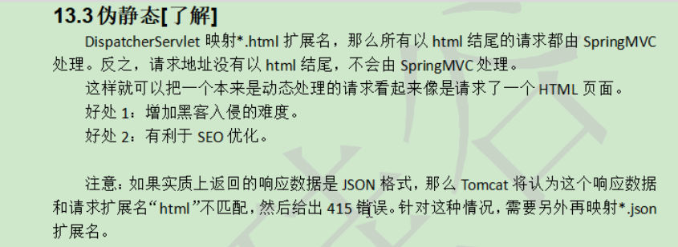

业务实现

1：首页以及登录功能
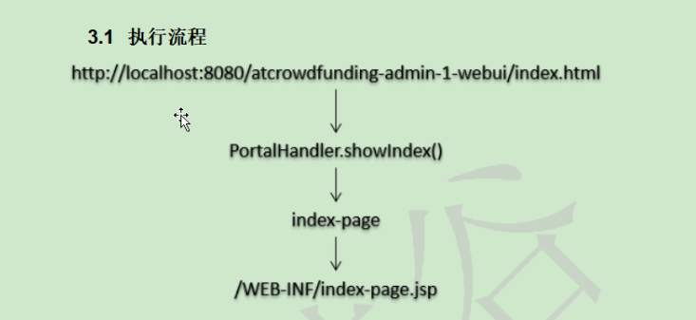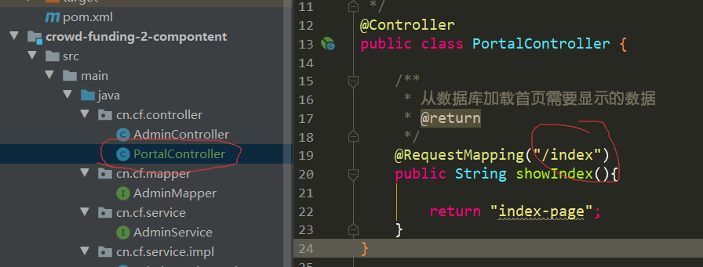

路径设置问题

配置文件实现页面跳转
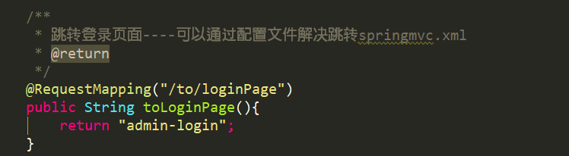
下面这种配置必须使用拓展名（web.xml设置的拦截html结尾的请求）上面方式可以不加拓展名
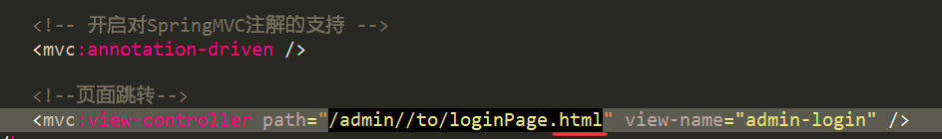

MD5加密
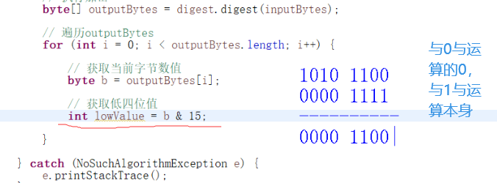
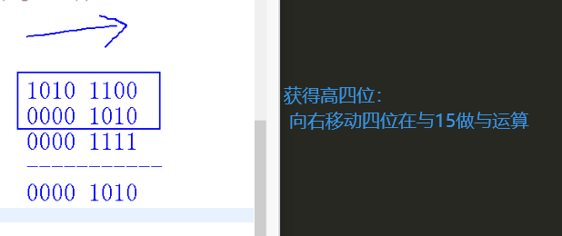
public class Md5Util {
/**
* 判断集合是否有效
* @param collection
* @param <E>
* @return true表示有效 false表示无效
*/
public static <E> boolean collectiveEffective(Collection<E> collection){
return collection != null && collection.size() > 0;
}
public static <K,V> boolean mapEffective(Map<K,V> map){
return map != null && map.size() > 0; //&&短路 避免空指针
}
/**
* 判断输入的明文是否有效
* @param source
* @return true表示有效 false表示无效
*/
public static boolean stringEffective(String source){
return source != null && source.length() > 0;
}
/**
* 加密方法
* @param source 明文
* @return 密文
*/
public static String md5Encrypt(String source){
//判断明文是否有效
if(!stringEffective(source)){
throw new RuntimeException("MD5加密，明文无效！！！");
}
//准备一个字符数组获取对应的值
char[] characters = {'0', '1', '2', '3', '4', '5','6', '7', '8', '9', 'A', 'B', 'C', 'D', 'E', 'F'};
//用于拼接密文---StringBuilder 相较于 StringBuffer 有速度优势，所以多数情况下建议使用 StringBuilder 类。然而在应用程序要求线程安全的情况下，则必须使用 StringBuffer 类。
StringBuilder builder = new StringBuilder();
//指定加密算法
String algroithm = "MD5";
try {
MessageDigest digest = MessageDigest.getInstance(algroithm);
//将欲加密的明文转换为字节数组(一个字节8位 Byte = 8bit)
byte[] inputBytes = source.getBytes();
byte[] outputBytes = digest.digest(inputBytes);
//一个字节8位 四位对应一个16进制数 将其变成16进制
for(int i = 0;i<outputBytes.length;i++){
//获得当前字节
byte b = outputBytes[i];
//获得低四位
int lowValue = b&15;
//获得高四位
int highValue = (b >> 4) & 15;
//以高四位，低四位为下标获取字符数组中的值
char highCharacter = characters[highValue];
char lowCharacter = characters[lowValue];
//拼接密文
builder.append(highCharacter).append(lowCharacter);
}
} catch (NoSuchAlgorithmException e) {
System.out.println("加密工具类异常");
e.printStackTrace();
}
return builder.toString();
}
}

配置异常界面
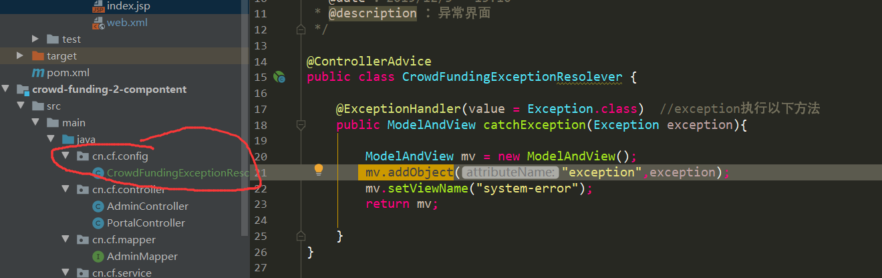
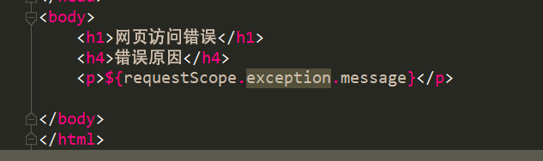

退出登录-拦截器

附：Modelandview


