**Create Virtual Machine using ARM Template**

**Step 1:** Run **Visual Studio 2019**

**Step 2:** Click on **Create New Project**

**Step 3:** Search for Cloud and Select Azure Resource Group.

Click on Next button.

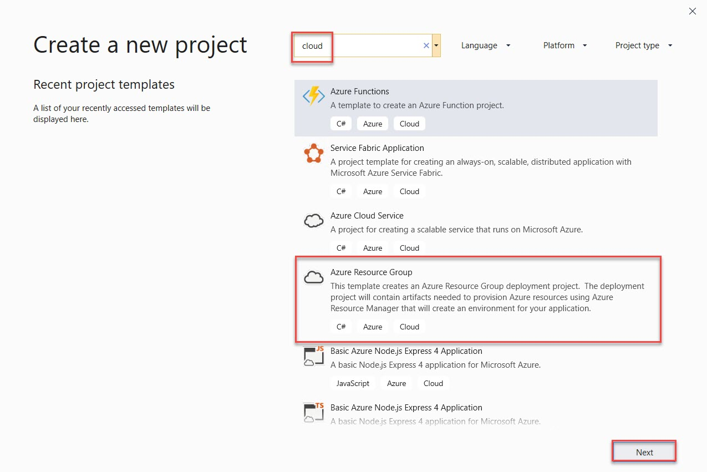

Go with Default Project or change and click on Create button.

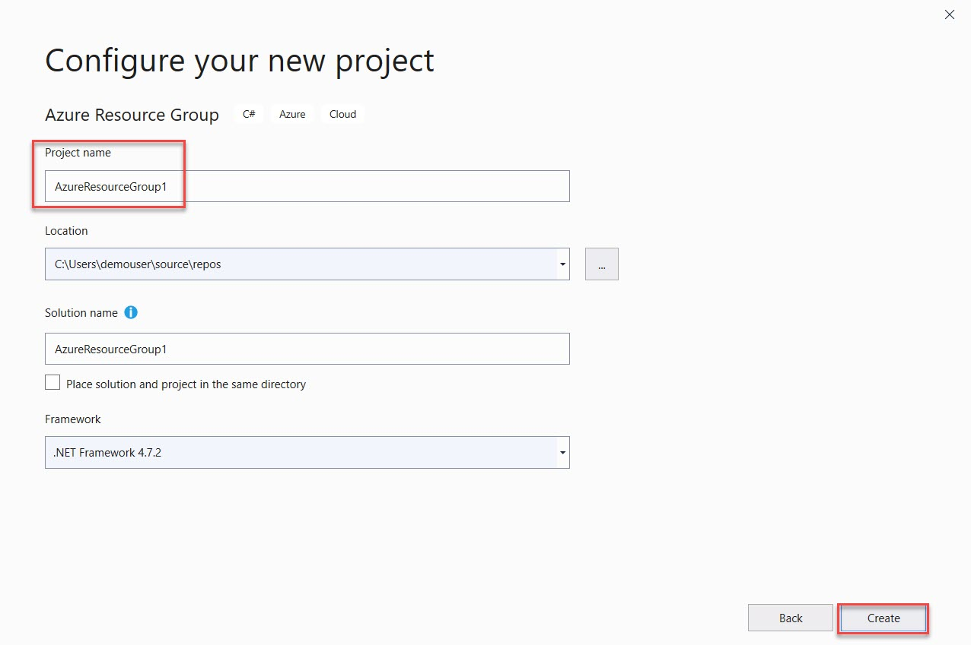

**Step 4:** **Select template:** Visual Studio Templates

**Search:** Blank Template

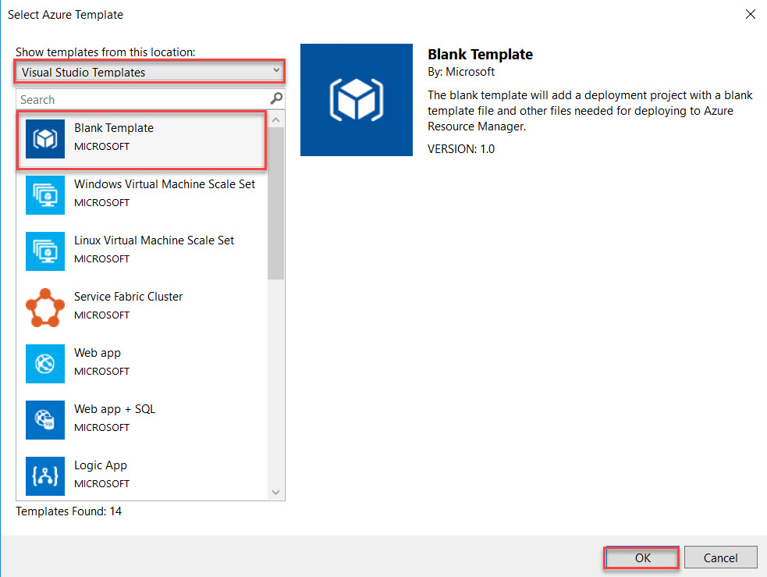

**Step 5:** Right size you can see Solution Explorer available.

Right Click on **azuredeploy.json -> Show Outline**

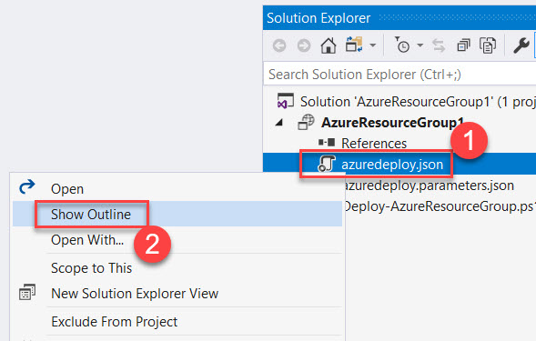

**Step 6:** Left side you can see **JSON Outline** available

There are four options: parameters, variables, resources, outputs

Right click on **resources -> Add New Resource**

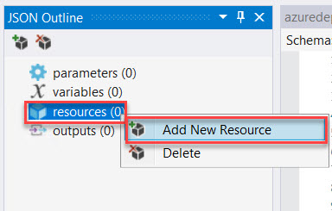

Storage account is required for any Virtual Machine so first we are trying to add storage account.

Search for **storage** and select **Storage Account** from the list

**Enter Name:** enter unique name of storage

Click on **Add** button.

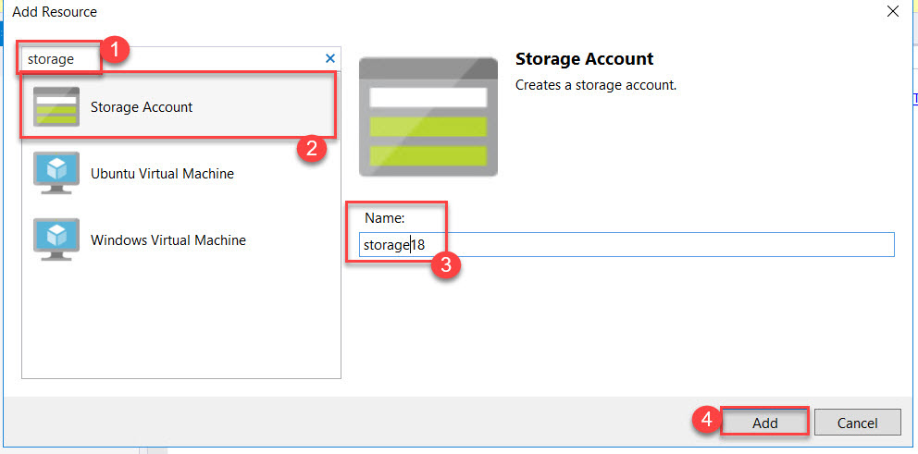

**Step 7:** Again, we need to add other resources for Virtual Machine

Right click on **resources -> Add New Resource**

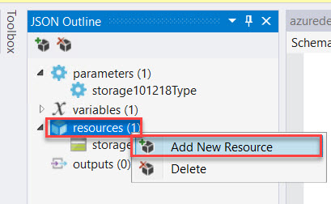

Search for **ubuntu** and select Ubuntu Virtual Machine from the list

**Enter Name:** myubuntuvm

**Storage account:** select existing from the list

**Virtual network/subnet:** Click on Create New

Click on **Add** button.

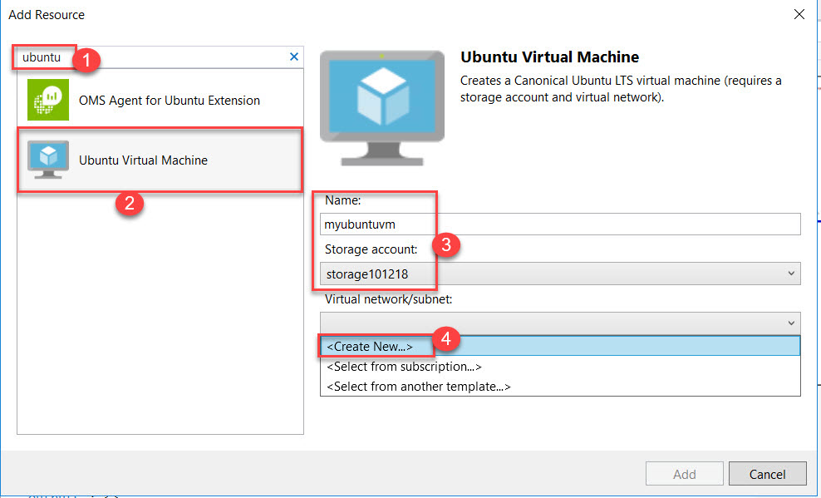

**Enter Virtual Network Name:** ubuntuVnet

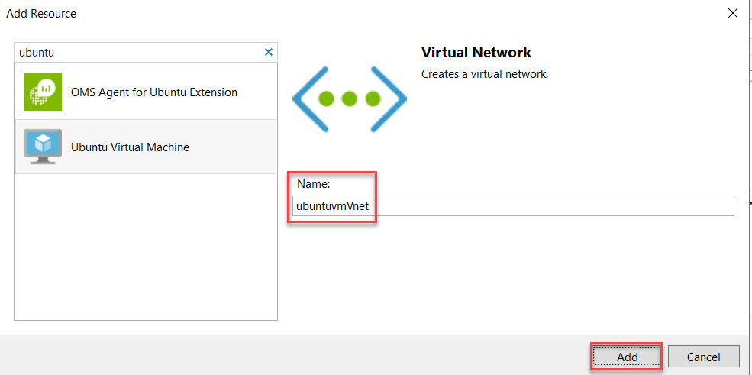

Validate and click on **Add** button.

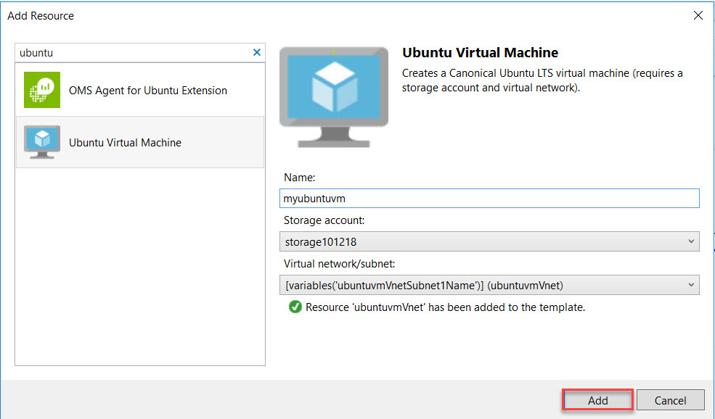

**Step 8:** Again, Right click on **resources -> Add New Resource**

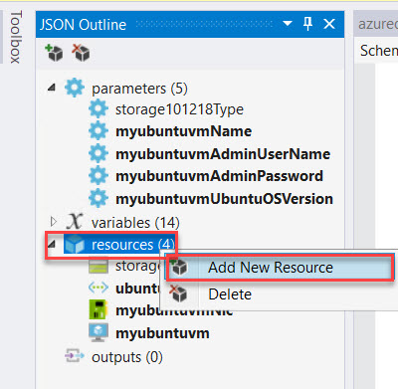

Search for **public ip** and select **Public IP Address** from the list

**Enter Public IP Address Name:** ubuntuvm18pip

**Network interface:** Select existing from the list

Click on **Add** button.

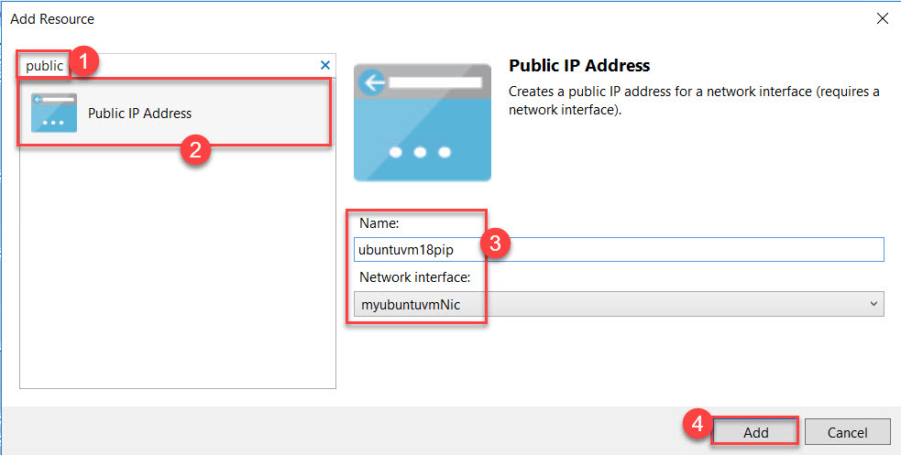

**Step 9:** Now time to deploy ARM Template Virtual Machine to Azure.

Right click on **Project name -> Select Deploy -> New….**

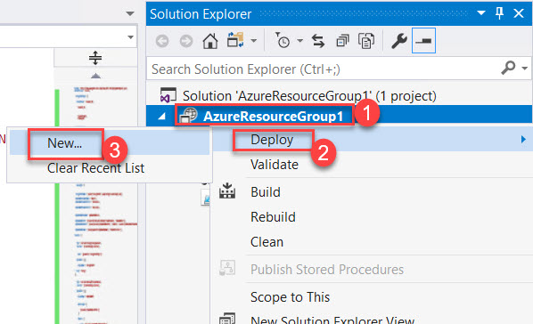

**Step 10:** Deploy to Resource Group dialog box will open

**Subscription:** Choose working Subscription

**Resource Group:** Create New

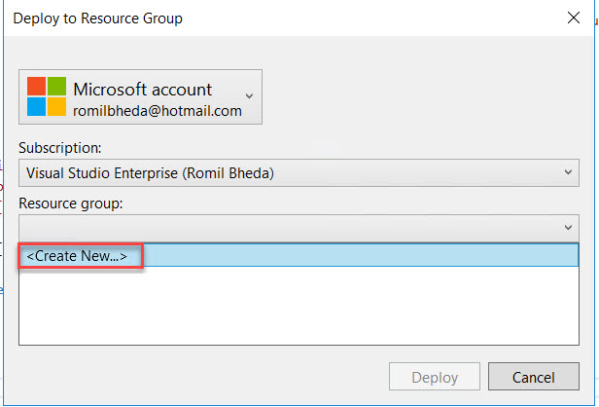

**Resource Group Name:** Enter Resource Group Name (Ex. armRG)

**Resource Group Location:** Choose any nearest region

Click on **Create** button.

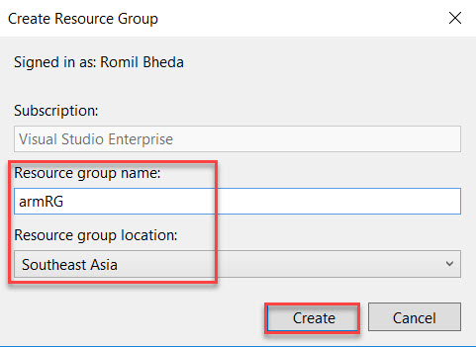

Edit Template parameters file

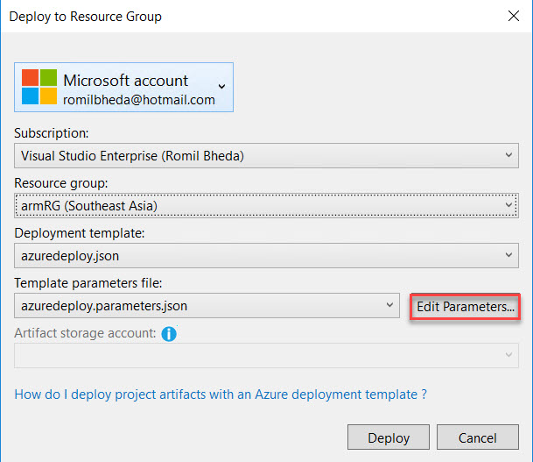

**Enter VM Name:** ubuntuvm

**Admin Username:** demouser

**Admin Password:** Demouser@123

**Dns Name:** Enter DNS Name

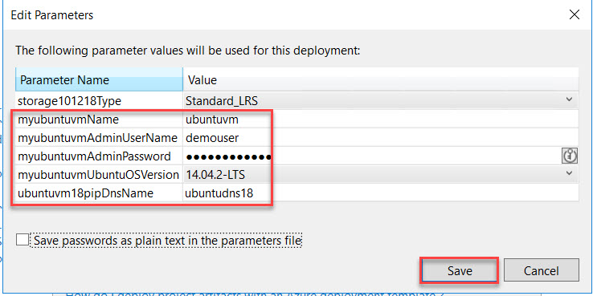

Finally click on **Deploy** button to publish all on Azure.

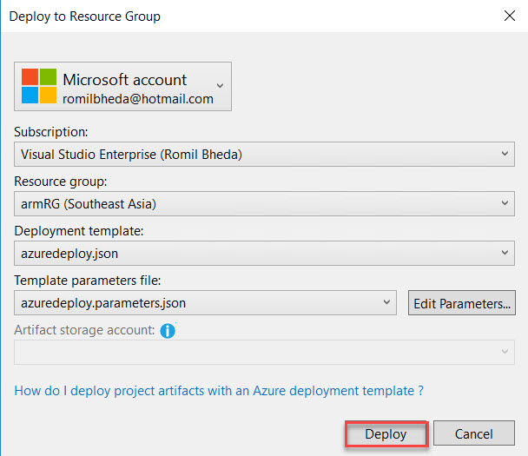

**Step 11:** Powershell windows will open and asking for password once again.

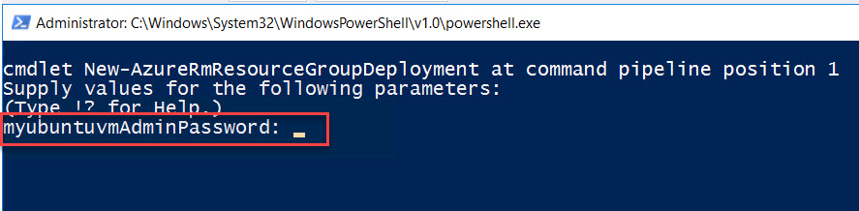

**Step 12:** In Output window you can see all the logs

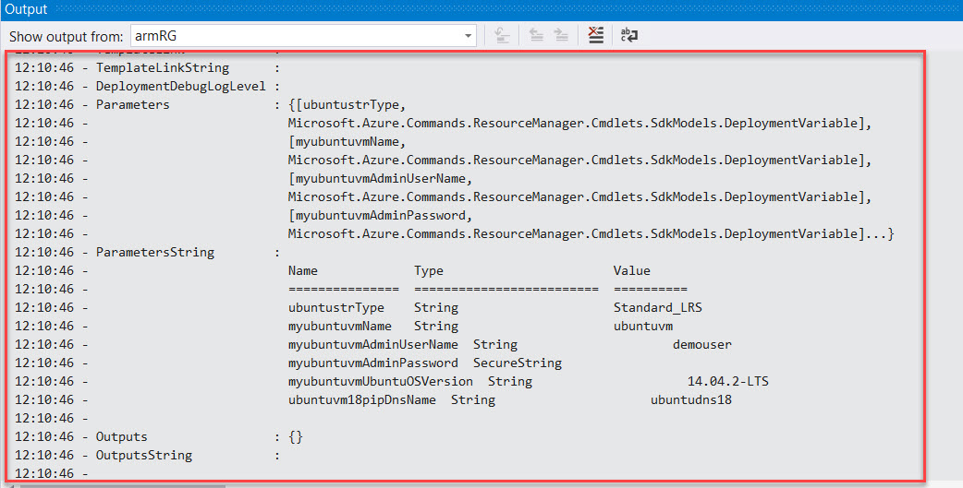

**Step 13:** Navigate to Azure Portal and Click on **Resource Groups**.

Click on newly created resource group

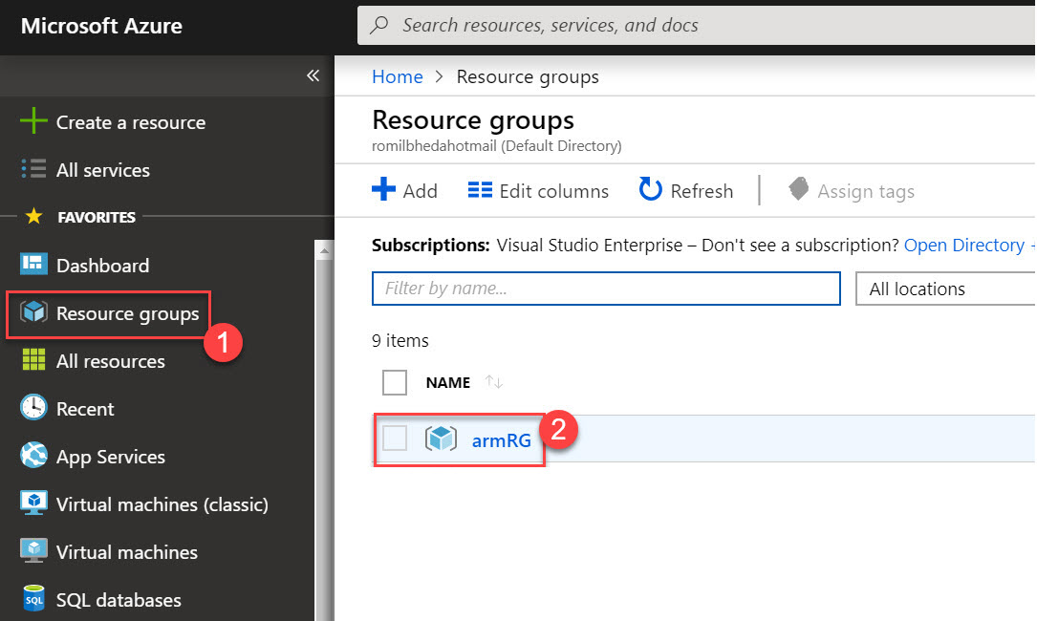

Select **Virtual Machine**

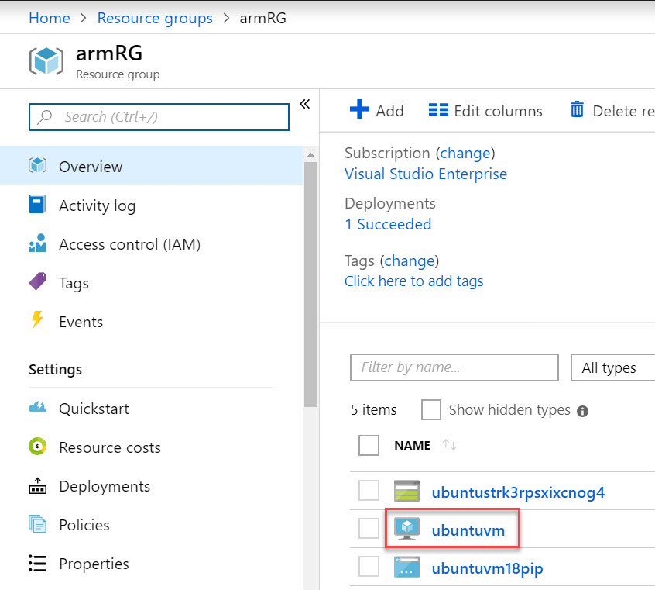

**Step 14:** Open **PuTTY** & enter **Public IP Address** of Virtual Machine

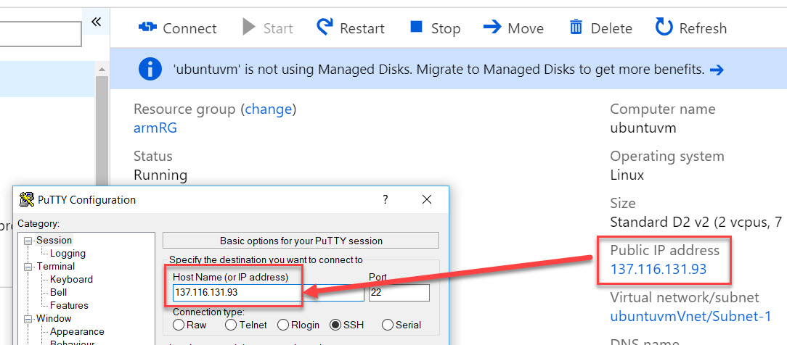

**Step 15:** Enter Virtual Machine Credentials

**Username:** demouser

**Password:** Demouser@123

