**Deploy Java App and Configure CI/CD**

Step 1: Open Azure DevOps Portal

[https://dev.azure.com](https://dev.azure.com/)

Step 2: Click on + Create Project

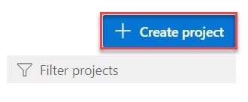

Step 3: Create New Project.

Project Name: **JavaDevOpsProject**

Click on **Create** button.

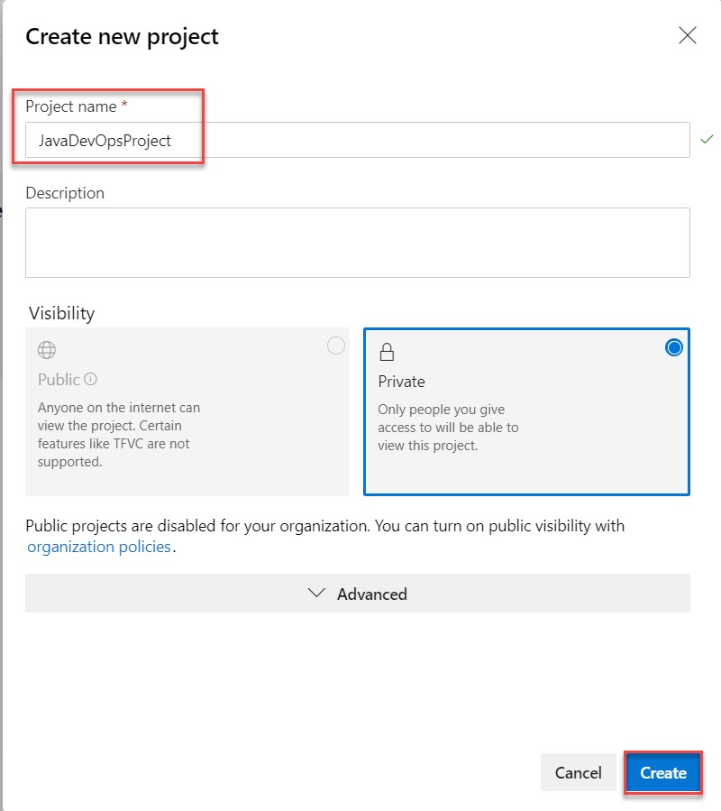

Step 4: Click on Repos and Import repository by click on Import button.

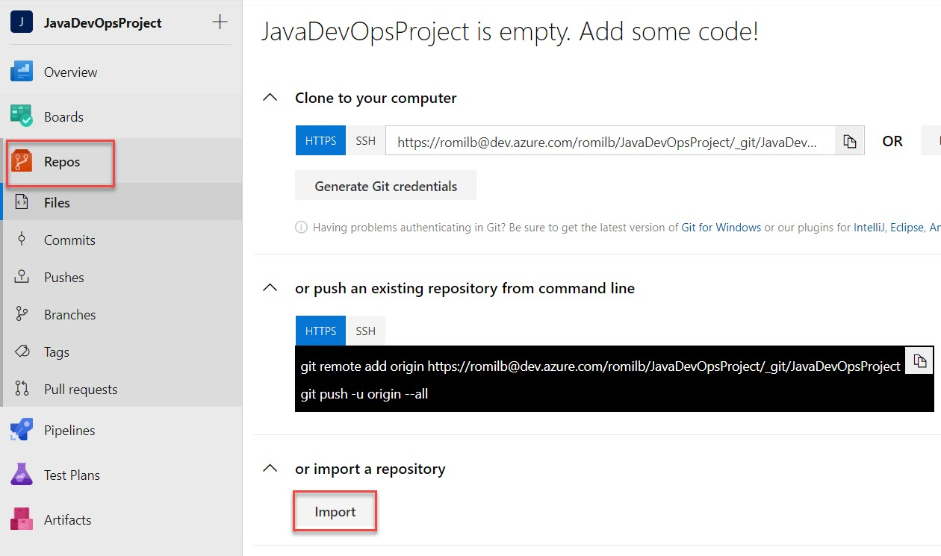

Step 5: Import Git Repo link:

<https://github.com/romilbheda/javawebappdemo.git>

Click on Import button.

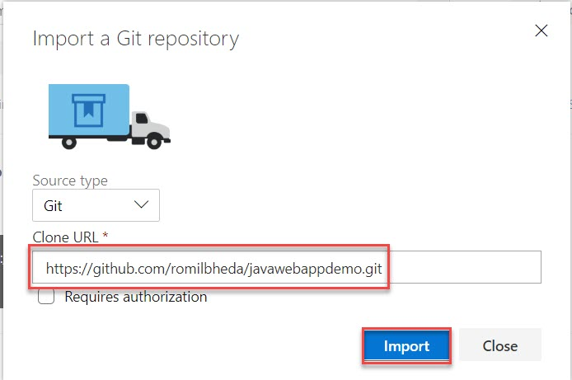

Step 6: Verify files

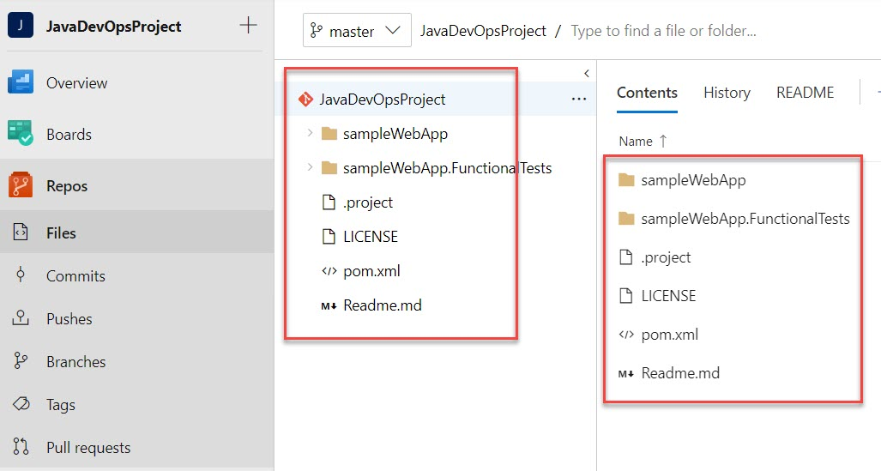

Step 7: Create Build Pipeline

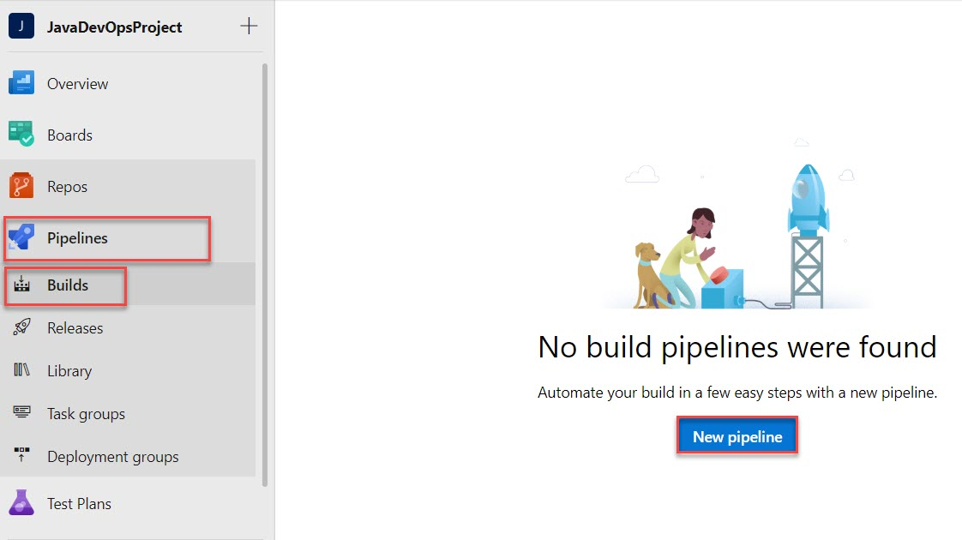

Step 8: Click on Use the classic editor

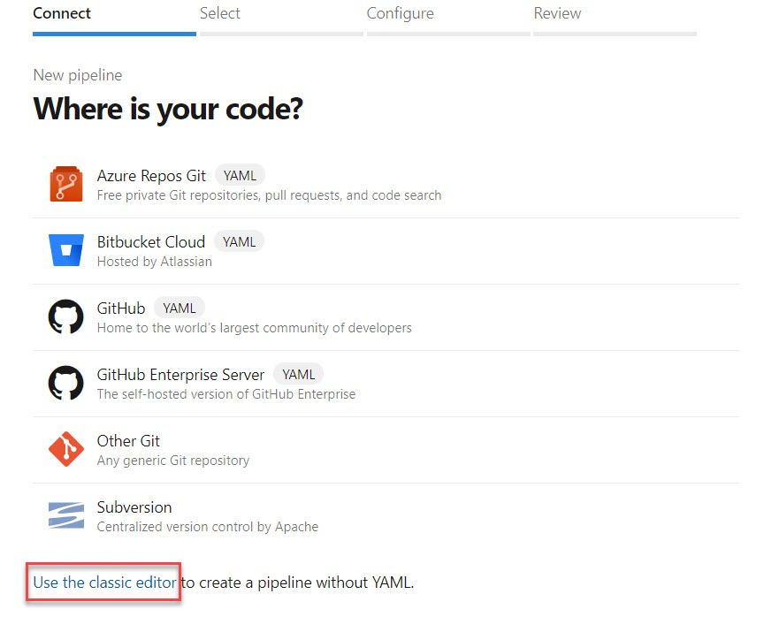

Step 9: Select Azure Repos Git and click on Continue button.

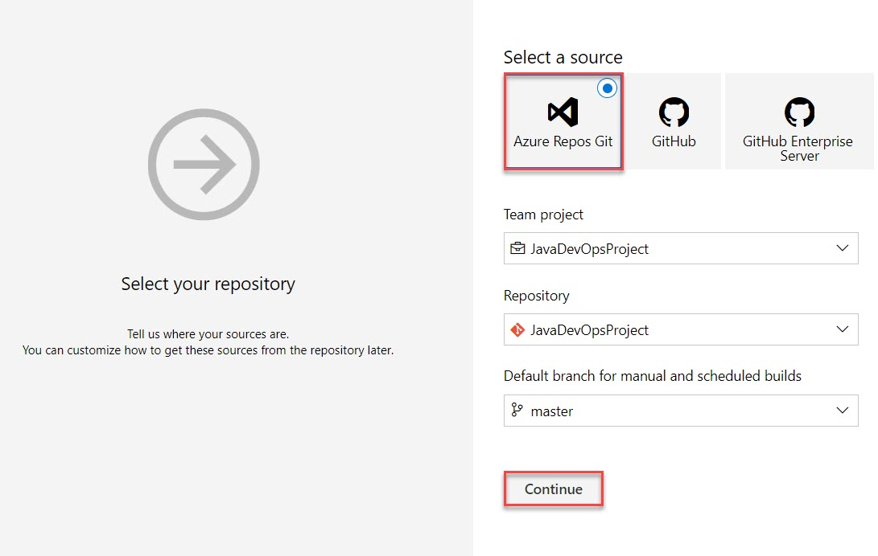

Step 10: Select Maven from list

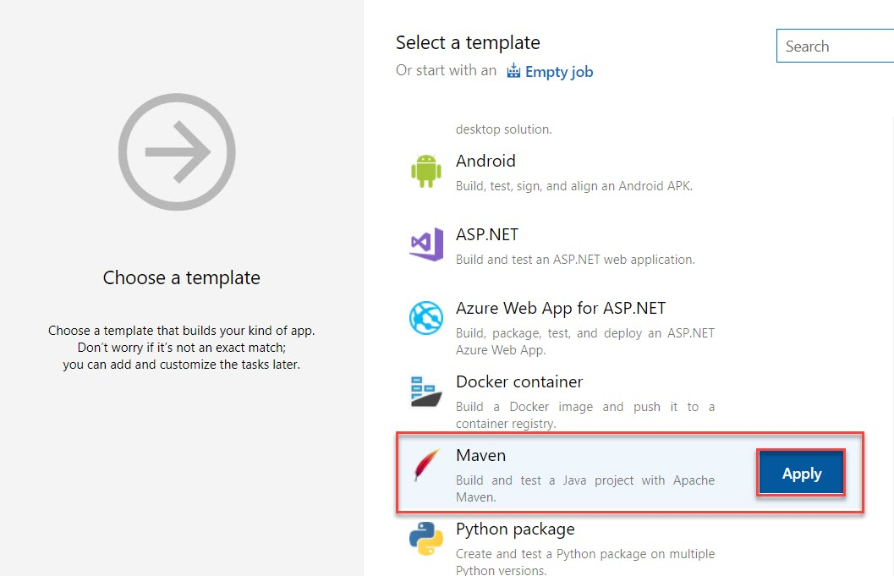

Step 11: Select Copy Files to and navigate to Contents option. Add .war

**/*.war

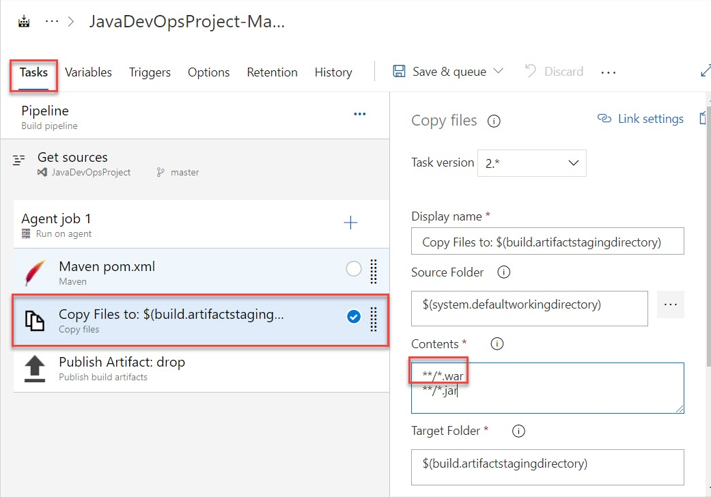

Step 12: Select Triggers tab.

Enable Continue Integration and click on Save & queue option

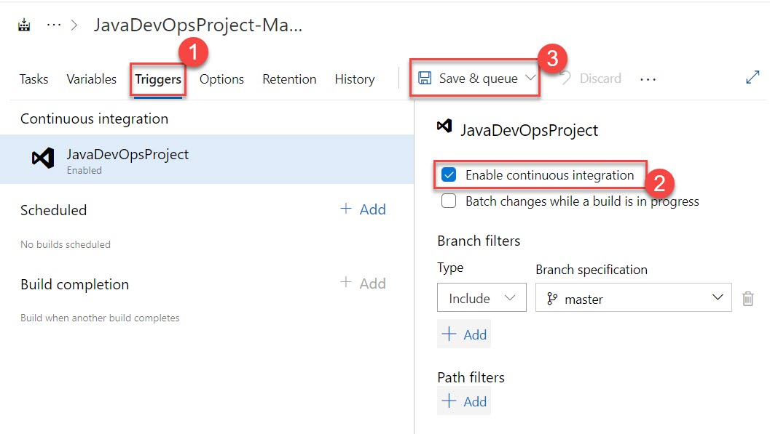

Step 13: Click on Save and run button.

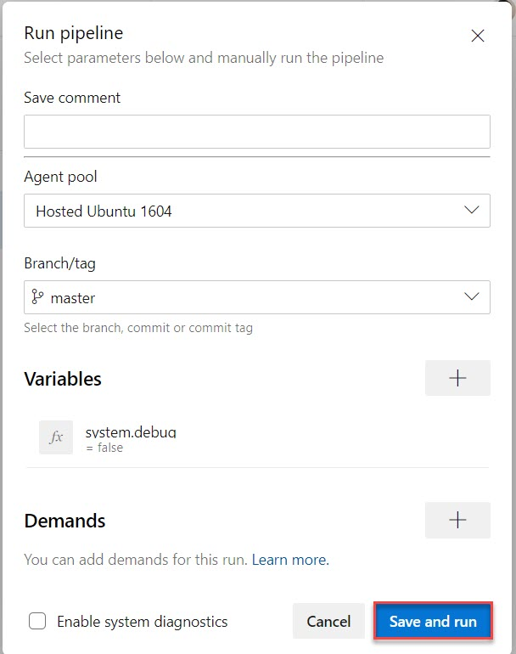

Step 14: Build pipeline is running.

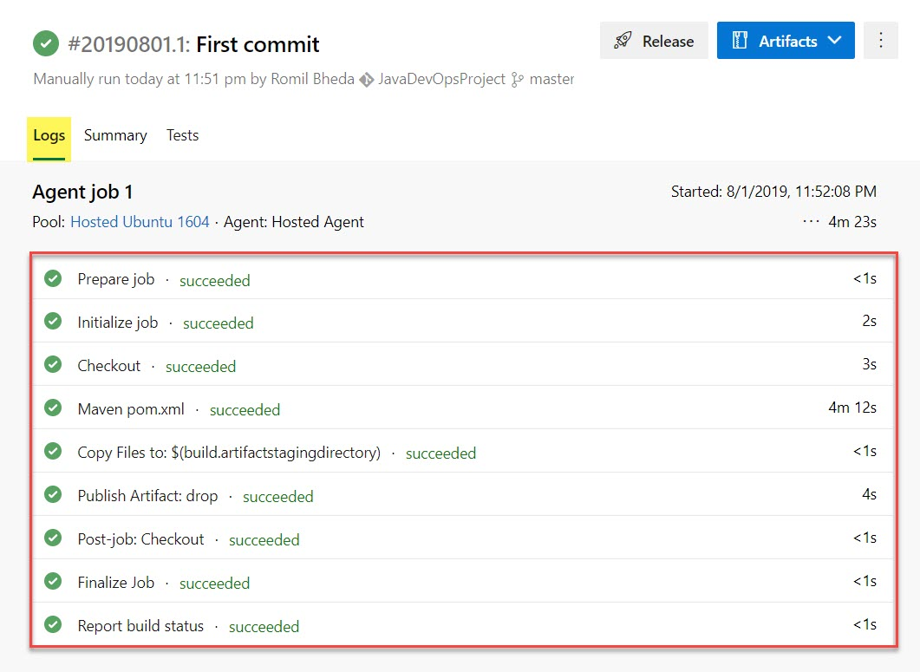

Step 15: Click on Summary and verify Drop folder

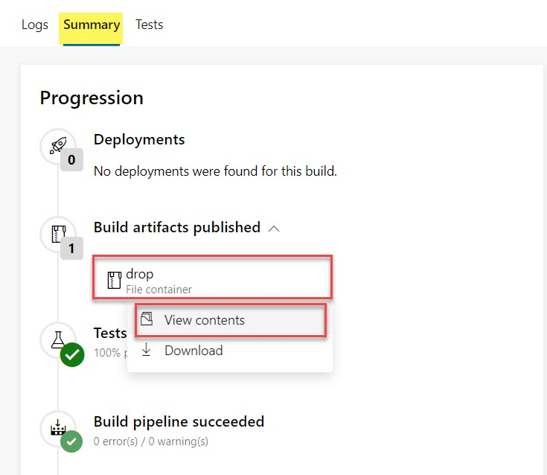

Step 16: navigate to war file.

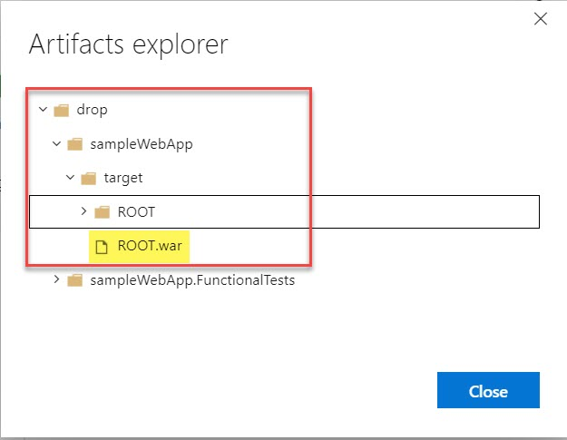

Step 17: Open Microsoft Azure Portal

[http://portal.azure.com](http://portal.azure.com/)

+ Create a resource -> Web -> Web App

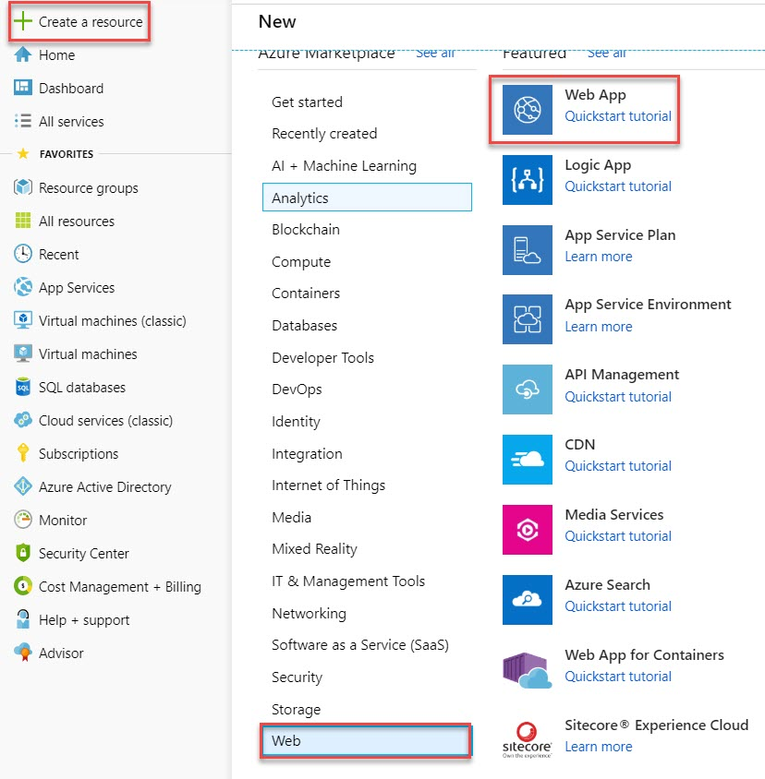

Step 18: Create Web App

Resource Group: **JavaDevOpsRG**

Name: **Enter unique name Ex javadevopsapp**

Publish : **Code**

Runtime stack : **Tomcat 9.0**

Operating System : **Windows**

Click on **Review and Create** button.

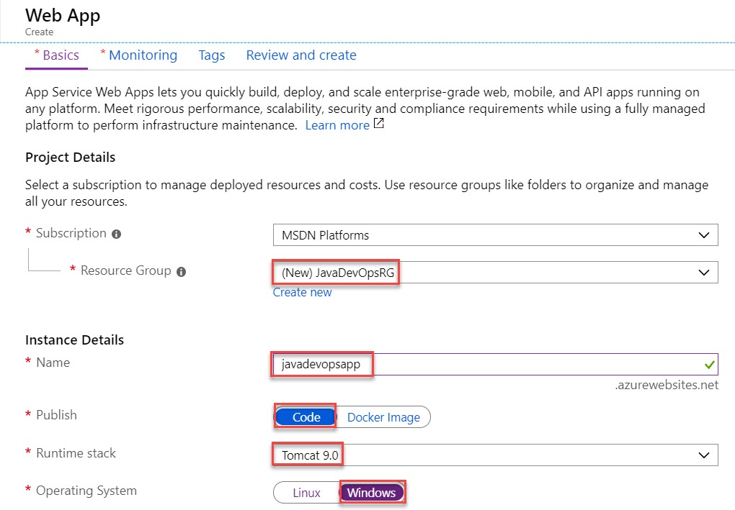

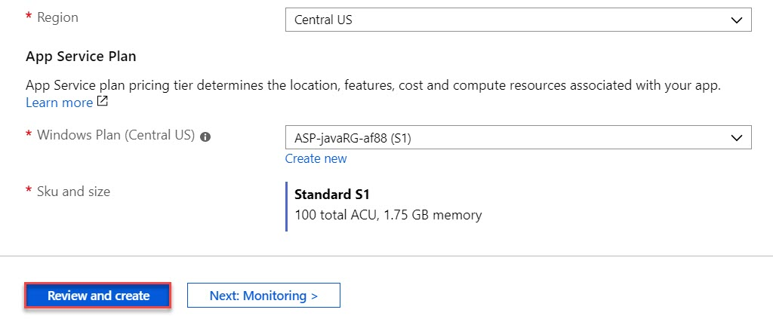

Step 19: Click on Create button.

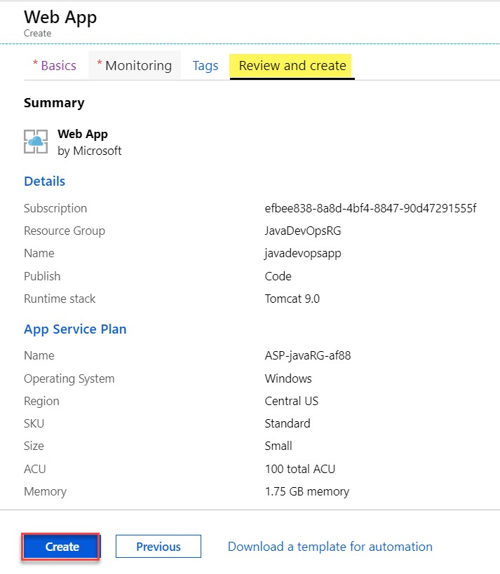

Step 20: wait for few seconds to deploy web app. Click on Go to resource button.

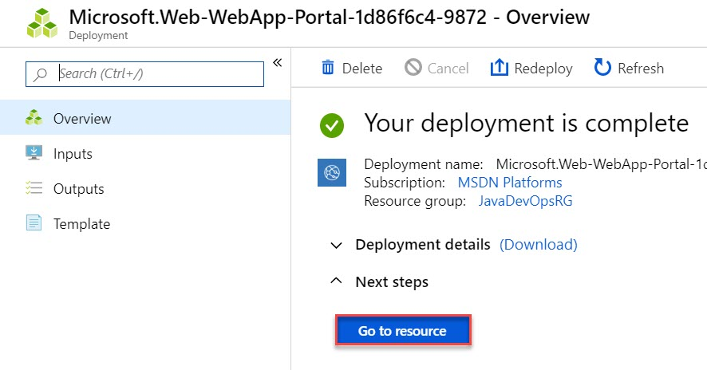

Step 21: Click on Browse to open web app

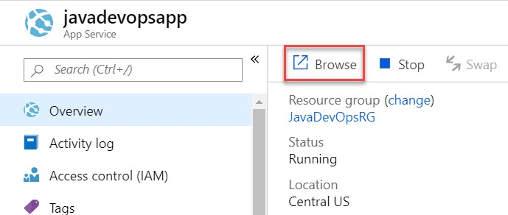

Step 22: Verify default page of Java App

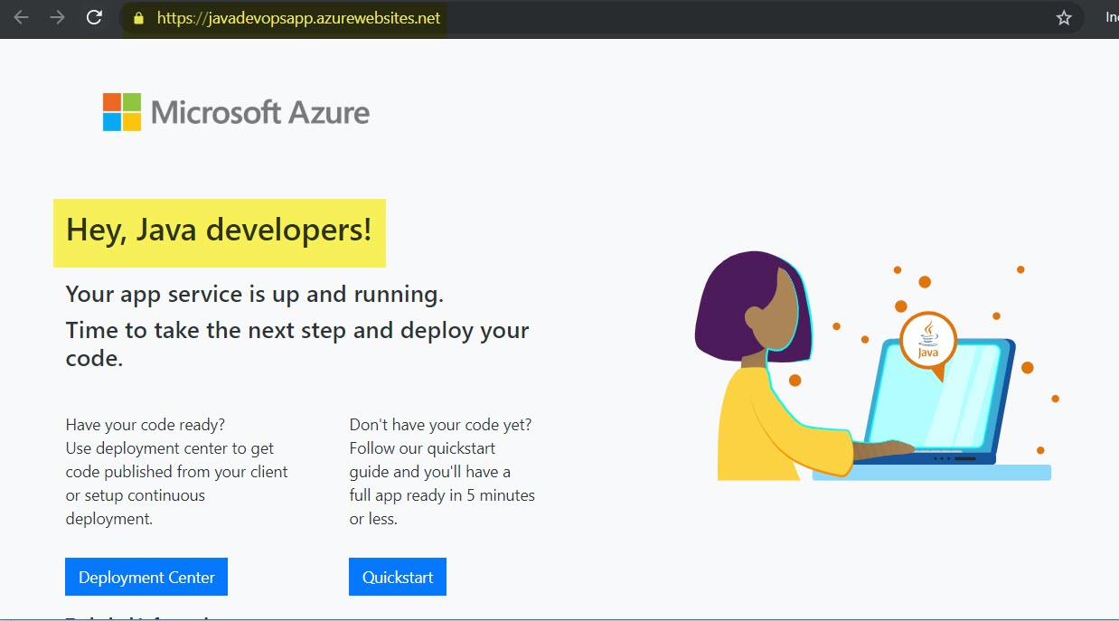

Step 23: Navigate to Azure DevOps Portal.

Create Release Pipeline

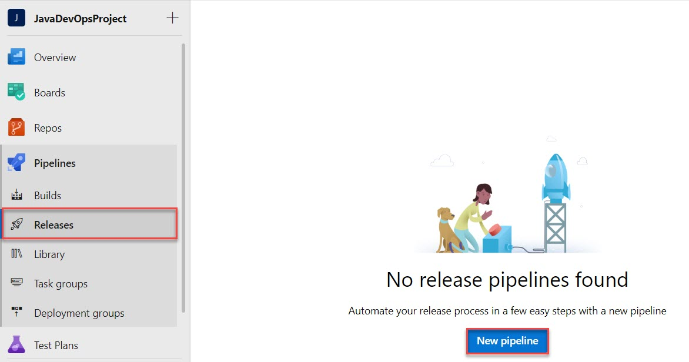

Step 24: We need to Deploy as Web App so select **Azure App Service Deployment**

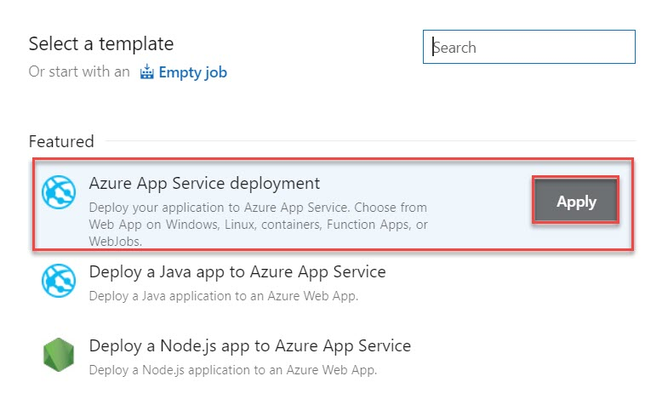

Step 25: Edit stage name: Production or dev or test

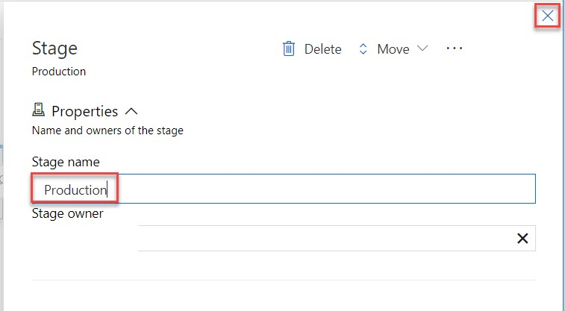

Step 26: Click on + Add an artifact option

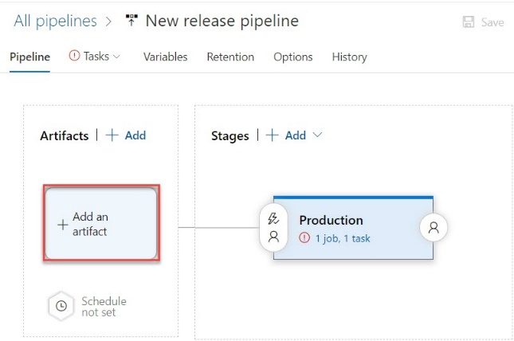

Step 27: Select Artifact

Source type: **Build**

Source (build pipeline): **Choose existing CI**

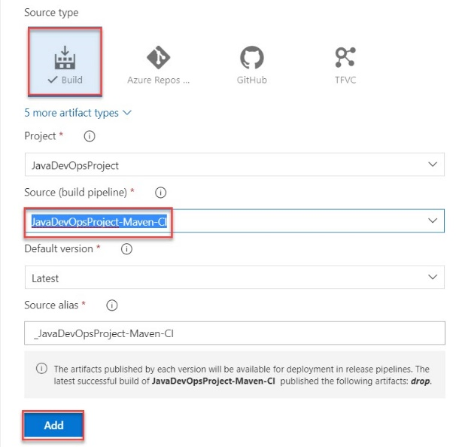

Step 28: Enable Continuous Deployment Trigger

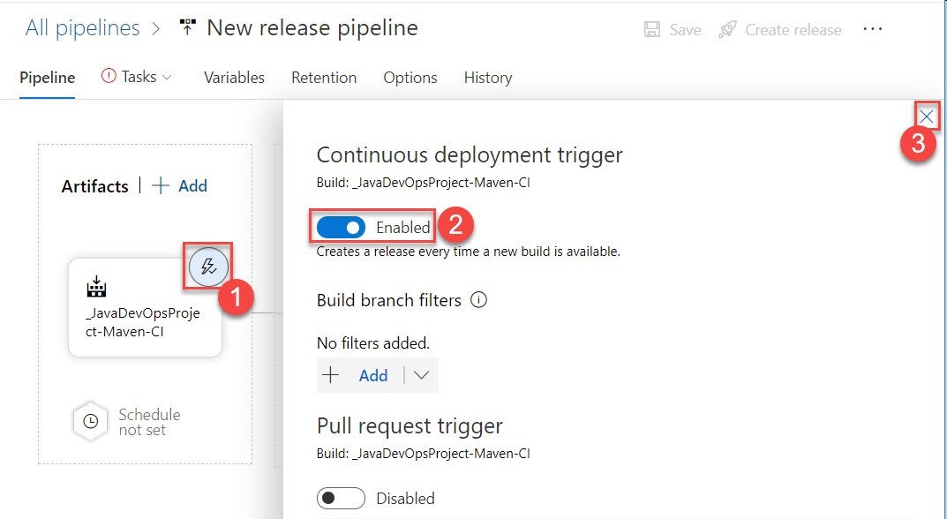

Step 29: Click on Tasks -> Production

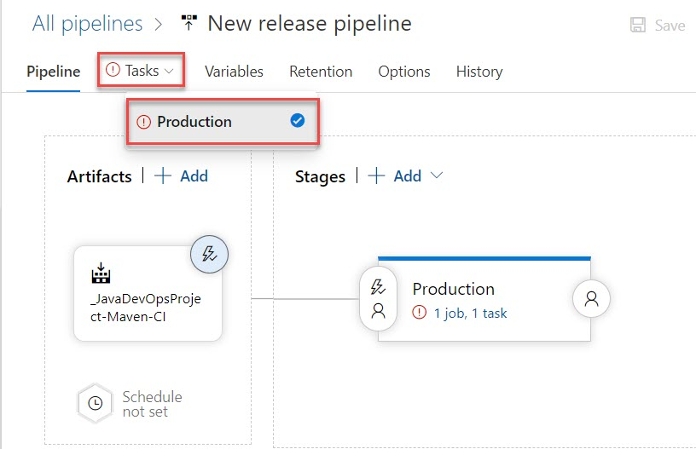

Step 30: Authorize with your Azure Subscription

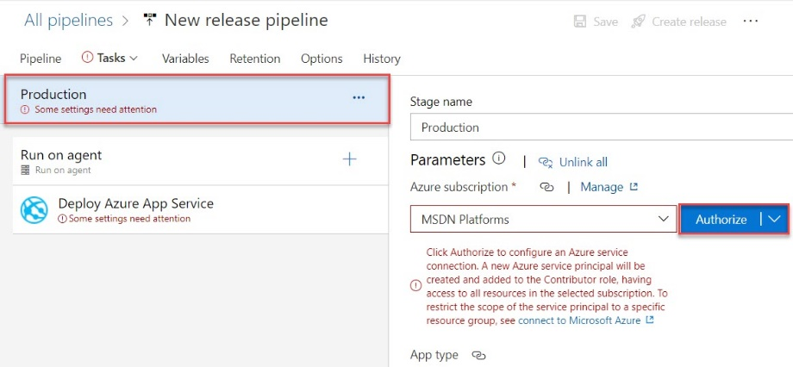

Step 31: Enter Microsoft Azure Credentials

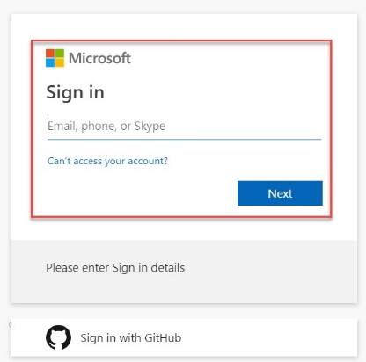

Step 32: App type: Web App on Windows

App Service name: Choose from existing list

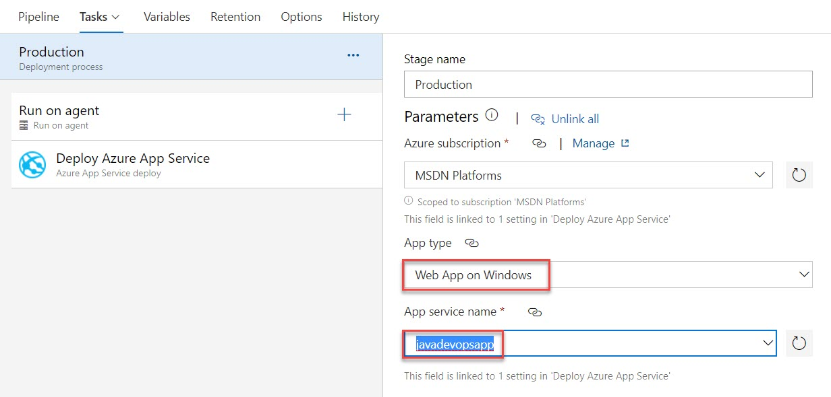

Step 33: Click on Deploy Azure App Service and select Package or folder

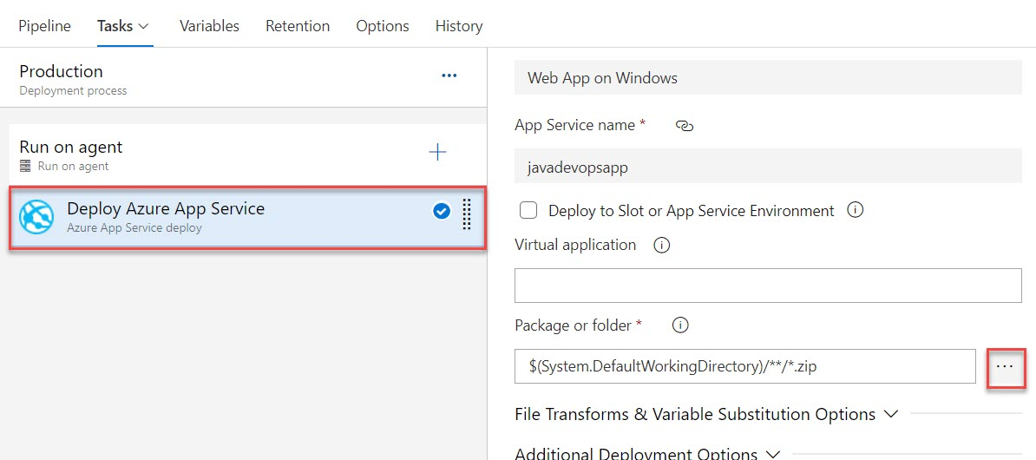

Step 34: Select war file

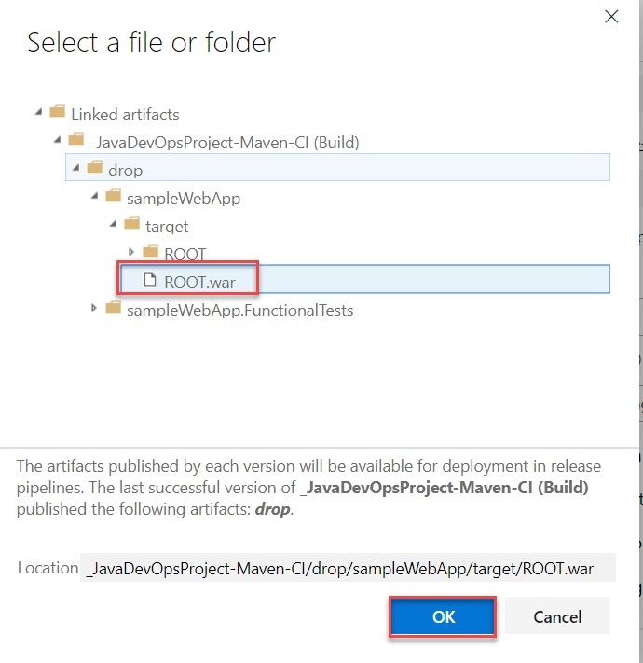

Step 35: Click on Save

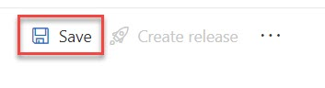

Step 36:

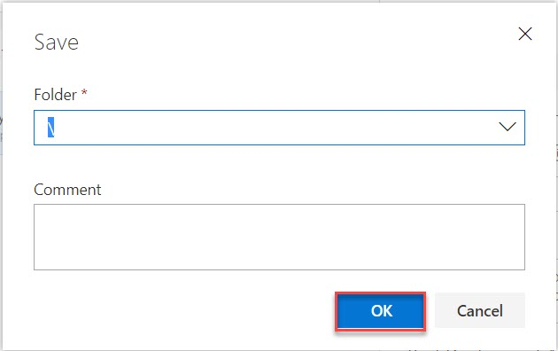

Step 37: Click on Create release



Step 38: click on Create button.

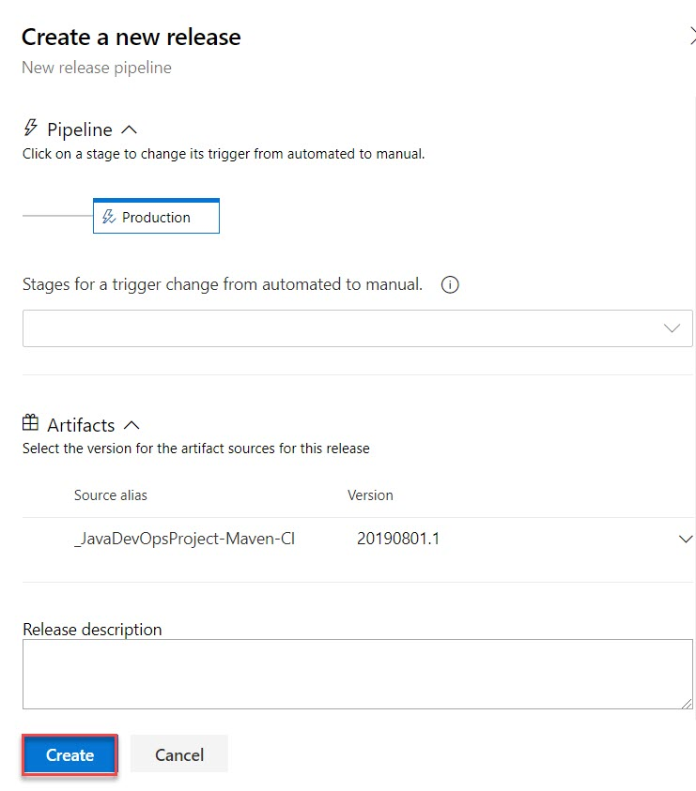

Click on Release-1

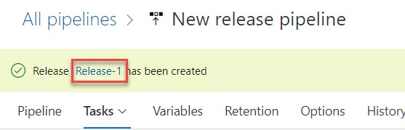

Step 39:

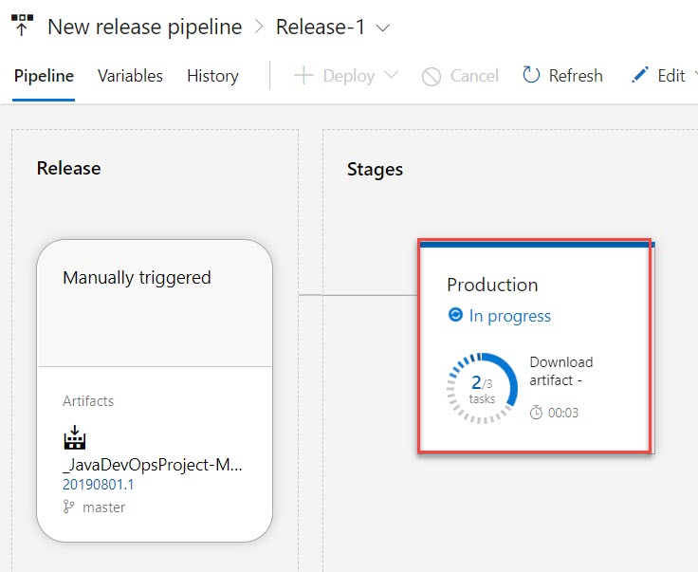

Step 40: Browse web app or refresh

