**Create Linux Virtual Machine & Configure nginx Using CloudShell**

**Step 1:** Open Microsoft Azure Portal ([https://portal.azure.com)](https://portal.azure.com/)

**Step 2:** Click on CloudShell icon (right-top side)

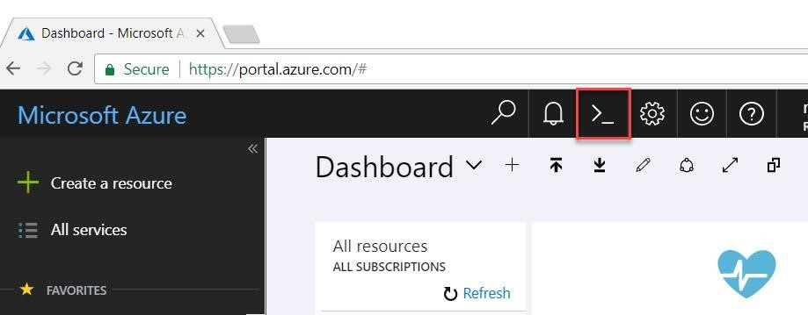

**Step 3:** CloudShell supports Bash and PowerShell. Select Bash (Linux).

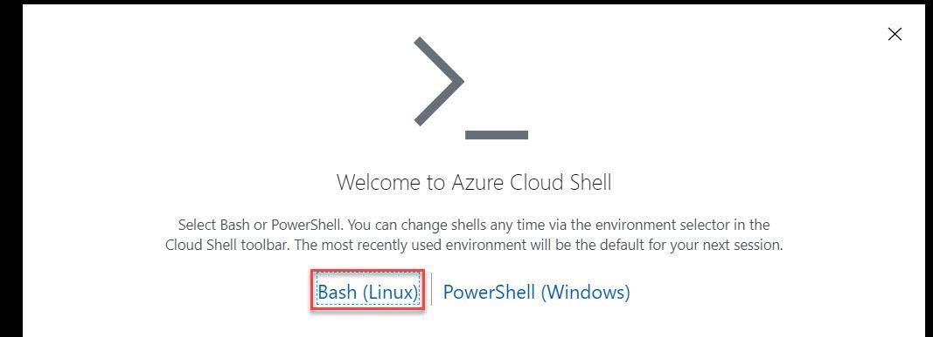

**Step 4:** Choose any working Azure Subscription. Click on Create Storage button.

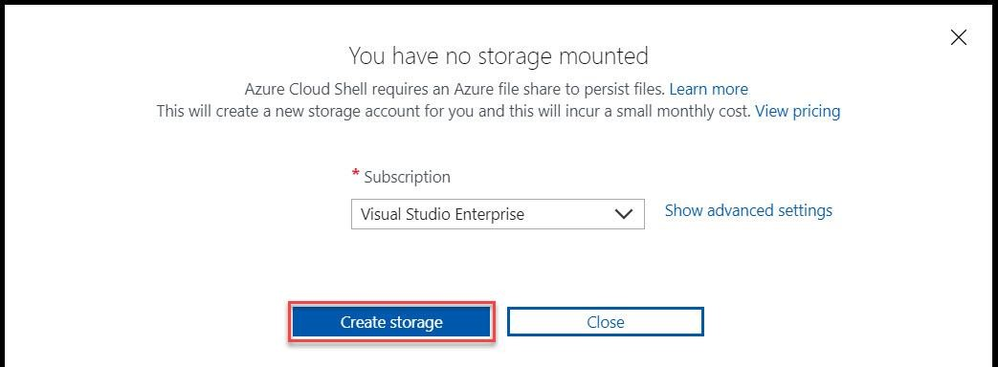

**Step 5**: Wait for couple of seconds to load bash.

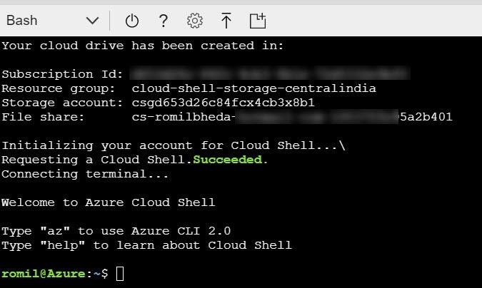

**Step 6:** type*az*to check all the commands

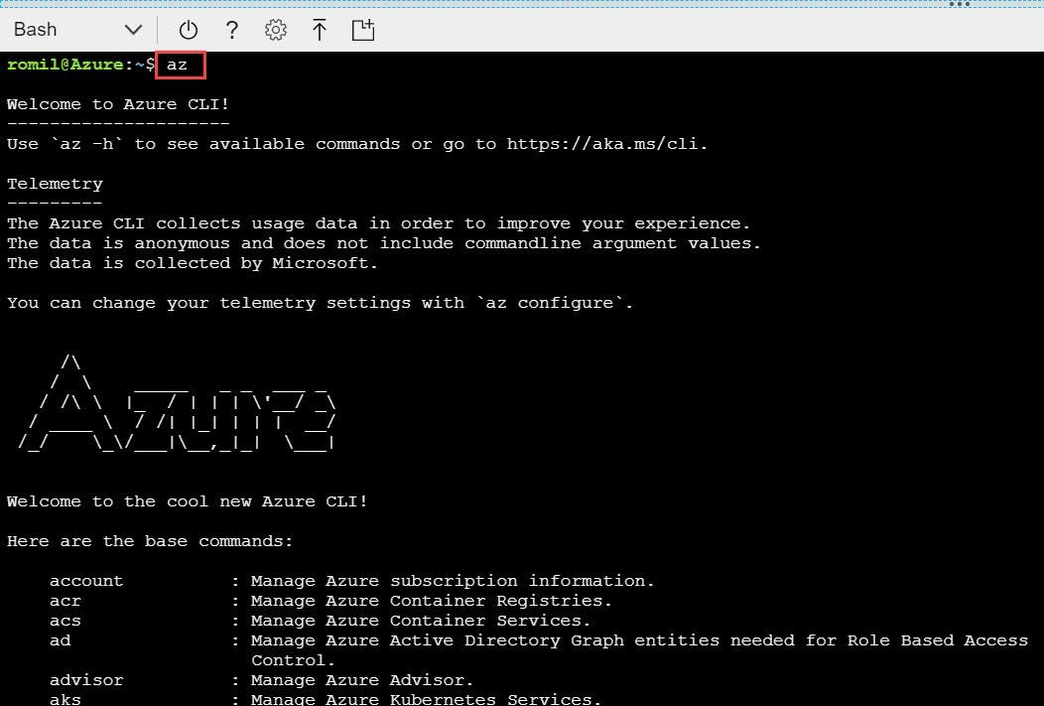

**Step 7:** To Create new resource group on particular location please type below commands:

*az group create --name myrg --location southeastasia*

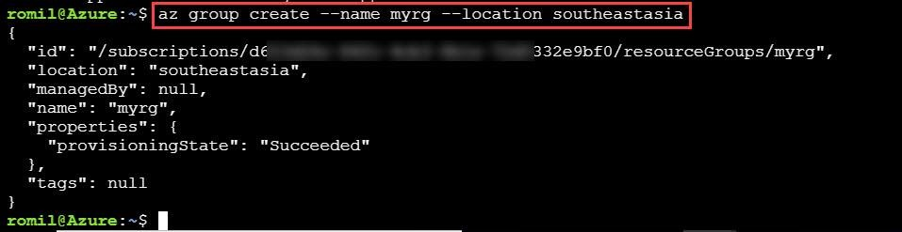

**Step 8:** To Create Ubuntu Virtual Machine with existing resource group & generating SSH Keys instead of VM Password. Type below commands:

*az vm create --resource-group myrg --name myubuntuvm1 --image UbuntuLTS --generate-ssh-keys*

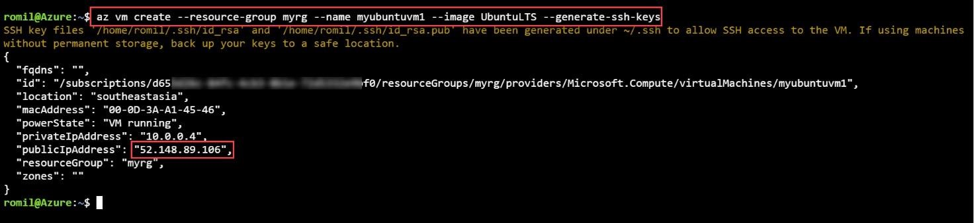

**Step 9:** To add Port 80 (HTTP) as an Inbound Rule to existing Virtual Machine please type below commands*:*

*az vm open-port --port 80 --resource-group myrg --name myubuntuvm1*

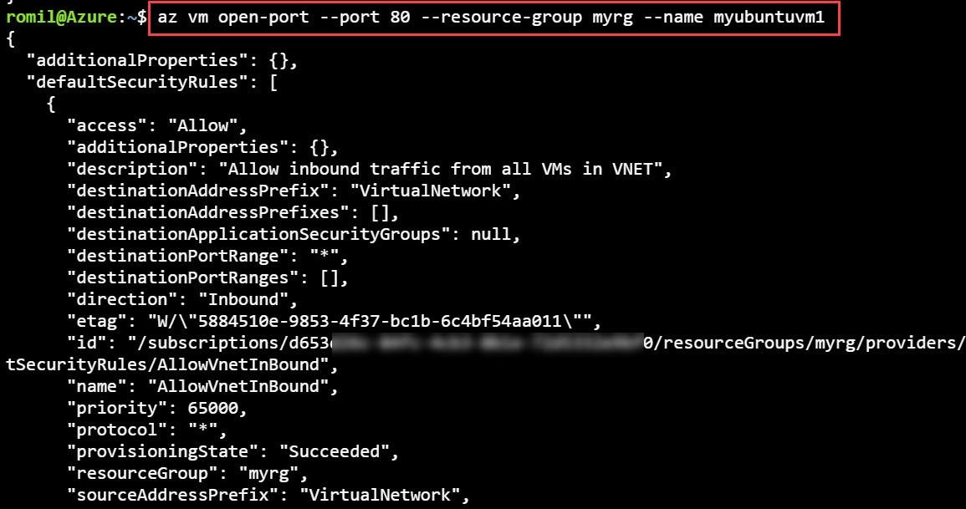

It will list all the added port with new Port 80 allowed.

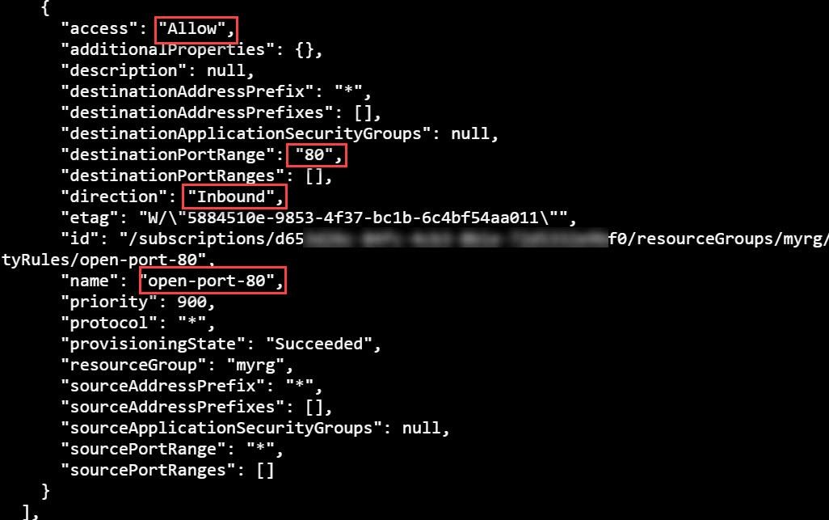

**Step 10:** Type ssh with Virtual Machine IP Address & hit enter. From step no. 8 you can get Public IP Address of Virtual Machine. Also type **yes** to connect with machine.

*ssh 11.22.33.44*

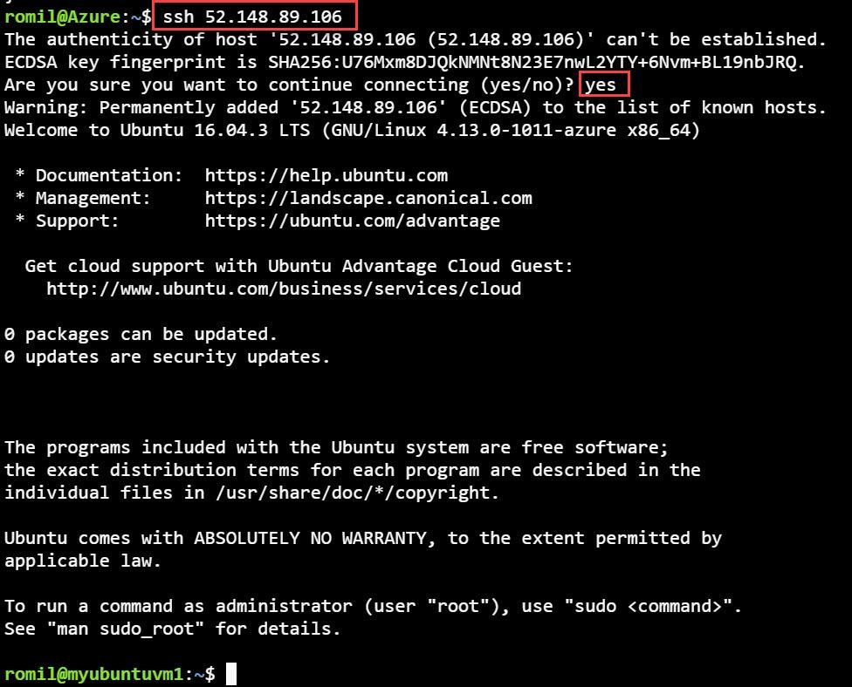

**Step 11:** Change User to Root User (administrator)

*sudo su*



**Step 12:** To Update the Packages of Ubuntu Virtual Machine Please type below command:

*apt-get update*

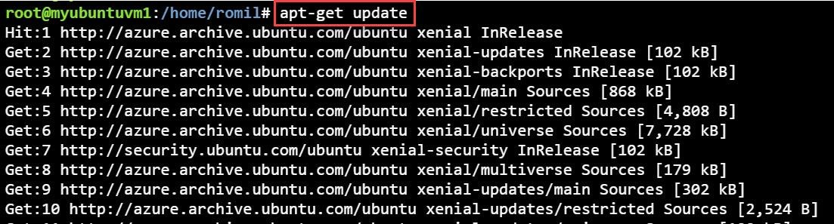

**Step 13:** To install nginx on newly created Machine type below command. Also type **y** to continue *apt-get install nginx*

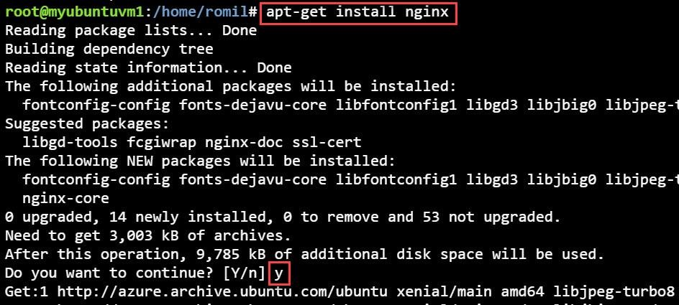

**Note: Nginx is a web server which can also be used as a reverse proxy, load balancer and HTTP cache. Nginx is free and open-source software, released under the terms of a BSD-like license. A large fraction of web servers use NGINX, often as a load balancer.**

**Step 14:** After installation of nginx open browser & type public ip address of virtual machine.

