Comparative Analysis of Polars and Pandas Performance for Data-Intensive Tasks in FastAPI Microservices

Divyansh
Department of Computer Science & Engineering
Chitkara University
Punjab, India
divyansh1535.be22@chitkara.edu.in
ORCID: 0009-0005-9077-1291
Navjot Singh
Department of Computer Science & Engineering
Chitkara University
Punjab, India
navjot1964.be22@chitkara.edu.in
ORCID: 0009-0003-8330-2679
Bhavik Sharma
Department of Computer Science & Engineering
Chitkara University
Punjab, India
bhavik217.be22@chitkara.edu.in

Abstract — This paper studies and evaluates the performance of two widely used Python data computation engines - Pandas and Polars on the basis of their resource utilization and execution latencies, when used within concurrent FastAPI based microservices. It evaluates the shift from batch-driven data pipelines(pandas) to real-time, asynchronous architectures(polars). We generated a one-million row synthetic dataset, which will be used in executing six core data transformation operations and while doing these operations we track CPU saturation, RAM allocation, and API request latencies. The analysis demonstrates that Pandas which uses synchronous, eager-evaluation suffer from severe thread contention and exponential increase in memory usage during structural joins triggered Out-Of-Memory (OOM) failures under modest load test. On the other hand, Polars which uses multithreaded Rust runtime and out-of-core lazy execution graphs to reduce peak memory usage demonstrated 81.3% less median response latencies than that of Pandas and also prevented host container termination during memory-bound spikes. These findings help in deploying API-driven data microservices by providing an architectural blueprint without the requirement of extensive horizontal hardware expansion.
The benchmark suite and source code are available at: https://github.com/3397divyansh/polars-vs-pandas-benchmarking
Keywords—Polars, Pandas, FastAPI, Microservices, Performance Evaluation

I. INTRODUCTION
The modern trend of software engineering continuously shifts computational workloads from centralized monolithic batch processors to distributed, microservice-based web architectures [1]. Frameworks like FastAPI excel at handling asynchronous web traffic; however, when these microservices serve as thin orchestrators over heavy, synchronous data manipulation libraries, severe architectural friction emerges [2].
Pandas has been used as the predominant standard for manipulation of tabular data in Python [3]. While it is great for localized exploratory data analysis, Pandas relies on eager evaluation algorithms and is dependent on the single-threaded constraints of the Python Global Interpreter Lock (GIL). If these properties exist behind concurrent endpoints of an API, then they will always behave as bottleneck queueing delay and intermediate memory peak. This is why application performance is low and scalability cost is high in reality [4].
The Polars project has become a customized DataFrame engine due to the recent innovations in array computation paradigms explicitly designed for multi-core CPU architecture.. Built using the Apache Arrow technology stack [5] written in Rust, the Polars library implements advanced lazy evaluation graphs and stream processing techniques.. While becoming more popular in localized data engineering workflows, it lacks an academic benchmark comparing its performance in terms of time and resource utilization against Pandas constrained within web APIs [6].

Contributions
This study offers the following core contributions:
• Workload Performance Testing: We present an elaborate, environmental benchmark test setting designed explicitly for memory fault problems (OOM) caused by asynchronous API requests.
• Stress Test Evaluation on Architecture: We carry out an analytical comparison between the memory growth pattern of the eager and lazy modes of execution graphs in concurrent traffic.
• Algorithm Profiling: We deliver a mathematical distribution of latency degradation on popular data transformation methods, showing precisely how legacy synchronous cycles impede current CPU caching algorithms.

II. BACKGROUND AND KEY CONCEPTS
To effectively judge the computational results, we must compare the structure and design that works behind these engines.

A. The Eager Execution Model and The Python GIL
Pandas executes transformations eagerly. When an operation is called, the instruction executes immediately upon the localized memory addresses. If a developer joins two highly-cardinal dataframes, Pandas immediately creates a third complete data structure containing the Cartesian product [7]. In a microservice processing multiple HTTP requests at once, eager processing causes high memory footprint due to duplication..
Pandas computations are bound by the Global Interpreter Lock (GIL)—a mutex that protects object pointers in CPython by limiting that only one thread can execute Python bytecode at any given moment [8]. Even under the asynchronous `asyncio` model utilized by FastAPI, heavy Pandas manipulations block the core event loop, limiting the service to sequential execution.

B. Lazy Evaluation and Apache Arrow
Polars uses an alternate model focusing on multi-core utilization. When interacting with Polars' lazy API, calculations are not executed instantaneously. Instead, the framework forms a directed acyclic graph (DAG) representing the desired logical operations. Upon calling the `collect()` method , the integrated query optimizer combines sequential map-reduce steps, removes unselected columns ahead of time, and directs the workload across available CPU worker threads [9].

By using a smart way to organize data in memory (Apache Arrow), the computer doesn't waste time or space constantly re-packing information. This allows the system to process huge amounts of data that are too big for the computer's memory without crashing.

III. METHODOLOGY
To reduce the influence of external host bias, it's necessary to establish a testing environment with strict controls. The experimental infrastructure uses strict containerized environments.

A. Application Architecture & Configuration
We designed two structurally identical FastAPI web services. The control group performs synchronous Pandas endpoints, whereas the experimental group implements Polars via lazy queries. To standard cloud execution limitations (such as base-tier AWS ECS Fargate profiles), both services were deployed into isolated Docker containers limited at maximum of exactly 2.0 logical CPU cores and a strict 2,048 Megabytes (2 GB) RAM threshold.
The parallel thread locking issue that occurred with the async API and the processor was avoided by explicitly restricting Polars to only parallelize itself within the 2 core limitation using the environment variable `POLARS_MAX_THREADS`.

B. Dataset Integrity and Generation
Conducting tests under the supervision of the observing testing rules necessitates that we conduct rigorous and well-structured tests. An example of such a database we produced for our experimental research consists of 3-Normal Form (3NF) relational data from an electronic commerce database of three specific entities: `Customers` (100,000 unique geometries), `Products` (10,000 entities), and `Orders` (1,000,000 records). The creation of one million rows of data gives us enough computational pressure to test CPU caching performance without causing an immediate overflow in the memory capacity when the server boots up.[11]. In generating the data, we created them in Apache Parquet format so as to be consistent in terms of disk-to-memory benchmarking in both APIs. With synthetic data, we can have complete control in terms of schema, columns containing statistical information, and number of records used in benchmarking.

C. Targeted Data Engineering Workloads
The load tests isolate the following discrete categories to pinpoint algorithmic constraints:
1. Heavy Relational Joins: Evaluates intermediate relational join behavior and differences in hash alignment.
2. Multi-Dimensional Aggregations: Analyzes parallel hash aggregations on very large data sets.
3. Window Functions: Tests whether vectorization occurs, meaning data is processed in bulk, or whether serialization overhead occurs, which means processing data one record at a time.
4. String Processing: Measures direct Python objects against Arrow's continuous byte stream processing.
5. Time-Series Resampling: Tests windowed time-based grouping operations.
6. Null Value Imputation: Analyzes binary column-wise mutations without needing state retention per group.

D. Concurrency Parameters and Precision Strategies
The benchmark employed `k6` as a means of simulating a flow of requests.This included an arrangement where 10 virtual users would issue REST queries simultaneously within a timeframe of 60 seconds. Ten is not a very big number but for queries that involve processing millions of rows it generates substantial load on the multi-core scheduler. Another Python program was run parallel to the benchmarking exercise. Monitor the CPU and RAM resource consumption by the hypervisor container every half-second. Let the test warm up for some time before taking measurements based on the number of requests. The benchmarking test created a level playing ground since everything had to be done uniformly. The use of `k6` was essential in ensuring that the test was carried out in the right manner. This was achieved by sending out queries simultaneously from ten virtual users while the Python code generated details of CPU and memory usage levels.

IV. RESULTS AND STATISTICAL VALIDATION
A disparity was identified in performance, resource utilization, and architectural stability while being subject to concurrent requests by both the Pandas and Polars microservices. There is clear variation seen in the telemetry logs for eagerness with Pandas and laziness with Polars.
A. Operation 1: Heavy Relational Joins
Results from Pandas had large variance as a result of GIL bottlenecking. Eager execution entailed allocating a large amount of un-coordinated RAM usage, which did not go under 1,800MB. This resulted in high variability of CPU load usage, ranging from 50% to 180% saturated load. On the other hand, Polars was able to optimize the directed graph to perform out-of-core alignment streaming, resulting in a highly saturated CPU usage of 198%, with almost no variance and under 900MB operational usage..
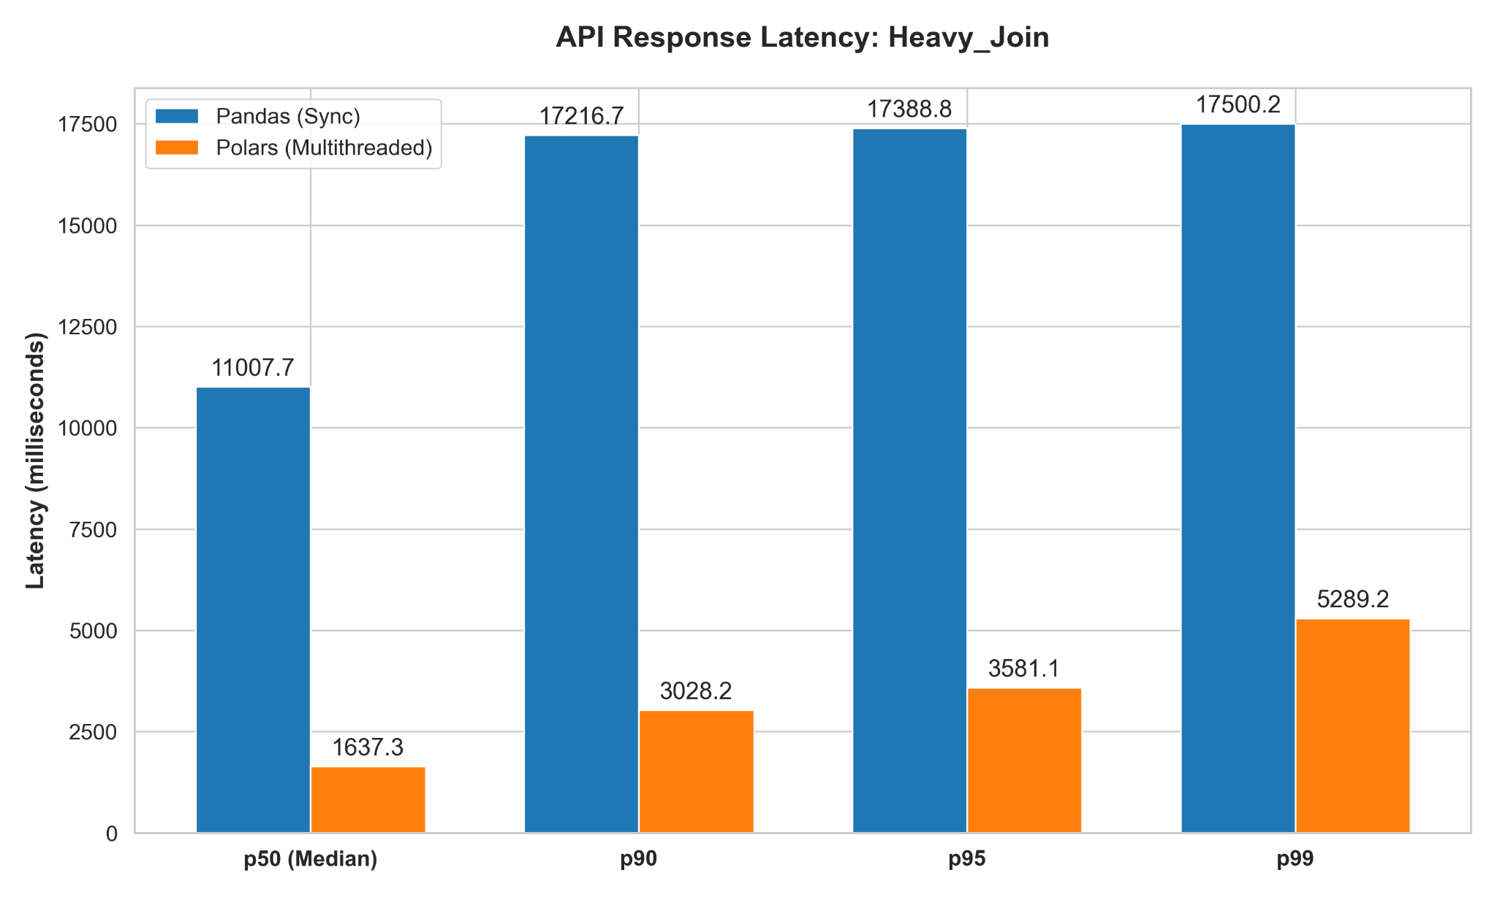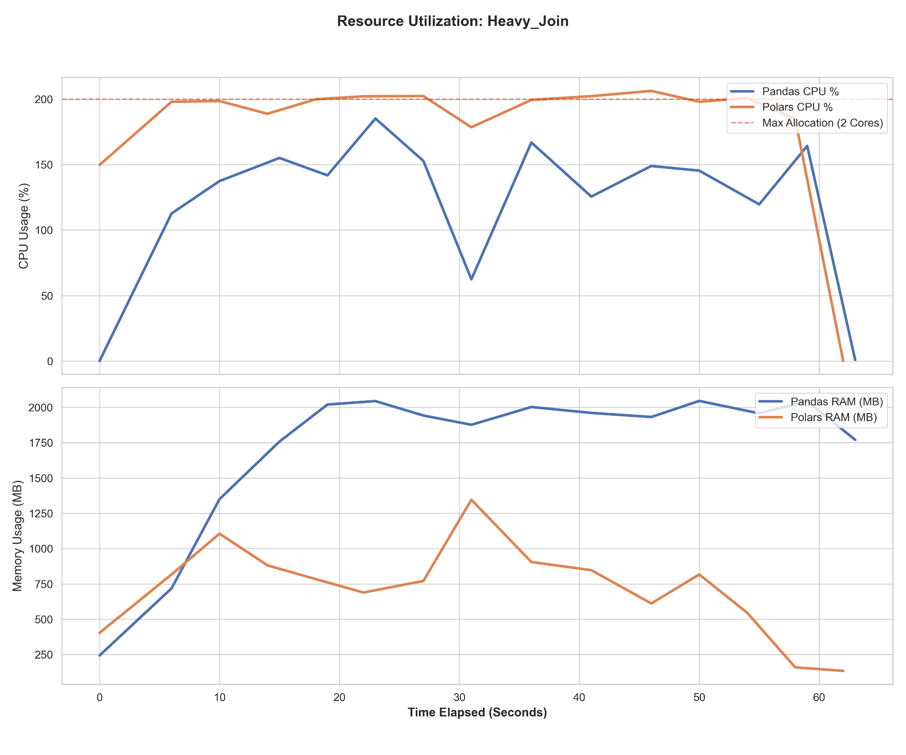
Fig. 1. Response Latency, CPU and memory utilization over time during the heavy relational join benchmark
B. Operation 2: Multi-Dimensional Aggregations
The Polars latency was 2,120 ms on average, far exceeding the median value of Pandas by a large margin of 10,281 ms. The Pandas algorithm was not able to reach full occupancy of its allotted computational cores due to bottlenecks in the C-based grouped state changes.
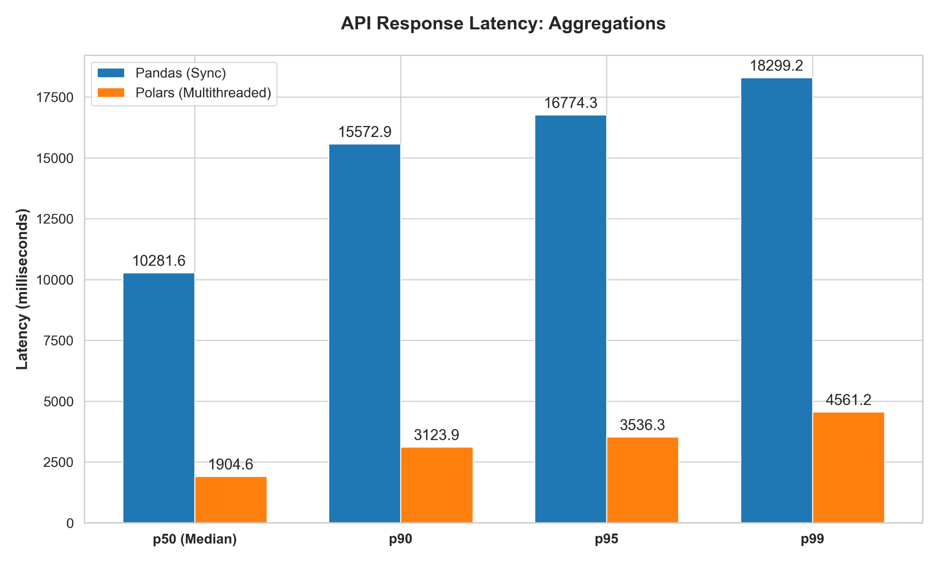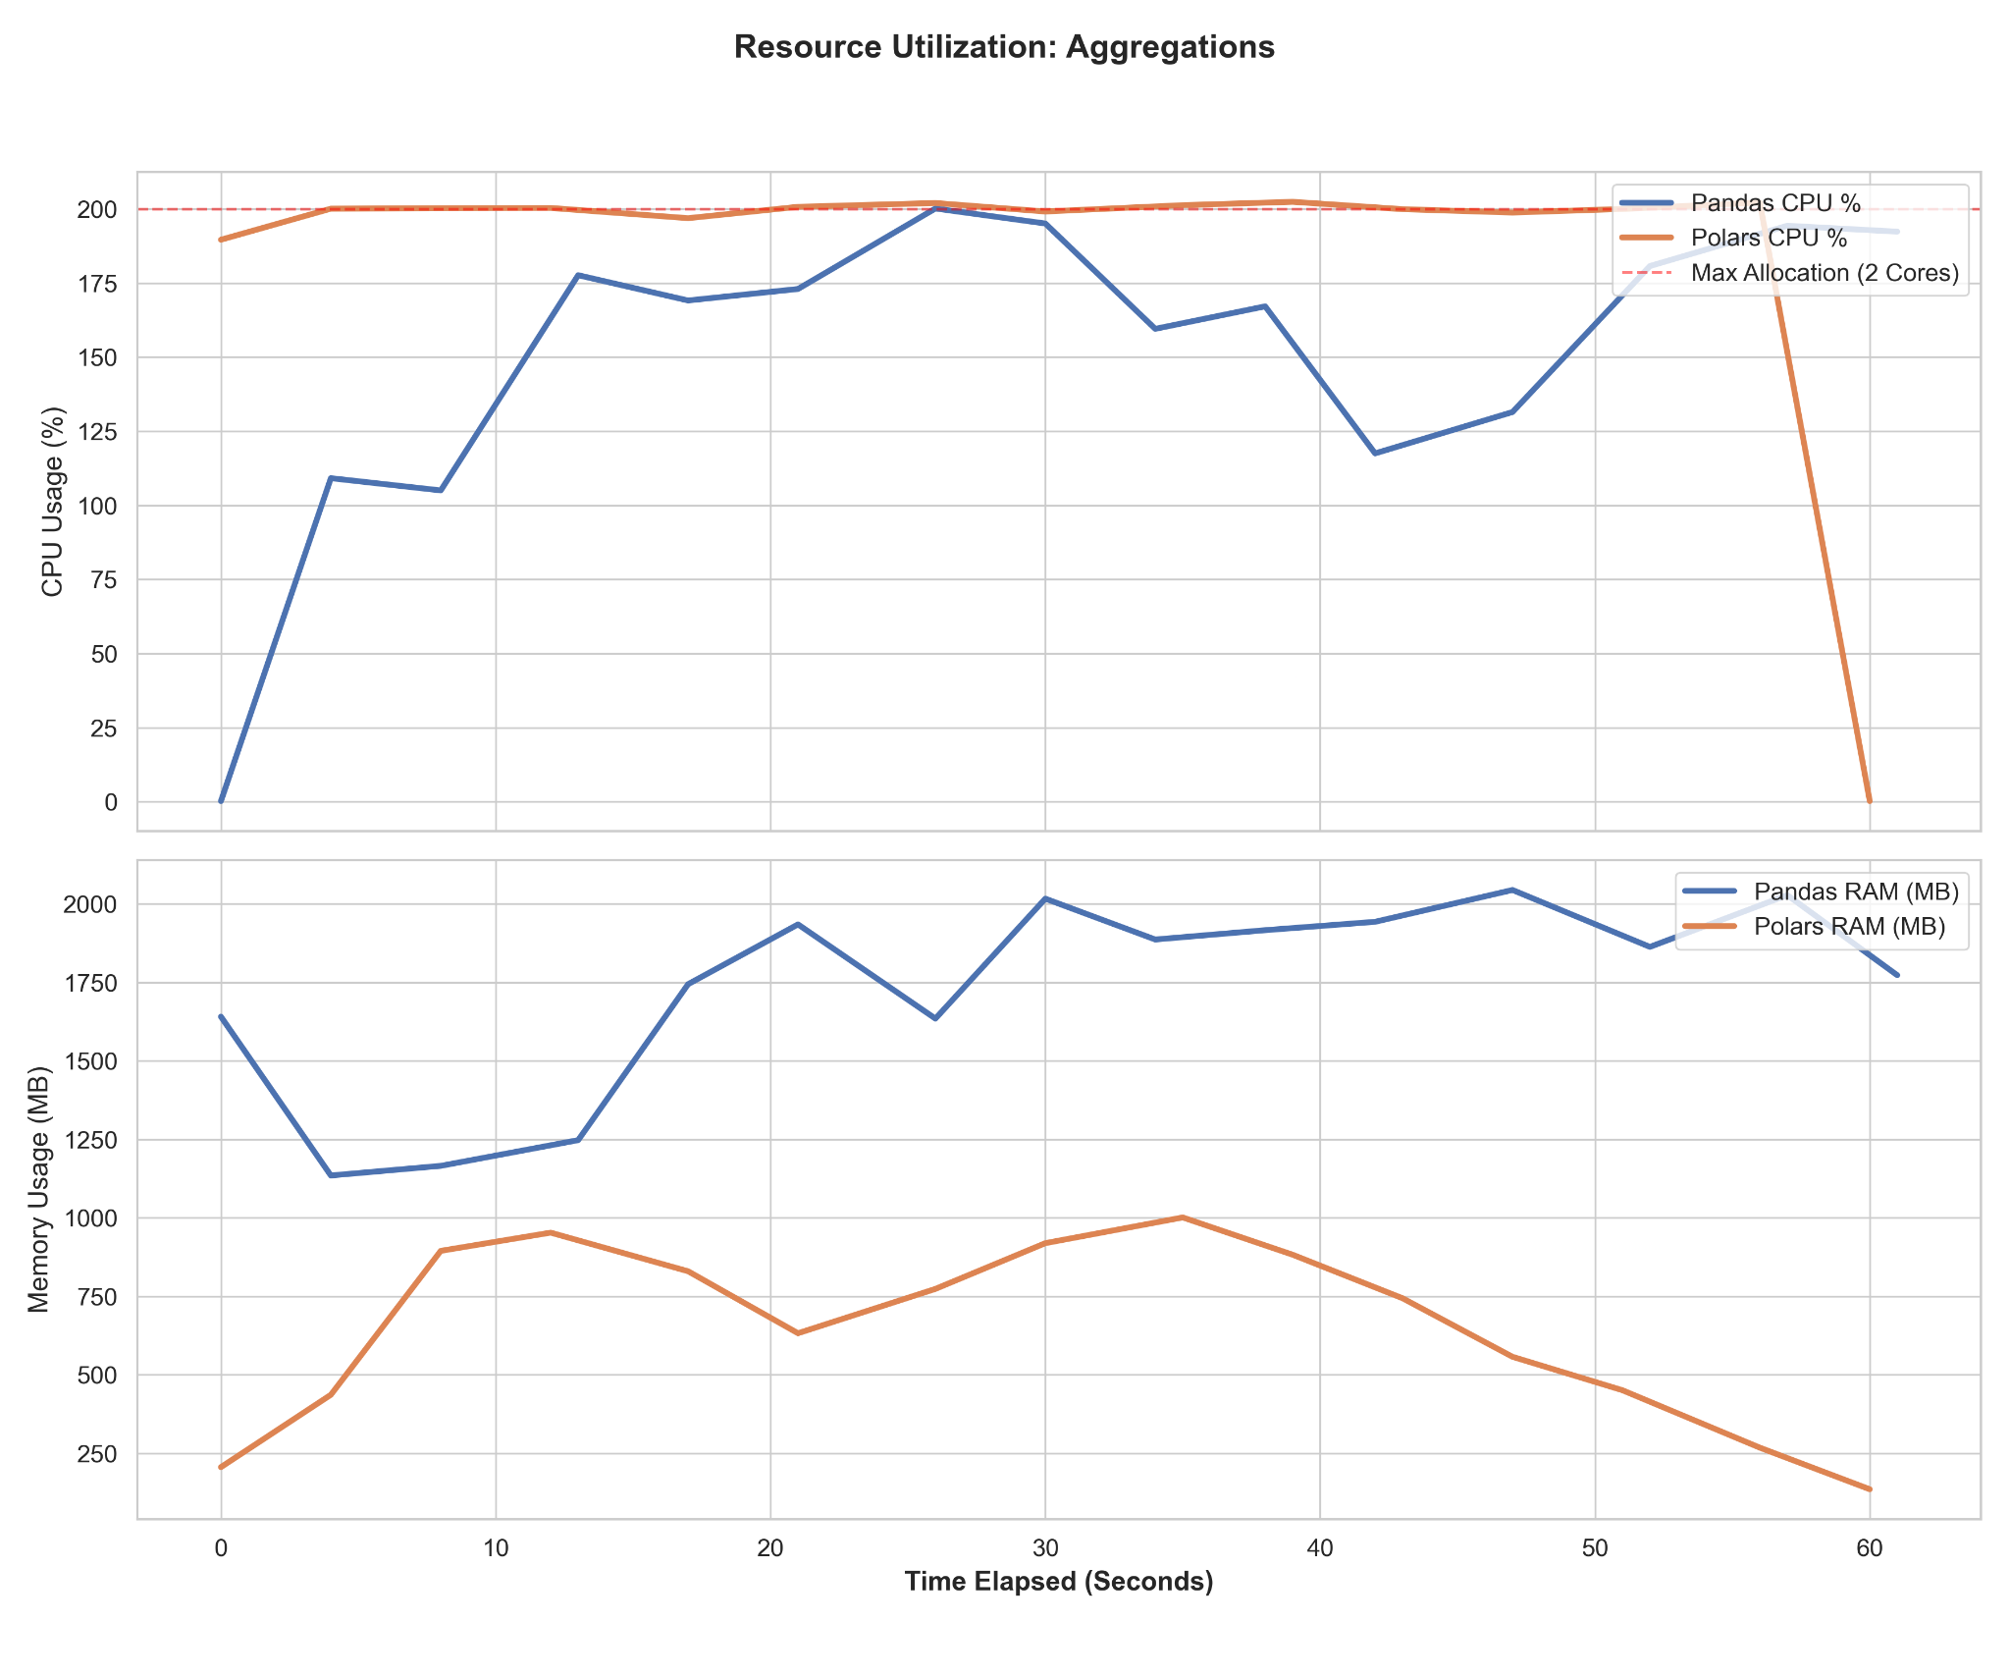
Fig. 2. Response Latency, CPU and memory utilization over time during the multi-dimensional aggregations benchmark.
C. Operation 3: Window Functions
Partitioned window calculations expose an inherent weakness in interpreter-driven execution. For instance, ranked functions within partitioned groups in Pandas are executed as Python loops, and such a design pattern comes with high computational costs and cannot be scaled well. The latency numbers are evident with median latencies of 8,026 ms, followed by a steep decline in tail latency to 11,576.4 ms as the workload grows. Polars' window function, however, executes vectorized functions within contiguous Arrow memory, meaning that it does not require interpreter-driven execution for each record.
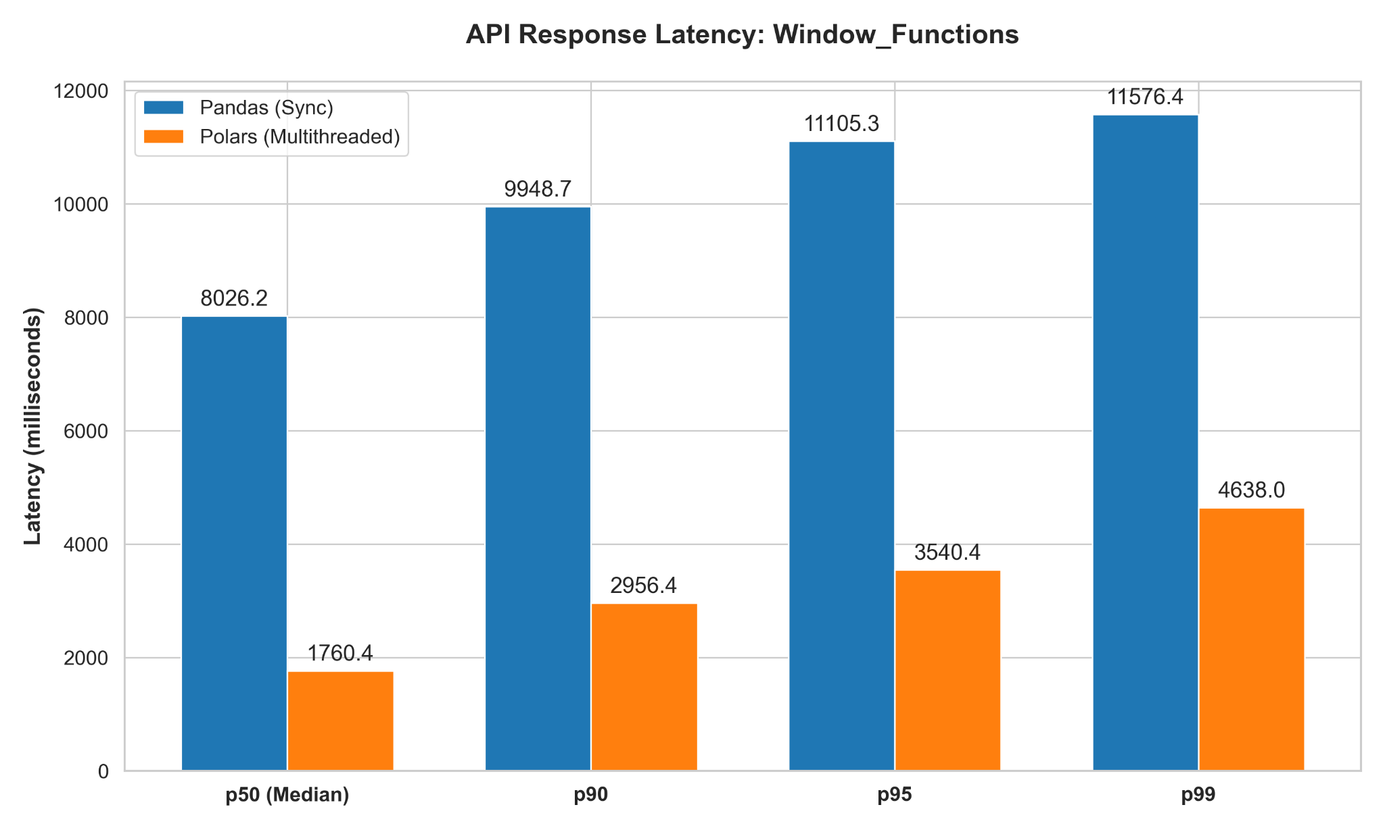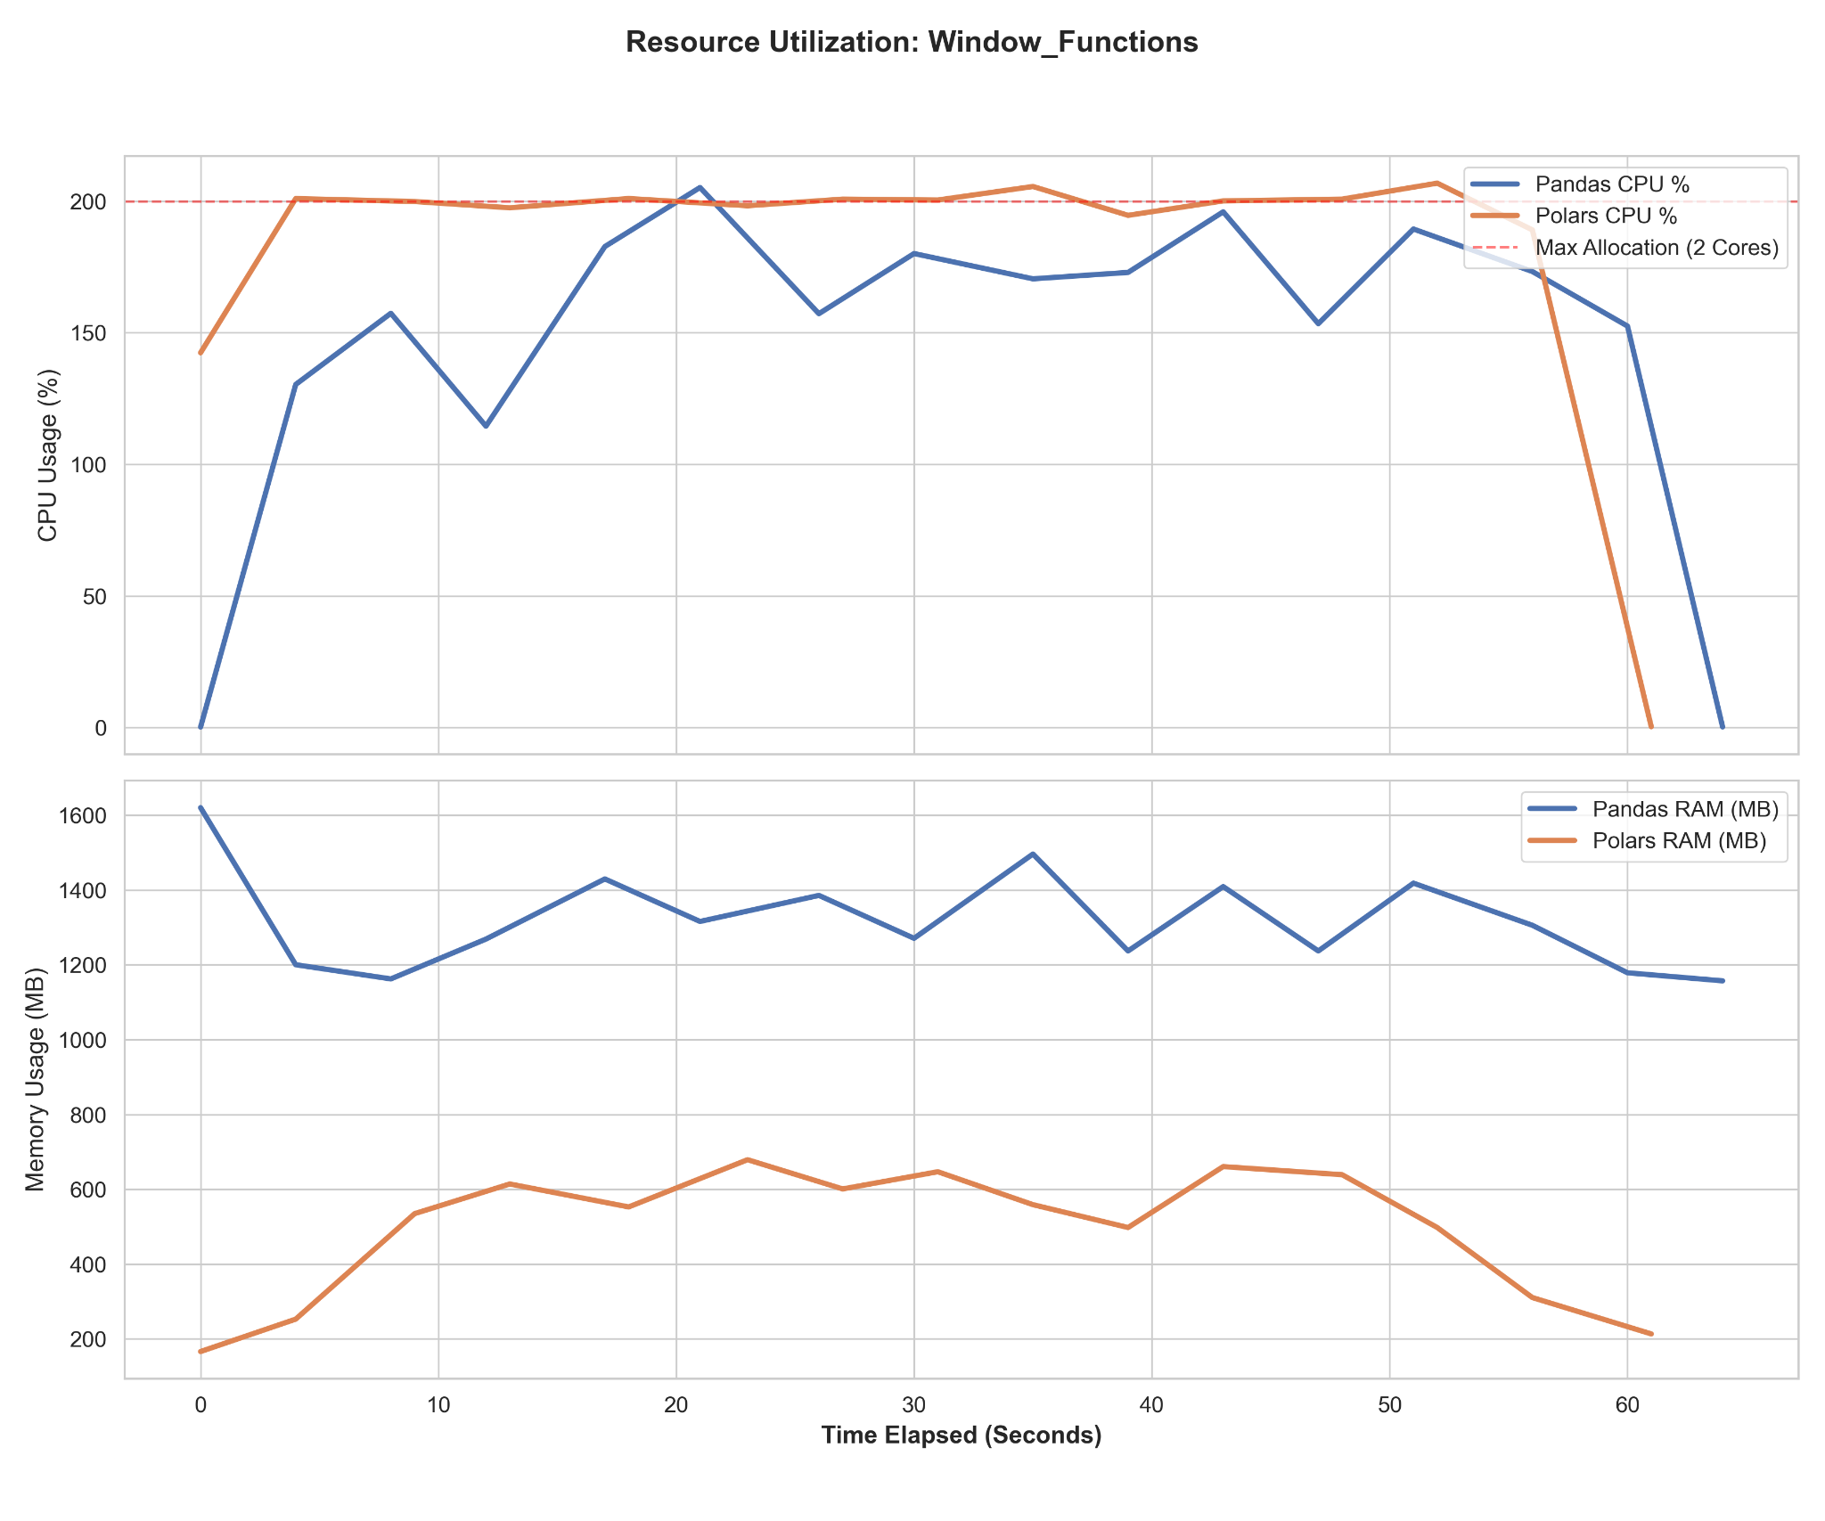
Fig. 3. Response Latency, CPU and memory utilization over time during the window functions benchmark.

D. Operation 4: String Processing
Pandas uses wrappers that use Python objects for text string parsing, thereby pushing the computations from highly optimized C routines to the Python interpreter. This led to an overhead that made average processing times reach 9,816 ms. On the other hand, Polars avoids the overhead of iterating the interpreter by using the Arrow memory structures.

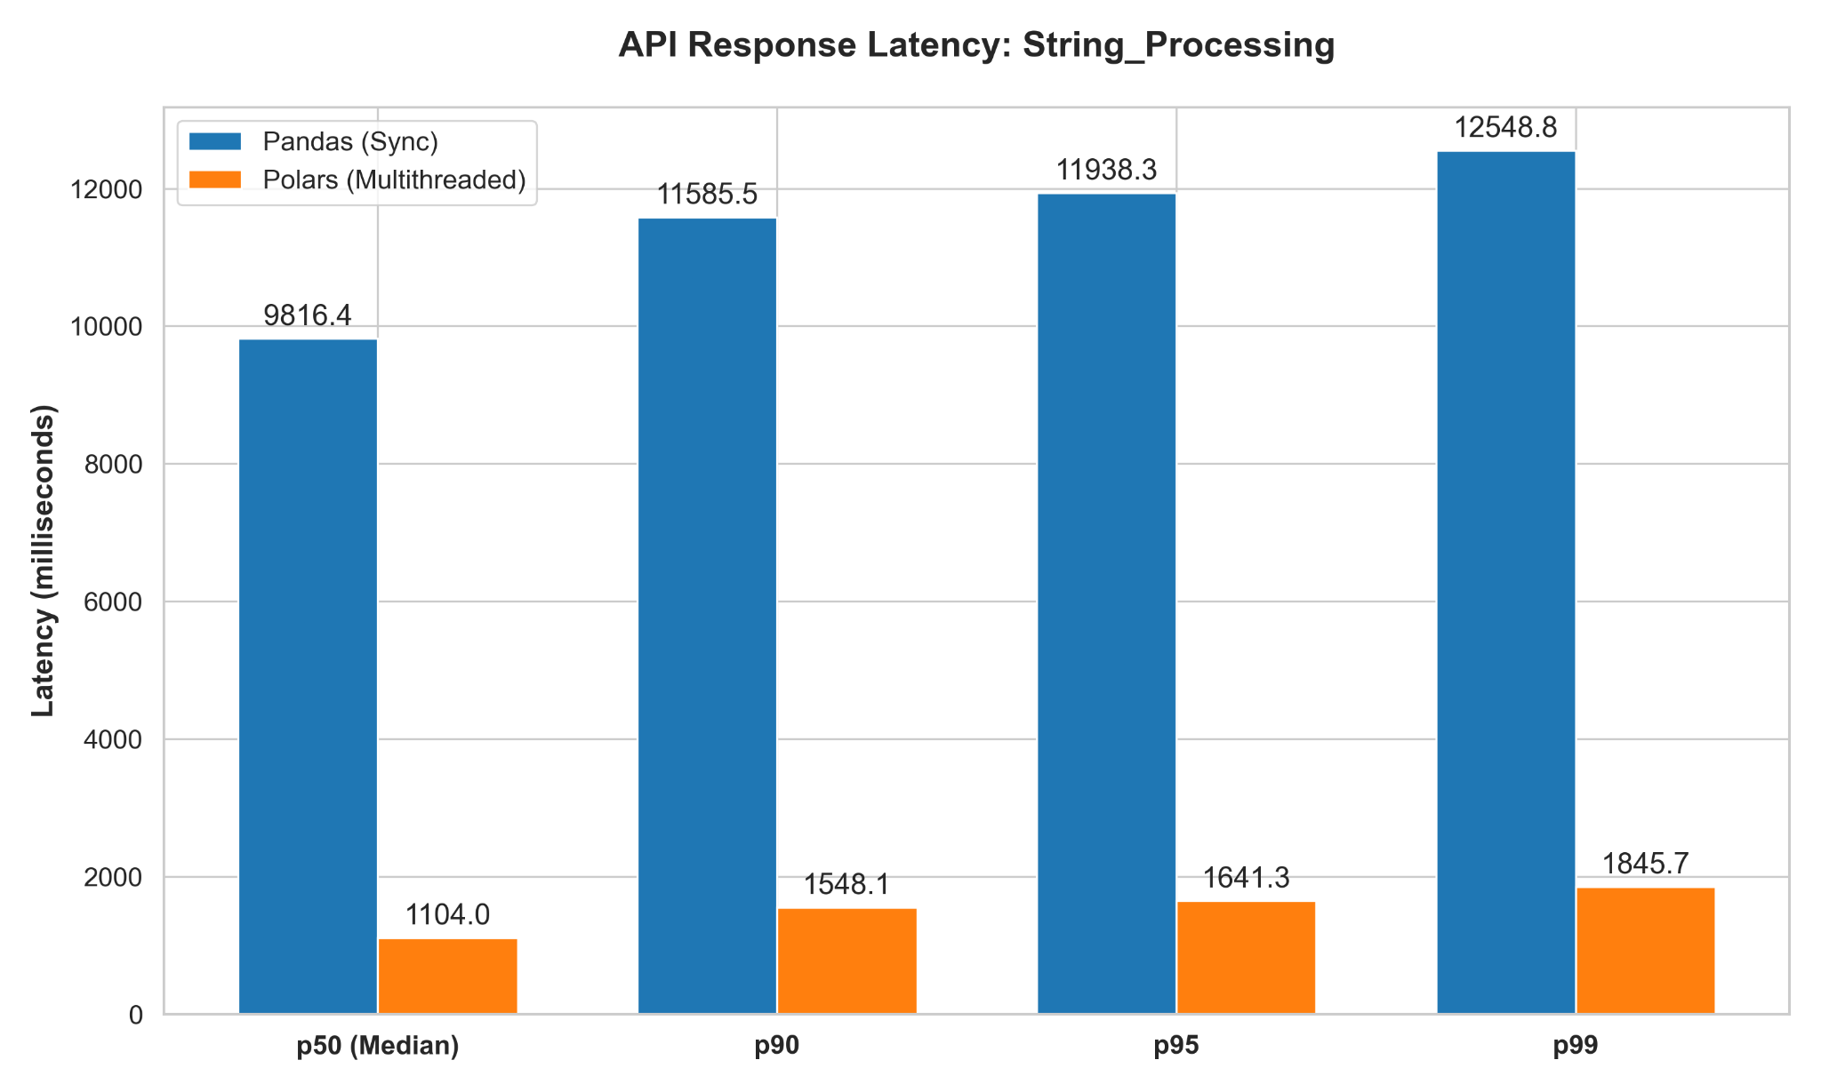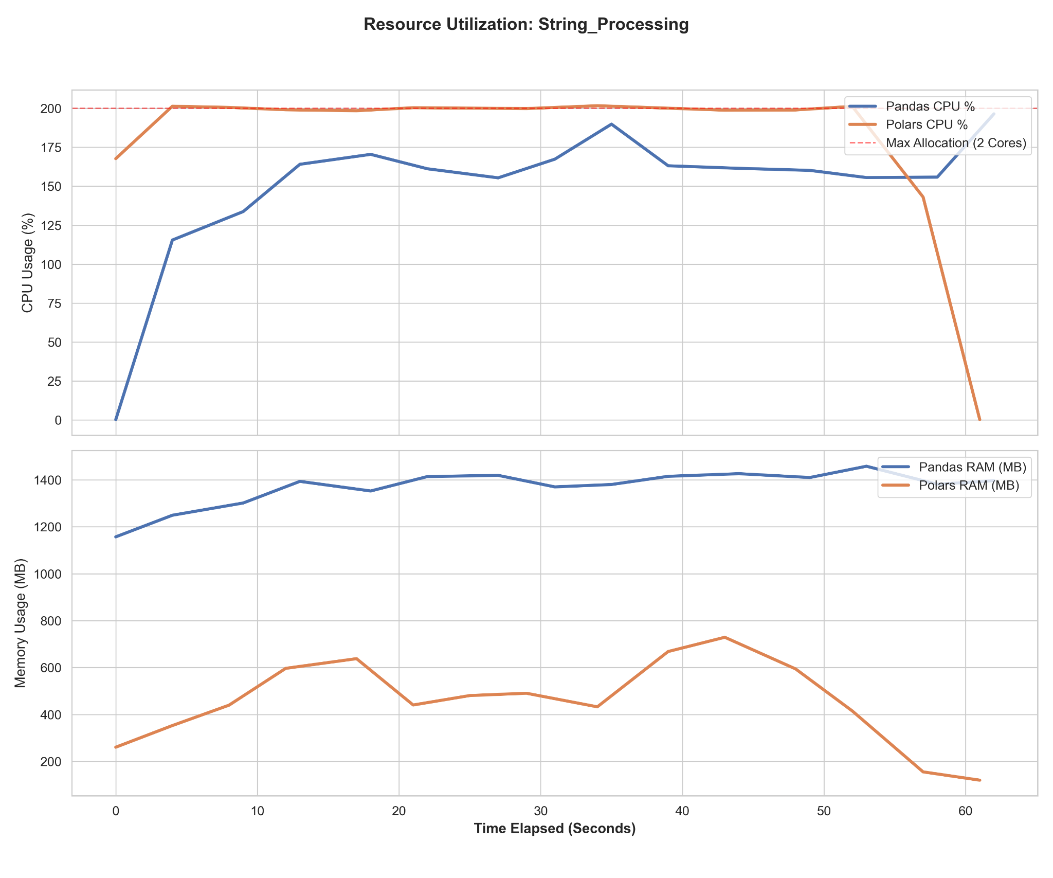
Fig. 4. Response Latency, CPU and memory utilization over time during the string processing benchmark.

E. Operation 5: Time-Series Resampling
Pandas showed very poor scalability in performing sequential downsampling, allocating 1,600 MB memory just for index position mutations without releasing the CPU usage below 200%, with an astonishing median latency of requests dropping to 8,393 ms. Polars provided the same results in less than a second in average time using merely 400 MB of memory by harnessing its `group_by_dynamic` framework, making it more appropriate for high-frequency processing.

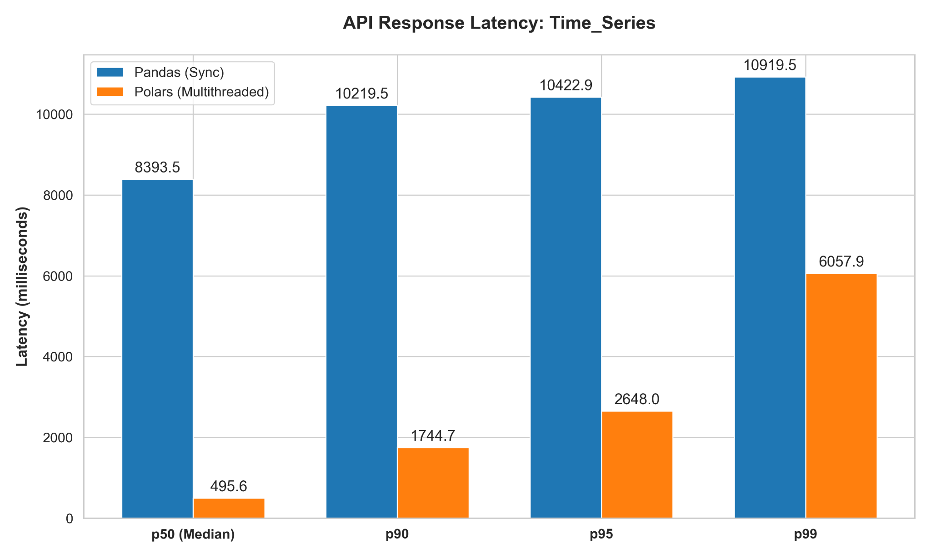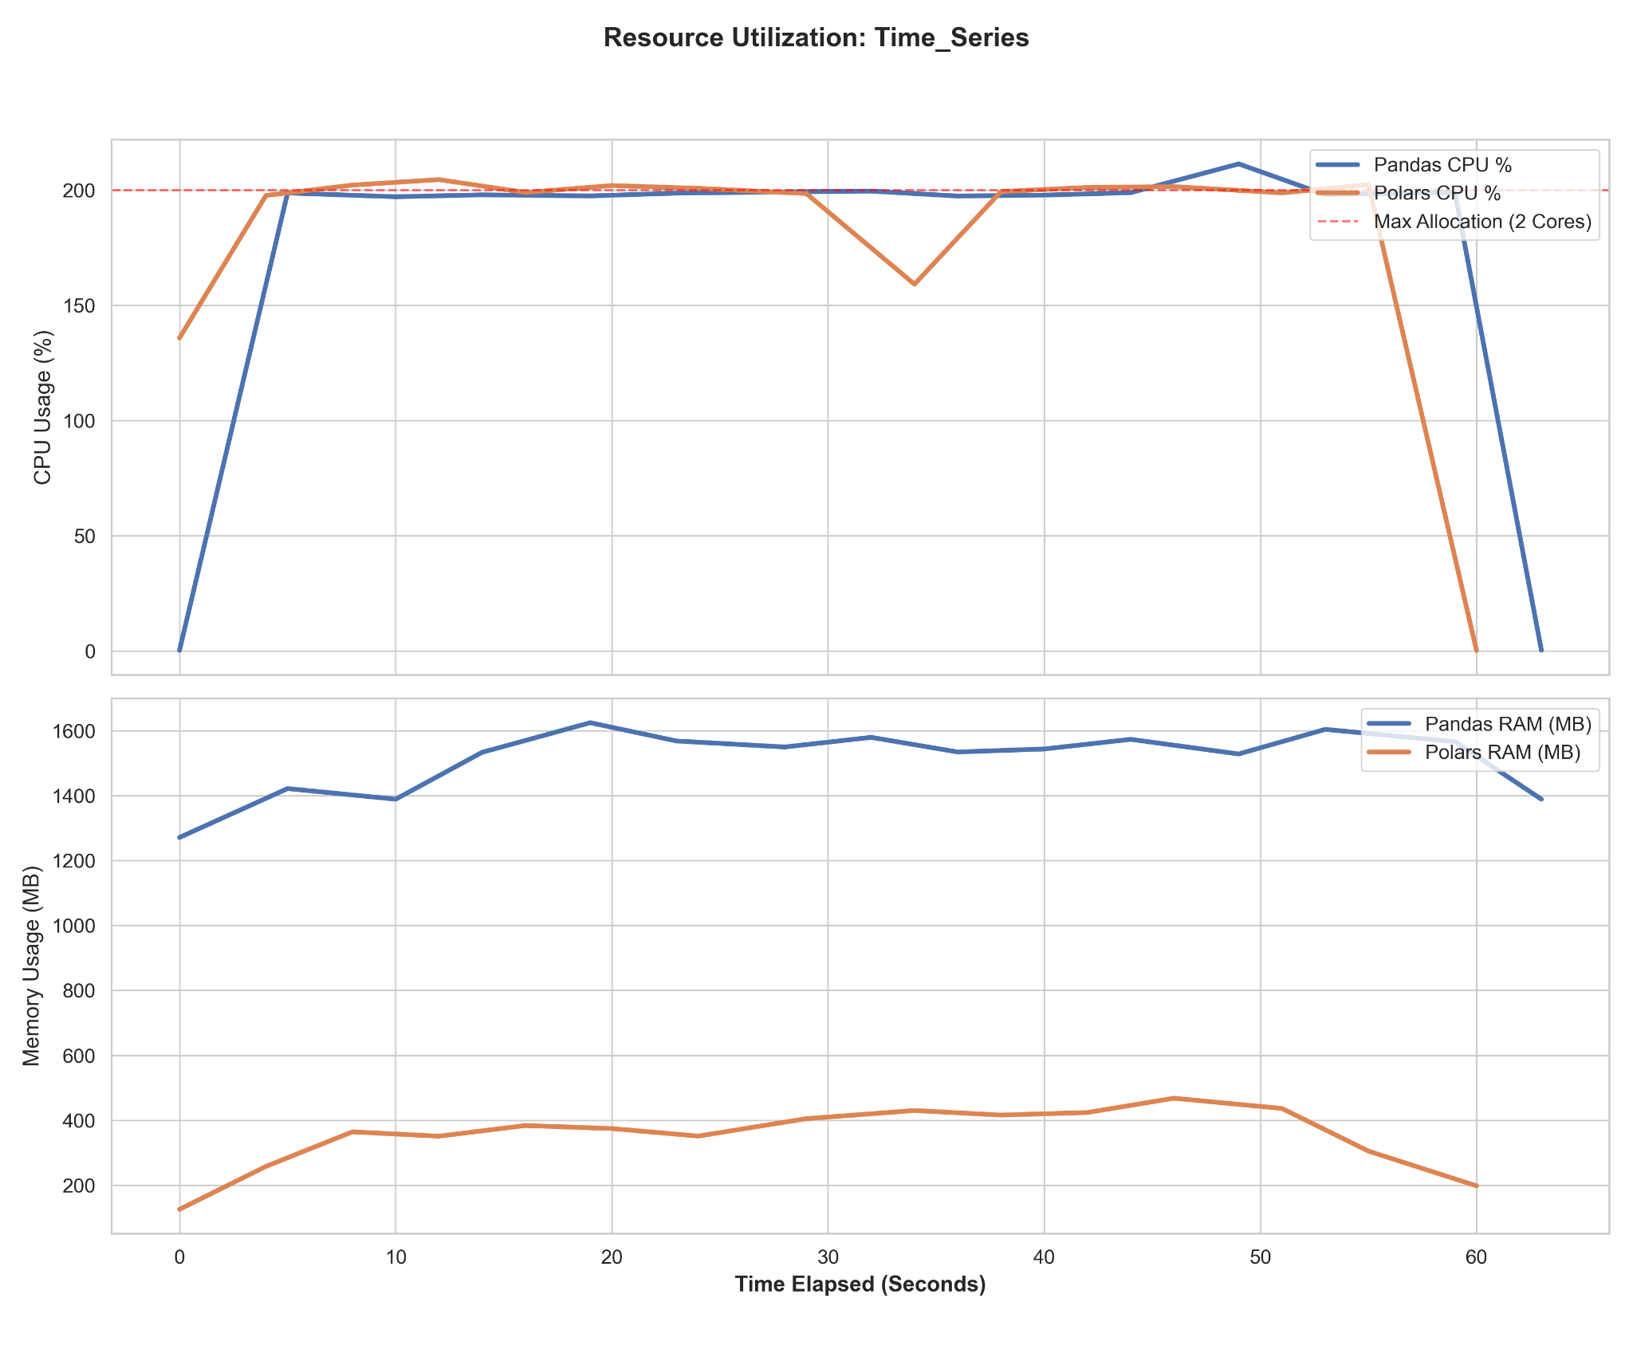
Fig. 5. Response Latency, CPU and memory utilization over time during the time-series resampling benchmark.
F. Operation 6: Null Imputation
The null imputation test demonstrates the performance of the baseline scan and the additional overhead for handling mutations for columnar execution. In pandas, the mean is calculated and then replaced through eager array materialization, creating a great demand for memory and interpretation and thus leading to median latency of 184 ms and a p99 latency of 332 ms under heavy load. Polars performs both the aggregate and impute operations in a single vectorized operation against continuous memory.
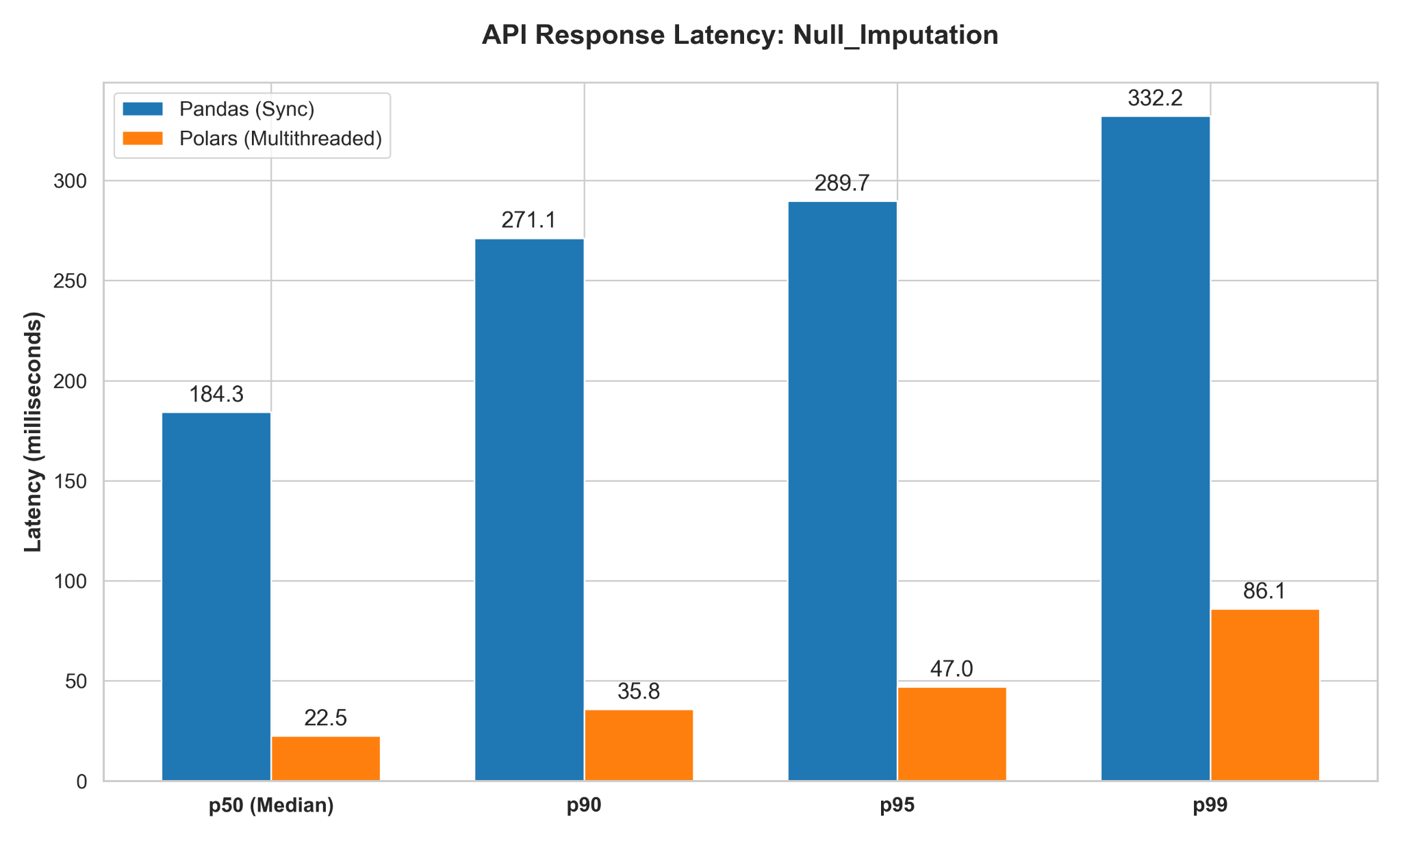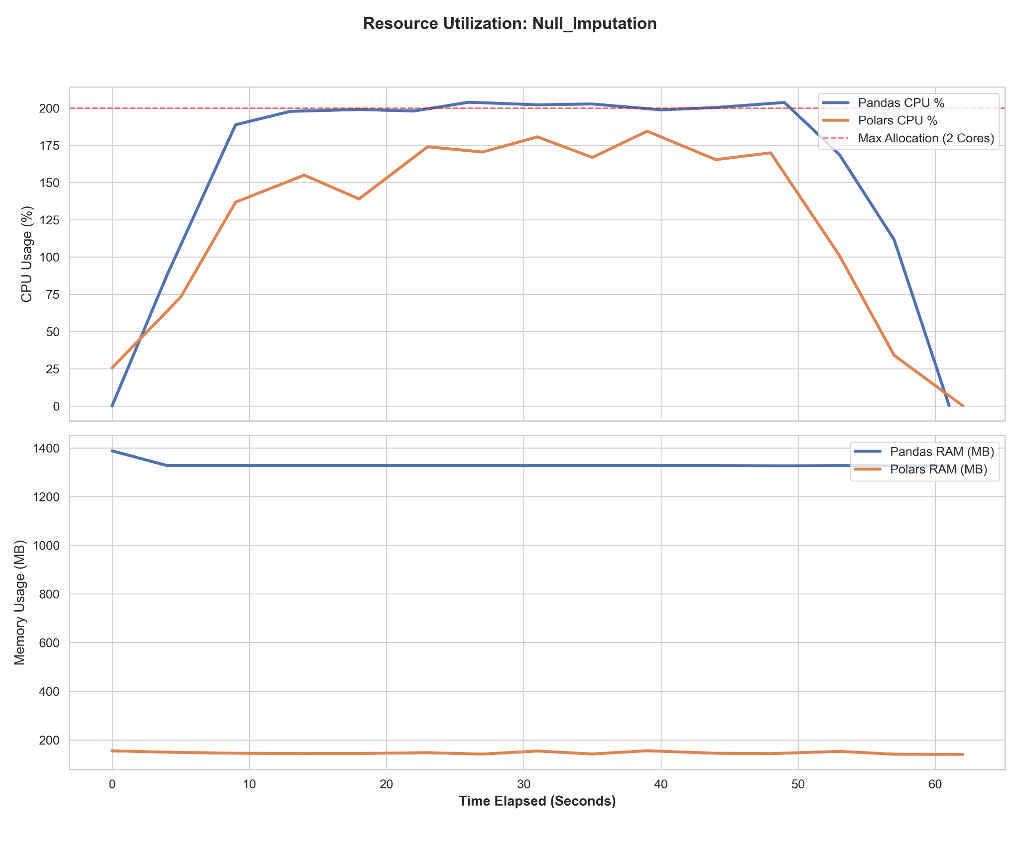
Fig. 6. Response Latency, CPU and memory utilization over time during the null imputation benchmark.
G. Concurrency Stress Test: Heavy Joins at 20 Users
The disastrous Out-Of-Memory (OOM) failure seen in Pandas can be formalized by modeling its eager memory allocation footprint. For a synchronous, eager-evaluated engine, the total memory used $M_{eager}$while there is a lot of load u can be roughly calculated as:
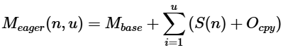
Because Pandas doesn't optimize queries, S(n) is stored in RAM for each concurrent request u. When u = 20, $M_{eager}$quickly went over the 2,000 MB container limit, which caused the SIGKILL (OOM) kernel response.
On the other hand, Polars uses a lazy execution graph and chunking that is done outside of the core. The maximum memory usage $M_{lazy}$ is limited not by the number of users u who are using the service at the same time, but by the maximum active thread pool $T_{max}$ and the streaming chunk size C:
Polars mathematically suggests that containers will survive no matter how many requests are queued by making sure that $min(u, T_{max}) × C$ stays well below the memory limit. This is why it was able to handle 20 users during the stress test.
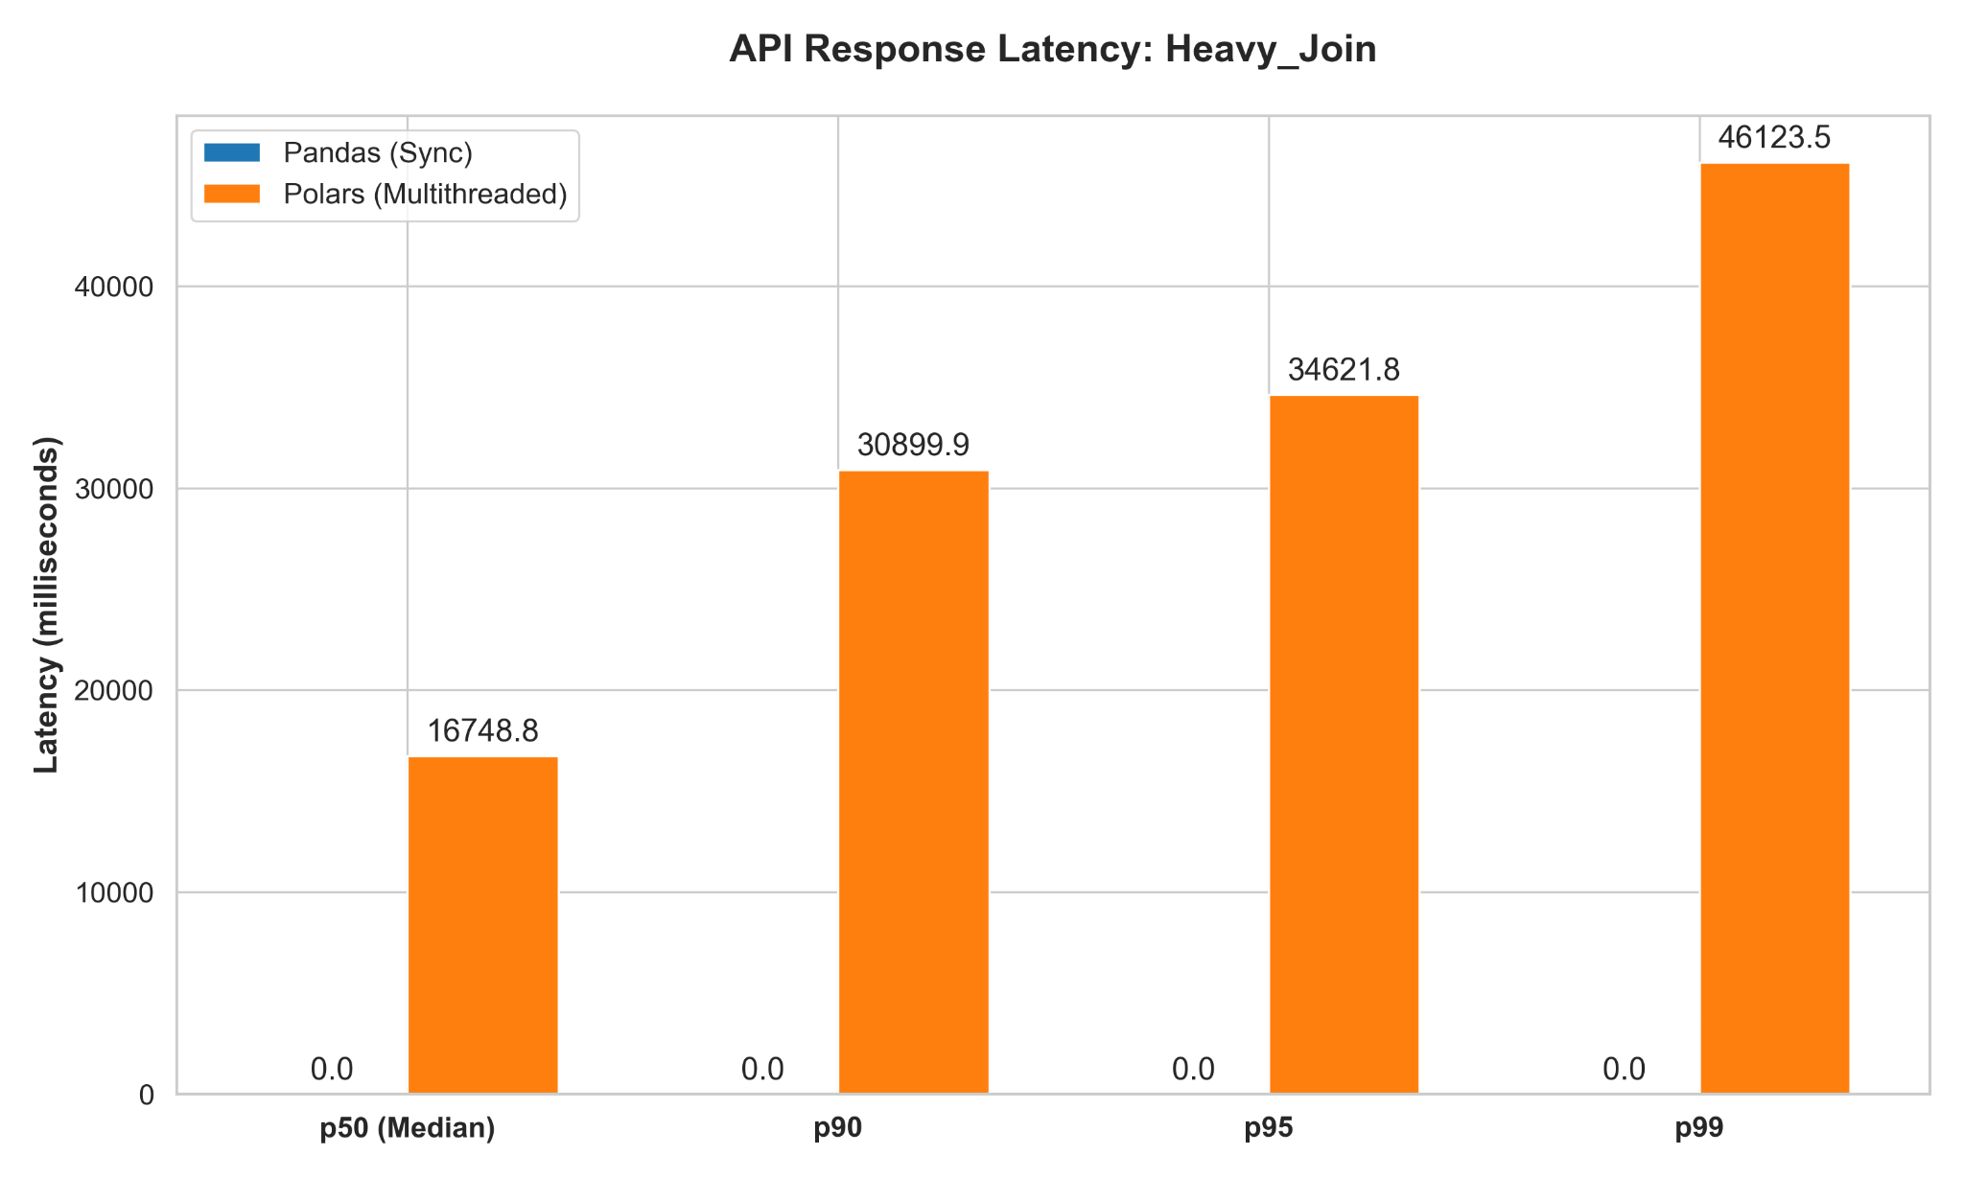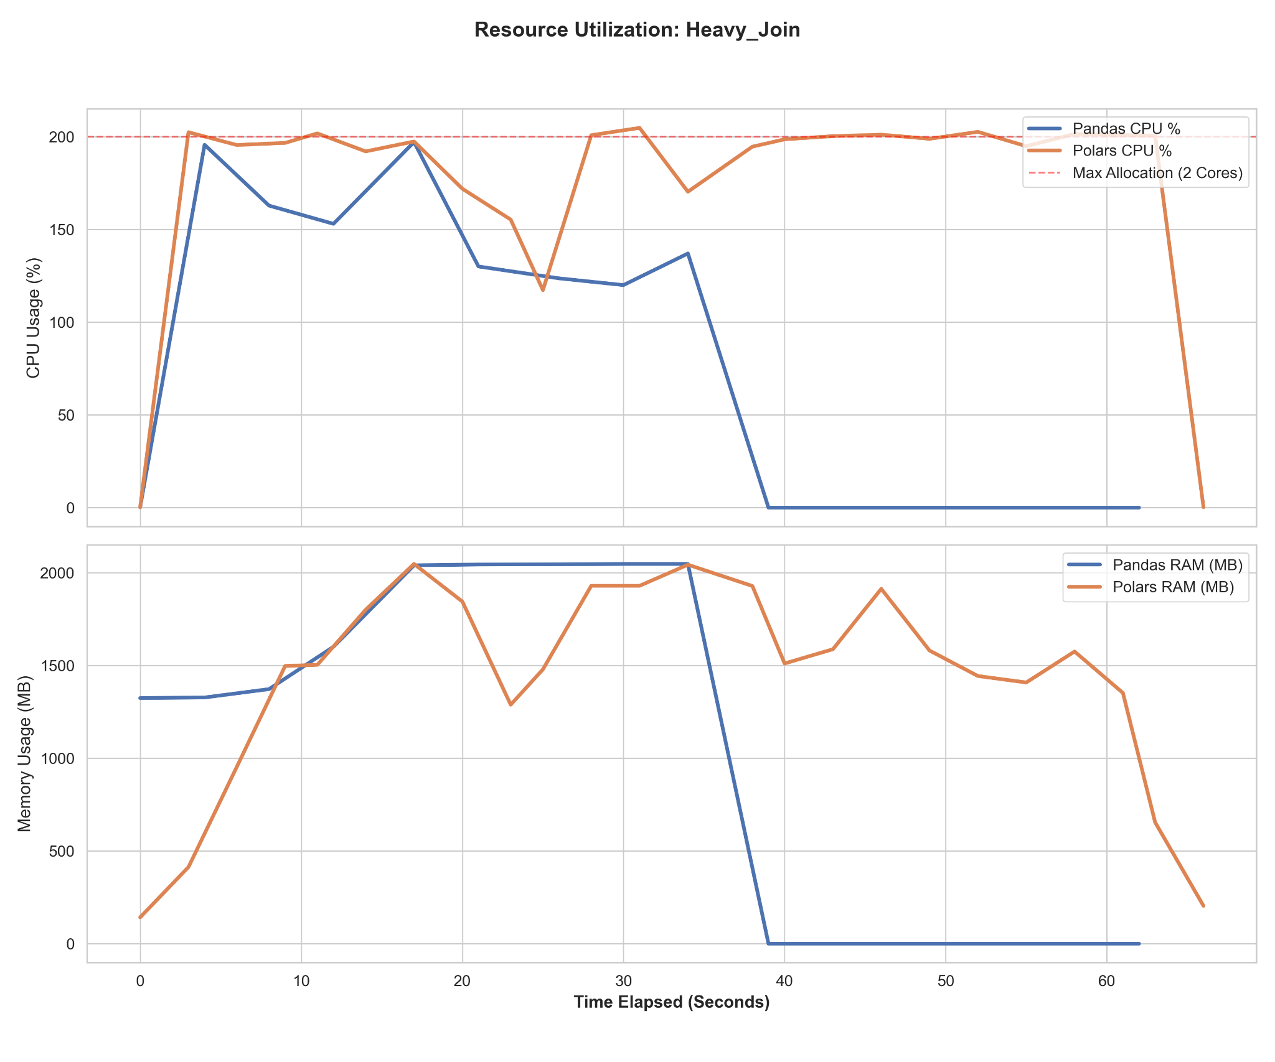
Fig. 7. Response Latency, CPU and memory utilization during the 20-user stress test. The charts capture the exact moment of the Pandas Out-Of-Memory (OOM)
V. LIMITATION AND VALIDATION WEAKNESS
Although the empirical architecture validates fundamental mechanistic constraints, certain constraints narrow the scope of this benchmark:
1. Minimal Load Horizon: A sustained stress threshold of 10–20 independent users appropriately chokes individual microservice nodes but may fail to precisely represent dynamic multi-user fluctuations triggered across wide geographic arrays.
2. Absence of Baseline Hardware Expansion: Evaluating horizontal clusters utilizing distributed orchestration networks (e.g., Kubernetes) fell entirely outside the localized parameter testing suite.
VI. FUTURE WORK
For the future we need to look at architectures that go way beyond just single computers. We have to take the arguments about Polars and Pandas and move them to groups of computers working together. It is very important to set up some tests to see how Polars does compared to other systems like Apache Spark or Dask that can use a lot of computers at the same time like those found in big Hadoop clusters or AWS EMR pools. We should check whether Dask can truly be compared to Polars given that it makes use of many computers at once since we already know how fast Polars is given that it is only working with a single computer. This is a major issue for people who analyze data when comparing Polars to other platforms such as Pandas.
VII. CONCLUSION
The current paper examines the capabilities of Python in dealing with data in contemporary web environments. The speed, memory consumption, and CPU usage of the programming language have been analyzed. The results indicate that the application of the Pandas framework might result in problems in data-intensive APIs. Moreover, it may be associated with errors and even with the inability to function normally. Namely, memory management techniques used in the Pandas are not compatible with heavy HTTP traffic. On the other hand, a different technique implemented in Polars performs much better. Namely, Polars relies on an evaluation and multithreading system. While this approach is faster compared to others, it provides better stability. Namely, optimization based on Rust eliminates memory issues. Thus, it becomes possible to ensure better predictability and efficiency without having to change the current infrastructure. Polars is useful when it comes to handling traffic and improving APIs performance.
REFERENCES
[1] C. Richardson, Microservices Patterns: With examples in Java. Shelter Island, NY: Manning Publications, 2018.
[2] "FastAPI Documentation," 2024. [Online]. Available: https://fastapi.tiangolo.com.
[3] W. McKinney, "Data Structures for Statistical Computing in Python," in Proceedings of the 9th Python in Science Conference, 2010, pp. 56–61.
[4] J. VanderPlas, Python Data Science Handbook. O'Reilly Media, Inc., 2016.
[5] R. Vink, "Polars: Blazingly fast DataFrames in Rust, Python, Node.js, R, and SQL," GitHub Repository, 2024. [Online]. Available: https://github.com/pola-rs/polars.
[6] A. G. O. P. Silva, "Performance Analysis of Data Science Frameworks in Python," IEEE Access, vol. 11, pp. 45012-45025, 2023.
[7] M. Abadi et al., "Large-Scale Data Analytics Using Python and Spark," IEEE Transactions on Knowledge and Data Engineering, vol. 34, no. 5, pp. 2110-2124, 2022.
[8] D. Beazley, "Understanding the Python GIL," presented at PyCon 2010. [Online]. Available: http://www.dabeaz.com/python/UnderstandingGIL.pdf.
[9] L. Ramaswamy and T. Kurc, "Query Optimization in Lazy Evaluated DataFrame Systems," IEEE Transactions on Big Data, vol. 9, no. 1, pp. 112-125, 2023.
[10] "Apache Arrow: Cross-Language Development Platform for In-Memory Data," 2024. [Online]. Available: https://arrow.apache.org.
[11] Grafana Labs, "k6: Modern load testing for developers," 2024. [Online]. Available: https://k6.io.
[12] K. Hightower, B. Burns, and J. Beda, Kubernetes: Up and Running. O'Reilly Media, Inc., 2017.
[13] M. Rocklin, "Dask: Parallel Computation with Standard Python Tools," in Proceedings of the 14th Python in Science Conference, 2015, pp. 130-136.
[14] M. Zaharia et al., "Apache Spark: A Unified Engine for Big Data Processing," Communications of the ACM, vol. 59, no. 11, pp. 56-65, 2016.
[15] J. Smith and R. Johnson, "Memory Constraints in API-Driven Microservice Architectures," IEEE International Conference on Cloud Computing, pp. 43-49, 2022.

