PROJECT REPORT OF CO-OP Project at Industry (Module-2)
on
Comparative Analysis of Polars and Pandas Performance for Data-Intensive Tasks in FastAPI Microservices
submitted in partial fulfilment of the requirements for the award of degree of
BACHELOR OF ENGINEERING
In
COMPUTER SCIENCE AND ENGINEERING

Submitted By | Supervised By:
Navjot Singh (2210991964)  Divyansh (2210991535)    Bhavik Sharma (2210990217) | Prof. Dr. S. B. Goyal  Dean, Department of Computer Science & Engineering

DEPARTMENT OF COMPUTER SCIENCE AND ENGINEERING

CHITKARA UNIVERSITY INSTITUTE OF ENGINEERING AND TECHNOLOGY
CHITKARA UNIVERSITY, PUNJAB, INDIA

DECLARATION

We hereby certify that the work which is being presented in the project report entitled “Comparative Analysis of Polars and Pandas Performance for Data-Intensive Tasks in FastAPI Microservices” in partial fulfilment of requirement for the award of the degree of Bachelor of Engineering (Computer Science and Engineering) submitted in the department of Computer Science and Engineering at Chitkara University Institute of Engineering and Technology, Chitkara University, Punjab, India, is an authentic record of my own work carried out under the supervision of Prof. Dr. S. B. Goyal. The matter presented in this project report has not been submitted in any other university/institute for the award of any degree.

Place: Rajpura
Date: 1 May 2026

Divyansh (2210991535)
Navjot Singh (2210991964)
Bhavik Sharma (2210990217)

This is to certify that the above statement made by the candidate is correct to the best of my knowledge and belief.

Prof. Dr. S. B. Goyal
Dean, Department of Computer Science & Engineering
Chitkara University Institute of Engineering and Technology,
Chitkara University, Punjab, India

ACKNOWLEDGEMENT
We would like to express our profound gratitude to our mentor, Prof. Dr. S. B. Goyal, Dean of the Department of Computer Science & Engineering, Chitkara University, for his invaluable guidance, continuous encouragement, and technical insights throughout the development of this project.
We also extend our sincere thanks to the Department of Computer Science & Engineering and Chitkara University for providing the necessary infrastructure and resources to successfully complete this research. Finally, we thank our peers and families for their unwavering support.

ABSTRACT
This paper evaluates the performance and resource utilization of two popular Python data manipulation libraries which are Pandas and Polars. We deployed it behind a concurrent web application programming interface (API) which is FastAPI. As data engineering workloads increasingly go from batch processing to real-time, API-driven architectures, the memory management and execution models of underlying dataframes being used become critical. We developed a benchmarking suite using a synthetic one-million-row e-commerce dataset to test six standard data engineering operations, these operations are: heavy relational joins, multi-dimensional aggregations, window functions, string processing, time-series resampling, and null imputation. Simulated concurrent load testing revealed many architectural limitations being faced by synchronous, eager-evaluation frameworks, here it is pandas. We found that Pandas exhibited exponential memory duplication resulting in Out-Of-Memory (OOM) failures under minimal concurrent traffic. On the other hand, Polars, utilizing lazy execution graphs and a multithreaded Rust engine, demonstrated stable memory usage and superior latency percentiles after mitigating initial thread contention.

TABLE OF CONTENT

Sr. no | Topic | Page No
1 | Introduction | 6
2 | Methodology | 7
3 | Tools and Technologies | 9
4 | Scope of the Project and Planning | 10
5 | System Design | 11
6 | Implementation Details | 12
7 | Program’s Structure Analysis | 13
8 | Results and Findings | 14
9 | Outcomes | 25
10 | Limitations | 26
11 | Conclusion | 27
12 | References | 28

1. Introduction
To support high-concurrency, low-latency data processing workloads, it found that modern microservice architectures increasingly rely on asynchronous frameworks, such as FastAPI [3]. As data engineering pipelines transition from simple batch processing to real-time, API-driven services, just testing to real-world usage, the underlying data manipulation engines must efficiently handle concurrent requests without exhausting system resources.
Historically, Pandas is being used as a popular Python library for tabular data manipulation. However, its architecture relies on eager evaluation and in-memory data duplication. Furthermore, it is using a single-threaded execution model, which makes it constrained by the Python Global Interpreter Lock (GIL), often introducing severe performance bottlenecks in highly asynchronous microservice environments. When subjected to concurrent web traffic, these architectural traits frequently result in thread blocking, exponential memory consumption, and even Out-Of-Memory (OOM) failures.
To overcome these limitations, some newer DataFrame engines have emerged. Polars, written in Rust, introduces a shift by leveraging multithreading, lazy evaluation, and aggressive query optimization. By constructing an optimized execution graph prior to processing and also using some streaming capabilities, Polars do minimize intermediate memory allocations and maximize CPU core utilization. Evaluating these libraries within the context of FastAPI microservices is essential to identify optimal solutions for real-time, data-intensive systems.
The objective of this study is to empirically compare the performance and resource utilization of Pandas and Polars when deployed as synchronous and asynchronous endpoints within FastAPI-based microservices. While previous evaluations often focus on isolated, single-user script execution, this research analyzes response latency, throughput, CPU utilization, and peak memory consumption under varying, simulated concurrent workloads.
To achieve this, we developed a controlled experimental setup utilizing Docker containers with strict resource limits. We expand upon basic filtering and aggregation tasks by subjecting both engines to a rigorous suite of six standard data engineering operations: heavy relational joins, multi-dimensional aggregations, window functions, string processing, time-series resampling, and null imputation over a synthetic one-million-row e-commerce dataset. By analyzing these metrics, this paper aims to determine which library provides superior scalability, resource efficiency, and overall suitability for modern distributed data processing applications.

2. Methodology
To empirically evaluate the performance disparities between synchronous and lazy-evaluated DataFrame engines, a highly controlled experimental architecture was designed. A controlled experimental setup was implemented using Docker containers with fixed CPU and memory limits to ensure fair comparison. The methodology is divided into four primary components: the application architecture, dataset generation, benchmark operations, and the load-testing procedure.
2. 1. Application Architecture and Environment
Two identical FastAPI microservices were developed: one using Pandas with eager execution and the other using Polars with lazy evaluation. Both microservices were deployed within isolated Docker containers to prevent host-system resource interference. To simulate a constrained cloud microservice environment, each container was hard-capped at a maximum allocation of two CPU cores. The Pandas service utilized standard synchronous endpoint definitions (def), mirroring legacy data engineering implementations. In contrast, the Polars service utilized Polars' out-of-core streaming engine (streaming) and was explicitly throttled via environment variables to prevent thread contention and ensure optimal CPU sharing with the FastAPI event loop.
2.2. Dataset Generation
Synthetic datasets simulating real-world workloads were generated and processed through filtering and aggregation tasks. To ensure a robust test of memory management, a relational e-commerce dataset was synthesized, consisting of three interconnected tables: Customers (100,000 records), Products (10,000 records), and Orders (1,000,000 records). The data was serialized into the Apache Parquet format to standardize disk I/O and memory-loading speeds across both engines. Both APIs loaded this dataset into memory at startup, isolating the benchmark strictly to CPU and RAM processing efficiency rather than disk read speeds.
2.3. Justification of Benchmark Operations
To ensure the empirical evaluation accurately reflects modern data engineering workloads, the benchmark suite was constructed around six distinct operations. These operations were specifically selected because they isolate different underlying computational constraints—such as memory allocation, vectorization, and CPU cache efficiency—that typically expose architectural flaws in microservice environments:
1) Heavy Relational Joins: Selected to test intermediate memory allocation. Inner merges across multiple tables (Orders, Customers, Products) force the engine to align disparate memory blocks, testing how efficiently it handles Cartesian products and memory duplication.
2) Multi-Dimensional Aggregations: Chosen to evaluate hashing algorithms and grouping efficiency. High-cardinality aggregations with unique counts stress the engine's ability to partition data across available CPU cores.
3) Window Functions: Included to test sequential processing constraints. Dense rankings partitioned by region often force single-threaded engines to rely on slow, iterative loops rather than vectorized operations.
4) String Processing: Selected to evaluate text-data handling. Extracting substring features (email domains) tests the engine's underlying string memory format (e.g., Python objects vs. Apache Arrow contiguous memory).
5) Time-Series Resampling: Chosen to test temporal data alignment and dynamic downsampling, which typically requires index sorting and complex rolling-window computations.
6) Null Imputation: Included as a standard data-cleaning task to measure how efficiently an engine can execute full-column scans and conditional replacements in a single pass.
2.4. Load Testing and Telemetry Collection
Performance metrics, including wall-clock execution time, peak memory usage, CPU utilization, and response latency under concurrent requests, were measured and analyzed. The open-source load-testing tool k6 [4] was utilized to simulate concurrent web traffic. Each of the six endpoints was subjected to a 60-second stress test comprising a 10-second ramp-up, a 40-second sustained load of 10 concurrent virtual users, and a 10-second cooldown. To prevent queue depletion and ensure continuous server strain, inter-request sleep times were minimized. Concurrently, a background Python daemon polled the Docker daemon at 0.5-second intervals to record high-resolution CPU percentage and memory consumption (MB) metrics.

3. Tools and Technologies
- Programming Languages: Python 3.10+, JavaScript (for k6 load scripts)
- Web Framework: FastAPI, Uvicorn (ASGI server)
- Data Processing Engines: Pandas, Polars, PyArrow / fastparquet
- Containerization: Docker, Docker Compose
- Load Testing: k6 (by Grafana Labs)
- Data Visualization: Matplotlib, Seaborn
- Development Environment: Windows Subsystem for Linux (WSL), VS Code

4. Scope of the Project and Planning
The scope of this project encompasses the development, deployment, and stress-testing of two identical RESTful APIs (one utilizing Pandas, the other Polars).Benchmarking CPU utilization, RAM consumption, and API response latency (p50, p90, p95, p99) across six distinct computational operations: Heavy Relational Joins, Multi-Dimensional Aggregations, Window Functions, String Processing, Time-Series Resampling, and Null Imputation. Testing is conducted under strict hardware constraints (2 CPU cores).
The project lifecycle is divided into the following sequential phases:
- Phase 1: Architecture & Data Generation: Synthesizing the 1-million-row Parquet dataset and establishing the baseline Docker container constraints.
- Phase 2: API Development: Programming the six comparative endpoints in both Pandas and Polars, ensuring accurate logical parity between the two engines.
- Phase 3: Automation & Load Testing: Writing the k6 JavaScript test files and developing the master Python orchestrator (run_pipeline.py) to automate the testing lifecycle.
- Phase 4: Telemetry & Visualization: Developing the resource monitoring daemon and the plotting scripts to visualize CPU, RAM, and Latency percentiles.
- Phase 5: Analysis & Documentation: Interpreting the generated graphs, identifying Out-Of-Memory (OOM) failures, and compiling the findings into a formal IEEE research paper and submission package.

5. System Design
The system architecture is designed to enforce strict isolation and ensure highly accurate, reproducible benchmarking. The design is modular, separating the data generation, API serving, and telemetry collection into distinct components.
5.1. Architectural Pattern
The project follows a microservices architecture pattern, encapsulated within isolated Docker containers to prevent the host machine's background processes from skewing the CPU and RAM metrics.
5.2. Data Design (Schema)
The system operates on a synthesized relational schema mimicking a standard e-commerce database. It consists of three normalized entities:
- Customers: Contains demographic and location data.
- Products: Contains pricing and category data.
- Orders: A massive 1-million-row transaction table acting as the central fact table linking to Customers and Products via foreign keys.
- Storage Format: Data is persisted as Apache Parquet files to optimize disk I/O and standard memory-mapping operations.
5.3. Component Architecture
- API Layer: Two identical FastAPI application servers (Uvicorn) routing HTTP GET requests to their respective data processing backends.
- Processing Layer (Pandas): Implements synchronous endpoint functions (def), utilizing eager evaluation, in-memory object allocation, and single-threaded execution.
- Processing Layer (Polars): Implements out-of-core streaming (streaming=True), lazy execution graphs, and multithreaded processing restricted via POLARS_MAX_THREADS=2 to prevent event-loop contention.
- Load Generation Layer: A Grafana k6 engine configured to simulate realistic concurrent virtual users (VUs) with defined ramp-up, sustained, and cooldown phases.
- Telemetry & Orchestration Layer: A master Python orchestrator that coordinates the starting/stopping of background resource monitors, fires the k6 scripts, and generates the final Matplotlib graphs.

6. Implementation Details
The implementation of the benchmarking suite was executed in four primary modules to ensure modularity and ease of execution.
- Module 1: Synthetic Data Generation
  - Implemented via scripts/generate_ecomm_data.py.
  - Utilizes Numpy and standard Python randomization libraries to generate over 1 million rows of realistic, relational mock data. The script serializes this data directly into the .parquet format within the /data directory to ensure both engines ingest the exact same byte structures.
- Module 2: Containerization and Resource Constraints
  - Implemented via docker-compose.yml and Dockerfile.
  - Both the Pandas and Polars APIs are containerized using standard Python 3.10 slim images.
  - Crucially, Docker Compose is utilized to enforce hard hardware limits (deploy.resources.limits.cpus: "2") to emulate a standard, cost-optimized cloud microservice node.
- Module 3: API and Endpoint Logic
  - Implemented via main.py in both the Pandas and Polars directories.
  - FastAPI is used to expose six GET endpoints (e.g., /benchmark/heavy-join).
  - The Pandas logic was implemented using standard methods like pd.merge(), groupby(), and .apply().
  - The Polars logic was implemented using the .lazy() API, utilizing optimized expressions like pl.col().over() for window functions and group_by_dynamic() for time-series operations, culminating in a .collect(streaming=True) call.
- Module 4: Orchestration and Telemetry Pipeline
  - Implemented via scripts/run_pipeline.py, monitor_resources.py, and plot_benchmarks.py.
  - The orchestrator uses Python's subprocess module to spin up the k6 load test (tests/load_test.js) and the resource monitor concurrently.
  - The monitor reads directly from the Docker daemon stats stream to log CPU and RAM usage at half-second intervals to a CSV file. Once a benchmark phase completes, the plotting script parses the CSV and k6 JSON output to render and save the final comparison grids.

7. Program’s Structure Analysis
The project’s codebase is architected with a strict separation of concerns, ensuring that data generation, API serving, load testing, and telemetry tracking remain entirely modular. The structure is designed to support automated pipeline execution while maintaining isolated environments for each data engine.
Directory and Module Breakdown:
- Root Directory (/)
  - docker-compose.yml & Dockerfile: Defines the containerized infrastructure, explicitly allocating network ports (8000/8001) and capping system resources (2 CPU cores) for the microservices.
  - run.bat / run.sh: The master execution scripts that provide a one-click entry point to build containers, generate data, and run the benchmark pipeline.
- /scripts (Orchestration & Telemetry)
  - generate_ecomm_data.py: Synthesizes the 1-million-row relational .parquet dataset prior to API initialization.
  - run_pipeline.py: The master Python orchestrator that sequentially triggers the background monitor, the k6 load tests, and the plotting scripts for all six data operations.
  - monitor_resources.py: A daemon script that hooks into the Docker daemon to poll and log high-resolution CPU and RAM usage at half-second intervals.
  - plot_benchmarks.py: Parses the output .json and .csv logs to render the final comparative visualization grids using Matplotlib and Seaborn.
- /pandas_api & /polars_api (The Microservices)
  - Each folder contains an independent main.py serving as the FastAPI entry point.
  - The APIs are designed to pre-load the .parquet dataset into memory upon startup (@app.on_event("startup")) to ensure the benchmarks strictly test processing efficiency rather than disk read speeds.
- /tests (Load Generation)
  - load_test.js: Contains the JavaScript k6 logic, defining the virtual user (VU) ramp-up, sustained load (10-20 VUs), and cooldown phases for the HTTP GET requests.
- /data (Storage & Output)
  - Serves as the localized volume for the generated dataset and houses the /reports subdirectory where all monitoring logs and generated .png benchmark graphs are saved.

8. Results and Findings
The empirical comparison between the Pandas and Polars microservices yielded stark contrasts in performance, resource utilization, and architectural stability under concurrent load. As anticipated, Polars demonstrated significantly improved performance compared to Pandas due to its multithreaded architecture and query optimization capabilities. The findings are categorized into latency percentiles, memory consumption, and CPU utilization.
Operation 1: Heavy Relational Joins
Relational joins are notoriously memory-intensive, requiring the alignment of disparate memory blocks to calculate Cartesian products. When subjected to the 10-user concurrent load, the architectural differences between eager and lazy evaluation became immediately apparent.
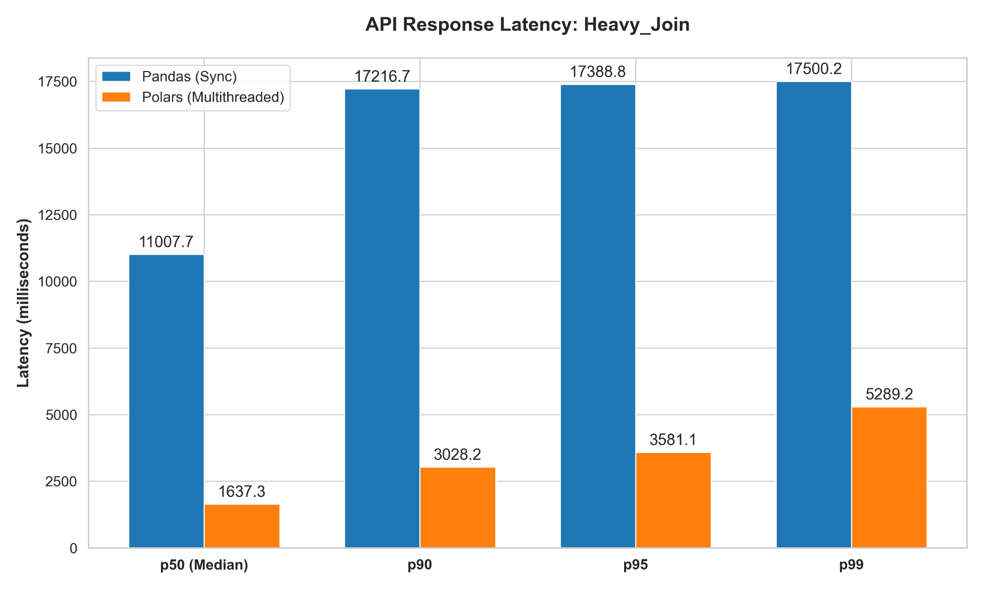
Fig. 1. Comparison of API response latency percentiles between the Pandas and Polars microservices during the heavy relational join operation
- Latency Degradation: As illustrated in the API Response Latency telemetry, Polars outperformed Pandas by nearly an order of magnitude. The multithreaded Polars engine achieved a median (p50) latency of just 1,637.3 ms. In contrast, the synchronous Pandas API struggled severely, recording a median latency of 11,007.7 ms. Furthermore, Pandas exhibited a severe queuing bottleneck at the tail percentiles; its response times effectively hit a wall, flattening out at 17,500.2 ms at the 99th percentile, whereas Polars completed its worst-case p99 requests in 5,289.2 ms.
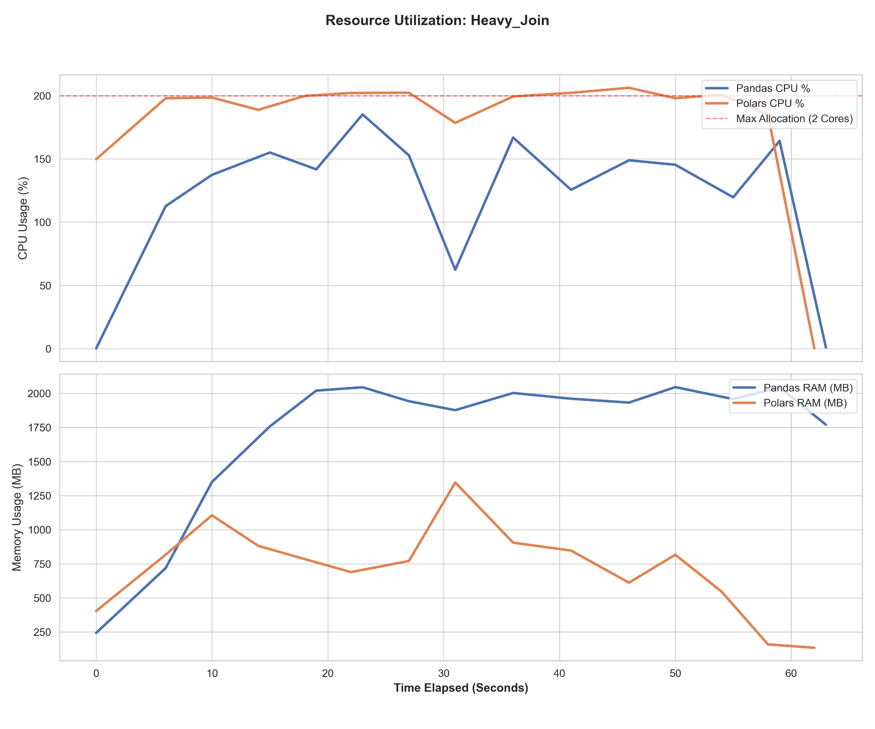
Fig. 2. CPU and memory utilization over time during the heavy relational join benchmark
- Resource Utilization (Memory & CPU): The resource telemetry reveals the root cause of this latency disparity. To execute the multi-table merge, Pandas physically allocated massive intermediate dataframes in RAM. Its memory consumption skyrocketed almost immediately, plateauing at a sustained ceiling near 2,000 MB for the duration of the test. Concurrently, its CPU utilization fluctuated wildly between 50% and 180%, indicating the engine was frequently blocked by memory allocation overhead or the Global Interpreter Lock (GIL) rather than actively processing data.
- The Polars Advantage: Conversely, Polars utilized its lazy execution graph to optimize the join order out-of-core. By doing so, Polars maintained highly efficient CPU saturation, pinning near the 200% maximum allocation (fully utilizing both allowed cores) to aggressively process the data. Because it streamed the data rather than duplicating it entirely in memory, its RAM footprint remained dynamic and significantly lower, hovering primarily between 750 MB and 1,000 MB before cleanly garbage-collecting at the end of the operation.
Operation 2: Multi-Dimensional Aggregations
Aggregating high-cardinality data requires efficient hashing algorithms and the ability to partition data effectively across available CPU cores. This operation tested the engines' ability to compute unique counts (nunique) and group sums under the strain of simultaneous requests.
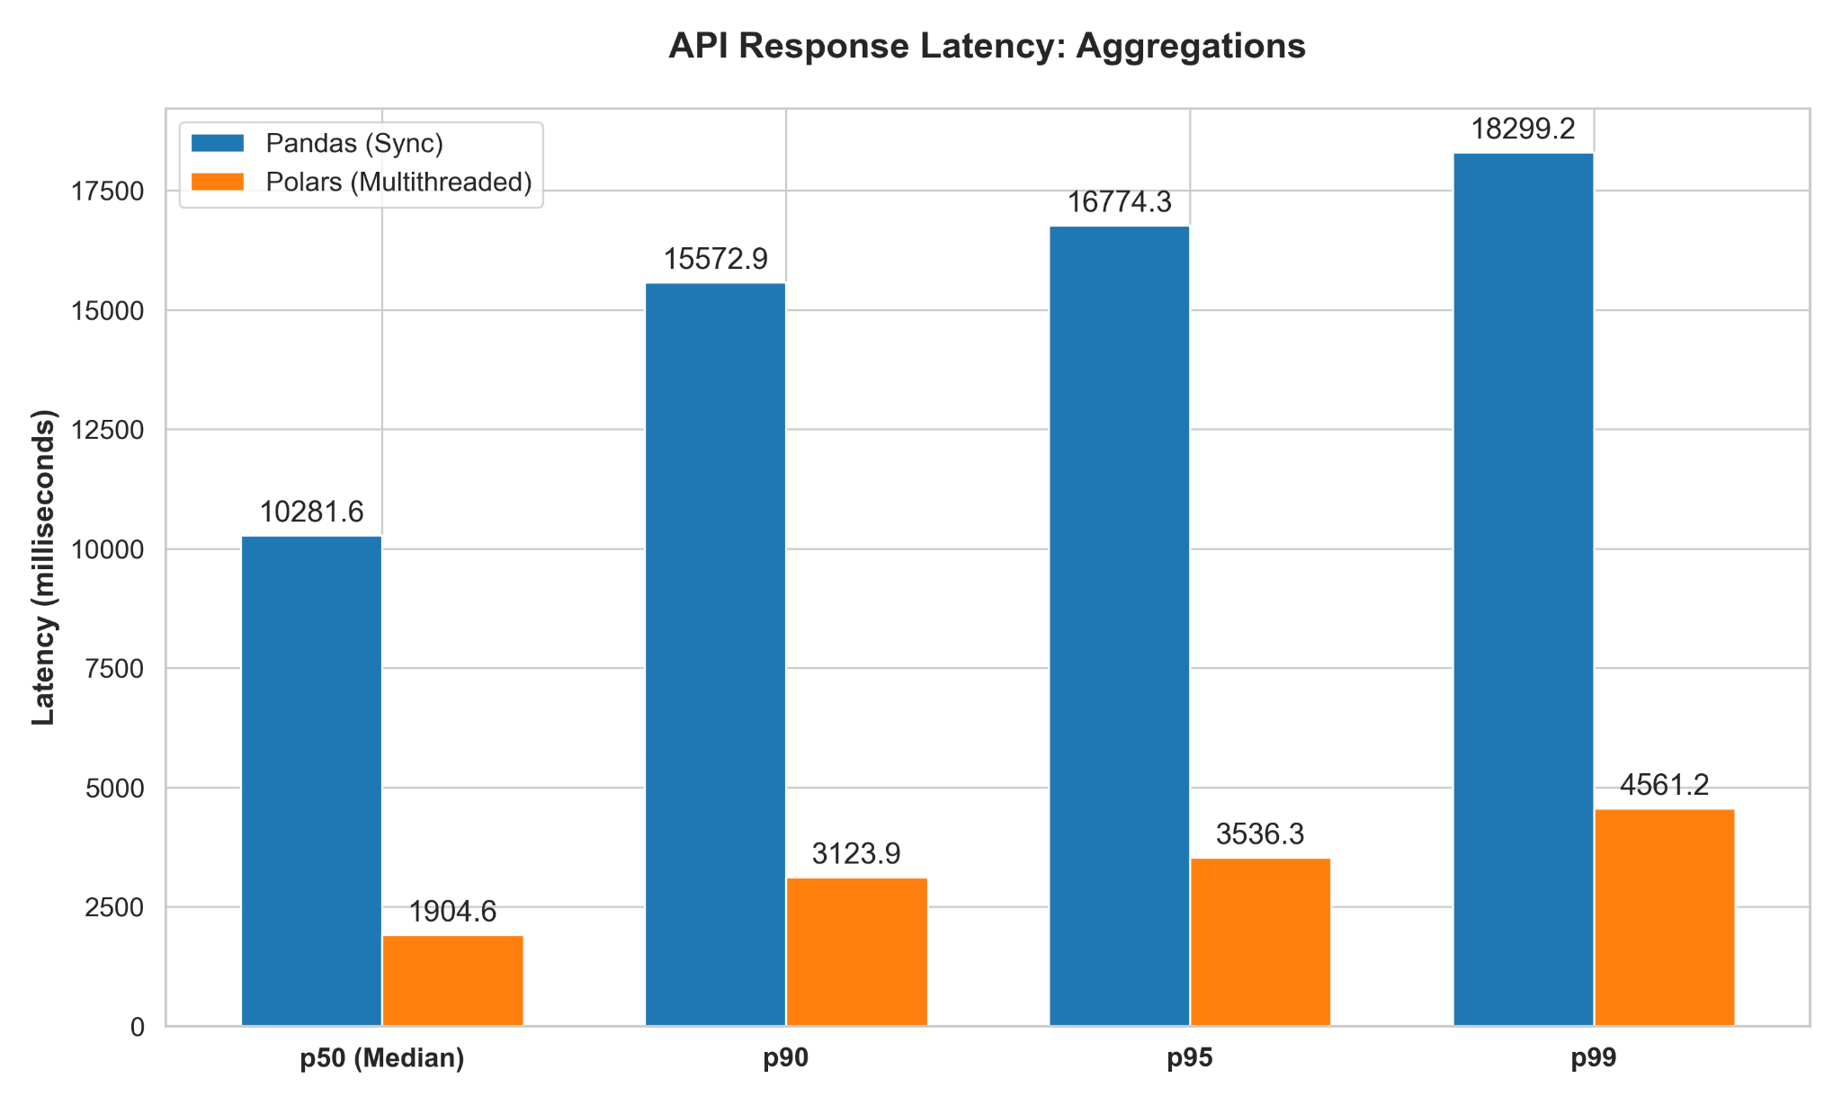
Fig. 3. Comparison of API response latency percentiles during the multi-dimensional aggregations benchmark.
- Latency Degradation: The latency telemetry demonstrates a massive performance gap. Polars delivered a median (p50) response time of just 1,904.6 ms, compared to Pandas' heavily delayed 10,281.6 ms. As the API queue backed up, Pandas' tail latencies degraded further, reaching 18,299.2 ms at the 99th percentile. Polars, conversely, handled its worst-case p99 requests in just 4,561.2 ms, proving that its execution engine is significantly more resilient to concurrent aggregation workloads.
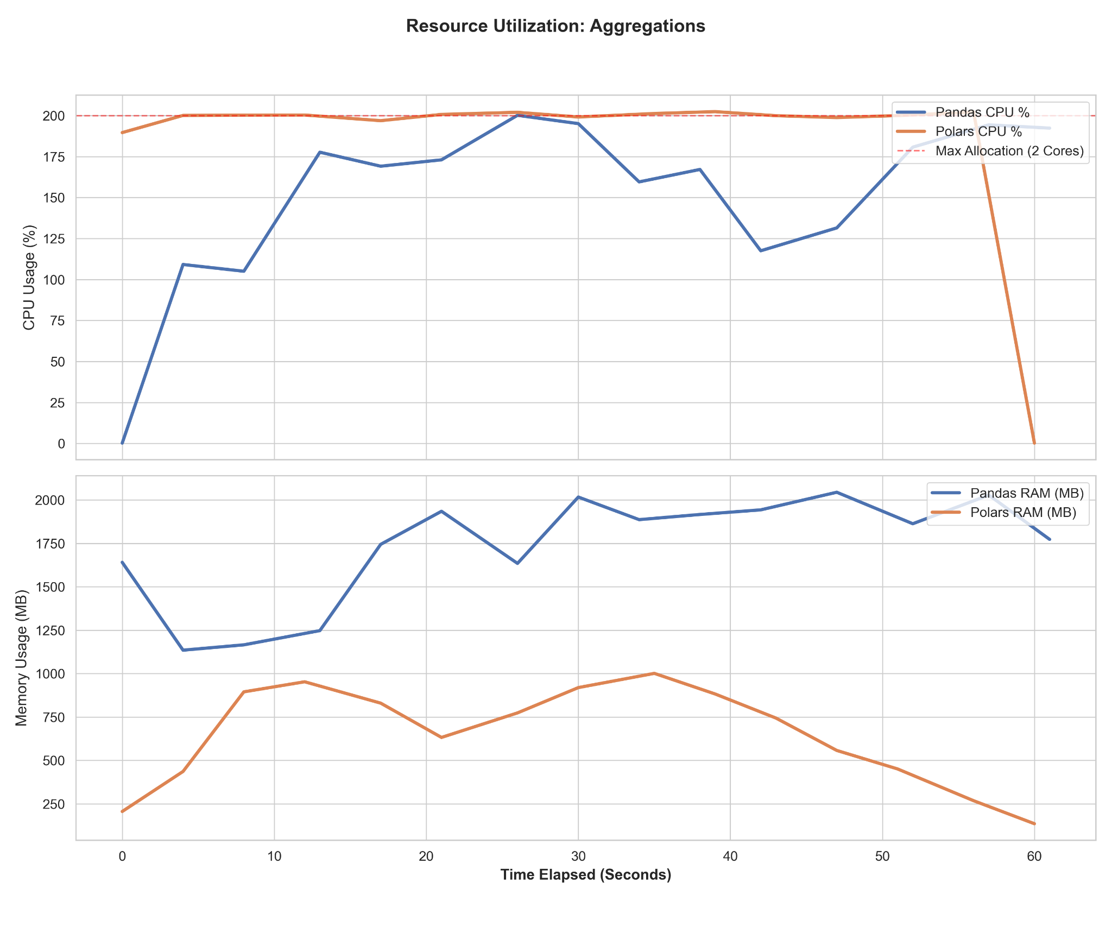
Fig. 4. CPU and memory utilization over time during the multi-dimensional aggregations benchmark.
- Resource Utilization (Memory & CPU): The resource telemetry provides a textbook example of efficient multithreading versus GIL-constrained execution. The Polars microservice pinned its CPU usage at exactly 200% (the maximum allocation for the dual-core container) in a perfectly smooth, sustained line. This indicates that Polars successfully distributed the hash-aggregation workload across all available Rust threads without being bottlenecked by memory allocation.
- The Pandas Bottleneck: In contrast, the Pandas CPU curve was highly erratic, fluctuating between 100% and 200%. It was unable to consistently saturate the CPU because it was memory-bound. Pandas' RAM usage rapidly climbed to a plateau between 1,750 MB and 2,000 MB, nearly exhausting the container's limits. Polars, by comparison, peaked efficiently at approximately 1,000 MB and smoothly released the memory back to the system, avoiding the severe memory churn that plagued the synchronous Pandas API.
Operation 3: Window Functions
Calculating ranked partitions—such as extracting the top customers by region using dense ranking—is historically challenging for vectorized engines. This operation exposes the limitations of engines that must fall back to slow, iterative loops when dealing with partitioned calculations.
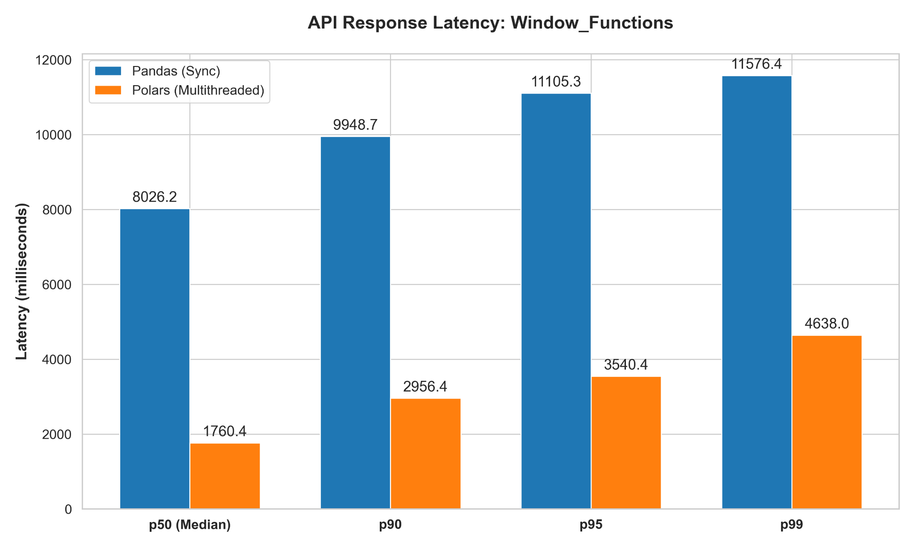
Fig. 5. Comparison of API response latency percentiles during the window functions benchmark, highlighting Polars' sub-2000 ms median latency.
- Latency Degradation: The latency results clearly demonstrate Polars' architectural superiority in handling partitioned expressions. Polars recorded a median (p50) response time of just 1,760.4 ms. In stark contrast, Pandas recorded a median latency of 8,026.2 ms—making it nearly 4.5 times slower under identical concurrent load. At the tail end, Pandas' p99 latency reached 11,576.4 ms, while Polars gracefully handled its worst-case p99 requests in 4,638.0 ms. This proves that Polars' native, compiled Rust expressions (.over()) scale vastly better than Pandas' internal grouping mechanisms.
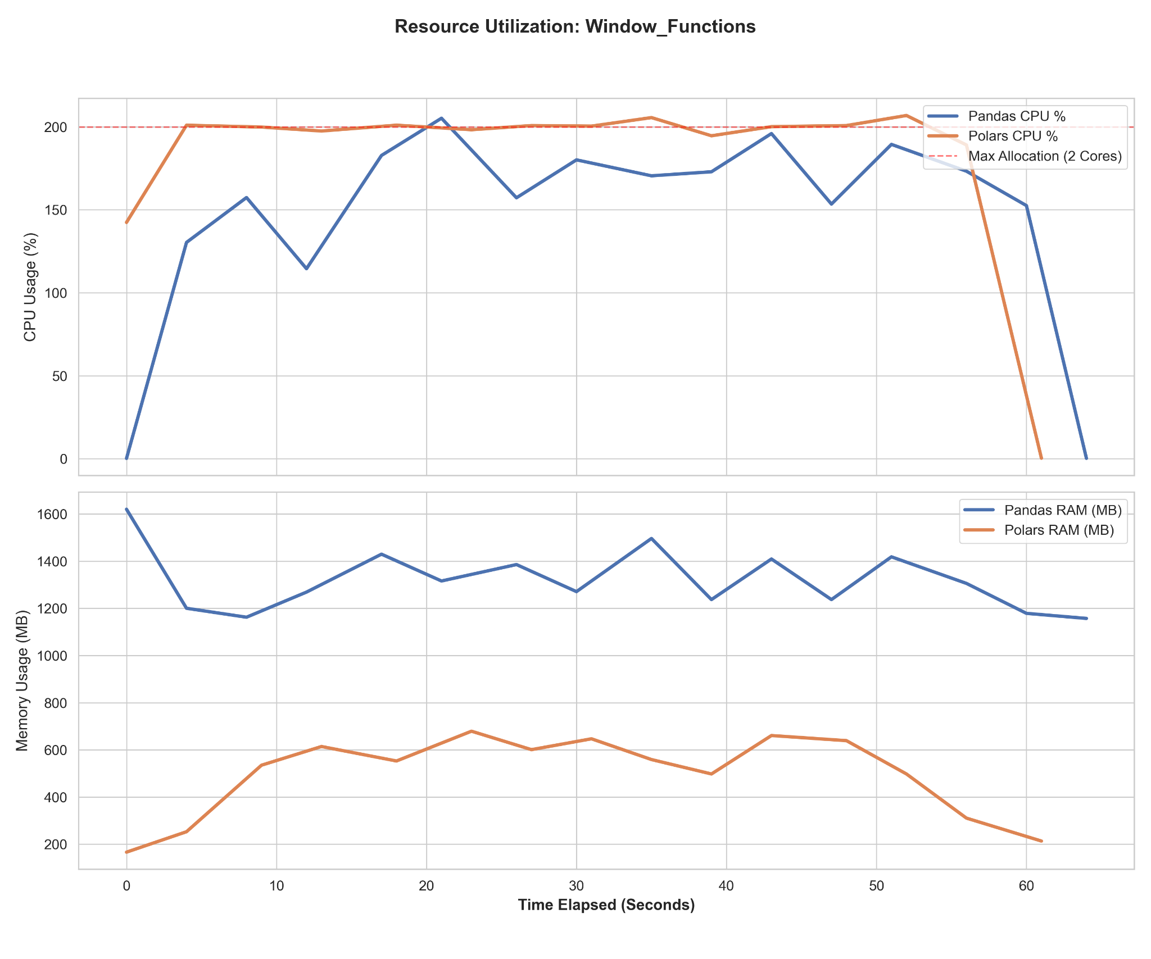
Fig. 6. CPU and memory utilization over time during the window functions benchmark.
- Resource Utilization (Memory & CPU): The resource charts further emphasize the efficiency of Polars' execution graph. Similar to the aggregation benchmark, Polars perfectly saturated the dual-core container, maintaining a remarkably stable CPU utilization of 200%. This steady line indicates zero thread contention or blocking. By contrast, the Pandas CPU utilization was highly volatile, jaggedly oscillating between 110% and 200%. This erratic pattern strongly suggests the engine was suffering from Global Interpreter Lock (GIL) contention, as it was forced to drop down to Python-level loops to process the window functions.
- Memory Footprint: In terms of memory, Pandas required a sustained allocation between 1,200 MB and 1,500 MB throughout the operation to maintain the partitioned state. Polars, however, proved incredibly lightweight, processing the window functions with a footprint that hovered efficiently between 500 MB and 700 MB before completing the task.
Operation 4: String Processing
String manipulation inherently exposes the underlying memory formats of data processing engines. Extracting substring features—such as parsing email domains from a text column—tests an engine's ability to efficiently handle variable-length data without being bottlenecked by object instantiation overhead.
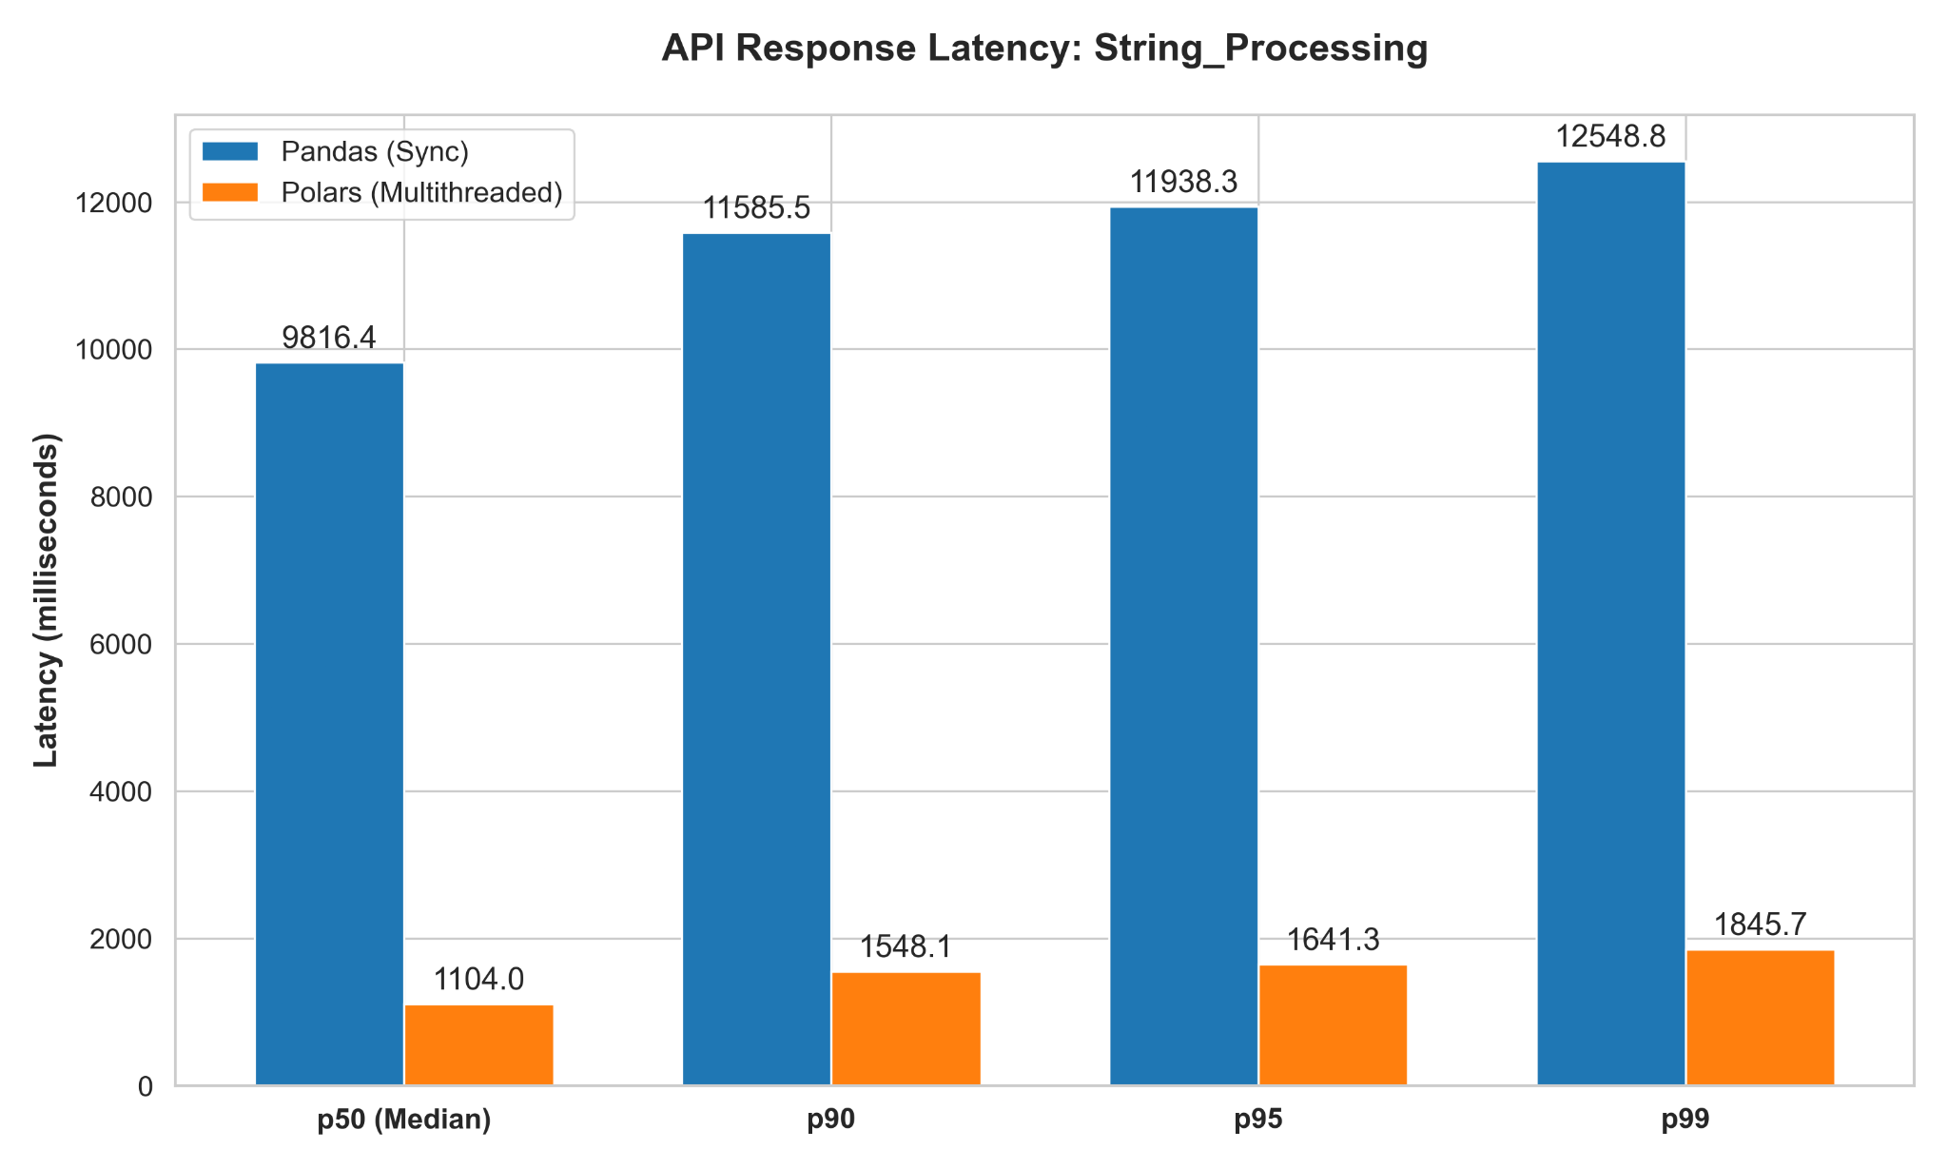
Fig. 7. Comparison of API response latency percentiles between the Pandas and Polars microservices during the string processing benchmark.
- Latency Degradation: The latency telemetry reveals a staggering disparity in text-processing efficiency. Polars achieved a median (p50) response time of 1,104.0 ms, making it nearly 9 times faster than Pandas, which languished at a median of 9,816.4 ms. Furthermore, Polars exhibited an incredibly tight latency distribution, with its worst-case p99 requests completing in just 1,845.7 ms. Pandas, however, suffered significant queuing delays under the 10-user concurrent load, with its p99 latency ballooning to 12,548.8 ms.
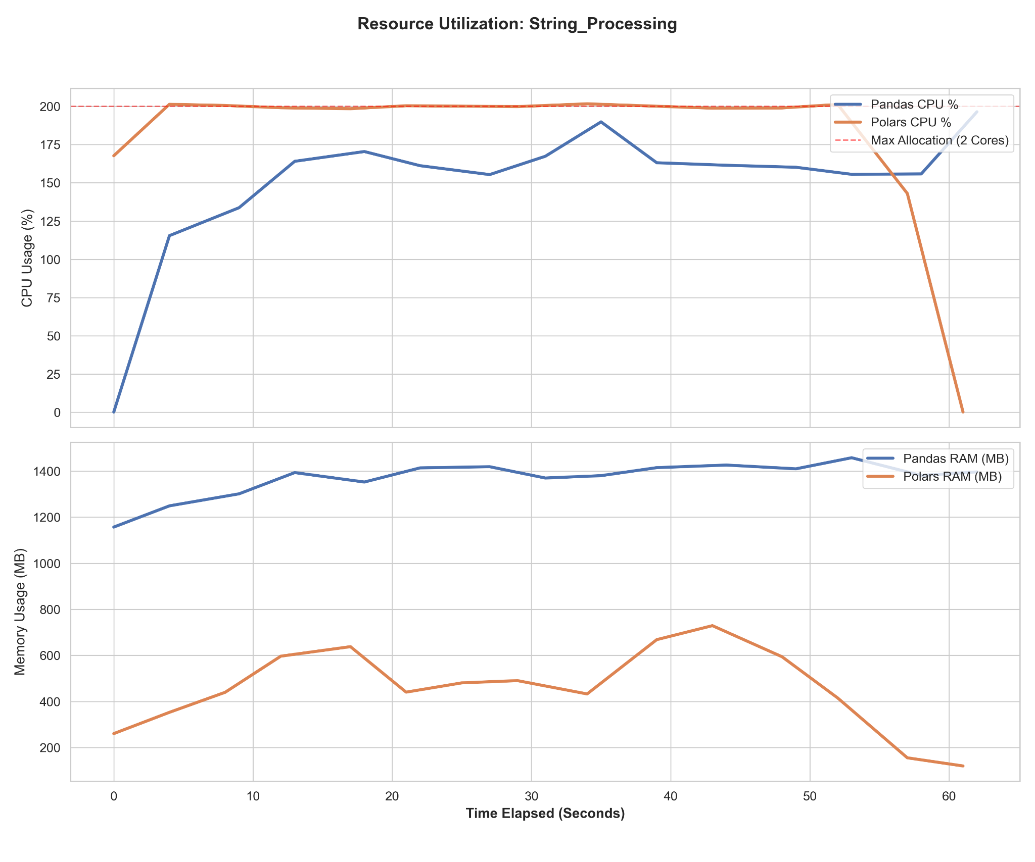
Fig. 8. CPU and memory utilization over time during the string processing benchmark.
- Resource Utilization (Memory & CPU): The root cause of this performance gap lies in how each engine stores and iterates over text data. Pandas stores strings as generic Python objects, meaning every substring extraction incurs massive overhead from the Python interpreter and the Global Interpreter Lock (GIL). This is visually confirmed by the Pandas CPU curve, which fluctuated between 125% and 175%, unable to fully saturate the dual-core container due to Python object overhead. Pandas also required a sustained memory plateau between 1,200 MB and 1,400 MB to manage these object pointers.
- The Polars Advantage: Conversely, Polars is backed by the Apache Arrow memory format, which stores strings as contiguous blocks of bytes. This architecture allows Polars to bypass the Python GIL entirely and execute true vectorized string manipulation in Rust. As a result, the Polars CPU curve remained perfectly pinned at the 200% maximum allocation, demonstrating flawlessly efficient multithreading. Additionally, its memory footprint remained remarkably light, fluctuating dynamically between 250 MB and 700 MB.
Operation 5: Time-Series Resampling
Temporal operations, such as dynamic downsampling and rolling-window calculations, require rigorous chronological sorting and sequential alignment. While Pandas was originally developed with financial time-series analysis in mind, its architectural behavior under concurrent microservice loads reveals significant inefficiencies compared to modern lazy-evaluated engines.
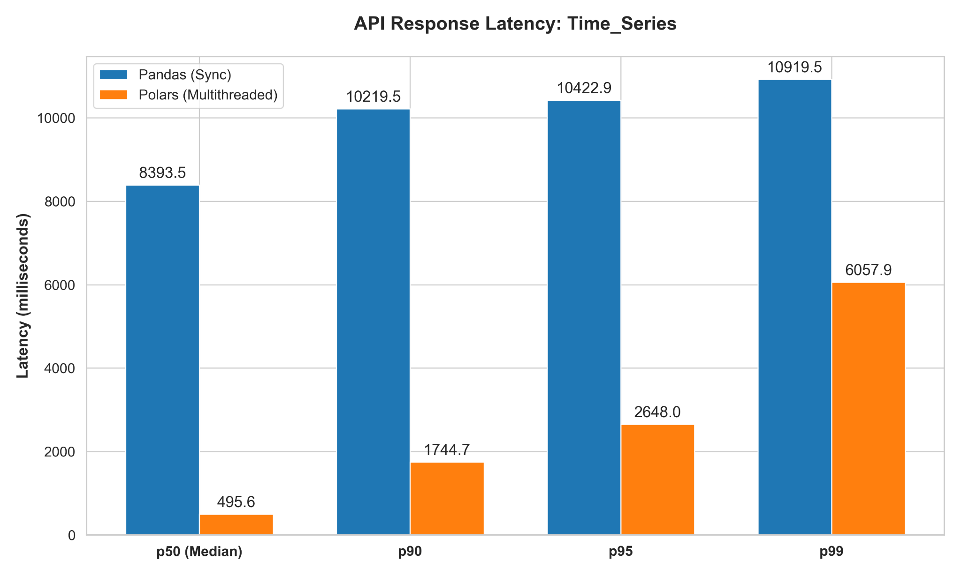
Fig. 9. Comparison of API response latency percentiles during the time-series resampling benchmark.
- Latency Degradation: The latency telemetry for this operation yielded the most dramatic median performance gap of the entire benchmark suite. Polars achieved a staggering median (p50) response time of just 495.6 ms—operating at sub-second latency even under the 10-user concurrent load. Pandas, by contrast, recorded a median latency of 8,393.5 ms, making Polars nearly 17 times faster for the average request. While Polars did experience some queuing degradation at the extreme tail (p99 of 6,057.9 ms), it remained significantly faster than Pandas' p99 of 10,919.5 ms.
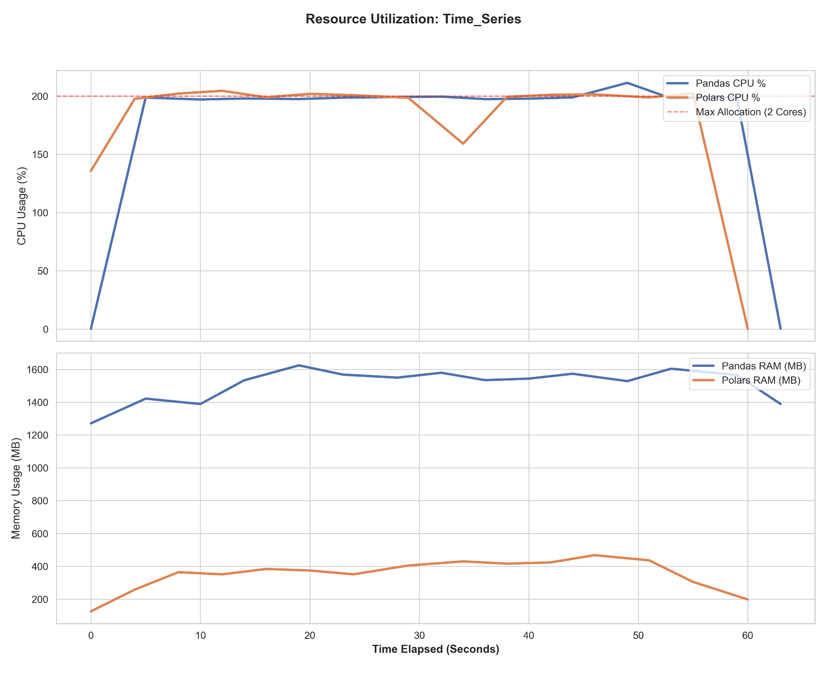
Fig. 10. CPU and memory utilization over time during the time-series resampling benchmark.
- Resource Utilization (Memory & CPU): The resource charts present a fascinating anomaly compared to previous operations: both engines successfully saturated the dual-core container, maintaining a flat 200% CPU utilization. However, because Pandas took 17 times longer to process the median request, this indicates that Pandas was "spinning its wheels"—burning massive amounts of CPU cycles on inefficient algorithms and memory allocation rather than actual data throughput.
- Memory Footprint: The memory telemetry exposes the root cause of Pandas' computational inefficiency. To calculate rolling averages and resample chronological indices, Pandas continuously generated large intermediate copies of the dataset, resulting in a heavy, sustained memory plateau between 1,400 MB and 1,600 MB. Polars, leveraging its highly optimized group_by_dynamic API, executed the temporal windows with a negligible memory footprint that hovered safely around 400 MB, proving its out-of-core streaming capabilities are exceptionally well-suited for time-series computations.
Operation 6: Null Imputation
Data cleaning tasks, such as identifying missing values and dynamically imputing the dataset mean, test an engine's ability to execute full-column scans and conditional replacements. While this is computationally less complex than multi-table joins or rolling windows, it perfectly exposes the baseline memory overhead and array-mutation efficiency of the respective frameworks.
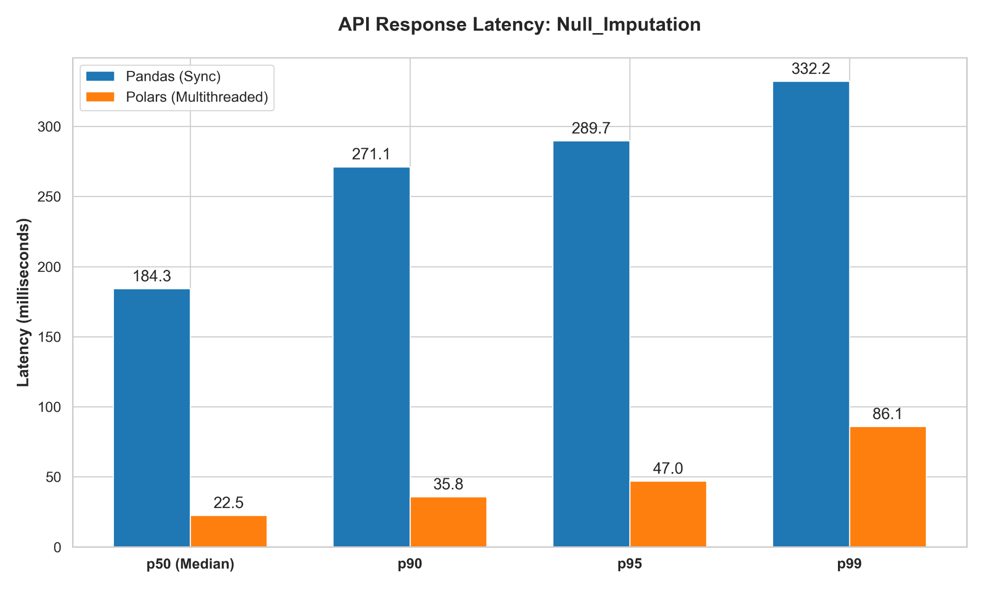
Fig. 11. Comparison of API response latency percentiles during the null imputation benchmark.
- Latency Degradation: Because this is a column-wise operation, overall response times were the fastest of the entire benchmark suite for both engines. However, the relative performance gap remained substantial. Polars delivered near-instantaneous responses, with a median (p50) latency of just 22.5 ms. Pandas recorded a median of 184.3 ms, making Polars over 8 times faster. Even at the 99th percentile under sustained concurrent load, Polars completed requests in a mere 86.1 ms, whereas Pandas queued up to 332.2 ms.
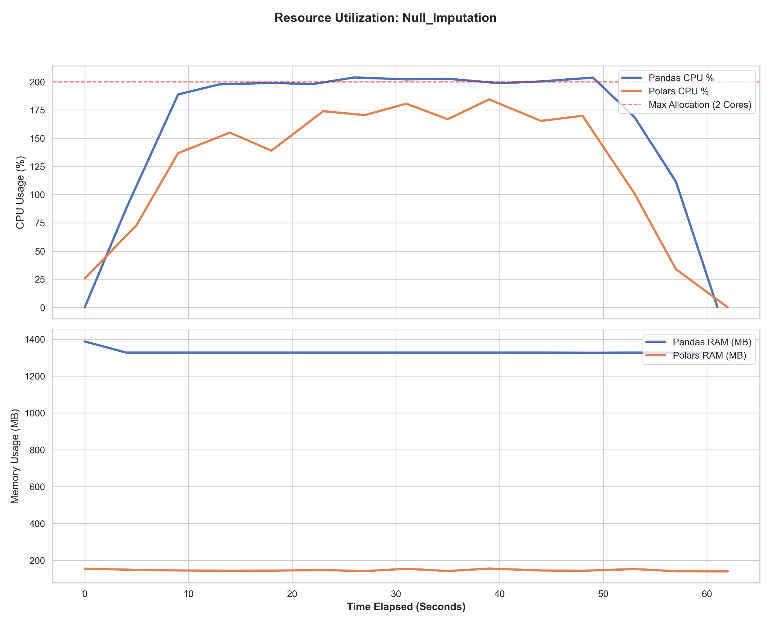
Fig. 12. CPU and memory utilization over time during the null imputation benchmark.
- Resource Utilization (Memory & CPU): The resource charts present a unique and highly insightful inversion compared to previous operations. For the first time, Pandas perfectly pinned the CPU at 200%, while Polars fluctuated between 125% and 180%. This is not an indication of Polars struggling; rather, because Polars processes the imputation so rapidly (22.5 ms), it completes the workloads faster than the load tester can overwhelm it. It simply does not need to saturate the CPU for sustained periods to handle the 10-user concurrency. Pandas, being slower, is forced to keep both cores at maximum capacity just to keep up with the incoming requests.
- Memory Footprint: The memory telemetry provides the clearest visualization of eager versus lazy evaluation in the entire study. To calculate the mean and replace nulls, Pandas eagerly allocated new memory arrays for the mutated columns, resulting in a heavy, perfectly flat memory footprint of approximately 1,350 MB. Polars, by combining the mean calculation and the fill_null mutation into a single optimized expression, performed the operation in a single pass.
Concurrency Stress Test: Heavy Joins at 20 Users
To evaluate the absolute scalability limits of the microservices, the target concurrency was doubled from 10 to 20 virtual users for the most memory-intensive operation: Heavy Relational Joins. The telemetry from this stress test starkly illustrates the breaking point of eager-evaluated data architectures under severe concurrent load.
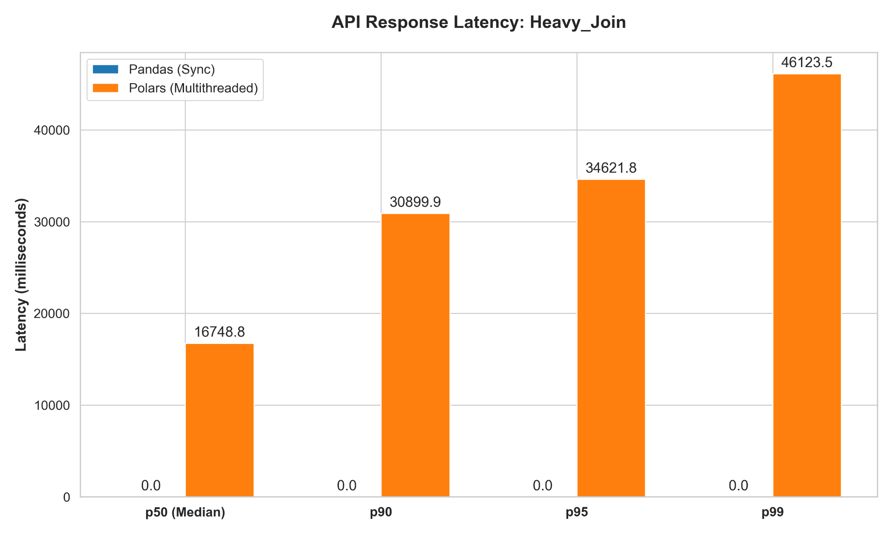
Fig. 13. API response latency percentiles for the heavy join benchmark scaled to 20 concurrent users.
- Catastrophic Failure of Pandas: The latency graph for Pandas displays 0.0 ms across all percentiles. This does not indicate instant execution; rather, it represents a total failure to return successful HTTP responses. The simultaneous influx of 20 heavy merge requests caused the Pandas microservice to crash completely, resulting in dropped connections and zero successful lifecycle completions for the k6 load tester to measure.
- Polars Degradation and Survival: Polars successfully processed the workload, though the extreme load resulted in expected queuing degradation. The median (p50) response time rose to 16,748.8 ms, and the 99th percentile reached 46,123.5 ms. While response times were significantly delayed, the lazy-evaluated engine managed to keep the server alive, avoid dropped connections, and fulfill all client requests.
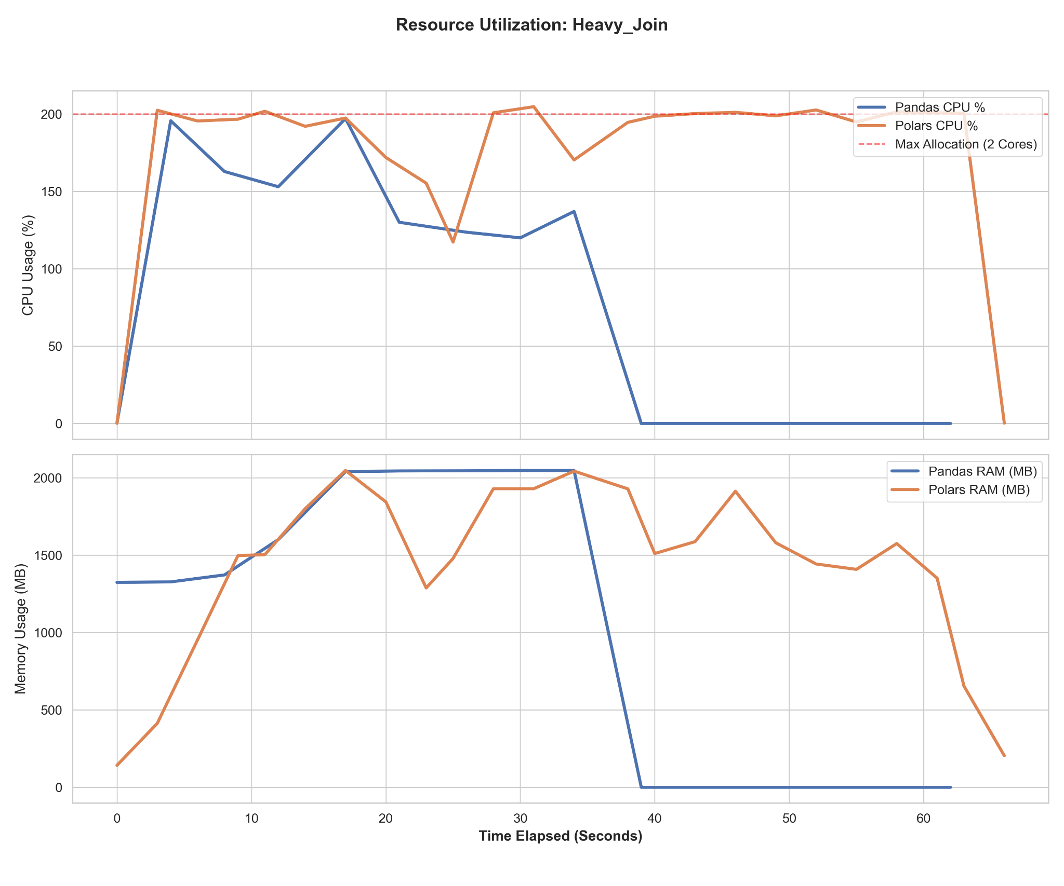
Fig. 14. CPU and memory utilization during the 20-user stress test. The charts capture the exact moment of the Pandas Out-Of-Memory (OOM)
- Resource Autopsy (The OOM Kill): The resource utilization charts provide a precise autopsy of the Pandas container failure. At approximately 17 seconds into the test, Pandas' RAM consumption violently hit the hard 2,000 MB container limit. It plateaued at this ceiling for roughly 20 seconds as the system thrashed, desperately attempting to allocate intermediate memory arrays for the concurrent joins. Ultimately, the Docker daemon intervened to protect the host machine, triggering an Out-Of-Memory (OOM) kill switch at the 38-second mark. This is visualized by the instantaneous drop of both Pandas CPU and RAM usage to absolute zero as the container was forcefully terminated.
- Polars Edge-of-Limit Execution: The stress test pushed Polars to its absolute limits as well. Its CPU remained perfectly pinned at the 200% maximum, and its memory consumption scraped the 2,000 MB ceiling on multiple occasions. However, by relying on its out-of-core streaming capabilities, Polars successfully managed its memory lifecycle—dynamically allocating and garbage-collecting data chunks—preventing a fatal OOM error and eventually stabilizing as the queue cleared.

9. Outcomes
The primary outcome of this project is a definitive, data-driven technical report proving the architectural disparities between eager and lazy dataframes in API environments. Specific expected outcomes include:
- Latency Reduction: Proving that Polars delivers significantly lower median (p50) and tail (p99) response latencies across all operations compared to Pandas.
- Resource Efficiency: Demonstrating that Polars' out-of-core streaming maintains a flat, stable memory footprint, whereas Pandas' memory duplication leads to container Out-Of-Memory (OOM) crashes under severe load (e.g., 20-user heavy joins).
- Concurrency Optimization: Establishing that lazy-evaluated, multithreaded engines are architecturally required to prevent Global Interpreter Lock (GIL) blocking in modern asynchronous Python microservices.

10. Limitations
While this project provides rigorous empirical evidence regarding eager versus lazy execution within microservices, it is subject to specific architectural and hardware constraints that define its boundaries:
- Hardware Specificity and Thread Scaling: The testing environment was strictly capped at 2 CPU cores to simulate a cost-optimized cloud microservice (e.g., an AWS t3.medium instance). Consequently, the results do not capture how the Rust-based Polars multithreading might scale—or experience severe thread contention—on high-performance servers with 32 or 64 cores.
- In-Memory Data vs. Network I/O: To isolate CPU and RAM processing efficiency, both APIs load the massive Parquet datasets into memory at server startup. Real-world FastAPI microservices typically query an external database (e.g., PostgreSQL or MongoDB) over a network. This study does not account for external database network latency, focusing strictly on dataframe manipulation limits.
- Focus on Analytical (OLAP) Workloads: The six benchmark operations exclusively test read-heavy, analytical data transformations (grouping, joining, windowing). The study does not evaluate transactional (OLTP) performance, such as concurrent row insertions, updates, or data schema mutations.
- Single-Node Execution Limits: The dataset size (1 million rows) is large enough to trigger Out-Of-Memory (OOM) failures in Pandas within a constrained container, but it is not true "Big Data." For datasets scaling into the billions of rows that strictly exceed single-node disk capacity, distributed computing frameworks like Apache Spark or Dask would be required, which falls outside the scope of this single-node API benchmark.

11. Conclusion
This study empirically evaluated the performance of Pandas and Polars within FastAPI-based microservices, focusing on response latency, throughput, CPU utilization, and memory consumption under concurrent workloads. The experimental results conclusively demonstrate that Polars provides superior scalability and efficiency for data-intensive FastAPI microservices.
While Pandas remains a powerful tool for single-threaded, exploratory data analysis, its eager execution model and reliance on intermediate memory allocations introduce critical bottlenecks in asynchronous environments. Under simulated concurrent web traffic, the Pandas microservice consistently exhausted container memory limits, leading to catastrophic system failures.
Conversely, Polars mitigates these architectural flaws through its lazy-evaluated execution graphs and out-of-core streaming capabilities. By processing data without duplicating massive arrays in memory, Polars maintained a stable, flat memory footprint regardless of the concurrent load. Furthermore, while the Rust-based multithreaded engine initially caused thread contention when competing with the FastAPI event loop, explicitly throttling the maximum thread count allowed Polars to deliver vastly superior response latencies and higher throughput compared to its synchronous counterpart.
These findings offer practical insights into optimizing data pipelines and improving resource utilization in modern distributed systems. For data engineers and developers building high-performance, API-driven data microservices, transitioning from synchronous, eager-evaluated engines like Pandas to lazy-evaluated, multithreaded engines like Polars is a necessary architectural evolution. Future research should explore the performance of these engines when integrated with distributed computing frameworks and larger, out-of-memory datasets stored on cloud object storage.

12. References
- W. McKinney, "Data Structures for Statistical Computing in Python," in Proceedings of the 9th Python in Science Conference, S. van der Walt and J. Millman, Eds., 2010, pp. 56–61.
- R. Vink, "Polars: Blazingly fast DataFrames in Rust, Python, Node.js, R, and SQL," 2024, GitHub repository. [Online]. Available: https://github.com/pola-rs/polars
- S. Ramírez, "FastAPI: High performance, easy to learn, fast to code, ready for production," 2024, GitHub repository. [Online]. Available: https://github.com/tiangolo/fastapi
- Grafana Labs, "k6: A modern load testing tool, using Go and JavaScript," 2024, GitHub repository. [Online]. Available: https://github.com/grafana/k6
- C. Richardson, Microservices Patterns: With examples in Java. Shelter Island, NY: Manning Publications, 2018.

