MODEL VALIDATION REPORT
Consumer Loan Approval Model — v1.0
Independent Model Risk Validation
Prepared by: Malcolm Riley
Role: Model Validation Analyst (Independent from Model Development)
Report Date: September 18, 2026
Classification: Internal — Portfolio Demonstration (Synthetic Data)
Overall Validation Rating: Approve with Conditions
Note: Applicant data in this report is synthetically generated for demonstration purposes and does not represent real individuals or real loan decisions. Methodology, metrics, and governance mapping follow standard model risk management practice (e.g., SR 11-7 / OCC 2011-12 style model validation and NIST AI RMF).

Table of Contents
Executive Summary
1. Model Overview & Intended Use
2. Data Description & Quality Assessment
3. Methodology
4. Performance Testing
5. Stability & Population Drift
6. Fairness & Disparate Impact Assessment
7. Limitations & Assumptions
8. Governance Mapping — NIST AI Risk Management Framework
9. Findings Summary & Recommendations
10. Validation Conclusion & Sign-Off

Executive Summary
This report presents an independent validation of the Consumer Loan Approval Model (v1.0), a gradient-boosted classifier that predicts the probability a consumer loan application should be approved. The validation was performed independently of model development, consistent with standard model risk management practice, and covers five areas: conceptual soundness, data quality, performance testing, stability/drift, and fairness (disparate impact) testing.
On a held-out test set of 1,500 applications, the model achieved an accuracy of 64.4% and an AUC-ROC of 0.696, indicating moderate discriminatory power. No material data quality issues were identified. Simulated forward-period drift testing found no significant population shift (PSI = 0.075, below the 0.10 "no significant change" threshold).
The fairness assessment identified a material finding: applicants in Group B were approved by the model at a 45.5% vs. 36.4% rate relative to Group A — a demographic parity ratio of 0.801 (80.1%). While this technically clears the commonly used 80% four-fifths screening threshold, it does so with a margin of only 0.001, and true positive rates also diverge meaningfully between groups (Group A: 60.1%, Group B: 50.9%). Investigation traced this gap to the zip_tier feature, which is correlated with Group membership and independently contributes 5.3% of model importance — a textbook proxy-discrimination pattern. No comparable material gap was found by gender (parity ratio 0.960).
Overall Validation Rating: Approve with Conditions. The model is approved for continued use subject to the remediation and monitoring conditions in Section 9.

1. Model Overview & Intended Use

1.1 Purpose
The model estimates the probability that a consumer loan application will be approved, based on applicant financial and credit attributes. It is intended to support (not fully automate) underwriting decisions, with outputs feeding a decision workflow that retains human review for declined and borderline applications.

1.2 Model Type & Features
Algorithm: Gradient Boosted Trees (scikit-learn GradientBoostingClassifier; 150 estimators, max depth 3, learning rate 0.08).
Training population: 4,500 applications. Validation (holdout) population: 1,500 applications, stratified by outcome.
Input features (9): credit_score, annual_income, debt_to_income, employment_length_years, age, num_open_accounts, delinquencies_2yr, loan_amount_requested, zip_tier.
Protected attributes excluded from model features: gender and protected_group (demographic classification) are excluded from training, consistent with fair-lending practice (ECOA / Regulation B), and are used only downstream by the independent validation team for fairness testing — mirroring how a compliance-held demographic file is used in practice.

2. Data Description & Quality Assessment
The underlying dataset contains 6,000 applications and 9 model features. Data quality checks below were run prior to model training.
Check | Result | Assessment
Missing values | employment_length_years: 1.2% missing; all other features: 0% | Acceptable — imputed via median
Duplicate applicant IDs | 0 | None found
Class balance (approved / declined) | 47.6% / 52.4% | Reasonably balanced — no resampling required
Credit score range | 451 – 850 | Within valid FICO-style range
Income outliers (>3 std. dev.) | 11 of 6000 | Immaterial — retained, no evidence of data entry error

3. Methodology
Validation followed a five-part test plan, aligned to standard model risk management practice and mapped to the NIST AI Risk Management Framework in Section 8:
- Performance testing: discrimination (AUC, precision/recall/F1) and calibration on a held-out test set never seen during training.
- Data quality review: completeness, duplication, class balance, and outlier scan.
- Stability testing: Population Stability Index (PSI) comparing the validation sample against a simulated forward-period population with shifted credit and income distributions.
- Fairness / disparate impact testing: demographic parity, equalized odds, and the four-fifths (80%) rule across protected_group and gender, using the Fairlearn library.
- Conceptual soundness review: feature importance review to confirm the model's top drivers are economically sensible and to screen for reliance on proxy variables.

4. Performance Testing
Metric | Value | Interpretation
Accuracy | 64.4% | Correct decisions overall
Precision | 64.1% | Of approvals, share that were correct
Recall (sensitivity) | 57.1% | Of true-approvable applicants, share identified
F1 score | 60.4% | Balance of precision and recall
AUC-ROC | 0.696 | Moderate discriminatory power (0.5 = random, 1.0 = perfect)
Brier score | 0.221 | Lower is better-calibrated; acceptable range
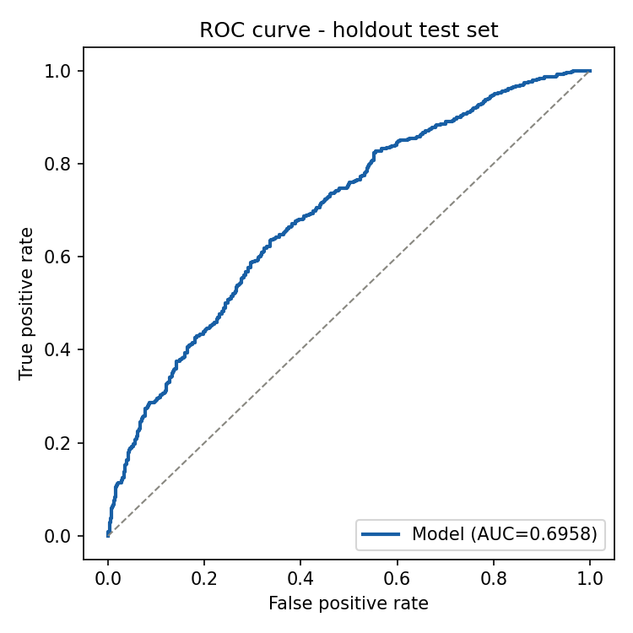
Figure 1. ROC curve, holdout test set (n=1500).
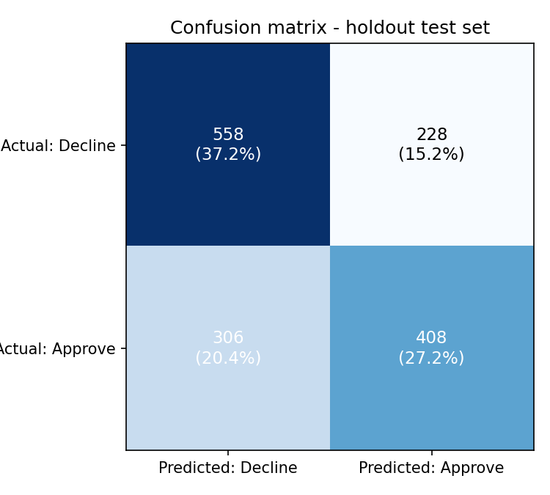
Figure 2. Confusion matrix, holdout test set.
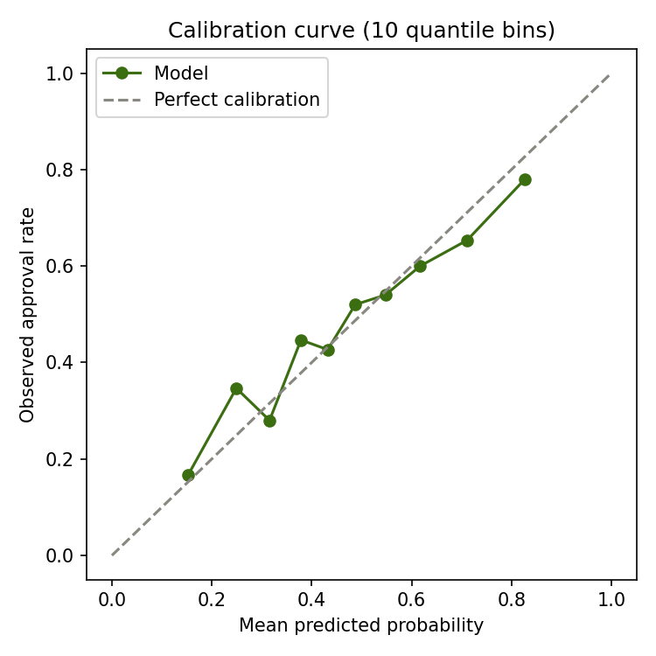
Figure 3. Calibration curve — predicted vs. observed approval rate across 10 quantile bins.
Finding: The model shows moderate, usable discriminatory power (AUC 0.696). Calibration is reasonable across most probability bins, with mild overconfidence at the extremes — a common and acceptable pattern for boosted-tree models. No performance-based finding requires remediation.
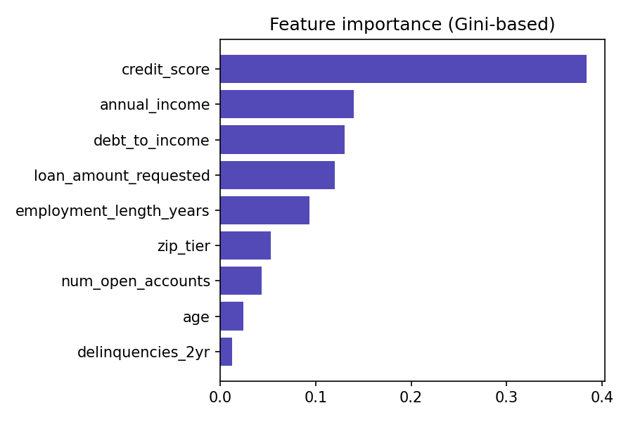
Figure 4. Feature importance (Gini-based).
Credit score is the dominant driver (38.4% importance), followed by annual income and debt-to-income — all economically sensible for a credit decision. zip_tier contributes 5.3% importance; while modest, this is the feature investigated further in Section 6 given its correlation with protected_group.

5. Stability & Population Drift
To test how the model would behave against a future applicant population, a forward period was simulated with a modest downward shift in credit score and income, and an upward shift in debt-to-income (representative of a mild economic softening scenario). The resulting model-score PSI was 0.075.
PSI range | Interpretation | This model
< 0.10 | No significant population change | ✓ Score PSI = 0.075
0.10 – 0.25 | Moderate shift — monitor
> 0.25 | Significant shift — investigate / consider retraining
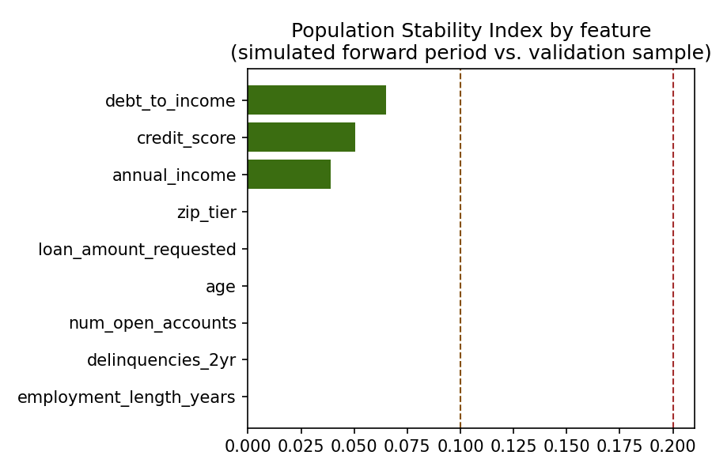
Figure 5. Feature-level PSI, simulated forward period vs. validation sample.
Finding: No feature exceeded the 0.10 caution threshold in this simulated scenario (highest: debt_to_income at 0.065). This is a simulated, moderate stress scenario only — it does not guarantee stability under a real, larger economic shift. Recommend quarterly PSI monitoring in production (Section 9).

6. Fairness & Disparate Impact Assessment
Fairness metrics were computed by joining model predictions on the holdout set back to a compliance-held demographic file (protected_group, gender) that was never exposed to the model during training. This mirrors standard fair-lending validation practice.

6.1 Protected Group
Metric | Group A | Group B | Gap / Ratio
Model approval (selection) rate | 45.5% | 36.4% | Ratio: 0.801
True positive rate | 60.1% | 50.9% | Diff: 9.2 pts (equalized odds)
False positive rate | 31.4% | 24.6%
Four-fifths (80%) rule |  |  | Passes (marginally)
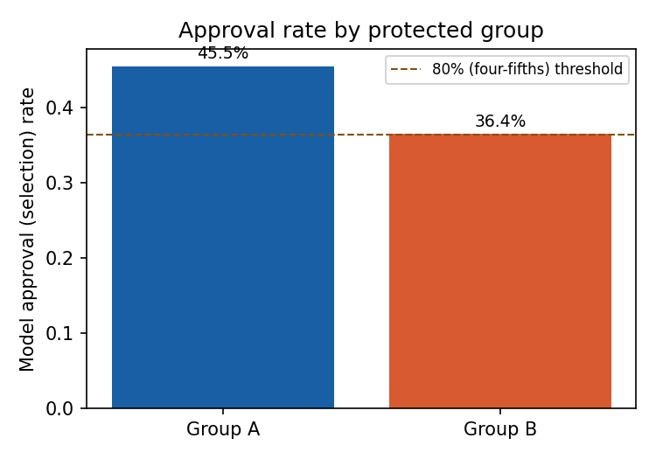
Figure 6. Model approval rate by protected group, vs. four-fifths threshold.
Finding — MATERIAL: Group B applicants are approved at 80.1% of Group A's rate. This technically clears the 80% four-fifths screening threshold but with only a 0.1-point margin, and the gap is corroborated by a 9.2-point equalized-odds difference (true and false positive rates both diverge by group). Group membership itself is not a model input; the mechanism was traced to zip_tier, which is disproportionately assigned to Group B applicants and independently penalizes approval probability — a proxy-discrimination pattern. This finding should be treated as material regardless of the nominal four-fifths pass, because the ratio sits inside the margin of estimation error for a sample this size and the underlying mechanism (a correlated proxy feature) is a known fair-lending red flag.

6.2 Gender
Metric | Female | Male | Gap / Ratio
Model approval (selection) rate | 43.3% | 41.6% | Ratio: 0.960
True positive rate | 57.1% | 57.1% | Diff: 5.2 pts (equalized odds)
Four-fifths (80%) rule |  |  | Passes comfortably
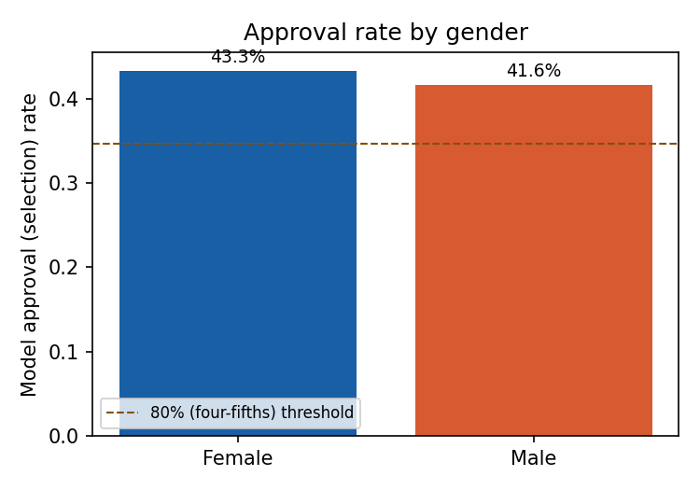
Figure 7. Model approval rate by gender, vs. four-fifths threshold.
Finding: No material disparity was found by gender (parity ratio 0.960, well clear of the 80% threshold). No remediation required on this dimension.

7. Limitations & Assumptions
- Data is synthetically generated for this demonstration; real applicant data would require additional PII handling, consent, and regulatory review (e.g., Reg B, FCRA) not modeled here.
- The forward-drift scenario in Section 5 is a single simulated stress scenario, not a guarantee of stability under all future conditions.
- Fairness testing covered two protected dimensions (protected_group, gender); a production validation should also test age, and intersectional combinations (e.g., Group B x Female).
- Sample size (1,500 holdout) is adequate for headline metrics but limits precision on subgroup-level rates; wider confidence intervals apply to the smaller Group B subgroup.

8. Governance Mapping — NIST AI Risk Management Framework
This validation's activities are mapped below to the four core functions of the NIST AI RMF (Govern, Map, Measure, Manage), for audit traceability.
NIST AI RMF Function | Activity in this Report | Status
Govern | Independent validation performed separately from model development; documented sign-off and rating (this report). | Complete
Map | Intended use, in-scope population, and excluded protected attributes documented (Section 1). | Complete
Measure | Performance, stability/PSI, and fairness metrics computed against defined thresholds (Sections 4–6). | Complete
Manage | Remediation and monitoring plan defined for the proxy-bias finding (Section 9). | Open — tracked

9. Findings Summary & Recommendations
# | Finding | Severity | Recommendation | Owner / Due
1 | zip_tier acts as a proxy for protected_group, producing a borderline four-fifths ratio (0.801) and a 9.0-point selection rate gap. | Material | Remove or re-engineer zip_tier (e.g., replace with a feature less correlated with protected class); retest fairness metrics before next production release. | Model Owner — next release cycle
2 | No comparable disparity found by gender. | Informational | No action required; continue standard monitoring. | —
3 | Model AUC (0.696) is moderate; some overconfidence at probability extremes. | Low | Acceptable for current use; revisit if a higher-performing candidate model is proposed. | Model Owner — next model review
4 | No significant drift found in simulated stress test, but real-world drift may exceed this scenario. | Low | Implement quarterly PSI monitoring in production with a 0.10 / 0.25 alert threshold. | Model Owner — ongoing

10. Validation Conclusion & Sign-Off
Overall Validation Rating: Approve with Conditions.
The model demonstrates acceptable performance and stability for its intended use. However, the proxy-discrimination finding in Section 6.1 is material and must be remediated on the timeline in Section 9 before the model's next production release; continued use in the interim should include enhanced monitoring of approval-rate parity by protected group.
Prepared by: Malcolm Riley, Model Validation Analyst
Independent of: Model Development / Business Unit
Date: September 18, 2026

