SCOUT INSIGHTS
Brief Scout Media's permission-based local research practice
No PII. Opt-in. Aggregate-only. The reader stays the customer — never the product.
The idea in one line
Turn a trusted, engaged, *local* audience into the region's best source of consumer and civic insight — sold as aggregate findings, never identities — building a high-margin, apolitical B2B revenue line that *deepens* trust instead of spending it, and makes Brief Scout the cited local authority.
Sequencing is the whole strategy: build depth before we monetize. We start with contest-based onboarding questions that form insights early (and immediately sharpen our own content, products, and events), deepen the dataset over time, establish credibility with house research, and only *then* open sponsored/custom panels.
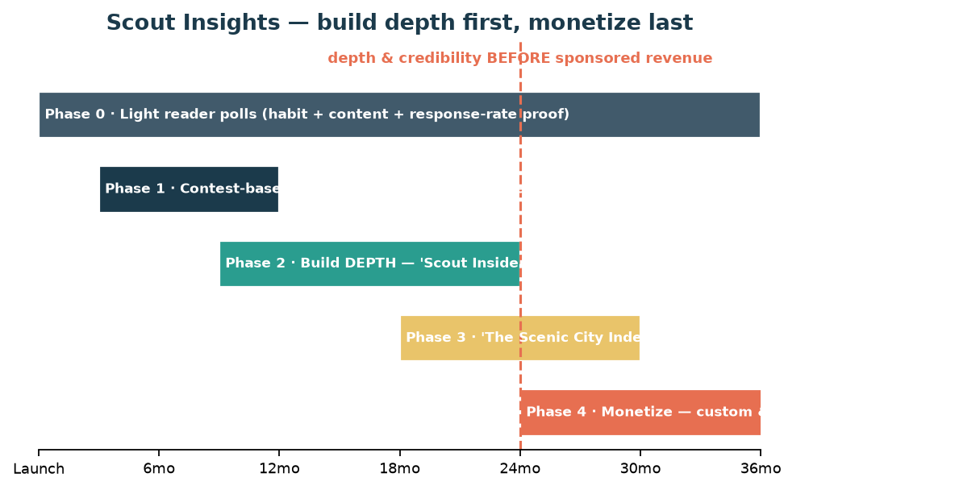
Figure. The five phases — depth and credibility come before any sponsored dollar.
The phased roadmap
Phase | When | What happens | Revenue
Phase 0 — Listen | Now (pre-10K) | Light in-newsletter 'Scout asks…' polls. Builds the response habit, makes great content, and proves people answer. | Internal only
Phase 1 — Onboard | ~3–12 mo | Contest-based 3–5-question micro-surveys at signup (and periodically). Collect consented, first-party profile data — age band, gender, part of town, interests, life stage. Insights form early. | Internal only
Phase 2 — Deepen | ~9–24 mo | Progressive profiling (one question an issue) grows the opt-in 'Scout Insiders' panel and a real longitudinal dataset. Add methodology rigor (sampling, weighting). | Internal only
Phase 3 — Authority | ~18–30 mo | Publish 'The Scenic City Index' — house research that makes Brief Scout the cited local authority. Feeds editorial; builds the B2B brand. | Brand / PR (low/none)
Phase 4 — Monetize | ~24 mo+ | Only now: custom 'Scout Insights' studies and sponsored/omnibus panels for local orgs — apolitical, aggregate-only, walled from editorial. | B2B research revenue

Phase 1 — the contest-based onboarding mechanic
New (and existing) subscribers answer 3–5 quick questions to enter a contest — the prize is a gift card to a local business we cover, so the reward itself champions a maker. The questions are first-party and consented; some are simple demographics (age, gender) so we build the *right* content, products, and events. Insights start forming immediately.
Onboarding question | What it powers right away | Later research value
Age band | Tone & reading level; product sizing/merch; event design (nightlife vs. daytime) | Demographic cross-tabs for every study
Gender | Balanced content & representation; product/merch mix; event programming | Representative weighting
Part of town / area | Local relevance; where to host events; which neighborhoods to feature next | Geographic segmentation (a real local edge)
Interests (food/makers/outdoors/arts/family/getaways/civic) | Which sections, products, and events to expand — demand, not guesswork | Interest-based panels for clients
Life stage / household | Family vs. date-night vs. retiree programming; product fit | Lifestyle segmentation
New to Chattanooga? (under 2 yrs) | Powers the 'Newcomer' Lens + relocation funnel; serves the migration wave | High-value transplant cohort

Every question earns its place twice — it improves the product now and becomes a research dimension later.
The guardrails (non-negotiable)
- No PII — ever. Clients receive aggregate findings and cross-tabs, never names, emails, or individual records.
- First-party & consented. Self-reported at opt-in, built up by progressive profiling. We do NOT silently buy third-party demographic appends and attach them — that's a trust and legal liability that contradicts the brand.
- Opt-in panel. 'Scout Insiders' is something readers choose to join, incentivized by a contest (prizes are gift cards to the local businesses we cover — the reward itself supports a maker).
- Frequency-capped. At most one profiling question per issue and one deeper survey a month. Belonging, not extraction — over-surveying churns the list.
- Walled from editorial. Research never dictates coverage; we decline political, religious, or advocacy work. Same bright line as the partner program.
- Transparent & secure. Clear privacy policy, easy opt-out honored immediately, sensible data security.
The immediate payoff — before a single external dollar
Even at $0 of research revenue, this pays for itself. Knowing your readers' age, neighborhood, life stage, and interests lets you segment sends, tailor sections, size merch, and design events people actually show up to — lifting free→paid conversion and retention across the core business. The data is a *product-development engine* first and a revenue line second.
The external products (Phase 3–4)
The Scenic City Index (house research) establishes authority and feeds editorial — the brand-builder. Scout Insights (custom + omnibus) is the demand-driven revenue, sold only after depth and credibility exist.
Product | What it is | Illustrative price
Omnibus question | Add one question to the monthly panel; client gets the cross-tabs | ~$250–$750 / question
Focused custom study | Concept/pricing/satisfaction test, n≈300–800, report + readout | ~$2.5K–$15K
Major study | Multi-segment or longitudinal work | ~$15K–$50K+
Scenic City Index | Subscription / underwriting of the flagship report (clearly labeled) | Subscription or sponsor

Illustrative; high margin because the audience already exists. Apolitical, aggregate-only, walled from editorial.
Fit in the model & a light 3-year contribution
Scout Insights is a fourth revenue line alongside membership, products, and events — and a walled B2B practice, like the partner program. It's deliberately back-loaded: the early value is internal (better content/products/events), the later value is revenue *and* the unbookable payoff of authority and brand.
Year | External revenue (illustrative) | The bigger payoff
Year 1 | ~$0 external | The payoff is internal: onboarding data makes content, products & events land — higher conversion & retention from day one.
Year 2 | ~$5K–$20K | First Index underwriting + a few omnibus/custom pilots as depth and credibility build.
Year 3 | ~$25K–$60K | Custom studies + Index subscriptions mature — plus the larger, unbookable payoff: authority, PR, and product-market fit.

Bottom line
A permission-based, no-PII insights practice is the most on-brand non-advertising revenue Brief Scout can build: it monetizes trust without selling the reader, sharpens the core product from week one, and — through 'The Scenic City Index' — makes Brief Scout the authority on what Chattanooga thinks. Build the depth first; the panels will be worth far more for the wait.

