BRIEF SCOUT MEDIA
Founder Strategy & Business Plan

Building a reader-funded local media & events company in Chattanooga, Tennessee
Flagship product: The Scenic City Insider — a weekly digital newsletter

No advertising. No sponsorship. Funded by members, products, and events.

Confidential Working Document · June 2026

1. Executive Summary
Brief Scout Media is a new local media and events company forming in Chattanooga, Tennessee. Its first product is The Scenic City Insider, a weekly digital newsletter that tells residents what matters and what to do in Chattanooga. The defining strategic choice is what the Insider will not do: it will not sell advertising or sponsorship inside the newsletter. Instead, Brief Scout Media monetizes its audience directly through three owned revenue pillars — paid membership, product and commerce sales, and live events (both proprietary and joint-venture).
This is a deliberate bet against the dominant local-newsletter playbook. The incumbent in Chattanooga, NOOGAtoday (a 6AM City property), is free and advertising-funded. The legacy daily, the Chattanooga Times Free Press, is a paywalled, mostly-digital newspaper that has publicly acknowledged operating at a loss and raised its price to roughly $39/month. Between a free ad-product and an expensive legacy paywall sits an open lane: a premium, ad-light, reader-funded local brand with a genuine events franchise. No Axios Local edition and no established paid independent newsletter currently occupies it.
Why this can work — the evidence:
- Email-first local media demand is proven here. NOOGAtoday reports a large local free list (26,500+ as far back as 2020) and the Times Free Press lists 60,000+ newsletter recipients — tens of thousands of Chattanoogans already read local email daily.
- Small lists can produce real income without ads. Catskill Crew, a hyperlocal newsletter in rural New York, earns roughly $52,000–$57,000 per month at under 20,000 subscribers, at ~85% margin, with zero advertising, across 11 revenue streams (events, merch, a discount card, even a region-themed board game). Charlotte Ledger reached ~$150,000–$175,000/yr on a membership model; Racket (Minneapolis) reported $322,000.
- Events are a validated media revenue pillar. Events are on pace to be ~50% of TIME's revenue and ~50% of Semafor's; the share of publishers earning meaningful event revenue jumped from 47% to 70% in a single year.
- The macro tailwind is strong. The U.S. has lost ~3,300 newspapers since 2005 and ~55 million Americans now have limited local news — while reader-funded digital outlets are the fastest-growing bright spot.
- The market is growing and affluent enough. The Chattanooga metro (~595,000 people) is growing at more than twice the national rate, fueled by higher-income transplants from California and Illinois — a steady stream of newcomers who need exactly what the Insider offers.
The financial arc. Modeled conservatively with no advertising, Brief Scout Media reaches roughly $31K in Year 1 (validation / side-income), ~$116K in Year 2 (approaching a full-time income), and ~$280K in Year 3 (a full-time founder salary plus a small contractor team and reinvestment). By Year 3 revenue is diversified across membership (~43%), events (~38%), and products (~19%) — the multi-stream structure that research repeatedly ties to local-media sustainability. Startup capital required is modest: roughly $5,000. These are deliberately conservative base-case figures; the proprietary discovery engine (Section 4.5) improves the Year-2/3 outlook by cutting content cost and lifting membership.
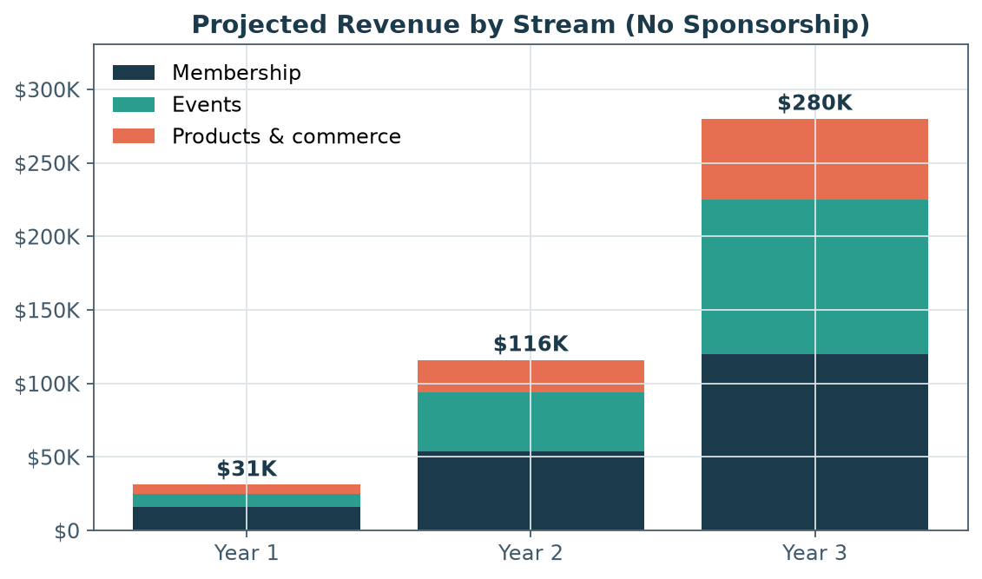
Figure 1. Projected three-year revenue, built entirely from members, products, and events — no sponsorship.
2. Company Overview
2.1 Mission & vision
Mission: Help people love living in Chattanooga by being the most trusted, most useful, and most loved guide to the city — independent of advertisers.
Vision: Build Brief Scout Media into a durable, locally-owned media company whose audience relationship is so strong that readers happily pay for it — and whose events become fixtures on the city's calendar. The Scenic City Insider is product one; the company is designed so the same reader-funded playbook can extend to new verticals (e.g., a dedicated food/dining edition, a newcomer's guide, a kids/family edition) and, eventually, new Southeastern cities.
2.2 The flagship product — The Scenic City Insider
The Scenic City Insider is a weekly digital newsletter delivering a tightly curated brief on Chattanooga: what happened, what's changing, and — critically — what to do this week. "Scenic City" is Chattanooga's well-known civic nickname; the "Insider" voice is a trusted local insider who does the legwork so readers don't have to. The weekly cadence is a deliberate, sustainable choice: research shows over-sending accelerates churn and that daily-publishing burnout is a leading cause of solo-operator failure. A high-quality weekly protects editorial standards and founder stamina while a daily competitor (NOOGAtoday) saturates the inbox.
2.3 The core thesis — why no sponsorship
Most local newsletters are free and sell ads. That model works, but it has structural costs: it requires large scale to matter (6AM City targets ~50,000 subscribers per market just to be profitable), it sells the reader's attention to third parties, and it creates an unavoidable tension between what's good for the reader and what's good for the advertiser. Brief Scout Media rejects that trade. By taking sponsorship off the table entirely, the Insider makes the reader — not an advertiser — the customer. Every incentive points the same direction: make something people love enough to pay for, sell them products they actually want, and gather them at events they're glad they attended.
This is not idealism without precedent — it is the model behind some of the most resilient independent media of the last five years (Defector: 87% reader-funded, ~$4.6M/yr; 404 Media: profitable within ~6 months; Hell Gate, Racket, Aftermath; The Colorado Sun). Brief Scout Media applies that reader-funded ethic to a single mid-sized city.
Item | Detail
Company | Brief Scout Media (LLC to be formed)
Headquarters | Chattanooga, Tennessee (Hamilton County)
First product | The Scenic City Insider — weekly digital newsletter
Stage | Pre-launch concept
Revenue model | Membership + products/commerce + events (no ads/sponsorship)
Editorial cadence | Weekly (free tier) + members-only extras
Startup capital | ~$5,000
3-yr revenue target | ~$280,000 with diversified, reader-funded streams

Table 1. Brief Scout Media at a glance.
3. The Market Opportunity
3.1 A local-news vacuum and a newsletter renaissance
The collapse of legacy local news is well documented. Northwestern's Medill "State of Local News 2024" report counts ~3,300 newspapers lost since 2005 (more than a third of all U.S. papers), 127 closures in the prior 12 months (~2.5 per week), 1,563 counties with only one remaining news source plus 208 with none, and roughly 55 million Americans with limited or no local news. The bright spot: a net +81 standalone digital news sites in a single year — the fastest-growing replacement for shuttered print, concentrated in metros like Chattanooga.
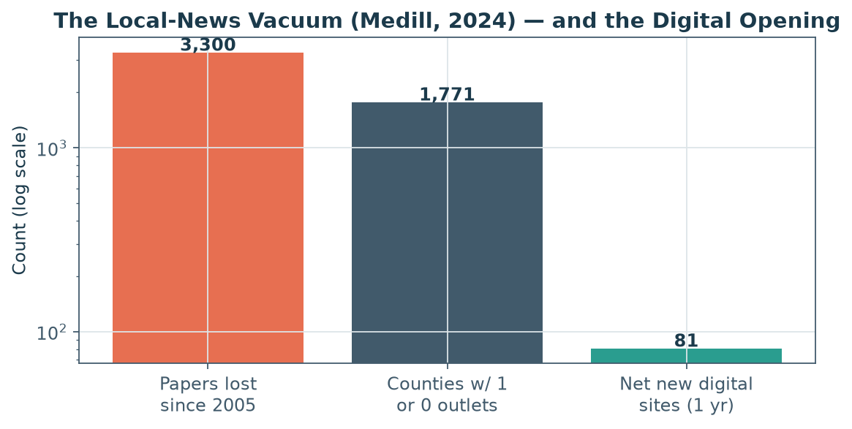
Figure 2. Legacy local news is collapsing while digital-native outlets grow — the structural opening Brief Scout Media is built for. Source: Medill State of Local News 2024.
Email is the medium of choice for this rebuild. Newsletters are owned audience — a direct, portable relationship not subject to a social platform's algorithm — which is precisely why operators from Morning Brew to Axios to thousands of indies have made the inbox their home. Typical newsletter open rates run 20–40% (far above most digital media), and the email list is consistently cited as the single most defensible asset a small media company can own.
3.2 The reader-revenue shift
Across the industry, reader revenue is now the top investment priority for publishers, and the most durable independent outlets are funded primarily by their audiences rather than advertisers. The frameworks are mature: the Lenfest Institute and American Press Institute stress diversified reader-centric revenue and that "retention is the new acquisition"; the Membership Puzzle Project distinguishes transactional subscription from mission-driven membership, where people "join the cause." Brief Scout Media is explicitly a membership business, not merely a paywall.
3.3 The Chattanooga market
Chattanooga is an unusually good fit for a reader-funded local brand: large enough to support real revenue, small enough to dominate, growing fast, increasingly affluent, and digitally wired.
Indicator | Value | Source
City of Chattanooga population | ~194,000 (2025 est.) | U.S. Census / Times Free Press
Chattanooga MSA (6-county TN-GA) | ~595,000 (2025) | U.S. Census / UTC CRER
MSA households (est.) | ~235,000 | Derived from Census
Metro growth, 2020–2025 | +31,000 people; >2× U.S. rate | UTC CRER (2026)
Top in-migration origins | California (#1), Illinois (#2) | UTC CRER (2026)
Median household income (county) | $76,183 | ACS 2024 / FRED
Median household income (city) | ~$64,500 | ACS 2024
Median age (city) | ~36 | U.S. Census
Tourism — annual visitors | ~11.1 million (2024) | Chattanooga Tourism Co.
Tourism — visitor spending | $1.806 billion (2024, record) | Chattanooga Tourism Co.
Local events serviced / attendees | 253 events / 299,000+ (2024) | Chattanooga Tourism Co.
EPB "Gig City" fiber customers | ~122,000 (~70% of homes) | EPB 2024 Annual Report
Unemployment (MSA) | ~3.4% (Dec 2025) | BLS / FRED
State income tax | None (Tennessee) | State of Tennessee

Table 2. Chattanooga market snapshot.
Three features stand out for this business. First, growth and migration: the metro is adding higher-income transplants faster than almost any peer, and newcomers are the ideal audience for a "make sense of your new city" product. Second, a deep events and tourism economy: $1.8B in visitor spending and 253 serviced events a year mean a thick calendar to curate and a population primed to attend. Third, "Gig City" digital readiness: as the first U.S. city with citywide gigabit fiber (~70% household penetration), Chattanooga has an unusually connected, online-native population.
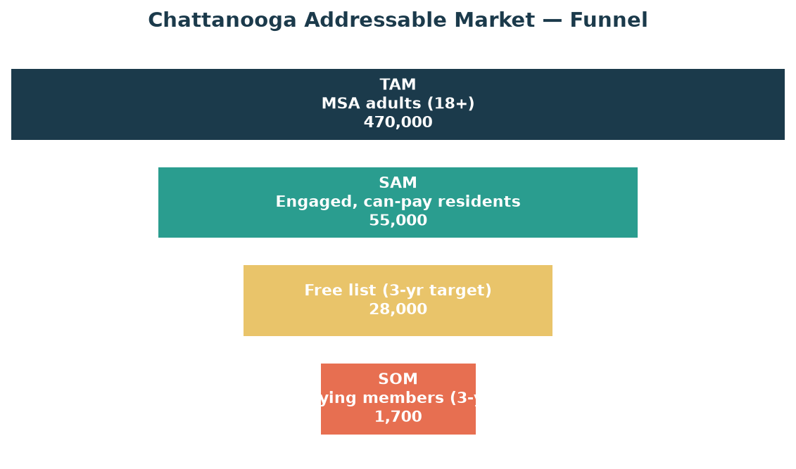
Figure 3. Top-down market sizing. The realistic three-year target captures a small slice of the engaged, able-to-pay audience.
3.4 Market sizing — TAM / SAM / SOM
- TAM — ~470,000 MSA adults. The total universe of potential readers across the six-county metro.
- SAM — ~55,000 engaged, able-to-pay residents. Benchmarked against demonstrated local email engagement (NOOGAtoday's local list plus the Times Free Press's 60,000+ newsletter recipients) and an income filter (the ~80,000–105,000 MSA households above ~$75K). This is the realistically reachable, willing-to-engage audience.
- SOM — ~28,000 free subscribers and ~1,700 paying members within three years. A small, credible share of the SAM, consistent with comparable operators. Paid conversion is modeled at the realistic 3–6% of an engaged free list (median ~3%; up to 10% only with a strong funnel).
3.5 Competitive landscape
Player | What it is | How it's funded | Strengths | Gaps / vulnerabilities
NOOGAtoday (6AM City) | Free daily newsletter | Advertising / sponsorship | Large free local list; daily habit | No paid tier; ad-driven; inbox saturation
Times Free Press | Legacy daily, mostly digital | Hard paywall ~$39/mo | Newsroom, brand, archives | Expensive; "operating at a loss"; legacy feel
The Chattanooga Pulse | Alt-weekly (arts/events) | Was print ads | Events/arts heritage | Print suspended since 2020; diminished
Chattanoogan.com | Free web news daily | Display ads | Breaking/community news, free | Utilitarian; not curated; no events
ChattaMatters | Civic explainer | Grant / city-funded | Civic depth | Narrow scope; not consumer/events
Brief Scout Media | Weekly curated brief + events | Members + products + events | Reader-aligned; premium; events franchise | New entrant; must earn trust

Table 3. Competitive landscape. The reader-funded, events-anchored, premium lane is uncontested.
The whitespace is clear. The strongest newsletter (NOOGAtoday) is free and ad-funded; the only paid product (Times Free Press) is an expensive legacy paywall; the events/arts vehicle (The Pulse) effectively vacated the field in 2020. There is no Axios Local edition and no established paid independent Chattanooga newsletter. Brief Scout Media can be the premium, reader-funded, events-driven alternative — a position incumbents are structurally unable to copy without cannibalizing their own model.
4. The Business Model
Brief Scout Media runs on three reinforcing revenue pillars, all owned and all reader-aligned. The newsletter is the engine that builds the audience and trust; membership, products, and events are the monetization. Research is unambiguous that diversification is what separates sustainable local media from fragile single-stream operators — outlets with 3+ revenue streams are markedly more likely to be stable, and a formal business plan alone correlated with a 137% revenue increase in one LION Publishers study.
4.1 Pillar 1 — Membership
A paid membership (target $8/month or $80/year, within the proven $5–$15/mo · $50–$120/yr band for local independent media) unlocks members-only content, early event access and member pricing, the digital archive, and the sense of belonging to the cause. Modeled conversion is a conservative 3–6% of the free list; at $80–$100/yr with ~3–4% monthly churn (typical for engaged local lists), gross member lifetime value lands around $200–$275.
4.2 Pillar 2 — Products & commerce
High-margin owned products turn brand affection into revenue without touching advertising: Chattanooga-pride merchandise (print-on-demand to test, bulk once proven — ~$17/unit vs ~$42 on-demand), digital city guides (newcomer guide, best-of guides — near-100% margin after creation), a "Insider Card" local discount program (recurring, partner-funded value for members), a job board / classifieds line ($200+/listing), and signature specialty items. Catskill Crew's region-themed board game (sold out in 17 days) is the proof that a beloved local brand can sell almost anything to its people.
4.3 Pillar 3 — Events
Events are the highest-leverage pillar and the strongest moat. Two structures:
- Proprietary events — ticketed gatherings the Insider owns end-to-end: member mixers, a "new to Chattanooga" newcomer night, themed tasting walks, and eventually an annual signature festival. Local consumer events cluster at a $30–$50 ticket sweet spot, with $40–$75 of additional per-attendee on-site spend.
- Joint-venture events — co-produced with breweries, restaurants, venues, and festivals on a revenue-share basis. The Insider brings the audience and promotion; the partner brings the space and operations; risk and cost are shared. This is the capital-light way to run frequent events without owning infrastructure.
The pillar is well-validated at scale — events are tracking toward ~50% of revenue at TIME and Semafor, and the share of publishers earning meaningful event income leapt from 47% to 70% in one year — and Chattanooga's 253-event, $1.8B visitor economy is fertile ground.
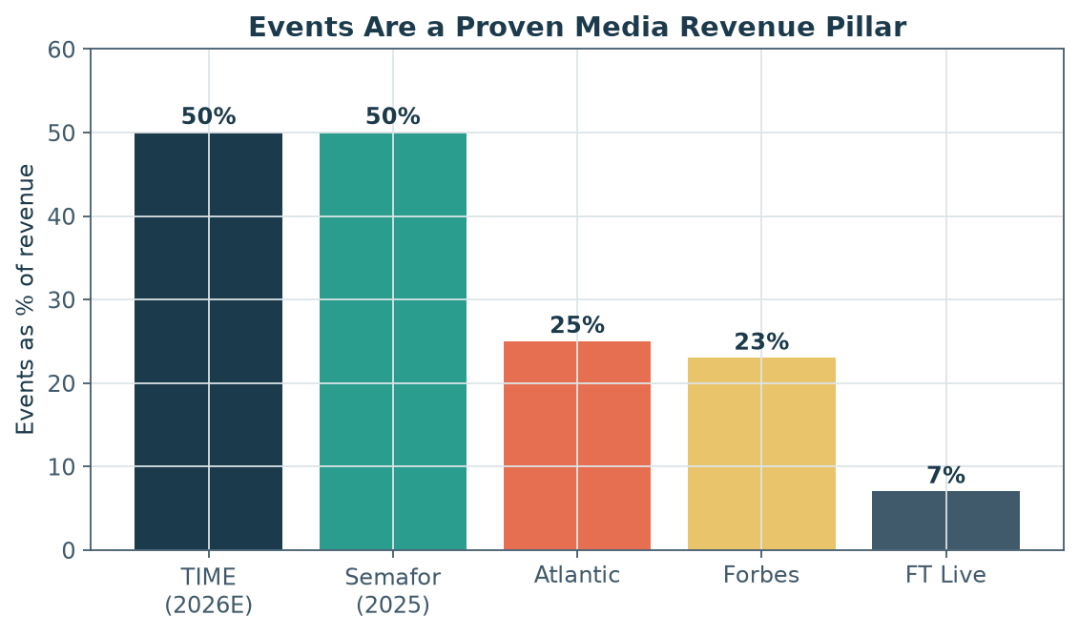
Figure 4. Events have become a core revenue pillar for media companies of every size. Sources: company disclosures via Adweek, Digiday, A Media Operator (2024–2026).
4.4 Proof points — comparable operators
Brief Scout Media's model is assembled from tactics already working at named operators. The key insight: a small, deeply engaged list can out-earn a large, shallow one when monetized through membership, products, and events rather than ad impressions.
Operator | Market | Subscribers | Est. revenue | Model / notes
Catskill Crew | Catskills, NY | <20,000 | ~$620K/yr (~$52–57K/mo) | Reader/events/products (no ads), ~85% margin, 11 streams
Charlotte Ledger | Charlotte, NC | 2,000 paid / 6,900 free | ~$150–175K/yr | Membership ($9/mo, $99/yr)
Racket | Minneapolis, MN | ~3–4K paid | ~$322K/yr | Worker-owned, reader-funded
Hell Gate | New York, NY | ~9,000 paid | ~$70K/mo MRR | Membership co-op (~⅔ from subs)
Defector | National (sports) | ~42,000 | ~$4.6M/yr | 87% reader-funded
Naptown Scoop | Annapolis, MD | ~18–21K | ~$200–300K/yr | Advertising ($70 CPM) — contrast model
NOOGAtoday | Chattanooga, TN | ~26.5K+ (2020) | n/d | Free, advertising — local incumbent

Table 4. Comparable local & independent newsletters. Sources: beehiiv, Nieman Lab, Inbox Collective, Side Hustle Nation, company reports.
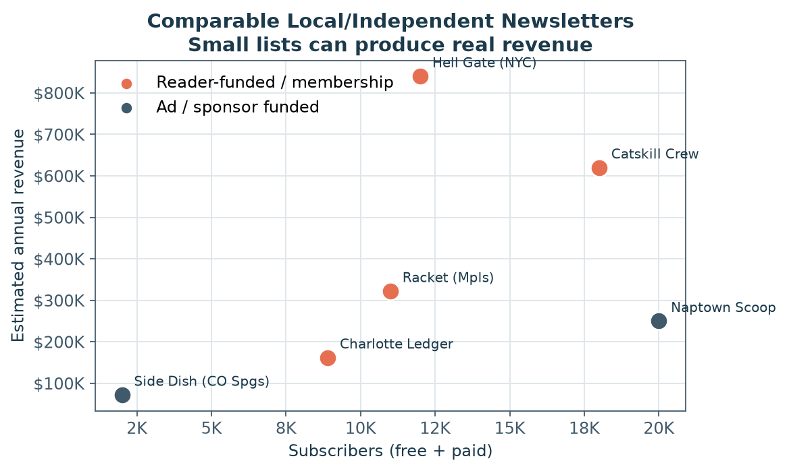
Figure 5. Revenue vs. list size for comparable operators. Reader-funded models (orange) extract far more value per subscriber than ad models.
4.5 The Discovery Engine — the asset that powers it all
Brief Scout Media is not merely a newsletter that scouts; it is a local discovery engine that happens to publish a newsletter. The company systematically mines public signals — the county's weekly new-business licenses, a satellite-town beat from LaFayette to Cleveland to the Sequatchie Valley, the maker markets and the food incubator — and uses AI to find and pre-research candidates, with a human always verifying, visiting, building the relationship, and writing the story. The newsletter is the most visible output of the engine, not the whole business.
The revenue model does not change — Brief Scout Media stays reader-funded (membership + products + events, no advertising). But the engine upgrades three things:
- A deeper moat. The promise becomes structural, not rhetorical: *we find the people building this city before anyone else, and we tell the truth about them.* Proprietary discovery is a fourth moat layer on top of trust, taste, and community — and the no-ads stance keeps it credible.
- A lower content cost. The expensive part of local media — finding and vetting what's worth covering — is largely automated, so a solo founder or tiny team can sustain newsroom-depth coverage. This makes the Year-1 'default-alive' economics safer and makes new verticals and new markets far cheaper to launch: the engine is the reusable asset carried into a food edition or a second city.
- A self-feeding flywheel. Events, products, and partner leads fall *out* of the pipeline rather than being separate lifts — Meet-the-Maker nights, a food-incubator showcase, maker guides, and a warm list of every new business the week it opens (celebrated editorially for free; the business-partner program kept walled and separate).
A new membership perk. The engine creates value that didn't exist before and that members will pay for: first word on new openings — the Insider's 'Just Licensed / Coming Soon' intel, delivered to members before the city knows. A concrete, unique reason to upgrade that lifts both conversion and retention.
The one rule. The engine *sources*; humans *own the trust*. AI finds and pre-vets; a real person verifies, visits, and writes in the Insider's voice. The moment it reads like an automated directory, the moat collapses — so the engine stays an internal weapon, never the product.
Engine-adjusted outlook (Years 2–3). Holding Year 1 as the conservative base case, the engine's two clearest effects — lower content/sourcing cost and the membership intel perk — improve the later years (with events and products also easier to source). The figures below are illustrative upside, not a replacement for the conservative base model in Section 9; notably, the engine-adjusted Year-3 total (~$310K) lands close to the focused-model estimate in Addendum 2.
Line item | Year 2 — base | Year 2 — engine | Year 3 — base | Year 3 — engine
Membership | $54K | $60K | $120K | $135K
Events | $40K | $44K | $105K | $115K
Products & commerce | $22K | $24K | $55K | $60K
Total revenue | $116K | $128K | $280K | $310K
Operating expenses | $34K | $30K | $84K | $76K
Owner's draw / profit | $82K | $98K | $196K | $234K

Table 4b. Discovery-engine-adjusted outlook (illustrative). Year 1 unchanged; Section 9 remains the conservative base case.
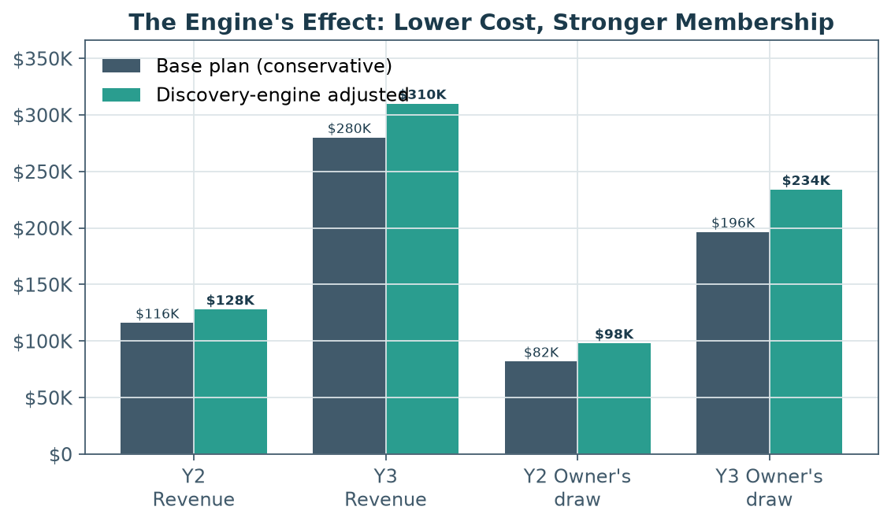
Figure 5b. The engine's two clearest effects — lower content cost and a stronger membership intel perk — lift owner's draw in Years 2–3.
4.6 Insider Insights — a fourth, walled revenue line (at scale)
Beyond the three reader-funded pillars, a fourth line emerges once the audience is large and well-profiled: Insider Insights, a permission-based local research practice. It monetizes the brand's scarcest asset — a trusted, engaged, demographically-profiled local audience — by selling aggregate insight, never identities (no PII; opt-in; aggregate-only; walled from editorial; strictly apolitical). It is fully consistent with the no-advertising promise: companies buy research, not the reader's attention.
Depth before monetization. It begins as contest-based onboarding micro-surveys that collect consented, first-party profile data (age, neighborhood, life stage, interests) — which sharpen content, products, and events *immediately*, before a dollar of external revenue. The dataset deepens into an opt-in 'Insiders' panel; house research ('The Scenic City Index') then establishes authority and B2B thought leadership; and only afterward do custom and sponsored panels open. (Full detail in the Insider Insights spec.)
Contribution (illustrative, deliberately back-loaded): roughly $0 external in Year 1 — the early payoff is internal, in better-targeted content, products, and events that lift conversion and retention — then on the order of $5–20K in Year 2 and $25–60K in Year 3 as the Index and custom studies mature. This is additive to the figures in Sections 4.5 and 9, and comes alongside the larger, unbookable payoff of local authority and brand.
5. Product & Editorial Strategy
5.1 The weekly Insider
Each issue is skimmable in five minutes and genuinely useful: a short read on the week's most important local development, a curated "what to do this week" events rundown, a local recommendation (a place, a person, a dish), and one practical civic or insider note. The voice is warm, opinionated, and unmistakably local. Quality and consistency are the product — the free issue is the funnel for everything else.
5.2 Membership tiers
Tier | Price | What's included | Role
Free | $0 | Weekly Insider newsletter; public event listings | Top-of-funnel; builds the list and the habit
Member | $8/mo or $80/yr | Members-only deep dives & archives; first word on new openings (the Insider's 'Just Licensed' intel); member event pricing; Insider Card discounts; community access | Core reader-revenue tier
Founding Member | $150/yr | All Member benefits + signature merch, name recognition, free annual signature-event ticket | Higher ARPU; superfans who fund the mission

Table 5. Membership tiers. Pricing sits within the proven local-media band and mirrors Charlotte Ledger / 404 Media / Defector.
5.3 The product ladder
The business is designed as an ascending ladder of commitment: a reader discovers the free Insider → becomes a habitual reader → attends a free or low-cost event → buys a guide or merch → converts to membership → upgrades to founding member and attends signature events. Each rung deepens the relationship and raises lifetime value, and every rung is reader-aligned.
6. Revenue Model — Deep Dive
6.1 Membership economics
The table below shows annual membership revenue at a mature free-list scale of ~26,000, across a realistic grid of conversion rates and prices (net of ~3% payment processing). The base case — ~5% conversion at $80–$100 — produces a six-figure membership line on its own.
Conversion (on 26K list) | $80/yr | $100/yr | $120/yr
3% (780 members) | $61K | $76K | $91K
5% (1,300 members) | $101K | $126K | $151K
7% (1,820 members) | $141K | $177K | $212K

Table 6. Annual membership-revenue sensitivity (net of payment fees).
6.2 Event economics
Events range from low-cost community gatherings to a signature annual festival. Illustrative unit economics for representative event types:
Event type | Typical attend. | Ticket | On-site spend | Est. net to Insider | Strategic role
Member mixer (JV bar/venue) | 60 | Free / $5 | $5–10 | $300–600 | Retention + funnel
Tasting walk / sip & stroll | 150 | $40 | $15–20 | $3,500–4,500 | Ticket + partner share
Newcomer night (quarterly) | 100 | $25 | $10 | $1,800–2,500 | Onboards transplants
Signature festival (annual) | 1,500 | $35 | $50+ | $30,000–40,000 | Brand + sponsorship-free gate/commerce

Table 7. Illustrative event unit economics. Ticket and on-site figures benchmarked to local consumer-event data (Eventbrite, Ticket Fairy, regional festivals).
Joint-venture structures keep events capital-light: the partner supplies the venue, alcohol license, and operations; the Insider supplies the audience and promotion; the two share gate and/or food-and-beverage revenue. Note that because the Insider takes no in-newsletter sponsorship, event sponsorship is treated separately — it is permissible to have a brewery co-host an event, since that is a partnership around an experience, not a sale of the reader's inbox attention. (If the founder prefers absolute purity, events can run on tickets and commerce alone.)
6.3 Products & commerce
Merchandise begins print-on-demand (zero inventory risk) and shifts proven designs to bulk screen-print (~$17/unit vs ~$42 on-demand) once demand is validated. Digital guides carry near-100% margins after creation. The Insider Card discount program is a recurring, partner-funded member perk that costs the Insider little and deepens member value. A job board/classifieds line adds modest, passive revenue ($200+/30-day listing).
7. Go-to-Market & Growth Strategy
Critical constraint: geo-restricted local newsletters generally cannot use the paid acquisition networks (beehiiv Boosts, SparkLoop) that national newsletters rely on, because those deliver out-of-market subscribers. Growth must therefore come from organic, referral, and partnership channels — which research confirms are both the most effective and the most trusted for hyperlocal (42% of operators rank word-of-mouth #1; referral programs add ~17% to growth).
- Referral engine. A built-in referral program (milestone rewards: stickers → merch → free membership month) turns readers into recruiters — the top growth lever for comparable operators.
- Local partnerships. Co-promotion with breweries, coffee shops, gyms, neighborhood associations, the startup ecosystem (CO.LAB, the Edney/Innovation District), realtors, and relocation services — especially powerful given heavy in-migration.
- Events as acquisition. Every event is a list-building machine; attendees join on the spot.
- Organic social & content. Short-form local video and Instagram/Facebook (where ~60% of younger residents discover events) drive inbound signups; the Insider's POV makes it shareable.
- Newcomer funnel. A free "New to Chattanooga" guide as a signup magnet targets the fast-growing transplant population precisely when they're hungry for local guidance.
Target trajectory (organic-led): ~7,000 free subscribers by end of Year 1, ~16,000 by Year 2, ~28,000 by Year 3 — well within demonstrated local benchmarks (Mirror Indy grew its list +608% in year one; Catskill Crew went 0→10,000+ in under a year).
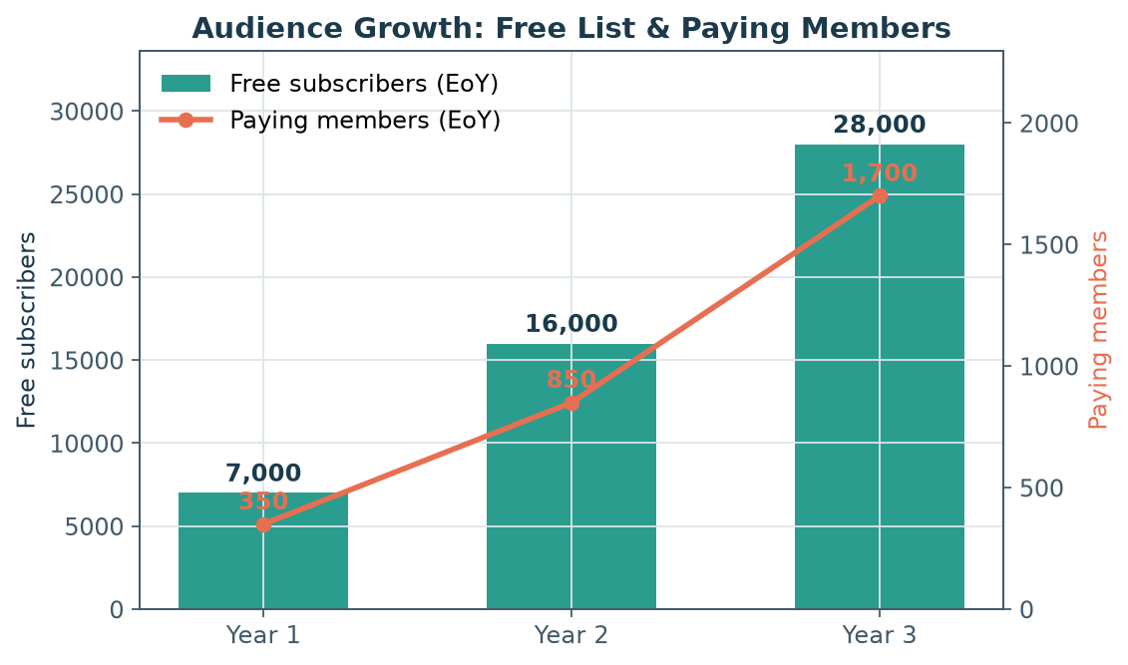
Figure 6. Modeled audience growth. The free list is the funnel; paying members are the conservative 3–6% who convert.
8. Operations & Technology
The operating philosophy is lean: a single founder-operator at launch, low fixed costs, and a platform that does not tax subscription revenue. Contractors (a part-time editor, an events/ops helper) are added as revenue allows, primarily in Years 2–3.
8.1 Platform selection
The recommended platform is beehiiv (or self-hosted Ghost): both charge 0% on subscription revenue, unlike Substack's 10% cut. On a $10 subscription, beehiiv/Ghost net ~$9.41 after Stripe vs. ~$8.41 on Substack — a ~12% revenue difference that compounds at scale.
Platform | Indicative price | Cut of sub revenue | Notes
beehiiv | Free to 2,500; Scale ~$43–49/mo | 0% | Built-in paid subs, referral engine, web
Ghost (Pro) | Publisher ~$29/mo (annual) | 0% | Own-your-stack, memberships, 0% fee
Substack | $0 platform fee | 10% + Stripe | Easiest start; discovery network
Kit (ConvertKit) | Free to 10K; Creator ~$33/mo | n/a (ESP) | Automation-heavy; no native paywall
Mailchimp | From ~$13/mo | n/a | General ESP; weak for paid membership

Table 8. Platform comparison. beehiiv and Ghost avoid taxing subscription revenue. Prices are 2026 indicative; verify on vendor pages.
8.2 Cost structure & startup costs
Pre-launch item | Cost
LLC formation + basic legal | $800
Brand identity, logo & website setup | $1,500
Platform & tools (3-month runway) | $200
Initial merch / design + launch event | $1,500
Contingency | $1,000
Total startup capital | ~$5,000

Table 9. Startup capital requirement (lean, solo). Consistent with the $1,500–$5,000 range for solo local newsletters.
Ongoing tooling is remarkably cheap — roughly $60–$130/month early (ESP + Canva + domain) — so operating break-even on tools alone is just ~6 members or one small event. The dominant "cost" of this business is the founder's time, which is why the financial plan treats owner's compensation as the key milestone rather than tooling break-even.
9. Financial Plan
9.1 Key assumptions
- No advertising or sponsorship revenue in any year (the core thesis).
- Free list: 7,000 / 16,000 / 28,000 (end of Years 1–3), organic-led.
- Paying members: 350 / 850 / 1,700 (EoY) — a conservative 3–6% of the free list.
- Blended membership ARPU ~$90/yr net of payment fees; ~3–4% monthly churn.
- Events scale 3 → 7 → 12 per year, adding a signature festival in Year 3.
- Products scale with brand: merch, guides, Insider Card, specialty items.
- All event and product figures shown net of direct costs (COGS, venue/JV share).
9.2 Three-year revenue build
Revenue stream | Year 1 | Year 2 | Year 3
Membership | $16K | $54K | $120K
Events | $9K | $40K | $105K
Products & commerce | $6K | $22K | $55K
Total revenue | $31K | $116K | $280K

Table 10. Revenue build by stream.
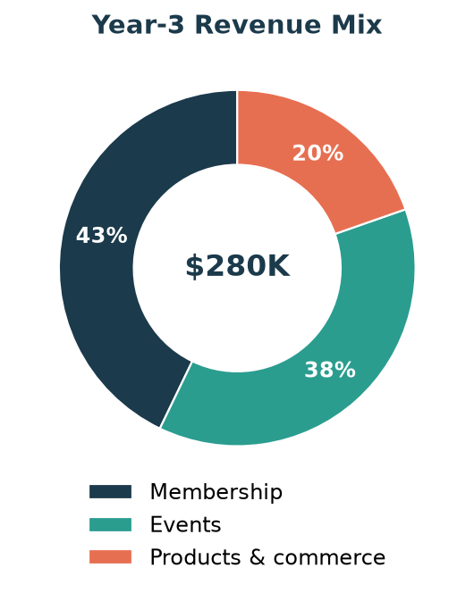
Figure 7. Year-3 revenue mix — diversified across all three reader-funded pillars.
9.3 Profit & loss summary
Line item | Year 1 | Year 2 | Year 3
Total revenue | $31K | $116K | $280K
Operating expenses | $10K | $34K | $84K
Tools / platform | $1,800 | $2,600 | $3,500
Marketing / growth | $3,000 | $7,000 | $14,000
Legal / admin / accounting | $2,200 | $3,500 | $5,000
Contract content / team | $2,000 | $18,000 | $55,000
Misc / contingency | $1,500 | $3,000 | $6,000
Owner's draw / net profit | $20K | $82K | $196K

Table 11. Simplified P&L. Sub-lines of operating expenses are indented.
Interpretation. Year 1 is validation: a ~$20K owner's draw alongside a likely day job. Year 2 approaches a full-time income (~$82K) as membership compounds and events scale. Year 3 supports a full founder salary plus a part-time contractor team (already inside operating expenses) with profit to reinvest — roughly the ~18-month-to-profit arc 6AM City reports for new markets, achieved here without advertising. An engine-adjusted view (Section 4.5) raises Year-2 owner's draw toward ~$98K and Year-3 toward ~$234K as content costs fall and the membership intel perk lifts conversion.
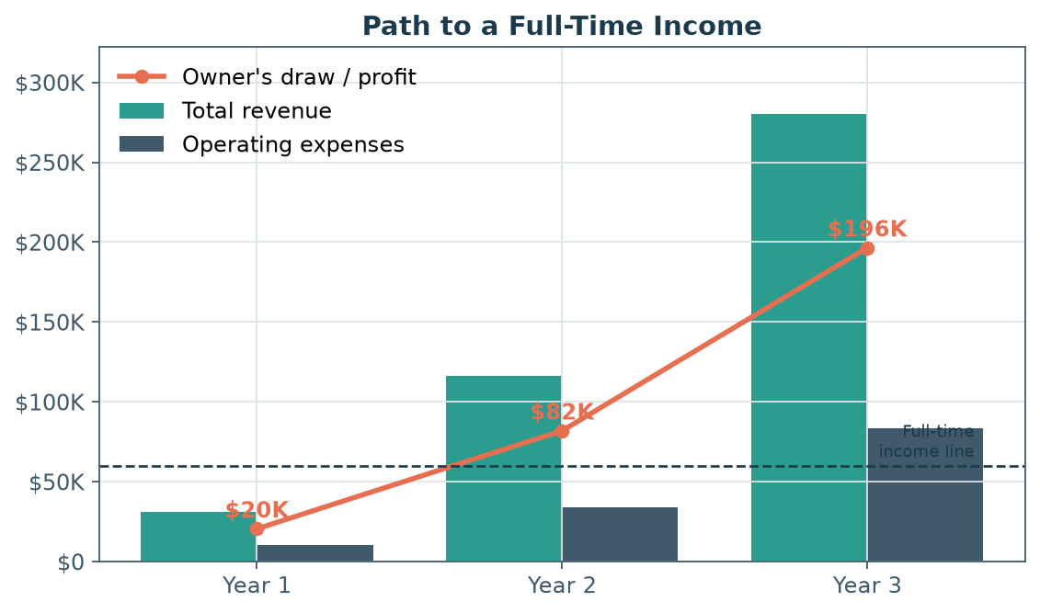
Figure 8. Revenue, operating expenses, and owner's draw. The founder crosses a full-time income line during Year 2.
9.4 Scenario analysis
Scenario | Y3 free list | Y3 members | Y3 revenue | Drivers
Conservative | 20,000 | 1,100 | $180K | Slower list growth; events ramp delayed
Base | 28,000 | 1,700 | $280K | Plan assumptions as modeled
Optimistic | 38,000 | 2,600 | $420K | Strong referral flywheel; festival overperforms

Table 12. Three-year (Year-3) scenarios. Even the conservative case clears a full-time income.
10. Risks & Mitigations
Risk | Severity | Mitigation
Slow monetization / long ramp | High | Local media takes ~18+ months to profit; capitalize for a long runway, keep costs near-zero, validate willingness-to-pay early with a founding-member presale.
Founder burnout | High | Weekly (not daily) cadence; templatized production; bring on a part-time editor in Year 2; protect a sustainable workload.
Unproven local willingness-to-pay | Medium | No paid independent newsletter exists here yet — run a paid founding-member presale before launch to prove demand; lean on events/products if conversion lags.
Incumbent response (NOOGAtoday) | Medium | Compete on quality, curation, community and events, not volume; the incumbent's ad model can't easily add a premium paid tier without conflict.
Platform / deliverability dependency | Medium | Own the email list; choose a portable platform (beehiiv/Ghost); monitor inbox placement; never rely on a single social channel.
Over-reliance on one stream | Medium | Three pillars by design; target no single stream >50% of revenue (mirrors Catskill Crew's 11-stream resilience).
Affordability ceiling (city poverty ~19%) | Low | Free tier keeps the brand universally accessible; paid tiers target the affluent, growing transplant segment.

Table 13. Risk register.
11. Roadmap & Milestones
Phase | Key milestones
Pre-launch (Mo. 0–2) | Form LLC; build brand & site; choose beehiiv; line up 5–10 launch partners; open founding-member presale to validate demand.
Launch (Mo. 3) | Publish first weekly Insider; activate referral program; host launch event.
Mo. 3–12 | Grow to ~7,000 free / ~350 members; run 3 events; ship first guide + merch drop.
Year 2 | Scale to ~16,000 free / ~850 members; 7 events incl. quarterly ticketed; add part-time editor; launch Insider Card.
Year 3 | ~28,000 free / ~1,700 members; 12 events incl. signature festival; full-time founder + contractor team; evaluate a second edition/vertical.

Table 14. Phased roadmap.
12. Conclusion
Brief Scout Media is a focused bet on a simple, evidence-backed idea: in a city losing legacy news but gaining engaged, affluent newcomers, a beloved weekly newsletter can be funded directly by the people who read it — through membership, products, and events — rather than by advertisers. The Chattanooga market is large, growing, wired, and event-rich; the competitive lane for a premium reader-funded brand is wide open; comparable operators from Catskill Crew to Charlotte Ledger to Defector prove the model pays; and the capital required is small. The plan is conservative by design and still reaches a full-time founder income within roughly 18–24 months, on three diversified, mission-aligned revenue streams. The path is demanding — local media rewards patience and consistency — but the structure is sound and the timing is right.

Appendix — Selected Sources
This plan synthesizes a multi-source research effort. Key references by theme:
Local news & newsletter industry
- Northwestern Medill, State of Local News 2024 — localnewsinitiative.northwestern.edu
- Press Gazette, 6AM City / Axios Local coverage (2024) — pressgazette.co.uk
- Newsletter Operator; HubSpot State of Newsletters 2025; ClickMinded Newsletter Statistics 2026
- beehiiv — Catskill Crew case study; Side Hustle Nation — Naptown Scoop ($200K)
Reader-revenue & membership economics
- Lenfest Institute — Business Models for Local News; American Press Institute — subscriber retention
- Membership Puzzle Project — The Membership Guide; Piano — Subscription Performance Benchmarks 2024
- Substack conversion analyses (Simon Owens; yana-g-y); Nieman Lab — Defector, Hell Gate, 404 Media, Racket
- Editor & Publisher — Charlotte Ledger, Cityside/Berkeleyside; Colorado Sun
Events as media revenue
- Adweek / Digiday — TIME, Semafor, Bloomberg, Atlantic, Forbes events revenue (2024–2026)
- A Media Operator — Financial Times / FT Live 2024 results; Eventbrite TRNDS Report; Ticket Fairy festival economics
Platforms, products & costs
- beehiiv, Substack, Ghost, Kit, Mailchimp pricing (2026); Stripe / Wise fee guides
- TailorBrands / LLCUniversity — LLC formation costs; print-on-demand vs bulk merch economics
Chattanooga market
- U.S. Census Bureau QuickFacts; UTC Center for Regional Economic Research white papers (2026)
- Chattanooga Tourism Co. 2024 Annual Report; Tennessee Dept. of Tourist Development (2024)
- EPB 2024 Annual Report (Gig City fiber); Times Free Press; Chattanooga Chamber major-employers list
- Times Free Press, NOOGAtoday/6AM City, The Chattanooga Pulse, Chattanoogan.com, ChattaMatters
Note: several figures are operator anecdotes or industry estimates (flagged as such in the underlying research) rather than audited statistics; Chattanooga subscriber counts for competitors are self-reported. Verify load-bearing local figures (Times Free Press circulation, current competitor lists, Census household/income tables) directly before external use.

