BRIEF SCOUT MEDIA
The Portfolio — a town, a generation, and a table
How Scenic City Insider, Encore & Mise en Place roll up · all figures illustrative & conservative

One company, three audiences
Brief Scout Media isn't one product — it's a small house of titles on shared infrastructure, each serving a different audience with a different model. The discipline that holds it together is the bright line: the reader-funded titles keep their souls ad-free, and the sponsored title is openly, honestly sponsored. Same values, different engines.
Title | Audience | Model | The promise
Scenic City Insider | A town — Chattanooga | Reader-funded, no ads | Know the city deeply; the reader is the customer
Encore | A generation — accomplished 55–75, national | Reader-funded, no ads | Build what's next; members are the only customer
Mise en Place | A table — Chattanooga food & drink | Openly sponsored + events | Eat & drink well; sponsors labeled, picks never for sale

Two reader-funded titles for trust and depth; one sponsored title for cash flow and joy. The sponsored engine can even help fund the patient ones.
The combined revenue shape
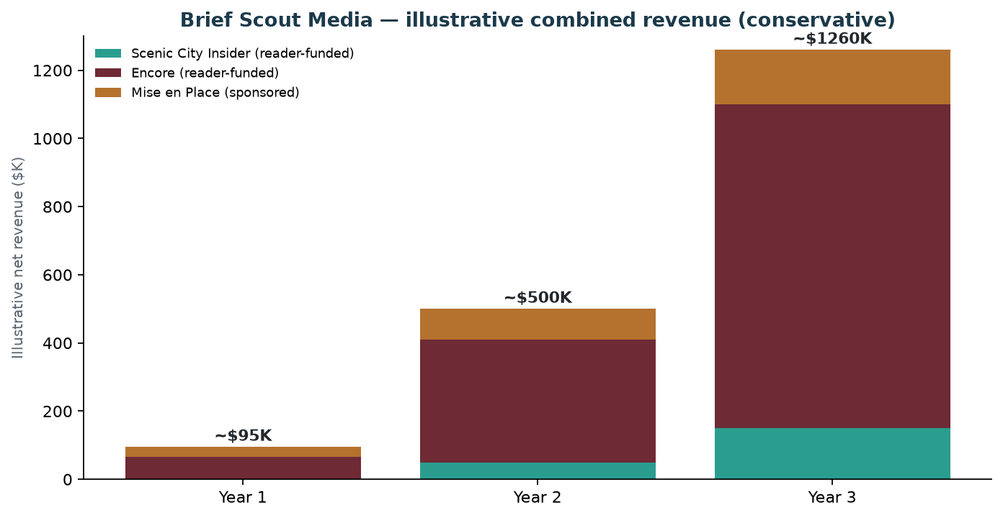
Illustrative, conservative — Encore is the scale driver, MeP the early local cash flow, SCI the patient premium soul.
Year | SCI | Encore | MeP | Combined (illustrative)
Year 1 | ~$0 (build) | ~$65K | ~$30K | ~$95K
Year 2 | ~$50K | ~$360K | ~$90K | ~$500K
Year 3 | ~$150K | ~$950K | ~$160K | ~$1.26M

Read it as shape, not forecast. Each title's revenue lives in its own model doc; this simply stacks them. Encore carries the ceiling (national + affluent + events), MeP delivers early local cash and joy, SCI compounds slowly toward its 200×$1,000 premium core.

Shared infrastructure — why a house beats three startups
- One production system — the HITL + AI workflow and the Scouts-and-Nerds research pipeline serve all three titles.
- One stack — beehiiv, the brand toolkit, the events playbook, the membership plumbing — built once, reused.
- Cross-pollination — SCI and MeP share Chattanooga ground (cross-promote freely); Encore brings the national, affluent reach. A reader can belong to more than one.
- One founder voice & credibility — the retired-CEO-and-author standing underwrites all three; the certifications (WSET/bourbon) feed MeP specifically.
- Shared events muscle — the dinner/retreat/supper-club operating model transfers across titles.
The real constraint: founder bandwidth — so sequence it
You cannot run three weeklies, three events calendars, a credential ladder, and a book at once, solo. The portfolio is a *destination*, reached in order. A sensible sequence:
Phase | Lead with | Why | Add when ready
Now → Yr 1 | Scenic City Insider (the soul) | It's the flagship and the trust engine; patient by design (little Y1 revenue) | Open founding-member waitlists for all three
Yr 1 → 2 | Mise en Place (cash + joy) | Fastest to revenue (events + sponsors), ties to your passion & certs, shares Chattanooga ground with SCI | Stand up the Supper Club; begin SCI membership
Yr 2 → 3 | Encore (the ceiling) | Most personal and the biggest revenue ceiling; needs the network and your time | Cohorts, retreats, the Founders' Circle

Alternative: if energy pulls you to MeP first (passion + fast cash), lead there and let SCI build alongside — the order is yours; the point is *one at a time gets the founder's full heart*.
What the house adds up to
Three honest titles, two engines, one set of values: a town, a generation, and a table. Conservatively, the portfolio reaches roughly $1M+ in combined revenue by Year 3 — but the truer measure is that each title is something you'd be proud to make, funded by the people it serves (or by clearly-labeled sponsors who never buy a word). Built once as a house, on shared rails, it's far more achievable than three separate startups — and it's unmistakably yours.
Each title's detail lives in its own docs: the business plan & manifesto (SCI), the concept brief & revenue model (Encore), and the one-pager, samples & revenue model (MeP).

