THE SCENIC CITY SCOUT
Competitive Landscape — and why reader-funded is open ground
The Chattanooga local-info field, verified June 2026 — by format, revenue model, and overlap with us
The one-sentence read
Almost every local-info product in Chattanooga is free to the reader and funded by advertisers, sponsors, or grants — the lone reader-paid product is the legacy daily, which is actively retreating from print. A reader-funded, no-ads, curated membership product is open ground. Our risk isn't a price war (you can't out-free a sponsor- or foundation-subsidized rival); it's the *events-calendar and community-bulletin* functions, which free incumbents do well. We win on curation, voice, reporting, and inbox ownership — not on being cheaper.
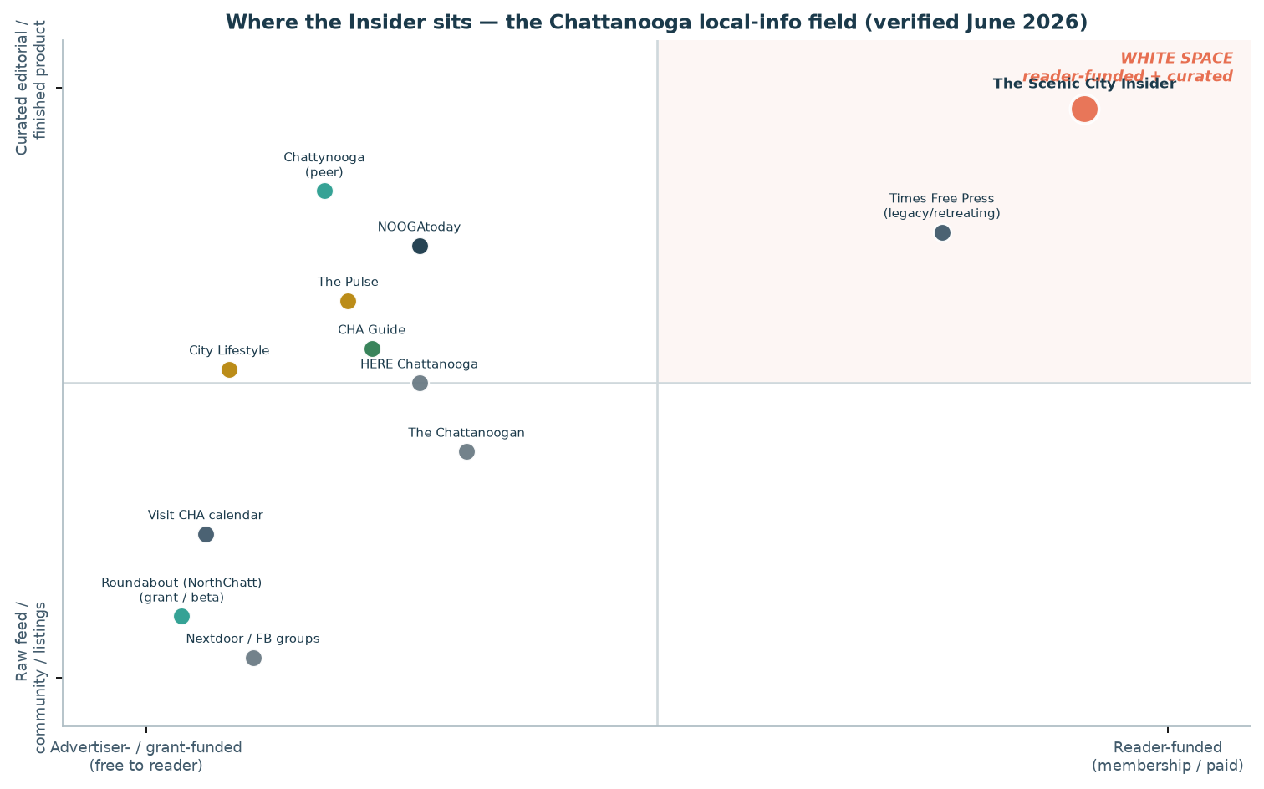
Funding model (left↔right) by product type (feed↔curated). The top-right quadrant — reader-funded + curated — is essentially unoccupied.

The field, outlet by outlet
Outlet | Type | Revenue model | Focus | Overlap with the Insider (our read) | Conf.
NOOGAtoday (6AM City) | Free daily email + web | Ads / sponsorship; free to reader | 'Need-to-know' news, things-to-do, events; broad audience | HIGH — same daily-newsletter habit & events hook. The scaled, professional incumbent. | High
Chattanooga Times Free Press | Daily news org; print + digital | Subscription / paywall + ads | Region's paper of record; full local + events (ChattNow) | MED — reader-paid like us, but legacy & retreating (weekday single-copy retail ended Jan 2026; Sunday print only). | High
Chattynooga | Weekly email newsletter | Free; word-of-mouth + paid Meta ads; occasional creative sponsorship | 'Porch-level' feel-good stories, neighbors, events; ~900 subs | HIGH (tone) — closest in spirit (warm, curated, hyperlocal). Also stewards Roundabout NorthChatt. The peer to know. | High
Roundabout / New_ Public | Local community app (AT Protocol) | Grant / philanthropy; free; revenue model undefined | Channels + events calendar + guides; suburban ring; closed beta | LOW-MED — community feed, not editorial. Adjacent; possible channel/tip-line, not a substitute. | High
CHA Guide | Weekly email + mobile app | Free; local-partner content | Upbeat 'positive news,' events, restaurants, experiences | MED — curated discovery overlap; free/partner-funded. | Med
HERE Chattanooga | Local news site + newsletter (HERE network) | Advertising + paid services / press releases | Local news, business, lifestyle; Hamilton County | MED — ad-funded local news; events & business overlap. | Med
The Pulse | Alt-weekly, now online-only (Brewer Media) | Ads; free | Arts, music, culture, dining; young professionals | MED — culture/events calendar overlap; print suspended 2020. | High
The Chattanoogan | Free web-only daily | Free; ad-supported (inferred) | Breaking news, obituaries, gov't, business; since 1999 | LOW — hard news/record, not curated lifestyle. | Med
Chattanooga City Lifestyle | Glossy lifestyle mag/site (franchise) | Advertising (franchise) | Affluent lifestyle features | LOW-MED — advertiser-driven by design; opposite of our bright line. | Med
Visit Chattanooga / Nextdoor / FB groups | Tourism calendar + social platforms | Tourism-funded / free ad platforms | Events listings; neighbor chatter & recommendations | MED (events) / LOW (editorial) — discovery & community substitutes, not finished editorial. | Med

Sources & confidence per row in competitive_landscape.csv. 'Overlap' is our editorial judgment, not the outlet's claim.
What this means for us
- Don't compete on price — compete on the finished product. Sponsor- and grant-funded rivals are free forever; we can't and shouldn't undercut. We sell curation, voice, trust, and a no-ads promise the ad-funded field structurally can't make.
- Defend the events overlap with a point of view. A free calendar is a commodity; 'the five things actually worth your Saturday, chosen by a neighbor' is not. Curate, don't list.
- Treat Chattynooga as the peer to know, not the enemy. Same warm, hyperlocal lane; it also stewards Roundabout NorthChatt. Coopetition, cross-promo, and shared respect beat a turf fight in a small town.
- Use Roundabout as a channel, not a worry. A trust-first community feed is a clean Insider tip-line and a place to seed content that drives signups — adjacent infrastructure, not a substitute for editorial.
- Watch two triggers: (1) anyone standing up a strong *metro* (not suburban) Roundabout, and (2) any free outlet moving into original *reporting* with a paid tier. Either narrows the white space.
- Own the bright line publicly. In a field where the reader is usually the product sold to advertisers, 'the reader is the customer — never the product' is both true and a differentiator. Say it often.

Positioning paragraph for the beehiiv About page
Drop-in copy that distinguishes a curated, reader-funded newsletter from a community feed and from ad-funded roundups — without naming competitors or going negative. Matches the existing About voice (a real local neighbor, not private equity).
Primary — for the About page (≈90 words):
A quick word on what the Insider is, and isn't. It isn't a feed to scroll, a community bulletin board, or a roundup paid for by the places it covers. There are good versions of all of those in town, and I read them. The Insider is something narrower: one carefully made issue a week, written by a neighbor, paid for by you. No ads, ever, and no sponsored sentences — because the day a business can buy its way in is the day you stop being able to trust what's here. My only job is to be worth your inbox.

Short — for a footer, signup form, or 'why pay?' line (≈30 words):
No ads. No sponsorships. No sponsored sentences. The Insider is one curated issue a week, written by a neighbor and paid for by readers — so the reader is the customer, never the product.

One-liner — tagline / social bio:
A curated weekly for Chattanooga — reader-funded, ad-free, written by a neighbor. The reader is the customer, never the product.

Plain-text and HTML versions of these are saved alongside this doc (insider_positioning_about.txt / .html) for pasting into beehiiv.

