THE SCENIC CITY SCOUT
Content Architecture
The section catalog, weekly issue template, a 12-week rotation, the membership tiers, and how every section feeds the business

The principle: no commodity content
The free incumbent owns the commodity lane — the generic event calendar, weather, traffic, national headlines, paid 'best-of' lists. We run none of it. Every section in this architecture is a point of view only the Insider has, which is the reason a membership is worth paying for. The portfolio runs on three layers — Discovery (acquisition), Relationship (retention), and a Premium layer — and each section throws off a product, an event, or a membership perk, so the content *is* the reader-funded business model.
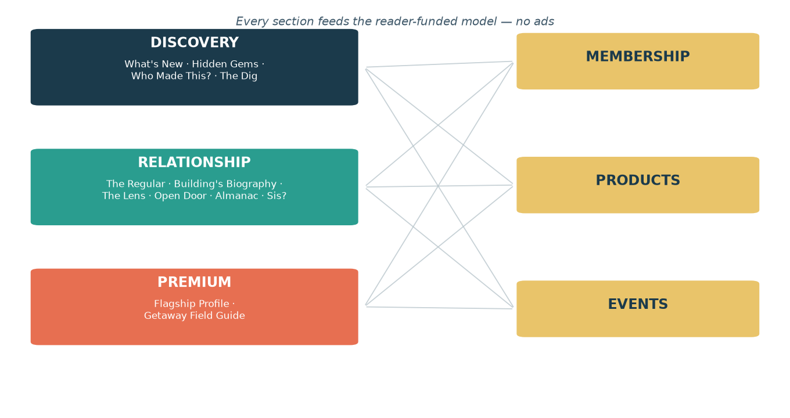
Figure 1. The content portfolio in three layers, every one feeding the ad-free model.
Editorial standards — The Once Rule & the Nerd's veto
These are non-negotiable, because repetition and filler make independent editorial look like advertising or automation — the two things that would destroy the brand's whole premise and the founder's personal credibility.
- The Once Rule. A business or location appears once per issue — never twice. Across a month, no more than twice, and twice is rare — reserved for genuine news (a closing, then later a reopening) and always from a *fresh* angle, never a repeat. Recurring *threads* are welcome; recurring *mentions of the same name* are not.
- Freshness across issues. Each issue's cast of businesses should be distinct from the last issue's. If a place was the Hidden Gem last week, it is not the 'now open' note this week.
- The Nerd's veto. The research layer does more than check facts — it kills copy that reads forced, lazy, padded, or 'paid-for,' and anything that smells like AI slop (recycled names, generic filler, the same story told twice). If it wouldn't survive a sharp local reader's eye, it doesn't run.
- The test before publish: would a skeptical Chattanoogan think this was written by a person who actually went there — or by a machine padding a template? Only the first ships.
The section catalog
Section | Layer | Frequency | The point of view | Primary monetization
The Insider's Note | Anchor | Every issue | Founder's voice — the human handshake an aggregator can't fake | Affinity & referrals
What's New Around Town | Anchor · Discovery | Weekly | Openings/closings + members-first 'Just Licensed' intel from the engine | Membership upgrade driver; new-opening crawl
You Told Us | Anchor | Weekly | The reader mailbag — community loop made visible | Word-of-mouth growth
The Standing Invitation | Anchor · Discovery | Weekly | One evergreen thing to go do, with a POV — the anti-calendar | Member archive; '52 Assignments' deck
Hidden Gems | Discovery | Weekly–biweekly | The under-covered, across the wider territory — press footprint of none | Hidden-Gems map; road-trip event
Who Made This? (Meet a Maker) | Discovery | Weekly | Everyday things traced to the local hands behind them | 'Made Here' guide; maker market; collab merch
The Dig (What's Going In There?) | Discovery | Monthly | The curiosity beat + development watch — license-engine powered | Insider-tier driver
The Regular / Last Call | Relationship | Biweekly | People, not businesses — and reverent goodbyes when one closes | Portrait book; tribute events
The Building's Biography | Relationship | Monthly | The story of the address — who was there before | Building-bio prints; ticketed history crawl
The Lens | Relationship | Monthly | The city reframed by one need (Free / Newcomer / After Dark…) | Themed guide & map products
The Open Door | Relationship | Monthly | Access & inclusion service journalism almost no one does | Accessible directory; walled partner program
Good Dog | Relationship | Monthly | The city through a dog's eyes | Dog map; 'Yappy Hour' event; walled pet-partner
What's Up, Sis? | Relationship | Monthly–bimonthly | Chattanooga's sister cities via the people here (no politics) | Supper-club events; 'Eat the World' passport; org partnership
The Scenic City Almanac | Relationship | Seasonal (+annual print) | The rituals that make a year here — traditions, not events | Annual printed Almanac; seasonal socials
The Flagship Profile | Premium | Monthly (long-form) | The prestige 'Artisans of Craft' profile — editorial, never bought | Anchors premium tier; annual 'Builders' book
The Getaway Field Guide | Premium | Monthly + quarterly | Where a Chattanoogan goes to leave town — curated, not a brochure | Print perk (premium magnet); Insider-led trips; DMO underwriting

Sixteen sections; any single weekly issue runs the anchors + 2–3 rotating pillars.

The weekly issue template
Slot | What runs
Every issue opens with | The Insider's Note → What's New Around Town
Every issue includes | The Standing Invitation (one thing to go do)
Every issue closes with | You Told Us (mailbag) → the no-ads promise + membership invite
Plus each week | 2 rotating signature pillars (see the 12-week rotation)
Monthly | The Flagship long-form (linked from the issue, lives on the site/premium)

A five-minute read: warm open, what's new, two rotating features, one thing to go do, the mailbag, and the membership invite.
A 12-week sample rotation
Illustrative placement — monthly and seasonal pillars recur on roughly the cadence in the catalog. Anchors (Insider's Note, What's New, The Standing Invitation, You Told Us) run every week and aren't repeated below.
Wk | Rotating feature A (discovery) | Rotating feature B (pillar) | Monthly / premium drop
1 | Hidden Gems | The Open Door
2 | Who Made This? | The Building's Biography | Flagship profile drops
3 | Hidden Gems | The Lens — 'Free Chattanooga'
4 | Who Made This? | Good Dog
5 | Hidden Gems | The Dig — 'what's going in there?'
6 | Who Made This? | What's Up, Sis? — Accra/Ghana
7 | Hidden Gems | The Regular
8 | Who Made This? | The Almanac — the season turns | Getaway: Worth the Drive — Knoxville
9 | Hidden Gems | The Building's Biography | Flagship profile drops
10 | Who Made This? | The Lens — 'Newcomer's First Week'
11 | Hidden Gems | The Open Door
12 | Who Made This? | The Regular | Getaway: The Long Weekend — Asheville (quarterly)

The membership ladder
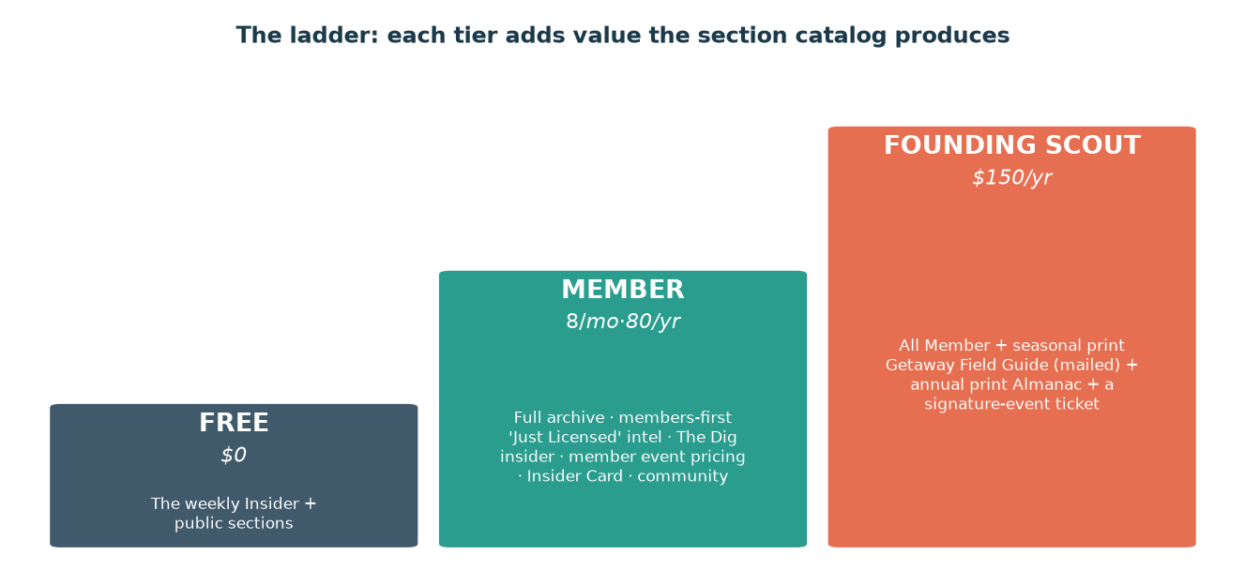
Figure 2. Three tiers; each higher tier unlocks value the section catalog already produces.
Tier | Price | What you get
Free | $0 | The weekly Insider newsletter and public sections. Top-of-funnel; builds the list and the habit.
Member | $8/mo or $80/yr | Full members-only archive; members-first 'Just Licensed' intel; The Dig insider notes; the Standing-Invitation assignment archive; member event pricing; the Insider Card; community access.
Founding Insider | $150/yr | Everything in Member, plus the seasonal print Getaway Field Guide mailed to your door, the annual printed Scenic City Almanac, a free signature-event ticket, the Flagship in print, and name recognition.

Free acquires; Member is the core reader-revenue tier; Founding Insider is built around the print perks (Getaway Field Guide + Almanac).

Content → revenue map
How each monetizable section converts into the three reader-funded lines (products, events, membership/partner) — no advertising anywhere.
Section | Product | Event | Membership / walled partner
What's New / The Dig | — | New-opening crawl | Members-first intel (upgrade driver)
Hidden Gems | Hidden-Gems map/guide | Gem-hunting road trip | —
Who Made This? | 'Made Here' field guide; maker merch | Maker market | Maker collabs
The Standing Invitation | '52 Assignments' deck | — | Member archive
The Regular / Last Call | 'Regulars' portrait book | Tribute / legacy nights | —
The Building's Biography | Building-bio prints | Ticketed history crawl | JV with featured venues
The Lens | Themed guides & maps (Free/Date/Newcomer) | — | Newcomer guide as signup magnet
The Open Door | 'Accessible Chattanooga' directory | — | Walled business-partner listings
Good Dog | Dog-friendly map | 'Yappy Hour' | Walled pet-business partners
What's Up, Sis? | 'Eat the World' passport | Sister-city supper club | Sister Cities org partnership
The Scenic City Almanac | Annual printed Almanac (giftable) | Seasonal socials (strawberry, leaf-turn) | —
The Flagship Profile | Annual 'Builders' book | — | Anchors the premium tier
The Getaway Field Guide | Seasonal print guide (premium perk + sales) | Insider-led group trips | DMO / destination underwriting (walled)

Walled partner lines (Open Door listings, Good Dog pet-partners, Getaway/DMO underwriting, the Insider Card) follow the bright line: a business can buy a booth, a listing, a ticket, or sponsor an experience — never a sentence of editorial.

