ENCORE
For people whose best work is still ahead.
Concept brief — positioning, audience, content, community & model · a Brief Scout Media title · working title, name pending vetting

The thesis — and the white space
Retirement is a 20th-century idea. A growing cohort of accomplished people in their late 50s, 60s, and early 70s are not winding down — they're reloading: starting second companies, buying and running small businesses, angel investing, taking board seats, mentoring, writing the book, making the art, traveling with intent. They have capital, time, hard-won judgment, and restlessness. And almost no one is making smart, ambitious media for them.
The market insults this reader from both sides. Retirement media frames them as declining — Medicare, downsizing, estate planning, golf. Startup, creator, and business media is obsessed with the 25-year-old founder and ignores them entirely. The intersection — *ambitious media built for the 55+ reader* — is open ground.
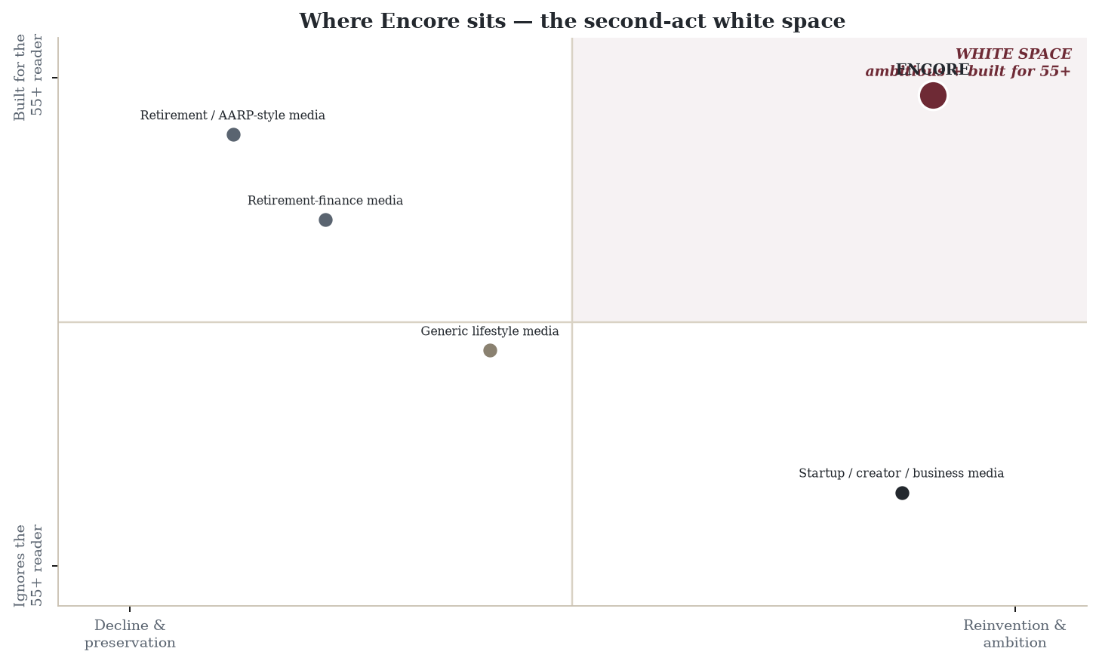
The second-act white space: the upper-right quadrant — reinvention-minded AND built for 55+ — is essentially unoccupied.
Why this is defensible — the founder is the moat
Encore's unfair advantage is that the founder is the reader: a retired CEO, the author of four books, in the middle of his own creative second act, openly looking for deeper connections with people doing the same. You cannot fake that. The voice has standing the moment it speaks, and the audience trusts a peer in a way it never trusts a 30-year-old editor explaining their lives back to them. Add the reader-funded ethic of the wider company — no one's attention is sold — and a community that compounds, and you have a brand that's hard to copy and easy to love.
Who it's for — five overlapping readers
The reader | What they're doing | What Encore gives them
The Founder-Again | Starting a second company or buying a small business | Playbooks, peers, and proof it's done after 55
The Angel / Investor | Deploying capital, joining boards, syndicates | How-to, deal-adjacent community, judgment
The Creator | Writing the book, making the art they deferred | Craft, encouragement, fellow late-bloomers
The Mentor / Operator | Advisory, fractional, board & nonprofit work | Ways to contribute that use the whole career
The Explorer | Reinventing the life — travel, learning, place | Expeditions, curricula, intent over idleness

The common thread isn't age — it's posture. Experienced, resourced, and not done.
The weekly — content architecture
Each section is a distinct point of view a competitor can't cheaply copy, and each ties to revenue without selling editorial.
Section | Frequency | The point of view | Monetization
The Opening | Weekly | The founder's first-person essay on the second-act life — the heart of the thing | Halo; the voice that drives membership
The Encore Profile | Weekly | Long-form profile of someone who reinvented after 50 — inspiration with receipts | Flagship shareable; series sponsor; book ties
The Playbook | Weekly | Tactical how-to for a second-act move (angel checks, buying a business, board seats, publishing) | Premium deep-dives; cohorts; partner tools
The Ledger | Biweekly | Money for deploying wealth, not just preserving it — the opposite of retirement-income content | Walled fee-only advisor partners (labeled)
The Table | Weekly (members) | The community: member asks & offers, intros, co-founder / advisor / investor matching | THE membership driver; directory; events
The Expedition | Monthly | Travel & experience with intent — sabbaticals, learning trips, working from elsewhere | Member retreats & trips (high-margin events)
The Long Game | Monthly | Health-span, relationships, meaning, legacy — performance, never decline | Longevity / coaching partners; retreats
Last Word | Weekly | A provocation to carry into the week | Shareable; brand

The membership & community model
This audience values connection and contribution over price — which is why community and events monetize far better here than advertising ever could, and why membership can begin earlier than a local newsletter's.
- Free — the weekly Opening, the Profile, and Last Word. The front door.
- Member (~$20–30/mo or ~$200–300/yr) — the full weekly, the archive, and The Table: the member directory, asks-and-offers board, intros, and online gatherings. The network is the product.
- Founding Circle (premium / invite, ~$1–3K/yr) — curated dinners, small peer cohorts (mastermind-style), priority on retreats, and direct access. This audience pays for the *room*.
- Events & retreats — the largest line: Encore Retreats, regional dinners, and peer cohorts. A high-margin, high-trust monetizer the ad model can't touch.
- Curated commerce & walled partners — books, tools, experiences, and clearly-labeled premium partners (fee-only advisors, longevity, education, travel). Same bright line as the rest of the company: a partner can sponsor a room or a guide — never a sentence of editorial.
Adjacent, not derivative — Encore and ROAR
The most credible incumbent is Michael Clinton's ROAR forward — a Hearst-backed platform built on his book *ROAR* (and the newer *Longevity Nation*). His body of work and Rolodex are exceptional and not worth copying. The good news: ROAR's center of gravity is B2B 'longevity-economy' intelligence sold to brands (the ROAR Report, a sponsored-content studio, an invitational Hearst-Tower Summit), wrapped in inspiration and identity reinvention with a lifestyle/beauty tilt. That leaves a clean, defensible lane.
The one-line distinction: ROAR owns 'reinvent who you are.' Encore owns 'build what's next.'
Dimension | ROAR forward (Clinton) | Encore
Core promise | Reinvent who you are (identity / mindset) | Build what's next — the work of the second act
Founder authority | Famous publisher who reinvented himself | Operator — built, ran, exited; an author who did it
Shape | Broadcast: host → audience, role-model profiles | Peer network: members transact (The Table)
Money | Sells longevity insight to brands; sponsored content | Reader-funded; no ads, no brand deals
Audience | Broad 50+, lifestyle/beauty skew | Accomplished operators 55–75, builder energy
Content | Inspiration & profiles | Operational playbooks (angel checks, buy-a-business, boards)
Events | Hearst-Tower Summit (stage, keynotes) | Small working retreats (deal reviews, pitch & board prep)

Differentiation moves (adjacent, not derivative):
- Lead with playbooks, not profiles — the promise is 'you'll *do* a thing this quarter,' not 'feel inspired.'
- Make The Table the product, not a perk — member-to-member deal flow (asks/offers, angel syndicates, acquisition search, board matching). ROAR's members are an audience to monetize; ours are a network to transact in — a moat it can't copy without breaking its model.
- Bank the reader-funded vow loudly — 'no ads, no brand deals, we never sell you to marketers,' positioned directly against ROAR's sell-to-brands engine.
- Weaponize operator credibility — the real math and mistakes of building, not 'follow your passion'; a faculty of retired *operators*, not lifestyle experts.
- Sharpen the cohort — accomplished people 55–75 who are reinventing, *not* retiring; claim the builder/founder energy and the comparatively open operator lane.
- Make the network — not the founder — the durable asset early, so Encore outlasts any one voice (the risk both founder-led brands share).
Where not to fight: don't out-glossy ROAR on inspiration, don't chase its B2B 'sell longevity insight to brands' model (its core, with Hearst behind it), and don't stage a celebrity-expert summit. If Encore drifts into generic midlife/purpose/wellness content, it becomes a thinner ROAR. Stay on doing/building + peer deal flow + reader-funded — the lanes ROAR structurally cannot follow.
The name — an honest flag
'Encore' is a strong idea but a crowded word. Encore.org (now CoGenerate) literally pioneered the term 'encore careers'; Wynn's Encore casinos and various Encore media/ticketing brands exist too. So — exactly as we did for Scenic City Insider — the name needs a domain + USPTO/TESS clearance before any commitment, and the distinctiveness will likely have to live in a lockup (e.g., *The Encore Letter*, *Encore Society*) or an alternative entirely. Worth vetting alongside: Second Act, Act Two, The Third Act, Next Chapter, Reload, Vantage, Prime. Use 'Encore' as the working title; don't print it on anything yet.
How it fits Brief Scout Media
Encore is the third title in one portfolio, on shared infrastructure: the same HITL+AI production system, the reader-funded ethic, and the community DNA. It can even borrow a Signal-style data section — 'what second-act founders are quietly filing and funding' (their own Form Ds and trademarks) — and, later, local chapters that echo Scenic City Insider's place-based community. One company, three audiences: a town (Insider), an industry/market (The Signal), and a generation (Encore).
Launch path
- Months 1–6: publish the weekly; establish the founder's voice; grow the free list; open a founding-member waitlist.
- Months 6–12: turn on membership and The Table; host the first dinners and a pilot retreat; convert founding members (this audience pays sooner than a local list).
- Year 2+: scale retreats and cohorts; add walled premium partners; consider local chapters and the Signal-style data section.
Full sample first issue accompanies this brief.

