**HMI-Based Automated Warehouse Control System**

Table of Contents

Inroduction 3

HMI Screen Design 3

Root Screen (Mode Selection) 3

Automatic Mode Screen 4

HMI Project Setup in TIA Portal 8

Adding a New HMI Screen 8

Add a New Screen 10

Create Navigation Buttons 11

Editing "Automatic" Screen (Screen_1) 13

Add a Start Button 13

Add a Running Indicator (Lamp) 15

Display Target Position (I/O Field) 16

Add a Navigation Button to Return to the Root Screen 17

# **Inroduction**

This document provides a step-by-step guide to designing an HMI (Human-Machine Interface) system for an automated warehouse using Siemens TIA Portal. It covers setting up an HMI screen, configuring buttons, lamps, and numeric displays to control and monitor the system.

## HMI Screen Design

### Root Screen (Mode Selection)

* Two selection buttons:
  + **Automatic Mode**
  + **Manual Mode**

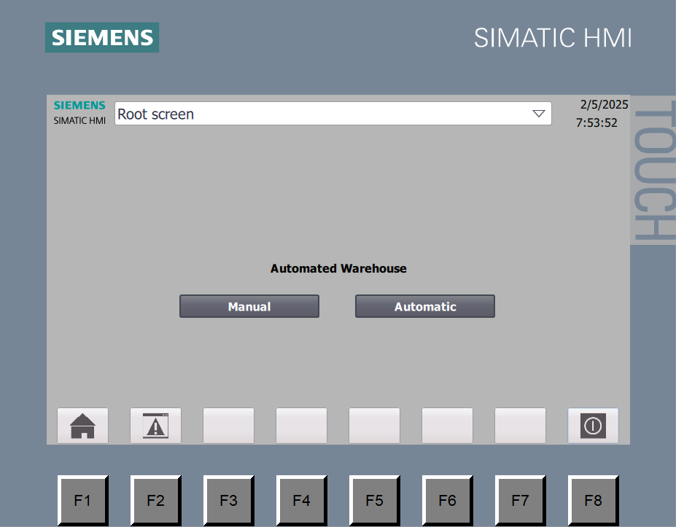

### Automatic Mode Screen

* **Start Button**: Activates warehouse automation.
* **Stop Button**: Stops the process.
* **Status Lamp**:
  + **Green** when the system is running.
  + **Red** when stopped.
* Display of the **target position** of the system.

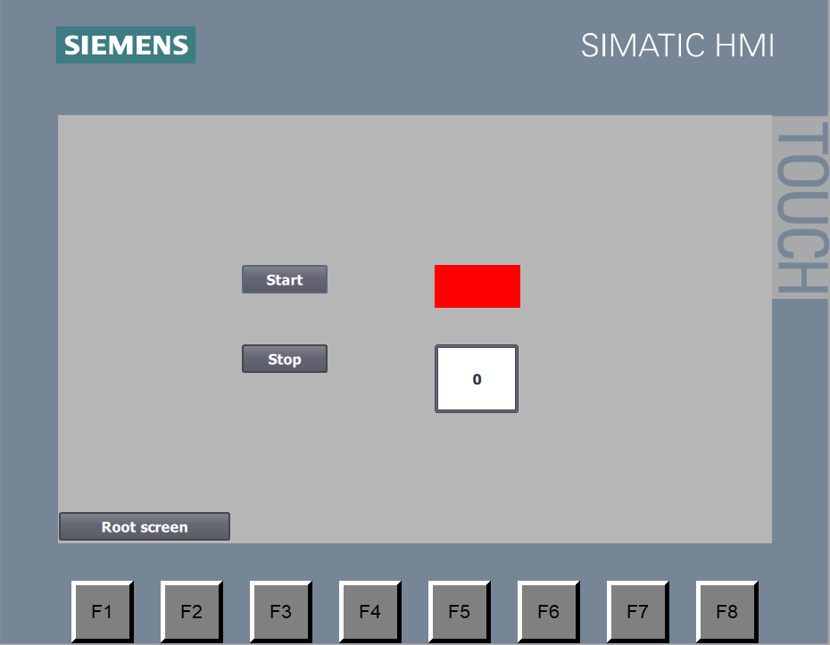

**2.**System Operation in TIA Portal

**1.** Startup and Mode Selection

* When the system starts, the **Root Screen** appears on the HMI.
* The user selects **Automatic Mode**, which navigates to a new screen containing:
  + **Start Button**
  + **Stop Button**
  + **Lamp (Status Indicator)**
  + **Target Position Display**

**2.** Start and Stop Button Logic

**2.1**. Start Button Behavior

When the **Start** button is pressed:

1. The **Start Lamp (HMI Lamp)** turns **Green**.
2. A Start Light is set in the PLC.
3. The **Warehouse Automation Process** begins.

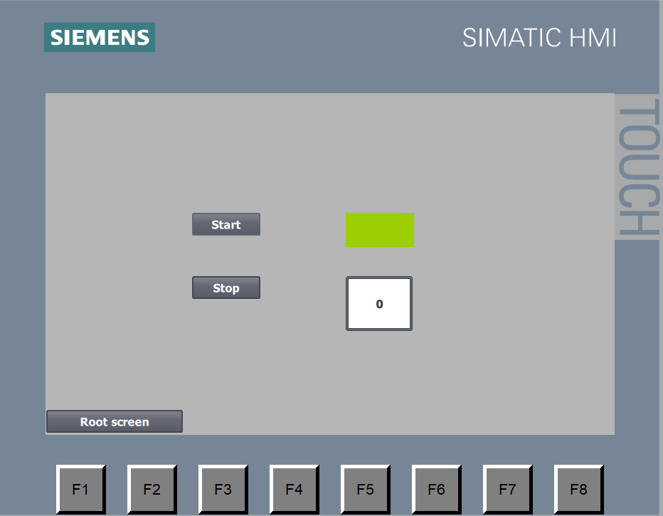

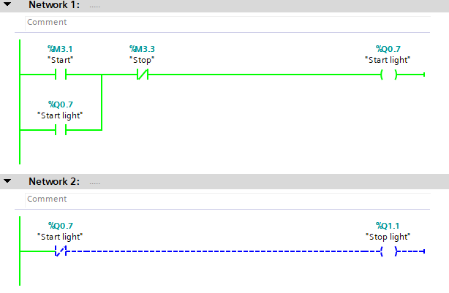

**2.2.** Stop Button Behavior

When the **Stop** button is pressed:

1. The **Start Lamp (HMI Lamp)** turns **Red**.
2. The **Start Light is reset** in the PLC and the Stop Light is set.
3. The **Warehouse Automation Process stops**.



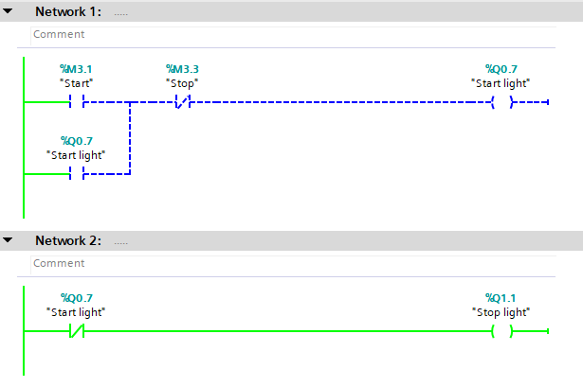

The **Target Position Screen** on the HMI is used to display the current target position of the automated warehouse.

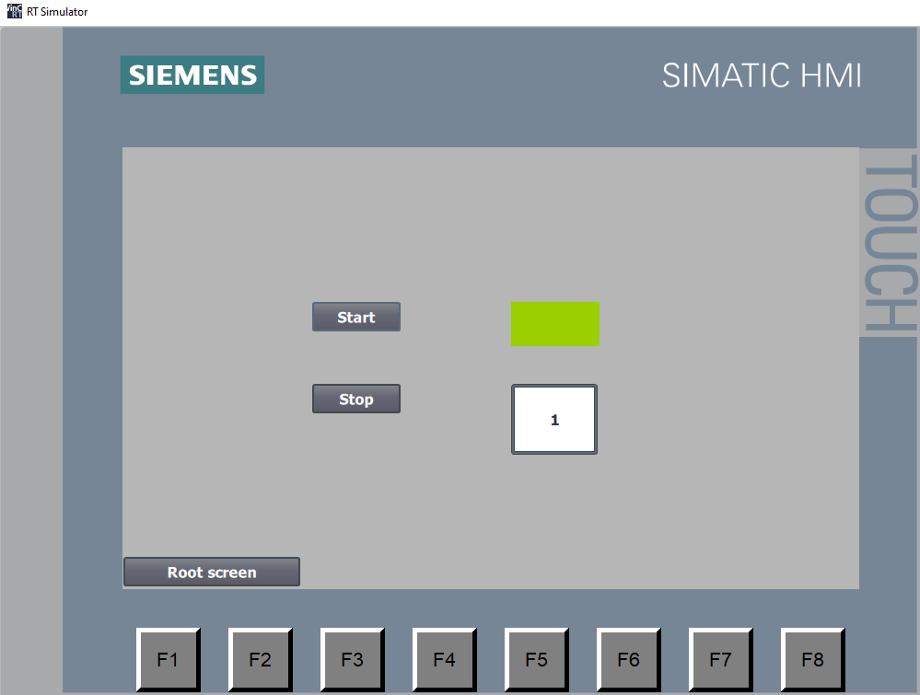

# HMI Project Setup in TIA Portal

## Adding a New HMI Screen

**1.**Add a New Device

1. In the **Project Tree** window, click **Add New Device**.
2. Select the appropriate HMI model, ensuring compatibility with your PLC.
3. Verify that the HMI supports the required communication protocol (e.g., **Profinet, Profibus, Modbus**).

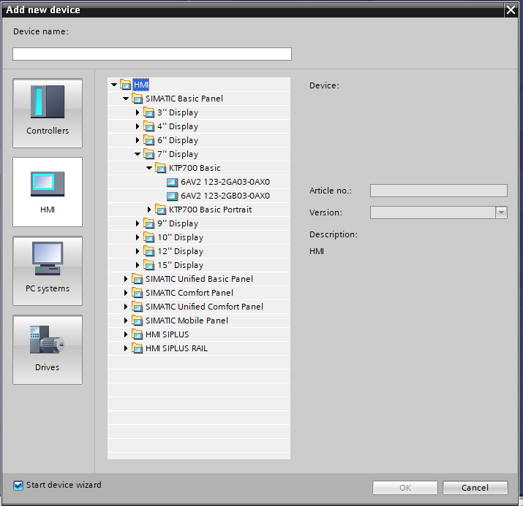

**2.**Connect HMI to the PLC

1. Establish a connection between the HMI and PLC within TIA Portal.

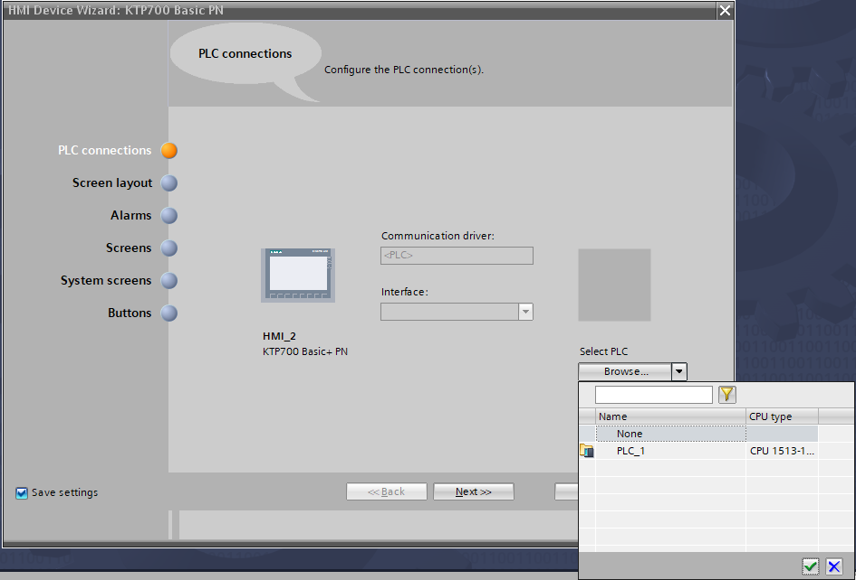

This is the Screen you will get after clicking finish.

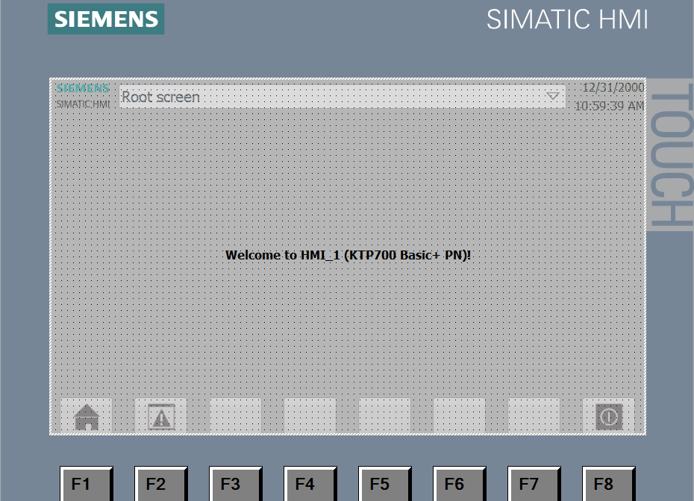

3.Adding and Navigating Between Screens

### Add a New Screen

1. From the HMI dropdown menu, select Add New Screen.
2. Name the screen appropriately based on its function (e.g., "Automatic").

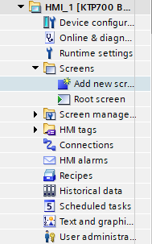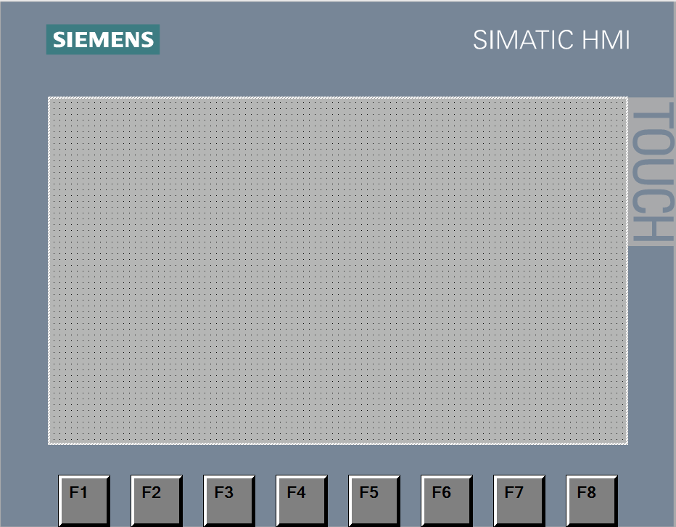

## **Create Navigation Buttons**

**Method 1:**

* 1. 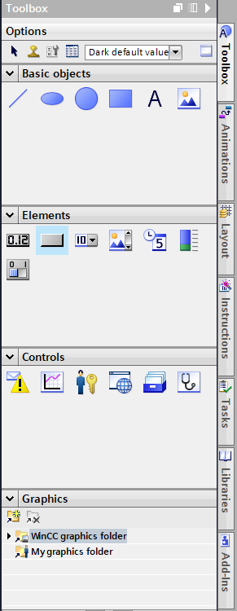Select a **button** from the **Elements** menu.
  2. 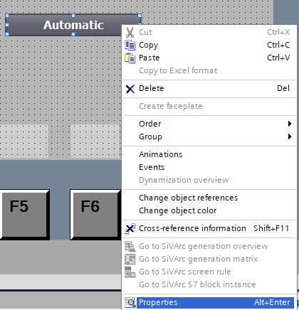Right-click on the button and choose **Properties**.
  3. 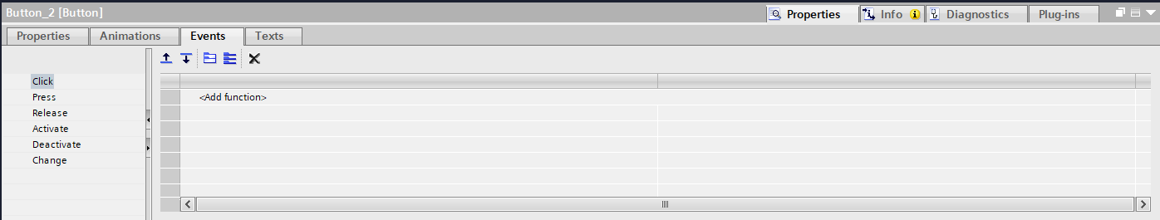Go to the **Events** tab and click **Add New Function**.
  4. Select **ActivateScreen**, then choose the target screen.
  5. 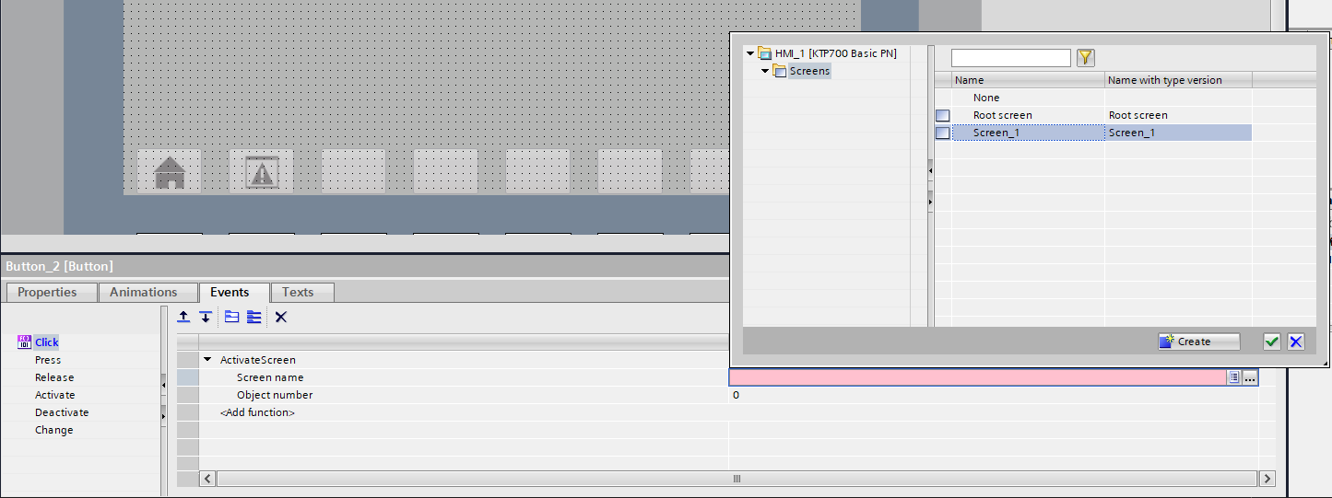Click **Create** to confirm.

**Method 2:**

* + - Simply **drag and drop** the target screen onto the root screen.

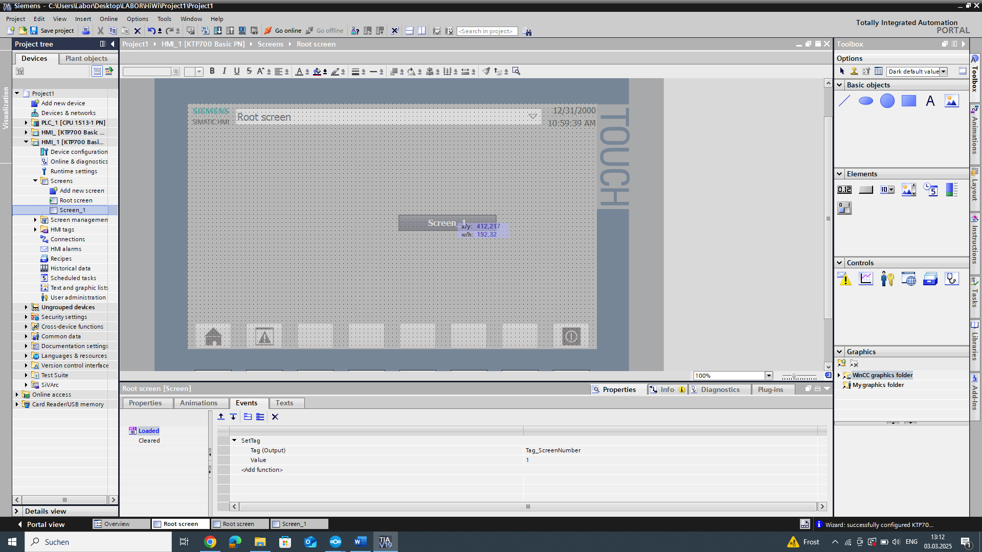

## 4.Editing "Automatic" Screen (Screen_1)

### Add a Start Button

* 1. Insert a button from the Elements menu.
  2. Right-click the button and select Properties.
  3. Navigate to Events, click Add New Function, and choose SetBit.
  4. 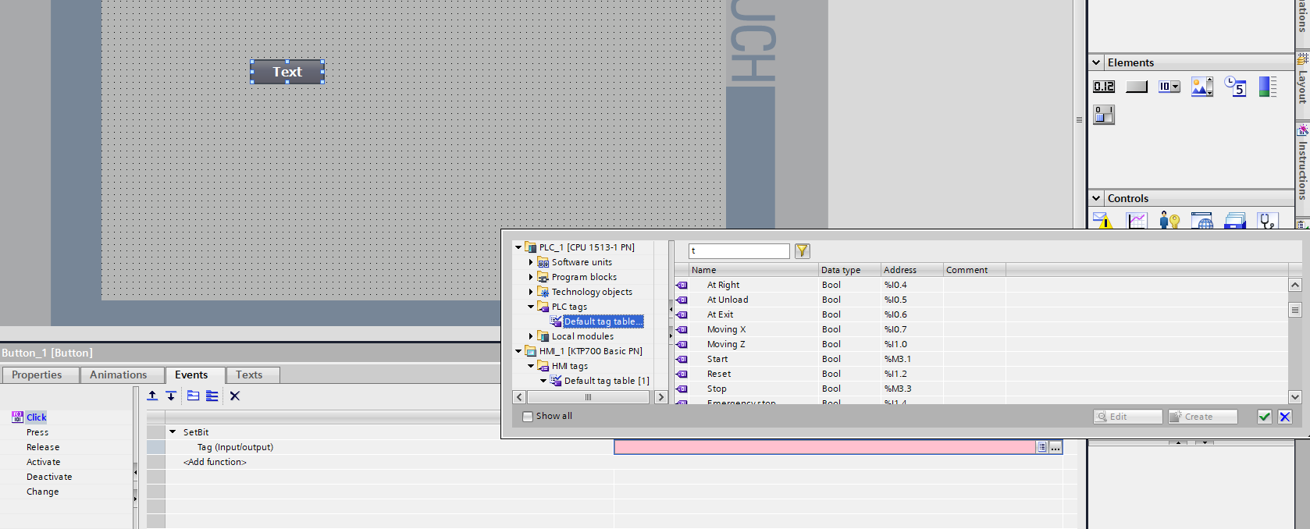Select the desired PLC tag from the PLC Tags menu.
  5. Add another function, ResetBit, and select the same tag.

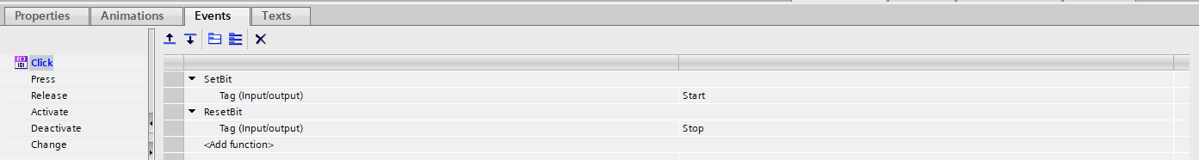

Use the same procedure to make the stop button

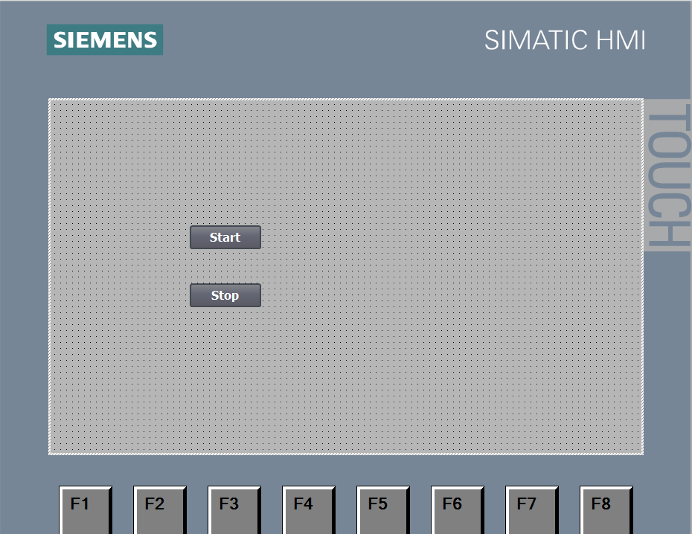

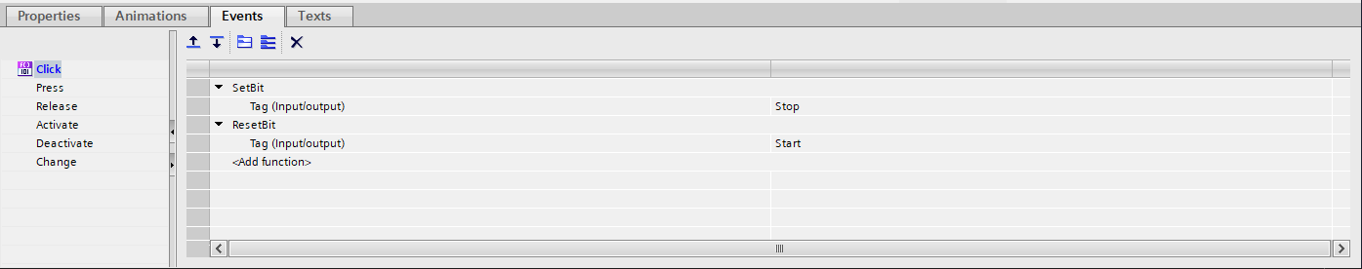

### Add a Running Indicator (Lamp)

* 1. Insert a rectangle from the Basic Objects menu.
  2. Right-click the rectangle and select Properties.
  3. Set the default color to red (indicating "not running").

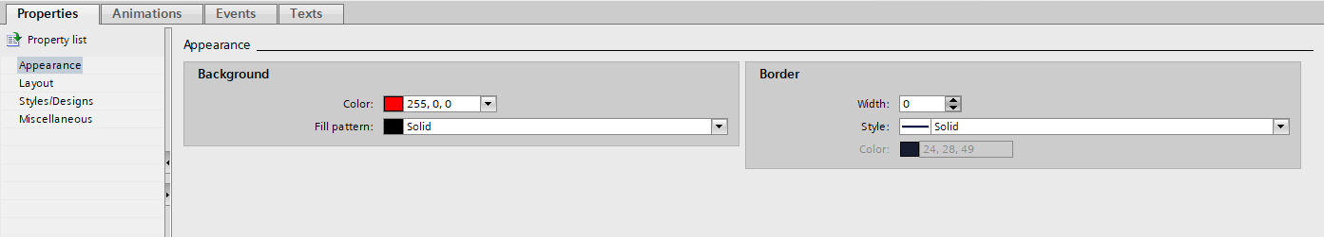

* 1. Navigate to Animation > Display > Appearance.

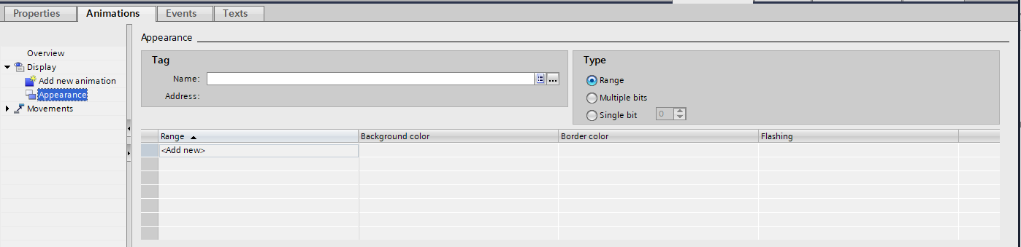

* 1. Click Add New, select the Start Light tag, and set the active color to green when the tag is ON.

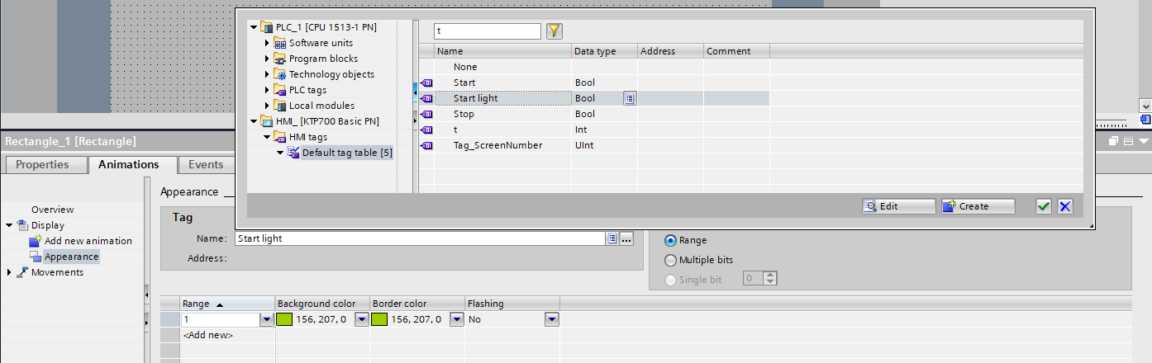

### Display Target Position (I/O Field)

* + 1. 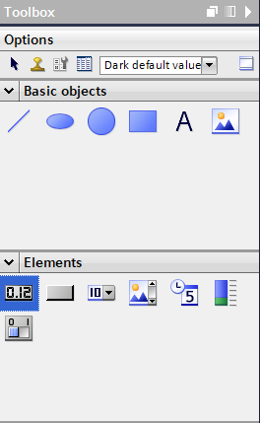Insert an I/O field from the Elements menu.
    2. Navigate to Animation > Process Value.
    3. Add the tag that represents the target position.

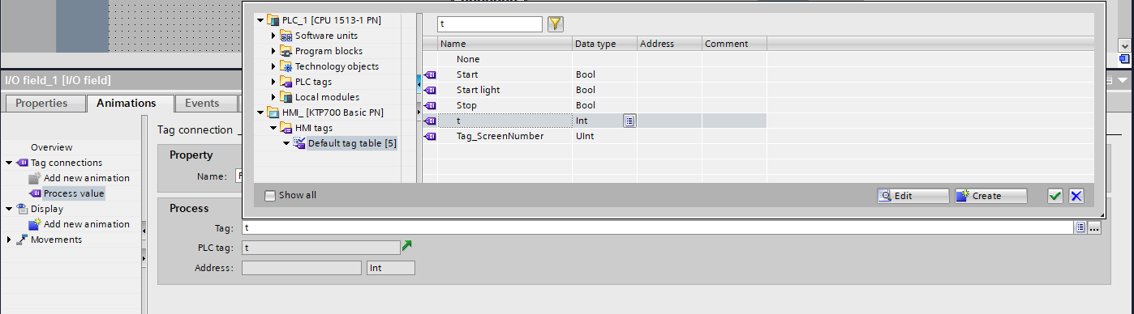

### Add a Navigation Button to Return to the Root Screen

Insert a button and use either of the two methods mentioned above to navigate back to the root screen.

