Sprint 1 AI Final Report
AI requirement coverage based on COMP3851A.pdf

1. Document Information
Field | Content
Document Status | Final Delivery Version / Final
Authoritative Source PDF | COMP3851A.pdf
Version ID | EN-Final
Source SHA-256 | Sprint 1

2. Sprint Purpose and Scope
Sprint 1 defines the earliest AI-related business scope for the project: basic profile setup, interest selection, basic AI Assistant Chat, basic group/event suggestions, recommendation explanation, and AI data consent. It does not define any later model provider, local runtime, application architecture, social-matching capability, administrative capability, production AI integration, or detailed database/UI implementation.

3. Timeline Boundary
- Sprint 1 may use basic profile information, selected interests, region, school/community context, selected preference, and AI data consent where the source PDF permits them.
- Sprint 1 must not include later model, runtime, architecture, administrative, social-matching, or deterministic implementation decisions.
- AI in Sprint 1 remains a basic support and suggestion capability, not a production-level AI architecture.

4. AI-Related Use Cases and User Stories
ID | AI-Relevant Requirement | Source Page | Coverage
UC3 / US3 | User chats with AI Assistant and receives a basic response within safety boundaries. | 1, 3, 5 | Covered in Sections 6 and 9
UC4 / US4 | User views basic group/event suggestions based on available profile, interest, and consent information. | 1, 3, 5 | Covered in Sections 5 and 7
UC5 / US5 | User sees a short recommendation explanation for a suggested group or event. | 1, 4, 5 | Covered in Section 8
UC6 / US6 | User understands and controls how profile and interest data may be used by AI. | 1, 4, 6 | Covered in Section 5
UC1 / UC2 | Basic profile and selected interests provide permitted inputs for later basic suggestions. | 1, 2, 6-10 | Covered in Section 5

5. Permitted Data and Consent Boundary
Sprint 1 permits only minimum data needed for profile setup, interest selection, and basic suggestions. The data scope is not open-ended.
- Basic profile may include display name, age group, region, and school/community context where relevant.
- Selected interests are saved to the user profile and may support basic group/event suggestions only according to the user's AI data consent choice.
- AI data consent must explain how selected profile and interest data may be used for AI-supported suggestions, save the user's choice, and apply that choice where relevant.
- If consent is not given, AI-supported suggestions are limited and the system explains that suggestions may be less personalised. Future suggestions follow any updated consent choice.
- The profile screen should avoid requesting sensitive information that is not needed for the current Sprint 1 scope.

6. AI Assistant Chat Requirements
Requirement Area | Sprint 1 Coverage
AI-FR1 to AI-FR3 | The system provides AI Assistant Chat; the user can type and send a message; the AI Assistant returns a basic text response.
AI-FR4 | The AI Assistant provides only basic guidance, app support, social suggestions, or general conversation.
AI-FR5 | Medical, psychological, legal, emergency, or unsafe advice requests trigger a safety boundary response.
AI-FR6 | The chat feature respects the user's AI data consent setting where applicable.
AI-NFR1 to AI-NFR6 | Responses should be clear, simple, mobile-suitable, privacy/consent-aware, non-harmful, and clearly limited to basic support.

7. Basic Group/Event Suggestions Requirements
Sprint 1 group/event suggestions are basic suggestions, not a full discovery system, not an event management system, and not an advanced AI ranking implementation.
Requirement Area | Sprint 1 Coverage
GS-FR1 to GS-FR4 | The system displays suggested groups/events, uses basic profile, selected interests, and consent where relevant, shows name/type/short description/tags, and distinguishes group from event.
GS-FR5 | Each suggestion shows a basic recommendation reason where possible.
GS-FR6 | If there are not enough matching suggestions, the system shows a fallback message or asks the user to update interests.
GS-NFR1 to GS-NFR6 | Suggestions should be mobile-scannable, short and understandable, consent-respecting, timely, and must not expose private groups, private user data, or sensitive information.

8. Recommendation Explanation Requirements
Recommendation explanation in Sprint 1 is short and basic. It may refer to selected interests, matching tags, nearby area, school/community context, or selected preference.
- Each recommendation should show a short explanation where possible, such as same interest, nearby area, or matching selected preference.
- If a specific explanation is not available, the system shows a simple general explanation.
- Recommendation reasons should be short and understandable, and the system should not claim production-level AI personalisation.

9. Safety, Privacy, and Out-of-Scope Boundaries
Boundary | Sprint 1 Statement
Safety | The AI Assistant must provide a boundary response for medical, psychological, legal, emergency, or unsafe advice, and should avoid harmful, unsafe, discriminatory, or manipulative responses.
Professional authority | The AI Assistant should not present itself as a professional expert, doctor, therapist, lawyer, or emergency service.
Privacy and consent | AI conversation data should be handled according to privacy and consent rules. Suggestions must respect AI data consent and must not expose private or sensitive data.
Implementation scope | Sprint 1 does not define a full AI companion personality, emotional dependency features, advanced memory, long-term personalisation, production-level AI integration, AI model design, full recommendation algorithm, or detailed UI/database behaviour.

10. Sprint 1 AI Flowchart
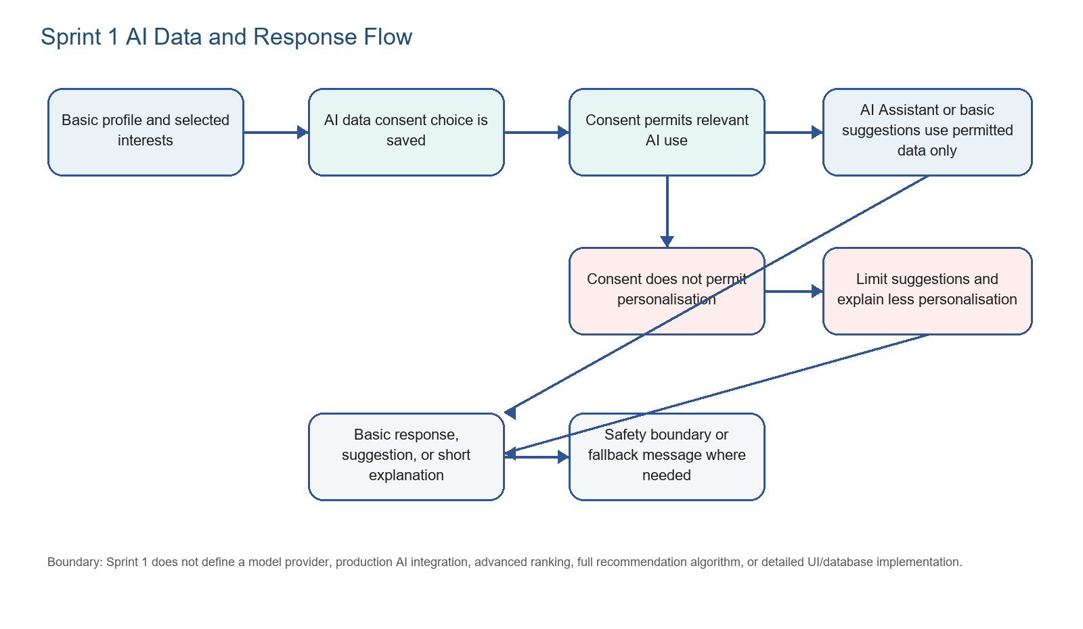
Figure 1. Sprint 1 AI data, consent, suggestion, and safety-boundary flow.

11. Acceptance Check
Check Item | Conclusion
Earliest timeline | Pass: no later model, provider, runtime, administrative, architecture, or implementation content is included.
AI Assistant Chat | Pass: basic chat, response, consent, safety boundary, and support-only limits are covered.
Basic suggestions | Pass: profile/interests/consent inputs, suggestion display, recommendation reason, fallback, and privacy limits are covered.
AI data consent | Pass: explanation, choice, saved preference, limited suggestions when no consent, and updated future behaviour are covered.
Flowchart | Pass: the Sprint 1 AI data and response flow is included as a diagram.

12. Key Requirement Traceability Summary
Requirement ID | Requirement Type | Source Page | Target Section | Coverage Result | Notes / Evidence
UC3 / US3 | Use Case / User Story | 1, 3, 5 | 6, 9, 10 | Complete | AI Assistant Chat returns basic responses within safety boundaries.
UC4 / US4 | Use Case / User Story | 1, 3, 5 | 5, 7, 10 | Complete | Basic group/event suggestions use permitted profile, interest, and consent information.
UC5 / US5 | Use Case / User Story | 1, 4, 5 | 8 | Complete | Short recommendation explanations are covered.
UC6 / US6 | Use Case / User Story | 1, 4, 6 | 5, 9, 10 | Complete | AI data consent is explained, saved, and respected.
BP-FR1-BP-FR6 | Functional Requirements | 8-9 | 5 | Complete | Basic profile setup and minimum profile data use are covered.
BP-NFR1-BP-NFR6 | Non-Functional Requirements | 9-10 | 5, 9 | Complete | Mobile-friendly profile setup, minimum data collection, secure storage, and sensitive-data avoidance are covered.
IS-FR1-IS-FR7 | Functional Requirements | 6 | 5 | Complete | Interest selection and selected interest availability for basic suggestions are covered.
IS-NFR1-IS-NFR6 | Non-Functional Requirements | 7 | 5, 9 | Complete | Interest clarity, consent-based use, limited options, and secure storage are covered.
GS-FR1-GS-FR6 | Functional Requirements | 7-8 | 7, 8 | Complete | Suggestion display, reason, and fallback are covered.
GS-NFR1-GS-NFR6 | Non-Functional Requirements | 8 | 7, 8, 9 | Complete | Mobile scanning, understandable reasons, no production-level AI claim, consent, latency, and privacy are covered.
AI-FR1-AI-FR6 | Functional Requirements | 10 | 6, 9 | Complete | AI Assistant function, basic response, support scope, safety boundary, and consent are covered.
AI-NFR1-AI-NFR6 | Non-Functional Requirements | 10-11 | 6, 9 | Complete | Clear responses, support-only framing, professional-authority boundary, privacy, and harmful-output avoidance are covered.

