Flight Operations Risk Assessment System (FORAS)

*Michael Hadjimichael*

*John McCarthy*

*Naval Research Laboratory[1]*

*Olga Fridman*

*Science Applications International Corporation2*

# Abstract

The goal of the Flight Operations Risk Assessment System (FORAS) project is to design a methodology and model framework for the identification and representation of risk factors and structures, and the quantitative assessment of particular risks associated with flight operations. The resulting risk model, implemented in software, is intended to serve as a decision support tool for use by operational safety managers to measure and reduce exposure to accident and incident risk-associated areas. The initial emphasis of FORAS is on modeling Controlled Flight Into Terrain (CFIT) risk, as a proof of concept. However, the framework is general, and easily adapted to other risk categories (e.g., injury due to turbulence, loss of control). It is a general approach that addresses the contribution of human factors and captures the dependency that exists between risk factors. In fact, the generality of the modeling process may support a broader set of applications. The FORAS project was initiated by the Icarus Committee of the Flight Safety Foundation, and is sponsored principally by the NASA Aviation Safety Program.

1.0 Introduction

The determination of a risk within flight operations requires assessment of the exposure of the flight system to particular hazards. The goal of the Flight Operations Risk Assessment System (FORAS) project is to design a methodology and model framework for the identification and representation of risk factors and structures (relationships), and quantitative assessment of such risks. The system is intended to serve as a decision support tool for use by operational safety managers to measure and reduce exposure to accident and incident risk-associated areas.

FORAS is a risk management tool that will assess various mishap risks associated with a flight operation. It is designed to give safety managers and other users a quantitative, relative assessment of specific risk for an operation, broken down into a variety of subgroups: by fleet, region, route, or even individual flight. This assessment is performed using a mathematical model which synthesizes a variety of inputs, including information on crew, weather, management policy and procedures, airports, traffic flow, aircraft, and dispatch operations. The system will identify those elements that contribute most significantly to the calculated risk, and will be able in some cases to suggest possible interventions.

The initial emphasis of FORAS is on modeling Controlled Flight Into Terrain (CFIT) risk. CFIT, the leading cause of aviation fatalities, occurs when an airworthy aircraft under the control of the flight crew is flown unintentionally into terrain, obstacles or water, usually with no prior awareness by the crew. However, the FORAS project has developed a model framework and development methodology that can be extended to other risk categories. This requires a general approach that addresses the contribution of human factors and captures the dependency that exists between risk factors. The calculation of the risk assessment index uses a fuzzy inference system and a knowledge base customized for the flight environment in which it is applied.

FORAS may be useful to a broad range of a flight operator hierarchy, from the safety manager down to the smallest operational decision making unit. Safety managers can assess the overall level of certain risks for their operation, and analyze the effects of management decisions on that risk level. Various risks can be tracked over time to analyze trends, and cost-benefit analyses can be conducted to compute the “value” of safety investments (in terms of reduced risk). A flight operation, such as an air carrier, will benefit from FORAS by having a more continuous, up-to-date, objective, and encompassing assessment and understanding of its exposure to various risk categories.

The FORAS model accepts inputs associated with a particular flight and produces a relative risk index. Whereas an *absolute* risk index might be interpreted as a probability of mishap, and can be considered in isolation from other flights, a *relative* risk index is an indicator useful only in comparison (relative) to other indicators generated by the same risk model, for the same flight operator. The assessment is relative, because system output is not an absolute measure of accident risk, but rather a number that is guaranteed to increase as the mishap risk of a situation increases.

While all flights have a very low risk of mishap, flights can be compared to identify those flights where mishap risk is greater. The analysis quantitatively evaluates a set of risk attributes associated with environment, human factors, terrain, airport, and aircraft. With this analysis, operator management can implement strategies to manage risk to an acceptable level.

Thus, a safety manager might compare risk assessments for flights sharing any number of common characteristics. For example, the relative risk index for a particular flight may be used to compare it to a baseline or average value for that route. As another example, the average assessment for one route can be compared to that of another route, or the same route might be studied under different environmental conditions or crew rest policies.

The risk model output is intended to be a measurement system that can determine the relative risk of a mishap. FORAS is not a means of preventing accidents; rather it is a means of quantifying the complex interaction of factors which influence risk.

2.0 Project Background

The FORAS project was initiated by the Icarus Committee of the Flight Safety Foundation, and is sponsored principally by the NASA Aviation Safety Program. The Icarus Committee has been examining ways to improve flight safety since the committee's inception in the early 1990s. The initial focus has been on improving flight safety with a decidedly human factors orientation. However, in the FORAS effort, the early work attempted to quantify safety as a metric that a flight safety department could use to monitor and thus improve the overall level of safety.

During the fall meeting of the full Icarus Committee hosted by Boeing, in Seattle,

Washington on September 3-4, 1997, members unanimously agreed to form a *Safety Index Working Group*. The purpose was to develop a working model of a safety metric with which an airline or other aircraft operator might manage, monitor and measure operational safety performance. In order to bring together appropriate knowledge and expertise to develop the working models a S*afety Index Development Group* was formed composed of individuals with specific subject matter expertise in a number of associated areas: CFIT, meteorology and turbulence, statistical modeling, database management, computer science, and flight operations, risk management. Ultimately, the ideas developed beyond the concept of a safety index, toward quantitative risk assessment and management. Progress on FORAS has been reported at the 1999 International Air Safety Seminar, and at the SAE Conference on Advances in Aviation Safety [1,2]. A website is also available [3].

3.0 System Description

FORAS is composed of two parts: a model development system, and a risk analysis system. The model development system is a tool which encodes human expert knowledge into a mathematical representation called a *risk model*. A FORAS risk model is an encoding of the human knowledge about a specific type of risk (e.g., Loss of control, Runway incursions, Controlled flight into terrain, etc). The risk analysis system applies the model representing the knowledge base to actual flight data, including variables such as crew statistics, flight schedules, environmental conditions, etc, and produces, for each flight, a relative risk assessment in the form of a single normalized value in the interval 0 to 100. This number represents an estimate of the specific risk, not as a probability, but relative to a baseline value or the assessment of another flight or group of flights.

The program components of FORAS are logically organized as shown in Figure 1. The Specification module (S) interfaces with the user to structure the risk factors elicited from the experts. The Relationship module (R) uses a specification of the desired behavior (the consequences of input conditions) to generate the mathematical form of the risk model. The Inference module (I) calculates the risk assessment for a set of flights (as requested by the user), and the Analysis module (A) provides spreadsheet functionality for examining the calculated assessments. In addition, the analysis module allows for “drill-down”' behavior, by which the assessment for any flight can be broken down to discover the high risk component factors.

The model development system interface is shown in Figure 2. It shows a single component of an example CFIT risk structure (c*rew functionality*) and shows the hierarchical nature of the risk decomposition (see Section 3.2), where *crew functionality* is a function of *crew experience* and *crew rest/fatigue*. The *crew experience* factor is a function of *commander experience* and *first officer experience*, while *crew rest/fatigue* is a function of *departure time* and *arrival hours*. These relationships have been determined by an extensive interview process with aviation experts. The relationships are expressed as *fuzzy rules*, which allow the representation of knowledge using easily understood terms like “low experience,” “early departure time,” etc. This is explained further in Section 3.3.

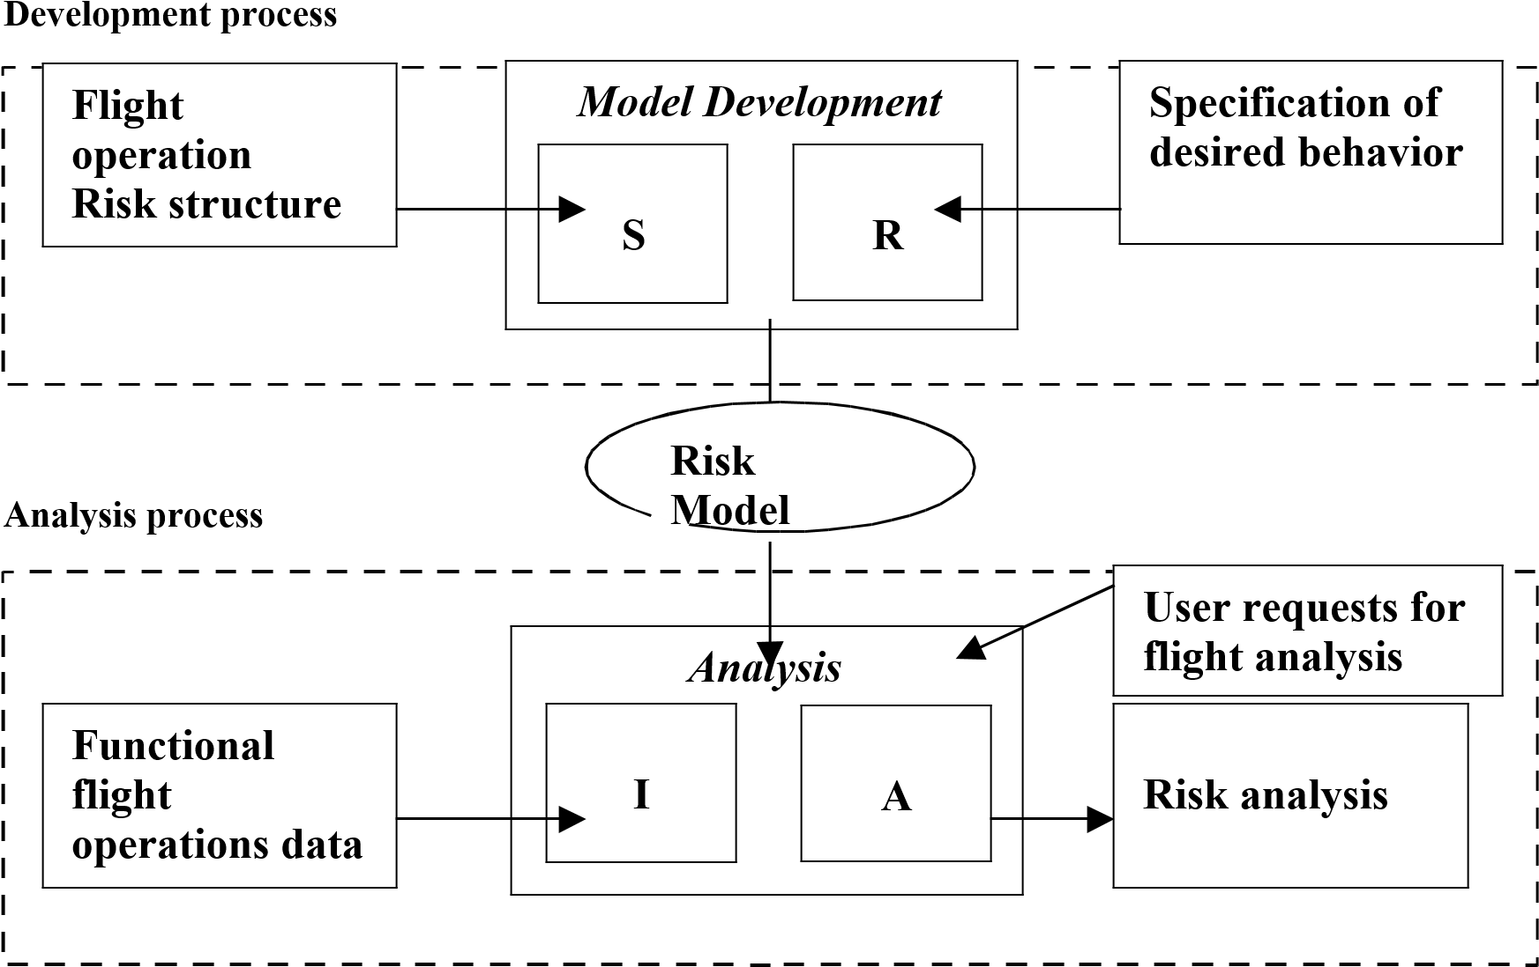

Figure 1 High-level representation of the FORAS structure

3.1 Model Development and Implementation Process

The model development and implementation process consists of several phases. In the knowledge elicitation phase, experts are interviewed to discover the factors (variables) which contribute to the selected risk, and the relationship between those factors. Each factor is hierarchically decomposed into as much detail as possible (limited by the data available from the information infrastructure of the organization). In the encoding phase, the knowledge elicited from the experts is encoded using the FORAS Model Development computer program. The knowledge is encoded as a set of rules and a set of relationships describing possible inputs and expected outputs. In the integration phase, the system is installed on an organization computer, and tied into the relevant organization databases, so that it may retrieve (only) data necessary to create the risk assessments. To create a FORAS risk model for an organization, it is necessary to perform the elicitation and integration phases on-site, in order to have access to the necessary domain experts, and determine the variables available, and the database systems from which data will be extracted.

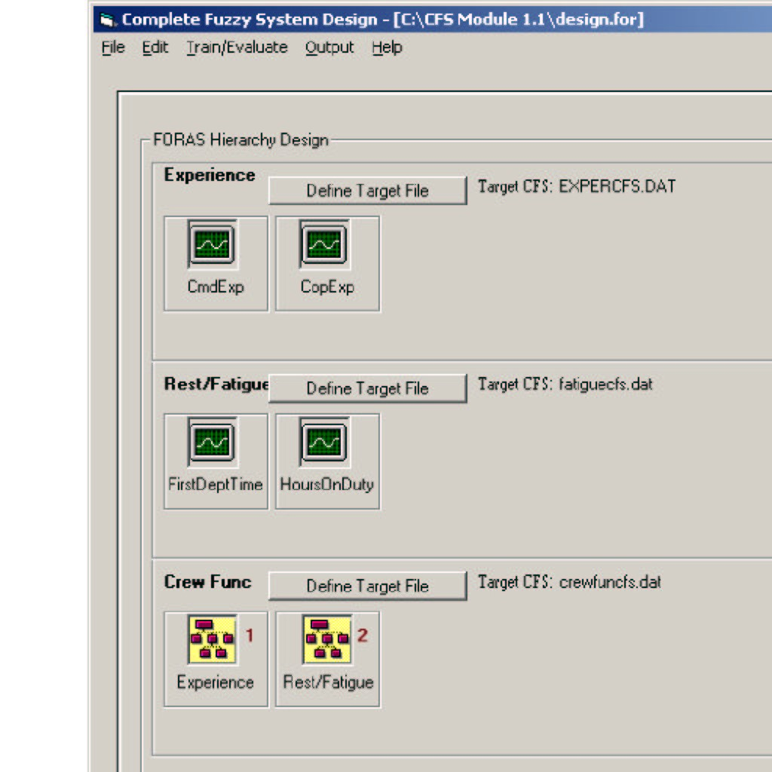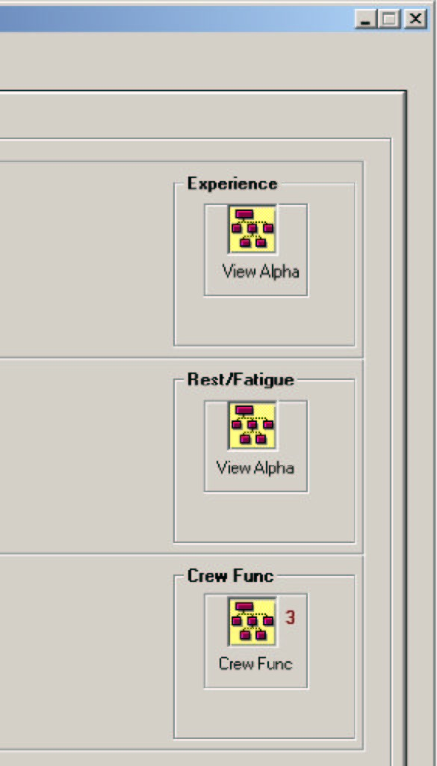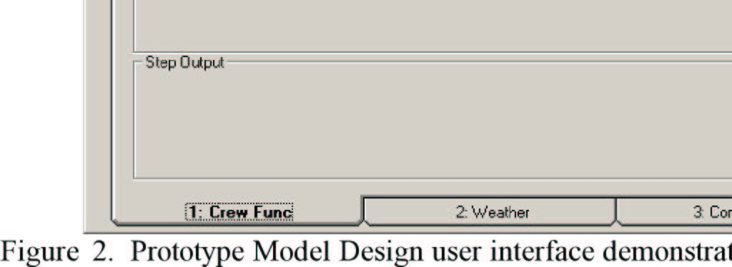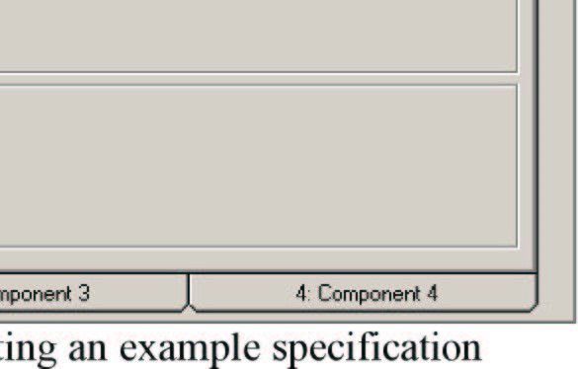

of the *crew functionality* component of CFIT risk.

Four visits to the organization would be required. In the first, relevant personnel of the organization are briefed on FORAS, its capabilities, and requirements, and a risk category is selected for FORAS modeling. The most intensive visit is the second, in which knowledge elicitation takes place. During knowledge elicitation, an interviewer will sit with a group of 3 to 5 domain experts (e.g., pilots) designated by the organization, and go through a series of questions about the selected risk and the various contributing factors. The exact questions depend on the risk chosen, and the experts interviewed. After the first interview session with a particular group, the interviewer will organize the risk factors into an initial risk structure. A second interview session later in this visit serves to confirm the derived structure and enhance it as necessary. This process is repeated with every group which will contribute domain knowledge to the system. Finally, a session with the information technology section database specialists will serve to determine the variables available, and their technical specifications.

A third visit is necessary to confirm the developed model and ensures that it is a correct representation of the organization's features. Also, initial testing may begin on the system and its integration.

At the fourth, final visit, the model is delivered and integrated into the organization, to the degree required by the Safety Manager. The FORAS Analyzer program is also delivered and installed. This program is the interface to the risk model and a query tool which allows a user to perform a risk assessment on any subset of the flight operation made available to the system. This final phase will also include training on the use of the software, feedback sessions, and discussion about follow-up visits for further feedback and model refinement as necessary.

3.2 CFIT Risk Structure

Controlled Flight into Terrain is the first flight operations risk category studied. Human experts in various areas of flight operations were interviewed to determine the contributory risk factors, and their inter-relationships. Each general risk factor has been decomposed into more focused risk factors, as in the *crew experience* variable. The decomposition and inter-relationships is referred to as the *risk structure*. The interview process identified *crew experience* (in-type) as a relevant risk factor, and within that factor, the factors of *captain experience* and *copilot experience*. It further identified the natural categories of experience as low, medium, and high. The structured knowledge elicitation process is based loosely on the Analytical Hierarchy Process [4]. Further questioning elicited the definitions of these categories, as described in Section 3.3.

Initial prototyping of a CFIT model determined four categories of risk factors: Crew, Environment, Airport/Aircraft, and Safety Culture. The selection of these categories is subject to the constraints of the flight operation under analysis, according to availability of data and relevance of variables. Every operator (e.g., air carrier, air force, etc) will have a unique risk factor structure reflected its constraints.

Each risk factor is decomposed into more specific categories. A sample decomposition, simplified for this presentation, might be:

Crew: experience, fatigue

Environment: precipitation, ceiling, visibility, time of day, temperature

Aircraft/Airport: navigational aids, runway, terrain

Safety Culture: training programs, standard procedures

Each of these factors, in turn, may be decomposed into even more specific factors, limited by the availability of data and logistics of data measurement and collection.

3.3 Modeling

Each FORAS risk model is represented as a fuzzy expert system [5,6]. Briefly, an expert system is an encoding of human expert knowledge as a set of ``if-then'' rules. A fuzzy expert system expresses these rules in terms of natural language words, each of which represents a mathematical function. For example, a rule might be: If *captain-experience* is high and copilot-experience is medium then *crew-experience* is high.

In this case, the terms in italics are linguistic variables, and the bold face terms are fuzzy values. For example, one possible definition of high experience is shown in Figure 3. In this example, the range of pilot experience between 0 and 12 months cannot be considered high at all (degree 0.0). The degree of “high-ness” increases in the range 12 to 24 months, to a maximum of “completely high” (degree 1.0) at 24 months experience. Thus, a pilot with 18 months experience in this example would be considered highly experienced with degree 0.5.

Fuzzy rules have the great advantage of being easy to express and understand for the domain experts from whom the knowledge base is derived. It is easy to see how the risk decomposition can be expressed as a set of fuzzy rules. Once the rule base is created, the FORAS Model Development program provides a simple tool for mathematically encoding the knowledge as a risk model, expressed by a set of mathematical equations. These equations are a function of the input variables. The Risk Analysis program assigns to each variable a set of values for each flight to be analyzed, and uses the equations to generate the relative risk assessments (for a particular risk, such as CFIT) of those flights.

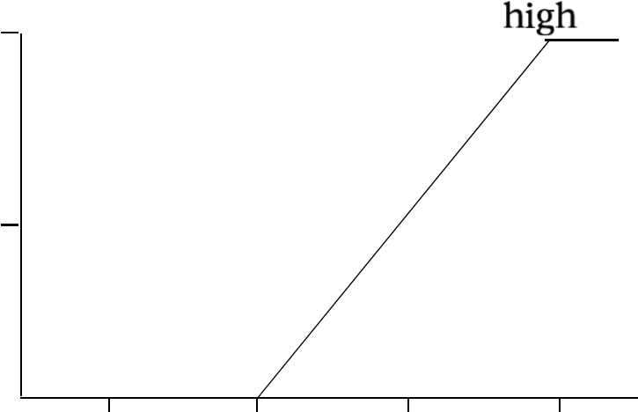

Figure 3. Example membership function demonstration a fuzzy definition of high experience.

4.0 Conclusion

FORAS uses advanced mathematical-modeling techniques to examine risk contributors such as weather conditions, flight crew human factors and airport conditions - and to generate a relative measurement of risk exposure for a flight operation. The result is a number; the higher the number, the higher the relative risk for the flight operation.

The FORAS methods for evaluating the risks of CFIT and turbulence-related injuries are being tested against data from airline flight operations. The capability to evaluate other risks will follow.

The FSF Icarus Committee believes that FORAS - in addition to enabling real-time risk evaluations for particular flights and monitoring of trends in exposure to particular risks eventually will enable the analysis and management of factors that are common to more than one risk.

Development of FORAS is funded by the Modeling and Simulation effort at the Ames Research Center as part of the Aviation Safety Program of the U.S. National Aeronautics and Space Administration (F.D. A63978D). Participants in development of the system are Airbus Industrie, AlliedSignal Aerospace, British Airways, Embry-Riddle Aeronautical University, TAP Air Portugal, United Airlines, the U.S. Air Force Safety Center, the U.S.

National Center for Atmospheric Research, the U.S. Naval Postgraduate School and the

U.S. Naval Research Laboratory.

References

1. Hadjimichael, Michael, D. M. Osborne, , D. Ross, D. Boyd, and B. G. Brown. The Fight Operations Risk Assessment System.. In *Proceedings of the SAE Advances in Aviation Safety Conference*. Society of Automotive Engineers, 1999.

2.[McCarthy, John, D. Schwartz, D.M. Osborne, and M. Hadjimichael. Modeling risk with the Flight Operations Risk Assessment System (FORAS). In *Proceedings, International Air Safety Seminar, Rio de Janeiro, Brazil*. Flight Safety Foundation, Nov 1999.](https://www.researchgate.net/publication/249660310_Flight_Operations_Risk_Assessment_System_FORAS?el=1_x_8&enrichId=rgreq-66e38c3fcaaee838b2e6646d10d55771-XXX&enrichSource=Y292ZXJQYWdlOzI0OTY2MDMxMDtBUzoyMDI5MTg2NjcwMDE4NjhAMTQyNTM5MDk4ODIxMg==)

3.Flight Operations Risk Assessment System Web page. http://www.nrlmry.navy.mil/foras.

4.Saaty, T.L., *The Analytic Hierarchy Process*, volume 1 of *The Analytic Hierarchy Process Series*. RWS Publications, 1996.

5.Kandel, Abraham, editor. *Fuzzy Expert Systems*. CRC Press, Boca Raton, FL, 1992.

6.Zadeh, Lotfi A Fuzzy sets. *Inf. Control*, 8:338--353, 1965.

[View publication stats](https://www.researchgate.net/publication/249660310)

1. Naval Research Laboratory, 7 Grace Hopper Ave., Monterey, CA 93943. hadjimic@nrlmry.navy.mil 2  SAIC, 550 Camino El Estero, Suite 205, Monterey, CA, 93940.