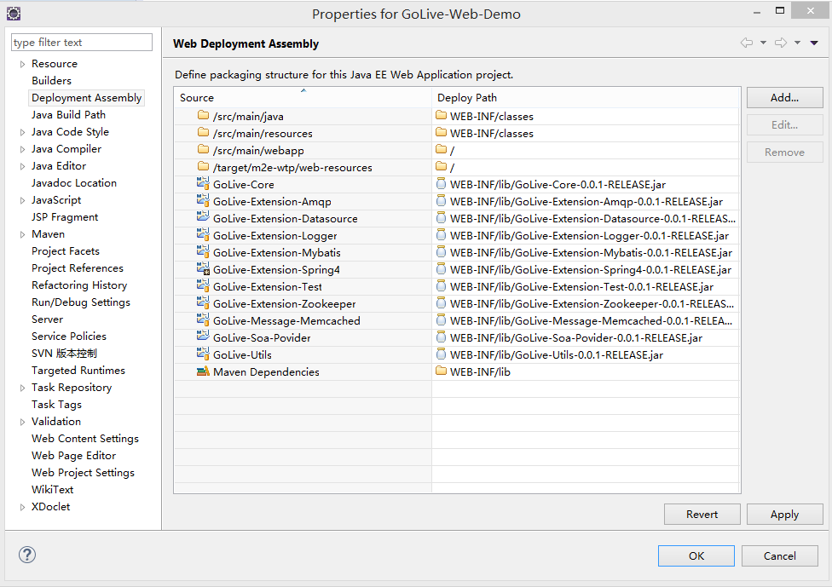

找到\.settings\org.eclipse.wst.common.component文件,打开并且添加下面两行

<wb-resource deploy-path="/WEB-INF/classes" source-path="/src/main/java"/>

<wb-resource deploy-path="/WEB-INF/classes" source-path="/src/main/resources"/>