**Daily Scrum or Standup Meeting**

Team name: 3rd Degree

Scrum Master: Adam Alder

Date: 10-05-2021

| **Team Member** | **What did you do since the last scrum?** | **What do you plan to do before the next scrum?** | **What obstacles do you have?** |
| --- | --- | --- | --- |
| Sean Collings | * Requirements Gathering * Prototypes * Toolchain setup * Setup Documentation | * Test Scaffolding * User Model * Signup |  |
| Adam Alder | * Requirements Gathering * Prototypes | * Drink Mode * Login |  |
| Jaren Glenn | * Requirements Gathering * Prototypes | * Tournament Model * Navbar / Drawer |  |
| Jonathan Gates | * Requirements Gathering * Prototypes | * Score Model * Home Page |  |
|  |  |  |  |

# Burndown

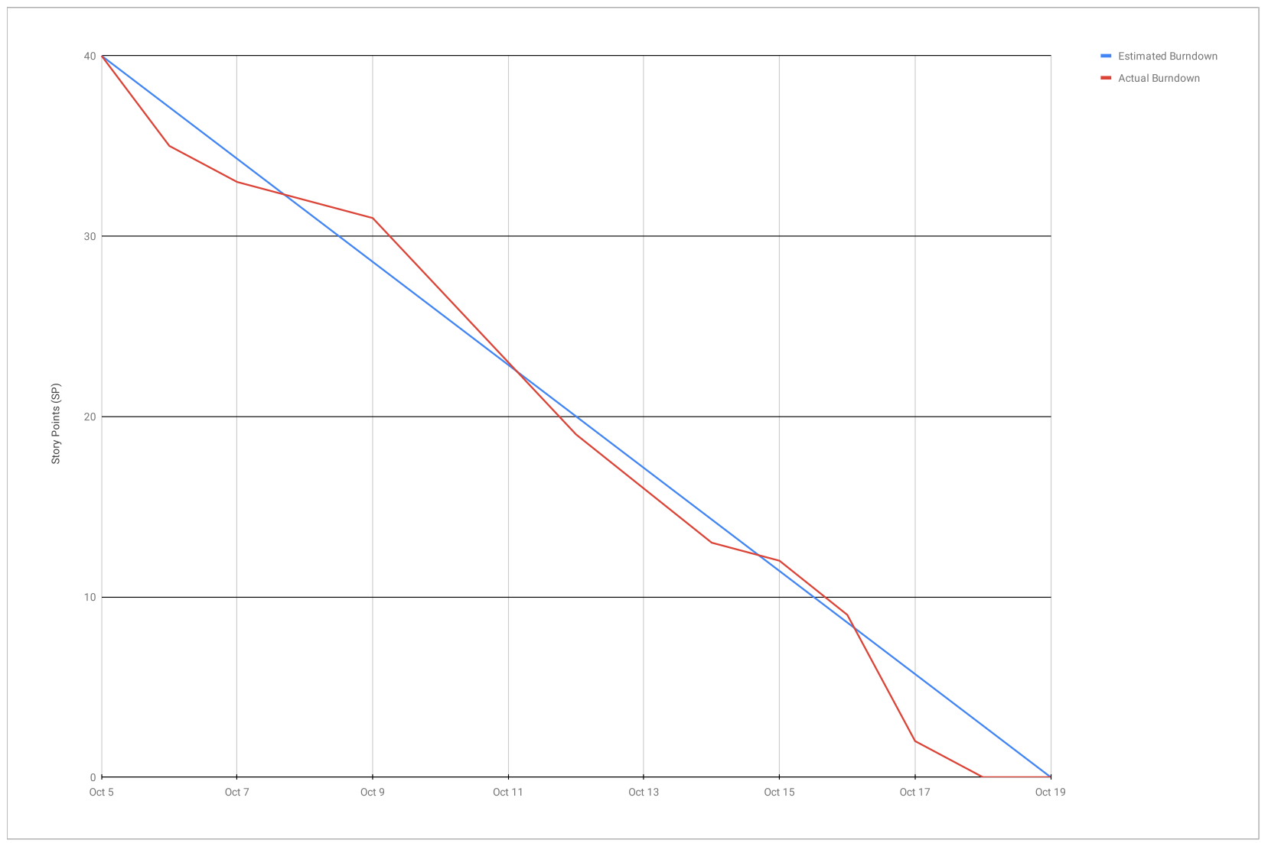

# 

# Screenshot of you project board

