**Daily Scrum or Standup Meeting**

Team name: 3rd Degree

Scrum Master: Adam Alder

Date: 10-07-2021

| **Team Member** | **What did you do since the last scrum?** | **What do you plan to do before the next scrum?** | **What obstacles do you have?** |
| --- | --- | --- | --- |
| Sean Collings | * User Model * Signup | * Test Scaffolding * Visual Design * User Crud |  |
| Adam Alder | * Drink Model | * Login |  |
| Jaren Glenn | * Navbar / Drawer | * Tournament Model |  |
| Jonathan Gates |  | * Score Model * Home Page | * Not sure how to construct many-to-many relationships |
|  |  |  |  |

# Burndown

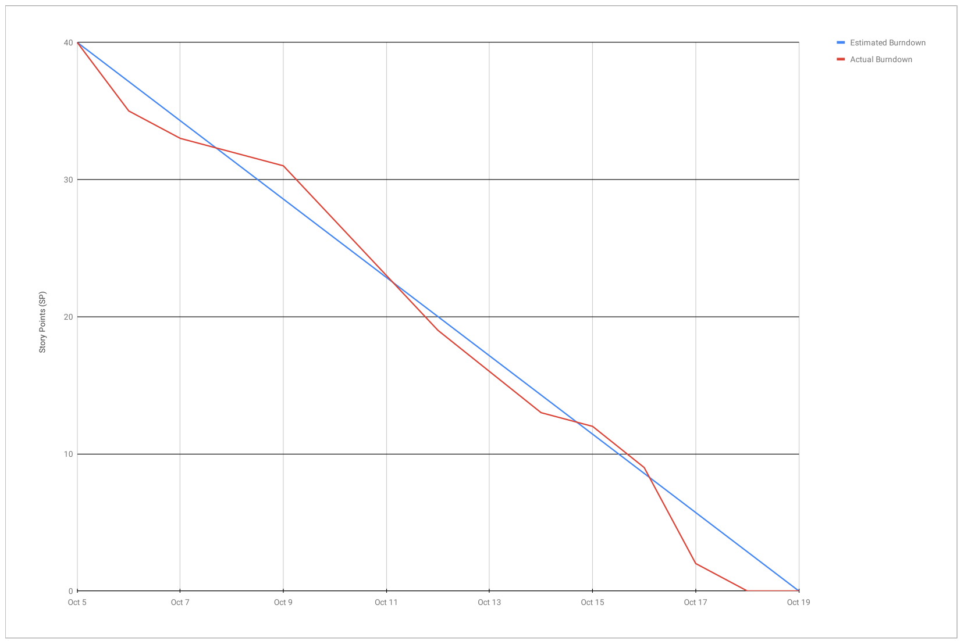

# 

# Screenshot of you project board

