**Daily Scrum or Standup Meeting**

Team name: 3rd Degree

Scrum Master: Adam Alder

Date: 10-12-2021

| **Team Member** | **What did you do since the last scrum?** | **What do you plan to do before the next scrum?** | **What obstacles do you have?** |
| --- | --- | --- | --- |
| Sean Collings | * Visual Design * User Crud | * Test Scaffolding |  |
| Adam Alder | * Login | * Drink Crud | * CSS Quirks |
| Jaren Glenn | * Tournament Model | * Tournament Crud * Account Management |  |
| Jonathan Gates | * TournamentEnrollment Model * Home Page | * Revise Requirements * Home page | * React hard :( |
|  |  |  |  |

# Burndown

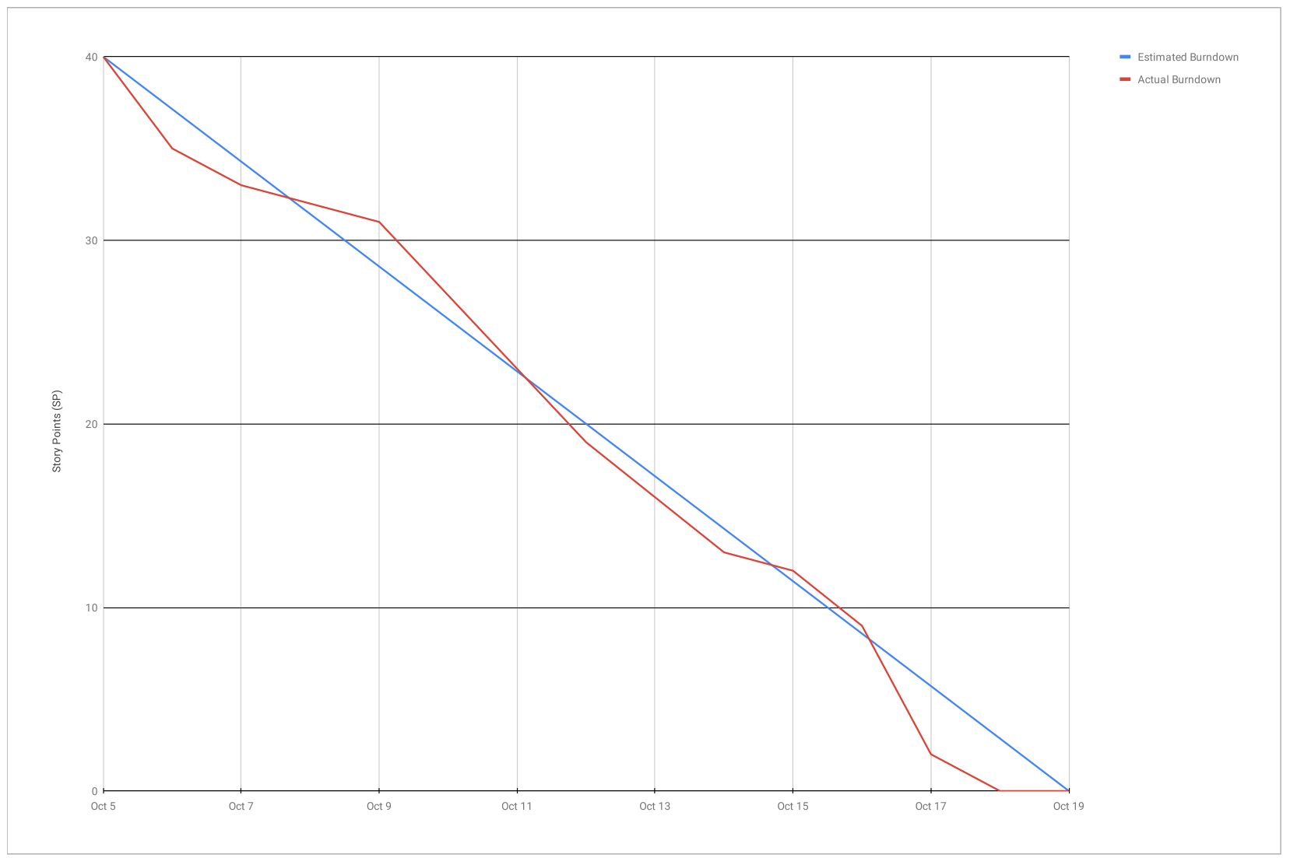

# 

# Screenshot of you project board

