**Daily Scrum or Standup Meeting**

Team name: 3rd Degree

Scrum Master: Adam Alder

Date: 14-10-2021

| **Team Member** | **What did you do since the last scrum?** | **What do you plan to do before the next scrum?** | **What obstacles do you have?** |
| --- | --- | --- | --- |
| Sean Collings | * Test Scaffolding | * Multiple Themes * Admin User Management * Finish up User Model |  |
| Adam Alder | * Drink Crud | * Login * Drink Crud |  |
| Jaren Glenn | * Navigation | * Tournament Crud * Account Management |  |
| Jonathan Gates | * Revise Requirements | * Home Page |  |
|  |  |  |  |

# Burndown

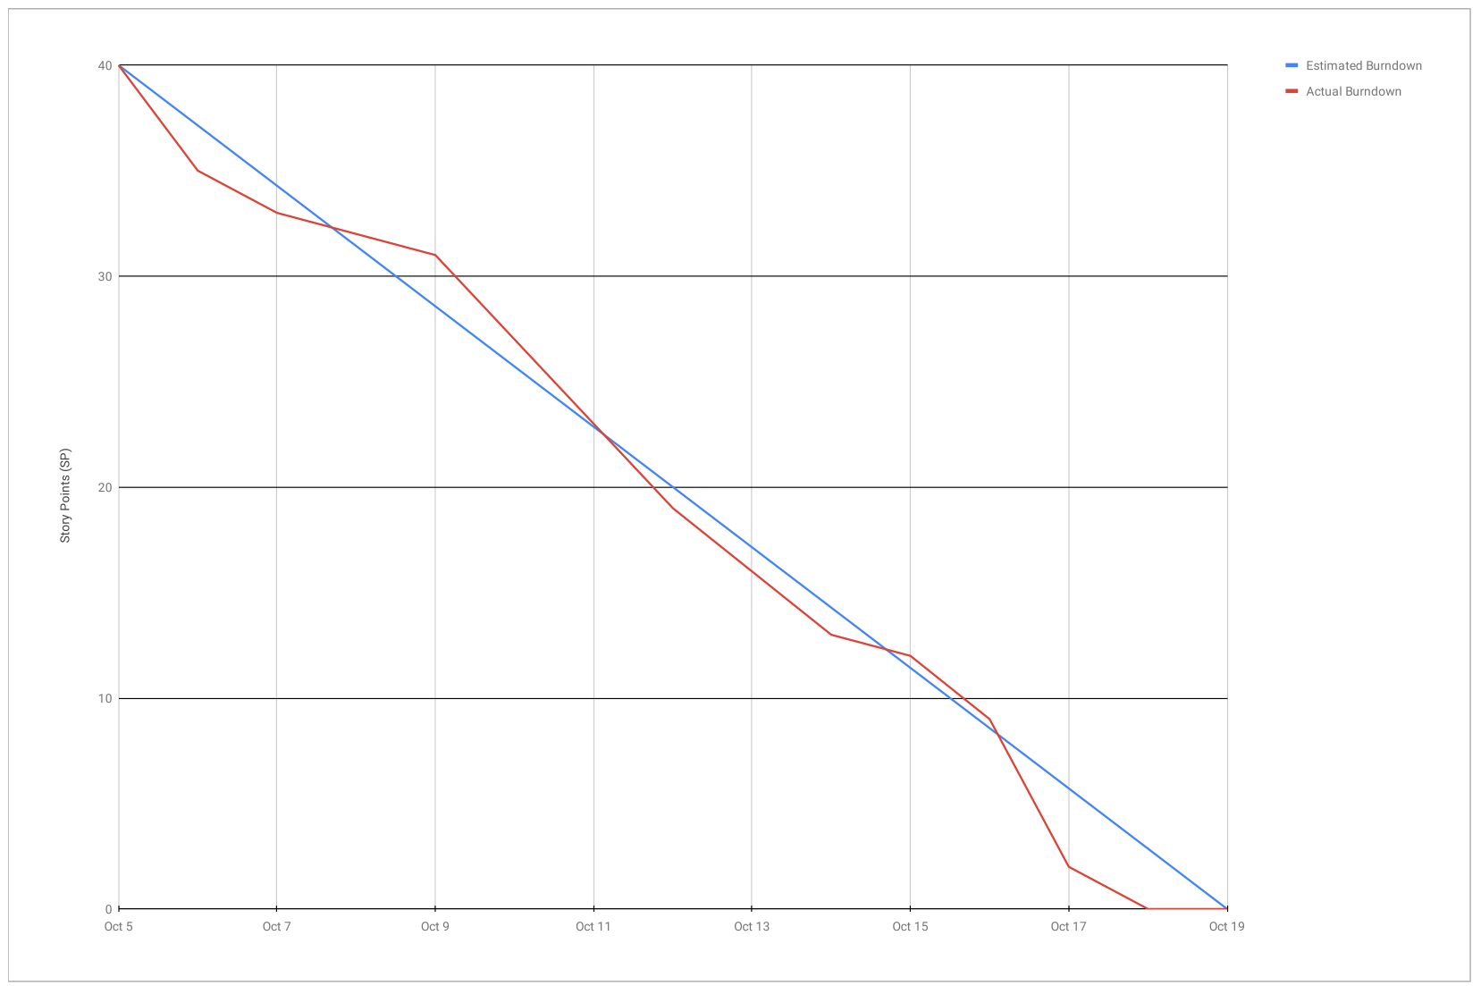

# 

# Screenshot of you project board

