**Daily Scrum or Standup Meeting**

Team name: Third Degree

Scrum Master: Jonathan Gates

Date: 10/21/21

| **Team Member** | **What did you do since the last scrum?** | **What do you plan to do before the next scrum?** | **What obstacles do you have?** |
| --- | --- | --- | --- |
| Adam Alder | * Worked on drink CRUD | * Drink order CRUD * Drink order schema * Drink order page |  |
| Sean Collings | * Theming | * Admin user page |  |
| Jonathen Gates | * Worked on homepage | * Work on homepage |  |
| Jaren Glenn | * Tournament CRUD | * **Tournament CRUD Unit Tests** |  |
|  |  |  |  |

# Burndown

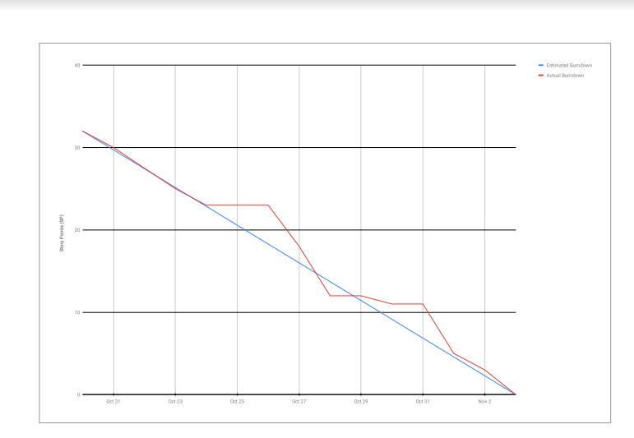

# Screenshot of you project board

