**Daily Scrum or Standup Meeting**

Team name: Third Degree

Scrum Master: Jonathan Gates

Date: 10/26/21

| **Team Member** | **What did you do since the last scrum?** | **What do you plan to do before the next scrum?** | **What obstacles do you have?** |
| --- | --- | --- | --- |
| Adam Alder | * Drink order CRUD * Drink Crud Unit tests | * Drink order schema * Drink order page |  |
| Sean Collings | * Worked on admin user page | * Admin user page |  |
| Jonathen Gates | * Worked on homepage | * Work on homepage |  |
| Jaren Glenn | * Worked on Tournament CRUD Unit Tests | * Score CRUD for Play Tournament Page * Finish Tournament CRUD user tests | * No way to update users for tournamen**t** |
|  |  |  |  |

# Burndown

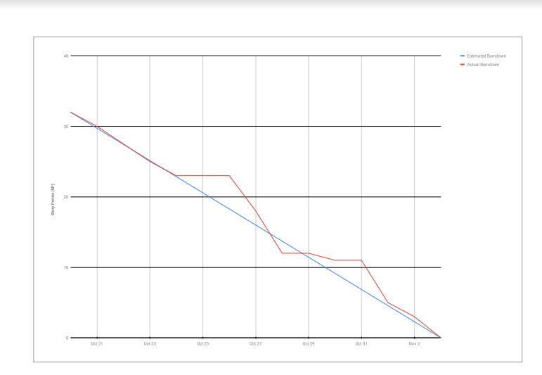

# Screenshot of you project board

