**Daily Scrum or Standup Meeting**

Team name: Third Degree

Scrum Master: Jonathan Gates

Date: 10/28/21

| **Team Member** | **What did you do since the last scrum?** | **What do you plan to do before the next scrum?** | **What obstacles do you have?** |
| --- | --- | --- | --- |
| Adam Alder | * Worked on order drinks page | * Keep working on order drinks page |  |
| Sean Collings | * Worked on admin user page | * Admin user page * Tournaments page |  |
| Jonathen Gates | * Finished homepage | * Start working on sponsor page |  |
| Jaren Glenn | * Tournament CRUD Unit tests | * Score CRUD for Play Tournament Page * Start working on Play Page |  |
|  |  |  |  |

# Burndown

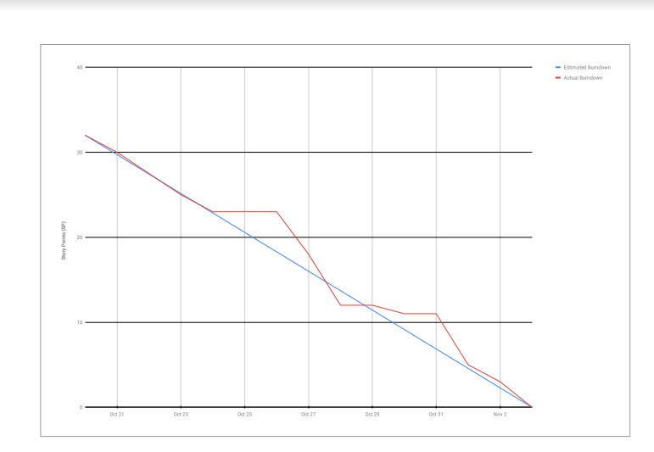

# Screenshot of you project board

