**Daily Scrum or Standup Meeting**

Team name: ___________Group3_________

Scrum Master: ______Sean Collings___

Date:_________November 2nd, 2021______

| **Team Member** | **What did you do since the last scrum?** | **What do you plan to do before the next scrum?** | **What obstacles do you have?** |
| --- | --- | --- | --- |
| Adam Alder | * worked on order drinks page | * Crud unit tests |  |
| Sean Collings | * Admin user page * Tournaments page | * Managing account balance |  |
| Jonathan Gates | * Work on homepage | * work on Sponsor Tournament page | * Know how of React and FastAPI |
| Jaren Glenn | * Worked on leaderboards and play page | * assist Jonathan * Keep working on leaderboards and play page |  |
|  |  |  |  |

# Burndown

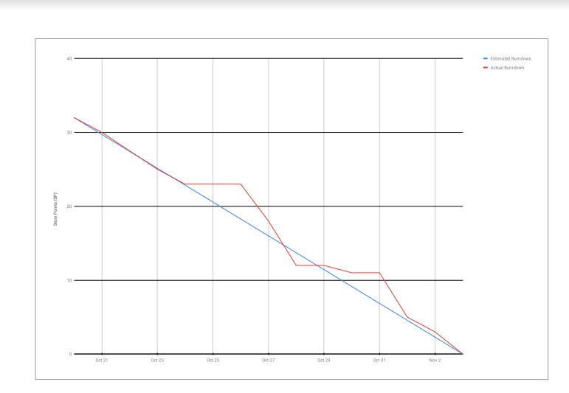

# Screenshot of you project board

