**Daily Scrum or Standup Meeting**

Team name: ___________Group3_________

Scrum Master: ______Sean Collings___

Date:_________November 11th, 2021______

| **Team Member** | **What did you do since the last scrum?** | **What do you plan to do before the next scrum?** | **What obstacles do you have?** |
| --- | --- | --- | --- |
| Adam Alder | * drinkmeister orders * order crud * wrapper for shell file | * drinkmeister orders |  |
| Sean Collings | * Tournament completion logic | * Tournament completion logic |  |
| Jonathan Gates | * worked on Sponsor Tournament page | * More Sponsor Tournament page | * Know how of React and FastAPI |
| Jaren Glenn | * assist Jonathan | * assist Jonathan |  |
|  |  |  |  |

# Burndown

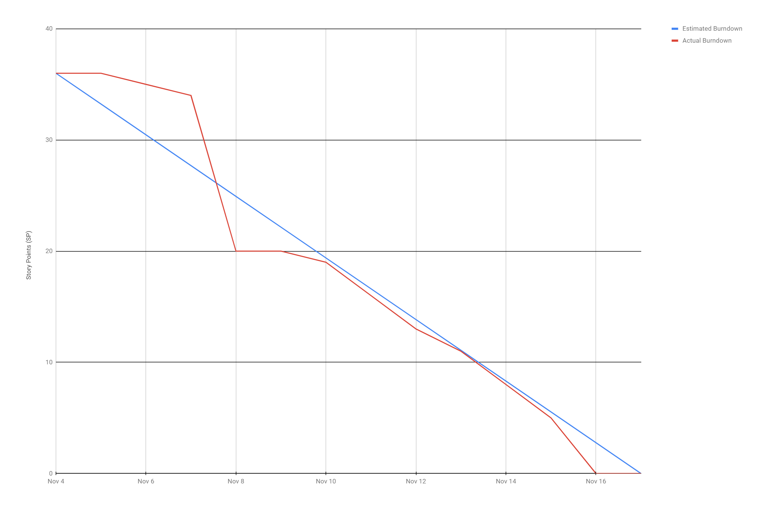

# 

# Screenshot of you project board

