地图题课堂笔记
- 地图题类型

- 第一种静止图：按逻辑分段描述内容即可
- 变迁图（常考）：描述地图各部分位置 + 变化
- 时态
- 两种写法：
- 按区间分布划分段落，直接描述变化
时态：按变化那张写；语言：被动为主
- 一段描写原来位置分布，另一段描写变化
时态：按每张图写；语言：被动为主

- 段落框架（分布+变迁）
有多少变化年份就写多少主体段
introduction
overview
body paragraph (1.2…..)

- introduction （注意时态）

present + future: The maps reveal the proposed changes in grange park in the future.
Past + present: The maps present the development have taken place in grange park.
Past + past: The maps present the development had taken place in grange park.

- Vocabularies
- 方位的描写
- 东east; 南south; 西west; 北north north -east东北；north -west 西北； south- west西南； south -east 东南
- 左右，隔壁
- 方位介词 to，on，in

其他方位描述
Northward/southward/eastward/westward 北/南/东/西边 - 名词后
left/right/beside;next to
位置描述
A main road - 主干道；海边的路 - coastal road
- A main road runs/cuts through the place from west to east
- A main road (extend) from north to south
Small businesses 小的商业体
On each side of the road 道路的两边
Junction 交汇处 - where one road meets another road

描述变化的词汇

- 扩张
expanded; made bigger; developed; extended; enlarged

The housing area has been enlarged.
A future difference is the enlargement of the housing area. (第二张图是将来时间)

- 移除
removed; demolished（拆除-建筑）; locked down; cut down（湿地/林地/森林）
the forest park has been _______
- 增加
Added/introduced ; constructed/ built 建筑; planted 植物; created 景观
a car park has been _____ _____ the east of the hotel

- 改造
Converted into/renovated/remodeled（建筑改造）; replaced by; occupied by; made into/change into
restaurant has been ______ _______ shops

- Overview (词汇高度概括) - 概括总结变化什么
- Overall, the maps present a change from a mainly ______ to a largely ______ area.
industrial area - commercial area 工业-商业
Residential 居住/high-rise 高楼建筑
Entertaining/recreational 娱乐的
- 概括相同和不同点
Overall, although the general _________ of the village does not change a lot, the function of constructions 建筑 in the village has changed from serving _______ and ____________ to ____________.

- Body paragraph
- 第一张图
内容：描述具体位置，各建筑或地点位置关系
顺序：有特殊参照物（门口，进出通道等）以此开展，然后西边和东边；无则按照分布区域划分
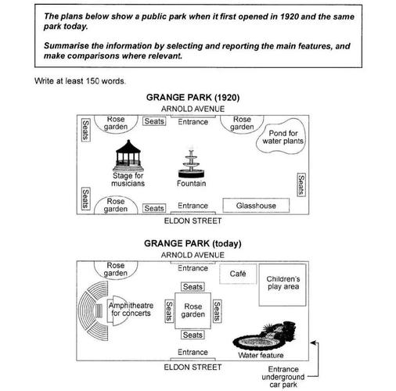
The fountain is located in the center of the park which is between the entrance to the south that is next to the Eldon street and another to the north that is next to the avenue.
Looking at the first picture/in 1920, there was a fountain in the centre of the grange park between the entrance to the south that next to the eldon street and another one to the north that next to the aronld avenue. To the west of the fountain, there was a stage for musicians. A glasshouse was located to the east/right of the entrance southward. Opposite to the glasshouse, there was a pond for water plants. Around the edges of 在....边缘the park there were rose gardens with seats nearby.
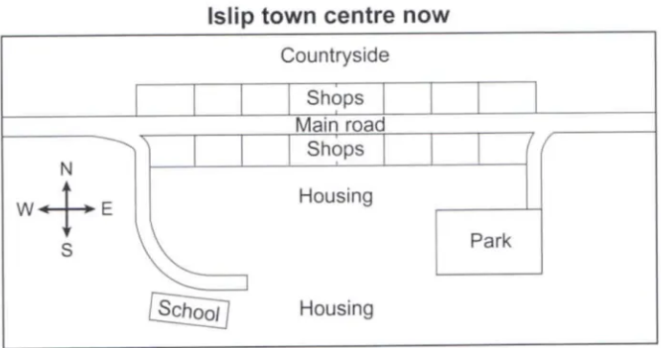
A main road runs through the town center. On each side of it, there are shops. On the north of shops northward, there is a countryside
Lead sb to/adjacent to on the north of A, there is a countryside A:shop northward shop southward
On the end of the access road that leads off west half part of the main road, there is a school where near the housing area.
- 第二张图：
内容：变化； 顺序：先写消除 - 扩大 - 转变 - 新增- 保留
南部：fishing port - restaurant/apartment - car park
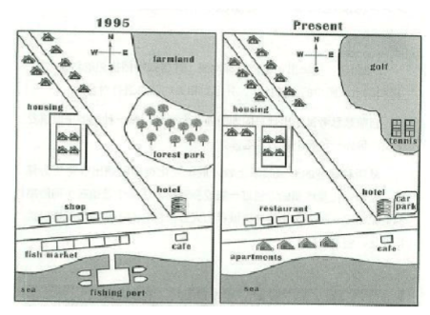
北部：forest park - farmland - golf course&tennis court - housing area

Looking at the first map, in the south part of the village, there was a fishing port on the sea. A coastal road cut through the community where fish market and shops were situated on each side. Opposite to the coffee shop in the north-east of the seashore, there was a hotel standing around the corner of the crossing. Noticeably, a housing area was constructed in the north-west of the village. In addition, in the northeast, there was a farmland where a forest park situating on the south of it.

In the second map, the fishing port has been removed and the fish market has been replaced by apartments. Several restaurants have occupied the place of the shops on the roadside. Moreover, a parking lot is newly built to the east of the hotel. In the northern part, a housing area has been enlarged. Apart from that, the forest park have been removed and the farming land has been converted into golf course and tennis courts.

Home work
The two maps below show an island before and after the construction of some tourist facilities.
