流程图

类型
循环：自然界（生物生命循环；水循环；碳循环）
线性：工序；工作原理

解图思路
1. 找出流程起点，按照箭头方向，仔细看图，理解图意
2. 如果出现生词，结合图中信息进行猜测，多数生词可以直接换成动词使用
3. 按图中步骤、分阶段进行描述，不要省略其中环节
4. 一定要是用表示逻辑顺序的衔接词
5. 通常选用一般现在时，注意主谓一致，注意适当使用被动语态
基本结构
Introduction： 改写题目，介绍图表信息
Overview： 要点概述（1. 两张图：对比区别；2. 一张图：概述总共需要几个步骤）
Body paragraphs: 细节描述（按照步骤的顺序，要点）; 如果有多个流程图， 注意分段，并且带有过渡句，然后顺序描述。
分段
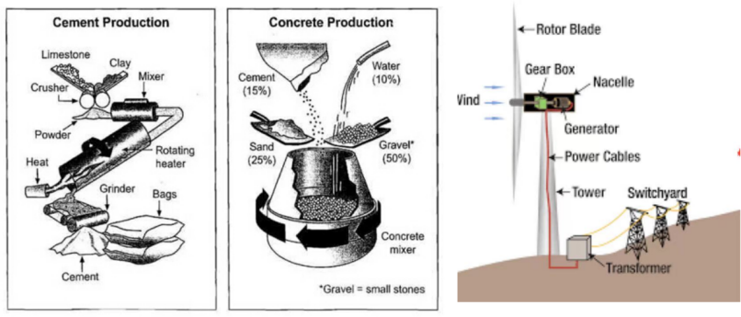
有逻辑分段： 两个图按图片划分；一张图划分阶段，如（电力生产 + 电力运输）
Introduction
工序图：The diagram below shows the stages in the production of silk cloth
- 步骤：stage/step
- 过程：process/procedure; _____ making process; process of _______ making
- 制作: produce/manufacture (v.); production/manufacture(n.)
- The diagram illustrates the steps in the silk cloth making process
- The diagram illustrates the steps involved in the silk cloth production
- The diagram compares the process by which silk cloth is produced
- The diagram illustrates how silk cloth is produced by step
生命循环图：The diagram shows the life cycle of the honey bee.
- life cycle of sth = stages in the life of sth
例：The diagram illustrates the various stages in the life of a honey bee.
水循环图：The diagram below shows the water cycle, which is the continuous movement of water on, above and below the surface of the Earth.
- the continuous movement of water = water pass from x to x to x
例：The picture illustrates the way in which water passes from ocean to air to land during the natural process known as the water cycle.
运作原理图：The diagram shows how electricity is generated by a hydroelectric dam.
- how sth is generated = the principle of sth
例：The diagram illustrates the basic principles of hydroelectric power.
Overview
- 不同的图片分别进行对比或描述步骤
- 一张图：归纳成不同阶段 or 概括流程步骤数量和开头与结尾
- the procedure/process can be divided into _____ phases/stages, beginning with _____ and ending with ___
- the procedure/process is comprised of ____ stages/phases, beginning with ____ and ending with _____

衔接方式
- 连接词
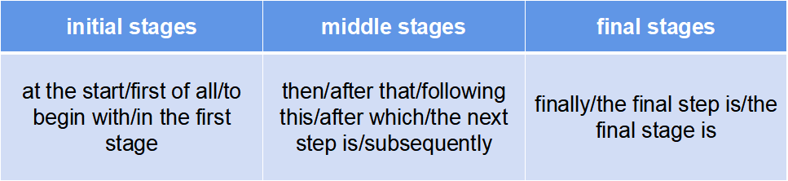
- 复杂句式
Once = as soon as/after….,…；….before….；…as/when/while…；….,where/which….
- 时间衔接
in ....days 多少天之后; after ....days; ....days later; it takes .....days 花了多少天

- 循环图结尾句：the cycle begins again

Body paragraph

The first stage of making cement involves crushing clay and limestone into powder. This powder is passed through a rotating heater, being heated before being ground by a grind to make a cement. The final product is put into bags ready for use.

With regard to concrete producing process, we can see that the cement production is part of concrete production, in which 15% of cement, 10% water, 25% sand and 50% gravel (small stones) are put inside a concrete mixer that rotate to combine these materials and ultimately produces concrete.

Home work
The diagrams below show the life cycle of silkworm and the stages in the productions of silk cloth.
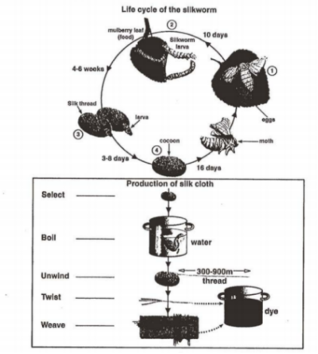select - boil - unwind - twist - wave - dye
补充词汇
Produce/manufacture/make 生产
lay/place/put 放置
add 添加
mix/compound/blend 混合
accumulate 积累
gather/collect/obtain/harvest 收集
store储存
remove/eliminate 移除
Heat up加热
boil 煮
dye染色
fade 退色
weave 编制
cover覆盖
secure 确保
expand 膨胀
bend 弯曲
cool down冷却
Disconnect断开连接
strike打击
compress/condense 压缩
reverse 颠倒倒转
adapt 适应
release 释放
accelerate 加速
press 按压
Absorb 吸收
Process 加工
crush/smash 粉碎
grind 碾碎
ignite 点燃
Burn 燃烧
Reflect反光
tum 转
record 录音
turn of关闭
turns up 调高
turns down 调低
winds 缠绕
unwinds 解开
Spin/revolve/rotate 旋转
Fond折叠
unfold打开
adjust调整
alter 改变
disappear 消失
draw/extract 提取
recycle 回收
Dissolve 溶解
exchange 交换
absorb 吸收
be made up of 由..组成
Promote 促进
be made of 由.制成
Renew/renovate 更新/修复
replace 替代
be made from 由.制成 swell肿胀
decompose/ break up/segregate分解
Switch/transform 改变 feed on以.…为食 vary改变
depend on/rely on 依赖 swap 交换
Release/send out释放 shrink 收缩 melt 独化
Sort/categorize 分类 separate分开
form/come into being/mold 形成 gain get/acquire 获取
transport/send transfer 运送 cut into 切成
evaporate 蒸发volatilize 挥发
poured into 例入 flows into流入 ferment 发酵 roast/bake 烤
reproduce/give birth/breed 繁殖
Rise up 上升 grow成长 pack打包

