静态图课堂笔记
- 静态图特征
- 静态图特点
定义：通常指没有时间变化的数据图
出现形式：柱图、饼图、表格
作用：用来比较数量大小的差异和多少
写作特点：对象多，适合归纳对比
- 静态图特征分析方法
- 极大值&极小值
- 大小关系比较
- 呈现差异对比
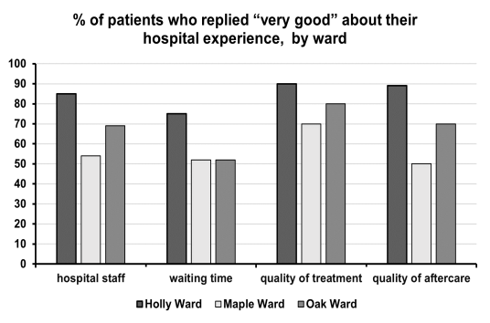
Holly医院病房在所有参考类别中得分最高；然而Maple医院病房在所有参考类型中得分最低
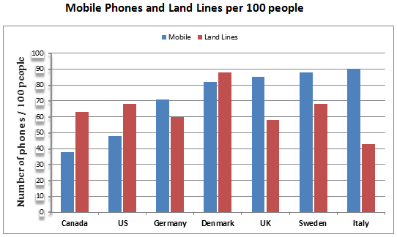
在英国、瑞典和意大利，移动电话的使用人数比固化使用人数高，然而加拿大、美国和丹麦情况相反。

- 静态图分组
- 按总体大小特征分段：数值大小分组归纳
- 按数值差异化分段：按不同的数值特征划分
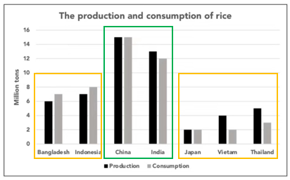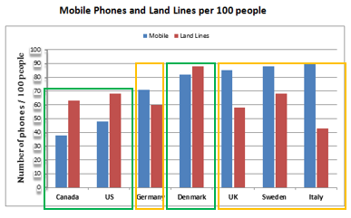

- 静态图必备表达
静态图数据会以百分比形式呈现。 关于百分比，考生需要有以下的表达储备：
1. 表示比例：proportion; percentage;
2. 表示大量/少数：
大量：the majority of; a significant/the vast/the overwhelming majority of; the bulk of;
少数：a small/tiny minority of; a small fraction of;
e.g. The majority of students showed interest in football, with over 80%.
3. 表示占据、构成：constitute/comprise/account for/make up
e.g. Clearly, fossil fuels constituted the bulk of energy used for producing electricity, with over 70 percent.
e.g. People of Irish background now comprise 10% of the inhabitants in Islip.

- 主体段写作方法
重点数据：
最大(若有两个明显大，而且数值相似，可摘取近似值)、第二大（当第二大数值比较明显时）、最小、相同、倍数（当倍数特征比较明显时, 如 2 倍或 3 倍）。
其他的非重点数据，通常可以采取下列方式对待：比较级比较、合并排序、区间。

表达最大：
• rank/take top/first
• be the most popular/favorable/preferred
• the largest number/percentage of sth.
表达最小：
• the lowest ranked/listed is/are sth.
in the lowest position is/are sth.
• be the least popular/ favorable/ preferred
be recorded as the lowest number/amount of

表达数值相同：
• The figure for X is identical to that of Y
• X is matched by/is equaled by Y
• X and Y have exactly the same numbers

表达第二大：
• be the second highest/ largest/ greatest
• share/enjoy the second most popularity

表达排序：
• X..... . It/This is followed by Y which ...
• X...., followed by Y which....
• X ...., with Y coming next
• Y follows closely behind
• Y follows at a distance

表达比较级：
• considerably/significantly/noticeably + adj.
• marginally/slightly/fractionally + adj.
• relatively +adj.

表达倍数：
• twice/triple/half as many/much as
区间数据描述：
• the number/amount of sth/figures range from 数值 to 数值
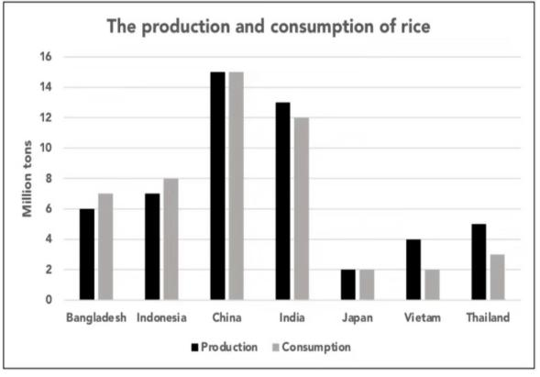
【参考范文】
The bar chart compares the production and consumption of rice in seven nations in the year 2008.
Overall, China and India took the lead in both consumption and production, with figures noticeably larger than those in the rest five countries.
Among all the countries, China was the largest rice producer as well as consumer, producing approximately 15 million tons of rice and consuming the same amount in 2008. It was closely followed by India, whose rice production reached around 13 million tons and was slightly higher than the consumption (12 million tons).
In the same year, Bangladesh and Indonesia were in similar situations, consuming more rice than they produced, figures ranging from 6 to 8 million tons. While, the pattern was different in Vietnam and Thailand, as their produced amount (4 million tons for Vietnam and 5 million tons for Thailand) was nearly twice as much as their usage. In terms of Japan, its production and consumption not only were recorded as the lowest figures but also were the same, at 2 million tons.

- 混合图的写作方法
- 概况：混合图是对图形分析能力的综合考察，一般由两种不同的图形组成；
- 特点：每张图各用一句话总结特点；
- 分段方法：一个图一段；
- 主体段：段落内部按照各个图形的写作步骤进行描述。
- introduction示例
The charts below show the main reasons for study among students of different age groups and the amount of support they received from employers.
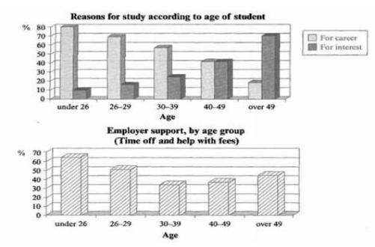
The bar charts compare students of different ages in terms of why they are studying and whether they are supported by an employer.
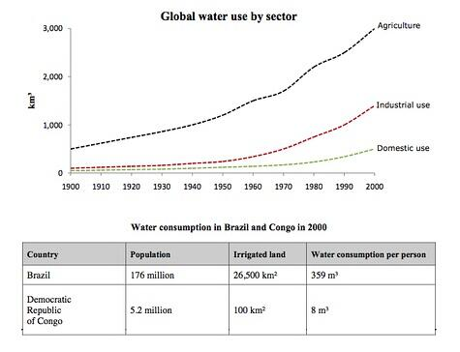
The line graph and table compare the amount of water used for agriculture, industry and homes around the world, and water use in Brazil and the Democratic Republic of Congo.

作业
The chart below shows the different level of post- school qualifications in Australia and proportion of men and women who held them in 1999.
