QuantBloom Terminal
  - A Technical Whitepaper — Machine Learning, Trading Strategies, and the Mathematics Behind Them
QuantBloom Research
Version 1.0
Table of Contents

Abstract
QuantBloom Terminal is a single-page, browser-native quantitative research and trading environment modelled on the workflow of a professional trading desk. It unifies market data, advanced charting, a machine-learning signal pipeline, an honest backtesting engine, a risk-gated paper-trading bot, a broad suite of portfolio and derivatives analytics, and a power/commodities pricing desk into a single 37-panel terminal. The system is written in JavaScript end to end — a React/Vite front end and an Express API — with every numerically load-bearing computation implemented as a pure, unit-tested module (332 tests at the time of writing).
This paper documents the system in depth. Its emphasis is on the mathematics of the trading and machine-learning components: the feature construction and triple-barrier labelling; the three in-app model families (regularised logistic regression, gradient-boosted decision trees, and a PCA latent-factor model built on a from-scratch Jacobi eigensolver) and their ensemble; the metrics used to judge them; and — most importantly — the overfitting guards (Probabilistic and Deflated Sharpe ratios, and the Probability of Backtest Overfitting via combinatorially-symmetric cross-validation) that form the publish gate. We also document the point-in-time backtester, the rule-based strategies, the trading bot’s risk gate and bracket/trailing-stop machinery, the portfolio analytics (mean-variance optimisation, three-method Value-at-Risk, factor regression, DCF, and time-value-of-money), and the power-markets desk (merit-order dispatch, locational marginal pricing under transmission congestion, spark spreads, and a Monte-Carlo heat-rate call option) derived from a Citadel power & gas primer.
A recurring theme is intellectual honesty. The system is explicit about the difference between observed and modelled quantities, and its most important design decision — the publish gate — is built to reject models that do not demonstrably beat a buy-and-hold benchmark out of sample. As documented in Section 16, none of the daily-bar models currently clear that bar. We treat that as the tooling working correctly, not as a failure to be tuned away.

1. Introduction and Motivation
Professional trading terminals — the Bloomberg Terminal being the archetype — succeed because they collapse the distance between a question and its answer. A trader types a ticker and a mnemonic and is instantly looking at the relevant chart, fundamental, or analytic. QuantBloom pursues the same ergonomic goal in a browser, but with a second, equally important commitment: every number it shows should be traceable to a tested computation, and every modelled quantity should be labelled as such.
The terminal is organised as a dashboard of independent panels. Each panel is a self-contained React component that polls the API for the data it needs and renders a focused view — a chart, a screener, a risk report, a pricing calculator. A global command palette (Ctrl+K, the Bloomberg TICKER <GO> pattern) sets the active symbol across the whole terminal or jumps to any panel; any panel can be popped out into its own live browser window (Ctrl+Shift+M) to spread work across monitors.
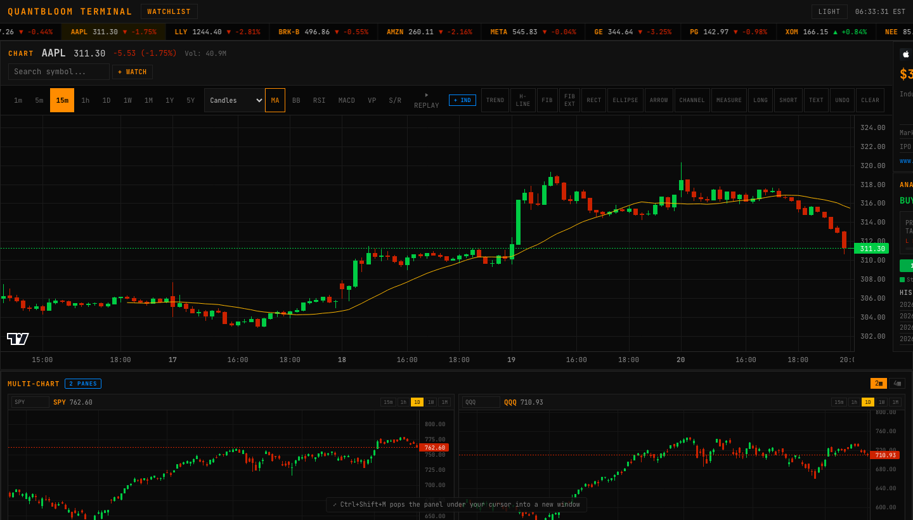
The QuantBloom hero view: navigation, the cross-asset ticker, and the primary chart with a moving-average overlay.
Figure 1. The terminal hero — command bar, cross-asset ticker tape, and the primary interactive chart.
Beneath the UI sit three intellectual pillars, each of which this paper treats in detail:
- Signal research — a supervised-learning pipeline that turns OHLCV bars into point-in-time features, labels them with a triple-barrier scheme, trains several model families, and — crucially — refuses to “publish” a model that cannot beat buy-and-hold out of sample after correction for multiple testing.
- Execution — a paper-trading bot whose every order passes a hard-coded risk gate, can carry broker-side stop-loss/take-profit brackets and a live trailing stop, and can be driven either by transparent rule strategies or by a selected ML model.
- Analytics — a broad set of desk tools: mean-variance portfolio optimisation, three-method VaR, factor regression, discounted-cash-flow valuation, time-value-of-money, and a power-markets pricing desk.

1.1 Design principles
- Tested maths, not trusted maths. Anything that produces a number a user might act on lives in a pure module with a dedicated test file that asserts its defining properties, not merely that it runs.
- Point-in-time everywhere. Both the live signal path and the backtester compute features from bars [0..t] only; a model never sees a bar it could not have seen in production. Train/live feature parity is enforced.
- Observed vs. modelled. Panels that display a model (DCF, VaR, the power desk, any ML signal) say so in the interface. The system never presents a simulation as an observation.
- Honest gating. The publish gate is deliberately demanding. Most strategies fail it, which is the correct outcome for daily-bar technical analysis on liquid names.

2. System Architecture

2.1 Runtime shape
QuantBloom is two processes:
- A React 18 + Vite front end (src/) that renders the terminal and holds all UI state through the React Context API and useReducer.
- An Express API (server.js, ~2,900 lines) that proxies market data, computes the shared technical-indicator payload, and hosts the bot, backtest, and model-training routes (~50 routes in total).
For local or Docker deployment the Express server also serves the built front-end, so node server.js is a single self-contained process. On a serverless host (Vercel) the same app is exported as a function; the stateful trading bot and file-based model persistence degrade gracefully to in-memory there, and the UI documents that the bot needs a persistent process.

2.2 Module layout
The numerically important code is deliberately isolated from the UI and the server so it can be tested in a plain Node process:
Concern | Module(s) | Tested in
Options pricing & Greeks | blackscholes.js | test/blackscholes.test.mjs
OLS regression | regression.js | test/regression.test.mjs
Mean-variance optimisation | portfolio-math.js | test/portfolio-math.test.mjs
Feature engineering & labels | bot/features.js | test/*
Logistic / PCA / ensemble models | bot/model.js | test/model.test.mjs, test/ensemble.test.mjs
Gradient-boosted trees | bot/gbm.js | test/gbm.test.mjs
Eigendecomposition (Jacobi) | bot/eigen.js | test/eigen.test.mjs
PCA | bot/pca.js | test/pca.test.mjs
Overfitting statistics | bot/statistics.js | test/statistics.test.mjs
Backtester | bot/backtest.js | test/backtest.test.mjs
Risk gate | bot/risk-gate.js | test/risk-gate.test.mjs
Brackets / trailing stop | bot/brackets.js | test/brackets.test.mjs
Strategies | bot/strategies.js | test/contrarian.test.mjs
Chart-type transforms | charting/chart-types.js | test/chart-types.test.mjs
Indicator series | charting/indicators.js | test/indicators-series.test.mjs
Drawing maths | charting/drawing-math.js | test/drawing-math.test.mjs
Volume profile & structure | charting/volume-profile.js | test/volume-profile.test.mjs
Bar-replay state | charting/replay.js | test/replay.test.mjs
Formula interpreter | charting/formula.js | test/formula.test.mjs
Power markets | charting/power.js | test/power.test.mjs
Time value of money | bot/tvm.js | test/tvm.test.mjs
Command-palette logic | src/lib/command.js | test/command.test.mjs
The rule is uniform: a panel is a thin rendering layer over a tested module.

3. Market-Data Layer
QuantBloom runs on free-tier and public data. Yahoo Finance (no key required) provides OHLCV candles across timeframes and powers charts, quotes, screeners, backtests, and the entire model lab. Optional keyed providers enrich specific panels — Finnhub (fundamentals, analyst ratings, calendars), FRED (macro and the yield curve), Alpha Vantage (quote fallback), Marketaux and NewsAPI (news with sentiment). A missing key disables only the panel that needs it; the terminal runs with none set.
The server maintains a small in-memory cache to smooth polling and shares one canonical technical-analysis payload builder (bot/indicators.js, computeTechnical) between the live /api/v1/technical route and the backtester, so a rule strategy sees byte-identical indicator inputs whether it is running live or being backtested. This is a deliberate anti-divergence measure: the single most common source of “it worked in the backtest” errors is a mismatch between research and production feature code.

4. The Charting Engine
The chart is built on lightweight-charts and extended with a family of tested, clean-room implementations of standard chart constructions and indicators.

4.1 Chart types
Eight chart types are available. Several are native series styles; three are deterministic transforms of the candle series implemented in charting/chart-types.js:
Heikin-Ashi. A smoothing transform that averages the OHLC to damp noise:
$$\begin{aligned}{\text{HA}}_{\text{close}}&=1/4(O+H+L+C) \\ {\text{HA}}_{\text{open}}&=1/2\left({\text{HA}}_{\text{open}}^{ t−1}+{\text{HA}}_{\text{close}}^{ t−1}\right) \\ {\text{HA}}_{\text{high}}&=max(H, {\text{HA}}_{\text{open}}, {\text{HA}}_{\text{close}}) \\ {\text{HA}}_{\text{low}}&=min(L, {\text{HA}}_{\text{open}}, {\text{HA}}_{\text{close}})\end{aligned}$$
with the seed ${\text{HA}}_{\text{open}}^{ 0}=1/2(O_{0}+C_{0})$. The transform preserves the time axis one-to-one; the test suite asserts that the close equals the OHLC mean, the open is the average of the previous HA open/close, and the high/low bound both the HA body and the true range.
Renko rebuilds the series as fixed-size “bricks”: a new brick of height equal to the box size (defaulting to the average true range) is emitted only when price moves a full box beyond the last brick’s close, discarding sub-box noise. Because Renko and Line-Break have no uniform time axis, bricks are emitted with strictly increasing synthetic times so a candlestick renderer can display them.
N-line break (default $N=3$) draws a new line only when the close breaks beyond the extreme of the last $N$ lines; smaller moves are absorbed, so a reversal requires conviction.

4.2 Indicator series library
charting/indicators.js computes full series (not the point-in-time snapshots the bot uses) for plotting. It provides SMA, EMA, WMA, anchored VWAP, Bollinger, Keltner, Donchian, Parabolic SAR and SuperTrend as price overlays, and RSI, MACD, Stochastic, CCI, Williams %R, ATR and OBV as sub-pane oscillators. A registry carries each indicator’s pane, colour, and parameters so the overlay manager is data-driven. Representative definitions:
$${\text{EMA}}_{t}=α P_{t}+(1−α) {\text{EMA}}_{t−1}, α=\frac{2}{n+1}$$
$${\text{RSI}}_{t}=100−\frac{100}{1+{\text{RS}}_{t}}, {\text{RS}}_{t}=\frac{{\overline{\text{gain}}}_{n}}{{\overline{\text{loss}}}_{n}}$$
with Wilder’s smoothing of the average gain and loss. The test suite asserts the defining behaviours — RSI is 100 on a monotonic rise and ~0 on a decline and stays in $[0,100]$; the MACD histogram equals MACD minus signal; Bollinger bands straddle the middle band and widen with volatility; Donchian’s upper/lower equal the rolling max-high/min-low; OBV rises on up-closes and falls on down-closes.

4.3 Volume profile and market structure
charting/volume-profile.js buckets traded volume by price rather than time, distributing each bar’s volume across the price buckets its high-low range spans weighted by overlap. It returns the point of control (the busiest price), and a value area computed by expanding outward from the POC — at each step taking whichever adjacent bucket holds more volume — until 70% of total volume is enclosed. A companion supportResistance clusters swing pivots (bars that are the strict extreme within a $±k$ window) into strength-ranked levels. The overlay renders as a right-edge histogram with the POC and value area highlighted, plus dashed support/resistance lines.

4.4 Drawing tools, replay, and multi-chart
The drawing layer stores anchors as {time, price} (so they stay pinned through pan/zoom) and offers trend lines, horizontal lines, Fibonacci retracement and extension, channels, ellipses, arrows, a measure tool (Δprice, Δ%, bars), and a long/short position tool with a live reward-to-risk readout. The numeric parts are factored into charting/drawing-math.js and tested — e.g., positionRR(100, 110, 95) returns a long trade with R:R 2.
Bar replay (charting/replay.js) reveals history one bar at a time from a cursor so a setup can be reviewed exactly as it looked then; every layer — base series, indicators, drawings, volume profile — slices to the same cursor, so nothing leaks the future. The key test asserts sliceUpTo never returns a bar whose time exceeds the cursor.
A multi-chart panel renders a 2- or 4-pane grid of fully independent charts, each with its own symbol, timeframe, and data feed.
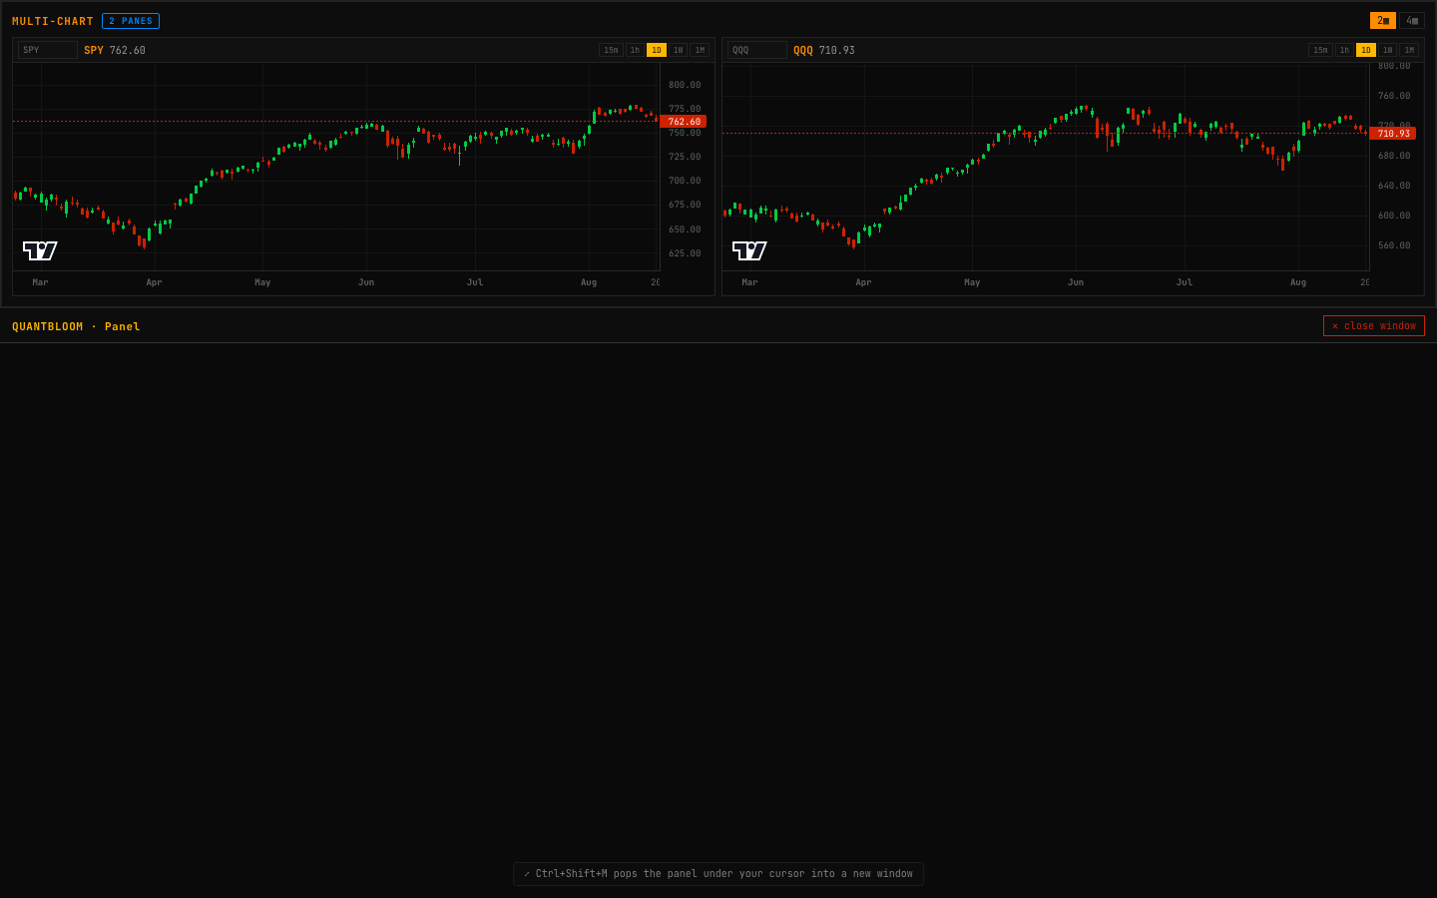
Independent multi-chart grid, each pane with its own symbol and timeframe.
Figure 2. The multi-chart grid — four independent, live charts.

4.5 A neutral custom-indicator language
charting/formula.js is a small, sandboxed expression interpreter — a tokeniser, a recursive-descent parser, and an AST evaluator over a fixed whitelist of series (open, high, low, close, volume, hl2, hlc3, ohlc4), functions (sma, ema, stdev, rsi, abs, max, min), and operators. It is not eval: there is no grammar rule that can produce a JavaScript global, prototype, or arbitrary call, so a user formula cannot reach outside itself. The test suite includes an explicit sandbox battery — constructor, window, eval, __proto__ and member access are all rejected — alongside correctness tests (SMA equals the hand-average, close - sma(close,20) is an oscillator).
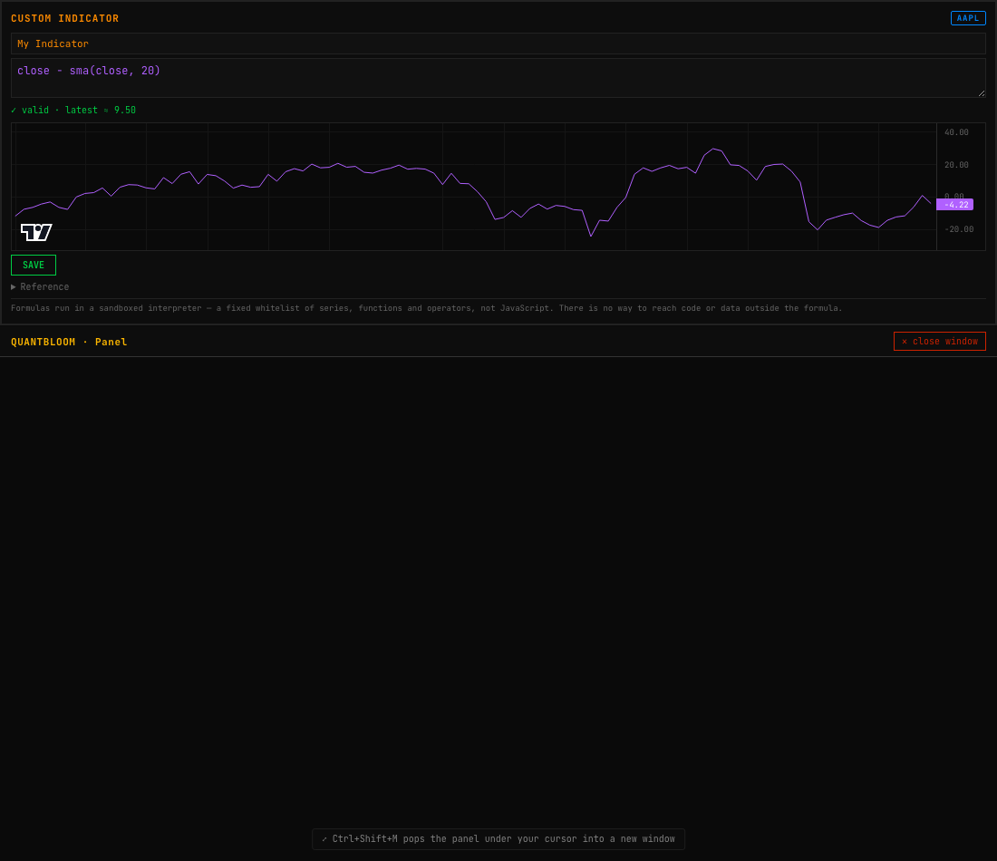
The custom-indicator editor with live validation and a preview chart.
Figure 3. The sandboxed custom-indicator editor: a formula, live validation, and a preview of the resulting series.

5. Feature Engineering and Labelling
The ML pipeline begins by turning a candle series into a supervised dataset. This is the most consequential and error-prone part of any trading-ML system, and the one where point-in-time discipline matters most.

5.1 Point-in-time features
bot/features.js computes, at each bar $t$, a 19-dimensional feature vector from bars $[0..t]$ only. The features are chosen to be scale-free and to span several economic ideas — momentum, mean-reversion, trend regime, range position, and volatility regime:
- Returns: ret1, ret5, roc20 (rate of change).
- Trend/location: priceVsSma50, priceVsSma200, sma20Slope.
- Oscillators: rsi14, rsiSlope, macdHist, stoch.
- Bands/range: bollingerPct, distFrom120High, distFrom120Low.
- Volume/vol: volumeRatio, volatility, volRegime, atrPct.
Every value passes through a finite-guard so no NaN/Infinity can reach a model. The dataset builder uses a 200-bar warm-up so that long-lookback features (SMA-200) are fully formed from the first training row.

5.2 Cross-asset (market-relative) features
Optionally, five market-relative features are appended, computed against a benchmark (SPY) whose closes are aligned to the stock’s bar times with carry-forward across gaps:
$${\text{excessRet}}_{k}=\frac{P_{t}}{P_{t−k}}−1−\left(\frac{B_{t}}{B_{t−k}}−1\right), k∈\{1,5\}$$
plus a 20-bar relative-strength term and the 60-bar $β$ and correlation to the benchmark:
$$β_{60}=\frac{Cov(r^{\text{stock}},r^{\text{bench}})}{Var(r^{\text{bench}})}, ρ_{60}=\frac{Cov(r^{\text{stock}},r^{\text{bench}})}{σ^{\text{stock}} σ^{\text{bench}}}.$$
Train/live parity is enforced by construction: the model artifact records its feature-name list; the live signal path detects a market-trained model by that list’s length and refuses to run without the benchmark rather than feed a mis-shaped vector.

5.3 The triple-barrier label
Labels follow the triple-barrier method (López de Prado). For a long entered at the close of bar $t$, three barriers are placed: an upper profit barrier at $P_{t}(1+u)$, a lower stop barrier at $P_{t}(1−d)$, and a vertical time barrier at $t+h$. Scanning forward,
$$y_{t}=\left\{\begin{matrix}1 & \text{if the upper barrier is touched before the lower within }h\text{ bars} \\ 0 & \text{if the lower barrier is touched first} \\ 1[P_{t+h}>P_{t}] & \text{if the time barrier is hit first}\end{matrix}\right.$$
with defaults $u=3\%$, $d=2\%$, $h=10$ bars. A conservative tie-break treats a bar whose range straddles both barriers as a stop (the pessimistic assumption for a long). Rows without enough future to determine the label are excluded — they cannot be labelled and must not be invented.

5.4 Temporal splitting
Time series are never shuffled before splitting; the test set is always the most recent contiguous slice (default 30%). Random $k$-fold splitting would leak future information through serially-correlated adjacent rows, inflating every metric. temporalSplit enforces this and is used everywhere a train/test split is needed.

6. Machine-Learning Models
QuantBloom trains models entirely in-app (JavaScript), so research is reproducible and requires no Python runtime. Four model families are available; all share one prediction interface, predictProba(model, featureRow) → [0,1], which dispatches on model.type, so evaluate(), modelStrategy(), the backtester, and the publish gate work with any family unchanged.
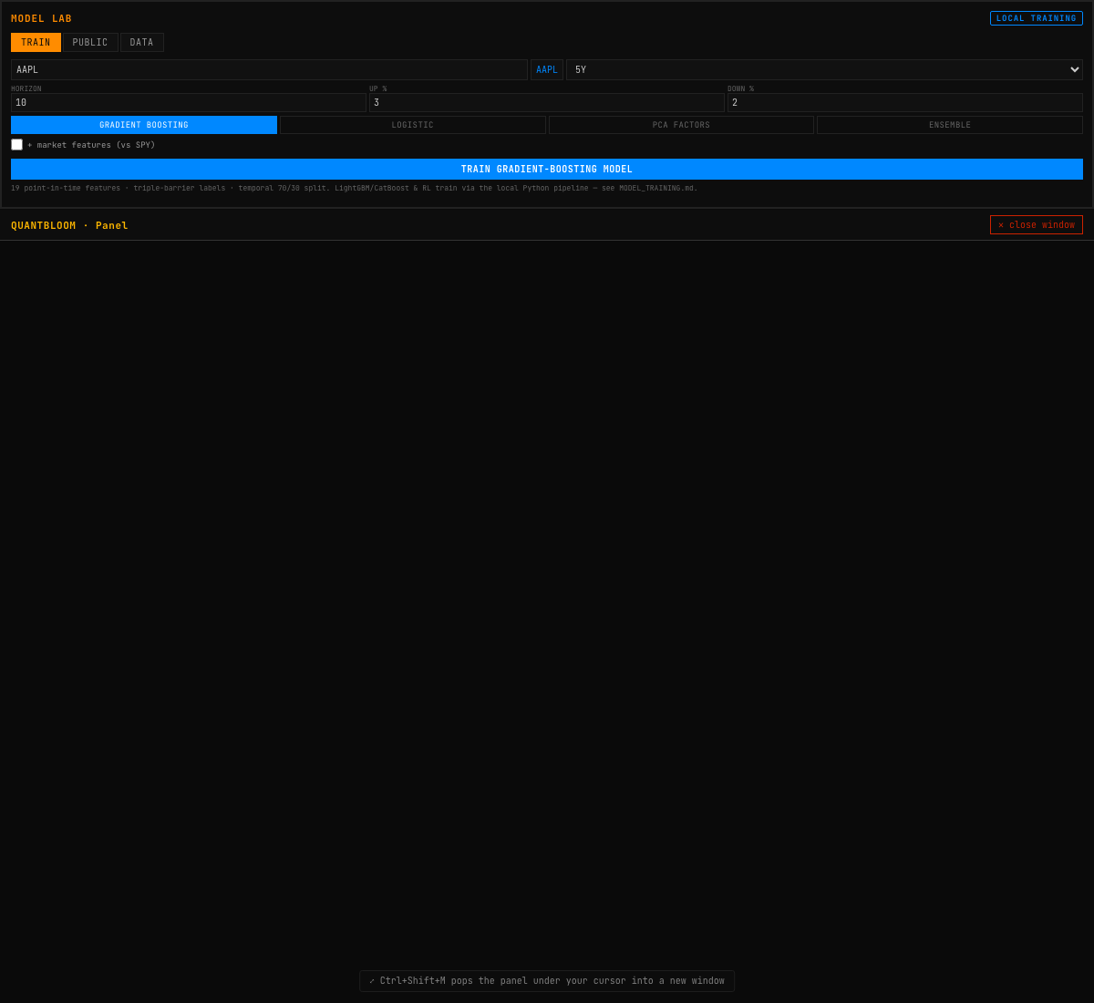
The Model Lab: model-type selector, training controls, out-of-sample metrics, and the publish gate’s verdict.
Figure 4. The Model Lab — train a model, read its out-of-sample metrics, and see the publish gate’s decision.

6.1 Regularised logistic regression
The baseline model predicts $P(y=1∣x)=σ(w^{⊤}z+b)$ where $σ(a)=1/(1+e^{−a})$ and $z$ is the standardised feature vector $z_{j}=(x_{j}−μ_{j})/σ_{j}$ (the scaler is stored with the model). Training minimises the L2-regularised cross-entropy
$$L(w,b)=−\frac{1}{N}\sum_{i=1}^{N}{\left[y_{i}logp_{i}+(1−y_{i})log(1−p_{i})\right]}+\frac{λ}{2}{\left\|w\right\|}^{2}$$
by batch gradient descent, using the standard logistic gradient ∇wL=1Ni​(pi−yi) zi+λw. It is a transparent, low-variance baseline; any more complex model has to beat it.

6.2 Gradient-boosted decision trees
bot/gbm.js implements Friedman’s gradient boosting as the in-app stand-in for LightGBM/CatBoost. It fits an additive model $F_{M}(x)=\sum_{m=1}^{M}{ν} h_{m}(x)$ of shallow regression trees to the pseudo-residuals of the log-loss. Working in logit space with $p=σ(F)$, the negative gradient of the log-loss at stage $m$ is simply
$$r_{i}^{(m)}=y_{i}−σ​\left(F_{m−1}(x_{i})\right),$$
i.e. the current probability error. Each stage fits a shallow CART regression tree $h_{m}$ to $\{(x_{i},r_{i}^{(m)})\}$ by exhaustive split search minimising squared error, with a minimum-leaf-size constraint, and the ensemble is updated with a learning rate $ν$ (shrinkage). The final prediction is $σ(F_{M}(x))$. Split-count feature importance is reported, normalised to sum to one.
The decisive test is that the GBM learns XOR — a function no linear model can represent — achieving accuracy $>0.85$ where logistic regression sits near $0.5$. Building this model also surfaced a real methodological bug: a naive linear-congruential PRNG produces serially-correlated “noise” that the GBM was powerful enough to learn, giving fabricated out-of-sample AUC of 0.96; switching to a mulberry32 PRNG with independent feature/label streams restored the expected $≈0.5$. This is itself a small demonstration of why the overfitting guards in Section 7 exist.

6.3 The PCA latent-factor model
The latent-factor family (the in-app, clean-room stand-in for the ml4t-models PCA/RPPCA/IPCA family) reduces the standardised features to their top-$k$ principal components — the directions of greatest variance, the “latent factors” — then predicts the label from those components with logistic regression.
PCA requires the eigenvectors of the feature covariance matrix. Because a covariance matrix is symmetric, QuantBloom uses a from-scratch cyclic Jacobi eigensolver (bot/eigen.js). Jacobi repeatedly applies a plane rotation $R(p,q,θ)$ that annihilates the largest off-diagonal entry:
$$θ=1/2atan2​\left(2a_{pq}, a_{pp}−a_{qq}\right), A←R^{⊤}AR,$$
accumulating $V←VR$ until $A$ is diagonal; the diagonal then holds the eigenvalues and the columns of $V$ the eigenvectors. The solver is verified against known decompositions, orthonormality, $Av=λv$ for every returned pair, and the trace/determinant identities. PCA (bot/pca.js) standardises $X$, forms the covariance from the columns, eigendecomposes it, and projects onto the top-$k$ loadings; the fraction of variance explained per component is reported. On real data, five factors typically capture $≈82\%$ of feature variance.

6.4 The ensemble
The ensemble averages the predicted probabilities of the GBM, logistic, and PCA members: ${\hat{p}}_{\text{ens}}(x)=1/3\left({\hat{p}}_{\text{gbm}}+{\hat{p}}_{\text{log}}+{\hat{p}}_{\text{pca}}\right)$. Averaging decorrelated errors trades a little of each model’s bias for lower variance; the test suite asserts the blend is never worse than its weakest member. As Section 16 records, on real data the ensemble improves robustness but does not beat the best single model, and — like every model here — does not beat buy-and-hold.

6.5 Evaluation metrics
evaluate() reports accuracy, precision, recall, F1, and a rank-based AUC computed via the Mann–Whitney statistic:
AUC=1|P||N|i∈P​j∈N​1pi>pj,
which is threshold-independent and is not fooled by class imbalance the way raw accuracy is. AUC is the primary discrimination metric in the publish gate.

7. Model Evaluation and the Publish Gate
The single most important design decision in QuantBloom is that a model cannot reach the public page — or be trusted — merely because it looked good on a backtest. Backtests are optimised over many trials, and the best of many random strategies will look excellent by chance. The publish gate (bot/model-registry.js, evaluateGate) enforces a battery of out-of-sample tests, corrected for multiple testing, before a model is eligible.

7.1 Risk-adjusted return
bot/statistics.js computes the standard summary statistics on an equity curve. For a return series $\{r_{t}\}$ with mean $μ$ and standard deviation $σ$, the annualised Sharpe ratio (with $N$ periods per year and risk-free rate $r_{f}$) is
$$\text{SR}=\frac{μ−r_{f}/N}{σ}\sqrt{N},$$
with the Sortino ratio replacing $σ$ by the downside deviation, and the maximum drawdown the largest peak-to-trough decline of the cumulative curve.

7.2 The Probabilistic Sharpe Ratio
A Sharpe estimate from a finite, non-normal sample is itself uncertain. The Probabilistic Sharpe Ratio (Bailey & López de Prado) gives the probability that the true Sharpe exceeds a benchmark ${\text{SR}}^{⋆}$, correcting for skew $γ_{3}$ and kurtosis $γ_{4}$ and sample length $n$:
$$\text{PSR}({\text{SR}}^{⋆})=Φ​\left(\frac{(\hat{\text{SR}}−{\text{SR}}^{⋆})\sqrt{n−1}}{\sqrt{ 1−γ_{3}\hat{\text{SR}}+{γ_{4}−1}/4{\hat{\text{SR}}}^{ 2} }}\right),$$
where $Φ$ is the standard-normal CDF. Fat tails and negative skew lower the PSR: the same point estimate is less trustworthy when returns are non-normal.

7.3 The Deflated Sharpe Ratio
When a researcher tries $M$ strategy variants and keeps the best, the maximum observed Sharpe is inflated purely by selection. The expected maximum Sharpe under the null (all variants have zero true edge) is approximated by
$$E[\max_{M}\hat{\text{SR}}]≈σ_{\text{SR}}\left[(1−γ) Φ^{−1}​(1−1/M)+γ Φ^{−1}​(1−1/{Me})\right],$$
with $γ$ the Euler–Mascheroni constant and $σ_{\text{SR}}$ the cross-trial dispersion of Sharpe estimates. The Deflated Sharpe Ratio is then the PSR benchmarked against this inflated threshold rather than zero: $\text{DSR}=\text{PSR}(E[\max_{M}\hat{\text{SR}}])$. A strategy with a high raw Sharpe but a DSR below ~0.90 is statistically indistinguishable from the luckiest of the variants that were tried.

7.4 The Probability of Backtest Overfitting
probabilityOfBacktestOverfitting implements combinatorially-symmetric cross-validation (CSCV). The performance matrix (strategies × time slices) is split into all balanced combinations of in-sample and out-of-sample halves; for each, the in-sample-best strategy’s out-of-sample rank is recorded, mapped to a logit $λ$, and the PBO is the fraction of combinations in which the in-sample winner underperforms the out-of-sample median ($λ<0$):
$$\text{PBO}=Pr[λ<0].$$
A PBO above 50% means selecting the best backtest is worse than a coin flip out of sample — a direct, model-agnostic measure of overfitting.

7.5 The gate
A model is eligible to publish only if, on the held-out test window, it clears all of:
Criterion | Threshold | Guards against
Test AUC | $≥0.55$​ | no directional edge
Out-of-sample Sharpe | $≥0.5$​ | poor risk-adjusted return
Beats buy-and-hold | required | closet indexing
Deflated Sharpe | $≥0.90$​ | multiple-testing luck
Test trades | $≥5$​ | statistically empty backtest
Test rows | $≥60$​ | too little held-out data
The gate is deliberately demanding. The server re-checks eligibility on publish, so a client cannot force a model through. Section 16 reports the honest consequence: no daily-bar model currently clears it.

8. Backtesting Methodology
bot/backtest.js is an event-driven, point-in-time backtester shared in spirit with the live engine. Its correctness rests on three rules:
- No look-ahead. At each bar $t$, signals are computed from bars $[0..t]$ only.
- Fills at the next bar’s open. A signal generated on the close of bar $t$ fills at $O_{t+1}$, never at $C_{t}$. Filling at the signal bar’s close is the classic way to fabricate returns; the backtester structurally forbids it.
- Costs on every fill. Each fill pays commission (0.5¢/share), slippage (5 bps), and half-spread (2 bps). The reported cost drag is explicit.
Every run is compared to a buy-and-hold benchmark over the identical window. walkForward runs rolling train/test folds and reports the fraction of folds in which the strategy beats buy-and-hold and the consistency of that outperformance. sweepStrategies tries many parameter variants and reports the Deflated Sharpe and PBO alongside the raw numbers, so a user reads the honest picture rather than the cherry-picked best.
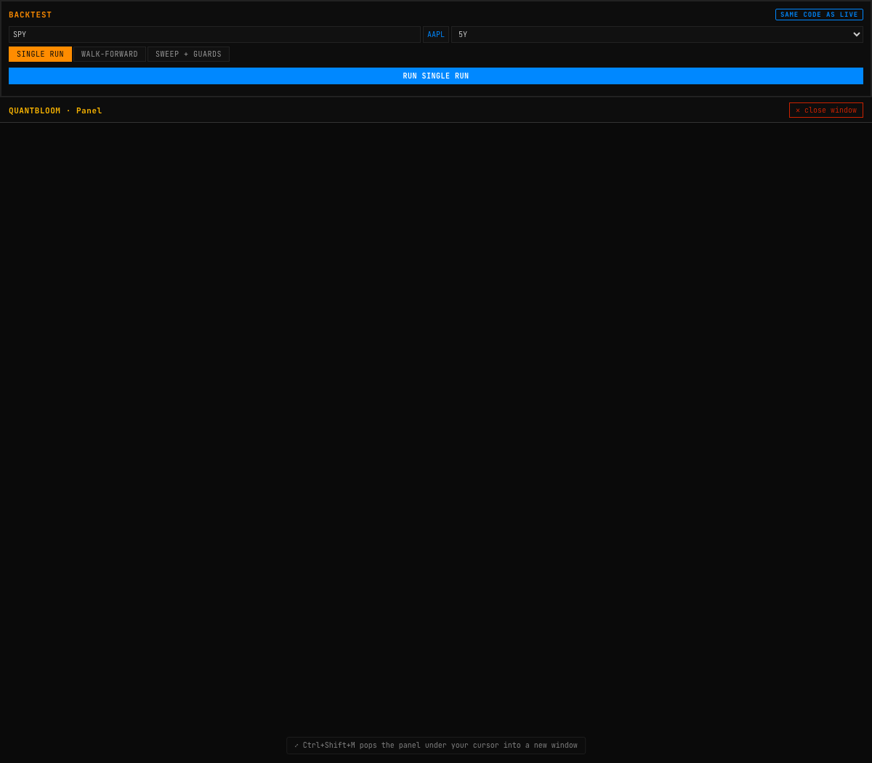
The backtester: strategy vs. buy-and-hold equity curves, a full metrics table, and the explicit cost drag.
Figure 5. A single backtest run — strategy equity (orange) against buy-and-hold, with a complete metrics table and the transaction-cost drag stated in dollars.
When run on real SPY data, the tooling behaves exactly as it should: a rule strategy returns +2.2% against buy-and-hold’s +81.6% over the window, with a Deflated Sharpe of 0 and a PBO of 65% — correctly reporting no edge.

9. Rule-Based Trading Strategies
bot/strategies.js provides six transparent strategies, each returning the same shape {action, confidence, rationale} so they compose:
- RSI reversion — buy oversold ($\text{RSI}<30$), sell overbought ($>70$).
- MACD momentum — follow the histogram sign, scaled by size relative to price.
- Trend following — the 50/200 golden/death cross confirmed by price vs. the 50-day.
- Bollinger reversion — fade moves outside the 20/2 bands.
- Contrarian — the default of the course trader bots: fade the latest move, $\text{position}=−sign$ of recent momentum, using the 12-EMA as the momentum reference.
- Indicator consensus — the net vote across the twelve indicators in the technical engine.
An ensemble takes a weighted vote across the enabled strategies; disagreement shrinks the confidence, and position size is confidence-proportional. Five presets (conservative, balanced, aggressive, trend-only, reversion-only) change how much the bot trades — pairing the two families that fail in opposite regimes is what keeps the ensemble mostly still. Each strategy documents its worksWhen and failsWhen in the UI.

10. The Trading Bot
The bot (bot/engine.js, bot/alpaca.js) trades a watchlist against an Alpaca paper account. It is off by default and every order passes a hard risk gate.
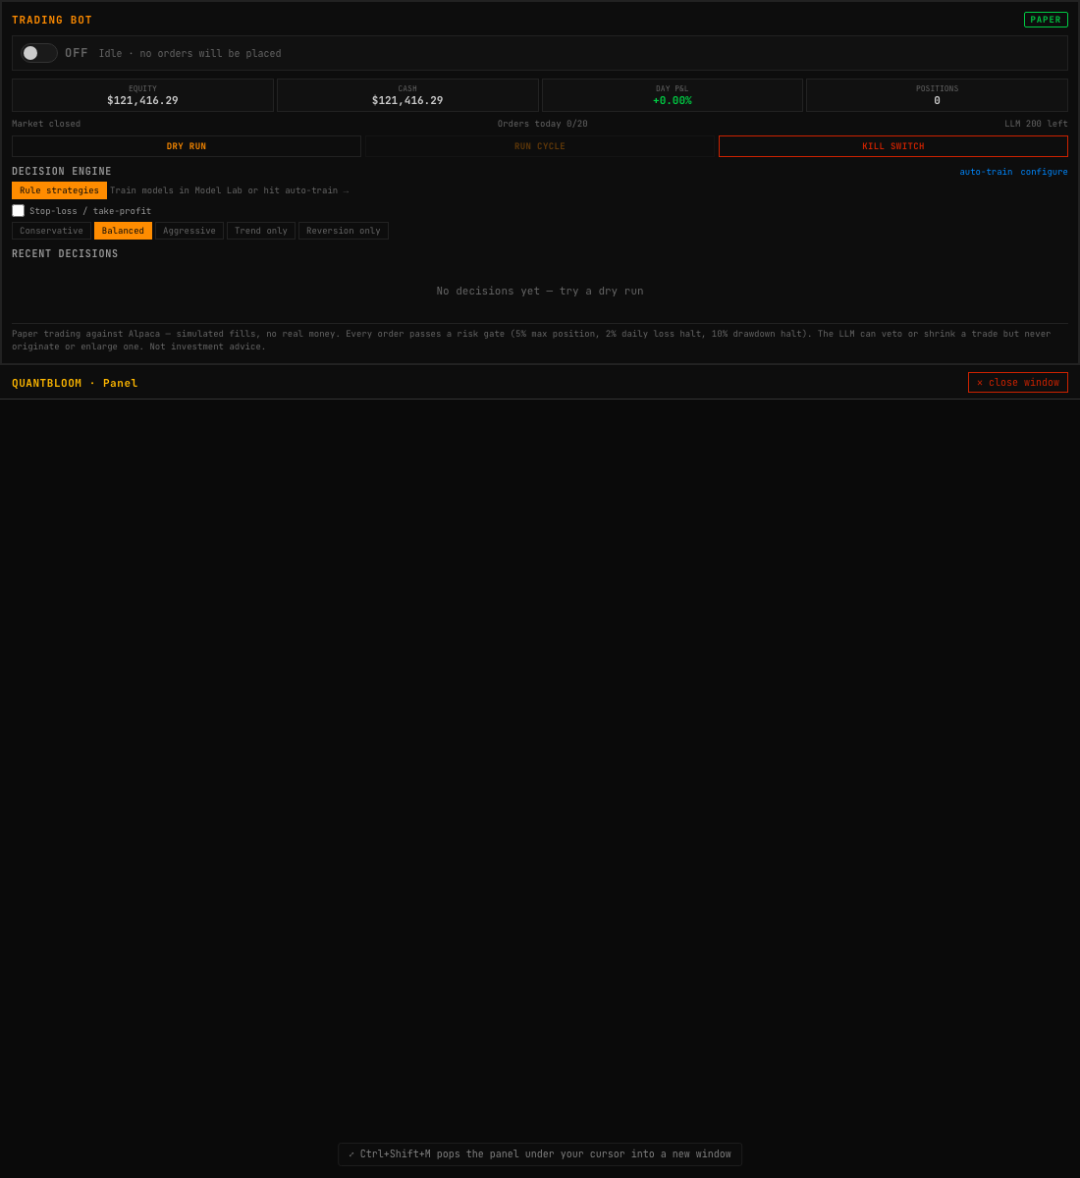
The trading bot: on/off switch, account state, decision engine selector (rule strategies or a trained model), protective-exit controls, and the decision log.
Figure 6. The trading bot — decision-engine selector, stop-loss/take-profit and trailing controls, and the risk gate at work.

10.1 The decision loop
Each cycle fetches account, positions and the market clock; checks halt conditions; and for each watchlist symbol produces a decision either from the rule ensemble or — if one is selected — from a trained ML model (modelStrategy). The decision optionally passes through the LLM advisory layer, then the risk gate, then execution.

10.2 The risk gate
bot/risk-gate.js is the safety core. Every order passes through evaluateOrder, which clamps rather than rejects where it can, enforcing hard ceilings that code — not configuration — guarantees:
- Max 5% of equity per position; max 25% per sector; max 100% gross exposure.
- Max 2% daily loss (auto-clears overnight) and max 10% drawdown from the high-water mark (requires a manual restart).
- Max 20 orders/day; a liquidity cap of a fraction of 20-day ADV; a minimum order value to avoid dust.
checkHaltConditions distinguishes a daily-loss halt (temporary) from a drawdown halt (which requires a deliberate restart), so a bad day cannot silently resume into a bad week.

10.3 Position sizing
Size is confidence-proportional, bounded by the position ceiling: $q=\left\lfloor {E⋅m⋅max(c, c_{min})}/P\right\rfloor$ where $E$ is equity, $m$ the max-position fraction, $c$ the decision confidence, and $P$ the price.

10.4 Protective exits
bot/brackets.js computes tick-rounded stop-loss and take-profit prices for a long entry ($\text{stop}<\text{entry}<\text{target}$) and submits them as an Alpaca bracket order, so the exits are managed broker-side and fire even if the bot process is down. Percentages are capped (stop $≤50\%$, target $≤200\%$) so a fat-finger cannot disarm the protection. A live trailing stop ratchets a per-symbol high-water mark each cycle and forces an exit when price falls the trail distance below the peak; it runs after the LLM review so a protective stop can never be vetoed.

10.5 The kill switch and self-training
The kill switch disables the bot, cancels working orders, flattens all positions, and requires a manual restart. Auto-train trains a model on every watchlist symbol and auto-selects the strongest — preferring one that clears the publish gate, else the best out-of-sample AUC — and honestly reports “none worth using” when nothing qualifies.

11. The LLM Advisory Layer
bot/mistral.js adds a Mistral LLM as a strictly advisory reviewer. It sees a decision the quantitative layers already made and returns a structured stance (AGREE / DISAGREE / CAUTION) with confidence and a stated key risk. Its influence is one-directional — toward doing less: a confident DISAGREE vetoes the trade (forces HOLD); a CAUTION or weak DISAGREE halves the confidence (and thus the size). It can never originate a trade, flip a direction, or increase size. Every call is logged with its full response, a daily budget cap is enforced, and the layer degrades to a no-op when unavailable. This containment is deliberate: the LLM’s qualitative context (an earnings event, a news shock) is valuable, but its failure modes — non-determinism, confident nonsense — are neutralised by giving it no execution authority.

12. Portfolio and Valuation Analytics

12.1 Mean-variance optimisation
portfolio-math.js implements Markowitz optimisation in closed form via two-fund separation. Given the covariance matrix $Σ$ and mean-return vector $μ$, with $1$ the ones vector, define $A=1^{⊤}Σ^{−1}1$, $B=1^{⊤}Σ^{−1}μ$, $C=μ^{⊤}Σ^{−1}μ$. The global minimum-variance portfolio is
$$w_{\text{mv}}=\frac{Σ^{−1}1}{A},$$
and every frontier portfolio is a combination of $w_{\text{mv}}$ and a second efficient fund. The efficient frontier is traced by sweeping the risk-aversion parameter $λ≥0$ (clamped non-negative so the lower, dominated branch of the hyperbola is excluded — a bug the monotonicity test caught early). The tangency (max-Sharpe) portfolio maximises $(w^{⊤}μ−r_{f})/\sqrt{w^{⊤}Σw}$.
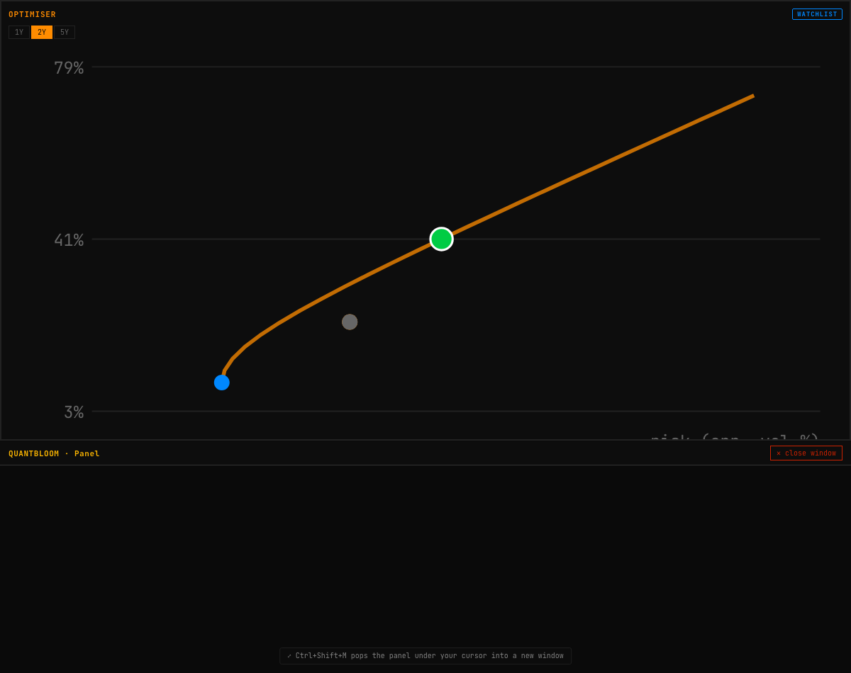
The optimiser: the efficient frontier with the minimum-variance and max-Sharpe portfolios against the current allocation.
Figure 7. Portfolio optimisation — the efficient frontier and the special portfolios, labelled clearly as a historical-input model.

12.2 Value at Risk
The VaR panel computes 95%/99% VaR and Conditional VaR (expected shortfall) by three methods whose disagreement is itself informative:
- Historical — the empirical quantile of realised returns.
- Parametric — ${\text{VaR}}_{α}=−(μ+z_{α}σ) V$ under normality, with $z_{α}$ the standard-normal quantile.
- Monte Carlo — simulated draws from the fitted distribution.
Fat tails show up precisely as historical VaR exceeding parametric VaR; CVaR (the mean loss beyond the VaR threshold) captures the tail the quantile omits.
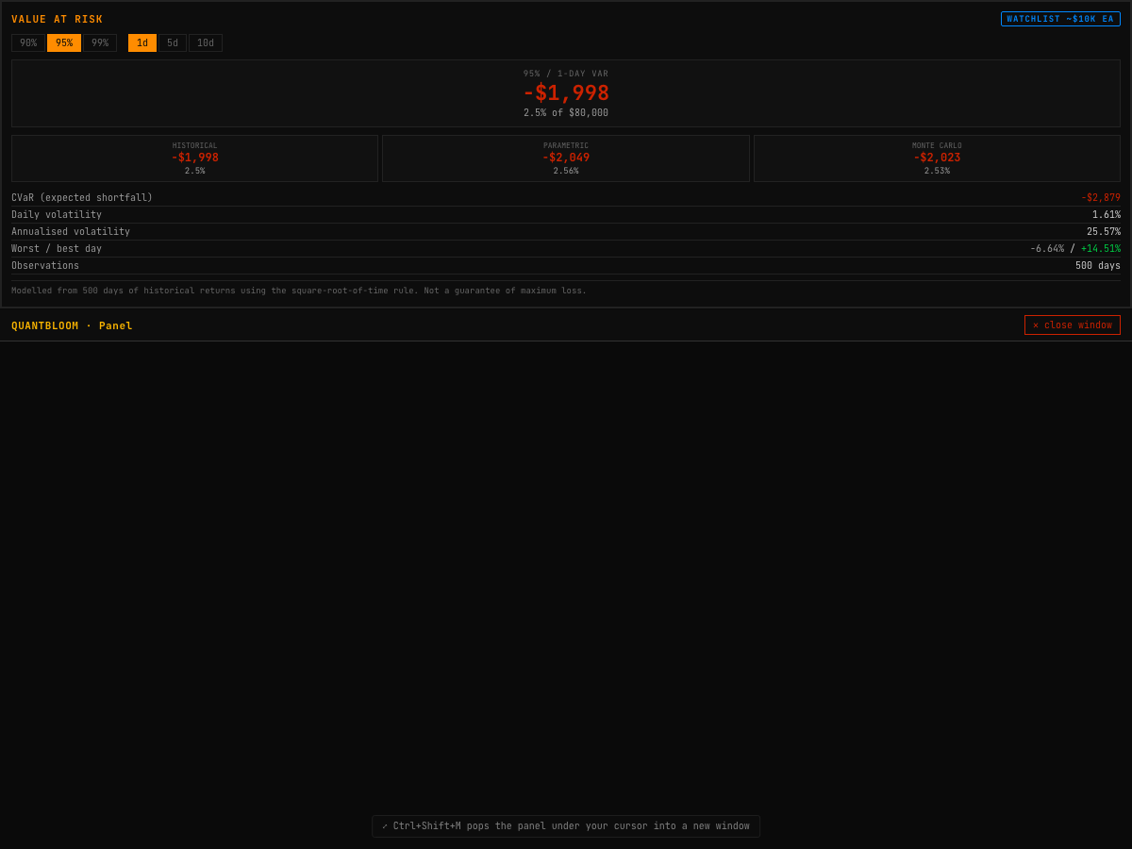
Value at Risk by three methods, with CVaR and the volatility diagnostics.
Figure 8. Three-method VaR — historical, parametric, and Monte-Carlo — with Conditional VaR and volatility, modelled from the return history.

12.3 Factor exposure
regression.js provides multiple OLS regression with $p$-values. The factor panel regresses portfolio returns on Fama–French-style factor proxies (market, size, value, momentum via representative ETFs),
rp=α+k​βkfk+ε,
to reveal unintended style tilts; each loading is reported with its significance.
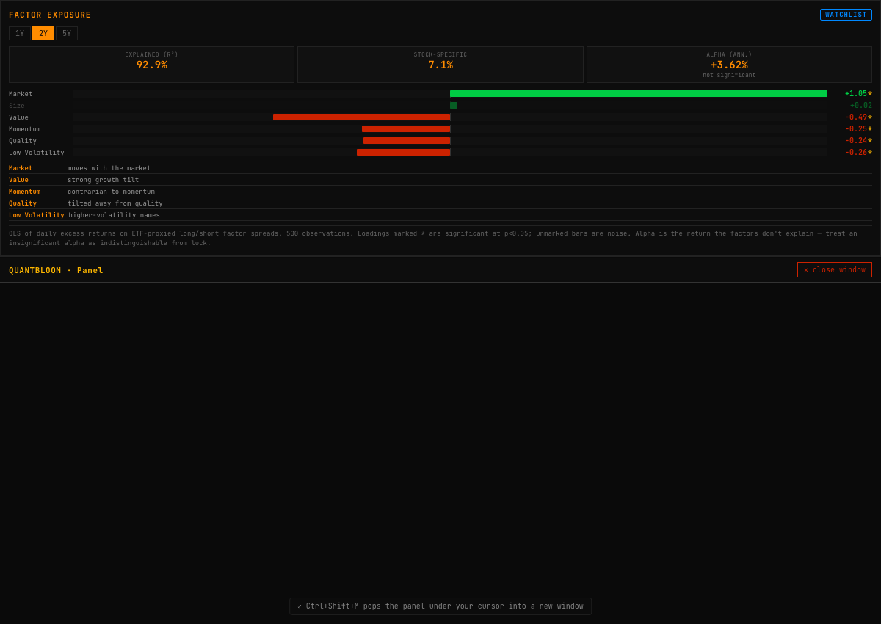
Factor exposure — regression loadings on the market, size, value, and momentum factors.
Figure 9. Factor regression — the portfolio’s style tilts and their significance.

12.4 DCF valuation and time value of money
The DCF panel discounts projected free cash flows with a Gordon-growth terminal value and a WACC × terminal-growth sensitivity grid, producing an intrinsic value against market price — labelled, emphatically, as a model only as good as its inputs.
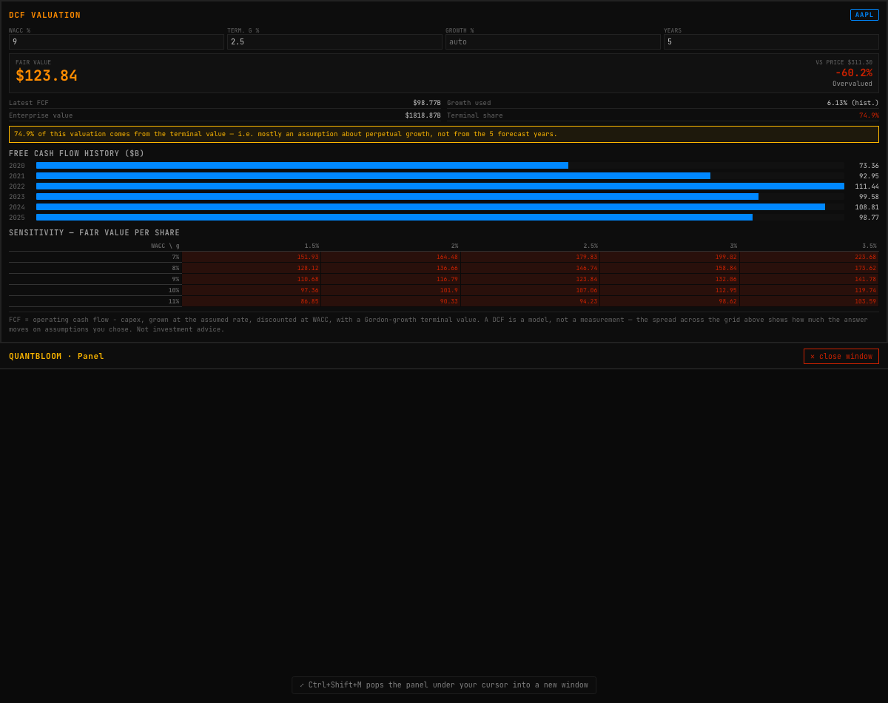
Discounted cash-flow valuation with an editable assumption set and a sensitivity grid.
Figure 10. DCF valuation — intrinsic value with a WACC × terminal-growth sensitivity table.
The time-value-of-money calculator (bot/tvm.js) implements present/future value with compounding frequency $m$, $\text{FV}=\text{PV} (1+r/m)^{nm}$; net present value NPV=i​CFi/(1+r)i; internal rate of return by Newton–Raphson with a bisection fallback; nominal/effective rate conversion; and level annuities. Its tests use the source course’s own worked answers as the oracle — a $1{,}000 payment discounted at 5% over 10 years is $613.9133 annually and $607.1610 monthly.

13. The Power & Commodities Desk
A distinctive addition, derived from a Citadel power & gas primer (“Power 2026: Electricity Pricing in the Age of AI”), is a wholesale-electricity pricing desk (charting/power.js). Wholesale power clears by marginal-cost (merit-order) pricing, which reduces to small, deterministic computations.
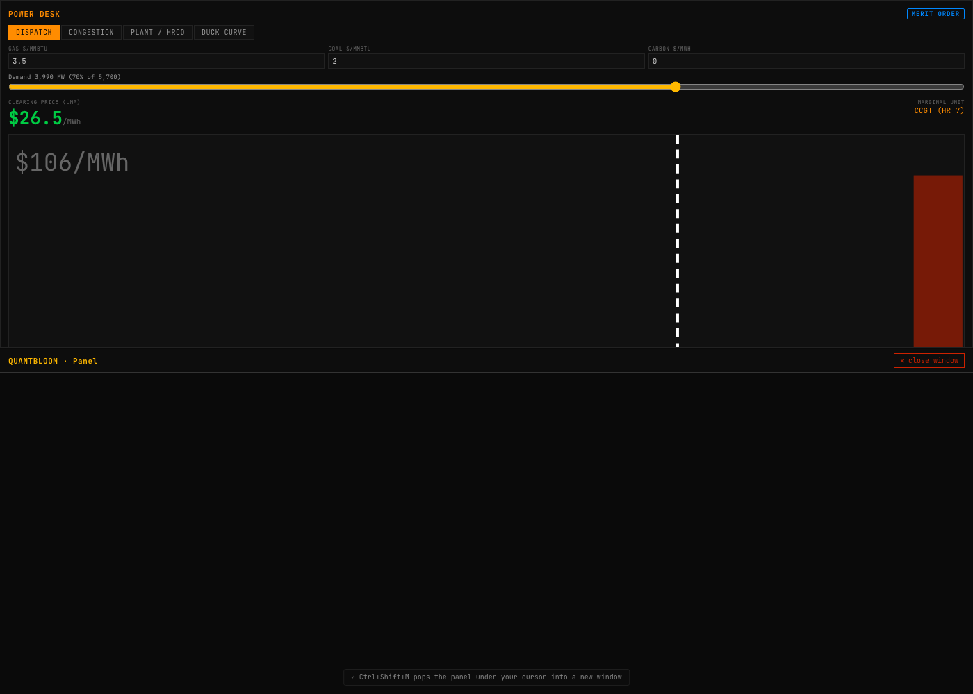
The Power Desk — a merit-order supply stack with the clearing price, the marginal unit, and the demand cut.
Figure 11. The Power Desk — the merit-order supply stack; the dashed line is demand, the marginal unit sets the clearing price.

13.1 Merit-order dispatch and marginal pricing
Generators are ranked cheapest-first and dispatched to meet demand; the last unit needed — the marginal unit — sets a single uniform clearing price that every dispatched unit is paid. A cheaper unit therefore earns inframarginal rent equal to (clearing price − its own cost) × MW, while the marginal unit earns zero. The marginal cost of a thermal unit is $\text{MC}=\text{HeatRate}×\text{FuelPrice}+\text{VOM}+\text{Carbon}$, so a change in the gas price re-orders the stack (fuel switching). The tests assert cheapest-first dispatch, that pushing demand past a cheap unit raises the price to the next unit, and that production cost sums own-cost (not the clearing price).

13.2 Two-node locational marginal pricing
With a transmission line of finite capacity between two buses, the cheaper node exports its spare capacity up to the line limit. While the line has slack, one price clears both nodes; the moment it saturates and the dearer node must self-supply, the prices decouple — the exporter clears at its low cost, the importer at its high cost. That gap is the congestion basis, the payoff of a Financial Transmission Right. The implementation reproduces the primer’s example exactly: 10 MW over a 50 MW line clears both nodes at $10; 60 MW pins the line and decouples to $100 / $10 (a $90 basis); widening the line re-couples the price.
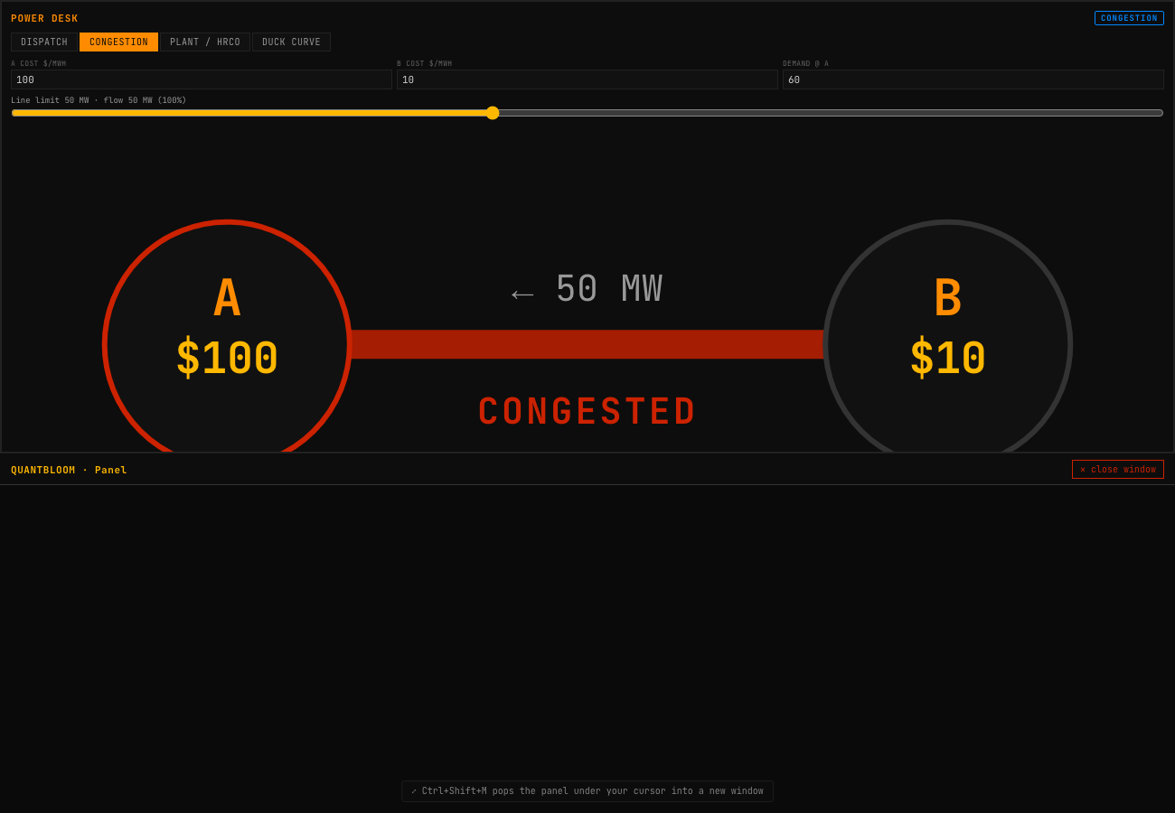
Two-node LMP under congestion: with 60 MW of demand at A and a 50 MW line, the line saturates and the prices decouple to $100 (A) and $10 (B).
Figure 13. Transmission congestion — the line is pinned at its 50 MW limit, so node A’s price jumps to its local cost while node B stays cheap. The gap is the congestion basis.

13.3 Spark spreads and the heat-rate call option
The spark spread is a gas plant’s gross margin, $\text{spark}=\text{Power}−\text{HeatRate}×\text{Gas}$ (the dark spread is the coal analogue), and the effective (break-even) heat rate ${\text{HR}}^{⋆}=\text{Power}/\text{Gas}$ is the efficiency at which a unit makes zero margin. A heat-rate call option monetises a plant’s optionality — it pays the positive spark day by day. QuantBloom values it by Monte Carlo on correlated lognormal power and gas paths with martingale drift; by convexity the option value is at least its intrinsic value, rises with volatility, and falls as power and gas co-move (a tighter spread). All four properties are asserted in the test suite.

13.4 The duck curve and scarcity pricing
Net demand (demand minus renewables) develops a midday trough and an evening spike as solar penetration grows — the duck curve — which forces less efficient units on in the evening and steepens the intraday price shape. Energy-only markets add a scarcity adder of VOLL × P(lost load) on top of the marginal energy price when supply runs short. Both are provided as interactive, clearly-labelled stylised models — QuantBloom has no live ISO/LMP feed, and says so.
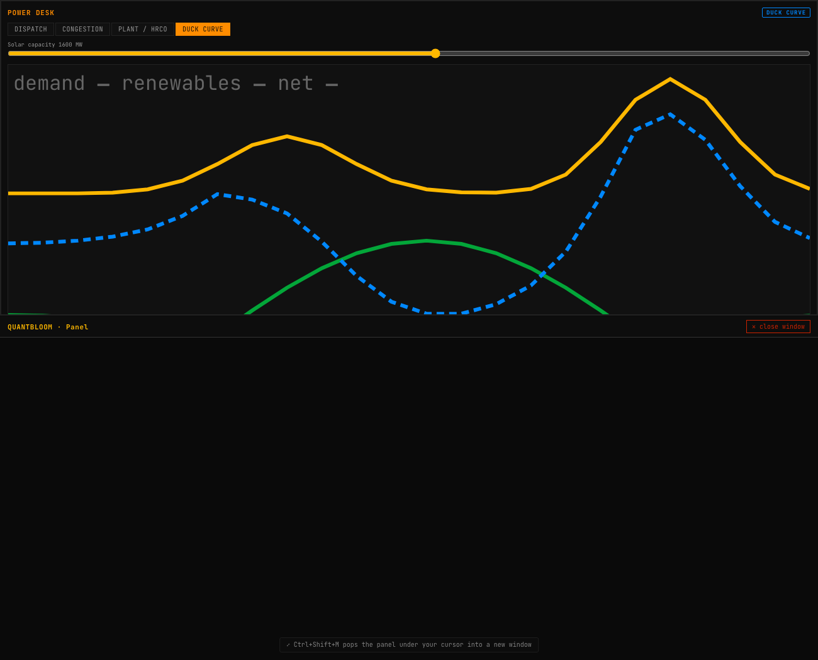
The duck curve — demand, renewables and net demand over 24 hours, with the resulting evening price spike, on/off-peak strips and a scarcity-adder calculator.
Figure 14. The duck curve — as solar (green) grows, net demand (blue) develops a midday belly and an evening neck, steepening the intraday price shape.

14. User Experience and Workflow
Two Bloomberg-signature interactions make the 37-panel terminal navigable:
- Command palette (Ctrl+K). The TICKER <GO> pattern: one box in which a ticker sets the active symbol across every panel, or a panel name jumps to it with a highlight flash. The parsing and ranking (src/lib/command.js) are pure and tested — a short alpha token is treated as a ticker; an exact panel-title match outranks the symbol command.
- Panel pop-out (Ctrl+Shift+M). Any panel opens in its own live browser window — the terminal navigates to ?solo=<index>, and a fresh app instance focuses that one panel full-window — so panels can be spread across monitors, each fully interactive with its own data. (Every figure in this paper was captured through exactly this mechanism.)
Authentication is optional and Bloomberg-style: with Supabase configured, access is gated behind a login screen and each signed-in user is mirrored to a Neon Postgres table; with it unconfigured, the terminal runs open. A Help & Shortcuts panel documents the interactions on-platform.
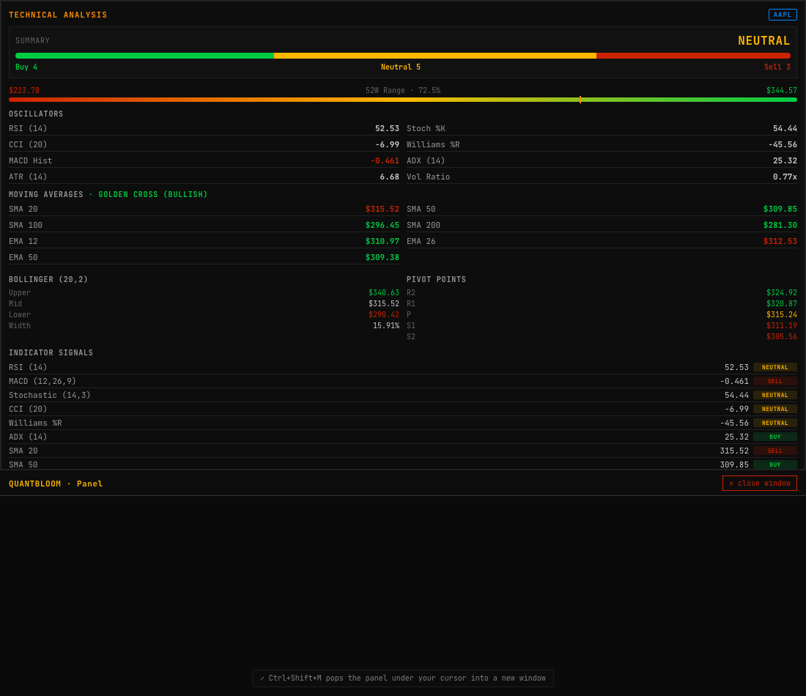
Technical analysis — twelve indicators with signal scoring and a consolidated verdict.
Figure 12. The technical-analysis panel — twelve indicators, each scored, rolled into an overall signal.

15. Testing and Validation
At the time of writing the repository carries 332 passing unit tests run by the Node built-in test runner (node --test). The philosophy is to assert defining properties rather than fixtures: the GBM must crack XOR; sliceUpTo must never leak a future bar; the eigensolver must satisfy $Av=λv$; the formula sandbox must reject constructor/window/eval; the two-node model must reproduce the primer’s $100/$10 decoupling; the TVM functions must match the source’s worked answers to the cent; the merit-order price must jump to the next unit when a cheap unit saturates. Where a computation is deterministic, the test pins the exact number; where it is stochastic, a fixed seed makes it reproducible. Numerically load-bearing changes are verified in the browser (the production bundle, served by node server.js) before they are committed.

16. Honest Limitations
QuantBloom is built to tell the truth, and the most important truth is about its own models:
- The models do not beat buy-and-hold. The best daily-bar model reaches a test AUC of roughly 0.59 — genuine but small discrimination — and none clears the publish gate. Long-only market-timing of a bull market with a strategy that is often in cash cannot beat simply holding the index. The ensemble improves robustness, not edge; cross-asset (SPY-relative) features help a high-beta name like NVDA (AUC $0.52→0.56$) but are noise for others. This is the honest reality of daily-bar technical analysis on liquid names, and the publish gate is designed to report it rather than hide it. We did not weaken the gate to manufacture a pass.
- No live LMP or Level-2 feed. The power desk, VaR, DCF, and TVM panels are calculators and stylised models, not live grid or order-book data. They are labelled as such throughout.
- Daily bars. The signal pipeline runs on daily OHLCV. The most credible path to genuine edge — per the source materials — is finer granularity (intraday bars), alternative data, or a different objective (confidence-weighted sizing rather than binary direction), not more model families on the same 19 features.
- Paper trading only. The bot targets an Alpaca paper endpoint by default; isPaperEndpoint() asserts it. Nothing here is investment advice.

17. Conclusion and Future Work
QuantBloom Terminal demonstrates that a rigorous, honest quantitative research and trading environment can be built entirely in the browser, with every load-bearing number backed by a tested module. Its contributions are less any single model than the discipline around them: point-in-time features with enforced train/live parity, a backtester that structurally forbids look-ahead, and a publish gate that corrects for multiple testing and refuses to endorse a model that cannot beat buy-and-hold out of sample.
Natural next steps follow directly from Section 16 and the roadmap: intraday-bar research; a cross-asset monitor board and an options volatility surface to round out Bloomberg parity; a live ISO/LMP integration to turn the power desk’s calculators into a live desk; and the local Python pipeline (documented in MODEL_TRAINING.md) for the heavier model families (LSTM/CAE/SDF) that cannot run in the Node runtime, imported back through the same artifact contract and the same unforgiving publish gate.

Appendix A — Notation
Symbol | Meaning
$P_{t},O_{t},H_{t},L_{t},C_{t}$​ | price / open / high / low / close at bar $t$
$r_{t}$​ | period return
$σ(⋅)$​ | logistic sigmoid
$z$​ | standardised feature vector
$Σ,μ$​ | covariance matrix, mean-return vector
$\text{SR},\text{PSR},\text{DSR}$​ | Sharpe, Probabilistic, Deflated Sharpe
$\text{PBO}$​ | Probability of Backtest Overfitting
$\text{LMP}$​ | locational marginal price
$u,d,h$​ | triple-barrier up / down / horizon

Appendix B — Module and Test Index
See the table in Section 2.2. Every listed module has a dedicated test file; the full suite is run with npm test (node --test "test/*.test.mjs").

Appendix C — A Worked Example: NVDA Through the Pipeline
To make the abstractions concrete, this appendix traces a single symbol through the full research pipeline with the actual numbers the system produces.
Step 1 — Data. Five years of daily NVDA candles are pulled from Yahoo (no key). With a 200-bar warm-up and a 10-bar label horizon, roughly 1,000 labelled rows survive.
Step 2 — Features. Each surviving bar becomes a 19-dimensional point-in-time vector (Section 5.1). Enabling the cross-asset option (Section 5.2) aligns SPY to NVDA’s bar times and appends five market-relative features, widening the vector to 24 and flagging the model usesMarket so the live path knows to supply the benchmark.
Step 3 — Labelling. Each row is labelled by the triple barrier (Section 5.3): $+3\%$ up, $−2\%$ down, 10-bar horizon. The dataset is split temporally, the most recent 30% held out and never shuffled.
Step 4 — Training. A gradient-boosted model (80 trees, depth 3, learning rate 0.08, minimum leaf 15) is fit on the training split. It reports split-count feature importance; on NVDA the top drivers are typically volume ratio, MACD histogram, and short-horizon return.
Step 5 — Metrics. On the held-out window, the model reaches a test AUC of about 0.59 with the base features. Adding the cross-asset features lifts a high-beta name like NVDA to ~0.56–0.62 depending on the window — genuine but modest discrimination. The logistic baseline sits near 0.50; PCA near 0.44–0.52; the ensemble lands between its members.
Step 6 — Out-of-sample backtest. The model is turned into a strategy (modelStrategy) and backtested over the test window with point-in-time signals, next-bar-open fills, and full costs. The strategy is compared to buy-and-hold; its Deflated Sharpe and trade count are computed.
Step 7 — The gate. The publish gate (Section 7.5) checks AUC $≥0.55$, OOS Sharpe $≥0.5$, beat buy-and-hold, Deflated Sharpe $≥0.90$, $≥5$ trades, $≥60$ rows. On daily NVDA the model fails — it does not beat buy-and-hold over a bull run in which it is often in cash — and auto-train reports it, honestly, as “not worth using.” A researcher may still select the model for paper testing; it simply cannot be published.
This is the pipeline working as designed: it produced a model with real (if small) discrimination, measured it without look-ahead, corrected for multiple testing, and declined to endorse it. Manufacturing a “pass” would require weakening the gate — which the system deliberately does not do.

Appendix D — Panel Gallery
The terminal’s 37 panels span data, analytics, execution, and pricing. A selection, each captured through the pop-out mechanism:
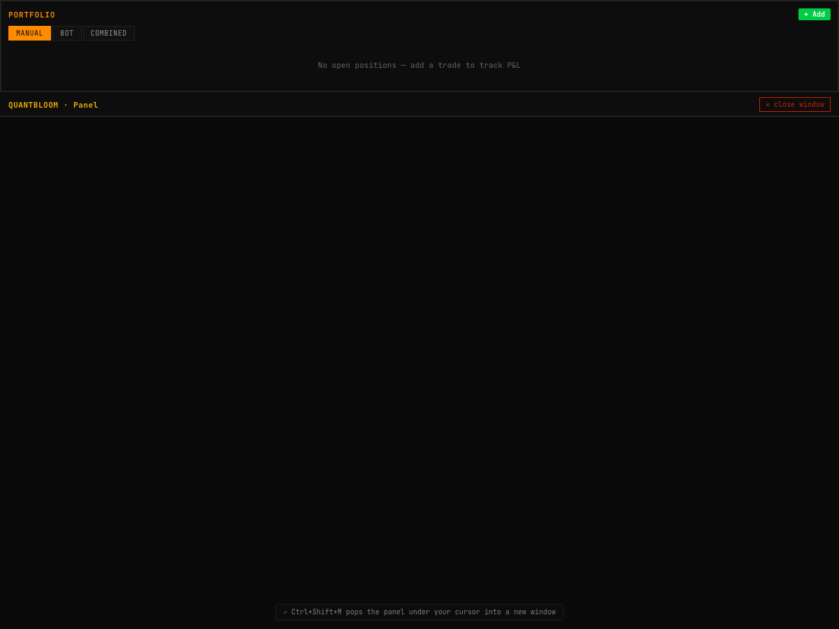 Figure 15. Portfolio — positions with live P&L, weights, and source tagging (manual vs. bot).
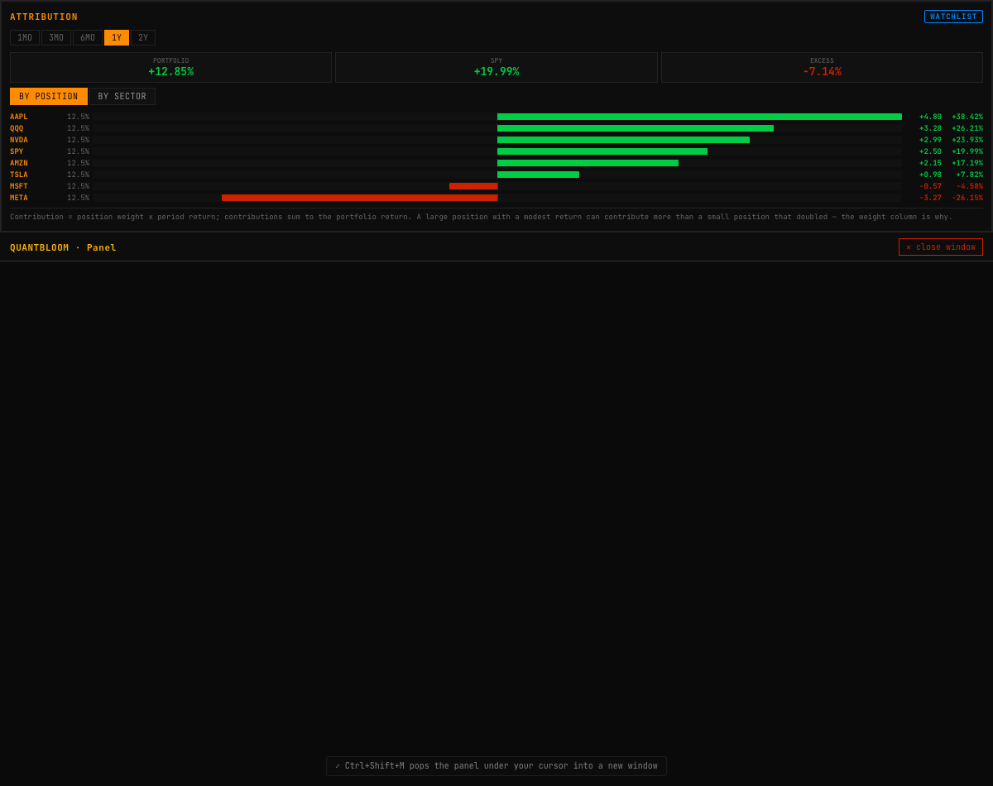 Figure 16. Performance attribution — return contribution by position and sector against the benchmark.
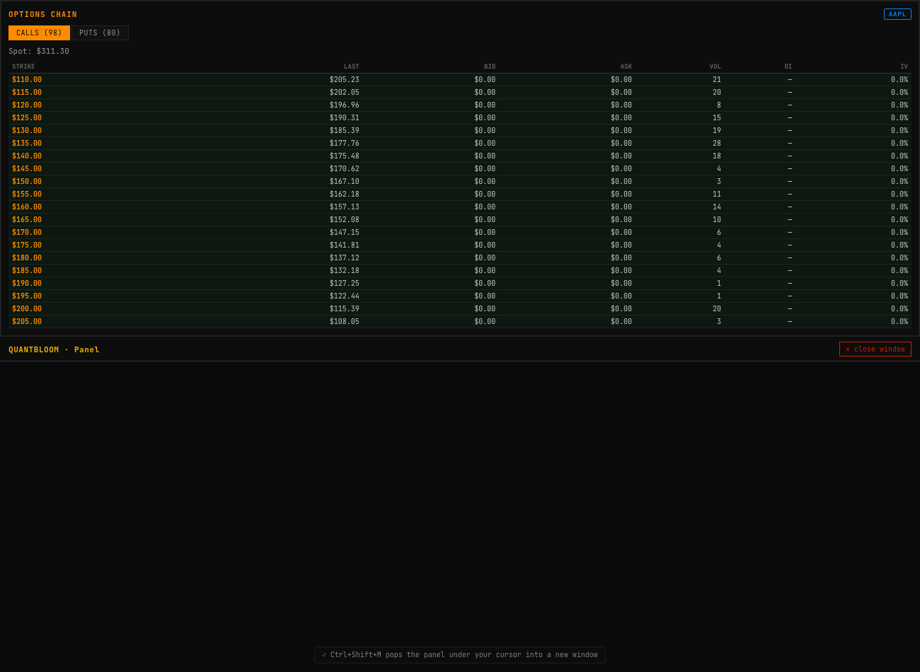 Figure 17. The options chain with Black-Scholes Greeks (delta, gamma, theta, vega) and numerically-solved implied volatility.
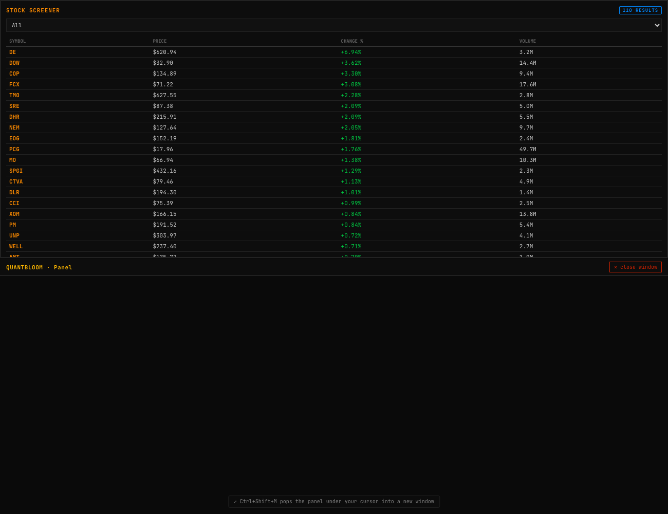 Figure 18. The stock screener — filtering the universe on fundamental and technical criteria.
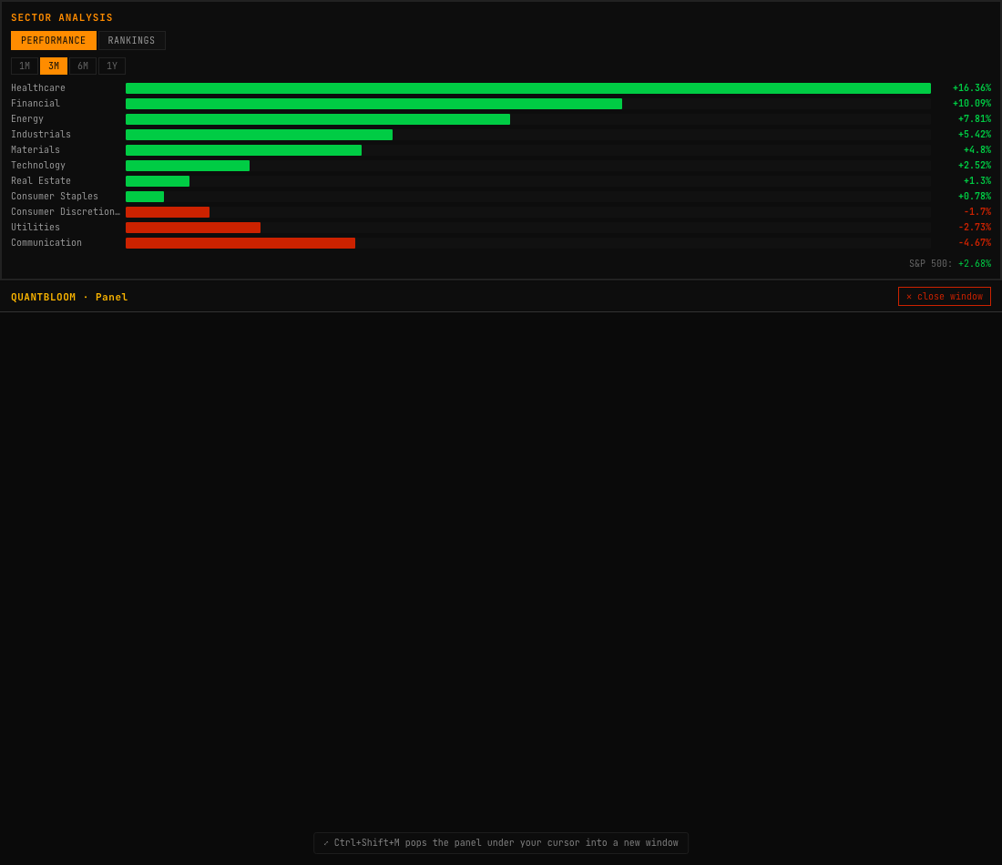 Figure 19. Sector analysis — a heat-tiled view of relative sector performance.
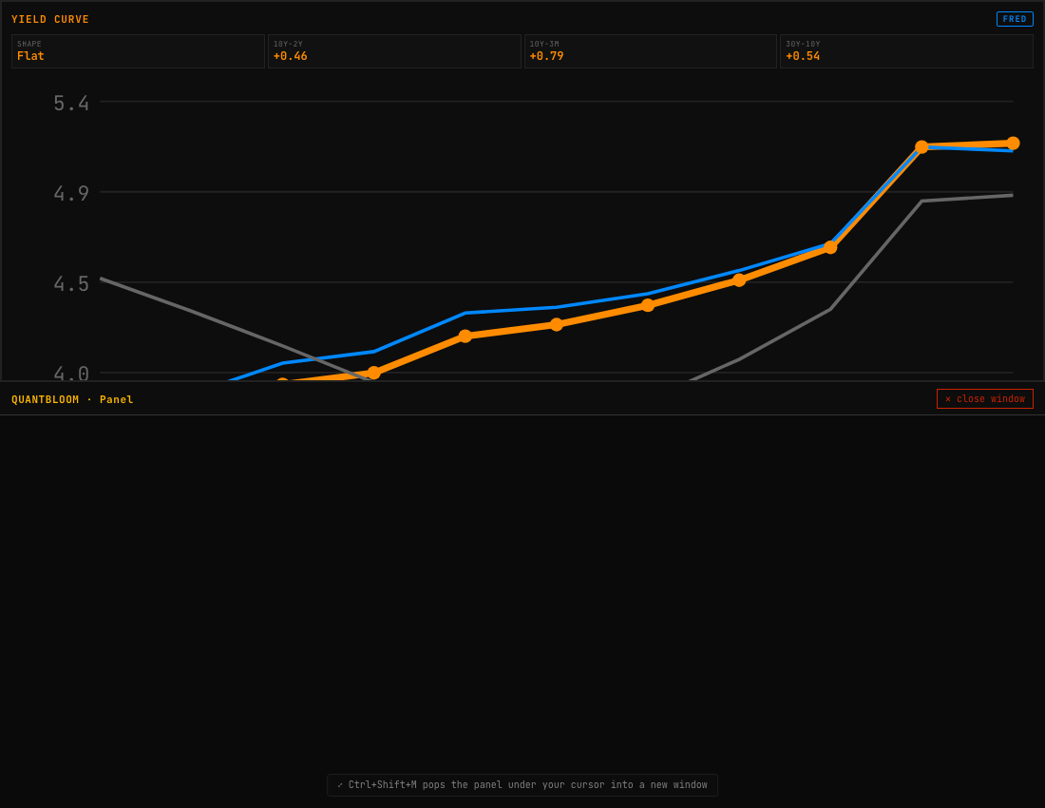 Figure 20. The Treasury yield curve from FRED, with key spreads.
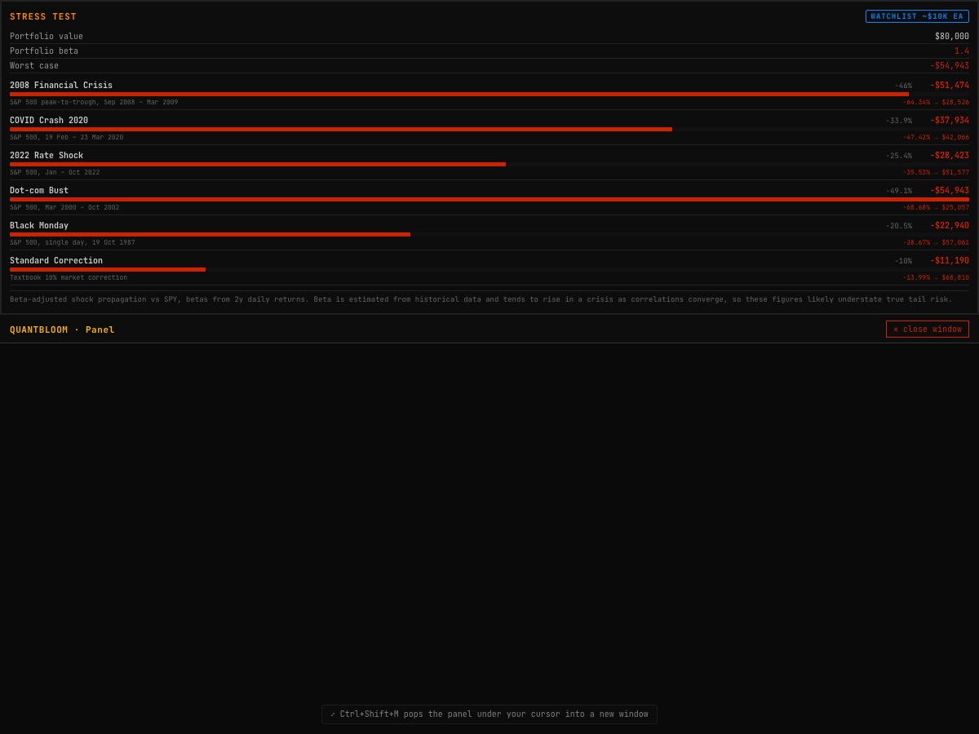 Figure 21. Stress testing — replaying historical crises and custom shocks against the current book via beta-adjusted propagation.
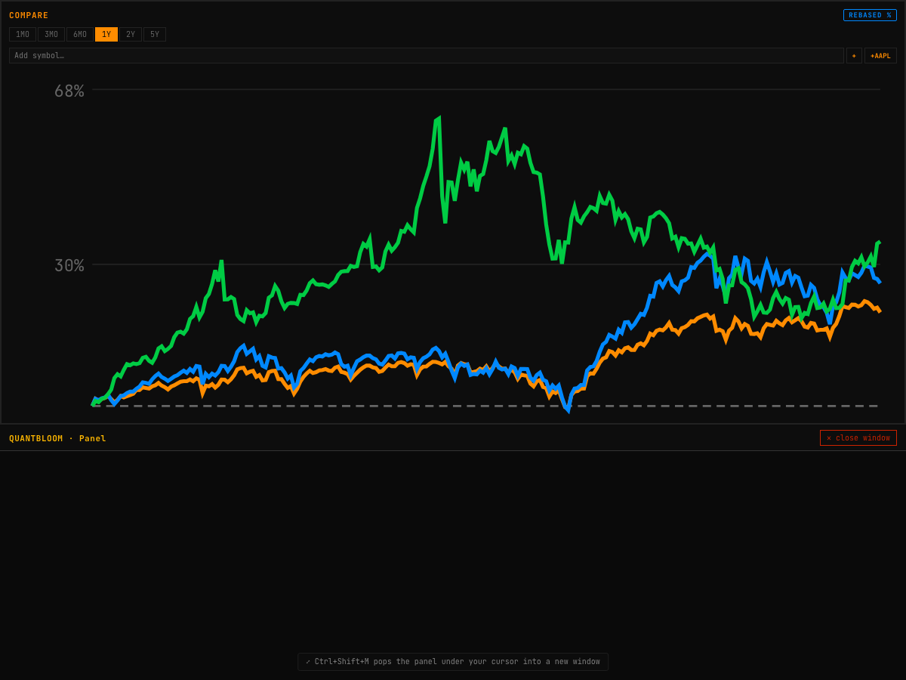 Figure 22. Rebased cross-asset comparison — several instruments normalised to a common base for relative-performance analysis.

References
- M. López de Prado, Advances in Financial Machine Learning, Wiley, 2018 (triple-barrier labelling; the Deflated Sharpe Ratio; CSCV / PBO).
- D. Bailey and M. López de Prado, “The Deflated Sharpe Ratio: Correcting for Selection Bias, Backtest Overfitting, and Non-Normality,” Journal of Portfolio Management, 2014.
- J. H. Friedman, “Greedy Function Approximation: A Gradient Boosting Machine,” Annals of Statistics, 2001.
- H. Markowitz, “Portfolio Selection,” Journal of Finance, 1952.
- N. Somani, Power 2026: Electricity Pricing in the Age of AI (merit-order pricing, LMP and transmission congestion, spark spreads, heat-rate call options, the duck curve, scarcity pricing).
- F. Black and M. Scholes, “The Pricing of Options and Corporate Liabilities,” Journal of Political Economy, 1973.

QuantBloom Terminal is a research and education platform. Nothing in this document is investment advice, and no metric is a prediction. The trading bot targets a paper account by default; backtested performance does not predict future returns.

