问题未解决：

热更新未完成。。。能start page 但是浏览器没刷新

[19:28:56] No gulpfile found

gulpfile文件命名错误

windows用npm i安装 否则安装失败

npm i -g del gulp-concat gulp-if gulp-live-server gulp-livereload gulp-plumber gulp-rename gulp-uglify gulp-util vinyl-named webpack webpack-stream yargs --save-dev

C:\Users\Administrator\WebstormProjects\es6>npm i -g babel-loader babel-preset-env --save-dev

C:\Users\Administrator\AppData\Roaming\npm

+-- UNMET PEER DEPENDENCY babel-core@6 || 7 || ^7.0.0-alpha || ^7.0.0-beta || ^7.0.0-rc

+-- babel-loader@7.1.2

+-- babel-preset-env@1.6.0

`-- UNMET PEER DEPENDENCY webpack@2 || 3

npm WARN babel-loader@7.1.2 requires a peer of babel-core@6 || 7 || ^7.0.0-alpha || ^7.0.0-beta || ^7.0.0-rc but none was installed.

npm WARN babel-loader@7.1.2 requires a peer of webpack@2 || 3 but none was installed.

解决

npm i -g babel-loader babel-preset-env webpack babel-core --save-dev

C:\Users\Administrator\WebstormProjects\es6\gulpfile.babel.js:1

(function (exports, require, module, __filename, __dirname) { import requireDir from 'require-dir';

<https://majing.io/questions/340>

重新装了babelloader

就可以了

ERROR in multi ./app/js/index.js

Module not found: Error: Can't resolve 'babel' in 'C:\Users\Administrator\WebstormProjects\es6'

BREAKING CHANGE: It's no longer allowed to omit the '-loader' suffix when using loaders.

You need to specify 'babel-loader' instead of 'babel',

see https://webpack.js.org/guides/migrating/#automatic-loader-module-name-extension-removed

@ multi ./app/js/index.js

解决

The error "**It's no longer allowed to omit the '-loader' suffix when using loaders.**" is simply saying you need to **append -loader** where you are using loader,  
like if you are using babel as a loader then you need to put "babe-loader"

eg : wrong

module: {

loaders: [

{

test: /\.jsx?$/,

exclude: /node_modules/,

loader: 'babel',

query: {

presets: ['es2015', 'react']

}

}

]

}

eg: correct

module: {

loaders: [

{

test: /\.jsx?$/,

exclude: /node_modules/,

loader: 'babel-loader',

query: {

presets: ['es2015', 'react']

}

}

]

}

问题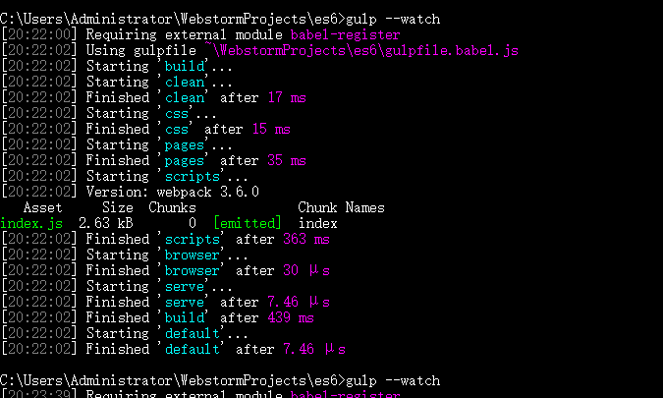

解决

Task下面的args没有导出

<http://www.imooc.com/wenda/detail/352110>

错误

Express server listening on port 3000

修改www下面的默认port

错误

访问localhost的默认端口拒绝访问

解决

Wwwjs无内容 没有启动服务器

错误

Error: ENOENT: no such file or directory, open 'C:\Users\Administrator\WebstormProjects\es6-exercise-project\es6\server\node_modules\public\favicon.ico'

at Error (native)

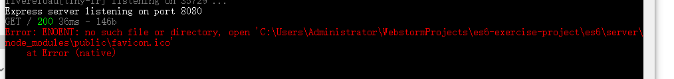

问题

app.use(**require**(**'connect-livereload'**)());

用于动态插入请求

Gulp-liveresload 刷新页面

问题

C:\Users\Administrator\WebstormProjects\es6-exercise-project\es6\server\routes\index.js:57

router.get('/', function (req, res, next) {

^

问题

[**https://github.com/Microsoft/vscode-eslint/issues/107**](https://github.com/Microsoft/vscode-eslint/issues/107)

**问题**

**require**

**不存在 -》setting-》nodejs&npm**