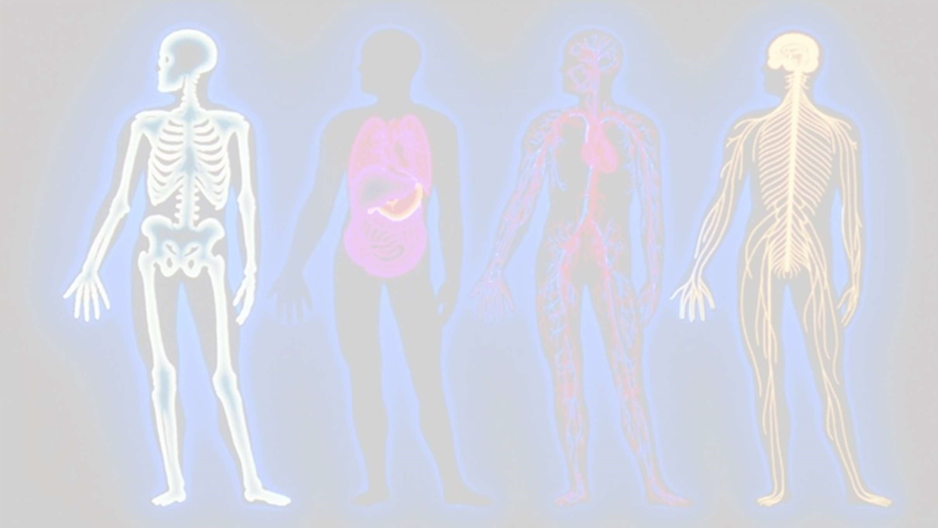
ANATOMY, PHYSIOLOGY & PATHOLOGY

SYNOPSIS

INTRODUCTION ORGAN SYSTEM
FLOWCHART & PICTURE PATHOLOGICAL CONDITION TERMINOLOGY
ICD & CPT

INTRODUCTION
- Anatomy is the study of the structure and form of organisms.

- Physiology is the study of functions and mechanisms of a living being.

- The words, or terms, which make up the language of medicine are referred to as the terminology of the medical field, or medical terminology.

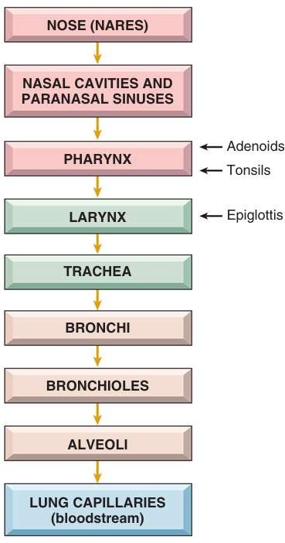
PATHWAY OF
RESPIRATORY SYSTEM

RESPIRATORY TERMINOLOGY
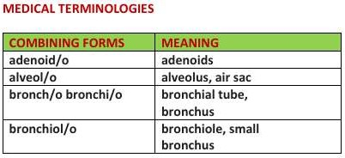
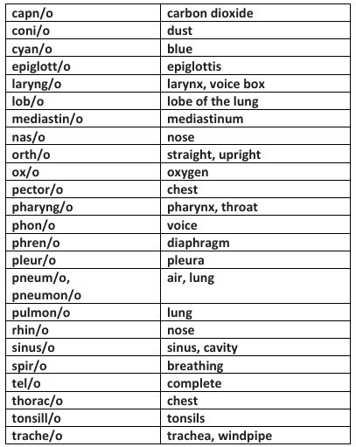

PATHOLOGICAL CONDITION
- Auscultation - Listening to sounds within the body.
- Percussion - Tapping on a surface to determine the difference in the density of the underlying structure.
- Pleural rub - Scratchy sound produced by pleural surfaces rubbing against each other.
- Rales (crackles) - Fine crackling sounds heard on auscultation (during inhalation) when there is fluid in the alveoli.
- Rhonchi (singular: rhonchus) - Loud rumbling sounds heard on auscultation of bronchi obstructed by sputum.
- Sputum - Material expelled from the bronchi, lungs, or upper respiratory tract by spitting.
- Stridor - Strained, high-pitched sound heard on inspiration caused by obstruction in the pharynx or larynx.
- Wheezes - Continuous high-pitched whistling sounds produced during breathing

- Croup
- Epistaxis
- Diphtheria
- Pertussis (Whooping Cough)
- Asthma
- Bronchiectasis
- Chronic Bronchitis
- Cystic Fibrosis (CF)
- Atelectasis
- Emphysema
- Lung Cancer
- Pneumoconiosis(Coal worker’s)
- Pulmonary Embolism (PE)
- Pulmonary Fibrosis
- Sarcoidosis
- Tuberculosis (TB)

ICD 10 CM

ANSWER KEY FOR ICD 10 CM
- J05.0 – Acute obstructive laryngitis (croup)
- R04.0 -epistaxsis
- A36.9 – Diphtheria, unspecified
- A37.9 – Whooping cough, unspecified organism
- J45.909 – Unspecified asthma, uncomplicated
- J47.9 – Bronchiectasis, uncomplicated
- J42 – Unspecified chronic bronchitis
- E84.9 – Cystic fibrosis, unspecified
- J98.11 – Atelectasis
- J43.9 – Emphysema, unspecified
- C34.90 – Malignant neoplasm of unspecified part of unspecified bronchus or lung
- J60 –pneumoconiosis
- I26.99 – Other pulmonary embolism without acute cor pulmonale
- J84.10 – Pulmonary fibrosis, unspecified
- D86.0 – Sarcoidosis of lung
- A16.9 – Respiratory tuberculosis, unspecified, without confirmation

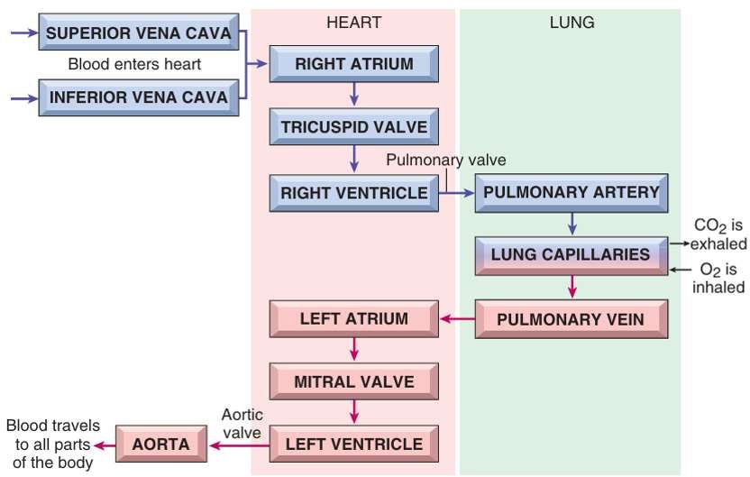
PATHWAY OF CARDIOVASCULAR SYSTEM

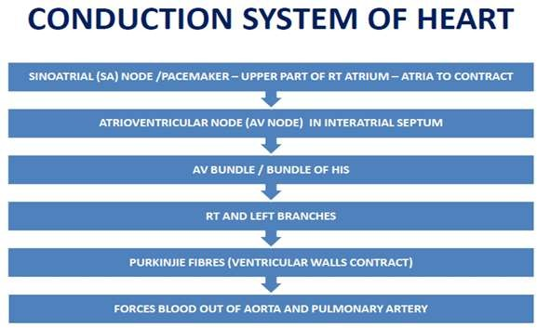

PATHOLOGICAL CONDITIONS
  - CONGESTIVE HEART FAILURE (CHF) - Heart is unable to pump its required amount of blood.
  - Coronary artery disease (CAD) - Disease of the arteries surrounding the heart – MAINLY OF ATHEROSCLEROSIS
  - Endocarditis - Inflammation of the inner lining of the heart.
  - Hypertensive heart disease - High blood pressure affecting the heart.
  - Cardiomyopathy - Any disease of the heart muscle.
  - Cardiac arrest (CA) - Failure of the systemic circulatory system due to absent or inadequate contraction of the ventricles
  - COR PULMONALE - Right ventricular enlargement that is caused by a lung disorder. It leads to hypertension in the pulmonary artery.
  - Mitral Valve Prolapse (MVP) Flaps of mitral valve extend back into L atrium causes leaking Mostly genetic basis

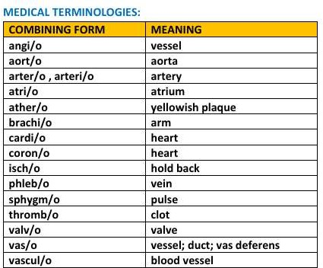

ICD 10 CM
  - Aneurysm
  - Angina pectoris
  - Other causes include coronary embolism.
  - Arteriovenous fistula
  - Arteritis Inflammation of one or several arteries
  - Atherosclerosis
  - Atrial septal defect (ASD)
  - Bruit
  - Bundle branch block (BBB)
  - Cardiac arrest (CA)
  - Cardiomyopathy
  - Congestive heart failure (CHF)
  - Myocardial infarction.
  - Coronary artery disease (CAD)
  - Embolism

ANSWER KEY FOR ICD 10 CM
  - Aneurysm-I72.9 – Aneurysm, unspecified
  - Angina Pectoris-I20.9 – Angina pectoris, unspecified
  - Coronary Embolism (Other causes of cardiac ischemia) I24.19 – Other forms of acute ischemic heart disease
  - Arteriovenous Fistula-I77.0 – Arteriovenous fistula, acquired,
  - Arteritis (Inflammation of arteries)-I77.6 – Arteritis, unspecified
  - Atherosclerosis-I70.90 – Atherosclerosis, unspecified
  - Atrial Septal Defect (ASD)-Q21.1 – Atrial septal defect
  - Bruit-R09.89 – Other specified symptoms and signs involving the circulatory and respiratory systems
  - Bundle Branch Block (BBB)-I45.19 – Other right bundle-branch block
  - Cardiac Arrest (CA)- I46.9 – Cardiac arrest, cause unspecified
  - Cardiomyopathy-I42.9 – Cardiomyopathy, unspecified
  - Congestive Heart Failure (CHF)-I50.9 – Heart failure, unspecified
  - Myocardial Infarction (MI)-I21.9 – Acute myocardial infarction, unspecified
  - Coronary Artery Disease (CAD)-I25.119 – With unspecified angina pectoris
  - Embolism-I74.9 – Arterial embolism and thrombosis, unspecified

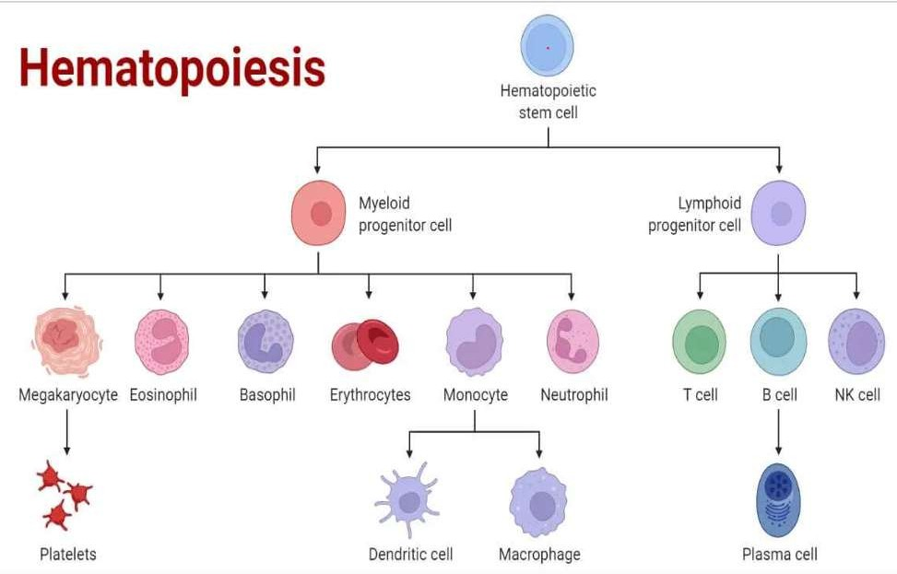
PATHWAY OF BLOOD SYSTEM

PATHOLOGICAL CONDITION
  - Any abnormal or pathologic condition of the blood - blood dyscrasia (disease).
  - Anemia - Deficiency in erythrocytes or hemoglobin.
  - Aplastic anemia - Failure of blood cell production in the bone marrow – Pancytopenia
  - Hemolytic anemia - Reduction in red cells due to excessive destruction – Eg : congenital spherocytic anemia (hereditary spherocytosis)
  - Pernicious anemia - Lack of mature erythrocytes caused by inability to absorb vitamin B12 into the bloodstream.
  - Sickle cell anemia - Hereditary disorder of abnormal hemoglobin producing sickle shaped erythrocytes and hemolysis.
  - Thalassemia - Inherited defect in ability to produce hemoglobin, leading to hypochromia. Thalassa is a Greek word meaning sea.
  - Hemochromatosis - Excess iron deposits throughout the body.
  - Polycythemia vera - General increase in red blood cells (erythremia).

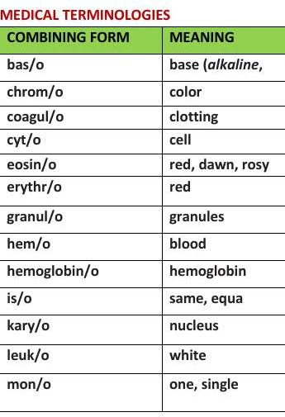

- Hemophilia A
- Von Willebrand Disease
- Thrombocytopenia
- Thrombocytosis
- Hemochromatosis
- Polycythemia Vera

ICD 10 CM

- Disseminated Intravascular Coagulation (DIC)
- Leukemia – Acute Lymphoblastic (ALL)
- Myelodysplastic Syndromes (MDS)
- Lymphoma – Hodgkin’s Disease
- Multiple Myeloma
- Pancytopenia
- Neutropenia
- Eosinophilia
- Hemolytic Uremic Syndrome (HUS)

ANSWER KEY
- Hemophilia A -D66 – Hereditary factor VIII deficiency
- Von Willebrand Disease -D68.0 – Von Willebrand's disease
- Thrombocytopenia-D69.6 – Thrombocytopenia, unspecified
- Thrombocytosis- D75.1 – Essential thrombocythemia
- Hemochromatosis-E83.11 – Hemochromatosis (iron overload disorder)
- Polycythemia Vera-D45 – Polycythemia vera (a myeloproliferative disorder)
- Disseminated Intravascular Coagulation (DIC)-D65 – Disseminated intravascular coagulation
- Leukemia – Acute Lymphoblastic (ALL)-C91.0x – Acute lymphoblastic leukemia (x denotes remission status)
- Myelodysplastic Syndromes (MDS)-D46.9 – Myelodysplastic syndrome, unspecified
- Lymphoma – Hodgkin’s Disease-C81.90 – Hodgkin lymphoma, unspecified, unspecified site
- Multiple Myeloma-C90.00 – Multiple myeloma not having achieved remission
- Pancytopenia-D61.818 – Other pancytopenia (reduction in RBCs, WBCs, and platelets)
- Neutropenia-D70.9 – Neutropenia, unspecified
- Eosinophilia-D72.1 – Eosinophilia
- Hemolytic Uremic Syndrome (HUS)-D59.3 – Hemolytic-uremic syndrome

MUSCULOSKELETAL SYSTEM

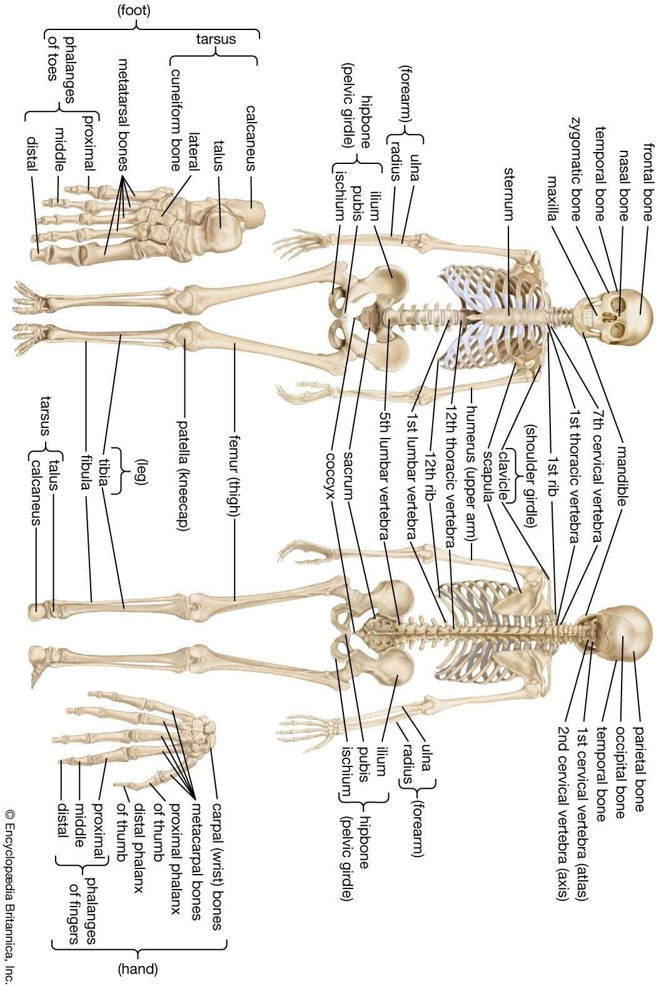

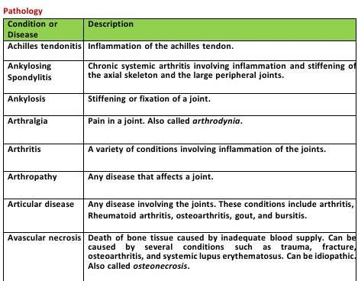
PATHOLOGICAL CONDITIONS

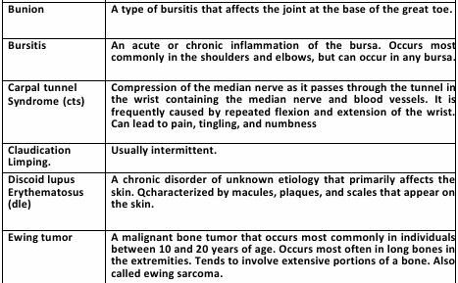

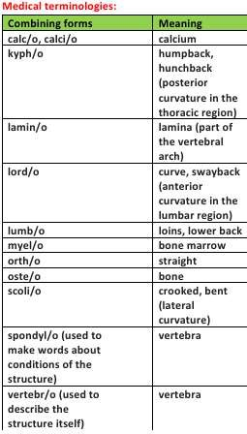
MEDICAL TERMINOLOGY

- Osteoarthritis
- Rheumatoid Arthritis (RA)
- Osteoporosis (without fracture)
- Gout-

ICD 10 CM
  - Carpal Tunnel Syndrome
  - Sciatica-
  - Herniated Disc (Intervertebral disc displacement)-

- Lupus (Systemic Lupus Erythematosus with organ involvement)-
- Fibromyalgia-
- Ankylosing Spondylitis
- Bursitis
- Tendinitis
- Rotator Cuff Tear
- Meniscus Tear (Knee)
- Scoliosis-
- Kyphosis-
- Lordosis-
- Muscle Strain (e.g., lower back)-
- Fracture of Femur (unspecified)-
- Myositis (inflammation of muscle)-

ANSWER KEY
- Osteoarthritis (OA)-M19.90 – Unspecified osteoarthritis, unspecified site
- Rheumatoid Arthritis (RA)-M06.9 – Rheumatoid arthritis, unspecified
- Osteoporosis (without fracture)-M81.0 – Age-related osteoporosis without current pathological fracture
- Gout-M10.9 – Gout, unspecified
- Lupus (Systemic Lupus Erythematosus with organ involvement)-M32.10 – Systemic lupus erythematosus, organ or system involvement unspecified
- Fibromyalgia-M79.7 – Fibromyalgia
- Ankylosing Spondylitis-M45.9 – Ankylosing spondylitis of unspecified sites
- Bursitis-M71.9 – Bursitis, unspecified
- Tendinitis-M77.9 – Enthesopathy, unspecified (commonly used for tendinitis)
- Rotator Cuff Tear-M75.121 – Complete rotator cuff tear or rupture of right shoulder
- Meniscus Tear (Knee)-S83.241A – Complex tear of medial meniscus, right knee, initial encounter
- Carpal Tunnel Syndrome-G56.01 – Carpal tunnel syndrome, right upper limb
- Sciatica-M54.30 – Sciatica, unspecified side
- Herniated Disc (Intervertebral disc displacement)-M51.26 – Other intervertebral disc displacement, lumbar region
- Scoliosis-M41.9 – Scoliosis, unspecified
- Kyphosis-M40.209 – Unspecified kyphosis, site unspecified
- Lordosis-M40.5 – Other lordosis
- Muscle Strain (e.g., lower back)-S39.012A – Strain of muscle, fascia and tendon of lower back, initial encounter
- Fracture of Femur (unspecified)-S72.90XA – Unspecified fracture of femur, initial encounter
- Myositis (inflammation of muscle)-M60.9 – Myositis, unspecified

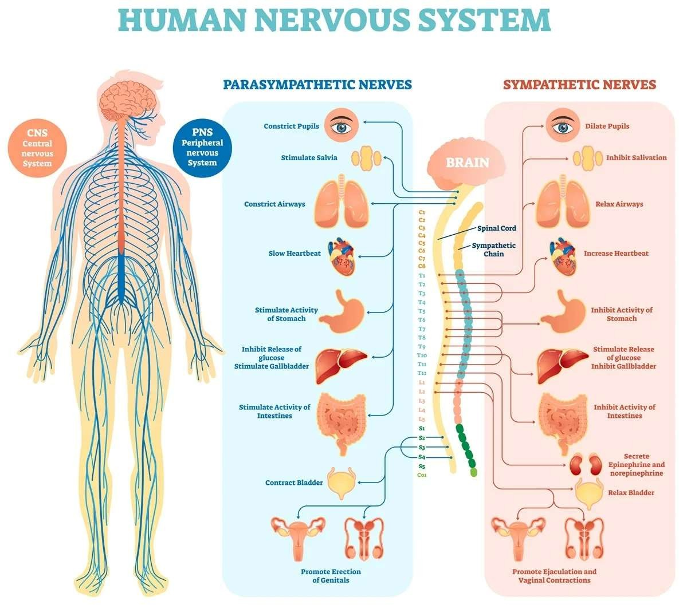
NERVOUS SYSTEM

PATHOLOGICAL CONDITIONS

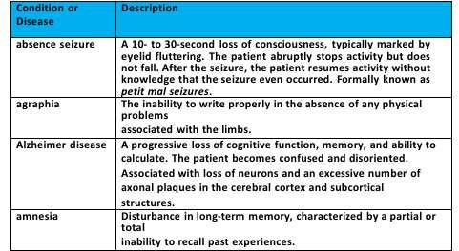
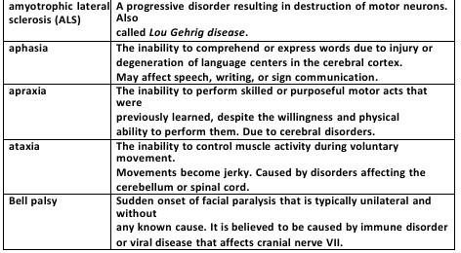

MEDICAL TERMINOLOGY

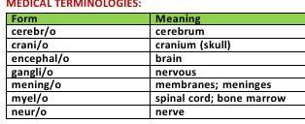

ICD 10 CM

- Agraphia
- Alzheimer Disease
- Amnesia
- Amyotrophic Lateral Sclerosis (ALS)
- Aphasia
- Apraxia
- Ataxia
- Bell Palsy

Condition | ICD-10-CM Code(s)
Agraphia | R48.2 – Apraxia (Note: Agraphia is often classified under apraxia)
Alzheimer Disease | G30.9 – Alzheimer's disease, unspecified
Amnesia | R41.3 – Other amnesia
Amyotrophic Lateral Sclerosis (ALS) | G12.21 – Amyotrophic lateral sclerosis
Aphasia | I69.320 – Aphasia following cerebral infarction
Apraxia | R48.2 – Apraxia
Ataxia | G11.9 – Hereditary ataxia, unspecified
Bell Palsy | G51.0 – Bell palsy



