《编译原理》大作业

学生姓名 李 蔚
班 级 计科2002
学 号 202801108
成 绩

2023年5月25日
题目：编写一个程序实现将赋值语句翻译成中间代码四元式和可执行的汇编程序代码。
运行截图：
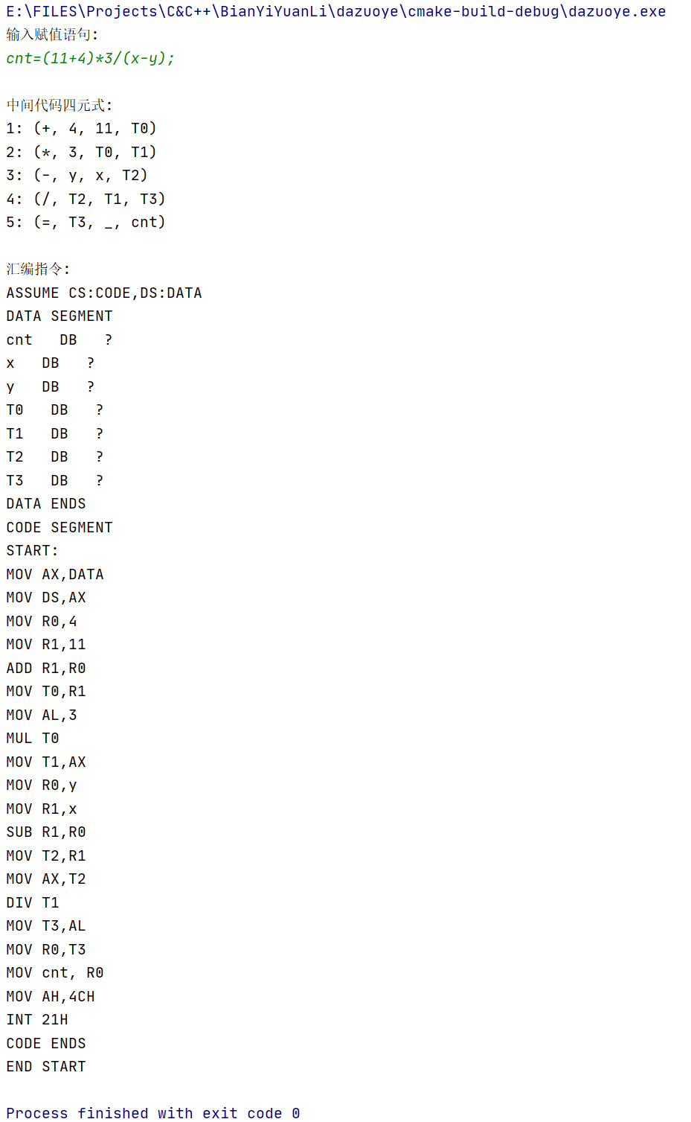
程序代码：
#include <iostream>
#include <string>
#include <vector>
#include <stack>
using namespace std;
enum TokenType {
IDENTIFIER,
OPERATOR,
NUMBER,
ASSIGNMENT,
END,
LEFT_PAREN,
RIGHT_PAREN
};
struct Token {
TokenType type;
string value;
};
struct Quadruple {
string op;
string arg1;
string arg2;
string result;
};
class Compiler {
public:
explicit Compiler(string input) : input_(move(input)) {}
void compile() {
lex();
parse();
generateIntermediateCode();
generateAssemblyCode();
}
private:
string input_;
vector<Token> tokens_;
vector<Quadruple> quadruples_;
string signtable[100];
int tempCount=0;
int signcnt=0;
void addsigntable(const string& str){
if(str.empty())return;
for(int i=0;i<signcnt;i++)
if(str==signtable[i])
return;
signtable[signcnt++]=str;
}
void lex() {
size_t pos = 0;
while (pos < input_.size()) {
if (isspace(input_[pos])) {
pos++;
continue;
}
Token token;
if (isalpha(input_[pos])) {
// 处理标识符
string identifier;
while (isalnum(input_[pos])) {
identifier += input_[pos];
pos++;
}
token.type = IDENTIFIER;
token.value = identifier;
addsigntable(identifier);
}
else if (isOperator(input_[pos])) {
// 处理操作符
token.type = OPERATOR;
token.value = input_[pos];
pos++;
}
else if (isdigit(input_[pos])) {
// 处理数字
string number;
while (isdigit(input_[pos])) {
number += input_[pos];
pos++;
}
token.type = NUMBER;
token.value = number;
}
else if (input_[pos] == '=') {
// 处理赋值符号
token.type = ASSIGNMENT;
token.value = "=";
pos++;
}
else if (input_[pos] == ';') {
// 处理结束符号
token.type = END;
token.value = ";";
pos++;
}
else if (input_[pos] == '(') {
// 处理左括号
token.type = LEFT_PAREN;
token.value = "(";
pos++;
}
else if (input_[pos] == ')') {
// 处理右括号
token.type = RIGHT_PAREN;
token.value = ")";
pos++;
}
else {
cout << "Error: Invalid character encountered!" << endl;
return;
}
tokens_.push_back(token);
}
}
static bool isOperator(char c) {
return (c == '+' || c == '-' || c == '*' || c == '/');
}
void parse() {
if (tokens_.empty()) {
cout << "Error: No tokens to parse!" << endl;
return;
}
int currentToken = 0;
while (currentToken < tokens_.size()) {
Token token = tokens_[currentToken];
if (token.type == END) {
return;
}
if (token.type != IDENTIFIER) {
cout << "Error: Expected identifier!" << endl;
return;
}
string variable = token.value;
currentToken++;
if (currentToken >= tokens_.size() || tokens_[currentToken].type != ASSIGNMENT || tokens_[currentToken].value != "=") {
cout << "Error: Expected assignment operator!" << endl;
return;
}
currentToken++;
stack<Token> postfix;
stack<Token> operators;
while (currentToken < tokens_.size() && tokens_[currentToken].type != END && tokens_[currentToken].value != ";") {
Token current = tokens_[currentToken];
if (current.type == IDENTIFIER || current.type == NUMBER) {
postfix.push(current);
}
else if (current.type == OPERATOR) {
while (!operators.empty() && operators.top().type == OPERATOR && precedence(current.value) <= precedence(operators.top().value)) {
postfix.push(operators.top());
operators.pop();
}
operators.push(current);
}
else if (current.type == LEFT_PAREN) {
operators.push(current);
}
else if (current.type == RIGHT_PAREN) {
while (!operators.empty() && operators.top().type != LEFT_PAREN) {
postfix.push(operators.top());
operators.pop();
}
if (operators.empty() || operators.top().type != LEFT_PAREN) {
cout << "Error: Unmatched parentheses!" << endl;
return;
}
operators.pop(); // 弹出左括号
}
else {
cout << "Error: Invalid token encountered!" << endl;
return;
}
currentToken++;
}
while (!operators.empty()) {
if (operators.top().type != OPERATOR && operators.top().type != LEFT_PAREN) {
cout << "Error: Invalid expression!" << endl;
return;
}
postfix.push(operators.top());
operators.pop();
}
processPostfix(variable, postfix);
}
if (currentToken == tokens_.size() && tokens_[currentToken].type != END)
cout<< "Error: lack of ';'!" << endl;
}
static int precedence(const string& op) {
if (op == "*" || op == "/") {
return 2;
}
else if (op == "+" || op == "-") {
return 1;
}
else {
return 0;
}
}
void processPostfix(const string& variable, stack<Token>& postfix) {
vector<Token> expression;
while (!postfix.empty()) {
expression.push_back(postfix.top());
postfix.pop();
}
stack<string> evaluation;
for (int i = expression.size() - 1; i >= 0; i--) {
Token current = expression[i];
if (current.type == IDENTIFIER || current.type == NUMBER) {
evaluation.push(current.value);
}
else if (current.type == OPERATOR) {
if (evaluation.size() < 2) {
cout << "Error: Invalid expression!" << endl;
return;
}
string arg1 = evaluation.top();
evaluation.pop();
string arg2 = evaluation.top();
evaluation.pop();
string temp = generateTempVariable();
Quadruple quad = { current.value, arg1, arg2, temp };
quadruples_.push_back(quad);
evaluation.push(temp);
}
else {
cout << "Error: Invalid token encountered!" << endl;
return;
}
}
if (evaluation.size() != 1) {
cout << "Error: Invalid expression!" << endl;
return;
}
string result = evaluation.top();
Quadruple assignment = { "=", result, "", variable };
quadruples_.push_back(assignment);
}
string generateTempVariable() { //产生中间变量
string str = "T" + to_string(tempCount++);
addsigntable(str);
return str;
}
void generateIntermediateCode() { //产生四元式
cout << "\n中间代码四元式:" << endl;
int cnt=1;
for (const auto& quad : quadruples_) {
if (quad.op == "+") {
cout << cnt++ << ": (" << "+, " << quad.arg1 << ", " << quad.arg2 << ", " << quad.result << ")" << endl;
}
else if (quad.op == "-") {
cout << cnt++ << ": (" << "-, " << quad.arg1 << ", " << quad.arg2 << ", " << quad.result << ")" << endl;
}
else if (quad.op == "*") {
cout << cnt++ << ": (" << "*, " << quad.arg1 << ", " << quad.arg2 << ", " << quad.result << ")" << endl;
}
else if (quad.op == "/") {
cout << cnt++ << ": (" << "/, " << quad.arg1 << ", " << quad.arg2 << ", " << quad.result << ")" << endl;
}
else if (quad.op == "=") {
cout << cnt++ << ": (" << "=, " << quad.arg1 << ", " << "_" << ", " << quad.result << ")" << endl;
}
}
}
void generateAssemblyCode() { //产生汇编
cout << "\n汇编指令:" << endl;
cout << "ASSUME CS:CODE,DS:DATA\nDATA SEGMENT" << endl;
for(int i=0;i<signcnt;i++)
cout << signtable[i] << " DB ?" << endl;
cout << "DATA ENDS\nCODE SEGMENT\nSTART:\nMOV AX,DATA\nMOV DS,AX" << endl;
for (const auto& quad : quadruples_) {
if (quad.op == "+") {
cout << "MOV R0," << quad.arg1 << endl;
cout << "MOV R1," << quad.arg2 << endl;
cout << "ADD R1,R0" << endl;
cout << "MOV " << quad.result << ",R1" << endl;
}
else if (quad.op == "-") {
cout << "MOV R0," << quad.arg1 << endl;
cout << "MOV R1," << quad.arg2 << endl;
cout << "SUB R1,R0" << endl;
cout << "MOV " << quad.result << ",R1" << endl;
}
else if (quad.op == "*") {
cout << "MOV AL," << quad.arg1 << endl;
cout << "MUL " << quad.arg2 << endl;
cout << "MOV " << quad.result << ",AX" << endl;
}
else if (quad.op == "/") {
cout << "MOV AX," << quad.arg1 << endl;
cout << "DIV " << quad.arg2 << endl;
cout << "MOV " << quad.result << ",AL" << endl;
}
else if (quad.op == "=") {
cout << "MOV R0," << quad.arg1 << endl;
cout << "MOV " << quad.result << ", R0" << endl;
}
}
cout << "MOV AH,4CH\nINT 21H\nCODE ENDS\nEND START" << endl;
}
};
int main() {
// 输入赋值语句
string input;
cout << "输入赋值语句: " << endl;
cin>>input;
Compiler compiler(input);
compiler.compile();
return 0;
}

