《编译原理》实验报告（四）

学生姓名 李 蔚
班 级 计科2002
学 号 202801108
指导老师 陈 宏 建
成 绩

序号 | 项目名称 | 考核比重 | 得分
1 | 实验预习 | 10%
2 | 实验验收 | 60%
3 | 实验报告 | 30%

2023年6月7日
实验名称： 语法制导翻译与中间代码及目标代码的生成
实验时间： 2023 年 5 月 29 日 第 16 周 星期 一
一、实验预习
1、实验目的
懂得语法制导翻译的方法及中间代码的表示；掌握赋值语句语法制导翻译方法；会运用LR分析表和语义子程序编写语法制导翻译程序。

2、实验内容（包括自己设计增加的内容等）
编写一个简单的编译程序，将赋值语句翻译成中间代码四元式和汇编程序。

3、硬、软件环境
硬件环境：CPU：intel core i5 13500 ，RAM：32G
软件环境：Windows 11 ，Clion2020

4、实验预备工作
（1）学习LR分析法的相关内容；
（2）学习如何将赋值语句转化为中间代码四元式；
（3）学习如何将中间代码四元式转化为汇编语言。
（4）复习表达式计算算法以及词法分析和语法分析。

二、实验报告
1、实验步骤
（1）实现文法的语义子程序；
（2）归约时生成中间代码四元式；
（3）由中间代码四元式生成汇编语言。

2、实验结果（包括程序运行结果、实测数据结果、数据分析等）
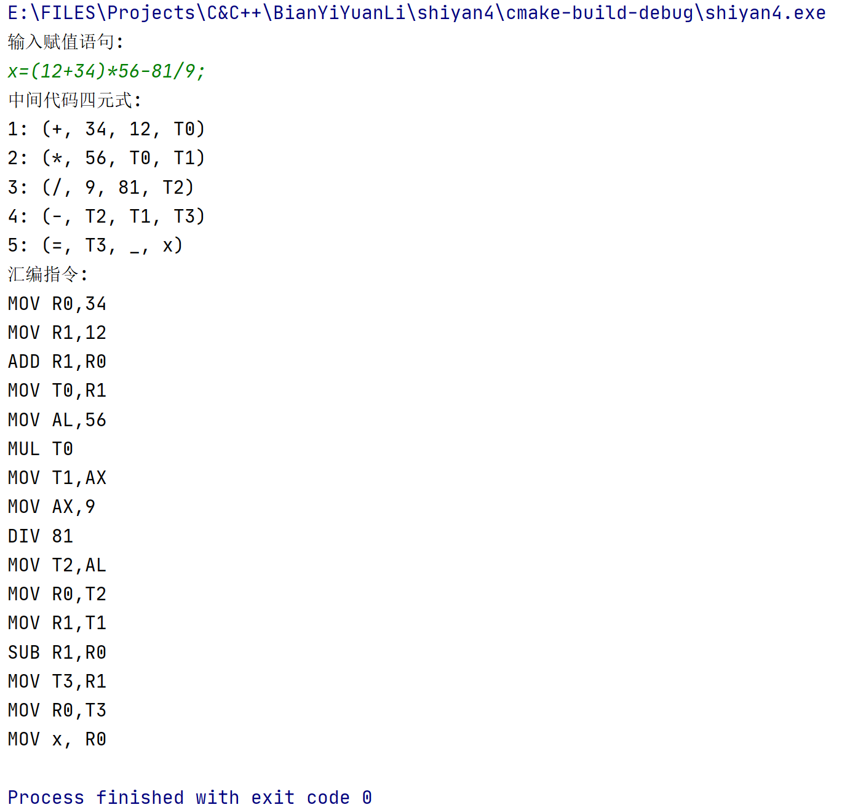

3、实验结论
本次实验进一步实现了将赋值语句转化为中间代码四元式，并且能够根据中间代码四元式生成相应的汇编程序。这样，我们可以将高级语言的赋值语句转化为底层的汇编指令序列，实现对赋值语句的执行和计算。

附录：（程序源代码）

#include <iostream>
#include <string>
#include <vector>
#include <stack>
using namespace std;
enum TokenType {
IDENTIFIER,
OPERATOR,
NUMBER,
ASSIGNMENT,
END,
LEFT_PAREN,
RIGHT_PAREN
};
struct Token {
TokenType type;
string value;
};
struct Quadruple {
string op;
string arg1;
string arg2;
string result;
};
class Compiler {
public:
explicit Compiler(string input) : input_(move(input)) {}
void compile() {
lex();
parse();
generateIntermediateCode();
generateAssemblyCode();
}
private:
string input_;
vector<Token> tokens_;
vector<Quadruple> quadruples_;
void lex() {
size_t pos = 0;
while (pos < input_.size()) {
if (isspace(input_[pos])) {
pos++;
continue;
}
Token token;
if (isalpha(input_[pos])) {
// 处理标识符
string identifier;
while (isalnum(input_[pos])) {
identifier += input_[pos];
pos++;
}
token.type = IDENTIFIER;
token.value = identifier;
}
else if (isOperator(input_[pos])) {
// 处理操作符
token.type = OPERATOR;
token.value = input_[pos];
pos++;
}
else if (isdigit(input_[pos])) {
// 处理数字
string number;
while (isdigit(input_[pos])) {
number += input_[pos];
pos++;
}
token.type = NUMBER;
token.value = number;
}
else if (input_[pos] == '=') {
// 处理赋值符号
token.type = ASSIGNMENT;
token.value = "=";
pos++;
}
else if (input_[pos] == ';') {
// 处理结束符号
token.type = END;
token.value = ";";
pos++;
}
else if (input_[pos] == '(') {
// 处理左括号
token.type = LEFT_PAREN;
token.value = "(";
pos++;
}
else if (input_[pos] == ')') {
// 处理右括号
token.type = RIGHT_PAREN;
token.value = ")";
pos++;
}
else {
cout << "Error: Invalid character encountered!" << endl;
return;
}
tokens_.push_back(token);
}
}
static bool isOperator(char c) {
return (c == '+' || c == '-' || c == '*' || c == '/');
}
void parse() {
if (tokens_.empty()) {
cout << "Error: No tokens to parse!" << endl;
return;
}
int currentToken = 0;
while (currentToken < tokens_.size()) {
Token token = tokens_[currentToken];
if (token.type == END) {
return;
}
if (token.type != IDENTIFIER) {
cout << "Error: Expected identifier!" << endl;
return;
}
string variable = token.value;
currentToken++;
if (currentToken >= tokens_.size() || tokens_[currentToken].type != ASSIGNMENT || tokens_[currentToken].value != "=") {
cout << "Error: Expected assignment operator!" << endl;
return;
}
currentToken++;
stack<Token> postfix;
stack<Token> operators;
while (currentToken < tokens_.size() && tokens_[currentToken].type != END && tokens_[currentToken].value != ";") {
Token current = tokens_[currentToken];
if (current.type == IDENTIFIER || current.type == NUMBER) {
postfix.push(current);
}
else if (current.type == OPERATOR) {
while (!operators.empty() && operators.top().type == OPERATOR && precedence(current.value) <= precedence(operators.top().value)) {
postfix.push(operators.top());
operators.pop();
}
operators.push(current);
}
else if (current.type == LEFT_PAREN) {
operators.push(current);
}
else if (current.type == RIGHT_PAREN) {
while (!operators.empty() && operators.top().type != LEFT_PAREN) {
postfix.push(operators.top());
operators.pop();
}
if (operators.empty() || operators.top().type != LEFT_PAREN) {
cout << "Error: Unmatched parentheses!" << endl;
return;
}
operators.pop(); // 弹出左括号
}
else {
cout << "Error: Invalid token encountered!" << endl;
return;
}
currentToken++;
}
while (!operators.empty()) {
if (operators.top().type != OPERATOR && operators.top().type != LEFT_PAREN) {
cout << "Error: Invalid expression!" << endl;
return;
}
postfix.push(operators.top());
operators.pop();
}
processPostfix(variable, postfix);
}
if (currentToken == tokens_.size() && tokens_[currentToken].type != END)
cout<< "Error: lack of ';'!" << endl;
}
static int precedence(const string& op) {
if (op == "*" || op == "/") {
return 2;
}
else if (op == "+" || op == "-") {
return 1;
}
else {
return 0;
}
}
void processPostfix(const string& variable, stack<Token>& postfix) {
vector<Token> expression;
while (!postfix.empty()) {
expression.push_back(postfix.top());
postfix.pop();
}
stack<string> evaluation;
for (int i = expression.size() - 1; i >= 0; i--) {
Token current = expression[i];
if (current.type == IDENTIFIER || current.type == NUMBER) {
evaluation.push(current.value);
}
else if (current.type == OPERATOR) {
if (evaluation.size() < 2) {
cout << "Error: Invalid expression!" << endl;
return;
}
string arg1 = evaluation.top();
evaluation.pop();
string arg2 = evaluation.top();
evaluation.pop();
string temp = generateTempVariable();
Quadruple quad = { current.value, arg1, arg2, temp };
quadruples_.push_back(quad);
evaluation.push(temp);
}
else {
cout << "Error: Invalid token encountered!" << endl;
return;
}
}
if (evaluation.size() != 1) {
cout << "Error: Invalid expression!" << endl;
return;
}
string result = evaluation.top();
Quadruple assignment = { "=", result, "", variable };
quadruples_.push_back(assignment);
}
static string generateTempVariable() { //产生中间变量
static int tempCount = 0;
return "T" + to_string(tempCount++);
}
void generateIntermediateCode() { //产生四元式
cout << "中间代码四元式:" << endl;
int cnt=1;
for (const auto& quad : quadruples_) {
if (quad.op == "+") {
cout << cnt++ << ": (" << "+, " << quad.arg1 << ", " << quad.arg2 << ", " << quad.result << ")" << endl;
}
else if (quad.op == "-") {
cout << cnt++ << ": (" << "-, " << quad.arg1 << ", " << quad.arg2 << ", " << quad.result << ")" << endl;
}
else if (quad.op == "*") {
cout << cnt++ << ": (" << "*, " << quad.arg1 << ", " << quad.arg2 << ", " << quad.result << ")" << endl;
}
else if (quad.op == "/") {
cout << cnt++ << ": (" << "/, " << quad.arg1 << ", " << quad.arg2 << ", " << quad.result << ")" << endl;
}
else if (quad.op == "=") {
cout << cnt++ << ": (" << "=, " << quad.arg1 << ", " << "_" << ", " << quad.result << ")" << endl;
}
}
}
void generateAssemblyCode() { //产生汇编
cout << "汇编指令:" << endl;
for (const auto& quad : quadruples_) {
if (quad.op == "+") {
cout << "MOV R0," << quad.arg1 << endl;
cout << "MOV R1," << quad.arg2 << endl;
cout << "ADD R1,R0" << endl;
cout << "MOV " << quad.result << ",R1" << endl;
}
else if (quad.op == "-") {
cout << "MOV R0," << quad.arg1 << endl;
cout << "MOV R1," << quad.arg2 << endl;
cout << "SUB R1,R0" << endl;
cout << "MOV " << quad.result << ",R1" << endl;
}
else if (quad.op == "*") {
cout << "MOV AL," << quad.arg1 << endl;
cout << "MUL " << quad.arg2 << endl;
cout << "MOV " << quad.result << ",AX" << endl;
}
else if (quad.op == "/") {
cout << "MOV AX," << quad.arg1 << endl;
cout << "DIV " << quad.arg2 << endl;
cout << "MOV " << quad.result << ",AL" << endl;
}
else if (quad.op == "=") {
cout << "MOV R0," << quad.arg1 << endl;
cout << "MOV " << quad.result << ", R0" << endl;
}
}
}
};
int main() {
// 输入赋值语句
string input;
cout << "输入赋值语句: " << endl;
cin>>input;
Compiler compiler(input);
compiler.compile();
return 0;
}

