Contents

1. Set testing environment 2

2. Test script descript 2

2.1 button check 2

2.2 I2C inventory check 3

2.3 PA fault check 4

2.4 BT paring 4

2.5 Set LED 4

2.6 Get NTC 5

2.7 GPIO set 6

2.8 Audio set 6

2.9 volume set 7

2.10 Mic loopback 9

2.11 burn in mode 9

2.12 battery info 10

2.13 NVRAM operate 10

2.14 Set Wlan0 MAC address 11

2.15 Set BT MAC address 11

2.15 Mic record 11

2.16 Mic record close 11

2.17 Audio play 12

2.18 Audio play close 12

# 1. Set testing environment

All script already install to “/etc/factory-test” both of it available for test.

Run “enter_factory_mode.sh” to set DUT environment for factory test. (Currently just disable LED manage)

When finished factory test run “exit_factory_mode.sh” to revert DUT environment for user mode.

**NOTICE: the command path have been change, but the exp. picture of this document will using the old one.**

# 2. Test script descript

Test script fold tree as below:

Factory test ------- main fold

| ---- platform ------- main script for whole platform

|----- zepp ------- project fold test script for specify project

|----- conf ------- configure file for specify script

For testing running the script at project fold (exp: zepp)

To configure specify test script: modify the .conf file at conf fold.

## 2.1 button check

Run button check script “button_f_check.sh” then push the button will get the test result. This script will wait 10S for pushing button.

All key define at conf file “key_list.conf”. 1st row as key code using Hex form and 4bytes. 2nd row as key name

Exp:

0066 KEY_FORMATION

00a4 KEY_PLAY_PASUE

Test command:

adb shell /etc/factory-test/zepp/button_f_check.sh

Exp:

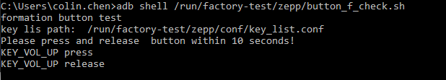

## 2.2 I2C inventory check

Run “inventory.sh”

All I2C chip define at conf file “inventory.conf”. 1st row was i2c bus name , 2nd  row was I2C address, 3rd row was chip names.

**Notice: I2C address using 7bits address and Hex form. (exp: Address “0x40” will be “0x40/2” only use the digital part “20”)**

**Conf file exp:**

i2c-2 20 PA1-MA12070

i2c-2 21 PA2-MA12070

i2c-2 22 PA3-MA12070

i2c-3 64 VLED-IS31FL3196A

i2c-3 67 KB-LED-IS31FL3196A

Test command :

adb shell /etc/factory-test/zepp/inventory.sh

exp:

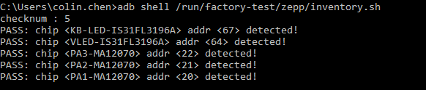

## 2.3 PA fault check

Run “get_pa_fault.sh”

PA fault pin define at file “pa_fault.conf”. 1st row as gpio number. 2nd row as gpio name.

Exp:

81 PA1-fault

22 PA2-fault

23 PA3-fault

Test command :

adb shell /etc/factory-test/zepp/get_pa_fault.sh

Exp: (currently those gpio didn’t mount to system so this exp was fail exp)

## 2.4 BT paring

Run “bt_paring.sh”

And BT will enter paring state. Using smart phone can search devices name.

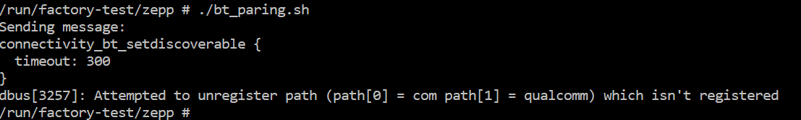

## 2.5 Set LED

Run “set_led.sh”

Led name and number define at file “led.conf”. 1st row as led name. 2nd row as led number

Exp:

led-formation1 1

led-formation2 2

led-voice-service1 3

led-voice-service2 4

all all

Parameter “all” support to operate all the available LED.

Command form:

set_led.sh <Led name> <R brightness> <G brightness> <B brightness>

Brightness range: 0~255

Exp:



## 2.6 Get NTC

Run “get_ntc.sh”

Thermal zone define at “ntc.conf”. 1st  row as thermal zone name. 2nd row as thermal zone number

Exp :

thermal_zone4 4

output form:

<thermal zone name>

<type> ----- name define at thermal driver

<thermal value> ------ value of micro Celsius degree

Exp:

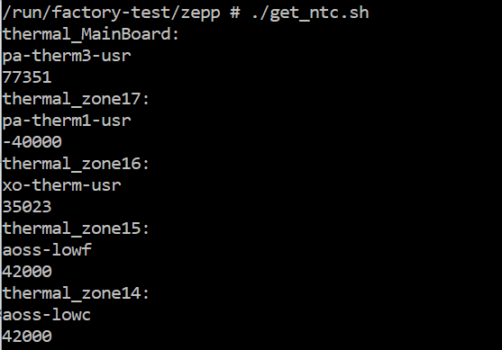

## 2.7 GPIO set

Run “set_gpio.sh”

GPIO list define at “gpio.conf” 1st row as gpio name. 2nd row as gpio number

Exp:

pa-mute 42

pa-en 40

Command form:

./set_gpio.sh <gpio name> <value>

Exp:

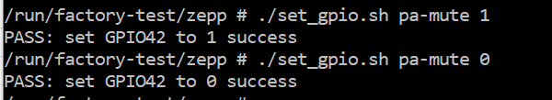

## 2.8 Audio set

Audio set using single script for each setting. Table as below:

|  |  |
| --- | --- |
| **script** | **function** |
| EQ_bypass.sh | Set EQ (DSP) bypass |
| EQ_enable.sh | Enable EQ |
| WF_mute.sh | WF mute |
| WF_enable.sh | WF enable |
| LMF_mute.sh | LMF mute |
| LMF_enable.sh | LMF enable |
| RMF_mute.sh | RMF mute |
| RMF_enable.sh | RMF enable |
| LHF_mute.sh | LHF mute |
| LHF_enable.sh | LHF enable |
| RHF_mute.sh | RHF mute |
| RHF_enable.sh | RHF enable |
| ~~AEC_L_mute.sh~~ | ~~Mute AEC L~~ |
| ~~AEC_L_enable.sh~~ | ~~Enable AEC L~~ |
| ~~AEC_R_mute.sh~~ | ~~Mute AEC R~~ |
| ~~AEC_R_enable.sh~~ | ~~Enable AEC R~~ |
| master_mute.sh | Mute all |
| master_enable.sh | Unmute all |
| set_master_source.sh | Set master source: soc/local/spdif |
| get_dsp_version.sh | Get DSP version |
| l_tone1_enable.sh | L channel tone1 enable |
| l_tone1_disable.sh | L channel tone1 disable |
| r_tone1_enable.sh | R channel tone1 enable |
| r_tone1_disable.sh | R channel tone1 disable |

Exp:

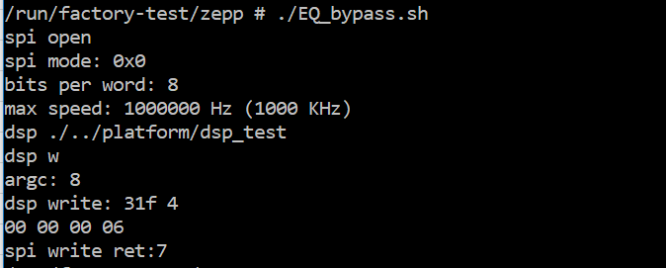

## 2.9 volume set

Run “set_volume.sh”

Volume detail data define at volume.conf from 1st line to last line was mute volume to max volume

Command form:

./set_volumen.sh <value>

Value support number from 0~max volume level also “mute”, “max”

Exp:

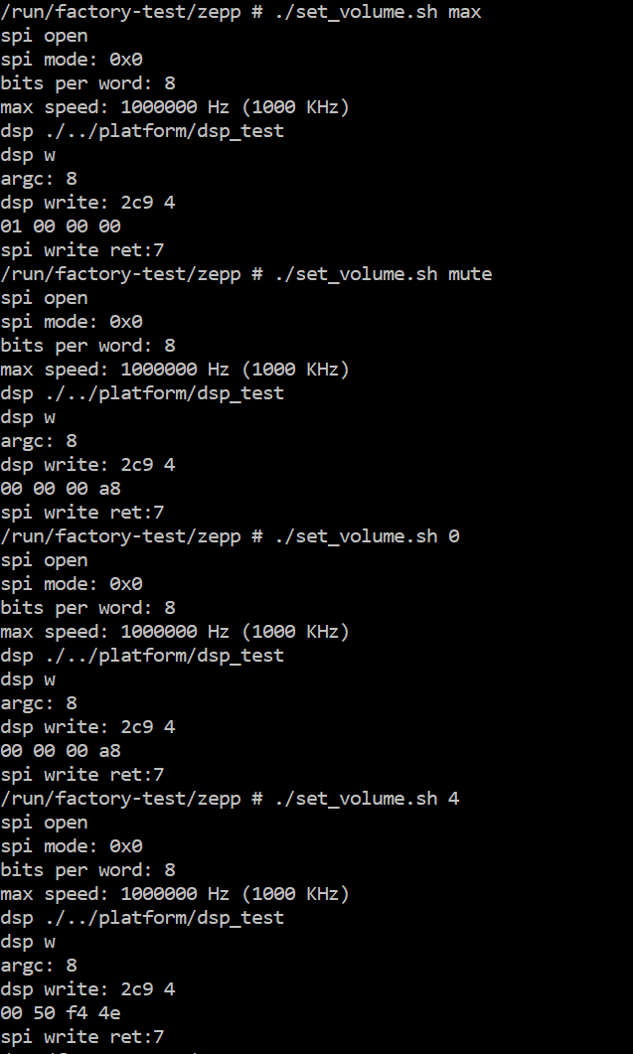

## 2.10 Mic loopback

Run “loopback_mic.sh” to start mic loopback.

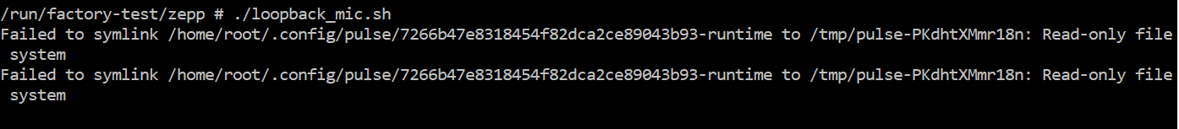

Run “loopback_close.sh” to close mic loopback. Or force close the script to stop it.

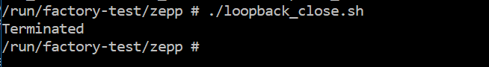

## 2.11 burn in mode

Run “set_burn_in.sh” to mark burn in mode.



This script will cope files that burn in mode need to /data

Run “burn_in_check.sh” will check the burn in mark, if it exist run the loop play pinknoise.

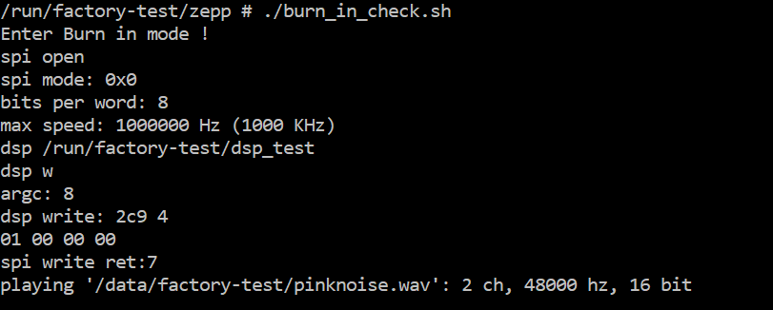

Currently auto running burn_in_check.sh can’t keep looping play pinknoise. When run on command line. It work.

## 2.12 battery info

Get battery capacity run “get_batt_capacity.sh”

Get battery temperature run “get_batt_temp.sh”

Get battery current run “get_batt_current.sh” . if the value was minus means charge out.

Get battery voltage run “get_batt_voltage.sh”

## 2.13 NVRAM operate

|  |  |
| --- | --- |
| **Script** | **Function** |
| nvram_fs.sh | Formal NVRAM, after formal need to reboot to active it. |
| get_assembly.sh | Get ASSEMBLY No. |
| Set_assembly.sh | Set ASSEMBLY No. |
| get_board_version.sh | Get board version |
| get_country_code.sh | Get country code |
| set_country_code.sh | Set country code exp: US |
| get_eth0_mac_addr.sh | Get ETH0 MAC address |
| set_eth0_mac_addr.sh | Set ETH0 MAC address |
| get_wlan0_mac_addr.sh | Get WLAN0 MAC address |
| set_wlan0_mac_addr.sh | Set WLAN0 MAC address |
| get_wlan1_mac_addr.sh | Get WLAN1 MAC address |
| set_wlan1_mac_addr.sh | Set WLAN1 MAC address |
| get_wlan2_mac_addr.sh | Get WLAN2 MAC address |
| set_wlan2_mac_addr.sh | Set WLAN2 MAC address |
| get_bt0_mac_addr.sh | Get BT0 MAC address |
| set_bt0_mac_addr.sh | Set BT0 MAC address |
| get_base_mac_addr.sh | Get BASE MAC address |
| set_base_mac_addr.sh | Set BASE MAC address |
| get_fp_part.sh | Get FP part |
| Set_fp_part.sh | Set FP part |
| get_unused0.sh | Get UNUSED0 |
| set_unused0.sh | Set UNUSED0 |
| get_unused1.sh | Get UNUSED1 |
| set_unused1.sh | Set UNUSED1 |
| get_model.sh | Get MODEL name |
| set_model.sh | Set MODEL name |

Currently only wlan1 and bt0 mac address will set to modules. Others just store at NVRAM, and can be read. FW must have “nvram” tool.

Formal:

./set_xxxx.sh <context>

Exp:

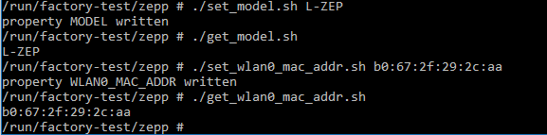

## 2.14 Set Wlan0 MAC address

Formal:

./set_wlan0_mac_addr.sh <6 bytes hex number>

Exp: ./set_wlan0_mac_addr.sh 000AF5898FF

And the get command was:

./get_wlan0_mac_addr.sh

## 2.15 Set BT MAC address

Forml:

./set_bt0_mac_addr.sh <6 bytes hex number with ‘:’ split >

Exp:

./set_bt0_mac_addr.sh 70:c9:4e:9b:64:11

And the get command was

./get_bt0_mac_addr.sh

## 2.15 Mic record

Formal:

./mic_record.sh

When running this script will need 11S for 4 channels mic audio path setting. Then will record audio to “/data/factory-test/mic-4ch.wav”

## 2.16 Mic record close

Formal:

./mic_record_close.sh <number of record time in second>

Exp:

./mic_record_close.sh 4

Means close record after recording 4 seconds, please notice: Mic record must run just before mic record close.

Exp:

adb shell /etc/factory-test/zepp/mic_record.sh

adb shell /etc/factory-test/zepp/mic_record_close.sh 4

Means: start audio record and record audio for 4 seconds then close it.

## 2.17 Audio play

Formal:

./audio_play.sh <audio path>

Exp:

./audio play.sh /data/pinknoisc.wavZZ

## 2.18 Audio play close

Formal :

./audio_play_close.sh