**四级作文提分讲座？**

**万能模板**

**判卷原则**

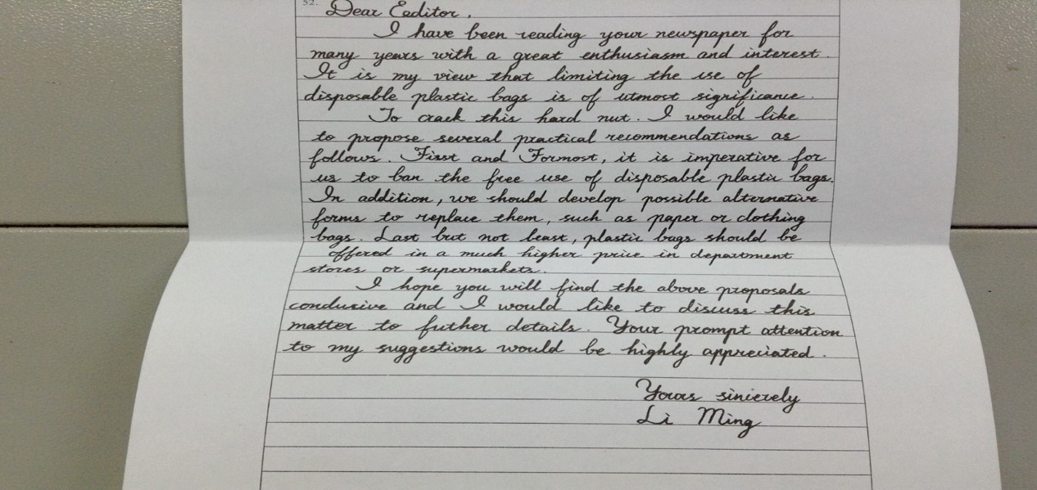

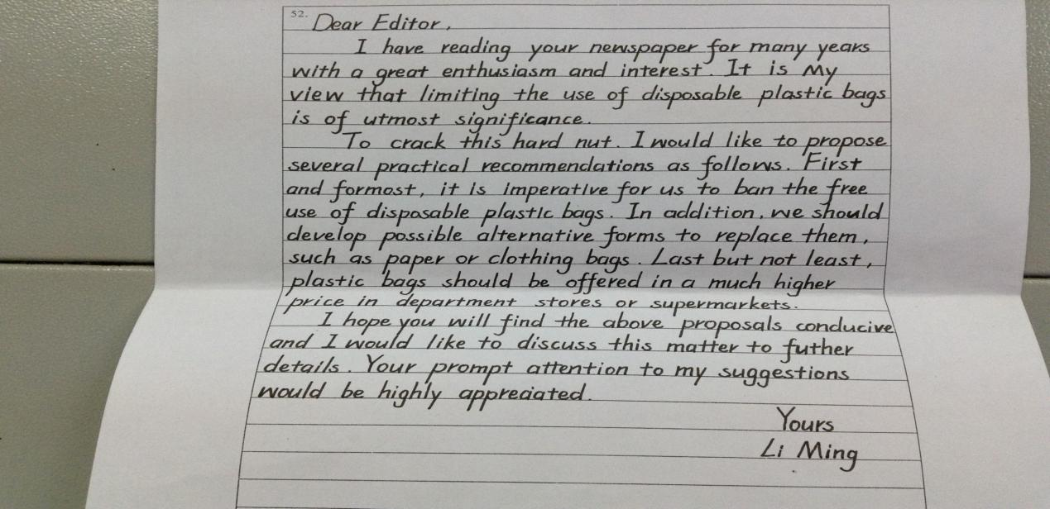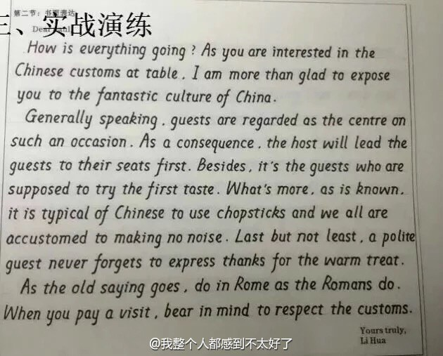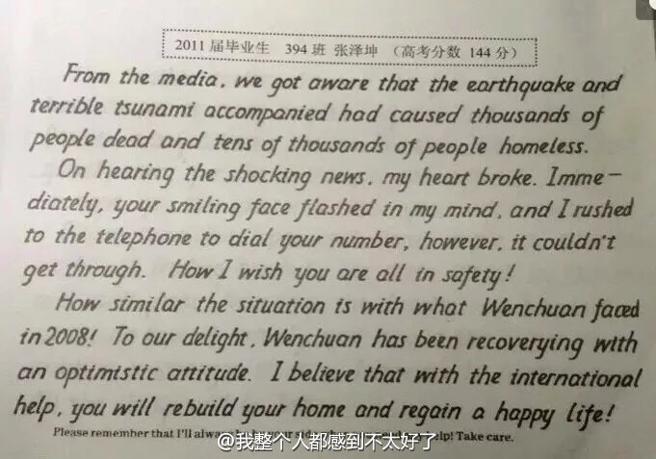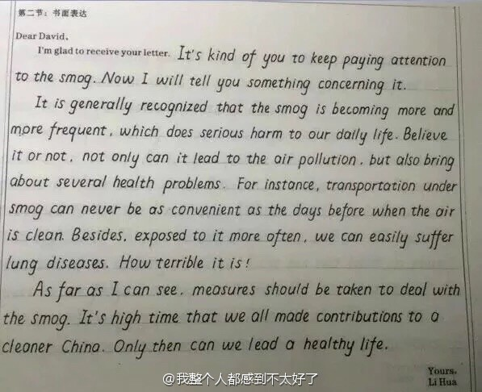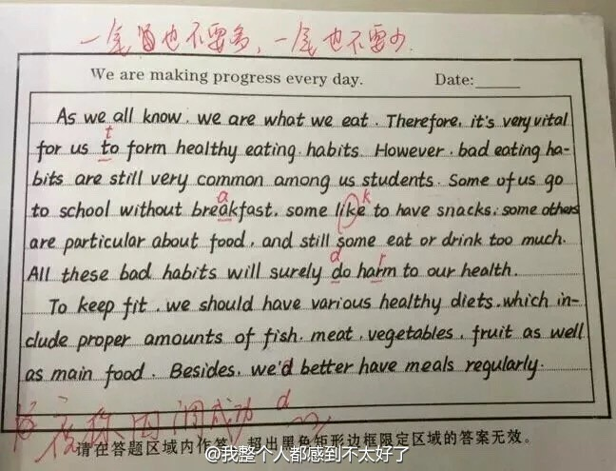

**2016 上半年 应用文---感谢信**

**write a letter to express your thanks to your parents or any family members upon making memorable achievement.**

**2016下半年 议论文--观点选择**

**Suppose you have two options upon graduation: one is to find a job somewhere and the other to start a business of your own**

**2017上半年---应用文--写广告write an advertisement on your campus website to sell a bicycle you used at college.--**

**2017 下半年--议论文 问题解决**

**. how to best handle the relationship between teachers and students.**

**2018上半年--议论文--问题解决**

**Directions: For this part, you are allowed 30minutes to write a short essay on the importance of speaking ability and how to develop it. You should write at least 120 words but no more than180 words.**

**2018下半年--议论文--现象解释**

**the challenges of living in a big city.**

**2019年上半年-应用-news report新闻报道**

**--预测 议论文**

**议论文**

**应用文都有些什么东西**

**Letter--写信**

**News report新闻报道**

**advertisement广告**

**预测：notice通知，invitation邀请函，announcement通告，speech演讲稿**

**议论文分为哪几类？**

**问题解决：how to**

**提出一个问题**

**三个段落（11句）**

**第一段（2-3句）前1-2提出你的问题，第3句过渡句.**

**第二段（6个句子）：第一句：论点1第二句：论据1. 第三句第四句：论点2+论据2 第五句+第六句（论点3+论据3）**

**第三段：第一句：重申观点+第二句万能结尾（提出期望）。**

**例题：2018上半年作文**

**the importance of speaking ability and how to develop it**

**要不要写题目：不要写**

**第一段：1万能开头作用：提出问题**

**With the rapid development of society/economy/education/technology/**

**culture/medical service, it is of great necessity for youngster/students to improve our speaking ability.**

**2过渡句：The following solutions can account for this phenomenon/issue.**

**第二段6句话**

**第一句作用 提出第一个论点**

**First and foremost, there is no doubt that we should practice more.**

**第二句：论据1**

**Base on a most recent survey，a majority of successful social elites admit that they prefer practicing new things.**

**第三句：论点2**

**Furthermore，it is obvious that it is beneficial for students to make foreign friends.**

**第四句：论据2 万能谚语**

**Where there is a will, there is a way.有志者 事竟成**

**Where there are foreign friends, there is communication, therefore our speaking ability can be improved.**

**第五句：论点3**

**Last but not least，no one can deny that it is high time that we can travel to a English speaking country, so that our speaking ability can be enhanced.**

**第六句：论据3**

**Though....., ....**

**Though we don’t have a good language environment, we can experience it in a short time.**

**最后一段 两句话 重申观点+万能结尾**

**In a word, it is clear that we should promote our speaking ability. If we try our utmost to__develop our spoken English_, the future of our life will be promising and hopeful.**

**写句子 写成最简单的结构**

**谁+做+什么**

**谁+是+什么**

**谁+被+这样**

**观点选择： option，choice**

**现象解释：what， why**