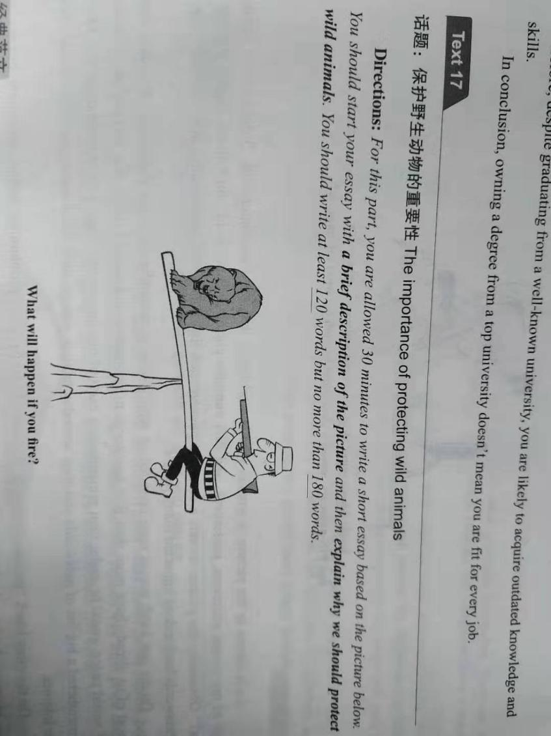

描述图片+分析问题+感受（过渡句）

庸俗：**As is vividly depicted in the picture**，

高雅：**As is starkly mirrored（reflected） in the** image/chart（表格）that **a cruel hunter was holding** an **ice-cold gun** towards an **innocent** bear.（描述图片） There is a question/statement below/above: what will happen if you fire?

（分析问题）

分析问题：

庸俗：It tells us____, it is revealed that____ it shows, we can find that____. displayed that___.

高雅 Digging into it,（深挖其本质）

Digging into it, indeed we need to consider it seriously. Why human should protect wild life.？**The following reasons can account for this issue.（过渡句）**

**First and foremost,黄金圣衣句型，论点1+.论据1. Furthermore， 黄金圣衣句型+论点2+论据2.**

**Last but not least,黄金圣衣句型+论点3+论据3.**

**结尾段： 重申观点 提出希望。**