得分：_______


算法分析

学号：_______

姓名：________

班级：________

- 学习内容
1. 题目概述（必做）
给定两个序列x，y，使用动态规划算法计算它们的最长公共子序列。
输入: x，y
输出:最优值表c，路径表b
使用Java实现。
2. 题目概述（必做）
给定矩阵的尺寸数组b，使用动态规划算法计算它们的最少数乘次数。
输入: 尺寸数组b
输出:最优值表m，路径表s
使用Java实现。

二、实验代码
（1）
public class LCS {
public static int lcsLength(char[] x, char[] y, int[][] b, int[][] c) {
int m = x.length - 1;
int n = y.length - 1;

for (int i = 0; i <= m; i++) c[i][0] = 0;
for (int j = 0; j <= n; j++) c[0][j] = 0;

for (int i = 1; i <= m; i++) {
for (int j = 1; j <= n; j++) {
if (x[i] == y[j]) {
c[i][j] = c[i-1][j-1] + 1;
b[i][j] = 1;
} else if (c[i-1][j] >= c[i][j-1]) {
c[i][j] = c[i-1][j];
b[i][j] = 2;
} else {
c[i][j] = c[i][j-1];
b[i][j] = 3;
}
}
}

return c[m][n];
}

public static void lcs(int i, int j, char[] x, int[][] b) {
if (i == 0 || j == 0) return;

if (b[i][j] == 1) {
lcs(i-1, j-1, x, b);
System.out.print(x[i]);
} else if (b[i][j] == 2) {
lcs(i-1, j, x, b);
} else {
lcs(i, j-1, x, b);
}
}

public static void printC(int[][] c) {
System.out.println("Optimal value table c:");
for (int i = 0; i < c.length; i++) {
for (int j = 0; j < c[i].length; j++) System.out.print(c[i][j] + " ");
System.out.println();
}
}

public static void printB(int[][] b) {
System.out.println("Path table b:");
for (int i = 0; i < b.length; i++) {
for (int j = 0; j < b[i].length; j++) System.out.print(b[i][j] + " ");
System.out.println();
}
}

public static void main(String[] args) {
if (args.length < 2) {
System.out.println("Please provide two sequences as arguments when running the program:");
System.out.println("Example: java LCS ABCBDAB BDCABA");
return;
}

String inputX = args[0];
String inputY = args[1];

System.out.println("Input sequence X: " + inputX);
System.out.println("Input sequence Y: " + inputY);

char[] x = new char[inputX.length() + 1];
char[] y = new char[inputY.length() + 1];

for (int i = 0; i < inputX.length(); i++) x[i + 1] = inputX.charAt(i);
for (int i = 0; i < inputY.length(); i++) y[i + 1] = inputY.charAt(i);

int m = x.length - 1;
int n = y.length - 1;

int[][] b = new int[m + 1][n + 1];
int[][] c = new int[m + 1][n + 1];

int result = lcsLength(x, y, b, c);

System.out.println("Length of LCS: " + result);
System.out.print("LCS: ");
lcs(m, n, x, b);
System.out.println();

printC(c);
printB(b);
}
}

（2）

public class MatrixChain {
public static void matrixChain(int[] p, int[][] m, int[][] s) {
int n = p.length - 1;
for (int i = 1; i <= n; i++) {
m[i][i] = 0;
}
for (int r = 2; r <= n; r++) {
for (int i = 1; i <= n - r + 1; i++) {
int j = i + r - 1;
m[i][j] = m[i + 1][j] + p[i - 1] * p[i] * p[j];
s[i][j] = i;
for (int k = i + 1; k < j; k++) {
int t = m[i][k] + m[k + 1][j] + p[i - 1] * p[k] * p[j];
if (t < m[i][j]) {
m[i][j] = t;
s[i][j] = k;
}
}
}
}
}

public static void printOptimalParens(int[][] s, int i, int j) {
if (i == j) {
System.out.print("A" + i);
} else {
System.out.print("(");
printOptimalParens(s, i, s[i][j]);
printOptimalParens(s, s[i][j] + 1, j);
System.out.print(")");
}
}

public static void main(String[] args) {
java.util.Scanner scanner = new java.util.Scanner(System.in);
int[] b = null;
boolean validInput = false;

System.out.println("请输入矩阵尺寸数组（空格分隔，至少2个元素）：");

while (!validInput) {
String inputLine = scanner.nextLine();
if (inputLine.trim().isEmpty()) continue;
String[] tokens = inputLine.trim().split("\\s+");

if (tokens.length < 2) {
System.out.println("错误：至少需要2个元素，请重试。");
continue;
}

b = new int[tokens.length];
boolean hasError = false;

try {
for (int i = 0; i < tokens.length; i++) {
b[i] = Integer.parseInt(tokens[i]);
}
} catch (NumberFormatException e) {
System.out.println("错误：请仅输入数字。");
hasError = true;
}

if (!hasError) validInput = true;
}

scanner.close();
int n = b.length - 1;
int[][] m = new int[n + 1][n + 1];
int[][] s = new int[n + 1][n + 1];

matrixChain(b, m, s);

System.out.println("\n输入数组：");
for (int i = 0; i < b.length; i++) {
System.out.print(b[i] + " ");
}
System.out.println("\n");

System.out.println("最优值表m：");
for (int i = 1; i < m.length; i++) {
for (int j = 1; j < m[i].length; j++) {
System.out.print(m[i][j] + "\t");
}
System.out.println();
}

System.out.println("\n路径表s：");
for (int i = 1; i < s.length; i++) {
for (int j = 1; j < s[i].length; j++) {
System.out.print(s[i][j] + "\t");
}
System.out.println();
}

System.out.print("\n最优计算顺序：");
printOptimalParens(s, 1, n);
System.out.println();

System.out.println("\n最少数乘次数：" + m[1][n]);
}
}

三、运行效果
(1)
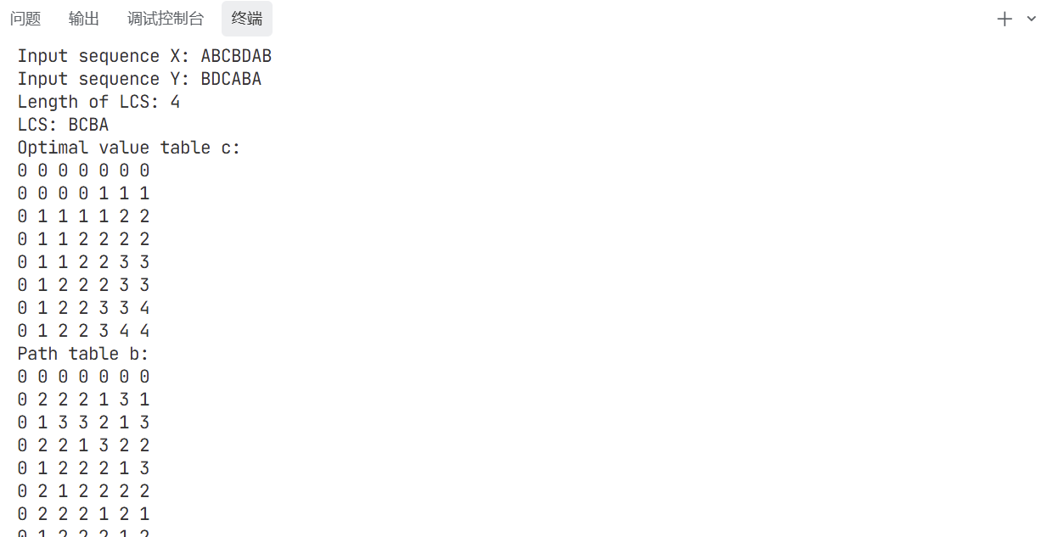
(2)
