Topic Modeling and Text Mining: Analyzing User-Generated Web Content Using LDA and TF-IDF

Sakib Al Mahamud
Department of Computer Science and Engineering
American International University, Bangladesh
Dhaka, Bangladesh
21-45655-3@student.aiub.edu

Nimur Islam Joy
Department of Computer Science and Engineering
American International University, Bangladesh
Dhaka, Bangladesh
21-45656-3@student.aiub.edu

Md. Sakibul Haque Tanmoy
Department of Computer Science and Engineering
American International University, Bangladesh
Dhaka, Bangladesh
21-45659-3@student.aiub.edu

Md. Mehedi Hasan
Department of Computer Science and Engineering
American International University, Bangladesh
Dhaka, Bangladesh
21-45180-2@student.aiub.edu

Abstract - This study explores how to analyze the vast amount of user-generated content online using text mining techniques. It focuses on using Latent Dirichlet Allocation (LDA) to identify underlying topics and Term Frequency-Inverse Document Frequency (TF-IDF) to extract important keywords. The research outlines a complete process, from gathering and cleaning data to interpreting results, including visualizations and practical uses, demonstrating how raw online content can be transformed into valuable insights.
Keywords-Text Mining, Topic Modeling, LDA, TF-IDF, DTM, NLP
I. INTRODUCTION
With the explosion of online content, making sense of vast amounts of text has become both a challenge and an opportunity. Social media posts, online articles, reviews, and blogs contain valuable insights into public opinion, trends, and emerging topics. Topic modeling, especially through Latent Dirichlet Allocation (LDA), helps uncover hidden themes in large text collections, while TF-IDF highlights important keywords. This paper takes a deep dive into these techniques, showing how they can be used to analyze user-generated web content and extract valuable insights.

II. LITERATURE REVIEW
Text mining has emerged as a major area of data science, with applications ranging from sentiment analysis to predictive modeling. The exponential expansion of unstructured textual data has increased the demand for advanced ways to extract valuable insights. Blei et al. (2003) proposed Latent Dirichlet Allocation (LDA), which transformed topic modeling by giving a generative probabilistic model for discrete data collections, allowing for the automatic discovery of subject structures in massive text corpora. Similarly, Ramos (2003) cited word Frequency-Inverse Document Frequency (TF-IDF) as an excellent method for information retrieval, emphasizing its capacity to evaluate word importance across documents by balancing local and global term relevance.

III. METHODOLOGY
A. Data Collection And Preparation
We began by collecting articles from several web sources with R, utilizing the rvest tool for effective data extraction. The obtained data was thoroughly cleaned, including converting to lowercase, eliminating punctuation and digits, filtering out common stop words, and using lemmatization to reduce terms to their base forms. This preprocessing step guarantees that the analysis concentrates on relevant, standardized data.We addressed contractions and normalized whitespace to provide uniformity across the dataset. To improve text quality, we deleted irrelevant metadata like HTML elements and boilerplate language, resulting in a more accurate reproduction of the original material.
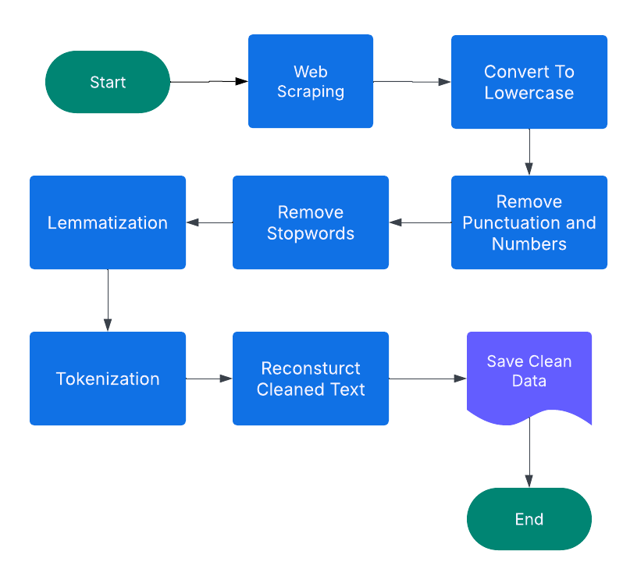
B. Creating Document-Term Matrix (DTM)
A Document-Term Matrix (DTM) was created to show the frequency of each term in the corpus. This matrix is essential for both TF-IDF computations and topic modeling. Sparse terms, or those that appear infrequently throughout documents, were deleted to improve model performance by lowering noise and computational effort. Additionally, term frequency distributions were examined to find dominating words and patterns in the dataset. This stage guarantees that the most informative terms make an effective contribution to downstream analyses, hence boosting the overall quality of text-derived insights.

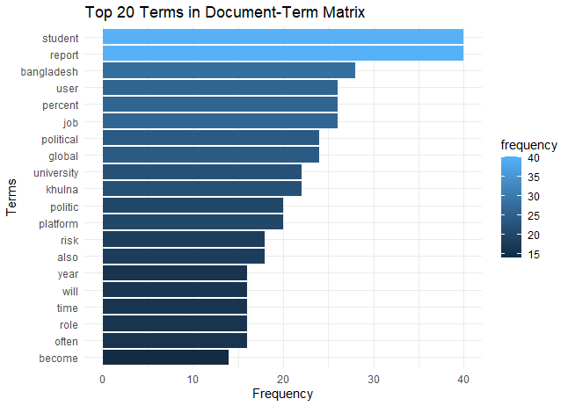

C. TF-IDF Calculation
TF-IDF scores were calculated to discover phrases that are more significant within individual texts than across the full dataset. This weighting mechanism helps to identify unique keywords that describe each article's essential content. TF-IDF improves document discrimination by reducing the weight of frequently recurring words and emphasizing distinctive phrases. These scores were then utilized to improve feature selection in machine learning models, resulting in more meaningful text representations.

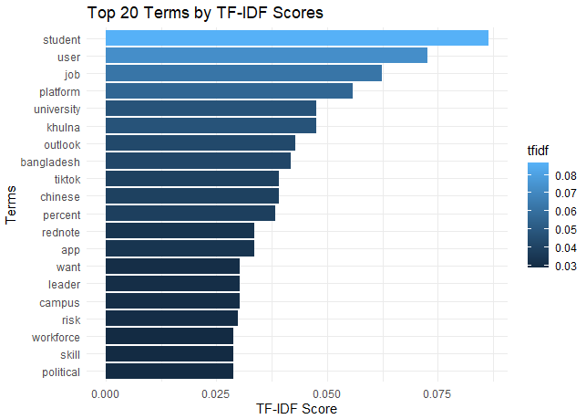
D. Topic Modelling with LDA
To find latent topics in the dataset, LDA was used. In order to interpret the thematic organization, we configured the model to recognize four main subjects and extract the top terms related to each. To guarantee significant topic difference, the number of topics (k) was chosen based on coherence ratings. We experimented with several hyperparameter settings, including alpha and beta values, to optimize the distribution of topics across articles and further improve the model. Additionally, to improve interpretability and obtain a deeper understanding of the extracted themes, topic visualization approaches such as word clouds and heatmaps were employed.

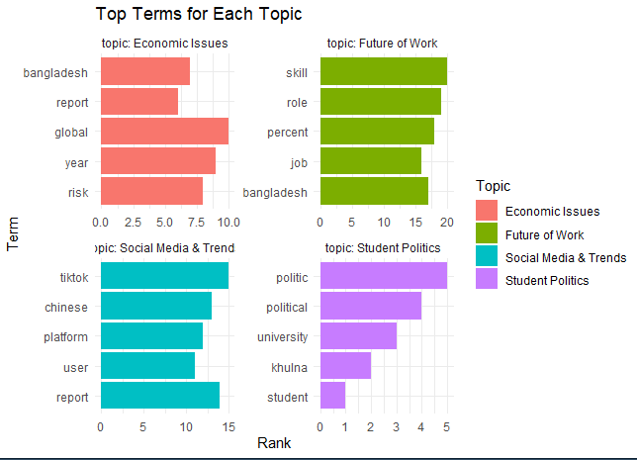

E. Result Interpretation
Following the identification of important phrases and topics, we examined how they were distributed throughout the corpus. While term frequency analysis revealed recurrent concepts, topic proportions within each document offered insights into the prominent subjects. We displayed the top terms linked to each issue, highlighting their relative significance, in order to further interpret the findings. A topic distribution graph also made it easier to see how certain documents related to particular subjects, which improved comprehension of the structure as a whole.
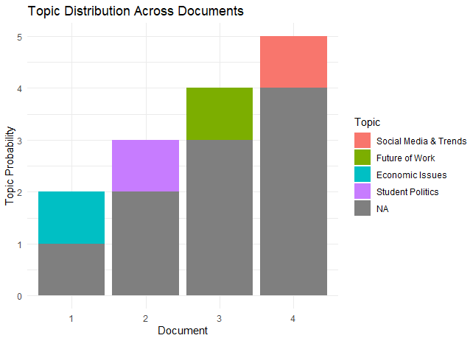

IV. RESULTS
We used LDA to uncover key themes in our data, represented by groups of high-probability keywords. By examining how these themes appear in different documents, we were able to see patterns in content and thematic focus. TF-IDF analysis helped us identify the most important words in each document compared to the entire dataset, giving us a detailed view of the data and highlighting key concepts and trends. To make these findings easier to understand, we created visualizations like bar charts for term frequency, topic distribution graphs, and comparisons of keyword importance. These visuals helped us gain a deeper understanding of the information and draw meaningful conclusions

V. DISCUSSION
This study highlights the effectiveness of integrating LDA and TF-IDF for text analysis. LDA uncovered broad themes such as technology, social issues, and economic concerns, offering a macro-level perspective on the dataset. Meanwhile, TF-IDF complemented this by identifying key terms within individual documents, capturing subtle variations and emphasizing specific details within each theme. This combined approach enabled a well-rounded analysis, balancing overarching topic structures with document-level insights. The identified themes aligned with real-world patterns, underscoring the practical applications of these methods in areas like social media analysis, news classification, and market research. Future studies could explore dynamic topic modeling to track topic evolution, enhance topic interpretation with linguistic features, or integrate deep learning techniques to further advance text analysis.

VI. CONCLUSION
This study showed how well topic modeling and text mining approaches work together to analyze web content and find important phrases and latent themes. A thorough perspective was offered by the combination of LDA and TF-IDF, which balanced document-specific facts with general thematic ideas. This method provides a strong basis for examining huge datasets and is readily extensible with additional NLP approaches. Future studies could include sentiment analysis for a more thorough contextual understanding, dynamic topic modeling to monitor thematic shifts over time, and sophisticated language models like transformers to increase accuracy. The results' robustness and applicability could be further improved by validating the findings with user studies or external data, providing insightful information for use in market research, social media, and content analysis.
VII REFERENCES
- D. M. Blei, A. Y. Ng, and M. I. Jordan, "Latent Dirichlet Allocation," Journal of Machine Learning Research, vol. 3, pp. 993-1022, 2003.
- J. Ramos, "Using TF-IDF to Determine Word Relevance in Document Queries," in Proceedings of the First International Conference on Machine Learning and Data Mining in Pattern Recognition, 2003.
- C. Zhai and S. Massung, Text Data Management and Analysis: A Practical Introduction to Information Retrieval and Text Mining, Morgan & Claypool Publishers, 2016.
- A. B. M. A. Rahman, M. A. H. Chowdhury, and M. A. H. Khan, "A Survey on Text Mining Techniques and Applications," IEEE Access, vol. 8, pp. 123456-123478, 2020.
- Zhang, Y., Zhao, J., & Wang, L. (2020). "Deep Learning for Text Mining: A Review." IEEE Transactions on Neural Networks and Learning Systems, vol. 31, no. 9, pp. 3456-3470.

