**AMERICAN INTERNATIONAL UNIVERSITY–BANGLADESH (AIUB)**

**FACULTY OF SCIENCE & TECHNOLOGY**

**DEPARTMENT OF Computer Science and Engineering**

##### INTRODUCTION TO DATABASE

**Section: B**

##### Project: Superstore Management System

**Supervised By**

**JUENA AHMED NOSHIN**

**Submitted By**

|  |  |  |
| --- | --- | --- |
| **Name** | **ID** | **Contributions** |
| **Sakib Al Mahamud** | **21-45655-3** | **Scenario Description, Table Creation, Conclusion** |
| **Nimur Islam Joy** | **21-45656-3** | **ER Diagram, Query Writing** |
| **Istyak Ahmed** | **21-45658-3** | **Normalization, Schema Diagram, Introduction** |
| **Md.Sakibul Haque Tanmoy** | **21-45659-3** | **Data Insertion, Relational Algebra** |

**Contents**

**Page no.**

**1. Introduction** ---------------------------------------------------------------------- 03

**2. Scenario Description** ----------------------------------------------------------- 03

3. **ER Diagram** ----------------------------------------------------------------------- 04

**4. Normalization** -------------------------------------------------------------------- 05

**5. Schema Diagram** ---------------------------------------------------------------- 13

**6. Table Creation** ------------------------------------------------------------------- 14

**7. Data Insertion** -------------------------------------------------------------------- 26

**8. Query Writing** -------------------------------------------------------------------- 35

**9. Relational Algebra** --------------------------------------------------------------- 42

**10. Conclusion** ------------------------------------------------------------------------ 43

**Introduction:**

Detailed SQL queries of our project start after the system’s ER Diagram is completed. This phase aims to develop the internal relationship between each of the entities identified during the designing of the ER Diagram. In the ER Diagram, a more detailed specification is given by explaining the types of information in attributes which entities are supposed to carry.

**Scenario Description:**

In a Superstore management system, a superstore sells various products to the customers who visit the superstore to buy their needs. A superstore has its unique shop no. It also has the name, phone, and address. A superstore has suppliers who are identical by their supplier id. A supplier also has more attributes, such as name and phone number. One specific supplier supplies just one particular product to the store. Each product has its unique id and type. They also have their name, price, description, weight, and unit. Customers are identical to their customer ID and have their usual name, phone, email, and geographical address. The customer makes a payment to purchase any product. Each payment gets recorded in the store database through their unique id and a few more details like Payment date, amount, and description. There are also employees who work in the superstore to keep all the activities going. Each delivery man is recognized by their distinct employee id. They also have a few recorded details like their name, date of birth, salary, address, and phone number. This is how a superstore management system is built.

**ER Diagram:**

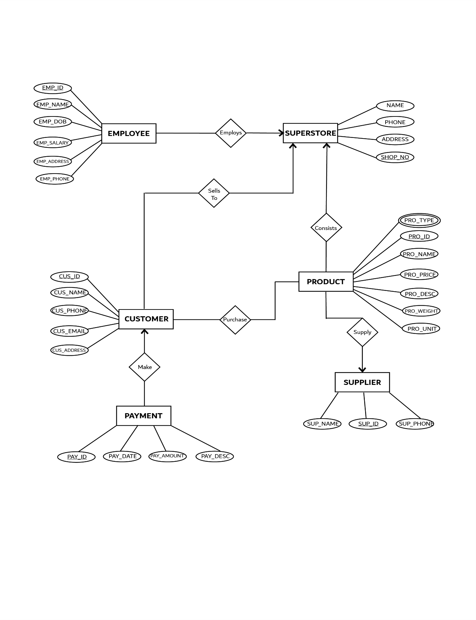

**Normalization:**

**Make**

**UNF**

Make(Cus_id, Cus_Name , Cus_phone, Cus_Email, Cus_Address, Pay_ID, Pay_Date, Pay_Amount, Pay_Desc)

**1NF**

There is no multi valued attribute , Realtion already in 1NF.

1. Cus_id, Cus_Name , Cus_phone, Cus_Email, Cus_Address, Pay_ID, Pay_Date, Pay_Amount, Pay_Desc

**2NF**

1. Cus_id, Cus_Name , Cus_phone, Cus_Email, Cus_Address.

2. Pay_ID, Pay_Date, Pay_Amount, Pay_Desc.

**3NF**

There is no transitive dependency. Relation already in 3NF

1. Cus_id, Cus_Name , Cus_phone, Cus_Email, Cus_Address.

2. Pay_ID, Pay_Date, Pay_Amount, Pay_Desc.

**TABLE CREATION**

1. Cus_id, Cus_Name , Cus_phone, Cus_Email, Cus_Address.

2. Pay_ID, Pay_Date, Pay_Amount, Pay_Desc, **Cus_id**

**Purchase**

**UNF**

Purchase(Cus_id, Cus_Name , Cus_phone, Cus_Email, Cus_Address, Pro_ID, Pro_Type, Pro_Name, Pro_Price, Pro_Desc, Pro_Weight, Pro_Unit)

**1NF**

Pro_Type is a multi valued attribute.

1. Cus_id, Cus_Name , Cus_phone, Cus_Email, Cus_Address, Pro_ID, Pro_Type, Pro_Name, Pro_Price, Pro_Desc, Pro_Weight, Pro_Unit

**2NF**

1. Cus_id, Cus_Name , Cus_phone, Cus_Email, Cus_Address.

2. Pro_ID, Pro_Type, Pro_Name, Pro_Price, Pro_Desc, Pro_Weight, Pro_Unit

**3NF**

There is no transitive dependency. Relation already in 3NF

1. Cus_id, Cus_Name , Cus_phone, Cus_Email, Cus_Address.

2. Pro_ID, Pro_Type, Pro_Name, Pro_Price, Pro_Desc, Pro_Weight, Pro_Unit

**TABLE CREATION**

1. Cus_id, Cus_Name , Cus_phone, Cus_Email, Cus_Address.

2. Pro_id, Pro_Type, Pro_Name, Pro_Price, Pro_Desc, Pro_Weight, Pro_Unit

3. Cus_id, Pro_id

**Supply**

**UNF**

Supply(Sup_ID, Sup_Name, Sup_Phone, Pro_hID, Pro_Type, Pro_Name, Pro_Price, Pro_Desc, Pro_Weight, Pro_Unit)

**1NF**

Pro_Type is a multi valued attribute.

1. Sup_ID, Sup_Name, Sup_Phone, Pro_ID, Pro_Type, Pro_Name, Pro_Price, Pro_Desc, Pro_Weight, Pro_Unit

**2NF**

1. Sup_ID, Sup_Name, Sup_Phone

2. Pro_ID, Pro_Type, Pro_Name, Pro_Price, Pro_Desc, Pro_Weight, Pro_Unit

**3NF**

There is no transitive hdependency. Relation already in 3NF

1. Sup_ID, Sup_Name, Sup_Phone .

2. Pro_ID, Pro_Type, Pro_Name, Pro_Price, Pro_Desc, Pro_Weight, Pro_Unit .

**TABLE CREATION**

1. Sup_ID, Sup_Name, Sup_Phone .

2. Pro_id, Pro_Type, Pro_Name, Pro_Price, Pro_Desc, Pro_Weight, Pro_Unit, **Sup_id**

**Consists**

**UNF**

Consists(Name,Phone,Address,Shop_No,Pro_Type,Pro_id,Pro_Name,Pro_Price,Pro_Dese,Pro_Weight,Pro_unit)

**1NF**

Pro_Type is a multi valued attribute.

1.Name,Phone,Address,Shop_No,Pro_Type,Pro_id,Pro_Name,Pro_Price,Pro_Dese,Pro_Weight,Pro_unit

**2NF**

1. Name,Phone,Address,Shop_No

2. Pro_Type,Pro_id,Pro_Name,Pro_Price,Pro_Dese,Pro_Weight,Pro_unit

**3NF**

There is no transitive dependency. Relation already in 3NF.

1. Name,Phone,Address,Shop_No

2. Pro_Type, Pro_id, Pro_Name,Pro_Price,Pro_Dese,Pro_Weight,Pro_unit

**Table Creation**

1. Name,Phone,Address,Shop_No

2. Pro_Type,Pro_id,Pro_Name,Pro_Price,Pro_Dese,Pro_Weight,Pro_unit, **Shop_No**

3. Shop_No , Pro_id.

**Employs**

**UNF**

employs(Emp_id, Emp_Name, Emp_Dob, Emp_Salary, Emp_Address, Emp_Phone, Name, Phone, Address, Shop_No)

**1NF**

There is no multivalued attribute, Realtion already in 1NF

1. Emp_id, Emp_Name, Emp_Dob, Emp_Salary, Emp_Address, Emp_Phone, Name, Phone, Address, Shop_No

**2NF**

1. Emp_id, Emp_Name, Emp_Dob, Emp_Salary, Emp_Address, Emp_Phone

2. Name, Phone, Address, Shop_No

**3NF**

There is no transitive dependency. Relation already in 3NF

1. Emp_id, Emp_Name, Emp_Dob, Emp_Salary, Emp_Address, Emp_Phone

2. Name, Phone, Address, Shop_No

**Table Creation**

1. Emp_id, Emp_Name, Emp_Dob, Emp_Salary, Emp_Address, Emp_Phone, **Shop_No**

2. Name, Phone, Address, Shop_No

**Sells To**

**UNF**

Sells to(Cus_id,Cus_Name,Cus_Phone,Cus_Email,Cus_Address,Name,Phone,Address,Shop_No)

**1NF**

There is no multivalued attribute.

1.Cus_id, Cus_Name, Cus_Phone, Cus_Email, Cus_Address, Name, Phone, Address, Shop_No

**2NF**

1. Cus_id, Cus_Name, Cus_Phone, Cus_Email, Cus_Address

2. Name, Phone, Address, Shop_No

**3NF**

There is no transitive dependency. Relation already in 3NF

1. Cus_id, Cus_Name, Cus_Phone, Cus_Email, Cus_Address

2. Name, Phone, Address, Shop_No

**Table Creation**

1.Cus_id, Cus_Name, Cus_Phone, Cus_Email, Cus_Address ,Shop_No

2.Name, Phone, Address, Shop_No.

3. Cus_id, Shop_No

**Temporary Table:**

1. ~~Cus_id, Cus_Name , Cus_phone, Cus_Email, Cus_Address.~~

2. Pay_ID, Pay_Date, Pay_Amount, Pay_Desc, **Cus_id**

3. ~~Cus_id, Cus_Name , Cus_phone, Cus_Email, Cus_Address.~~

4. ~~Pro_id, Pro_Type, Pro_Name, Pro_Price, Pro_Desc, Pro_Weight, Pro_Unit~~

5. Cus_id, Pro_id

6. Cus_id, Cus_Name, Cus_Phone, Cus_Email, Cus_Address

7.~~Name, Phone, Address, Shop_No.~~

8. Cus_id, Shop_No

9. Shop_No , Pro_id.

10. ~~Name, Phone, Address, Shop_No~~

11. ~~Pro_Type,Pro_id,Pro_Name,Pro_Price,Pro_Dese,Pro_Weight,Pro_unit~~

12. Emp_id, Emp_Name, Emp_Dob, Emp_Salary, Emp_Address, Emp_Phone, **Shop_No**

13. Name, Phone, Address, Shop_No

14. Sup_ID, Sup_Name, Sup_Phone .

15. Pro_id, Pro_Type, Pro_Name, Pro_Price, Pro_Desc, Pro_Weight,

Pro_Unit, **Sup_Id**

**Final Tables:**

1. Name, Phone, Address, Shop_No

2. Emp_id, Emp_Name, Emp_Dob, Emp_Salary, Emp_Address, Emp_Phone, **Shop_No**

3. Pro_id, Pro_Type, Pro_Name, Pro_Price, Pro_Desc, Pro_Weight,

Pro_Unit, **Sup_Id**

4. Cus_id, Cus_Name, Cus_Phone, Cus_Email, Cus_Address

5. Sup_ID, Sup_Name, Sup_Phone.

6. Pay_ID, Pay_Date, Pay_Amount, Pay_Desc, **Cus_id**

7.Cus_id, Pro_id

8. Cus_id, Shop_No

9. Shop_No , Pro_id

**Schema Diagram:**

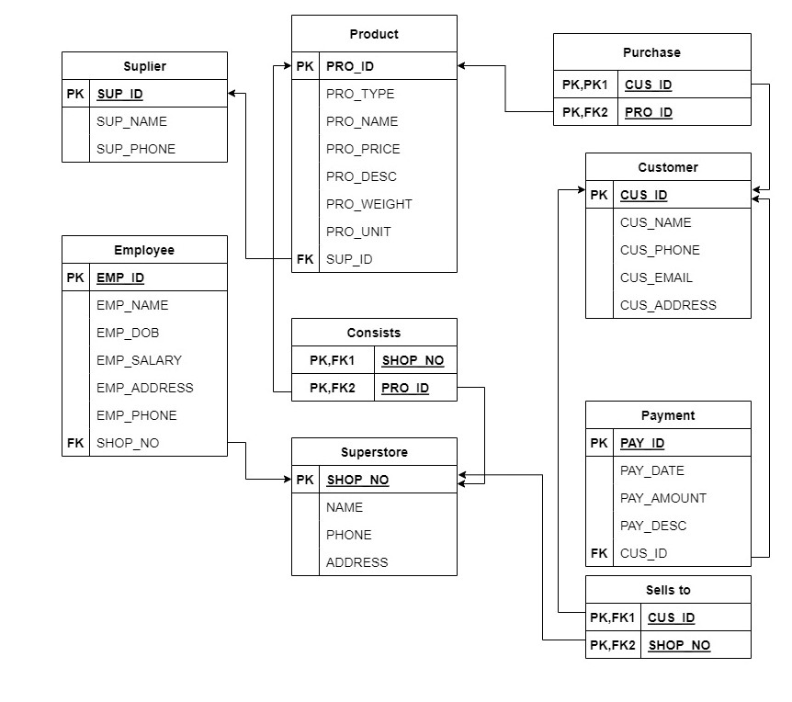

**Table Creation:**

CREATE TABLE SUPERSTORE(

NAME Varchar2(20),

PHONE Number(10),

ADDRESS Varchar2(20),

SHOP_NO Number(10)

);

ALTER TABLE Superstore

ADD CONSTRAINT SHO_PK

PRIMARY KEY (SHOP_NO);

desc employee

select constraint_name, column_name

from user_cons_columns

where table_name = 'SUPERSTORE';

drop TABLE SUPERSTORE

CREATE TABLE EMPLOYEE(

EMP_ID Number(10),

EMP_NAME varchar2(10),

EMP_DOB Date,

EMP_SALARY Number(7),

EMP_ADDRESS varchar2(10),

EMP_PHONE number(10),

SHOP_NO number(10)

);

ALTER TABLE EMPLOYEE

ADD CONSTRAINT EMP_PK

PRIMARY KEY (EMP_ID);

select constraint_name, column_name

from user_cons_columns

where table_name = 'EMPLOYEE';

alter table EMPLOYEE

add constraint EMP_SHO_FK foreign key(SHOP_NO) references Superstore(SHOP_NO);

desc employee

drop table EMPLOYEE

CREATE TABLE Product(

PRO_ID Number(10),

PRO_TYPE Varchar2(20),

PRO_NAME Varchar2(20),

PRO_PRICE Number(10),

PRO_DESC Varchar2(20),

PRO_WEIGHT Number(10,2),

PRO_UNIT Number(10),

SUP_ID Number(10)

);

ALTER TABLE PRODUCT

ADD CONSTRAINT PRO_PK

PRIMARY KEY (PRO_ID);

alter table PRODUCT

add constraint PRO_SUP_FK foreign key(SUP_ID) references SUPPLIER(SUP_ID);

select constraint_name, column_name

from user_cons_columns

where table_name = 'PRODUCT';

drop table PRODUCT

CREATE TABLE CUSTOMER(

CUS_ID NUMBER(10),

CUS_NAME Varchar2(20),

CUS_PHONE Number(10),

CUS_EMAIL Varchar2(10),

CUS_ADDRESS Varchar2(10)

);

ALTER TABLE CUSTOMER

ADD CONSTRAINT CUS_PK

PRIMARY KEY (CUS_ID);

select constraint_name, column_name

from user_cons_columns

where table_name = 'CUSTOMER';

desc customer

drop table CUSTOMER

CREATE TABLE SUPPLIER(

SUP_ID NUMBER(10),

SUP_NAME Varchar2(20),

SUP_PHONE Number(10)

);

ALTER TABLE SUPPLIER

ADD CONSTRAINT SUP_PK

PRIMARY KEY (SUP_ID);

select constraint_name, column_name

from user_cons_columns

where table_name = 'SUPPLIER';

desc

drop table SUPPLIER

CREATE TABLE PAYMENT(

PAY_ID NUMBER(10),

PAY_DATE date,

PAY_AMOUNT Number(10),

PAY_DESC Varchar2(20),

CUS_ID Number(10)

);

ALTER TABLE PAYMENT

ADD CONSTRAINT PAY_PK

PRIMARY KEY (PAY_ID);

alter table PAYMENT

add constraint PAY_CUS_FK foreign key(CUS_ID) references CUSTOMER(CUS_ID);

select constraint_name, column_name

from user_cons_columns

where table_name = 'PAYMENT';

desc

drop table PAYMENT

desc purchase

CREATE TABLE PURCHASE(

CUS_ID Number(10),

PRO_ID Number(10),

constraint PUR_PK primary key (CUS_ID, PRO_ID)

);

alter table PURCHASE

add constraint PUR_CUS_FK foreign key(CUS_ID) references CUSTOMER(CUS_ID);

alter table PURCHASE

add constraint PUR_PRO_FK foreign key(PRO_ID) references PRODUCT(PRO_ID);

select constraint_name, column_name

from user_cons_columns

where table_name = 'PURCHASE';

drop table PURCHASE

CREATE TABLE SELLSTO(

CUS_ID NUMBER(10),

SHOP_NO Number(10),

constraint SELLS_PK primary key (CUS_ID, SHOP_NO)

);

alter table SELLSTO

add constraint SELLS_CUS_FK foreign key(CUS_ID) references CUSTOMER(CUS_ID);

alter table SELLSTO

add constraint SELLS_SHO_FK foreign key(SHOP_NO) references SUPERSTORE(SHOP_NO);

select constraint_name, column_name

from user_cons_columns

where table_name = 'SELLSTO';

drop table SELLSTO

desc consists

CREATE TABLE CONSISTS(

SHOP_NO Number(10),

PRO_ID Number(10),

constraint CONS_PK primary key (SHOP_NO,PRO_ID)

);

alter table CONSISTS

add constraint CONS_SHO_FK foreign key(SHOP_NO) references SUPERSTORE(SHOP_NO);

alter table CONSISTS

add constraint CONS_PRO_FK foreign key(PRO_ID) references PRODUCT(PRO_ID);

select constraint_name, column_name

from user_cons_columns

where table_name = 'CONSISTS';

drop table CONSISTS

INSERT INTO SUPERSTORE VALUES ('FARM PICKED',789564, 'NEVADA', 2254);

INSERT INTO SUPERSTORE VALUES ('MAX GROCERY',758925, 'DENVER', 1734);

INSERT INTO SUPERSTORE VALUES ('STOP & SHOP',284524, 'KANSAS', 9872);

INSERT INTO SUPERSTORE VALUES ('GROCERY DEPOT',631510, 'NASHVILLE', 1342);

INSERT INTO SUPERSTORE VALUES ('FRESH FOODS',851265, 'OREGON', 6452);

SELECT *

FROM SUPERSTORE

INSERT INTO EMPLOYEE VALUES (73124,'NATHAN', '11-NOV-1978', 1000, 'NEVADA', 567812, 2254);

INSERT INTO EMPLOYEE VALUES (75435,'DRAKE', '07-JUN-1984', 800, 'DENVER', 786421, 1734);

INSERT INTO EMPLOYEE VALUES (98767,'AURTHUR', '13-JAN-1987', 1400, 'KANSAS', 167598, 9872);

INSERT INTO EMPLOYEE VALUES (90762,'MORGAN', '26-SEP-1978', 1100, 'NASHVILLE', 753892, 1342);

INSERT INTO EMPLOYEE VALUES (69875,'RHEA', '27-JUN-1978', 1700, 'OREGON', 432114, 6452);

SELECT *

FROM EMPLOYEE

INSERT INTO SUPPLIER VALUES (67481,'JAKE', 875168);

INSERT INTO SUPPLIER VALUES (89571,'GYLLENHAAL', 567122);

INSERT INTO SUPPLIER VALUES (97056,'ROBERT', 751123);

INSERT INTO SUPPLIER VALUES (76233,'NIRO', 880751);

INSERT INTO SUPPLIER VALUES (57122,'JACKMAN', 751282);

SELECT *

FROM SUPPLIER

INSERT INTO PRODUCT VALUES (8934,'NICHE', 'T-Shirt', 10, 'Made In VIETNAM', 100.00, 6, 67481);

INSERT INTO PRODUCT VALUES (4122,'LUXURY', 'PERFUME', 200, 'Made In FRANCE', 500.00, 8, 89571);

INSERT INTO PRODUCT VALUES (5791,'CONSUMER', 'BUTTER', 5, 'Made In INDIA', 500.00, 12 , 97056);

INSERT INTO PRODUCT VALUES (7589,'COMMODITIES', 'OIL', 2, 'Made In BRAZIL', 1000.00, 10, 76233);

INSERT INTO PRODUCT VALUES (8591,'CONVENIENCE', 'SOFT DRINK', 3, 'Made In AUSTRIA', 25.00, 7, 57122);

SELECT *

FROM PRODUCT

INSERT INTO CUSTOMER VALUES (3612,'AEGON', 12412, 'aegon@.com', 'KANSAS');

INSERT INTO CUSTOMER VALUES (5142,'ALLEN', 41242, 'allen@.com', 'DENVER');

INSERT INTO CUSTOMER VALUES (7491,'BEN', 63463, 'ben@.com', 'NEVADA');

INSERT INTO CUSTOMER VALUES (9755,'DAVID', 76518, 'david@.com', 'NASHVILLE');

INSERT INTO CUSTOMER VALUES (9763,'RABIOT', 75912, 'rabit@.com', 'OREGON');

SELECT *

FROM CUSTOMER

INSERT INTO PAYMENT VALUES (4124, '15-JUN-2009', 7, 'PAID', 7491);

INSERT INTO PAYMENT VALUES (6741, '21-JUN-2009', 17, 'PAID', 3612);

INSERT INTO PAYMENT VALUES (8791, '08-JUN-2009', 90, 'DUE', 5142);

INSERT INTO PAYMENT VALUES (4742, '19-JUN-2009', 67, 'PAID', 9763);

INSERT INTO PAYMENT VALUES (8091, '29-JUN-2009', 45, 'DUE', 9755);

SELECT *

FROM PAYMENT

INSERT INTO PURCHASE VALUES (3612,8934);

INSERT INTO PURCHASE VALUES (5142,4122);

INSERT INTO PURCHASE VALUES (7491,5791);

INSERT INTO PURCHASE VALUES (9755,7589);

INSERT INTO PURCHASE VALUES (9763,8591);

SELECT *

FROM PURCHASE

INSERT INTO SELLSTO VALUES (3612,2254);

INSERT INTO SELLSTO VALUES (5142,1734);

INSERT INTO SELLSTO VALUES (7491,9872);

INSERT INTO SELLSTO VALUES (9755,1342);

INSERT INTO SELLSTO VALUES (9763,6452);

SELECT *

FROM SELLSTO

INSERT INTO CONSISTS VALUES (2254,8934);

INSERT INTO CONSISTS VALUES (1734,4122);

INSERT INTO CONSISTS VALUES (9872,5791);

INSERT INTO CONSISTS VALUES (1342,7589);

INSERT INTO CONSISTS VALUES (6452,8591);

SELECT *

FROM CONSISTS

CREATE USER t

IDENTIFIED BY abcd;

**DATA INSERTION**

**Superstore Table:**

1. INSERT INTO SUPERSTORE VALUES ('FARM PICKED',789564, 'NEVADA', 2254);

2. INSERT INTO SUPERSTORE VALUES ('MAX GROCERY',758925, 'DENVER', 1734);

3. INSERT INTO SUPERSTORE VALUES ('STOP & SHOP',284524, 'KANSAS', 9872);

4. INSERT INTO SUPERSTORE VALUES ('GROCERY DEPOT',631510, 'NASHVILLE', 1342);

5. INSERT INTO SUPERSTORE VALUES ('FRESH FOODS',851265, 'OREGON', 6452);

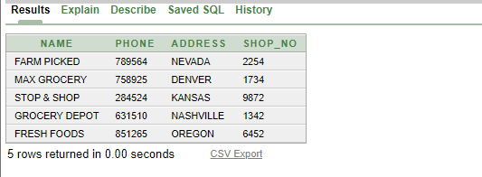

**Employee Table:**

1. INSERT INTO EMPLOYEE VALUES (73124,'NATHAN', '11-NOV-1978', 1000, 'NEVADA', 567812, 2254);

2. INSERT INTO EMPLOYEE VALUES (75435,'DRAKE', '07-JUN-1984', 800, 'DENVER', 786421, 1734);

3. INSERT INTO EMPLOYEE VALUES (98767,'AURTHUR', '13-JAN-1987', 1400, 'KANSAS', 167598, 9872);

4. INSERT INTO EMPLOYEE VALUES (90762,'MORGAN', '26-SEP-1978', 1100, 'NASHVILLE', 753892, 1342);

5. INSERT INTO EMPLOYEE VALUES (69875,'RHEA', '27-JUN-1978', 1700, 'OREGON', 432114, 6452);

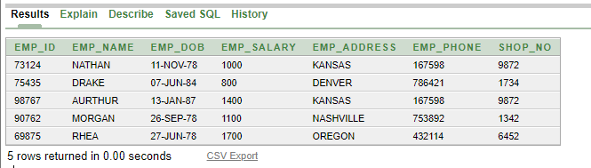

**Supplier Table:**

1. INSERT INTO SUPPLIER VALUES (67481,'JAKE', 875168);

2. INSERT INTO SUPPLIER VALUES (89571,'GYLLENHAAL', 567122);

3. INSERT INTO SUPPLIER VALUES (97056,'ROBERT', 751123);

4. INSERT INTO SUPPLIER VALUES (76233,'NIRO', 880751);

5. INSERT INTO SUPPLIER VALUES (57122,'JACKMAN', 751282);

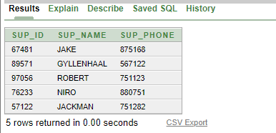

**Product Table:**

1. INSERT INTO PRODUCT VALUES (8934,'NICHE', 'T-Shirt', 10, 'Made In VIETNAM', 100.00, 6, 67481);

2. INSERT INTO PRODUCT VALUES (4122,'LUXURY', 'PERFUME', 200, 'Made In FRANCE', 500.00, 8, 89571);

3. INSERT INTO PRODUCT VALUES (5791,'CONSUMER', 'BUTTER', 5, 'Made In INDIA', 500.00, 12 , 97056);

4. INSERT INTO PRODUCT VALUES (7589,'COMMODITIES', 'OIL', 2, 'Made In BRAZIL', 1000.00, 10, 76233);

5. INSERT INTO PRODUCT VALUES (8591,'CONVENIENCE', 'SOFT DRINK', 3, 'Made In AUSTRIA', 25.00, 7, 57122);

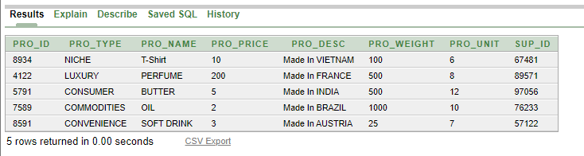

**Customer Table:**

1. INSERT INTO CUSTOMER VALUES (3612,'AEGON', 12412, 'aegon@.com', 'KANSAS');

2. INSERT INTO CUSTOMER VALUES (5142,'ALLEN', 41242, 'allen@.com', 'DENVER');

3. INSERT INTO CUSTOMER VALUES (7491,'BEN', 63463, 'ben@.com', 'NEVADA');

4. INSERT INTO CUSTOMER VALUES (9755,'DAVID', 76518, 'david@.com', 'NASHVILLE');

5. INSERT INTO CUSTOMER VALUES (9763,'RABIOT', 75912, 'rabit@.com', 'OREGON');

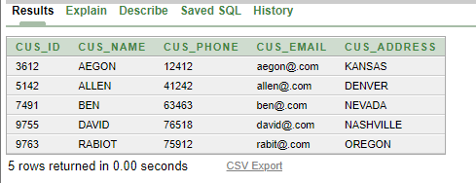

**Payment Table:**

1. INSERT INTO PAYMENT VALUES (4124, '15-JUN-2009', 7, 'PAID', 7491);

2. INSERT INTO PAYMENT VALUES (6741, '21-JUN-2009', 17, 'PAID', 3612);

3. INSERT INTO PAYMENT VALUES (8791, '08-JUN-2009', 90, 'DUE', 5142);

4. INSERT INTO PAYMENT VALUES (4742, '19-JUN-2009', 67, 'PAID', 9763);

5. INSERT INTO PAYMENT VALUES (8091, '29-JUN-2009', 45, 'DUE', 9755);

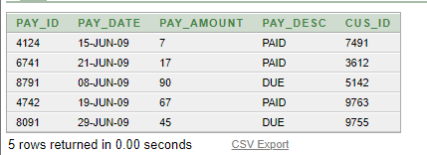

**Purchase Table:**

1.INSERT INTO PURCHASE VALUES (3612,8934);

2. INSERT INTO PURCHASE VALUES (5142,4122);

3.INSERT INTO PURCHASE VALUES (7491,5791);

4. INSERT INTO PURCHASE VALUES (9755,7589);

5. INSERT INTO PURCHASE VALUES (9763,8591);

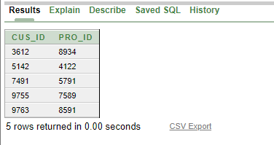

**Sells to Table:**

1. INSERT INTO SELLSTO VALUES (3612,2254);

2. INSERT INTO SELLSTO VALUES (5142,1734);

3. INSERT INTO SELLSTO VALUES (7491,9872);

4.INSERT INTO SELLSTO VALUES (9755,1342);

5.INSERT INTO SELLSTO VALUES (9763,6452);

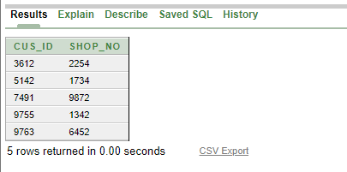

**Consists Table:**

1. INSERT INTO CONSISTS VALUES (2254,8934);

2. INSERT INTO CONSISTS VALUES (1734,4122);

3. INSERT INTO CONSISTS VALUES (9872,5791);

4. INSERT INTO CONSISTS VALUES (1342,7589);

5. INSERT INTO CONSISTS VALUES (6452,8591);

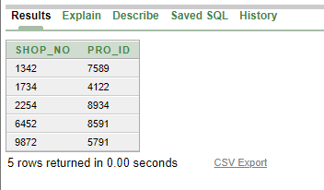

**Screenshots After Inserting Data:**

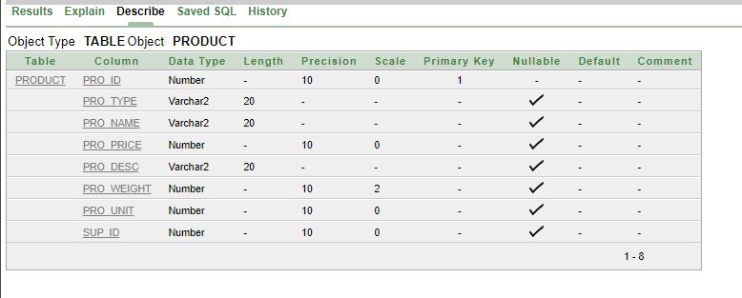

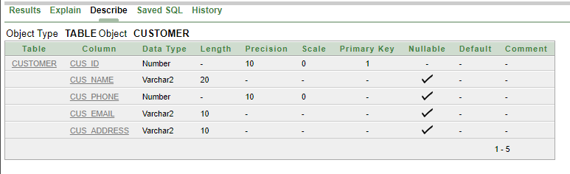

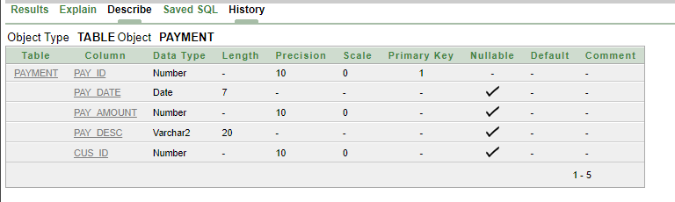

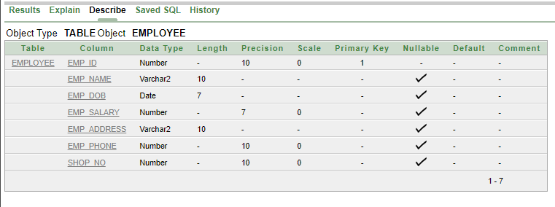

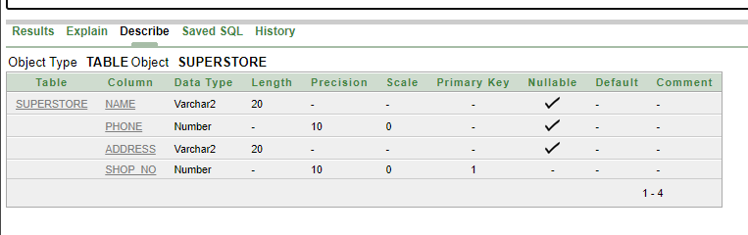

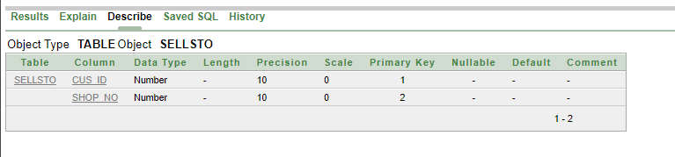

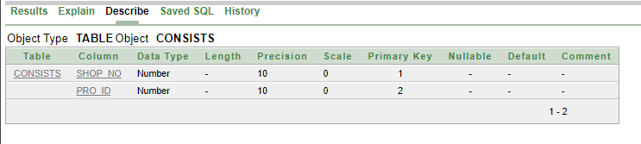

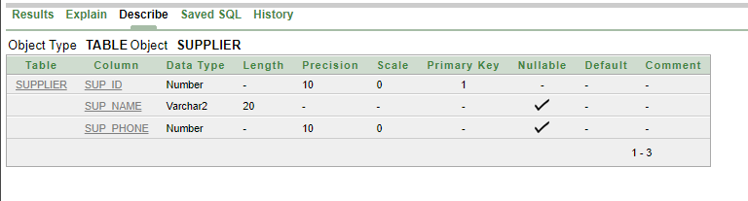

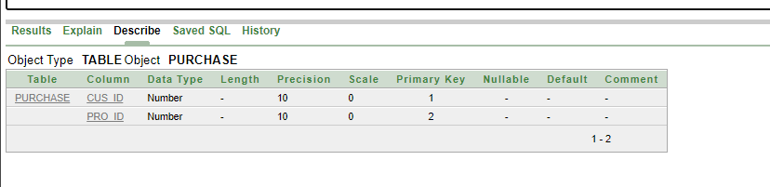

**Query Writing:**

**SINGLE ROW FUNCTION**

**QUES 1.** Display only the column Employee salary from EMPLOYEE table for employee “DRAKE”

**Query:**

SELECT EMP_SALARY

FROM EMPLOYEE

WHERE EMP_NAME = 'DRAKE';

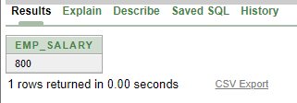

**QUES 2.** Determine age of all employess in Weeks.

**Query:**

SELECT EMP_NAME, ROUND((SYSDATE-EMP_DOB)/7,2) WEEKS

FROM EMPLOYEE

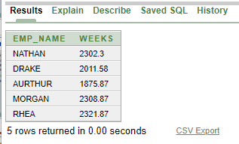

**GROUP FUNCTION**

**QUES 1.** Display average product price, max product price, minimum product price from Product table

**Query:**

SELECT AVG(PRO_PRICE), MAX(PRO_PRICE), MIN(PRO_PRICE)

FROM PRODUCT

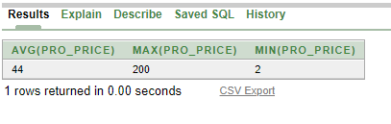

**QUES 2**. Display employee name, employee salary, employee address who have salary more than 1000, in descending order

**Query:**

SELECT EMP_NAME, EMP_SALARY, EMP_ADDRESS

FROM EMPLOYEE

WHERE EMP_SALARY> 1000

ORDER BY EMP_SALARY DESC

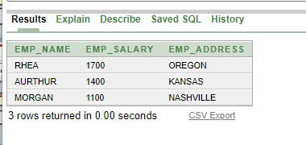

**SUB-QUERY:**

**QUES 1.** Select product name from Product table which has more price than Butter using subquery.

**Query:**

SELECT PRO_NAME

FROM PRODUCT

WHERE PRO_PRICE>

(SELECT PRO_PRICE

FROM PRODUCT

WHERE PRO_NAME='BUTTER');

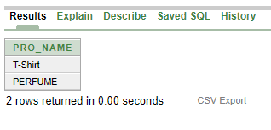

**Ques 2:**

Display customer name from customer table where customer id is 9763 using subquey.

SELECT CUS_NAME

FROM CUSTOMER

WHERE CUS_ADDRESS =

(SELECT CUS_ADDRESS

FROM CUSTOMER

WHERE CUS_ID= 9763);

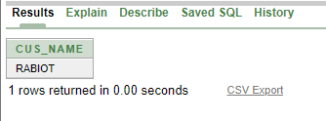

**JOINING:**

**QUES 1**

Display Product name, Product price, supplier name, supplier id from Product and supplier table using equijoins.

**Query:**

SELECT PRODUCT.PRO_NAME, PRODUCT.PRO_PRICE, SUPPLIER.SUP_NAME, SUPPLIER.SUP_ID

FROM SUPPLIER, PRODUCT

WHERE SUPPLIER.SUP_ID=PRODUCT.SUP_ID;

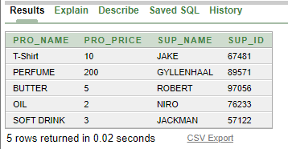

**QUES 2.**

Query Display workplace of all employee using joining method.

SELECT EMPLOYEE.EMP_NAME||' works at '||SUPERSTORE.ADDRESS

FROM EMPLOYEE, SUPERSTORE

WHERE EMPLOYEE.SHOP_NO = SUPERSTORE.SHOP_NO;

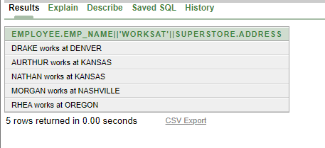

**Creating View:**

**Ques 1 .**

Create a view Payment10, which contains Payment amount, payment id,customer id for due payment description,

Query

CREATE VIEW Payment10

AS SELECT PAY_Amount, PAY_ID, CUS_ID

FROM PAYMENT

WHERE PAY_DESC ='DUE';

select *

from Payment10

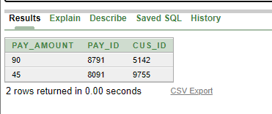

**Ques 2.**

Create a view Employee10, which contains Employee name, Employee Date of Birth, Employee Address for employees who have salary more than 1500.

**Query:**

CREATE VIEW employee10 AS SELECT EMP_NAME,EMP_DOB,EMP_ADDRESS FROM EMPLOYEE

WHERE EMP_SALARY <1500;

select *

from employee10

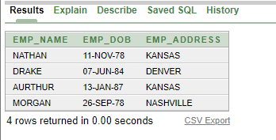

**Relational Algebra:**

1. Fine the employee’s name where EMP_ID = 73124

**Ans: emp_name (emp_id=”Nathan”())**

2. Fine the product type where PRO_NAME = Butter

**Ans: PRO_TYPE (PRO_TYPE=””(CONSUMER))**

3. Find the supplier phone number where SUP_NAME = ROBERT

**Ans: SUP_PHONE (SUP_PHONE=””(751123))**

4. Find the payment date where PAY_ID = 4742

**Ans: PAY_DATE (PAY_DATE=””(19-JUN-09))**

5. Find the superstore name where SHOP_NO = 1342

**Ans: NAME (NAME=””(GROCERY DEPOT))**

**Conclusion**

This project helped us understand how to efficiently handle large amounts and multiple types of data. We have also learned how SQL works, structure information, and analyze them ourselves. If we're looking to the future, we obviously want to invest our time in looking deeper into database management that's still widely used and will continue to be in the years to come.