One image in the header and other one in the body of the document:

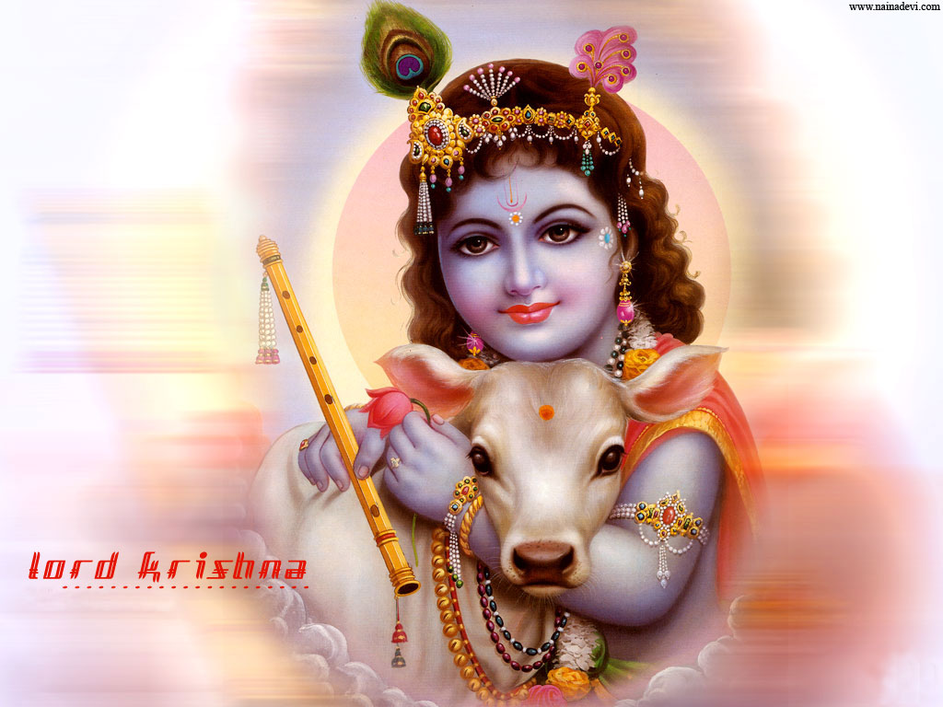

This document has been generated with a **trial** copy of **PHPDocX**. Please, visit the **[PHPDocX website](http://www.phpdocx.com)** to buy the license that best adapts to your needs.