Expression of interest (EoI)

Briefing document

For

**Test One**

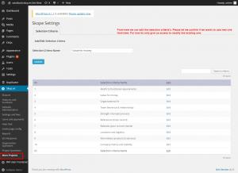

sdsfds

#520

Chandigarh, test, 160048

26 March 2015

Nipun

Table of Contents

Introduction

About this document

About sdsfds

Key project Objectives

Project Scope

Milestones and timelines

# Introduction

## About this document

This document has been created to brief you and your organisation on our pending project and to ascertain your level of interest in participating in its delivery.

The document is only intended as a high level brief, full and detailed project documentation will be supplied to you soon, including functional requirements, should you wish to provide a quotation for the delivery of the project.

## About sdsfds

There are no mission just wants to kill the tension.

## Key project Objectives

Go on & move on the height of success.

# Project Scope

Currently we have identified a number of high level functional areas that we require the project to deliver upon. There are total **1** functional areas.

Future documentation will include a drill down into each of these areas, specifying a list of features within each.

Contact Database  
  
In almost all membership system builds, whether on or off line, the contact database is a central feature. It is mandatory to the implementation of a working membership system.  
  
 Your contact database records information on all of your constituency, independent of their relationship to your organisation. These attributes (for example, subscriber, current member, committee member) all refer back to the central contact database.  
  
 A list of functional line items are provided below for you to include or exclude and to provide a ranking of importance for your project.  
  
 Contact database features include:  
 - Adding new contact details  
 - Managing and editing contacts and status  
 - Manage access and user permissions

# Milestones and timelines

The project duration is expected to be **731** days.

* The intended start date is: **25 March 2015**
* The target completion date is: **25 March 2017**

The project will include key milestones, these will help us monitor and keep the project on time and budget. The milestones are not finalised, but are likely to include:

|  |  |  |
| --- | --- | --- |
| Milestone No. | Milestone name | Date |
| 1 | Project Commencement | 25 March 2015 |
| 2 | Supplier engaged | 18 March 2017 |
| 3 | Supplier engagedsdfsf | 23 June 2015 |
| 4 | Project Completion | 25 March 2017 |