Received: 15 July 2023 Revised: 7 May 2024 Accepted: 3 June 2024
IET Intelligent Transport Systems

DOI: 10.104t/itr2.12521

ORIGINAL RESEARCH

A multi-agent deep reinforcement learning approach for traffic signal coordination

Ta-Yin Hu Zhuo-Yu Li

Department oF Transportation and Communication Management Science, National Cheng Kung University, Tainan, R.O.C. Taiwan

Correspondence
Ta-Yin Hu, Department oF Transportation and Communication Management Science, National Cheng Kung University, Tainan, Taiwan, R.O.C. Email: tayinhu@gmail.com

Funding information National Science and Technology Council, Taiwan, Grant/Award Number: 108-2410-H-00G-078-MY3

Abstract
The purpose oF signal control is to allocate time For competing traFfic flows to ensure saFety. Artificial intelligence has made transportation researchers more interested in adap- tive traFfic signal control, and recent literature confirms that deep reinForcement learning (DRL) can be eFFectively applied to adaptive traFfic signal control. Deep neural networks enhance the learning potential oF reinForcement learning. This study applies the DRL method, Double Deep Q-Network, to train local agents. Each local agent learns inde- pendently to accommodate the regional traFfic flows and dynamics. AFter completing the learning, a global agent is created to integrate and uniFy the action policies selected by each local agent to achieve the purpose oF traFfic signal coordination. TraFfic flow conditions are simulated through the simulation oF urban mobility. The benefits oF the proposed approach include improving the eFficiency oF intersections and minimizing the overall average wait- ing time oF vehicles. The proposed multi-agent reinForcement learning model significantly improves the average vehicle waiting time and queue length compared with the results From PASSER-V and pre-timed signal setting strategies.

INTRODUCTION
SaFety is the Fundamental core oF traFfic management. TraFfic operators allocate time to traFfic flow in diFFerent directions through traFfic signal control to ensure the saFety oF all road users and improve the overall traFfic system [1]. Taiwan’s traFfic environment is extremely complicated, with dense intersec- tions and mixed vehicles in the city. Road users may waste excess time at the red light because there are Few vehicles on the minor street. However, with the progress oF technolo- gies and communications, road condition detection equipment such as vehicle detectors (VD) and closed-circuit television (CCTV), responsive and actuated signal control systems are applied in practice to solve the above problems by detecting the number oF vehicles on arterial roads and minor streets and adjusting the duration oF phase split to improve the opera- tional eFficiency oF the intersection [2]. UnFortunately, although the eFficiency oF intersections has increased to some extent, it can still not Fully meet the dynamic variations oF traF- fic flows. It is still based on large manual calibration and assumptions [3].
Recently, with the progress oF AI, transportation researchers have been paying more attention to adaptive traFfic signal regu- lation [4]. Through powerFul neural networks and algorithms, Fewer devices can be used to optimize signal control. Adap- tive traFfic signal control perForms edge calculations and adjusts phase split in real-time by collecting real-time traFfic data to avoid traFfic gridlock caused by sudden changes in traFfic flow [5]. Many countries are actively developing adaptive signal con- trol at present. In particular, recent literature confirms that deep reinForcement learning (DRL) can be eFFectively applied to adaptive signal control [G]. In addition, the metropolitan area oF Taiwan is densely populated. The main intersections are not Far away From the adjacent intersections. Managers oFten set up traFfic signal coordination to provide drivers with the eFFects oF continuous driving, such as progressive and simultaneous sys- tems [7]. This study aims to apply DRL to train the local agent at each intersection in short street profiles. It also designs a global agent to integrate its action policies For traFfic signal coordi- nation to provide continuous traFfic flows For traFfic arterials. Numerical experiments are conducted to veriFy and compare the eFFectiveness oF the models.

This is an open access article under the terms oF the Creative Commons Attribution-NonCommercial-NoDerivs License, which permits use and distribution in any medium, provided the original work is properly cited, the use is non-commercial and no modifications or adaptations are made.
© 2024 The Author(s). IET Intelligent Transport Systems published by John Wiley & Sons Ltd on behalF oF The Institution oF Engineering and Technology.
1428 wileyonlinelibrary.com/iet-its
IET Intell. Transp. Syst. 2024;18:1428–1444.

Contributions oF this study include: (1) the DDQN-based DRL algorithm is used to construct multiple agents in the traFfic arteries For dense and closely connected intersections and (2) a reward mechanism with penalties For minor streets is proposed. The multiple local agents are controlled through a global agent to achieve more eFficient signal coordination.
The paper is organized as Follows: The literature review is given in the next section; the methodologies are described in Section 3. Experiment settings are discussed in Section 4. The results oF the experiment are explained in Section 5. The conclusions and suggestions are presented in the last section.

LITERATURE REVIEW
With the advancement oF AI, adaptive signal control has attracted the attention oF transportation researchers. Through powerFul neural networks and algorithms, adaptive signal control can use Fewer devices to optimize signal control, over- coming the disadvantage oF not considering an intersection’s overall traFfic flow characteristics. In particular, much literature confirms that RL can be eFFectively applied to adaptive traFfic signal control recently [8].
RL has become a popular AI technique, and the most com- monly used method is Q-learning [t]. However, RL has a curse oF dimensionality. It cannot deal with the problem oF too large state spaces because the calculation process will become too complicated [10]. ffortunately, RL is very scalable and com- patible with deep learning. Deep neural networks have been used successFully to improve the ability to learn RL to solve the dimensional curse problem, and they are called DRL [11]. Unlike RL, the environment provides the state to the agent as the input layer oF the neural networks. Through neural net- work processing, the values corresponding to the action are output in the output layer For the agent to choose [12]. One oF the essential advantages oF DRL is that high-quality results can be provided exceptionally Fast once the DRL agent has been trained.
Mnih et al. [11] proposed the method oF Deep Q-Network, which has been widely applied in traFfic signal control. Due to the compatibility oF RL and deep neural networks, many pieces oF research currently use RL combined with various neural net- work models For traFfic signal control, such as convolutional neural networks (CNN). It can quickly evaluate visual inForma- tion and employ convolutional layers to map each state-action combination to a value, allowing them to determine the opti- mum action policy For every state [13–15]. With the success oF the Deep Q-Network algorithm, many extended algorithms have also been applied to traFfic signal control. Based on the microscopic approach, these studies use simulation soFtware to simulate traFfic conditions.
Even though deep neural networks have enhanced the RL’s scalability, it is inFeasible to train a centralized agent For a wide range oF traFfic signal control. In practice, this central- ized state processing will result in high latency and Failure rates and the loss oF traFfic network inFormation. ThereFore, it is eFficient to use DRL with multiple agents For traFfic signal con-
trol by distributing the global control to each local agent. To achieve coordination among multiple intersections, Van der Pol and Oliehoek [1G] extended a single-agent solution to multiple agents’ settings. Recently, the application oF DRL methods with multiple agents to traFfic signal control has become increasingly popular, and each extensive study has good research results. Wiering [17] integrated Q-learning into a multi-agent model For a small traFfic grid to operate signal controls. Using a Deep Q- Network in a coordination algorithm is a promising method For multi-agent DRL [1G]. Prabuchandran et al. [18] propose using tabular Q-learning to manage several traFfic signals on neigh- boring junctions to maximize traFfic flow. Each agent consults the local observations, including the number oF queue lengths, determines the green light duration, and shares the queue length with neighbors. Each agent’s cost is the average oF its neighbors’ queue lengths, so it strives to keep its own and its neighbors’ queue lengths as short as possible. Gu et al. (2020) employed a Double Deep Q-Network to reduce congestion at a Four-phase signalized intersection eFficiently. Still, the curse oF dimension- ality prevented it From being deployed For large-scale signal control. Houli et al. [1t] use the Q-learning algorithm to train multiple agents For traFfic signal control and consider three types oF traFfic conditions For experiments, including low, medium, and congested.
Multi-intersection modelling problems have attracted increasing attention. Because each agent’s actions directly impact the other agents, cooperation among the agents is criti- cal in the traFfic signal management problem. A large amount oF real-time traFfic data is collected, and it should be possible For agents to share and connect appropriately. Intersections may cause traFfic chaos due to inter-agent interFerence, so proper cooperation mechanisms are needed to improve perFormance. Chu et al. [20] propose MA2C, a completely cooperative system in which each junction trains an individual agent to share observations with neighbour agents. Instead oF just Focusing on their intersections, local agents have inFormation about traFfic in the area to make better decisions about traFfic flow. The results show that sharing local inFormation among agents at various intersections is helpFul. Tan et al. [21] used the actor-critic method with multiple agents For large-scale traFfic signal control. They proposed a method oF cooperative DRL to create a global agent to integrate several regional agents. The reward Function considers the queue length and the number oF moving vehicles on the route. The goal is to reduce the total queue length and waiting time.
Li et al. [22] researched intersections with unbalanced traFfic conditions. They Found that the Proximal Policy Optimiza- tion algorithm significantly reduces traFfic metrics compared to fixed-time control, decreasing the average waiting time by G2.5% and shortening the travel time by 47.5%.
An and Zhang [23] applied a modified PPO and indicated that the model generated by the proposed algorithm exhibits a G8.3% increase in cumulative reward and a G5.3% decrease in average waiting time when contrasted with the baseline DQN model.
BouktiF et al. [24] discussed that most DRL applications in TSC rely on selF-defined states and rewards For model training;

however, these proposed approaches restrict the reinForce- ment learning agent’s ability to choose the optimal behaviour. BouktiF et al. [24] proposed consistently designing states and rewards to enhance the agent’s learning perFormance. This study employed the DDQN algorithm with the prioritized experience replay method (PER), increasing the probability oF experiences being sampled based on their importance. The research Found that consistently designing states and rewards can enhance training stability, allowing the model to converge quickly to the best strategy. This approach reduced travel time From 1G% to 45%.
Canh et al. [25] introduce a SAC algorithm For a three- way crossroad environment. The proposed algorithm perForms superiorly compared to the other algorithms, including PPO, Twin Delayed Deep Deterministic Policy Gradient (TD3), and Deep Deterministic Policy Gradient (DDPG) when evalu- ated in the signal optimization simulation environment at the three-way crossroad.
Yu et al. [2G] described that ineFficient traFfic signals and bus headway control strategies can lead to significant prob- lems, including traFfic congestion, bus passenger delays, and bus crowding. ThereFore, Yu et al. [2G] aimed to manage traF- fic flow at intersections within large-scale networks, solving the challenge oF integrating various objectives. At each decision step, the agents strive to achieve two objectives simultaneously: reducing the total stopping time For vehicles and equalizing the space headways ahead oF and behind buses when they approach intersections. This study employs the Deep Q-Network (DQN) algorithm to navigate the challenges oF a continuous state space, with a principal Focus on achieving uniForm bus traF- fic via traFfic signal control, all while maintaining traFfic eFficiency.
While a considerable body oF research has advanced the field oF large-scale traFfic signal control utilizing multi-agent deep reinForcement learning, most oF these studies have con- centrated on the nuanced scenario oF mastering arterial traFfic signal control. The arterial traFfic control problem, character- ized by a large state-action space, presents significant obstacles in eFficiently extracting pertinent inFormation and navigating the solution space. Mao et al. [27] proposed the MASAC model, which integrates an attention mechanism into actor and critic networks to bolster traFfic inFormation extraction. The atten- tion mechanism, a pivotal deep learning technique, is engineered to enhance the model’s perFormance in processing sequence data by allowing it to dynamically Focus on specific segments oF the input data at each step oF its operation. This approach ensures the model Focuses on essential inFormation, side-lining the irrelevant.
As mentioned in the previous sections, there are many diFFerent DRL algorithms with various neural networks to train agents and use various methods to integrate multi- ple agents For eFficient traFfic signal control, demonstrating its eFFectiveness and scalability. This study adopts a Double Deep Q-Network algorithm to construct multiple agents For traFfic signal coordination. Consider diFFerent traFfic condi- tions For experiments, including low, normal, congested, and unbalanced.

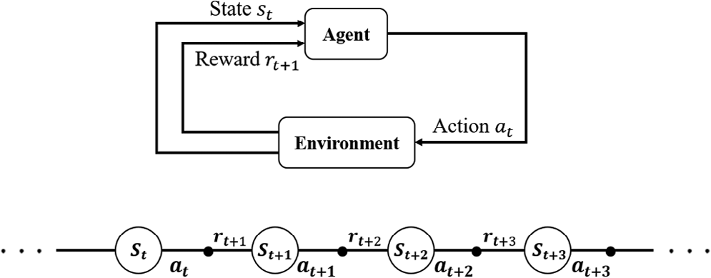

FIGURE 1 ReinForcement learning process. a_{t}, action at time t; r_{t}, reward at time t; s_{t}, stae variable at timestep t.

RESEARCH METHODOLOGY

Reinforcement learning algorithm
ReinForcement learning (RL) is a machine learning method that does not require labelled input and output pairs. The agent learns through interaction with the environment to maximize the expected benefits. RL is to solve the Markov decision pro- cess. This process usually consists oF three elements, including state s, action a, and reward r . An RL agent receives a state s_{t} From the environment at timestep t and takes action a_{t} . Then, the environment transitions to the next state s_{t} ₊₁ and Feedback a reward r_{t} ₊₁ to the agent. Briefly speaking, the system that uses state s_{t} and action a_{t} to determine the next state s_{t} ₊₁ is called the Markov decision process. ffigure 1 shows a schematic diagram oF the RL process.
The goal oF the agent is to maximize the expected cumulative reward. AFter continuous trial and Failure, the best action pol- icy can be gradually chosen For diFFerent environments. In the process, the environment also rewards the actions selected by the agent to judge the contribution oF the action to the environ- ment. ffor the agent to maximize cumulative reward From the environment, in addition to the current reward, Future rewards also need to be considered and discounted by a discount Factor,
𝛾. The cumulative reward G_{t} at each timestep t can be written as Equation (1),
∑∞
Gt = rt +1 + 𝛾rt +2 + 𝛾2rt +3 + 𝛾3rt +4 + ⋯ = 𝛾krt +k+1 (1)
k=0

where r_{t} ₊₁ is the reward at time step t +1, 𝛾 ∈ [0, 1) is the discount Factor.
Q-learning is a value-based RL algorithm first proposed by Watkins and Dayan [t]. The principal idea is to create a Q-table to store the Q-values, and the agent chooses the action policy that can get the largest benefit based on the Q-values. The Q- value oF a_{t} in the s_{t} is called Q(s_{t} , a_{t} ). We only need to use the solution oF the action-value Function to find the best solution indirectly. As shown in Equation (2).

Q(s_{t} , a_{t} ) = r_{t} ₊₁ + 𝛾max Q(s_{t} ₊₁, a) (2)
a

RL algorithms revolve around temporal-diFFerence (TD) learning and can learn From experience directly. Like the

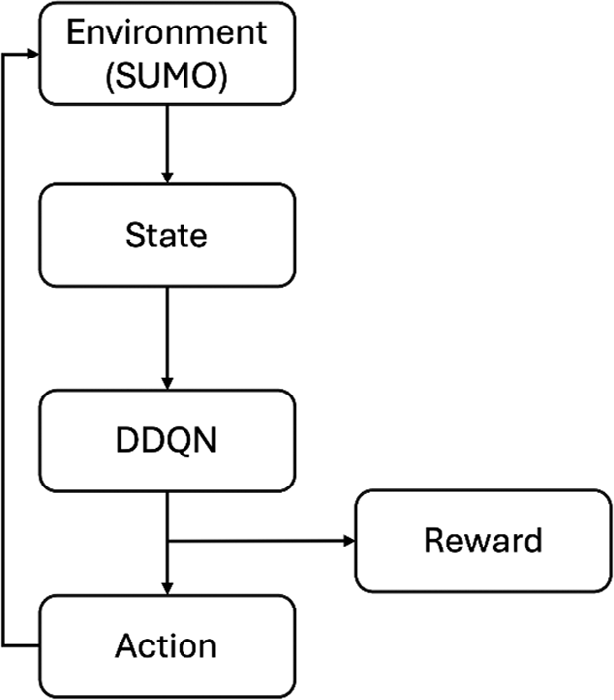

FIGURE 2 A conceptual Framework For the proposed process.

dynamic programming method, it can improve current esti- mating findings without waiting For the entire event to end. However, in the learning process, it is impossible to find the action-value Function, so the mathematical relation oF Equa- tion (2) is invalid. At this time, the diFFerence in the above mathematical relation is the temporal-diFFerence error δ. When δ is 0, the action-value Function has completed the learning. The temporal-diFFerence error is shown in Equation (3).

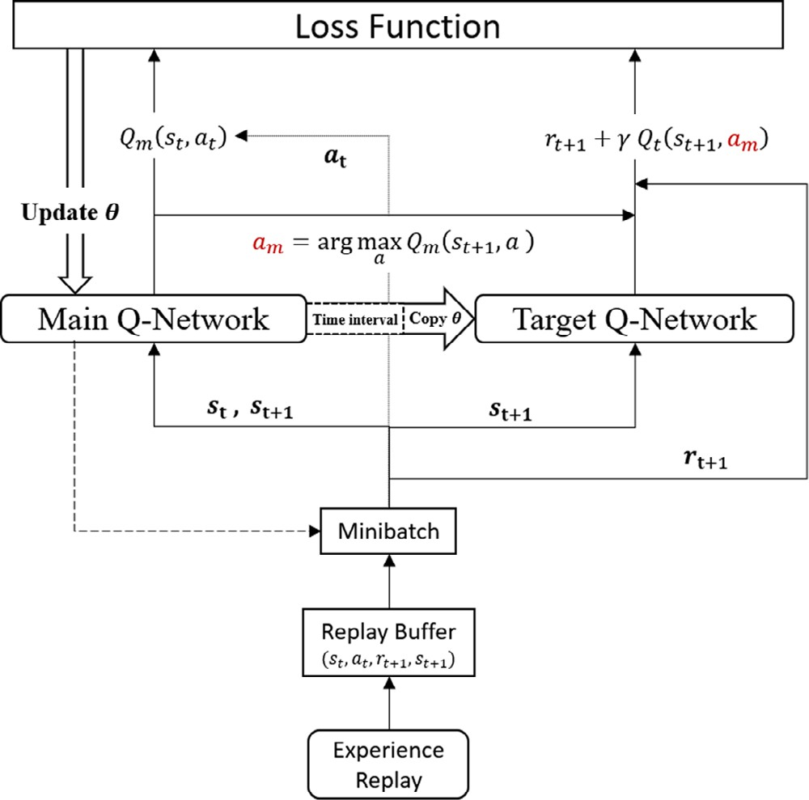
FIGURE 3 Double deep Q-network update process. a_{t}, action at time t;
r_{t}, reward at time t; s_{t}, stae variable at timestep t.

Equation (5)
(
a

𝛿 = r_{t} ₊₁ + 𝛾max Q(s_{t} ₊₁, a) − Q(s_{t} , a_{t} ) (3) Value-based RL algorithm is an iterative method based on
a
Q_{m} (s_{t} , a_{t} ) = Q_{m} (s_{t} , a_{t} ) + 𝜂
)
− Q_{m} (s_{t} , a_{t} )
r_{t} ₊₁ + 𝛾max Q_{t} (s_{t} ₊₁, a)

(5)

the Bellman equation. It iterates using the old value and the
estimated value in the Future. The update Formula oF the action-value Function Follows Equation (4),

Q(s_{t} , a_{t} ) = Q(s_{t} , a_{t} ) + 𝜂(r_{t} ₊₁ + 𝛾max Q(s_{t} ₊₁, a) − Q(s_{t} , a_{t} ))
a
(4)
where η ∈ [0,1) is a learning rate, which is a parameter to determine the size oF each iteration step at each iteration while moving toward the minimum loss Function.

Deep reinforcement learning algorithm
Deep reinForcement learning (DRL) combines deep learning and the RL algorithm. One oF the important algorithms oF DRL is Deep Q-Network, proposed by Mnih et al. [11]. It inputs all state Features into the deep neural network and outputs the value oF each action in the output layer. The interrela- tionship among the input, output, and DDQN is illustrated in ffigure 2.
In addition to the original Main Q-Network, Q_{m}, the target network technique is applied to create a Target Q-Network, Q_{t} . When calculating the error, the Target Q-Network estimates action values with the Future state, and the Main Q-Network determines the action policy. The updated Formula oF the Deep Q-Network action-value Function is shown in the Following
where Q_{m} (s_{t} , a_{t} ) represents the value oF action policy a_{t} output by the Main Q-Network in the state s_{t} and Q_{t} (s_{t} ₊₁, a) represent the values oF actions a output by the Target Q-Network in the state s_{t} ₊₁. 𝜂 is a learning rate to determine the size oF each iter- ation step while progressing toward the least loss Function at each iteration. 𝛾 is a discount Factor in determining the extent to which Future rewards aFFect current rewards
Van Hasselt et al. (201G) proposed a Double Deep Q- Network to extend the algorithm oF the Deep Q-Network. All state Features are inputted into the deep neural network and out- put the value oF each action in the output layer. The core oF the Double Deep Q-Network is that its maximum estimated action value is generated together using two neural networks. The updated Formula oF the Double Deep Q-Network action-value Function is shown in Equations (G) and (7),
a_{m} = arg max Q_{m} (s_{t} ₊₁, a) (G)
a

Q_{m} (s_{t} , a_{t} ) = Q_{m} (s_{t} , a_{t} ) + 𝜂(r_{t} ₊₁ + 𝛾Q_{t} (s_{t} ₊₁, a_{m} ) − Q_{m} (s_{t} , a_{t} )) (7)
where a_{m} is the action index oF the maximum action value output by the Main Q-Network in the state s_{t} ₊₁.
The Double Deep Q-Network update process, as shown in ffigure 3, is similar to Deep Q-Network. s_{t} is inputted into the Main Q-Network and outputs the action values. Accord- ing to the a_{t} , an actual value can be obtained, Q_{m} (s_{t} , a_{t} ). The

diFFerence is that. s_{t} ₊₁ is inputted into the Main Q-Network first and outputs the action values. Select the maximum Q_{m} (s_{t} ₊₁, a) to get the action index, a_{m}. Then, s_{t} ₊₁ is also inputted into the Target Q-Network and the Q_{t} (s_{t} ₊₁, a_{m} ) can be obtained according to the a_{m}. Multiply Q_{t} (s_{t} ₊₁, a_{m} ) by the discount Factor and the r_{t} ₊₁ to get an estimated value. ffinally, the actual value and estimated value are inputted together with the learning rate into the loss Function to update the parameters oF the Main Q-Network. Besides, a time interval is set so that the Target Q-Network replicates the parameters oF the Main Q-Network at regular intervals. This update process continues until all the contents oF the minibatch are rounded once.

Deep reinforcement learning stabilization techniques
The experience replay technique is widely used to improve the stability oF parameter learning in DRL. Generally, the neural net- work continuously learns content highly related to time. The closer the time, the more similar the content is, so the neural net- work cannot stably learn the parameters. ThereFore, DRL algo- rithms combine with experience replay techniques to solve the above problem. ffirst, the agent’s experience content is stored in a replay buFFer. Then, a random sample minibatch oF experience contents From the replay buFFer will be used to train the neural networks to destroy the timing relationship between contents.
In addition, the Target Network technique is used to create a new neural network, Target Q-Network, in addition to the original neural network, Main Q-Network. The architectures oF the two neural networks are the same, but the parameters are diFFerent. The reason is that the Target Q-Network updates its parameters later than the Main Q-Network. When calculat- ing the error, use the Target Q-Network with older parameters instead oF the Main Q-Network to estimate the actions’ values to maintain the learning stability. A suitable update interval can even make training stable and Fast. In short, in the value-based

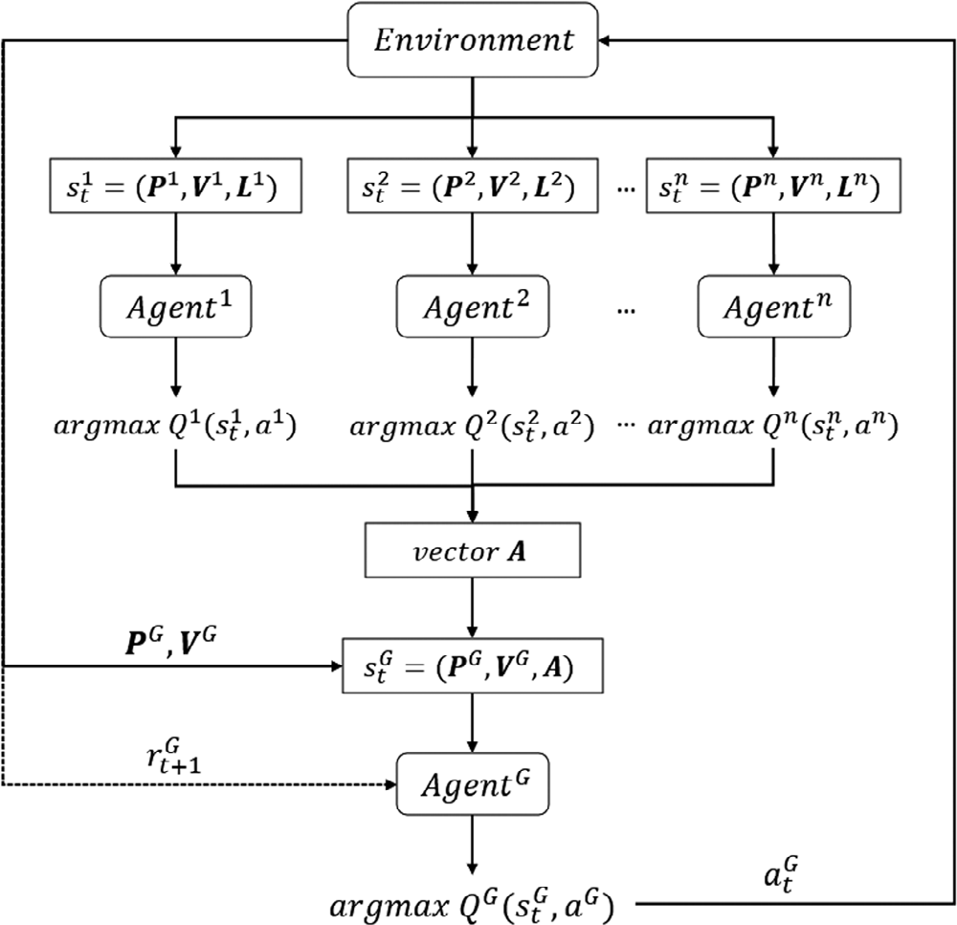

FIGURE 4 Deep reinForcement learning with multiple agents. a_{t}, action at time t; r_{t}, reward at time t; s_{t}, stae variable at timestep t.

s^{n}, including the matrix oF local vehicle position P, the matrix oF local vehicle speed V , and the vector oF the local current traF- fic light L, and outputs action values according to the state oF the intersection. Our goal is to achieve simultaneous systems oF traFfic signal coordination so that the traFfic signals on the arterial road can switch the green light simultaneously and allow vehicles to pass continuously. ThereFore, it is necessary to col- lect the action policies by the local agents at each intersection and integrate them into a global action policy so that all local agents perForm the same action policy.
t
A global agent is created to coordinate local agents. ffirst, integrate the action policies output by each local agent into a
vector A. The global agent collects global traFfic inFormation s^{G}

DRL algorithm process, the Main Q-Network is responsible
For determining the action policy, and the Target Q-Network
as input, including the matrix oF global vehicle position P
t
, global

is responsible For estimating the values oF the actions when calculating the error.
The agent is sometimes fixed by the randomly generated ini- tial value oF the action-value Function, resulting in subsequent Failure to learn correctly. ThereFore, deep reinForcement learn- ing adopts the epsilon-greedy (𝜖-greedy) technique to solve this problem, where 𝜖 is the probability oF choosing exploration,
𝜖 ∈ [0, 1). The agent has a probability oF 𝜖 to choose an action policy randomly and a probability oF 1−𝜖 to choose the action policy with the greatest value. The mechanism allows the agent to try new actions so that the action-value Function can learn in the right direction.

Deep reinforcement learning with multiple agents
Since the traFfic characteristics oF each intersection are diFFerent, this study utilizes the DRL to train a local agent For each inter- section. The trained local agent collects local traFfic inFormation
vehicle speed V , and the vector oF local agents’ action policies
A. Since the global agent needs to observe many state Features, pooling layers are used to reduce the dimensionality. Then, the global agent selects the global action policy with the greatest value so that all agents simultaneously Follow and switch the traFfic phase. AFter executing the action policy, the global reward is calculated and used to train the global agent. The method oF training the global agent is the same as the DRL algorithm used by the local agent. The global agent training process is shown in ffigure 4, where superscript represents the agent number, and subscript represents the timestep.

Traffic simulator
The traFfic simulator, simulation oF urban mobility (SUMO), provides a graphical interFace and basic Functions to simulate dynamic and static objects in traFfic, such as vehicles, roads, signals, and markings. Adjust various parameters to control the operation mode and characteristics oF internal objects For

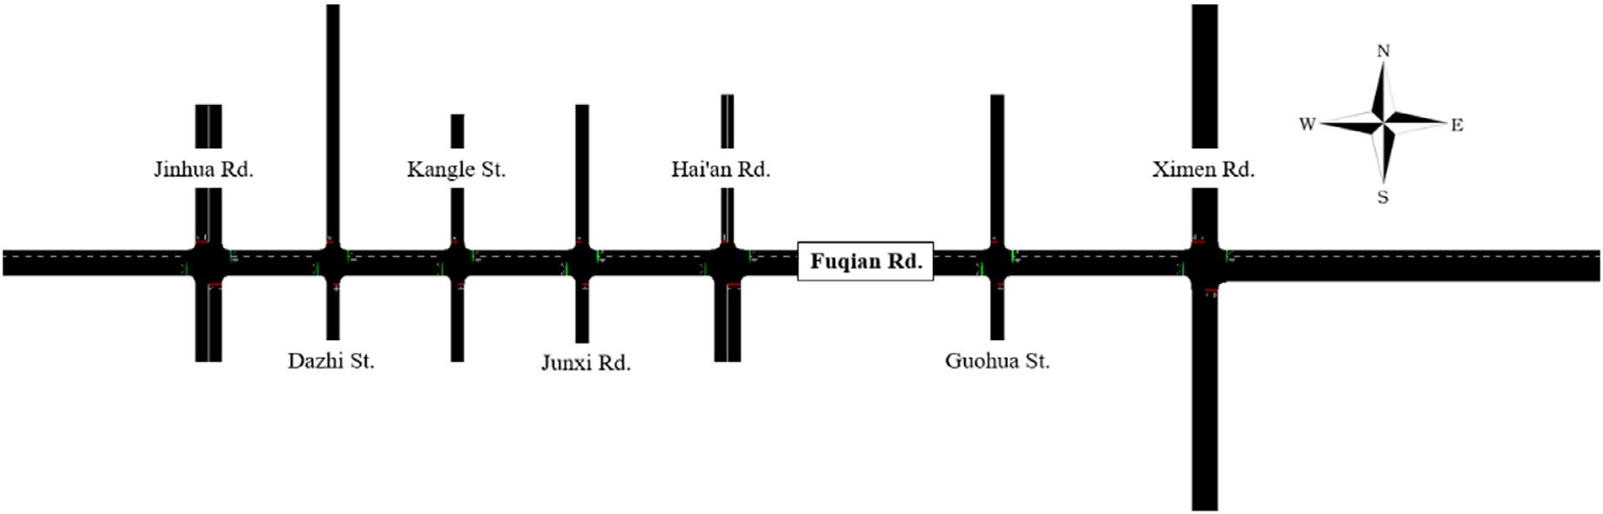

FIGURE 5 Intersection configuration oF the study scope.

traFfic flow simulation. This study uses SUMO to build an arterial traFfic environment with multiple close intersections. Set vehicle parameters and design diFFerent traFfic conditions to simulate traFfic flow. In addition, Python, combined with the TraFfic Control InterFace (TraCI) oF SUMO, collects the values oF simulated objects and even manipulates their behaviour to achieve the various goals this study expects.

NUMERICAL EXPERIMENTS

Simulation environment setting
This study selects the arterial oF Sections 1–2, ffuqian Road West Central District, Tainan City, as the study area. There are seven major intersections and seven traFfic signal controls For a total length oF t00 m in this study area. According to this road section, corresponding road sections, lanes, intersections, and signals in the traFfic simulator SUMO are constructed, and random vehicle data is generated to enable the agent to per- Form deep reinForcement learning in this environment. The reason For selecting this traFfic arterial is that it has good fixed- timed traFfic signal coordination and can be used as a standard to evaluate the eFFectiveness oF the DRL models. The inter- section configuration is shown in ffigure 5. The arterial roads are all two-lane roads. The phase oF each intersection is based on the design data oF the traFfic signal control system oF the Tainan TraFfic Control Centre, and there is no special phase For leFt turns. There are two green phases at each intersection, and the whole phase sequence is WEG, WEY, AR, NSG, NSY, AR. The WEG represents a Green phase in the West–East direction; similarly, NS represents a North–South direction, Y represents a Yellow light interval, and AR represents a red light interval.
The detailed settings oF the SUMO simulation environment are listed in Table 1.
This study uses 1−h traFfic demand to simulate traFfic flow in the SUMO environment. The low traFfic demand is shown in Table 2. The range oF flows is listed in Table 2, and the flow is generated through a normally distributed random num-
TABLE 1 SUMO simulation settings.

Parameter Value

Vehicle class Passenger
Vehicle length 4 m
Vehicle’s minimal gap 1.5 m
The model oF car-Following Krauss Following model
Max speed limit 1t.5 m∕s
Vehicle’s acceleration 0.8 m∕s²
Vehicle’s deceleration 4.5 m∕s²
Duration oF yellow light 3 s
Duration oF all red light 4 s
Minimum green time oF arterial road 30 s
Minimum green time For minor street 15 s
Maximum green time 80 s
Time span 𝜏span oF signal phase 5 s

ber oF vehicles coming in that direction per hour. The arterial road’s leFt-turning and right-turning traFfic demand is uniFormly distributed to each minor street. According to the low traFfic demand, 1 h oF vehicle data is randomly generated as a traFfic simulation For model training and testing.
AFter model training, this study also designs the normal and congested traFfic demands, as shown in Table 3 and Table 4.
This study designs the traFfic demand oF unbalanced direc- tional traFfic flow situations, as shown in Table 5. The three-element tuple represents traFfic flows For three periods, including 0–20, 20–40, and 40–G0 min.

Agent setting
Seven local agents and one global agent are designed, and the deep reinForcement learning attributes are designed For each agent, including state, action, and reward. The Following are introduced in order.

TABLE 2 | The low traFfic demand.
 |  | Traffic demand (1 h)
Road | Direction | Straight-going | Left-turning | Right-turning
Arterial | West–East | 300–375 vehs | 100–125 vehs | 200–250 vehs
 | East–West | 300–375 vehs | 100–125 vehs | 200–250 vehs
Minor street | North–South | 140–150 vehs/edge | 21–2t vehs/edge | 43–50 vehs/edge

(7 edges)
South–North 140–150 vehs/edge 21–2t vehs/edge 43–50 vehs/edge

TABLE 3 | The normal traFfic demand.
 |  | Traffic demand (1 h)
Road | Direction | Straight-going | Left-turning | Right-turning
Arterial | West–East | 375-450 vehs | 125-150 vehs | 250-300 vehs
 | East–West | 375-450 vehs | 125-150 vehs | 250-300 vehs
Minor street | North–South | 150-1G0 vehs/edge | 2t-3G vehs/edge | 50-57 vehs/edge

(7 edges)
South–North 150-1G0 vehs/edge 2t-3G vehs/edge 50-57 vehs/edge

TABLE 4 | The congested traFfic demand.
 |  | Traffic demand (1 h)
Road | Direction | Straight-going | Left-turning | Right-turning
Arterial | West–East | 450–525 vehs | 150–175 vehs | 300–350 vehs
 | East–West | 450–525 vehs | 150–175 vehs | 300–350 vehs
Minor street | North–South | 1G0–170 vehs/edge | 3G–43 vehs/edge | 57–G4 vehs/edge

(7 edges)
South–North 1G0–170 vehs/edge 3G–43 vehs/edge 57–G4 vehs/edge

State
Local agent: A local agent is set at each intersection, and the required intersection inFormation includes vehicle position, vehicle speed, and traFfic signal phase state, where the vehicle position and speed are represented by discrete cells. Consider a lane segmented into 5-m cells From the stop line, where each cell can accommodate one vehicle. The distance between the arterial road and the minor street observed by the local agent is 100 and
50 m, respectively (i.e., 20 cells and 10 cells). The length allows the local agent to observe the traFfic flow state Further upstream on the arterial road, as shown in ffigure G.
Then, collect the inFormation on vehicle position and speed into two matrices: matrix oF vehicle position P and vehicle speed V . The matrix P corresponding entry is set to 1 iF a vehicle is in one cell. The vehicle speed is normalized by the road speed limit oF 1t.5 m/s and recorded at the matrix V corresponding entry. IF no vehicle is present in cells, the corresponding entries

TABLE 5 | The unbalanced traFfic demand.
 |  | Traffic demand (1 h)
Road | Direction | Straight-going | Left-turning | Right-turning
Arterial | West–East | (375–450, 300–450, 300–375) | (125–150, 100–150, 100–125) | (250–300, 200–300, 200–250)
 | East–West | (375–450, 300–450, 300–375) | (125–150, 100–150, 100–125) | (250–300, 200–300, 200–250)
Minor street | North–South | 140–1G0 vehs/edge | 21–3G vehs/edge | 43–57 vehs/edge

(7 edges)
South–North 140–1G0 vehs/edge 21–3G vehs/edge 43–57 vehs/edge

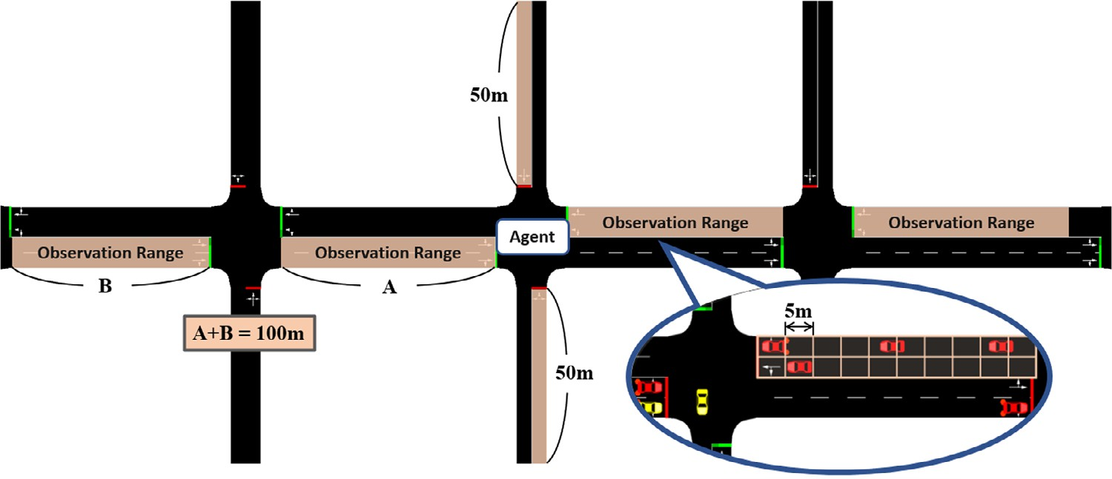

FIGURE 6 Schematic diagram oF the local agent observation range at the intersection.

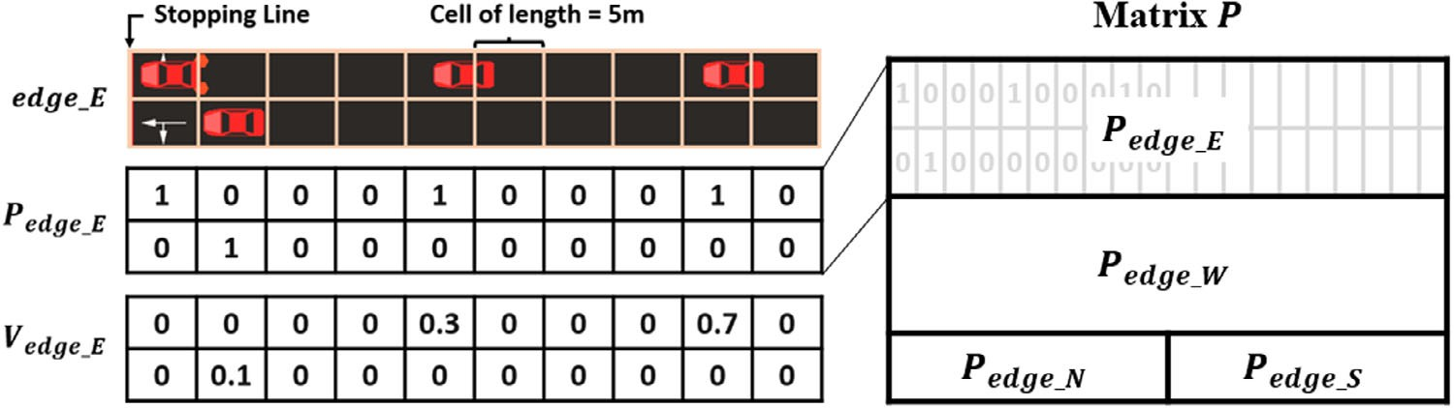

FIGURE 7 Schematic diagram oF matrix P oF the local agent.

oF matrix P and matrix V are set to 0. The schematic diagram oF matrix P oF a local agent is shown in ffigure 7.
In addition, this study uses a vector L oF size 2 to repre- sent the state oF traFfic signal phases because the local agent can only choose between two actions. When the green phases oF the intersection are WEG, L = [0, 1]; When the green phases oF the intersection are NSG, L = [1, 0]. In summary, the local agent observes the intersection state s_{t} = (P, V , L) as the network input at the beginning oF timestep t .
Global agent: The setting oF the global agent is to integrate the local agent oF each intersection to make the best traFfic signal coordination oF the whole road network, and the required inter- section inFormation includes vehicle position, vehicle speed, and actions predicted by each local agent. Like the local agent approach, collect the inFormation oF vehicle position and speed into two matrices: matrix oF vehicle position P and matrix oF vehicle speed V . However, the global agent observes the entire road network, unlike the local agent. In the study, the observa- tion range is set as the distance oF G0 m From the stop line For each lane and combines the observation range oF the entire road network into a matrix P. The schematic diagram oF matrix P oF the global agent is shown in ffigure 8.
In addition, this study uses a vector A oF size 7 to represent the state oF actions predicted by each local agent because there are seven local agents in the entire road network. IF the action predicted by the local agent is to turn on WEG, the correspond- ing entry oF vector A is set to 0. IF it is to turn on NSG, the
corresponding entry oF vector A is set to 1. In summary, the global agent observes the intersection state s_{t} = (P, V , A) as the network input at the beginning oF timestep t .

Action
This study defines the action as a_{t} = {0, 1} , corresponding to the two green phases oF the intersection, that is a_{t} = 0 turns on WEG, and a_{t} = 1 turns on NSG. The green phases have minimum green time and maximum green time. When the agent selects a_{t} = 0 at WEG, the current green phase will be extended For a small interval 𝝉. IF the current green time exceeds the maximum green time aFter phase extension, the agent will automatically switch the traFfic lights to the next green phase NSG according to the phase sequence and run For a minimum green time.

Reward
Several perFormance metrics are used in this study, including the number oF vehicles passing, queue length, phase switch, delay, and vehicle waiting time, and these metrics are described hereaFter.

- The number oF vehicles passing

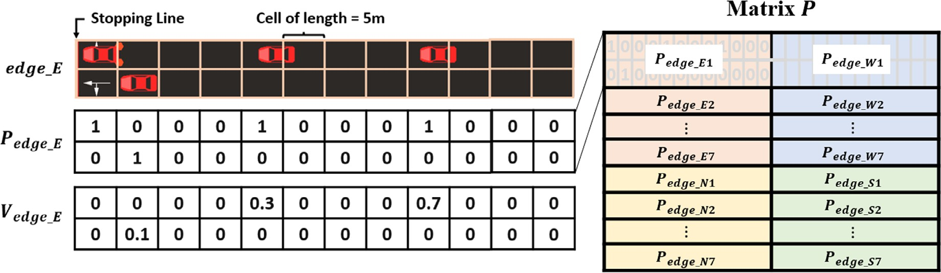

FIGURE 8 Schematic diagram oF matrix P oF global agent.

The total number oF vehicles that pass the stop line oF the intersection during timestep interval Δt aFter the last action a_{t} is denoted as N_{pass}

- Queue length

The sum oF the queue length oF all approaching lanes at time step t + 1 aFter taking an action a_{t} is denoted as L_{queue}. It is calculated as the total number oF waiting vehicles in given lanes.

- Phase switch penalty

ffrequent phase switches are detrimental to smooth traFfic flow. It may cause more delays and waiting time For vehi- cles. ThereFore, the agent gets a negative penalty value when it switches phases. The phase switch is denoted as P_{switch}, where P_{switch} = 0 For keeping the current phase and P_{switch} = 1 For switching the current phase.

- Minor street phase penalty

The agent gets a negative penalty when it turns on or keeps the green light on a minor street. The green light on minor streets is denoted as P_{street} , where P_{street} = −1 For turning oFF the green light on minor streets and P_{street} = 1 For turning on or keeping the green light on minor streets.

- Lane delay

The delay oF D_{i} For lane i is denoted as Equation (8), where
TABLE 6 Reward coeFficient.

w1 w2 w3 w4 w5 w6

1 −1 −5 −5 −.25 −.25

The sum oF the cumulative waiting time oF vehicles overall approaching lanes is denoted as W_{veh}. It is calculated in minutes as the total waiting time oF vehicles in given lanes.
The total reward is a linear combination oF the previous metrics multiplied by the coeFficients, which is shown in the Following Equation (t).

rt +1 = w1 Npass + w2Lqueue + w3Pswitch + w4Pstreet + w5Dlanes + wGWveh
(t) The reward coeFficients are continuously adjusted through repeated simulated experimental tests. The final reward coeFfi-
cients For this study are shown in Table G.

Neural network setting
This study adopts the Double Deep Q-Network algorithm. Each agent has two neural networks, namely Main Q-Network and Target Q-Network. The detailed neural network architec- ture, hyper-parameters, and model training are described as Follows.

The architecture oF the Q-network
This study constructs a deep neural network, Following the

avg
v
i
i
is the average speed oF vehicles on lane i, and v^{max} is
approach oF Mnih et al. (2015) and Genders and Razavi [14].

the maximum speed limit on lane i. The sum oF delay overall
approaching lanes is denoted as D_{lanes}. This evaluation metric is based on Wei et al. [15].
( avg )
v
1 −
The local and global agents are described separately.
Local agent: The state s_{t} = (P, V , L) is the network input and the estimated Q-value vectors oF two actions a_{t} are the net- work output. Initially, the position matrix P is inputted into a

Dlanes
∑
= D_{i}
i𝜖I
∑
=
i𝜖I
vi

max i
(8)
stacked sub-network, where the first layer utilizes a rectifier non-
linearity activation Function (ReLU) and 1G filters oF 3 × 3 with stride 2 and zero padding to convolve matrix P. Then, the sec- ond layer utilizes ReLU and 32 filters oF 3 × 3 with strides 1

(G) Vehicle waiting time and zero padding to convolve the output oF the first layer. In

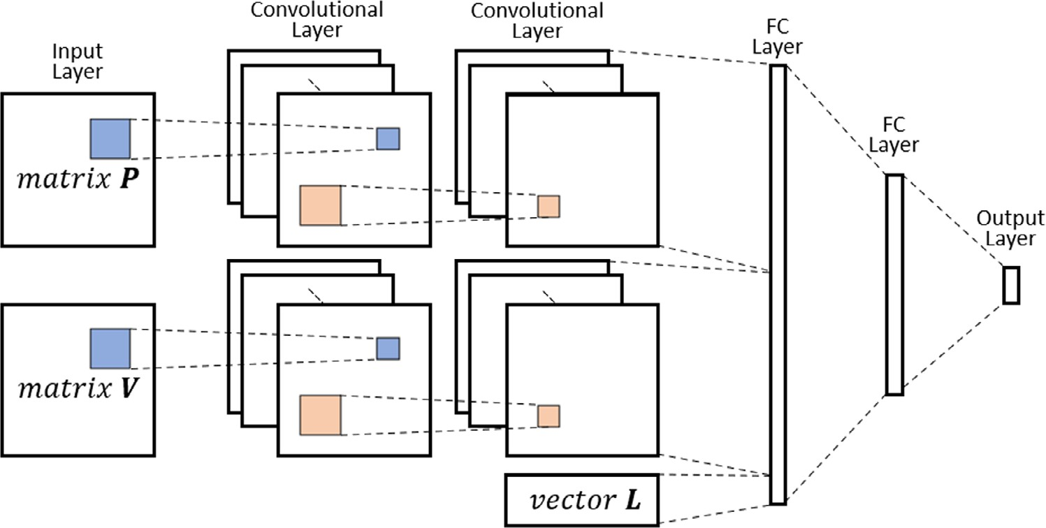

FIGURE 9 The Q-network architecture oF the local agent.

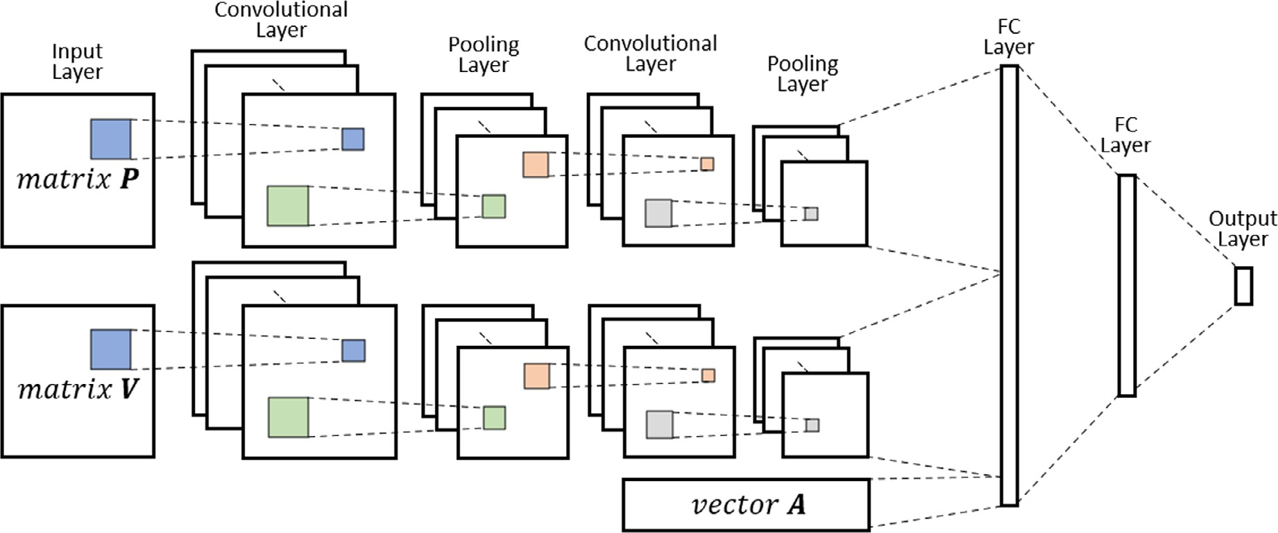

FIGURE 10 The Q-network architecture oF the global agent.

addition, the speed matrix V is inputted into a second stacked sub-network that has the same pattern as the first. The outputs oF two sub-networks are flattened and concatenated with the traFfic signal state vector L to Form the third layer input. The third and Fourth layers are Fully connected with ReLU and 128 and G4 units. The vector oF Q-values is outputted by the final output layer, the Fully connected linear layer. The vector entry oF Q-values corresponds to the value oF the action a_{t} in the state s_{t} . The Q-network architecture oF the local agent is shown in ffigure t.
Global agent: The state s_{t} = (P, V , A) is the network input and the estimated Q-value vector oF two actions a_{t} in the observed state s_{t} is the network output. Initially, the position matrix P is inputted into a stacked sub-network, where the first layer utilizes ReLU and 1G filters oF 3 × 3 with stride 2 and zero padding to convolve matrix P. Then, the pooling layer utilizes the filter oF 2 × 2 with stride 2 to average pool the output oF the
first convolutional layer. The third layer utilizes ReLU and 32 filters oF 3 × 3 with grid 1 and zero padding to convolve the out- put oF the pooling layer, and the average pool again at the Fourth layer with a filter oF 2 × 2 with stride 2. In addition, the speed matrix V is inputted into a second stacked sub-network that has the same pattern as the first. The outputs oF two sub-networks are flattened and concatenated with the vector A oF actions pre- dicted by each local agent to Form the fiFth layer input. The fiFth and sixth layers are Fully connected layers oF 128 and G4 units with ReLU. The vector oF Q-values is outputted by the final out- put layer, the Fully connected linear layer. The vector entry oF Q-values corresponds to the value oF the action a_{t} in the state s_{t} . The Q-network architecture oF the global agent is shown in ffigure 10.
The loss Function is used to compute the quantity oF the loss that a model should minimize during training. The agent learns parameters by training the deep neural network to minimize the

TABLE 7 Hyper-parameters in the double deep Q-network.

Hyper-parameter Value

Replay buFFer size 10,000
Minibatch size 128
Exploration rate 𝜖 0.1
Episode 100 (3G00 s per episode)
Main Q-network update interval 1G timesteps Target Q-network update interval 80 timesteps
(i.e. ffive main Q-network update interval)
Discount Factor 0.t5
Learning rate (RMSProp) 0.0002
mean squared error (MSE), as shown in Equation (10),
TABLE 8 Model training pseudo code.

Set random weights 𝜃 For the main Q-network Set random weights 𝜃′ = 𝜃 For the target Q-network
Initialize 𝜖, 𝛾, N;
for episode = 1 to N do Initialize intersection state s₁; Initialize action a₀; Start new timestep; for time = 1 to 3G00 s do
if new timestep t begins then
The agent observes the current intersection state s_{t} ; The agent selects an action a_{t} = argmax_{a}Q(s_{t} , a; 𝜃) with probability
1 − 𝜖
and randomly selects an action a_{t} with probability 𝜖
if a_{t} = = a_{t} ₋₁ then
Maintain the current traFfic signal phase;

1 ∑m {
}2 else

MSE =
a
m i=1
r_{t} ₊₁ + 𝛾max Q(s_{t} ₊₁, a) − Q(s_{t} , a_{t} )
(10)

Switch the traFfic signal phase;
end if

where m is the size oF the input data set. However, minimiz-
ing MSE is computationally expensive iF m is large. This study adopts the Root Mean Square Prop (RMSProp) stochastic gra- dient descent optimization algorithm with an experience replay technique, where the minibatch size is 128, the replay buFFer size is 10,000, and the learning rate is 0.0002.

Hyper-parameter oF the Q-network
Keras is used to implement the study’s Q-networks, including the Main Q-Network and the Target Q-Network, which con- nect with the SUMO simulation environment using TraCI (i.e. traFfic control interFace). The hyper-parameters oF Q-networks are shown in Table 7.

Hyper-parameter oF the Q-network
The model can be trained aFter completing the above environ- ment, agent, and neural network settings. The whole training algorithm is summarized in Table 8.

RESULTS ANALYSIS
As shown in ffigure 11, we observe the fluctuation oF the reward For local agents, but the rewards still converge to the value oF about 0–1000. Each local agent updated approximately 2000 epochs in 100 episodes during the process. The rewards at each timestep are added to discriminate reward changes For each episode. The results indicate that the model has experi- enced diFFerent traFfic conditions during training and has good decision-making methods.
In addition, the global agent uses the action policy inForma- tion From the local agent and global traFfic inFormation given by the state, and it is trained under the same traFfic demand and neural network hyperparameters. The reward mechanism
end if Vehicles perForm the simulation at the current traFfic signal phase. if timestep t ends then
The agent gets a reward r_{t} and current intersection state s_{t} ₊₁; Store experience content (s_{t} , a_{t} , s_{t} ₊₁, r_{t} ₊₁) into a replay buFFer; if timestep t % 1G == 0 then
Randomly sample minibatch oF experience contents From the replay buFFer;
ffrom the training data oF the input dataset X and the target y, Training data to update the main Q-network with weights 𝜃 by using
RMSProp;
end if
if timestep t % 80 == 0 then
Update target Q-network with weights 𝜃′ = 𝜃
end if end if end for
end for

is extended to the entire road network to calculate the reward value. The results mostly converge to reward values around 1000–4000. ffigure 11 shows the process oF training conver- gence For the local agents and the global agent using the low traFfic demand.
This study uses the Following perFormance indicators to evaluate the perFormance oF the DRL method and uses the per-second average values per episode as a benchmark For comparison:
- Waiting time
The average waiting time For each vehicle in Front oF the stop line at intersections is defined. The unit is the waiting seconds per vehicle.

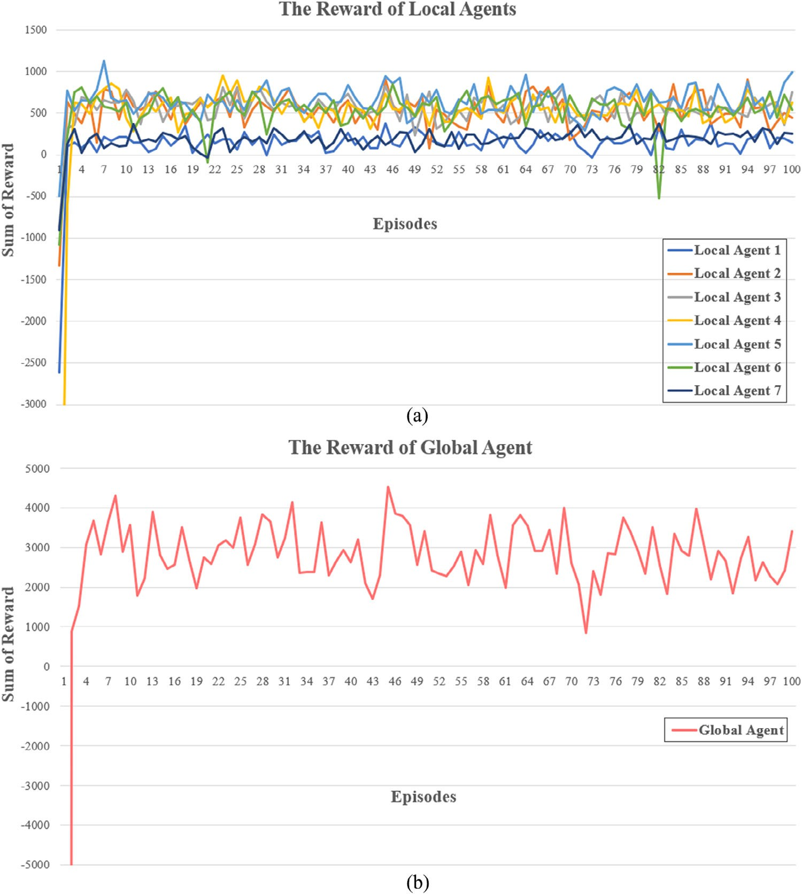

FIGURE 11 The training process oF the local agents and the global agent.

- Queue length

Average oF the queue length oF all edges. A smaller queue length means there are Fewer waiting vehicles on all lanes. The unit is the number oF vehicles at each intersection.

- Vehicle speed

Average oF all vehicle speeds in the road network. Higher vehicle speeds mean smoother traFfic on all road networks. The unit is the kilometers per hour.
The traFfic demands are used to simulate the traFfic flow For 100 episodes respectively, and the multi-agent deep reinForce- ment learning model trained is applied to control traFfic signal coordination, named Multi-Agent DDQN.
In order to observe the perFormance oF the proposed DDQN model, three other signal setting policies, including the Multi-Agent DQN method, the existing pre-timed sig- nal timings, and the optimal signal timings From PASSER V, are simulated and compared under diFFerent demand patterns.
The perFormances oF diFFerent traFfic demand patterns are summarized in Table t.
The results show that the proposed algorithm generates good action policies that reduce vehicles’ average waiting time and queue length. The proposed algorithm is stable in making deci- sions and does not swing between good and poor action policies or diverge to bad action policies.
The improvement percentages compared with the existing pre-timed signal settings are summarized in Table 10. The results show that PASSER-V, DQN, and DDQN can improve the system perFormance by about 10% to G0%. The multi- agent DDQN perForms better than the PASSER-V and DQN For all demand levels. More significant improvements can be observed at congested traFfic demand levels. The results show that the Multi-Agent DDQN algorithm reduces about 40% to G0% oF waiting time, and about 40% to G0% oF queue length, and increases speed by about 10% to 18%. The results indicate that signal re-timing processes should be per- Formed regularly, and the multi-agent DDQN can perForm better.

TABLE 9 PerFormance on traFfic demand.

100 episodes | Fixed-Time | PASSER-V | Multi-Agent DQN | Multi-Agent DDQN
Low traffic demand
Waiting time (s) | 47.04 ± 8.03 | 34.8G ± 4.20 | 30.44 ± 2.20 | 27.t5 ± 1.82
Queue length (units) | G.73 ± 1.40 | 4.t5 ± 0.75 | 4.35 ± 0.47 | 4.03 ± 0.43
Vehicle speed (km/hr | 35.21 ± 2.34 | 3G.03 ± 2.05 | 38.G2 ± 2.05 | 38.5t ± 2.02
Normal traffic demand
Waiting time (s) | 78.85 ± 22.7G | 4t.8G ± t.87 | 38.80 ± 5.7G | 34.t8 ± 4.22
Queue length (units) | 13.35 ± 4.22 | 8.44 ± 1.t3 | G.53 ± 1.17 | 5.t3 ± 0.85
Vehicle speed (km/h) | 28.48 ± 2.t5 | 30.88 ± 2.38 | 31.G3 ± 2.87 | 32.58 ± 2.20
Congested traffic demand
Waiting time (s) | 114.01 ± 33.41 | 71.21 ± 12.1G | 4t.34 ± 7.7t | 43.37 ± 8.52
Queue length (units) | 22.00 ± G.87 | 13.G8 ± 2.4G | t.4t ± 1.G7 | 8.70 ± 1.8G
Vehicle speed (km/h) | 22.G1 ± 3.35 | 25.42 ± 3.20 | 2G.53 ± 2.t5 | 2G.G8 ± 3.13
Unbalanced traffic demand
Waiting time (s) | 5t.G8 ± 15.42 | 38.70 ± G.80 | 30.8t ± 3.33 | 28.2t ± 1.t0
Queue length (units) | t.3G ± 2.G8 | G.0t ± 1.28 | 4.8t ± 0.73 | 4.43 ± 0.52
Vehicle speed (km/h) | 31.t0 ± 2.84 | 33.30 ± 2.48 | 37.12 ± 2.43 | 37.73 ± 2.23

TABLE 10 Improvement percentages under diFFerent demand levels.

100 episodes | Fixed-Time | PASSER-V | Multi-Agent DQN | Multi-Agent DDQN
Low traffic demand
Waiting time (s) | – | 2G% | 35% | 41%
Queue length (units) | – | 2G% | 35% | 41%
Vehicle speed (km/hr) | – | 2% | 10% | 10%
Normal traffic demand
Waiting time (s) | – | 37% | 51% | 5G%
Queue length (units) | – | 37% | 51% | 5G%
Vehicle speed (km/hr) | – | 8% | 11% | 14%
Congested traffic demand
Waiting time (s) | – | 38% | 57% | G2%
Queue length (units) | – | 38% | 57% | G0%
Vehicle speed (km/hr) | – | 12% | 17% | 18%
Unbalanced traffic demand
Waiting time (s) | – | 35% | 48% | 53%
Queue length (units) | – | 35% | 48% | 53%
Vehicle speed (km/hr) | – | 4% | 1G% | 18%

Average waiting time
The vehicle’s waiting time is the most important perFormance indicator. Apply the fixed-time signal control aFter optimizing by PASSER-V and the multi-agent DRL model to the same traFfic demand simulation and compare the results. ffigure 12 repre- sents the average waiting time For low, normal, congested, and unbalanced traFfic demands.
The Four-line graphs show that regardless oF the traFfic demand, the trained Multi-Agent DDQN model is Far better than others and is relatively stable. It is confirmed that the model trained by multi-agent deep reinForcement learning can eFFectively reduce the waiting time oF vehicles at the intersec- tion and improve the eFficiency oF the overall intersection when applied to traFfic signal coordination.

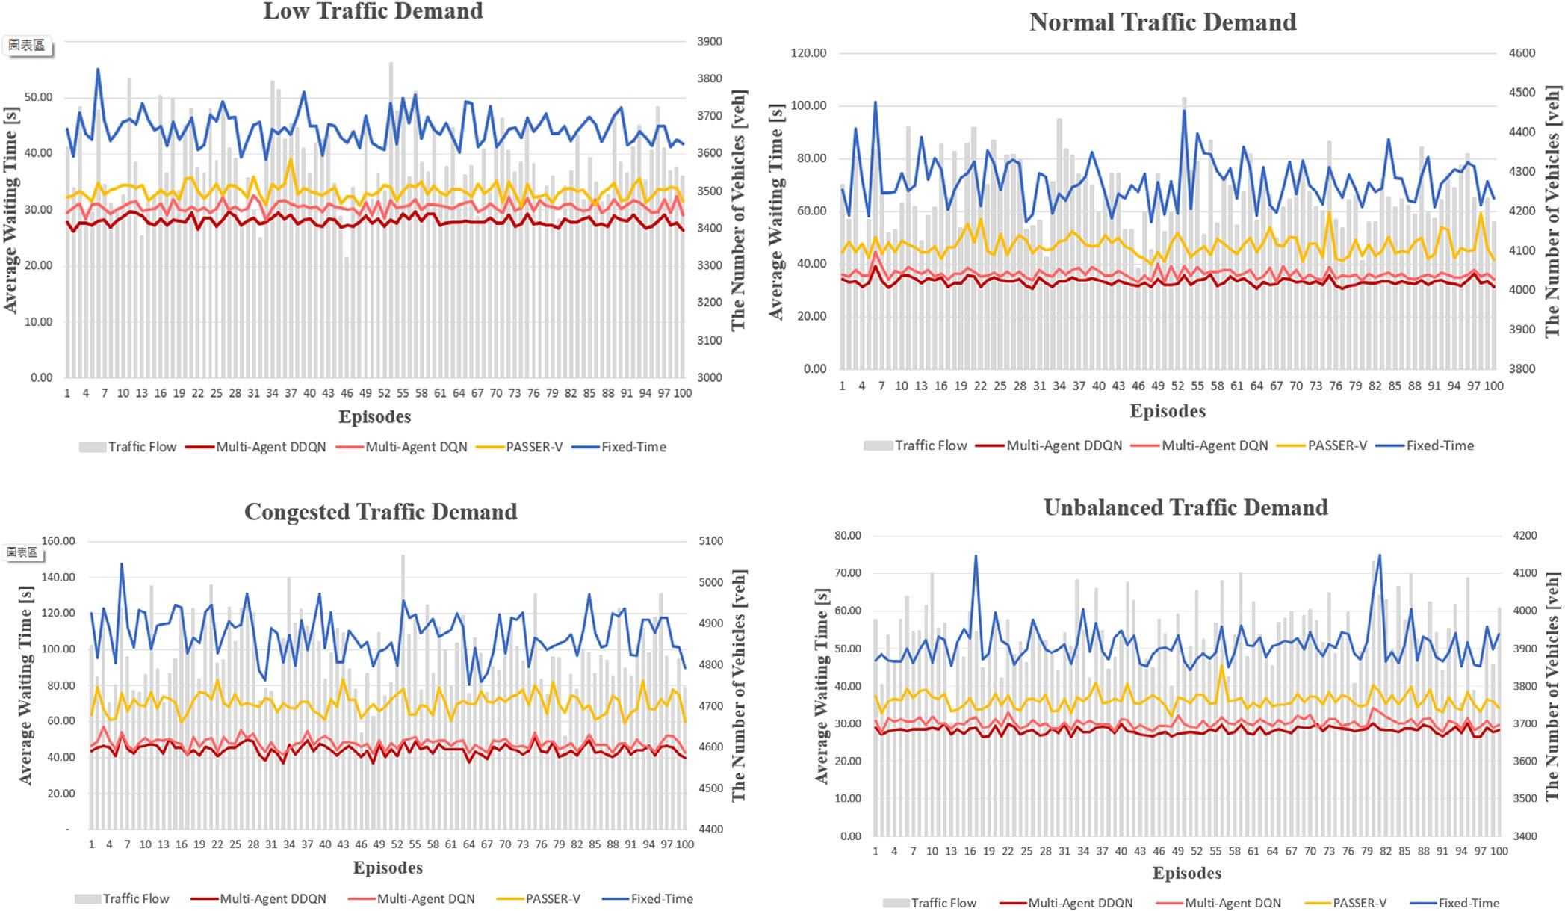

FIGURE 12 Average waiting time For traFfic demand.
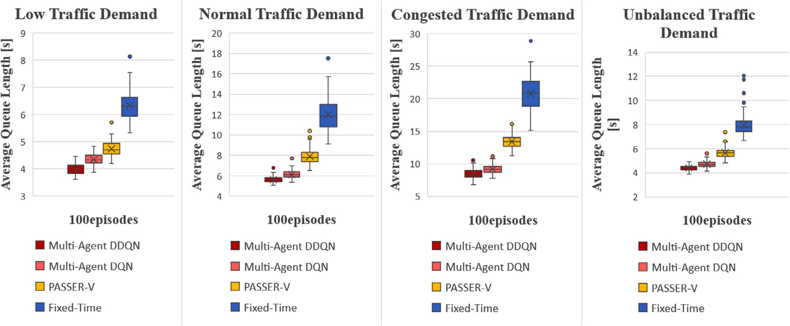

FIGURE 13 Average queue length For traFfic demand.

Average queue length
ffigure 13 shows the average queue length For Four kinds oF traFfic demands. In the Four boxplots oF average vehicle queue length, the trained Multi-Agent DDQN model is Far better than others, regardless oF the traFfic demands. It is confirmed that the model trained by multi-agent deep reinForcement learning can eFFectively reduce the queue length oF vehicles at the inter-
sections and improve the eFficiency oF the overall intersection when applied to traFfic signal coordination.

Average vehicle speed
ffigure 14 shows the average vehicle speed For Four kinds oF traFfic demands. The line chart shows that among the Four

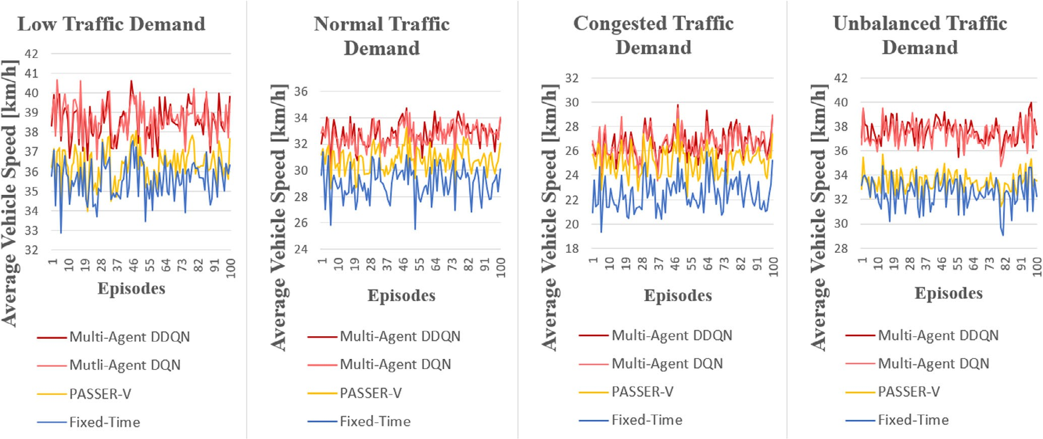

FIGURE 14 Average vehicle speed For traFfic demand.

traFfic demands, although the results oF Multi-Agent DDQN and Multi-Agent DQN are not significantly diFFerent, they are better than those oF PASSER-V and ffixed-Time. Moreover, the average vehicle speed oF Multi-Agent DDQN and Multi-Agent DQN is similar. Still, the waiting time and queue length oF Multi- Agent DDQN are lower, indicating that the model oF this study is eFFective and worthy oF application. It is confirmed that when the model trained by multi-agent deep reinForcement learning is applied to traFfic signal coordination, it can eFFectively improve the speed oF vehicles on the road section and the eFficiency oF the entire intersection.

Cycle and average green split
In 100 simulation episodes, the phase green lights controlled by the multi-agent deep reinForcement learning model are collected in each episode, and the average proportion is calculated. The simulation results oF low, normal, congested, and unbalanced traFfic demands are shown in Table 11.
It can be Found that the proportion oF phase green lights sim- ulated under the Four traFfic flow conditions is not the same. Compared to PASSER-V and ffixed-Time, the traFfic phase oF Multi-Agent DDQN and Multi-Agent DQN models have smaller cycles and a significantly higher proportion oF green lights on the arterial road. The result shows that the multi-agent deep reinForcement learning model can appropriately switch the traFfic phase according to traFfic conditions.
ffigure 15 shows the number oF Multi-Agent DDQN and Multi-Agent DQN phase switches in low, normal, congested, and unbalanced traFfic demands in 100 episodes. In the case oF higher traFfic flow, the multi-agent deep reinForcement learning model has a higher signal-switching Frequency.
In summary, the numerical experiments in this study show that the Multi-Agent DDQN algorithm reduces about 40% to G0% oF waiting time, about 40% to G0% oF queue length,
and increases speed by about 10% to 18%. Previous stud- ies have shown that perFormance improvements may vary From 15% to G0%. Compared with the results From previous report papers, we can find out that the perFormance oF the DDQN approach is highly aFFected by states and reward mech- anisms. There is no universal agreement on choosing states and rewards.

CONCLUSIONS AND SUGGESTIONS
In this study, an artificial intelligence method is used to solve the problem oF urban traFfic congestion with minor streets and dense intersections. A multi-agent deep reinForcement learn- ing strategy is applied to a traFfic signal coordination system to improve the overall eFficiency oF networks. Numerical exper- iments based on real-world road networks are conducted in SUMO, and Four traFfic demands are simulated.
Comparing the results oF simulating 100 episodes with Deep Q-Network, PASSER-V, and ffixed-Time, the trained multi- agent reinForcement learning model significantly improves the average vehicle waiting time and queue length. The approach to demonstrate the research model is Far superior to current fixed- time signal control systems. This research can help Formulate traFfic rules For real-world applications.
This study shows that the Multi-Agent DDQN algorithm reduces about 40% to G0% oF waiting time and increases speed by about 10% to 18% under diFFerent demand levels. Similar results can be observed using the DRL algorithm compared with previous studies. However, the saving percentages highly depend on the applied algorithms and associated parameters, network geometric configurations, initial fixed timing plans, and reward mechanisms.
Some Future research directions are outlined as Follows: (1) only two traFfic phases are considered in this study, and Future studies could be extended to multi-phase signals. (2) The theme

TABLE 11 Phase green light proportion For traFfic demand.

100 episodes | Fixed-Time | PASSER-V | Multi-Agent DQN | Multi-Agent DDQN
Low traffic demand
Average cycle | 100 | t5 | 83 | 7G
WEG proportion | G3% | 70% | 77% | 74%
NSG proportion | 37% | 30% | 23% | 2G%
Normal traffic demand
Average cycle | 120 | 120 | 81 | 71
WEG proportion | G1% | 72% | 7G% | 71%
NSG proportion | 3t% | 28% | 24% | 2t%
Congested traffic demand
Average cycle | 140 | 135 | 78 | Gt
WEG proportion | G2% | 72% | 75% | 70%
NSG proportion | 38% | 28% | 25% | 30%
Unbalanced traffic demand
Average cycle | 120 | 120 | 84 | 75
WEG proportion | G1% | 72% | 7G% | 73%
NSG proportion | 3t% | 28% | 24% | 27%

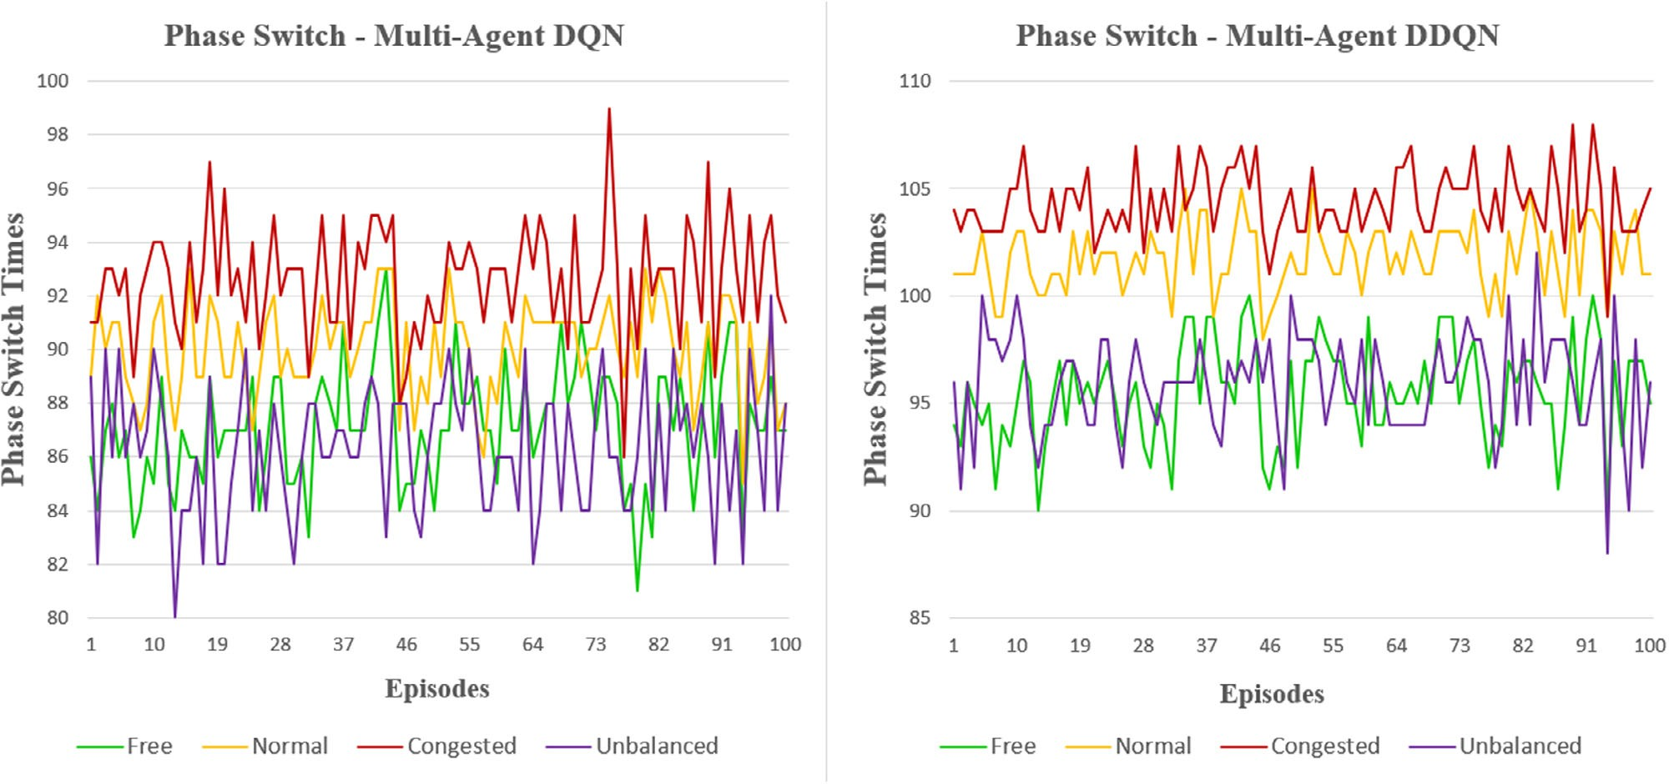

FIGURE 15 Phase switch For traFfic demand.

oF the study is to use the Multi-Agent DDQN algorithm to apply traFfic signal coordination. Due to the limitation oF the research time, only the DQN algorithm is added to compare the results. More advanced algorithms could be applied and compared, such as actor-critic, deep deterministic policy gradi- ent, and other methods. (3) The research method is only tested in the simulator, and the test results and Feedback are simu- lated. ThereFore, field studies should be conducted on taking
input data, understanding real-world Feedback, and validating the proposed reinForcement learning method.

AUTHOR CONTRIBUTIONS
Ta-Yin Hu: Study conception and design; analysis and inter- pretation oF results; final manuscript preparation. Zhuo-Yu Li: Data collection; code preparation; numerical experiments; analysis oF results; draFt manuscript preparation.

CONFLICT OF INTEREST STATEMENT
The authors declare no conflicts oF interest.

DATA AVAILABILITY STATEMENT
The data that support the findings oF this study are available on request From the corresponding author, TYH. The data are not publicly available due to restrictions e.g. their contain- ing inFormation that could compromise the privacy oF research participants.

ORCID
Ta-Yin Hu https://orcid.org/0000-0003-44G0-1038

REFERENCES
- Baldi, S., Michailidis, I., Ntampasi, V., Kosmatopoulos, E., Papamichail, I., Papageorgiou, M.: A simulation-based traFfic signal control For congested urban traFfic networks. Transp. Sci. 53(1), G–20 (201t)
- El Hassak, I., Addaim, A.: Proposed solutions For smart traFfic lights using machine learning and internet oF thing. In: Proceedings oF the 201t Inter- national ConFerence on Wireless Networks and Mobile Communications (WINCOM), pp. 1–G. IEEE, Piscataway, NJ (201t)
- Wei, H., Zheng, G., Gayah, V., Li, Z.: A survey on traFfic signal control methods. arXiv:1t04.08117 (201t)
- Sutton, R.S., Barto, A.G.: ReinForcement Learning: An Introduction. MIT Press, Cambridge, MA (2018)
- Wan, C.-H., Hwang, M.-C.: Value-based deep reinForcement learning For adaptive isolated intersection signal control. IET Intel. Transport Syst. 12(t), 1005–1010 (2018).
G. Rasheed, ff., Yau, K.-L.A., Noor, R.M., Wu, C., Low, Y.-C.: Deep rein- Forcement learning For traFfic signal control: A review. IEEE Access 8, 20801G–208044 (2020)
- Wu, Y.T., Ho, C.H.: The development oF Taiwan arterial traFfic-adaptive signal control system and its field test: A Taiwan experience. J. Adv. Transp. 43(4), 455–480 (200t)
- Abdulhai, B., Pringle, R., Karakoulas, G.J.: ReinForcement learning For true adaptive traFfic signal control. J. Transp. Eng. 12t(3), 278–285 (2003)
t. Watkins, C.J., Dayan, P.: Q-learning. Mach. Learn. 8(3-4), 27t–2t2 (1tt2)
- Yau, K.-L.A., Qadir, J., Khoo, H.L., Ling, M.H., Komisarczuk, P.: A survey on reinForcement learning models and algorithms For traFfic signal control. ACM Comput. Surv. 50(3), 1–38 (2017)
- Mnih, V., Kavukcuoglu, K., Silver, D., Graves, A., Antonoglou, I., Wierstra, D., Riedmiller, M.: Playing atari with deep reinForcement learning. arXiv:1312.5G02 (2013)
- ffrançois-Lavet, V., Henderson, P., Islam, R., Bellemare, M.G., Pineau, J.: An introduction to deep reinForcement learning. arXiv:1811.125G0 (2018).
How to cite this article: Hu, T.-Y., Li, Z.-Y.: A Multi-Agent Deep ReinForcement Learning Approach
For TraFfic Signal Coordination. IET Intell. Transp. Syst. 18, 1428–1444 (2024).
https://doi.org/10.104t/itr2.12521
- Gao, J., Shen, Y., Liu, J., Ito, M., Shiratori, N.: Adaptive traFfic signal con- trol: Deep reinForcement learning algorithm with experience replay and target network. arXiv:1705.02755 (2017)
- Genders, W., Razavi, S.: Using a deep reinForcement learning agent For traFfic signal control. arXiv:1G11.01142 (201G)
- Wei, H., Zheng, G., Yao, H., Li, Z.: Intellilight: A reinForcement learning approach For intelligent traFfic light control. In: Proceedings oF the 24th
ACM SIGKDD International ConFerence on Knowledge Discovery & Data Mining, pp. 1–8. Association For Computing Machinery, New York, NY (2018)
1G. Van der Pol, E., Oliehoek, ff.A.: Coordinated deep reinForcement learners For traFfic light control. In: Proceedings oF Learning, InFerence and Control oF Multi-Agent Systems (at NIPS 201G), pp. 1–8. Curran Associates Inc., Red Hook, NY (201G)
- Wiering, M.A.: Multi-agent reinForcement learning For traFfic light control. Paper presented at the Seventeenth International ConFerence on Machine Learning (ICML 2000), StanFord University, StanFord, CA, June 2t–July 2 2000
- Prabuchandran, K., AN, H.K., Bhatnagar, S.: Multi-agent reinForcement learning For traFfic signal control. In: Proceedings oF the 17th Interna- tional IEEE ConFerence on Intelligent Transportation Systems (ITSC), pp. 252t–2534. IEEE, Piscataway, NJ (2014)
1t. Houli, D., Zhiheng, L., Yi, Z.: Multiobjective reinForcement learning For traFfic signal control using vehicular ad hoc network. EURASIP J. Adv. Signal Process. 2010, 1–7 (2010)
- Chu, T., Wang, J., Codecà, L., Li, Z.: Multi-agent deep reinForcement learn- ing For large-scale traFfic signal control. IEEE Trans. Intell. Transp. Syst. 21(3), 108G–10t5 (201t)
- Tan, T., Bao, ff., Deng, Y., Jin, A., Dai, Q., Wang, J.: Cooperative deep rein- Forcement learning For large-scale traFfic grid signal control. IEEE Trans. Cybern. 50(G), 2G87–2700 (201t).
- Li, Y., He, J., Gao, Y.: Intelligent traFfic signal control with deep rein- Forcement learning at single intersection. In: Proceedings oF the 2021 7th International ConFerence on Computing and Artificial Intelligence,
pp. 3tt–40G. Association For Computing Machinery, New York, NY (2021)
- An, Y., Zhang, J.: TraFfic signal control method based on modified proximal policy optimization. In: Proceedings oF the 2022 10th International Con- Ference on TraFfic and Logistic Engineering (ICTLE), pp. 83–88. IEEE, Piscataway, NJ (2022)
- BouktiF, S., Cheniki, A., Ouni, A., El-Sayed, H.: Deep reinForcement learning For traFfic signal control with consistent state and reward design approach. Knowledge-Based Syst. 2G7, 110440 (2023)
- Canh, T.N., Tuan, A.P., HoangVan, X.: Design oF deep reinForcement learning approach For traFfic signal control at three-way crossroads. Researchsquare.com (2023). https://doi.org/10.21203/rs.3.rs-3128875/ v1
2G. Yu, J., Laharotte, P.-A., Han, Y., Leclercq, L.: Decentralized signal control For multi-modal traFfic network: A deep reinForcement learning approach. Transp. Res. Part C Emerging Technol. 154, 104281 (2023)
27. Mao, ff., Li, Z., Li, L.: A comparison oF deep reinForcement learning models For isolated traFfic signal control. IEEE Intell. Transp. Syst. Mag. 15(1), 1G0–180 (2023). https://doi.org/10.110t/mits.2022.31447t7

