**LAB2**

**Submitted by:**

**Pargat Singh.**

**Student ID: 22071833**

**Submitted to:**

**Professor: Nawaz Chowdhury**

**Subject: Programming Concepts 2**

**Course code: CSD214**

Honesty Statement: “I declare that this submission is my own work in compliance with Sault College Academic Policies.”

**Section A: Design and GUI (120 Marks)**

* + 1. Create a new JavaFX application project in your chosen Java IDE.
    2. Name the project using your name.
    3. Design the GUI interface for your JavaFX application, including a Table View, Buttons such as Insert, Update, Delete, and View Data to display data from the MySQL database tables and input fields for CRUD operations.
    4. Take a screenshot of your GUI layout, ensuring it includes your name, student ID, and date.

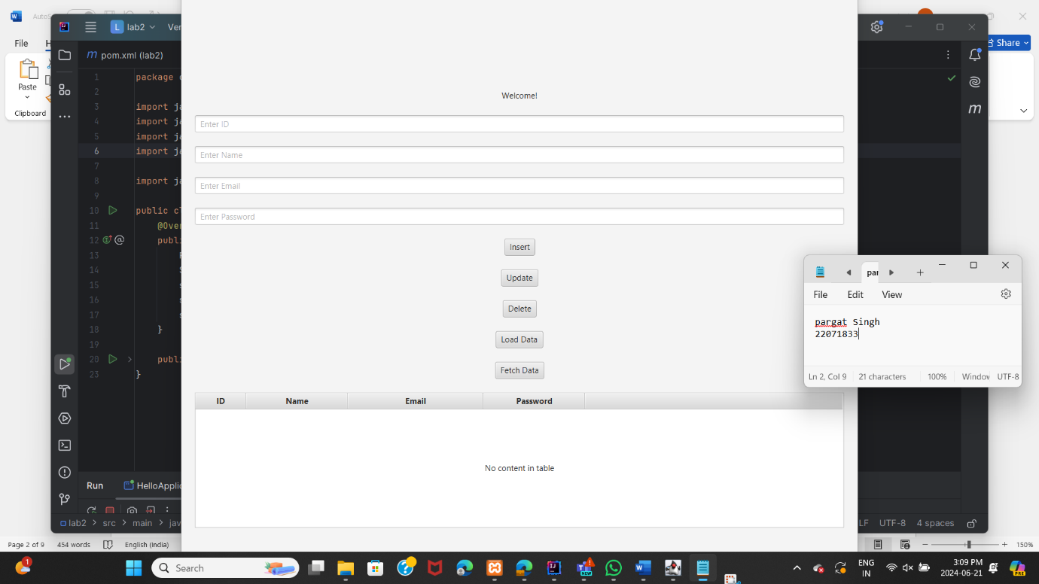

**Section B: Database Connection (180 Marks)**

* + 1. Implement the database connection code in your JavaFX application.
    2. Ensure it includes the necessary database URL, username, and password.
    3. Take a screenshot of the code where you establish the database connection.

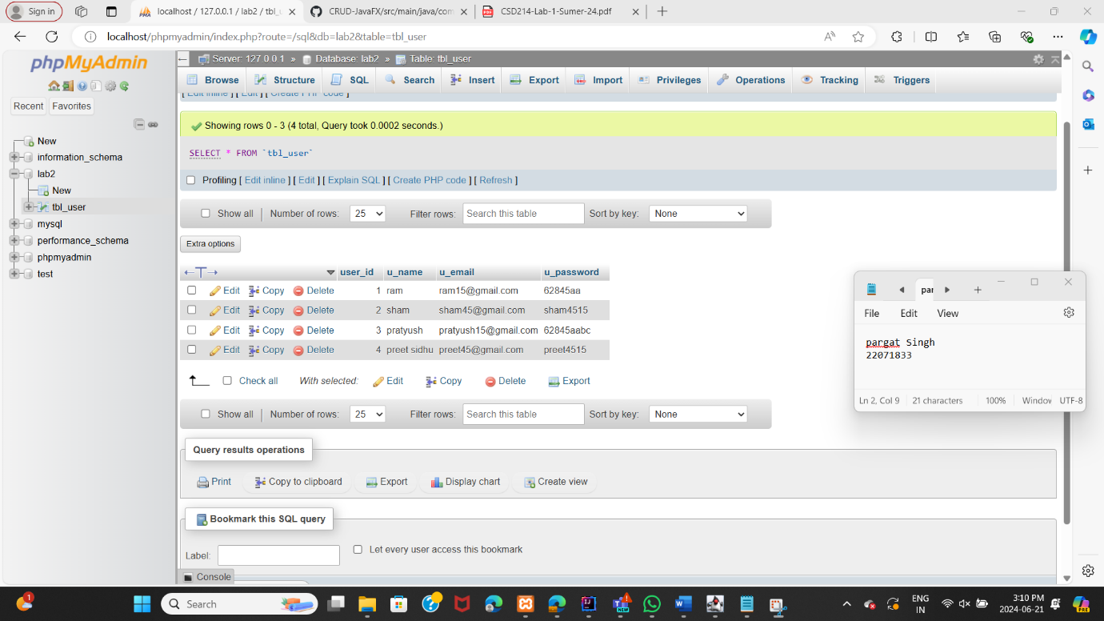

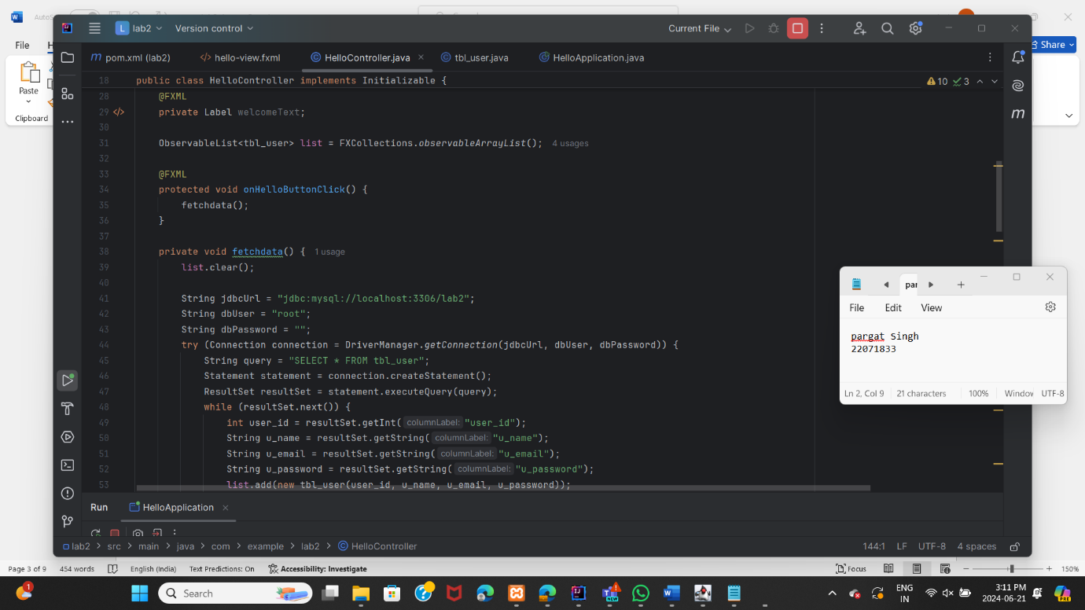

**Section C: Data Models and ORM (120 Marks)**

* + 1. Create Java classes that represent the structure of your database tables.
    2. These classes will be used to model the data you retrieve from and insert into the database.
    3. Use Object-Relational Mapping (ORM) techniques to simplify database interactions.

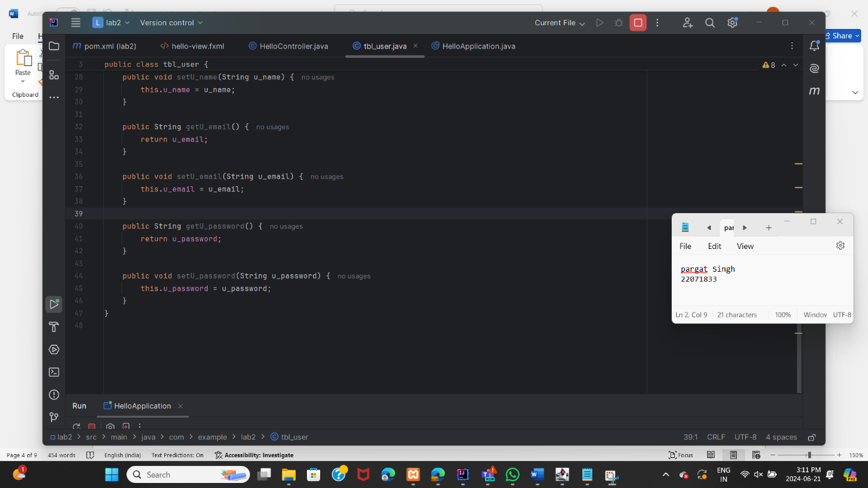

**Section D: Open JDBC Jar (120 Marks)**

* + 1. Download and include the appropriate JDBC driver (for example, MySQL Connector/J) in your project.
    2. Ensure that your project's build path includes the JDBC driver JAR file.

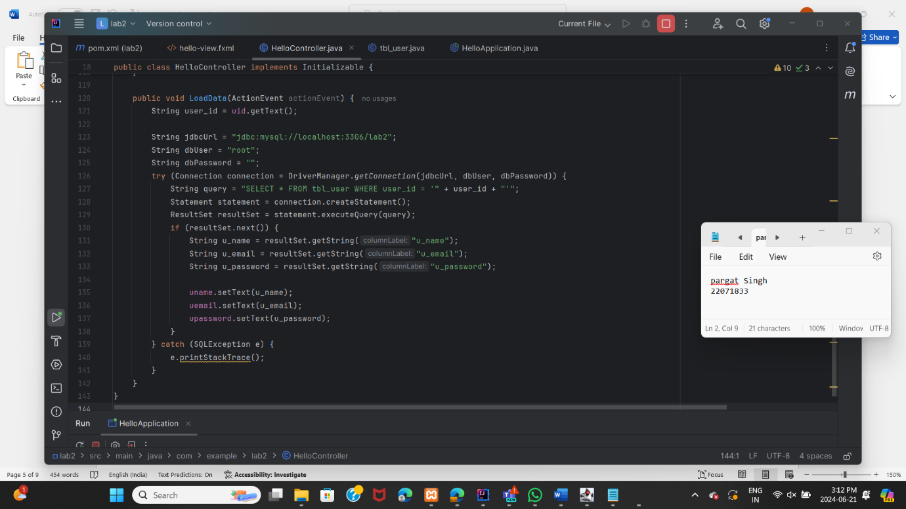

**Section E: Load Data in Table View (120 Marks)**

* + 1. Write code to retrieve data from the MySQL database tables and load it into the Table View component.
    2. Implement an event handler to trigger this action on button click.

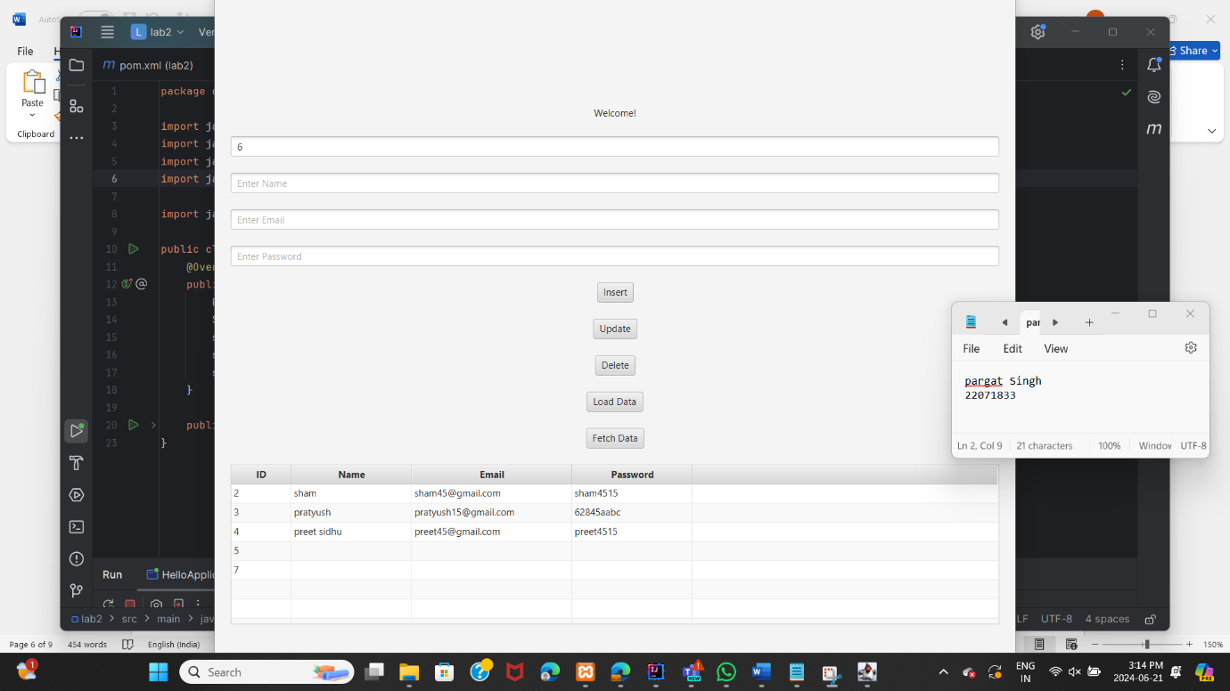

**Section F: Insert Data into Database (120 Marks)**

* + 1. Write code to insert data into the database when a button is clicked.
    2. Ensure that the input fields on the GUI are used to gather data for insertion.

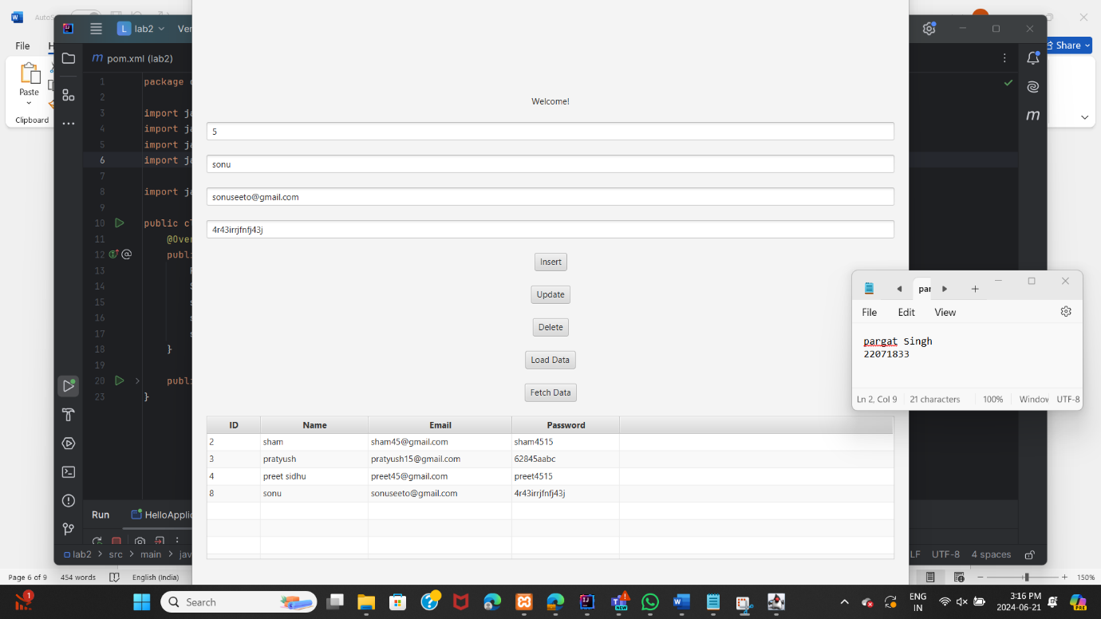

**Section G: Update Data in Database (120 Marks)**

* + 1. Write code to update existing data in the database when a button is clicked.
    2. Allow the user to provide an ID to identify the data to update.

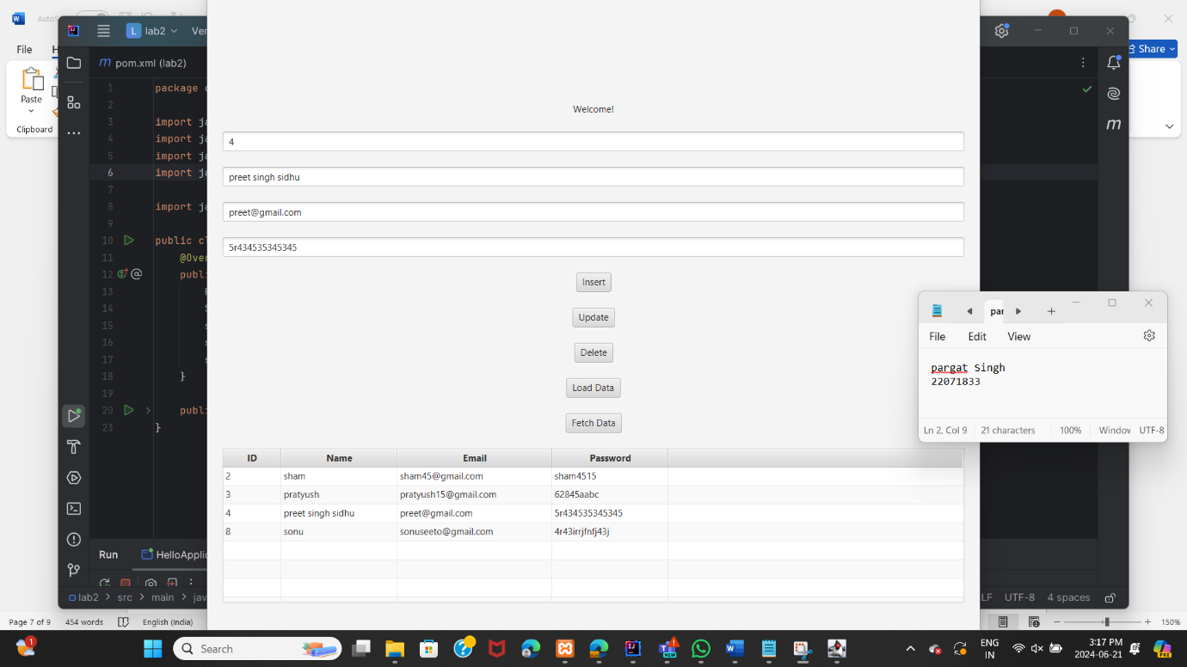

**Section H: Delete Data from Database (120 Marks)**

* + 1. Write code to delete data from the database when a button is clicked.
    2. Provide the option for the user to specify an ID for data deletion.

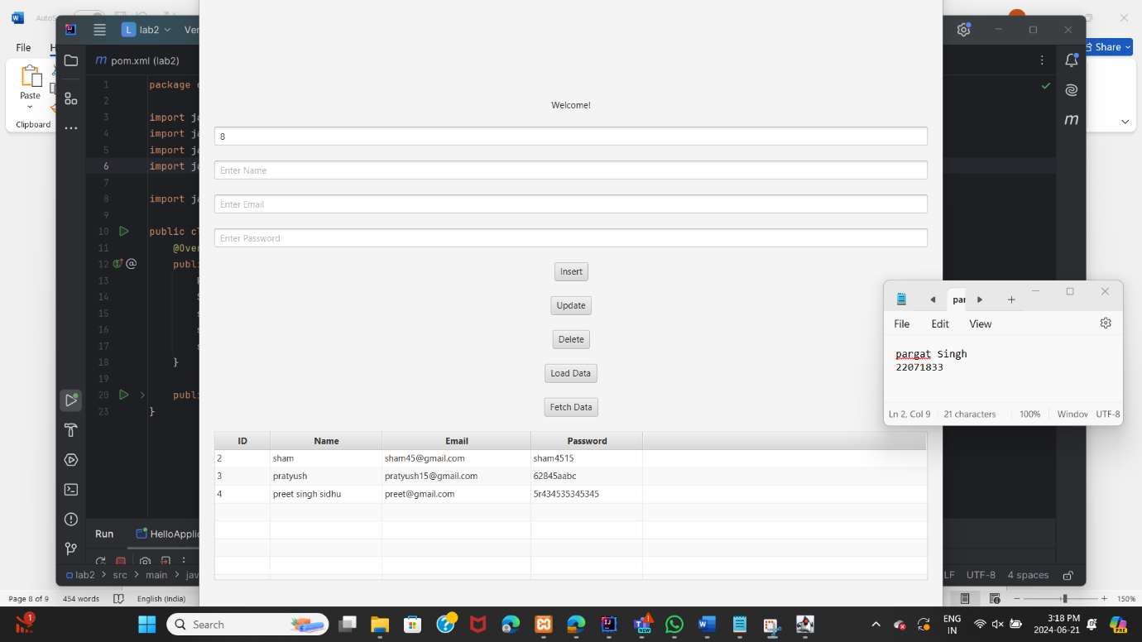

**Section I: GitHub and Documentation (180 Marks)**

* + 1. Upload your JavaFX project to a GitHub repository.
    2. Create a DOCX or PDF document including:
       - 1. Screenshots of your GUI layout with your name, student ID, and date.
         2. Screenshots of your database table structures and sample data.
         3. Screenshots of relevant portions of your code.
         4. A link to your GitHub repository.

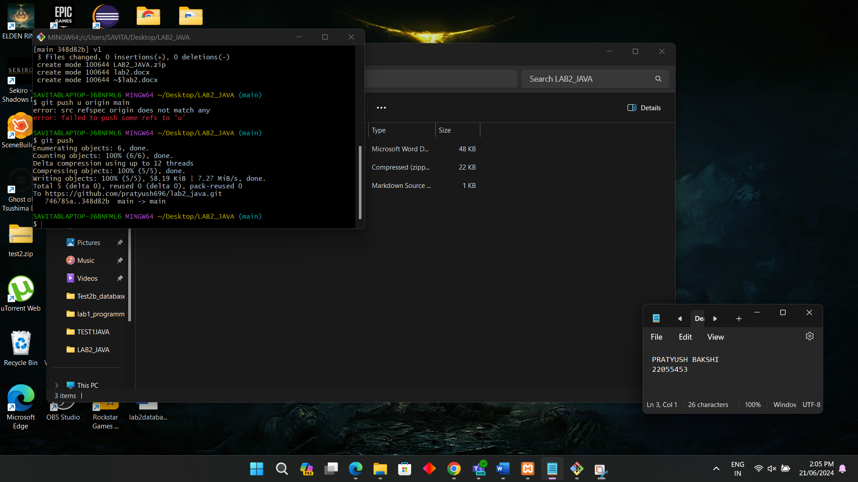

https://github.com/pratyush696/lab2_java.git