1. а) NOT ((xlog OR ylog) AND (zlog AND ylog))
= NOT ((TRUE OR FALSE) AND (FALSE AND FALSE))
= NOT (TRUE AND FALSE)
= NOT FALSE
= TRUE
б) NOT xlog OR ylog AND zlog AND ylog
= (NOT TRUE) OR (FALSE AND FALSE AND FALSE)
= FALSE OR FALSE
= FALSE
в) (NOT xlog) OR ((ylog AND zlog) AND ylog)
= (NOT TRUE) OR ((FALSE AND FALSE) AND FALSE)
= FALSE OR FALSE
= FALSE
2. а) (A ≠ 0) AND (B² - 4·A·C < 0)
б) (x - 1)² + y² > R²
в) (x ≥ y) AND (x ≥ z)
г) (x < y) OR (x < z)

- x−y <x+5 → $−1<8$→ TRUE
NOT xlog → TRUE
4.
а) $x∈[0;1]$: 0 ≤ x ≤ 1
б) $x∉[0;1]$: x < 0 OR x > 1
в) $x∈[2;5]∪[−1;1]$: (2 ≤ x ≤ 5) OR (-1 ≤ x ≤ 1)
г) $x∉[2;5]\text{ и }x∉[−1;1]$: (x < -1) OR (1 < x < 2) OR (x > 5)
д) $x,y,z>0$: (x > 0) AND (y > 0) AND (z > 0)
е) (x > 0 AND y ≤ 0 AND z ≤ 0) OR (y > 0 AND x ≤ 0 AND z ≤ 0) OR (z > 0 AND x ≤ 0 AND y ≤ 0)
ж) (x ≤ 0) AND (y ≤ 0) AND (z ≤ 0)
5.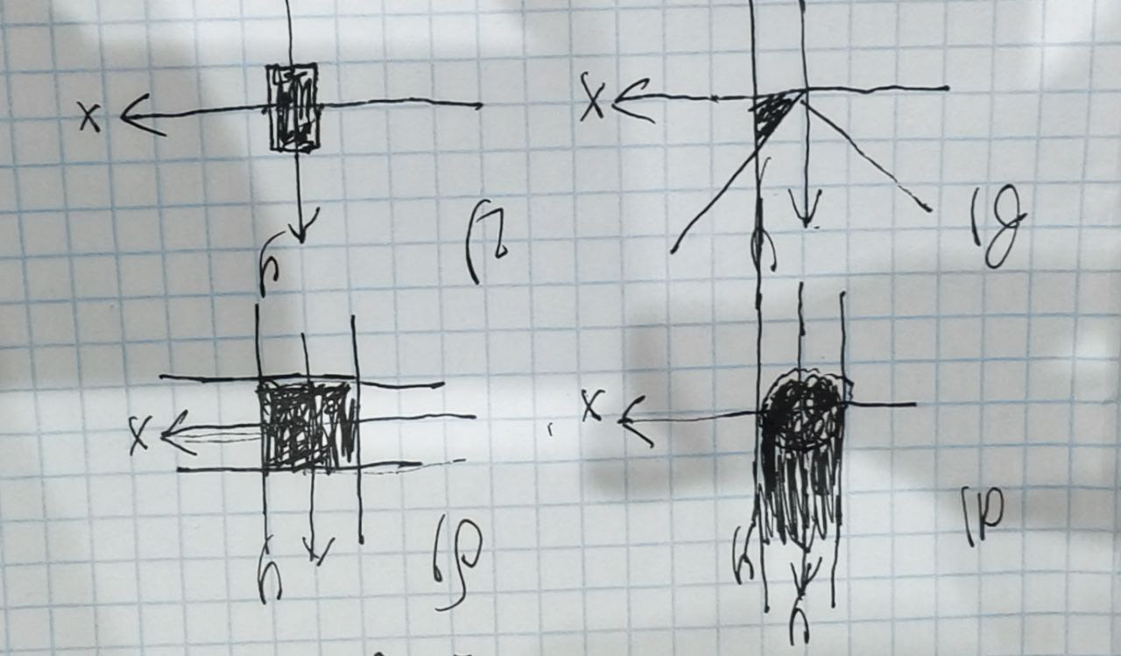
6.
a) |x| + |y| ≤ 1
b) (y ≥ 2|x|) ∧ (y ≤ 2)
7. if (0 < x) AND (x < 2) then y := cos(x)^2 else y := 1 - sin(x)^2;
8.d = a if a >= b and a >= c else (b if b >= c else c)
9. x := (a AND b) OR (NOT a AND c);
10. if a then x := true else x := (b AND c)

