ICT283 Assignment 1: Application Test Plan

Test | Description (including why the test is needed) | Actual Test Data | Expected Output | Passed
1 | Check program handles missing data_source.txt (file open failure must terminate safely). | Remove data/data_source.txt and run. | Print error opening data_source.txt; program terminated. | Passed
2 | Check program handles data_source.txt pointing to a missing or wrong CSV. | data_source.txt contains MetData-31-3aaaa | Print error opening CSV file; program terminated. | Passed
3 | Check program detects missing WAST header (required column). | CSV header does not contain WAST. | Print “Required column WAST not found”; program terminated. | Passed
4 | Check program loads correctly when column order changes (header index detection). | CSV columns shuffled (T and S header swapped place) | Program loads; menu outputs use correct fields; no crash. Still compute result. | Passed
5 | Check parser skips a row with invalid WAST format (prevents corrupt Date/Time). | One row WAST = BADDATE  (22-22-2222 0000) | Row ignored; program continues; no crash. | Passed
6 | Check for NA handling. Record still usable when one field is NA (needed for option 4 blank field rule). | Row has S=5.0, Deleted SR values, T=25. | Record stored; wind/temp stats include it; solar ignores missing SR. | Passed
7 | Menu input validation: invalid menu option handled without crashing. | Enter menu choice 6. | Print “Invalid option”; return to menu. | Passed
8 | Option 1: wind stats for month/year with data (mean + sample SD + km/h conversion). | Option 1; month=1, year=2016, use small test CSV with known wind values. | Print “January 2016”, average wind speed (km/h) and sample stdev (km/h). | Passed
9 | Option 1: wind stats for month/year with no valid wind data (No Data rule). | Option 1; choose month/year not present OR all wind values NA in that month. | Print “Month Year: No Data”. | Passed
10 | Option 2: temperature stats for each month of year with mixed months (some months have No Data). | Option 2; year=2016; test CSV where Feb has no valid temperature values. | Print 12 month lines; months with no temp show “No Data”; others will print avg + stdev. | Passed
11 | Option 2: entire year has no temperature data (all months No Data). | Option 2; year where T is NA for all records. Removed column to test. | All 12 months printed as “No Data”. | Passed
12 | Option 3: solar totals include only SR >= 100 W/m^2 (ignore night or low values). | Option 3; year where SR values include 120, 85, 100, 62, 39 in same month. | Monthly total counts only 120 and 100; ignores all under 100. | Passed
13 | Option 3: month has SR values but all < 100 (should be No Data). | Create month with all SR=10 (valid but below threshold). | Print “Month: No Data”. | Passed
14 | Solar conversion accuracy: each 10-min SR reading converted to kWh/m^2 using SR/6000. | Single month with exactly one record SR=600 (>=100). | Monthly total = 600/6000 = 0.1 kWh/m^2. | Passed
15 | Option 4: CSV output normal case (months with data output, correct formatting). | Option 4; year with Jan and Feb data. | WindTempSolar.csv line 1 is year; Month,windAvg(stdev),tempAvg(stdev),solarTotal. | Passed
16 | Option 4: month with no data must NOT be written (skip month line). | Option 4; year where March has no valid wind/temp/solar records. Removed all to test. | No “March” line in output file. | Passed
17 | Option 4: entire year no data. Print year then “No Data” on second line. | Option 4; year not present in dataset. | Output file line1=year; line2=No Data. | Passed
18 | Option 4: blank-field rule for missing metric (e.g., temp missing but wind+solar exist). | Month has valid wind+solar; all temp values NA. | Output line looks like: Month,windAvg(stdev),,solarTotal (blank temperature field). | Passed
19 | Sample SD handling: uses n-1 and avoids divide-by-zero when n<=1. | Create month with only 1 valid wind record. | Mean prints correctly; SD prints 0 (or safe value); no crash. | Passed
20 | Exit behavior: option 5 cleanly exits. | Choose menu option 5. | Program terminates cleanly. | Passed
21 | Limitation: user requests Daily statistics. | User asks for daily average wind speed for 15/03/2016 (no such menu option). | Not supported: program cannot produce daily report; documented as a limitation. | Failed
22 | Limitation: user requests humidity analysis. | CSV contains extra column RH (Relative humidity); user wants monthly humidity stats. | Not supported in current menu/design; documented as limitation. | Failed
23 | Limitation: user enters month name instead of numeric month. | Option 1; user types “January” instead of 1. | Not supported input format; document as limitation. | Failed

- 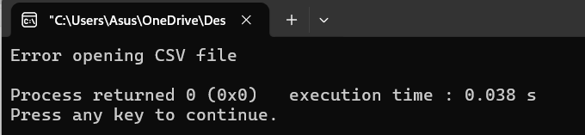
- 
- 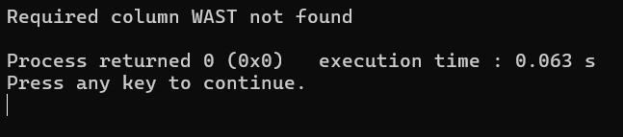
- 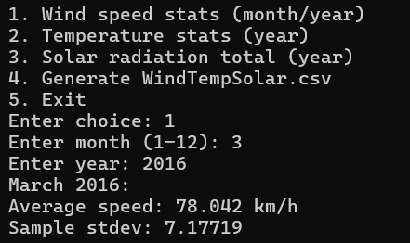
still computes results even when header index swapped.
- 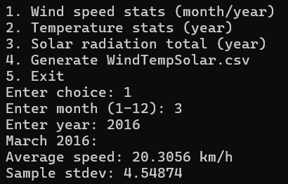
- 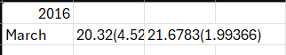
- 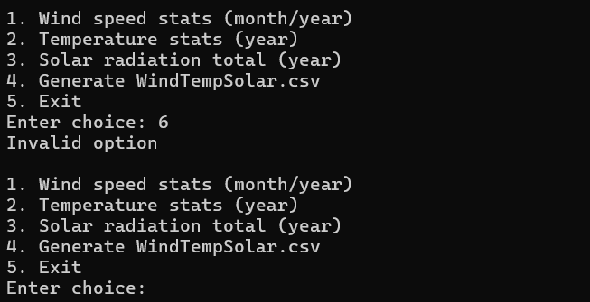
- 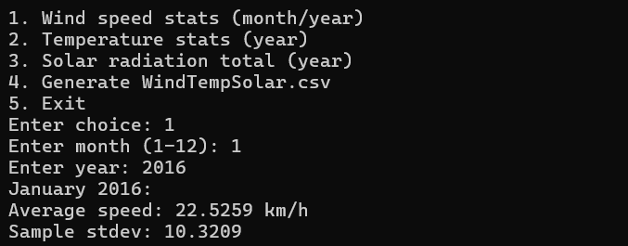
- 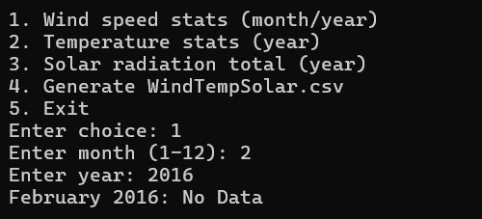
- 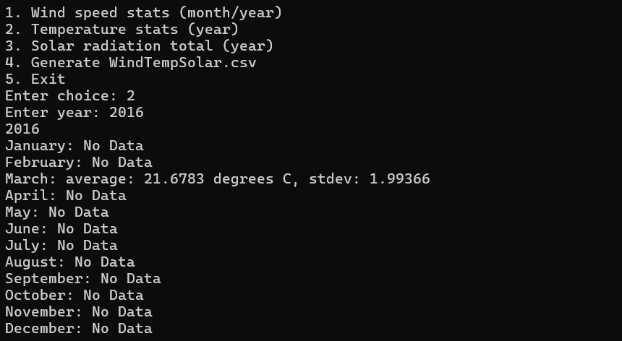
- 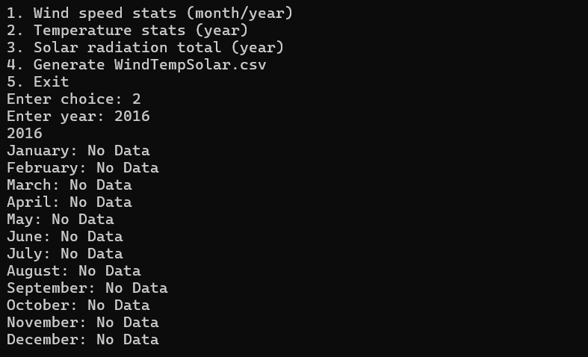
- 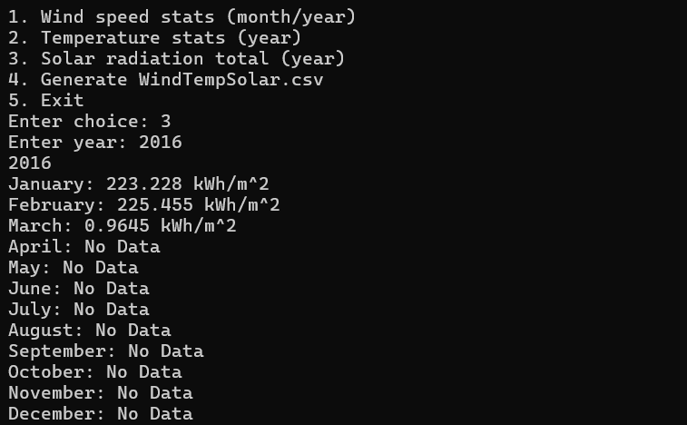
- 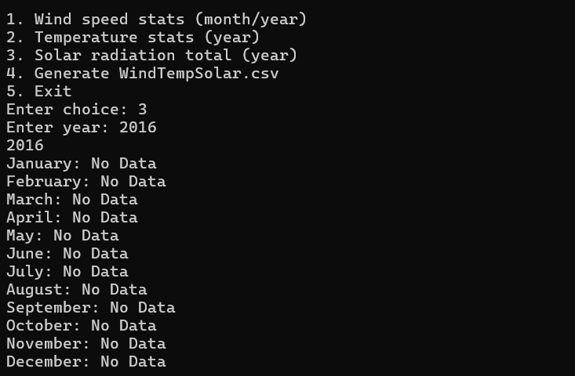
- 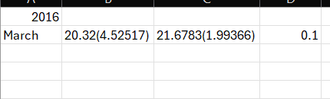
- 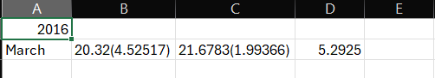
- 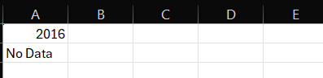
- 
- 
- C
- 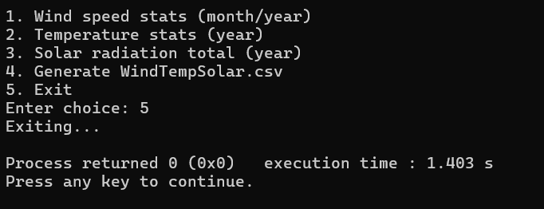

Classes Output Test Plan
Date Class
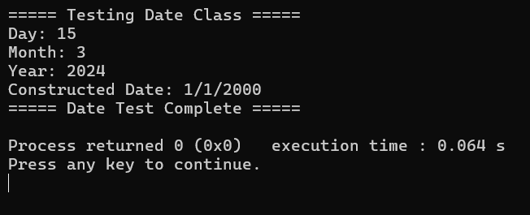
Time Class
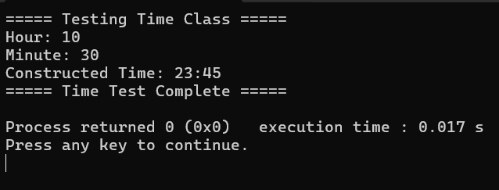

WeatherRec Class
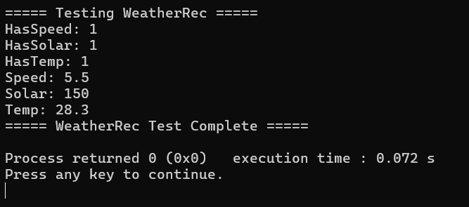
WeatherLog
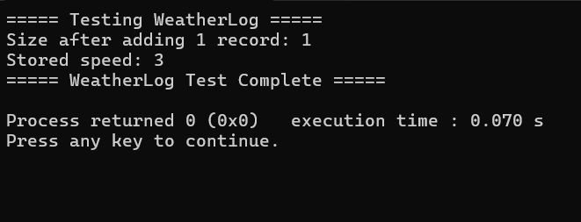

UtilityStats Class
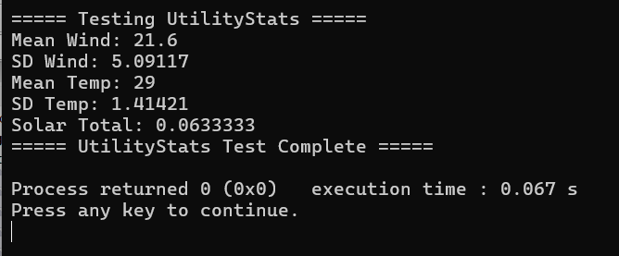

Vector Class
