羽毛球计分器

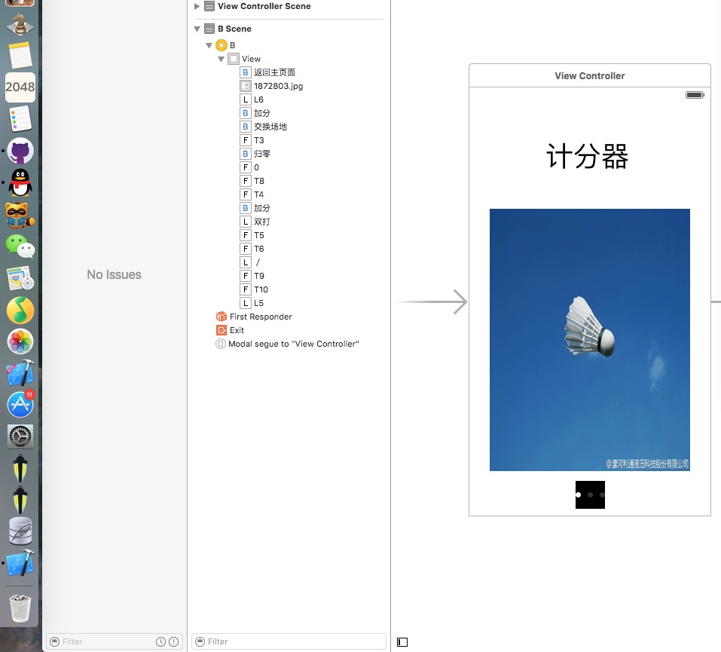

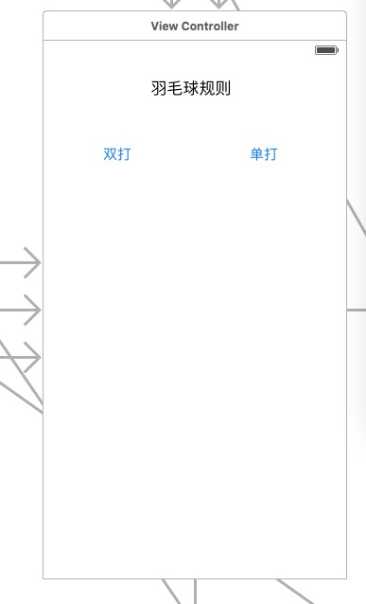

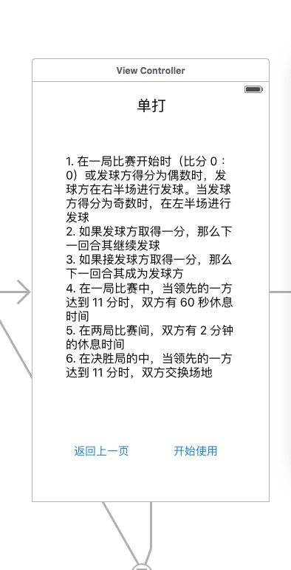

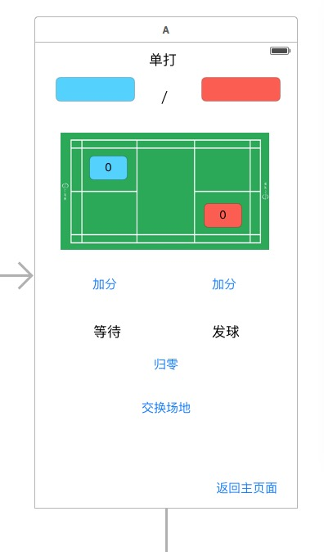

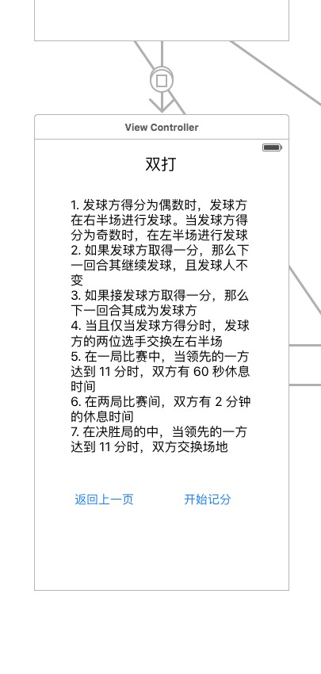

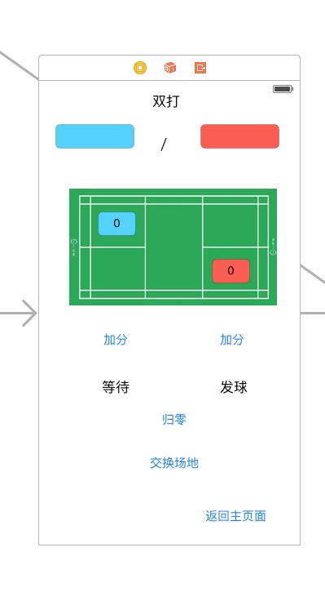

ç¢³هں؛ç”ںه‘½ن½“ 2016/6/23 16:46:51  
  
  
  
  
  
//  
//  A.swift  
//  asdasd  
//  
//  Created by King on 16/4/25.  
//  Copyright :emoji: 2016ه¹´ King. All rights reserved.  
//  
//import "sqlite3.h"  
//import <time.h>  
import UIKit  
var a3: Double=0;  
var a4: Double=0;  
var ar1: String=""  
var ar2: String=""  
var q1: Int = 0;  
var q2: Int = 0;  
var e1:String = "";  
var e2:String = "";  
var tx3:Int = 0;  
class A: UIViewController {  
      
    var db:SQLiteDB!  
      
    //@IBOutlet var txtUname: UITextField!  
    //@IBOutlet var txtMobile: UITextField!  
    //@IBOutlet weak var L1: UILabel!  
    //@IBOutlet weak var L2: UILabel!  
    //@IBOutlet weak var L3: UILabel!  
    //@IBOutlet weak var L4: UILabel!  
    @IBOutlet weak var L5: UITextField!  
    @IBOutlet weak var L6: UITextField!  
    //or = L3.text////  
    @IBOutlet weak var t8: UITextField!  
    @IBOutlet weak var t7: UITextField!  
    @IBOutlet weak var t6: UITextField!  
    @IBOutlet weak var t5: UITextField!  
    @IBOutlet weak var t4: UITextField!  
    @IBOutlet weak var t3: UITextField!  
    @IBOutlet weak var t9: UITextField!  
    @IBOutlet weak var t10: UITextField!  
    override func viewDidLoad() {  
        super.viewDidLoad()  
          
        //èژ·هڈ–و•°وچ®ه؛“ه®‍ن¾‹  
        db = SQLiteDB.sharedInstance()  
        //ه¦‚و‍œè،¨è؟کن¸چه­کهœ¨هˆ™هˆ›ه»؛è،¨ï¼ˆه…¶ن¸­uidن¸؛è‡ھه¢‍ن¸»é”®ï¼‰  
        db.execute("create table if not exists t_user(uid integer primary key,uname1 varchar(20),mobile1 varchar(20))")  
          
          
        db = SQLiteDB.sharedInstance()  
  
ç¢³هں؛ç”ںه‘½ن½“ 2016/6/23 16:47:42  
  
       //ه¦‚و‍œè،¨è؟کن¸چه­کهœ¨هˆ™هˆ›ه»؛è،¨ï¼ˆه…¶ن¸­uidن¸؛è‡ھه¢‍ن¸»é”®ï¼‰  
        db.execute("create table if not exists t_user(uid integer primary key,uname2 varchar(20),mobile2 varchar(20))")  
        //ه¦‚و‍œوœ‰و•°وچ®هˆ™هٹ è½½  
        initUser()  
    }  
      
    @IBAction func jh(sender: AnyObject) {  
        //if(t7.alpha==0&t8.alpha==0&t3.alpha == 1&t4.alpha == 1){}  
        //t7.alpha = 1;  
        //t8.alpha = 1;  
        //t3.alpha = 0;  
        //t4.alpha = 0;  
        //if(t7.alpha == 0&&t8.alpha == 0&&t3.alpha ==1&&t4.alpha == 1&&t9.alpha == 0&&t10.alpha == 0&&t5.alpha ==1&&t6.alpha == 1){}  
        if(t7.alpha==0){  
            if(t8.alpha==0){  
                if(t3.alpha == 1){  
                    if(t4.alpha == 1){  
                        if(t9.alpha == 0){  
                            if(t10.alpha == 0){  
                                if(t5.alpha == 1){  
                                    if(t6.alpha == 1){  
                                        t7.alpha = 1;  
                                        t8.alpha = 1;  
                                        t3.alpha = 0;  
                                        t4.alpha = 0;  
                                        t5.alpha = 0;  
                                        t6.alpha = 0;  
                                        t9.alpha = 1;  
                                        t10.alpha = 1;  
                                    }  
                                }  
                            }  
                        }  
                    }  
                }  
            }  
        }  
        else if(t7.alpha==1){  
            if(t8.alpha==1){  
                if(t3.alpha == 0){  
                    if(t4.alpha == 0){  
                        if(t9.alpha == 1){  
                            if(t10.alpha == 1){  
                                if(t5.alpha == 0){  
                                    if(t6.alpha == 0){  
                                        t7.alpha = 0;  
                                        t8.alpha = 0;  
                                        t3.alpha = 1;  
                                        t4.alpha = 1;  
                                        t5.alpha = 1;  
  
ç¢³هں؛ç”ںه‘½ن½“ 2016/6/23 16:47:57  
  
                                        t6.alpha = 1;  
                                        t9.alpha = 0;  
                                        t10.alpha = 0;  
                                    }  
                                }  
                            }  
                        }  
                    }  
                }  
            }  
        }  
        //txtMobile.text = user["mobile"] as? String  
        //x1.textColor=UIColor.redColor()  
        //x1.backgroundColor=UIColor.yellowColor()  
          
        //t3.alpha =  
          
        //t3.textColor = ;  
        //navigationController?.hidesBarsOnTap = true  
        //t3.didMoveToWindow()  
        //t3.window.  
    }  
    @IBAction func guiling(sender: AnyObject) {  
        t5.text = ""  
        t3.text = "0"  
        t7.text = "0"  
        let uname2 = self.t5.text!  
        let mobile2 = self.t3.text!  
        t7.text = t3.text  
        //وڈ’ه…¥و•°وچ®ه؛“ï¼Œè؟™é‡Œç”¨هˆ°ن؛†escه­—ç¬¦ç¼–ç په‡½و•°ï¼Œه…¶ه®‍وک¯è°ƒç”¨bridge.mه®‍çژ°çڑ„  
        let sql2 = "insert into t_user(uname2,mobile2) values('\(uname2)','\(mobile2)')"  
        print("sql2: \(sql2)")  
        //é€ڑè؟‡ه°پè£…çڑ„و–¹و³•و‰§è،Œsql  
        let result = db.execute(sql2)  
        print(result)  
        initUser();  
          
          
        t6.text = ""  
        t4.text = "0"  
        t8.text = "0"  
        let uname1 = self.t6.text!  
        let mobile1 = self.t4.text!  
        t8.text = t4.text  
        //وڈ’ه…¥و•°وچ®ه؛“ï¼Œè؟™é‡Œç”¨هˆ°ن؛†escه­—ç¬¦ç¼–ç په‡½و•°ï¼Œه…¶ه®‍وک¯è°ƒç”¨bridge.mه®‍çژ°çڑ„  
        let sql1 = "insert into t_user(uname1,mobile1) values('\(uname1)','\(mobile1)')"  
        print("sql1: \(sql1)")  
        //é€ڑè؟‡ه°پè£…çڑ„و–¹و³•و‰§è،Œsql  
        let result1 = db.execute(sql1)  
        print(result1)  
16:48:09  
ç¢³هں؛ç”ںه‘½ن½“ 2016/6/23 16:48:09  
  
        initUser();  
    }  
    //ç‚¹ه‡»ن؟‌ه­ک  
    @IBAction func saveClicked(sender: AnyObject) {  
        saveUser()  
    }  
  
    //ن»ژSQLiteهٹ è½½و•°وچ®  
    func initUser() {  
        let data = db.query("select * from t_user")  
        if data.count > 0 {  
            //èژ·هڈ–وœ€هگژن¸€è،Œو•°وچ®وک¾ç¤؛  
            let user = data[data.count - 1]  
            t5.text = user["uname1"] as? String  
            t3.text = user["mobile1"] as? String  
            t7.text = t3.text  
        }  
    }  
    @IBAction func saveClicked2(sender: AnyObject) {  
        saveUser2()  
    }  
    //ن؟‌ه­کو•°وچ®هˆ°SQLite  
    func saveUser() {  
        let uname1 = self.t5.text!  
        let mobile1 = self.t3.text!  
        t7.text = t3.text  
       // tx3 = (t5.text).Int;  
        //tx3 = tx3+1;  
          
        //وڈ’ه…¥و•°وچ®ه؛“ï¼Œè؟™é‡Œç”¨هˆ°ن؛†escه­—ç¬¦ç¼–ç په‡½و•°ï¼Œه…¶ه®‍وک¯è°ƒç”¨bridge.mه®‍çژ°çڑ„  
        let sql = "insert into t_user(uname1,mobile1) values('\(uname1)','\(mobile1)')"  
        print("sql: \(sql)")  
        //é€ڑè؟‡ه°پè£…çڑ„و–¹و³•و‰§è،Œsql  
        let result = db.execute(sql)  
        print(result)  
        //initUser()// Do any additional setup after loading the view, typically from a nib.  
    }  
    func saveUser2() {  
        let uname2 = self.t6.text!  
        let mobile2 = self.t4.text!  
        //var x = 0;  
        //x = Int(t4.text!)!  
        //  
        t8.text = t4.text//"\(x)"  
        // tx3 = (t5.text).Int;  
        //tx3 = tx3+1;  
          
        //وڈ’ه…¥و•°وچ®ه؛“ï¼Œè؟™é‡Œç”¨هˆ°ن؛†escه­—ç¬¦ç¼–ç په‡½و•°ï¼Œه…¶ه®‍وک¯è°ƒç”¨bridge.mه®‍çژ°çڑ„  
        let sql = "insert into t_user(uname2,mobile2) values('\(uname2)','\(mobile2)')"  
        print("sql: \(sql)")  
  
ç¢³هں؛ç”ںه‘½ن½“ 2016/6/23 16:48:22  
  
        //é€ڑè؟‡ه°پè£…çڑ„و–¹و³•و‰§è،Œsql  
        let result = db.execute(sql)  
        print(result)  
        //initUser()// Do any additional setup after loading the view, typically from a nib.  
    }  
      
    override func didReceiveMemoryWarning() {  
        super.didReceiveMemoryWarning()  
        // Dispose of any resources that can be recreated.  
    }  
      
    @IBAction func zuo1(sender: AnyObject) {  
        q2 = 0;  
        q1 = q1+1;  
        e1 = L5.text! as String;  
        e2 = L6.text! as String;  
        ar1 = "0";  
        ar1 = t3.text!;  
        t7.text = t3.text  
        a3 = ((ar1) as NSString).doubleValue  
        //operand2=((operand) as NSString).doubleValue  
        a3 = a3 + 1;  
        //ar = (a3)as NSString  
        t3.text = "\(a3)";  
        if(q1 == 2)  
        {  
            L5.text = e1;  
            L6.text = e2;  
            L5.text = e2;  
            L6.text = e1;  
        }  
        //for(;;)  
          
        //a3++;  
        //a3 = ((ar ) as NSString).intValue;  
          
    }  
    @IBAction func you2(sender: AnyObject) {  
        q1 = 0;  
        q2 = q2+1;  
        e1 = L5.text! as String;  
        e2 = L6.text! as String;  
        ar2 = "0";  
        ar2 = t4.text!;  
        t8.text = t4.text  
        a4 = ((ar2) as NSString).doubleValue  
        //operand2=((operand) as NSString).doubleValue  
        a4 = a4 + 1;  
        //ar = (a3)as NSString  
        t4.text = "\(a4)";  
  
ç¢³هں؛ç”ںه‘½ن½“ 2016/6/23 16:48:31  
  
        if(q2 == 2)  
        {  
            L5.text = e1;  
            L6.text = e2;  
            L5.text = e2;  
            L6.text = e1;  
        }  
  
    }  
    //@IBAction func zuo(sender: UIButton) {