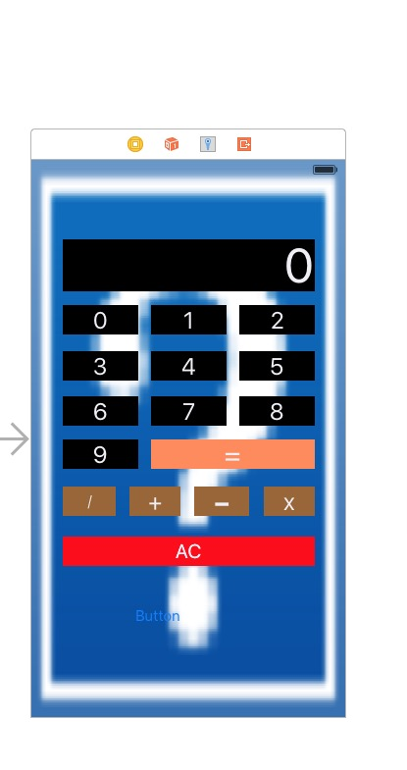

//  
//  ViewController.swift  
//  jsq  
//  
//  Created by King on 16/3/17.  
//  Copyright IMG_256 2016年 King. All rights reserved.  
//  
  
import UIKit  
  
class ViewController: UIViewController {  
      
    
    @IBOutlet weak var Abc: UILabel!  
    var operand1: Double=0  
    var operand2: Double=0  
    var operand: String=""  
    var x: Int=0  
    var y: Int=0  
    var z: Int=0  
    var operand3: String=""  
    ////////////////////////////  
    //var operatoe: String = ""  
    //x=Int(operand1)!  
  /\* @IBAction func jisuan(sender: UIButton) {  
       // println("\(sender.currentTitle)")  
        //println("\(sender.currentTitle)")  
        let value = sender.currentTitle  
        if(value=="+"||value=="-"||value=="X"||value=="/") {  
            operatoe = value!  
            return  
        }  
        else if value == "="{  
            var result = Int(operand1)! + Int(operand2)!  
            //let year = (yearofbirth.text as NSString).intValue  
            //var year = yearofbirh.text.toInt()  
            resultLabel.text = "\(result)"  
            return  
        }  
        if operatoe==""{  
            operand1 = operand1 + value  
        }  
        else{  
            operand2 = operand2 + value  
        }  
          
    @IBOutlet var huadong: UIPanGestureRecognizer!  
    }  
    \*/  
      
  
  
  
    @IBAction func huadong(sender: AnyObject) {  
        Abc.text = "1"  
    }  
    //@IBAction func asd(sender: AnyObject) {  
    //}  
    //@IBOutlet var huadong: [UIPanGestureRecognizer]!  
    //@IBOutlet var huadong: UIPanGestureRecognizer!  
   // @IBOutlet var huadong: UIPanGestureRecognizer!  
      
    @IBAction func AC(sender: UIButton) {  
        operand.removeAtIndex(operand.endIndex.predecessor())  
        Abc.text = "\(operand)"  
    }  
      
   @IBAction func jiu(sender: UIButton) {  
        operand+="9"  
    Abc.text = "\(operand)"  
    print("operand=\(operand)")  
    }  
    @IBAction func ba(sender: UIButton) {  
        operand+="8"  
        Abc.text = "\(operand)"  
    }  
    @IBAction func qi(sender: UIButton) {  
        operand+="7"  
        Abc.text = "\(operand)"  
    }  
    @IBAction func liu(sender: UIButton) {  
        operand+="6"  
        Abc.text = "\(operand)"  
    }  
    @IBAction func wu(sender: UIButton) {  
        operand+="5"  
        Abc.text = "\(operand)"  
    }  
    @IBAction func si(sender: UIButton) {  
        operand+="4"  
        Abc.text = "\(operand)"  
    }  
    @IBAction func san(sender: UIButton) {  
        operand+="3"  
        Abc.text = "\(operand)"  
    }  
    @IBAction func er(sender: UIButton) {  
        operand+="2"  
        Abc.text = "\(operand)"  
    }  
    @IBAction func yi(sender: UIButton) {  
        operand+="1"  
        Abc.text = "\(operand)"  
  
  
    }  
    @IBAction func ling(sender: UIButton) {  
        operand+="0"  
        Abc.text = "\(operand)"  
    }  
    //Abc.text = "\(operand)"  
    @IBAction func chu(sender: UIButton) {  
        x=1  
        y=y+1  
        z=1  
        print("y=\(y)")  
        operand1 = ((operand) as NSString).doubleValue  
        Abc.text = "/"  
        print("operand1=\(operand1)")  
        operand = ""  
        //Int(operand1)! / Int(operand2)!  
    }  
    @IBAction func cehng(sender: UIButton) {  
        x=2  
        y=y+1  
        z=1  
        print("y=\(y)")  
        operand1 = ((operand) as NSString).doubleValue  
        Abc.text = "x"  
        print("operand1=\(operand1)")  
        operand = ""  
        //Int(operand1)! \* Int(operand2)!  
    }  
    @IBAction func jian(sender: UIButton) {  
        x=3  
        y=y+1  
        z=1  
        print("y=\(y)")  
        operand1 = ((operand) as NSString).doubleValue  
        Abc.text = "-"  
        print("operand1=\(operand1)")  
        operand = ""  
        //Int(operand1)! - Int(operand2)!  
    }  
    @IBAction func jia(sender: UIButton) {  
        x=4  
        y=y+1  
        z=1  
        operand1 = ((operand) as NSString).doubleValue  
        Abc.text = "+"  
        print("y=\(y)")  
        print("x=\(x)")  
        print("operand1=\(operand1)")  
        operand = ""  
  
  
  
  
    }  
    @IBAction func dengyu(sender: UIButton) {  
       print("y=\(y)")  
       print("z=\(z)")  
        //for(y;y>0;y--)  
        //{  
         //   if(z==1) {  
                operand2=((operand) as NSString).doubleValue  
               // print(operand2)  
                print("operand2=\(operand2)")  
                operand = ""  
                //operand2 =((operand3) as NSString).doubleValue  
           // }  
        /\*  
           if(z==0) {  
                operand1=((operand) as NSString).doubleValue  
                print(operand1)  
                operand = ""  
            }  
            \*/  
            //var  xxx:Double  
            //xxx=((operand1) as NSString).doubleValue  
              
            if(x==1) {  
                //(Int)(operand1 !)/(Int)(operand2 !)  
                //operand3=((operand1) as NSString).doubleValue/((operand2) as NSString).doubleValue  
                print("operand1=\(operand1)")  
                operand1=operand1 / operand2  
                print("operand1=\(operand1)")  
            }  
            if(x==2) {  
                //Int(operand1)! \* Int(operand2)!  
                //operand3=((operand1) as NSString).doubleValue\*((operand2) as NSString).doubleValue  
                print("operand1=\(operand1)")  
                operand1=operand1 \* operand2  
                print("operand1=\(operand1)")  
            }  
            if(x==3) {  
                //Int(operand1)! - Int(operand2)!  
                //operand3=((operand1) as NSString).doubleValue-((operand2) as NSString).doubleValue  
                print("operand1=\(operand1)")  
                operand1=operand1 - operand2  
                print("operand1=\(operand1)")  
            }  
            if(x==4) {  
               // Int(operand1)! + Int(operand2)!  
                //operand3=((operand1) as NSString).doubleValue+((operand2) as NSString).doubleValue  
                print("operand1=\(operand1)")  
                operand1=operand1 + operand2  
                print("operand1=\(operand1)")  
  
  
  
            }  
        /\*var endoperand1 = (operand1 ).substringFromIndex(2)  
        if(endoperand1 == ".0") {  
            operand1.removeAtIndex  
        }  
\*/  
        //if(operand1.endIndex=0)  
        //var yyy: String = String(operand1)!  
        //Abc.text = "\(operand1)"  
        Abc.text = "\(operand1)"  
   //print("operand1=\(operand1)")  
    }  
     
   /\* @IBAction func baifenhao(sender: UIButton) {  
        var www: Int = Abc.text  
        www = www / 100  
        Abc.text = "\(www)"  
    }  
    \*/  
    
        //@IBOutlet weak var b1: UIButton!  
    //@IBOutlet weak var b2: UITextField!  
    //@IBOutlet weak var b1: UITextField!  
    //@IBOutlet weak var b2: UITextField!  
    // b1111  
    //blueButton.frame = CGRectMake(0, 60, 100, 30)  
    //b1111.setTitle("点我变蓝", forState: UIControlState.Normal)  
    //b1111.backgroundColor = UIColor.blueColor()  
    //b1111.tag = 101  
    //self.view.addSubview(b1111)  
    //  
  
   /\*@IBAction func add(sender: UIButton) {  
        //var me.(a,v,b,)  
        //b1=1  
        //var b1111==1  
        var a:Double!=0  
        var b:Double!=0  
        var c:Double!=0  
        if(!b1.text!.isEmpty){  
            a=(b1.text! as NSString).doubleValue// 定义b1  
        }  
       //b1=1;  
        if(!b2.text!.isEmpty){  
            b=(b2.text! as NSString).doubleValue// 定义b2  
        }  
        c=a+b  
        out.text="\(c)"  
    }\*/  
  
  
    override func viewDidLoad() {  
        super.viewDidLoad()  
        // Do any additional setup after loading the view, typically from a nib.//////  
    }  
  
    override func didReceiveMemoryWarning() {  
        super.didReceiveMemoryWarning()  
        // Dispose of any resources that can be recreated.  
    }  
  
  
}