**Creating an Arithmetic Calculator.**

**Problem Statement:-**

* write a program to create an arithmetic calculator.
* Using Core Java concepts: Variables, data types, operators, type casting, control statements, class, objects, access specifiers, and core keywords like final, this, and static

**Step1:Java-Code**

**package** mypackage;

**import** java.util.Scanner;

**public** **class** Calculator{

**public** **static** **void** main(String[] args) {

Scanner scanner = **new** Scanner(System.***in***);

System.***out***.println("Arithmetic Calculator");

System.***out***.print("Enter the first number: ");

**double** num1 = scanner.nextDouble();

System.***out***.print("Enter the second number: ");

**double** num2 = scanner.nextDouble();

System.***out***.print("Enter the operator (+, -, *, /): ");

**char** operator = scanner.next().charAt(0);

**double** result = 0;

**switch** (operator) {

**case** '+':

result = num1 + num2;

**break**;

**case** '-':

result = num1 - num2;

**break**;

**case** '*':

result = num1 * num2;

**break**;

**case** '/':

**if** (num2 != 0) {

result = num1 / num2;

} **else** {

System.***out***.println("Error: Cannot divide by zero.");

**return**; // Exit the program

}

**break**;

**default**:

System.***out***.println("Error: Invalid operator.");

**return**; // Exit the program

}

System.***out***.println("Result: " + result);

}

}

Step2: IDE-Eclipse.

2.1Create a new Project, Name it as Calculator 2.2Create a new class and name it as Calculator

2.3 Import packages

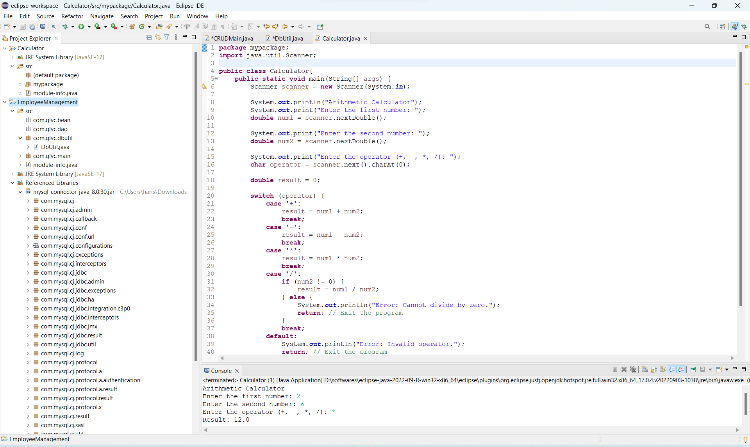

Step 3: Execution of code

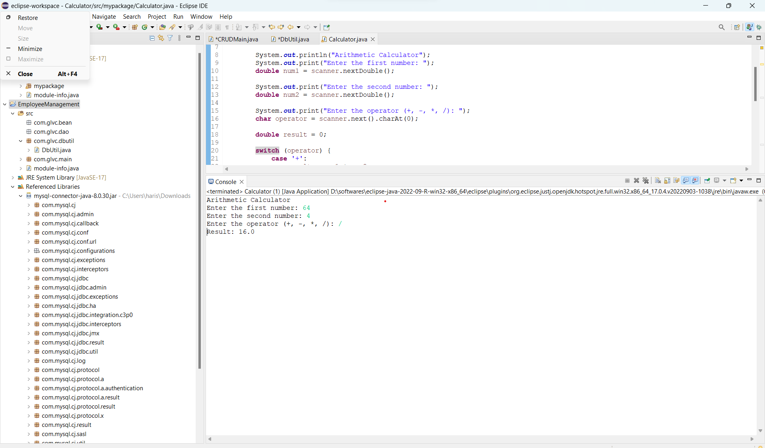

Step4: Output of the Program

This program demonstrates the use of variables, data types, operators, control statements (switch), and user input using the **Scanner** class. The **switch** statement is used to determine which arithmetic operation to perform based on the entered operator.Compile and run this program to use the arithmetic calculator. Keep in mind that this is a basic example, and you can expand or modify it according to your requirements.

Step 5: Pushing the code to git hubs

